MySQL Install
Michael Gordon
Bellevue University
Database Development and Use CSD310
Professor: Dr. Mortoza Abdullah
09/02/2026





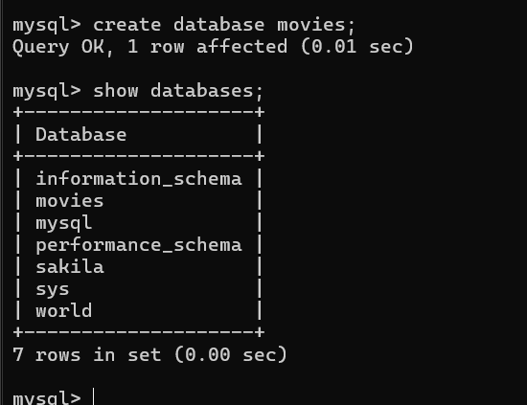

A database with Customer data was created to use for the w3schools functions
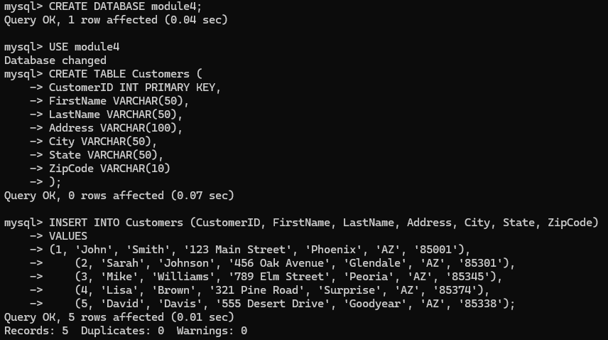

Concatenate Columns
The example provided by w3schools was the best example. Giving the full address an alias of “Address” and combining all the applicable columns could be very useful if you’ll be gathering all this data frequently.
SELECT CONCAT(Address, ‘, ‘, PostalCode, ‘ ‘, City) AS Address FROM Customers;
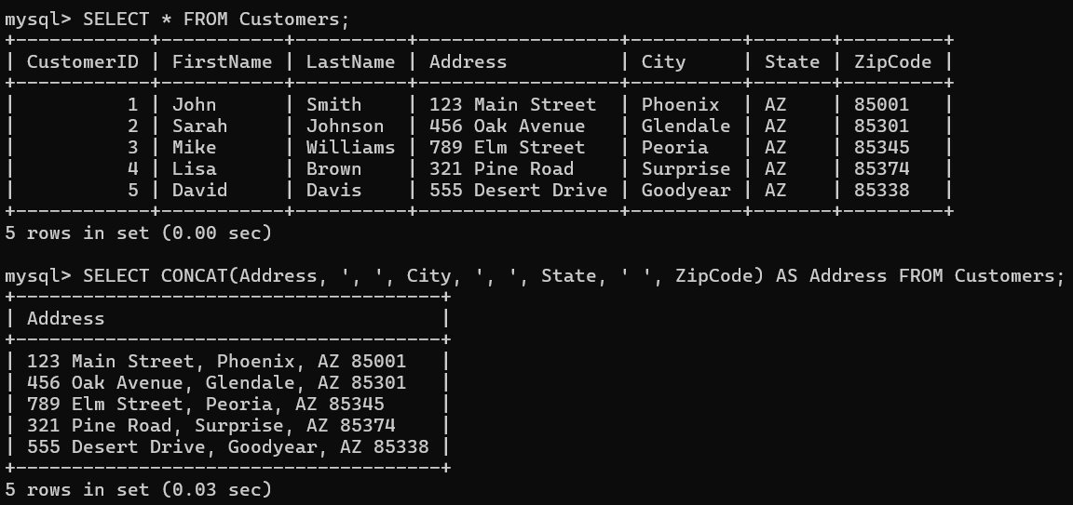

Alias for Table Syntax gives a table a shorter name within an SQL statement temporarily.
This would come in handy if the table were long or if working with several tables. This is a quick thing to save a bit of time.
SELECT c.FirstName, c.LastName FROM Customers AS c;
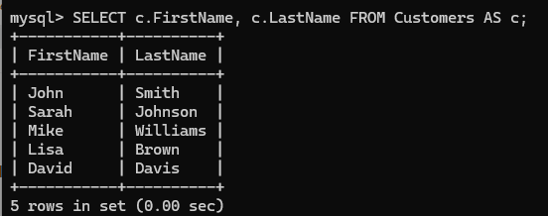

Alias with Spaces lets you have a space in the alias. I think combining it with Alias for Columns is a great way to change the heading that appears in the query results temporarily when the columns need to be made easier to understand.
SELECT FirstName AS “Customer First Name”, LastName AS “Customer Last Name”
FROM Customers;
