Michael Gordon
CSD325-302E Advanced Python
Module 1.2

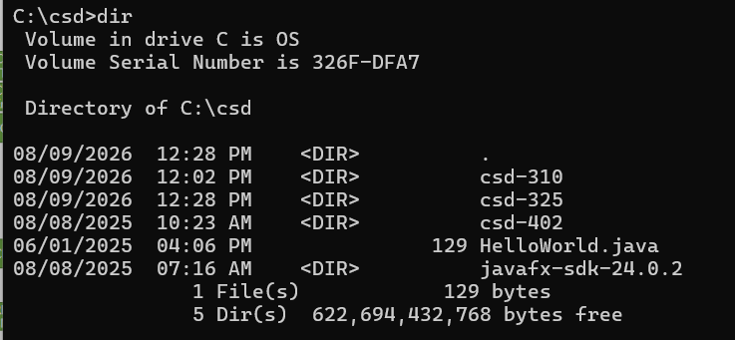
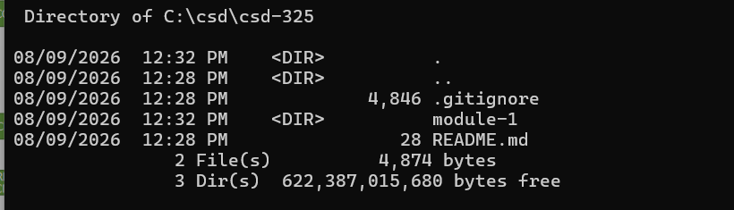
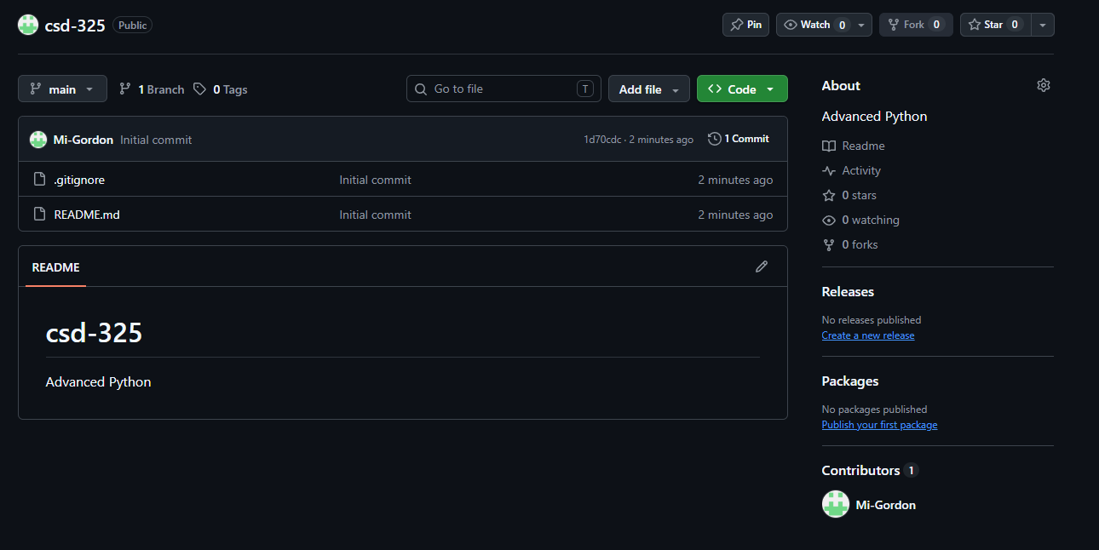
https://github.com/Mi-Gordon/csd-325.git

