High/Low Temperatures
Michael Gordon
Bellevue University
Advanced Python CSD325
Professor: Dr. Toni Farley
09/01/2026

Flowchart of original file
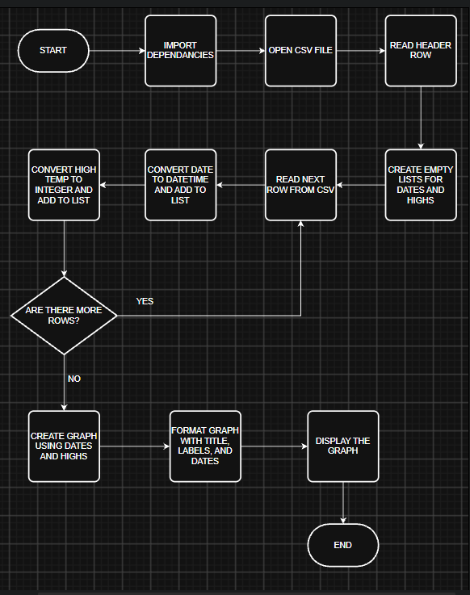

Flowchart with changes made
