Documented Debugging + Flowchart
Michael Gordon
Bellevue University
Advanced Python CSD325
Professor: Dr. Toni Farley
08/17/2026

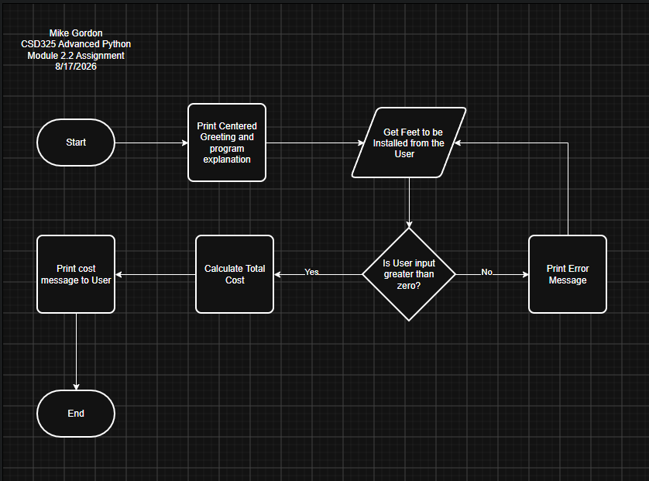

I started with adding a break point at the calculate function
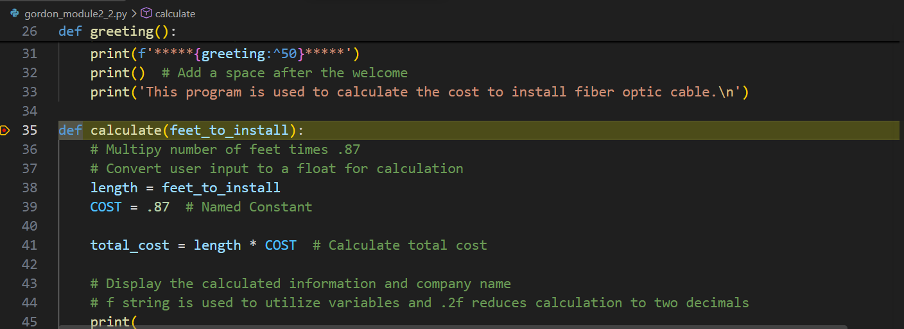
Entering a number greater than zero allows the program to finish running.
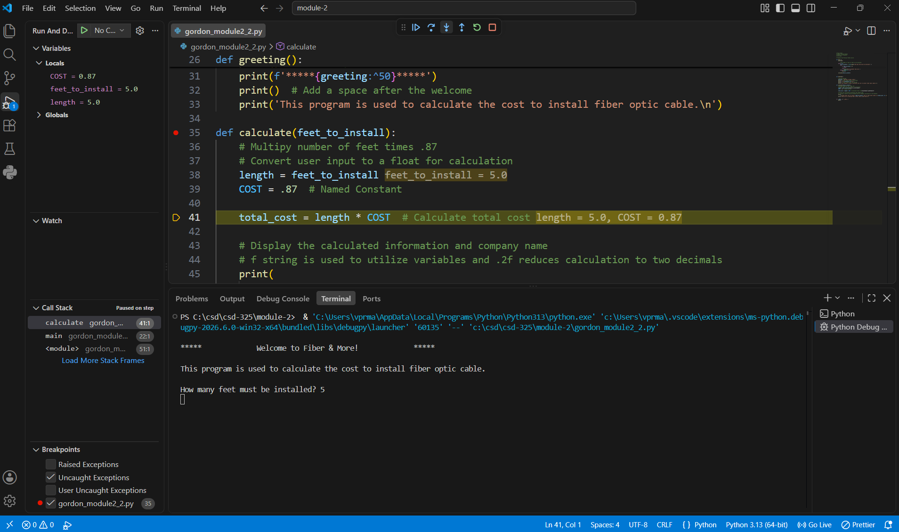

Entering an alphabetic character results in an error
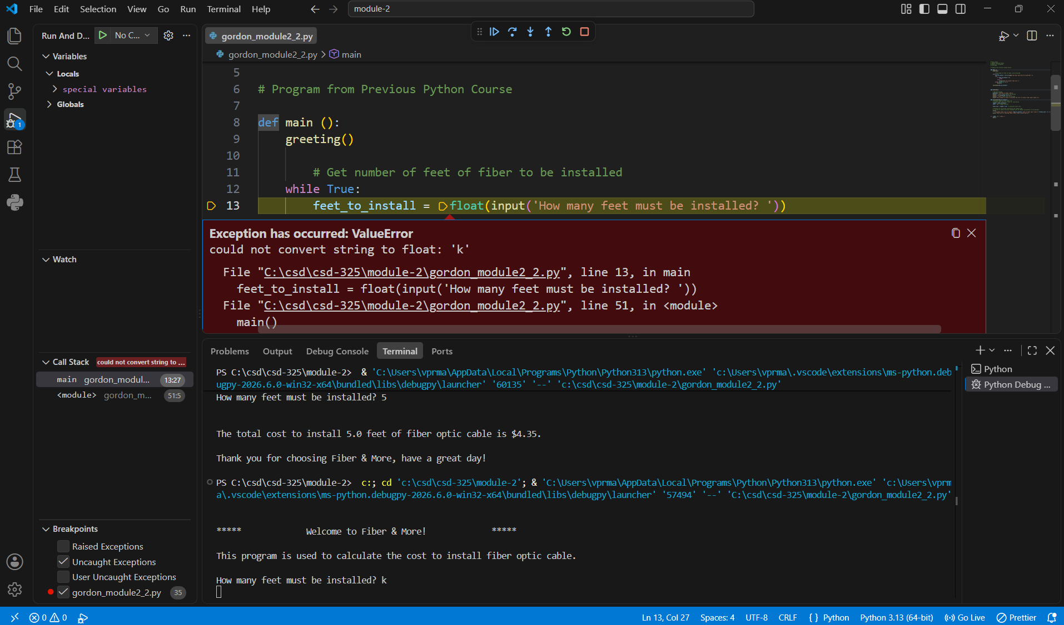
This showed me that I had mistakenly left the user input outside of the try/except. Moving it now keeps the program running when an alphabetic character is input.
