APIs
Michael Gordon
Bellevue University
Advanced Python CSD325
Professor: Dr. Toni Farley
09/23/2026

Status 200
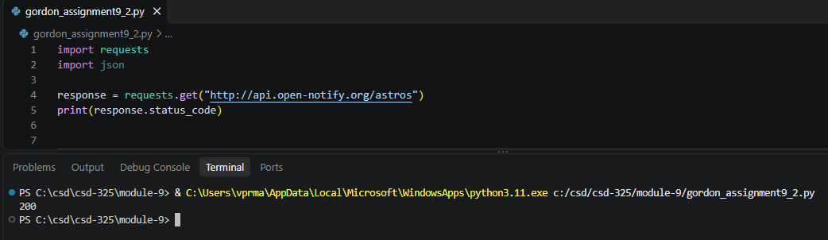
Formatted response
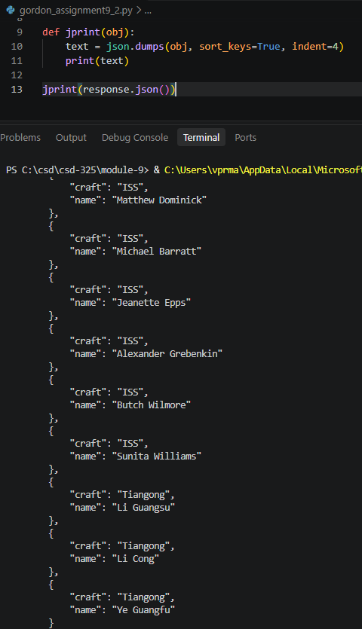
Fireball Data API Code – status 200
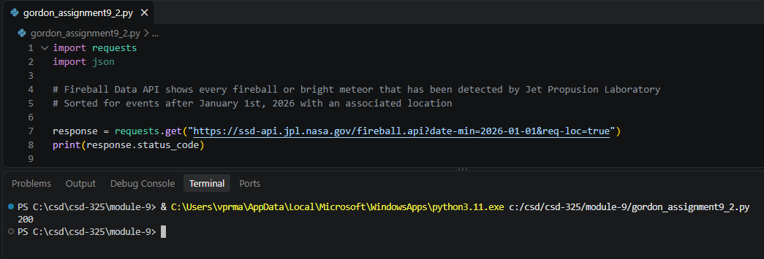
Unformatted results
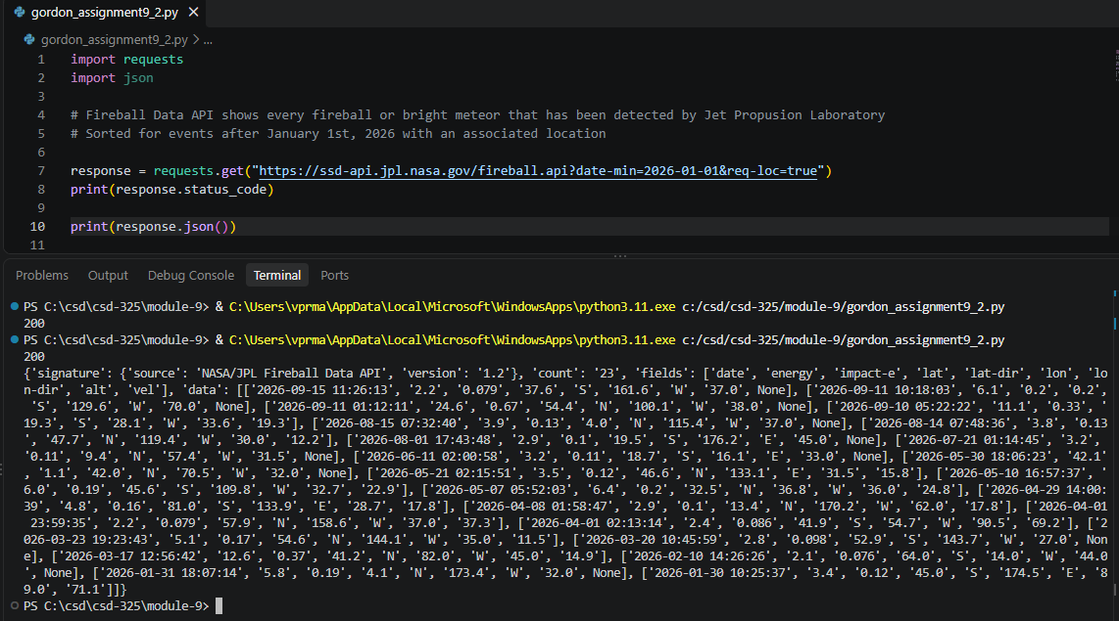

Formatted results
