GitHub Repository Setup
Michael Gordon
Bellevue University
CSD340 Web Development with HTML and CSS
Professor: Dr. Mortoza Abdullah
10/20/2026

GitHub Repo Link

Local Directory:
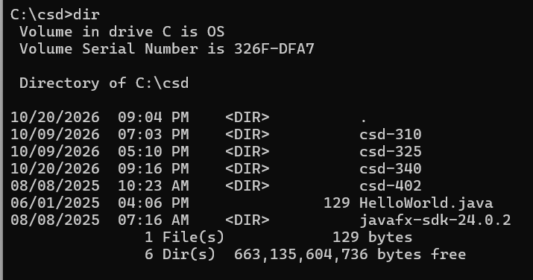

GitHub Repository:
