Building a Web Page Exercise, Part 1
Michael Gordon
Bellevue University
CSD340 Web Development with HTML and CSS
Professor: Dr. Mortoza Abdullah
10/20/2026

Validator results:
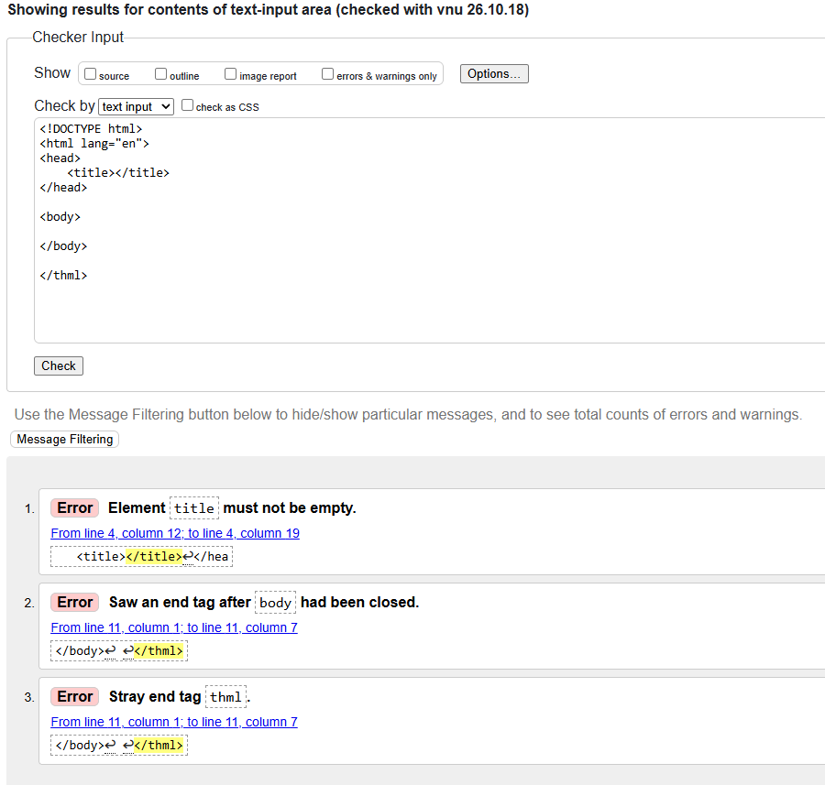

Revised code through Validator:
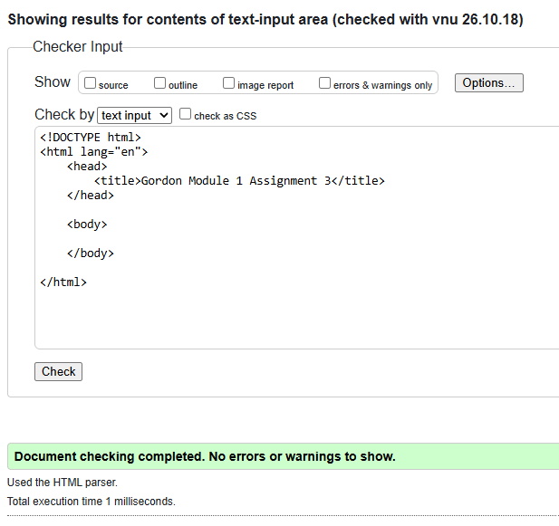

Final validation check:
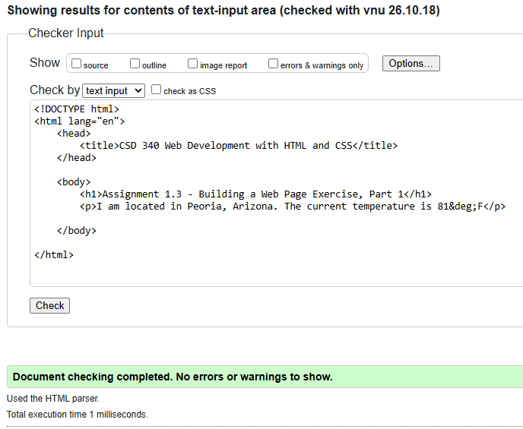

Browser:
