CST2555 Coursework 1

Implementation of a library management system

Done by: Teon Morgan

Table of Contents

Introduction 2

Design 3

Implementation 6

Testing Approach 14

Conclusion 15

# Introduction

**Student Number: M00829986**

The program is meant to simulate a simplified version of a library system. The system’s main classes consist of the following: Person, Member, Librarian and Book. The system is operated assuming the user is a librarian and is therefore in charge of the adding of members, as well as the issuing and returning of books. The system provides an interface in which the assumed librarian can perform these actions.

In this presentation, I will outline the UML diagrams that the system was based on, providing a clear description as to what each diagram is and how it is reflected in the actual implementation. Next, I will explain in detail the implementation as well as the tools used to achieve it and make workflow more efficient. After, the approach taken towards testing will be explored in depth. Finally, there will be a demonstration of the implementation.

# Design

Class Diagram

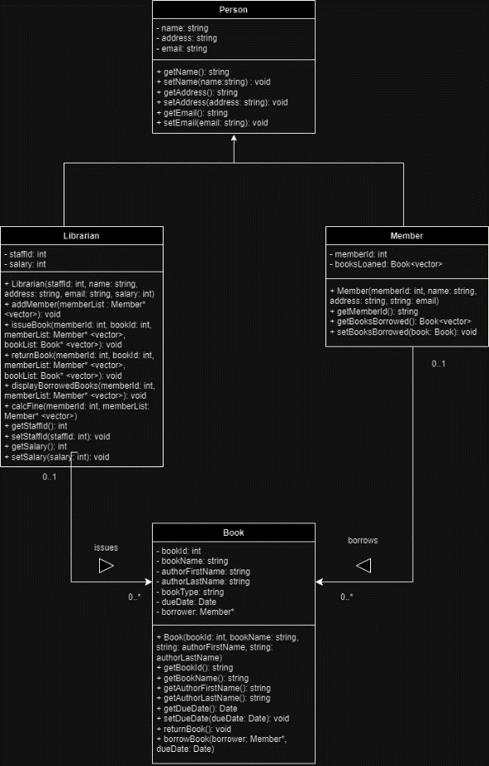

This class diagram depicts the properties and methods assigned to each of the classes used by the system. There is a differentiation between private and public properties of each class.

The relationships amongst classes are also outlined.

For instance, it is shown that both Librarian and Member inherit from the same parent class, that being Person. Other relationships as well as the multiplicities of the relationships are also depicted.

* 0..1 Librarian can issue 0..* number of books
* 0..1 Member can borrow 0..* number of books

Overall, the class diagram is a way to clearly depict all the properties and methods needed for classes as well as providing an indication as to how the classes should interact in a proper implementation.

Activity Diagram

The activity diagram above represents the general design structure for the system. It outlines all the major functionalities provided by the system as well as the results when certain conditions are met. It extrapolates all possible outcomes from utilizing the system and simplifies it, allowing for easier implementation as the intended flow of the system is already outlined.

Use Case Diagram

The use case diagram is used to represent a common scenario in which the system may be utilized to solve. In the above diagram, the use case depicts an interaction between a librarian and a person seeking a membership to borrow a book. This is a likely scenario in which the library management system could be utilized.

The construction of these use cases allows for an easier implementation of a design as we are actively thinking about how the system would work in an actual scenario.

# Implementation

When implementing the finalized design for the system I first went about creating as close as possible replications of the classes outlined in the design. Where necessary class properties or methods were adjusted to accommodate the coding environment (C++) being used.

**Class Implementation**

Person

The Person class is not directly used in the library management system but rather is used as a blueprint for which other classes can inherit from (Member and Librarian). As such the class consists only of important properties (name, address and email) as well as functions to change the values of the properties (setName, setAddress and setEmail) and a set of functions to get the value of these properties (getName, getAddress and getEmail).

Librarian

The Librarian class acts as the core of the system, this is because the system was made assuming that the librarian will be acting as the user. The class inherits from the Person class, meaning it shares the properties and methods of the Person class. Most of the operations that the program provides are directly made by this class. Operations that the librarian class allows for:

* Adding of members
* Issuing of books to members
* Processing the return of books from members
* Displaying the books, a member has out on loan
* Calculating fines for overdue books

Member

The Member class inherits from the Person class, as such it possesses all the properties and methods of the Person class as well as having its own unique methods and properties. The class is used to represent the data stored about a Member, as such most of its methods and properties are used externally (by the Librarian class mainly), rather than having methods to operate upon itself.

Book

The Book class is used to store all information regarding the library system’s listing of books. The list of books used by the system is loaded from a csv file. The following operations can be performed to a book:

* Issuing – A book can be issued out on loan to a Member class
* Returning – A book that was previously issued out on loan to a Member class can be reset to being not out on loan

**Main Function Implementation**

All the classes were made to interface with one another via the main function of the program. This main function made use of various helper functions, which performed a variety of tasks.

* loadBooks(filepath : string) : void– reads books from a csv file and loads them into memory as a list of Book classes
* createLibrarian() : Librarian – asks user to input data relevant to the librarian (name, email, address, salary and staffId) before creating an instance of the Librarian class with this information. The Librarian instance created in this function is the instance that will be used to perform various functions during the program’s runtime
* displayMenu() : int – displays the operations the user is able to perform. Returns the selection made by the user
* initialize() : string – starts the program, provides the user to terminate the program early. This is where the user is asked to provide the file to be loaded by the system, this filepath is returned by the function once it is determined the provided input is an actual file
* addMember(librarian : Librarian*, *memberList : Member* <vector>) : void – essentially a wrapper function for the librarian class’s addMember method. Allows for quicker, repeated execution of the adding member’s functionality should the user desire
* returnBook(librarian : Librarian*, *memberList : Member* <vector>, *bookList : Book* <vector>) – a wrapper function for the librarian class’s returnBook method. Ensures the data entered by the user is valid before passing to the librarian class’s returnBook method. Also allows for quicker, repeated execution of the function should the user desire
* bookIssuing(librarian : Librarian*, *memberList : Member* <vector>, *bookList : Book* <vector>) – a wrapper function for the librarian class’s issueBook method. Ensures the entered data is valid before passing to the librarian class’s issueBook method. Also allows for quicker, repeated execution of the function should the user desire
* displayMemberBooks(librarian : Librarian*, *memberList : Member* <vector>) – a wrapper function for the librarian class’s displayMemberBooks method. Ensures the entered data is valid before passing to the librarian class’s displayMemberBooks. Also allows for quicker, repeated execution of the function should the user desire
* main – the main function ties all the classes and functions together and executes operations in a sensible order

**Makefile**

The makefile was used to compile all the headers and their associated .cpp files that made up classes. Once these files were compiled, they were linked together with the main file to generate the final program. The makefile also provided the additional functionality of cleaning the working directory by removing files leftover from compilation.

**Version Control**

Github was the site used to manage the program’s version control. Version control was utilized as it allows one not only to keep track of progress being made towards project completion, but also allows for older versions of the program to be used instead of the most current. It typically allowed for a more streamlined workflow, being able to access and work on the project regardless of what device I had available was also very useful.

# Testing Approach

A reactive test approach was utilised for this project, meaning that the test design was formulated after the software was produced. An analytical approach was used to ensure that sections of the software critical to overall functionality were in proper working order.

The system being reliant on the classes outlined in the UML, they were the centre of most testing.

|  |  |
| --- | --- |
| **Test Cases** | **Description** |
| Person Construction | Ensured that the Person class was functional, meaning all methods performed the correct operation and returned the correct results |
| Librarian Construction | Ensured that the Librarian class was functional. The class’s constructor was tested to be functional (correct values being assigned to correct class properties) as well as the various other methods of the class. |
| Book Construction | Ensured that the Book class was functional.  The class’s constructor was tested to be functional (correct values being assigned to correct class properties) as well as the various other methods of the class. |
| Member Construction | Ensured that the Member class was functional. The class’s constructor was tested to be functional (correct values being assigned to correct class properties) as well as the various other methods of the class |

# Conclusion

The project was an implementation of a library management system. It assumed the user was a librarian and as such provided the user with operations useful to a librarian. The system was split into various classes to organize data and allow for easier manipulation of the values using various functions and methods.

The design of the system was thought of first. The use of class diagrams, activity diagrams and use case diagrams allowed for a simpler representation of the way the various parts of system would behave and interface with one another.

For the actual programming, version control was utilized to provide a safety net when implementing the different sections of the system.

Test cases were designed post-implementation and were made to test the critical components that make up the system.

Various limitations and challenges arose throughout the development of the system. The most noteworthy relating to some of the initial designs for classes utilized by the system. The lack of certain methods and properties meant the need for long workarounds to be implemented.

Creating a similar system in the future I would ensure that the designs the system is based on, is able to accommodate all required functionality in a simple manner.