HMVT Memo
Subject: Explanation on how to access data and important considerations
Date: 18-07-2023
For: Construction Team CW Griftpark
Prepared by: HMVT, Advisor: Joshua Both
Checked by: HMVT, PL: Paul Verhaagen
Project: CW Pilot Griftpark
Internal Project Number: 0481734.100

Table of Contents
1. Introduction
2. Retrieving the Data
- Downloading Data on-site via Device Configuration Utility
- Downloading Data via the FTP Server of Campbell
- Reading the .DAT File in Excel
3. Data Interpretation
- Battery Voltage
- Linking Sensor Numbers to Depth and Location
- Data Interpretation - SHE Reference Electrode Correction
4. Contacts
---

Introduction
There are 12 SWAP sensors installed in the CW pilot in Utrecht. These sensors conduct RedOx measurements every hour at four different depths in the CW pilot basins: 80, 60, 40, and 20 cm below surface level. The data is automatically uploaded to Koenders' server, where it can be accessed. Additionally, the data can also be manually downloaded on-site. This document explains how to retrieve the data, how to read it in Excel, what the data file contains, how to link the data to
specific sensors, and important considerations when interpreting the data.
---

Retrieving the Data

Downloading Data On-Site via the Device Configuration Utility

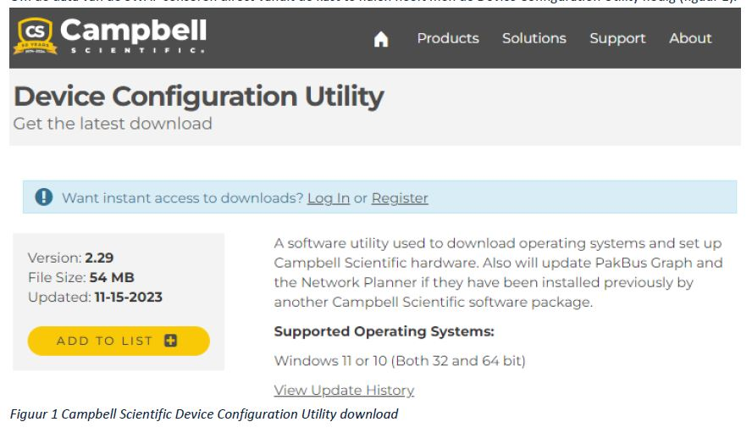
To extract data from the SWAP sensors directly from the data logger, the Device Configuration Utility from Campbell Scientific is required.

This program allows users to configure the logger and retrieve data.
To use the program with the data logger, a micro-USB cable must be connected to the logger and to a laptop. The program can be found by searching for "Campbell Scientific Device Configuration Utility" online.
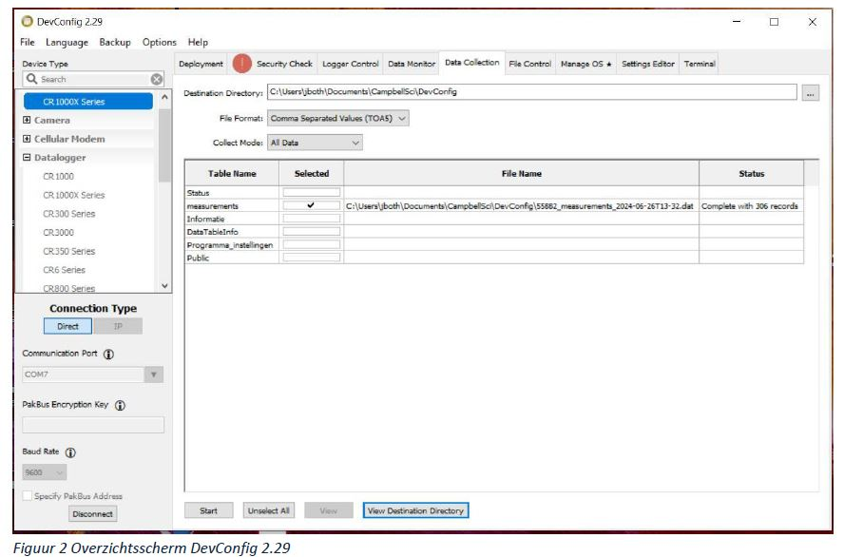
Once opened, select CR1000X Series from the left-hand menu, then choose Direct Connection under Communication Port COM7. Navigate to Data Collection, select File Format: Comma Separated Values (CSV), and choose Collect Mode: All Data. This will generate a .DAT file, which can be saved in a preferred location.

Downloading Data via the FTP Server of Campbell

No additional software is needed for this method. The data can be accessed by entering the following FTP link in Windows Explorer:

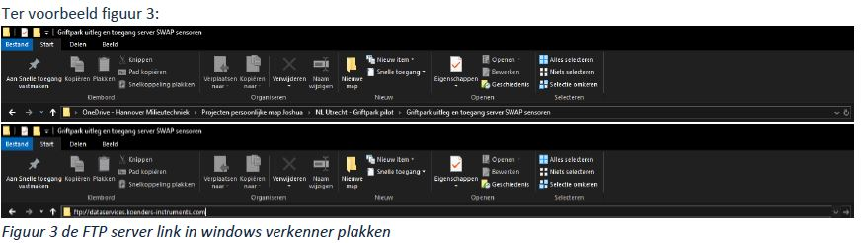
ftp://dataservices.koenders-instruments.com

When prompted, enter the following login credentials:
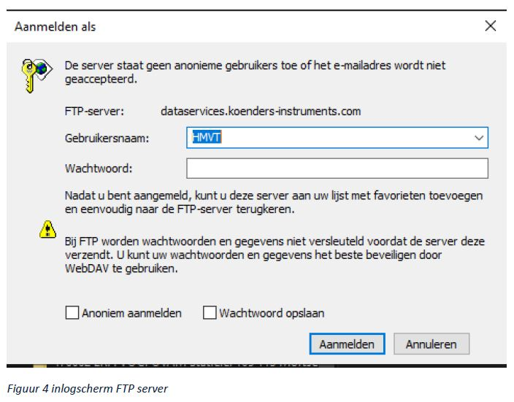

- Username: HMVT
- Password: 193yhbk#U

The data file is located in the folder "upload data". Every day at 00:15 (UTC+1), the file S9081*measurements.dat is transferred to the FTP directory. The file can be copied to a preferred location and then opened in Excel.

Reading the .DAT File in Excel

To open the .DAT file in Excel:
1. Go to the Data tab in Excel.
2. Click Get Data > From File > From Text/CSV.

This option opens Windows Explorer.
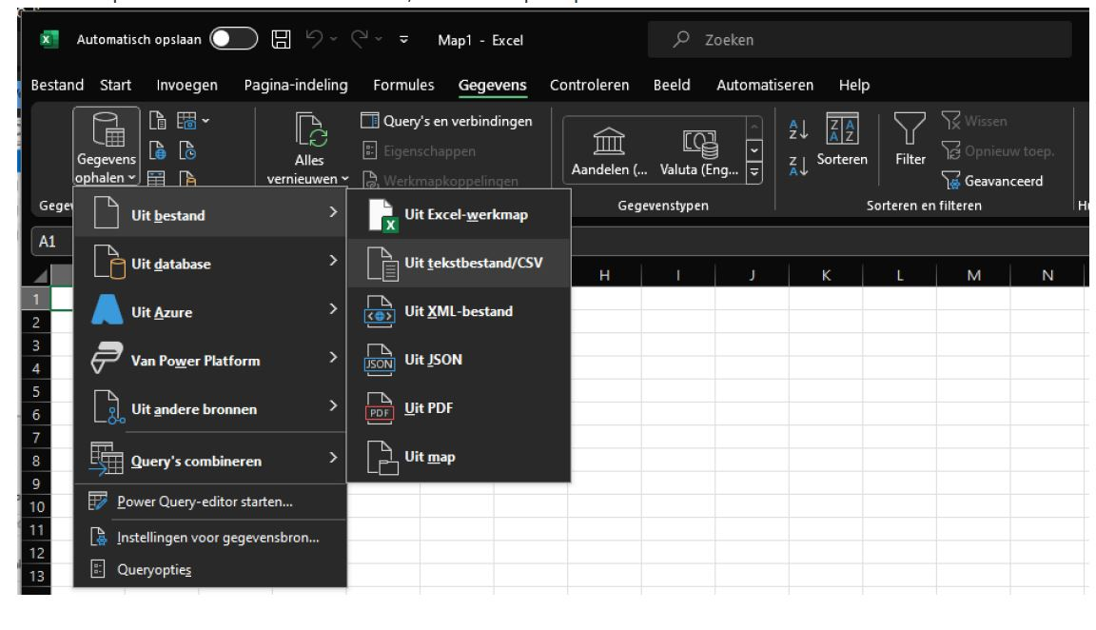
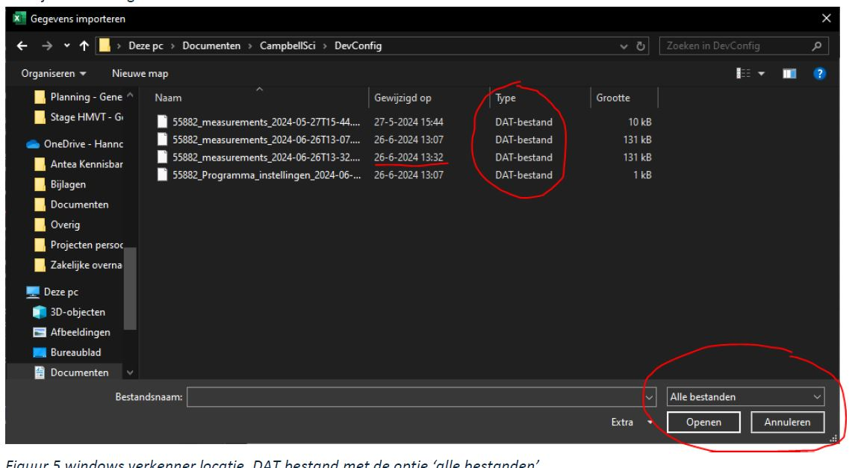
Once in the explorer, you can navigate to the location where you saved the .DAT file. To see the .DAT file, you need to select ‘all files’ in the option at the bottom right.

Then select the drop-down ‘All files’ at the bottom right to click on the .DAT file. Once you click on the file, Excel will load the file.
In Excel you will then see the following screen (figure 6):

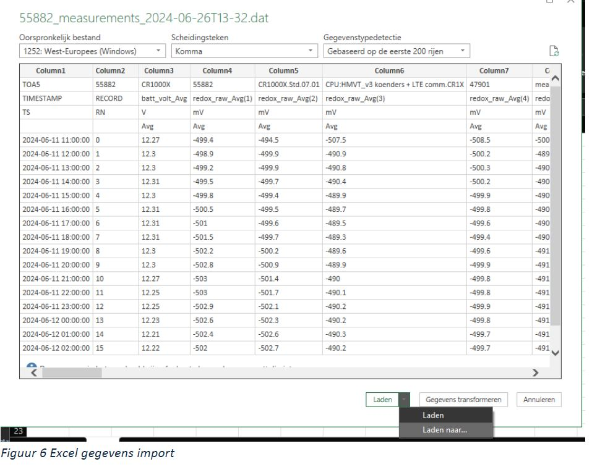

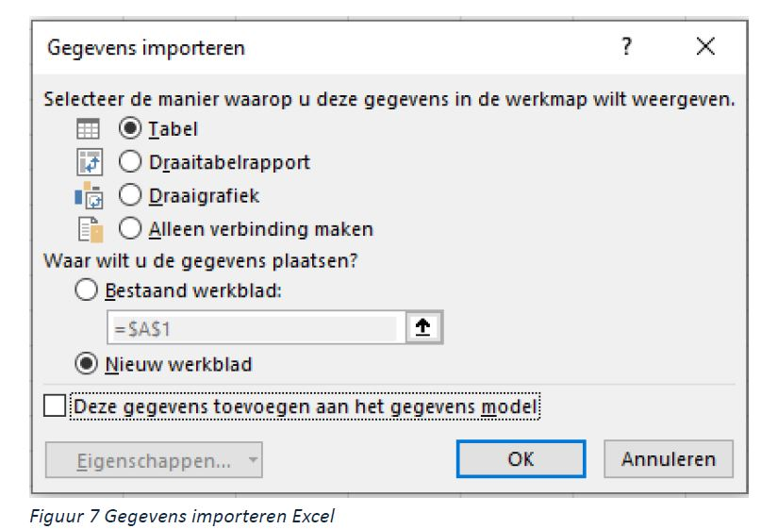
Then choose the option 'load to...' under load. Then select table and 'new worksheet' (figure 7). DO NOT add data to the data model.---
The data is in Excel (figure 8):
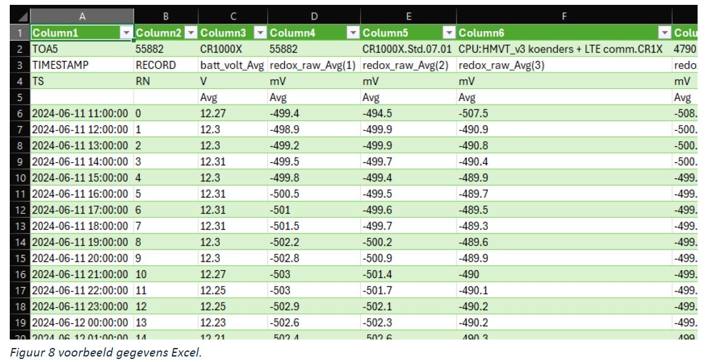

Data Interpretation

The Excel file contains a large amount of data. How it is divided is basically self-explanatory, but there are a number of things that one should pay attention to.

Battery Voltage

Column 3 of the data file contains battery voltage values. A voltage around 8V indicates that the battery should be replaced, though the exact threshold is still uncertain.

Linking Sensor Numbers to Depth and Location

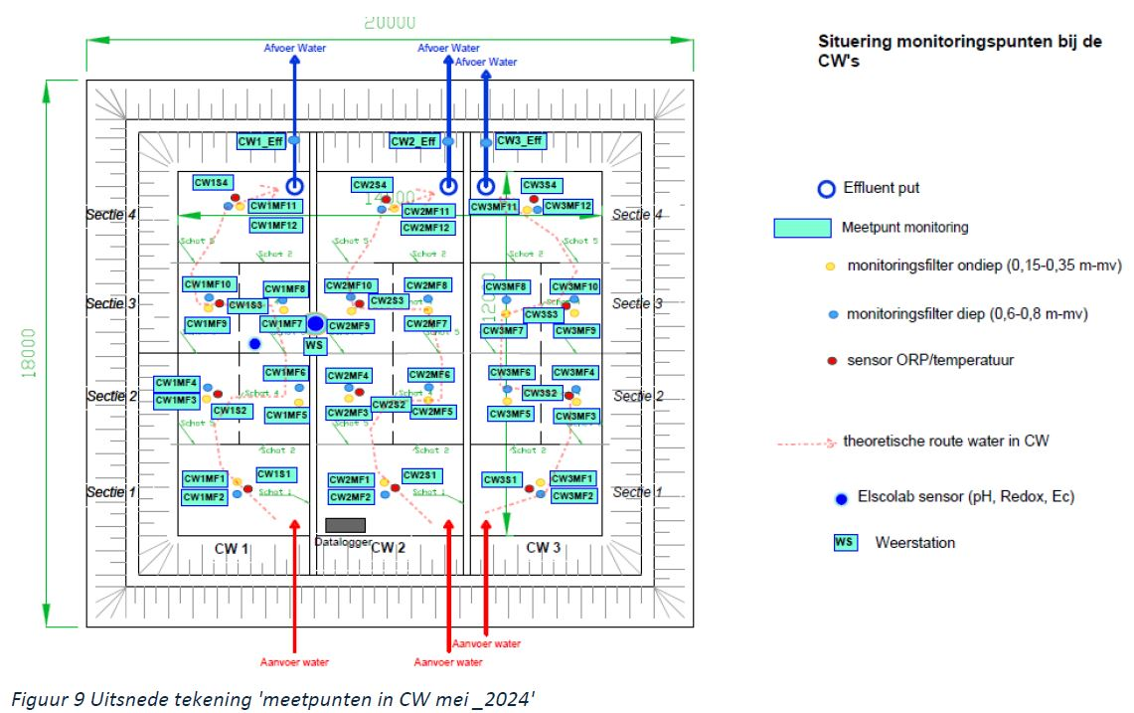

The sensor numbers 'redox_raw_Avg(X)' correspond to locations in the CW pilot measurement points (May 2024) diagram.
Each SWAP sensor is marked with a red dot in the diagram and follows the naming format CWXSX (e.g., CW1S1 refers to numbers 1-4, CW1S2 refers to 4-8, etc.).
- The top platinum circle on each sensor corresponds to number 1.
- Depth assignments:
- 1 = 20 cm
- 2 = 40 cm
- 3 = 60 cm
- 4 = 80 cm
For example, point 15 in the Excel file corresponds to 60 cm depth and belongs to CW1S4.

Data Interpretation - SHE Reference Electrode Correction

RedOx measurements in literature are typically referenced against the Standard Hydrogen Electrode (SHE). However, for this application, a 3M KCl reference electrode is used instead. To align with SHE values, 200 mV should be added to the recorded measurements. This value varies slightly (199-203 mV) due to air pressure and temperature, but for consistency, 200 mV is generally used.

---
Contacts
HMVT
- Joshua Both - jboth@hmvt.nl
- Paul Verhaagen - Paul.verhaagen@hmvt.nl - (+31 6 11 86 08 06)
SWAP Sensors
- Nikolaj Walraven - nikolaj@swapinstruments.com - (+31 6 25 10 29 80)
Hardware and Software Development
- Sander Smit - info@paleoterra.nl - (+31 6 81 64 05 50)
Data Logger Supplier
- Campbell Instruments - Michiel de Jong - michiel.dejong@koenders-instruments.com - (+31 6 53
36 15 53)

