**MANGALAMEVENTS.ME Events & Entries**

Berasia - Bhopal

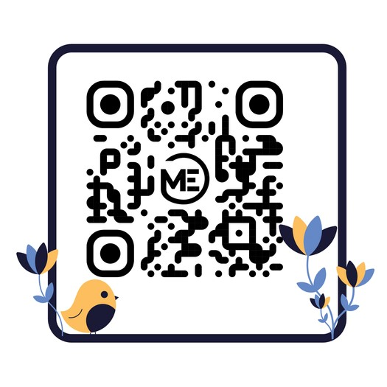

**QTY**

**TOTAL PRICE**

**PRODUCTS**

|  |  |  |
| --- | --- | --- |
|  | {{%tr for item in invoice_list %}} |  |
| {{item[1]}} | {{item[0]}} | {{item[3]}} |
|  | {{%tr endfor %}} |  |
| **Gross Total :** |  | {{ subtotal }} |

**INVOICE TO :**

**{{ name }}:**

Date : {{ phone }}

Bhopal Road Berasia

Berasia - Bhopal , 463106

Your invoice includes an exceptional array of premium products & access to exclusive entries.

Get ready to enjoy the best of the best at our event

**Thank you for purchase!**



MangalamEvents.me

6263058177