# 

# Electronic Automatic Transmission for Bicycle

# Final Report

Tianqi Liu, Ruijie Qi, and Xingkai Zhou

Team 4

ECE 445 – Spring 2018

TA: Hershel Rege

**Abstract**

This is a paper documenting the design and verification progress of a ECE 445 project - electronic automatic transmission for bicycle. With our design, bikes could automatically select the optimal gears under various conditions. The gear shifting logic is based on current speed and cadence. We also implemented a manual mode to allow bikers to manually change gears by using electrical buttons. Moreover, we include an LCD screen to display information for better user experience.

**Contents**

**1 Introduction** **4**

1.1 Objective 4

1.2 Features 4

1.3 System Overview 4

**2 Design** **6**

2.1 Power supply 6

2.1.1 Battery 7

2.1.2 Voltage regulator 8

2.2 Sensing unit 8

2.2.1 Cadence sensor 9

2.2.2 Speed sensor 9

2.3 Motor module 9

2.3.1 Gear motor 11

2.3.2 Motor Driver 12

2.4 Control Unit 12

2.4.1 Microcontroller 13

2.4.2 Buttons 14

2.5 User-interface module 15

2.5.1 LCD screen 16

2.6 Control Case 17

2.7 Software 18

**3 Cost** **21**

**4 Schedule** **22**

**5 Conclusion** **23**

5.1 Achievements, Uncertainties & Future work 23

5.2 Ethnics 23

**References** **24**

**Appendix A** **25**

**Appendix B** **27**

**Appendix C** **30**

# 1 Introduction

## 1.1 Objective

Nowadays, bicycles equipped with a transmission system which including chain rings, front derailleur, cassettes, and rear derailleur, are widespread [1]. However, it is challenging for most bikers to determine the optimal gear under various conditions. Thus, electronic automatic transmission for bicycles in desperate need.

There are three main advantages to implementing an automatic transmission system. Firstly, it can make your journey more comfortable. Except for expert bikers, most people cannot select the right gear intuitively. Secondly, an electronic automatic gear shifting system can guarantee bikers a safer journey. It is dangerous for a rider to shift gears manually under some specific conditions such as braking and accelerating. Thirdly, an automatic transmission can help bikers to ride more efficiently. For those who choose the wrong gears, they will either paddle too slow which could exhaust themselves quickly or paddle too fast which deliver the power inefficiently.

Traditionally, a bicycle changes gears by pulling or releasing a steel cable connected to the derailleurs. Our goal is to use sensors and a microcontroller to electronically determine and a gear motor to pull or release the rear-derailleur steel shift cable automatically. Besides, we add a manual mode to our devicel. Manual mode offers the user an option to take control of the transmission if he or she enjoys the fun of manually switching gears. In order to provide better user experience, we have a LCD screen to display speed, cadence, gear status and mode status.

In the current commercial market, electronic shifting system costs above $1000 as they integrate the servo motor inside the derailleurs of the bike. Thus, only professionals or rich enthusiasts can afford electronic automatic bicycles. In our design, the transmission system could potentially serve as an add-on device at an acceptable price. It can be installed easily on all types of bikes. The user only needs to detach the shift cable, then attach it to our motor.

## 1.2 Features

* In automatic mode, our system must be able to determine the optimal gear from 7 gears[2], based on the conditions described by sensors and change to the corresponding gear automatically.
* In manual mode, bikers can change gears using upshift or downshift buttons.
* In calibration mode, bikers can slightly adjust the position of gear.
* Bikers can visualize the current speed, cadence, gear status and mode status on a LCD screen.

## 1.3 System Overview

Figure 1 shows our block diagram including 5 modules: power supply, control unit, sensing unit, motor module, and user-interface module. The power supply regulates and provides stable electrical power to every component of our device. The sensing unit measures the rider’s cadence and speed. The control unit processes signal from the sensing unit and user inputs, then sends downshift/upshift signal to the motor module. The motor module pulls or releases the shift cable to actuate the rear derailleur and to shift gears. The user-interface module contains a LCD screen to display the current gear, current speed, current cadence, and mode status.

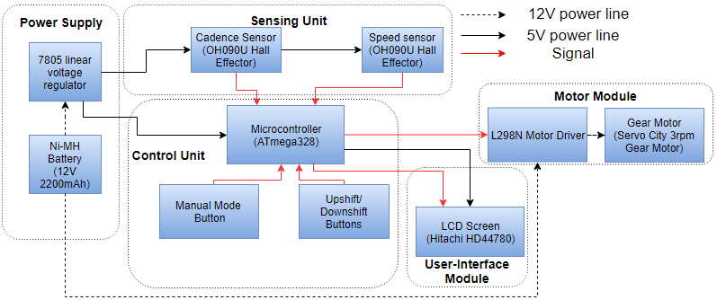

*Figure 1. Block Diagram*

Figure 2 represents the physical layout of each components on the bicycle as we design. Battery is on the corner of frames, which is secure and easy to unplug. The gear motor is very close to the rear derailleur to guarantee motor efficiency. Both hall effectors are placed on the non-moving frame to ensure tight wiring. The corresponding magnets are placed on the wheel spoke and crankset, in order to detect speed and cadence. Control module is inside a plastic case to avoid dust and water. The LCD screen and buttons are on the top of the case. The case is attached on the handle bar using Velcro tape, so that the user could visualize and operate them while riding. Based on our design, wiring will not hinder the bikers.

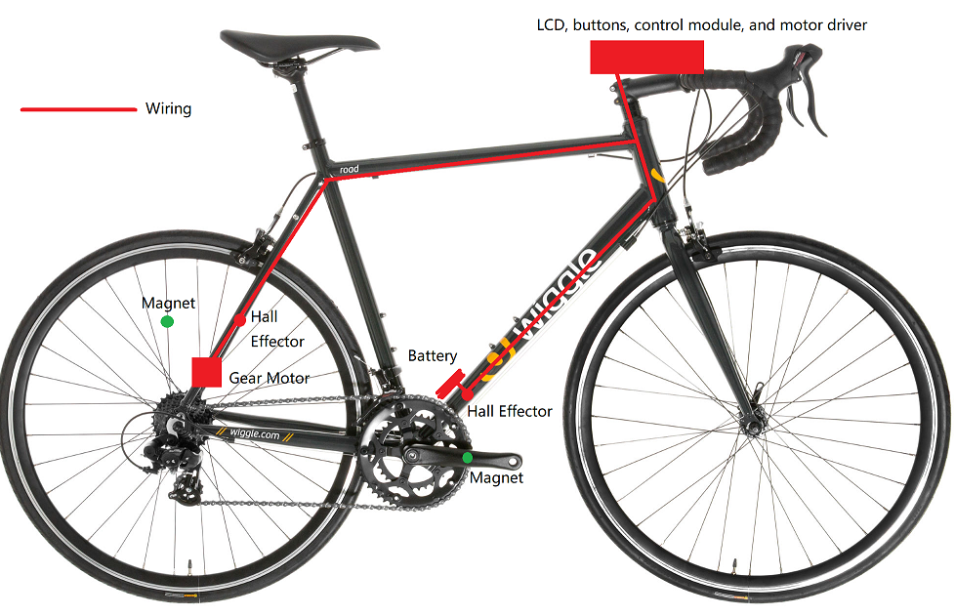

*Figure 2. Physical Layouts*

# 2 Design

## 2.1 Power supply

The power supply module contains a Ni-MH battery and a voltage regulator. Ni-MH battery provides 12 V to the motor directly and to provide stable 5 V to the other parts. When the motor is on, the theoretical maximum output current is around 550 mA (500 mA for motor and 50 mA for microcontroller, LCD screen and sensors). When motor is off, the current is around 50 mA (for microcontroller, LCD and sensors only).

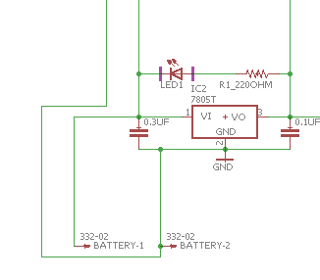

*Figure 3. Schematic for Power Supply*

### 2.1.1 Battery

In the original design, we used a 7.4 V Li-ion Battery. But experiment shows that 7.4 V is not enough to support the motor to pull gear switching cable. Thus, we chose a 12 V Ni-MH battery instead. Though, Ni-MH batteries’ power density is inferior to the Li-ion batteries, it is much safer, more environmental friendly and more tolerant to high current and extreme temperature, which is necessary for this project[3].

Since we are using a 3 RPM 12 V gear motor, according to datasheet[4], the maximum current is 500 mA when the motor is stalling. Thus, the maximum theoretical power of this motor is:

Based on personal biking experience, we assume that the bike rider changes gear once per 5 second on average. And the target re-charging cycle of our battery is 10 hours. For each gear shifting, we set the gear motor to take 400 ms to finish the action. Since the motor only operates during gear shifting, the power consumption during this 10 hour period is:

The microcontroller and the LCD screen have constant power consumption. The actual value may vary depending on the working condition. For simplicity, in the design document we assume the average current is 50 mA. The buttons and Hall Effector Sensors have negligible electricity consumption most of the time, here we don’t need to consider them. Since we are using the linear voltage regulator, while the output voltage is lower than input voltage, the current is still the same. So the power consumption for this part is:

Thus, our battery should have a capacity of at least:

For 12V 2000 mAh battery, the energy it theoretically contains should be 24 Wh, which is much larger than the requirement. Additionally, our hour-long road test proved the reliability of the NiMH battery.

### 2.1.2 Voltage regulator

In order to obtain stable battery voltage even when the battery is discharging, we need a voltage regulator. The 7805 linear voltage regulator we choose can convert 7 V to 35 V battery to a 5 V power source and sustain maximum current of 1.5 A[4].

## 2.2 Sensing unit

In order to choose the optimal gear to keep the paddle at an efficient range of cadence, we should monitor the cadence to check if the rider is paddling within the efficient range and also monitor the speed to calculate which is the optimal gear for the observed speed. Thus, we use two hall effectors as speed and cadence sensor. The microcontroller uses a polling method to calculate the speed and cadence. Every millisecond, the microcontroller checks the status of two sensors, if a falling edge is detected, the current time will be recorded. With the time intervals , the cadence (r/min) and speed (mi/h)can be calculated by:

Since the pedal and wheel are unlikely to rotate more than 10 times per second, the precision should be enough.

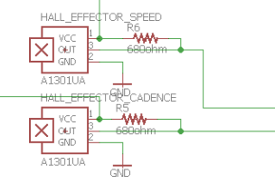

*Figure 4. Schematic for Sensing Unit*

### 2.2.1 Cadence sensor

We use oh090u 5 V Hall Effector as the cadence sensor. This hall effector is chosen due to its low price. It is common and easy to use a hall effector to measure the rpm of a spinning object. This Hall Effector is on the bike’s downtube and a piece of magnet attached to the crankset asFigure 2 so that it can measure the real cadence and send it to the microcontroller.

### 2.2.2 Speed sensor

We use oh090u 5 V Hall Effector as the speed sensor. The hall effector is on the frame and the magnet is on the wheel spokes.Since the diameter of bicycle wheel is known, the microcontroller could convert the time interval to get the current speed.

## 2.3 Motor module

Motor module receives signals from the control unit and mechanically actuates the shift cable. According to our measurements, it requires at least 10 kgf force to pull the cable.

Generally, there are three types of motors that we can choose: gear motor, servo motor and stepper motor. Based on the ECE machine shop staff’s experience on Spring 2016’s electronic bicycle shifting project, our motor should have more than 20 kg-cm rated torque. To generate the same torque, stepper motors are much more expensive than servo and gear motor. The gear motor with 44.1 kg-cm only cost $25, while a much inferior 19.9 kg-cm stepper motor would cost $51. Also, stepper motor requireds much higher current(2.8 A) compared to gear motor(0.5 A), which means we need to choose larger battery, thus increase the total cost and design difficulty even further[6].

The previous group uses the servo motor to pull the cable. However, the servo motor need to consume electricity all the time. Otherwise, the cable will be loose. But the 6 rpm gear motor equipped with worm gear, according to machine shop staff, should be able to hold the cable steady even after the electricity is cut off. Thus, the power consumption could be greatly reduced.

In the original design we used a 6 rpm gear motor. However, when the system switch from lower gear (larger wheel) to higher gear, this motor could not hold the cable and rear derailleur would slip to next gear. Thus, we chose 3 rpm gear motor instead, and the previous slippery issue never happened again.

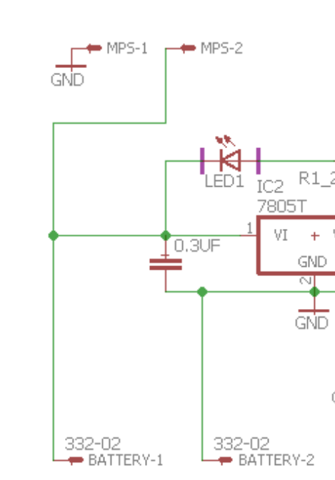 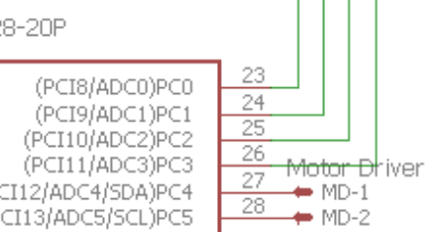

*Figure 5. Schematic for Motor Module(MPS=Motor Power Supply; MD= Motor Driver Control)*

### 2.3.1 Gear motor

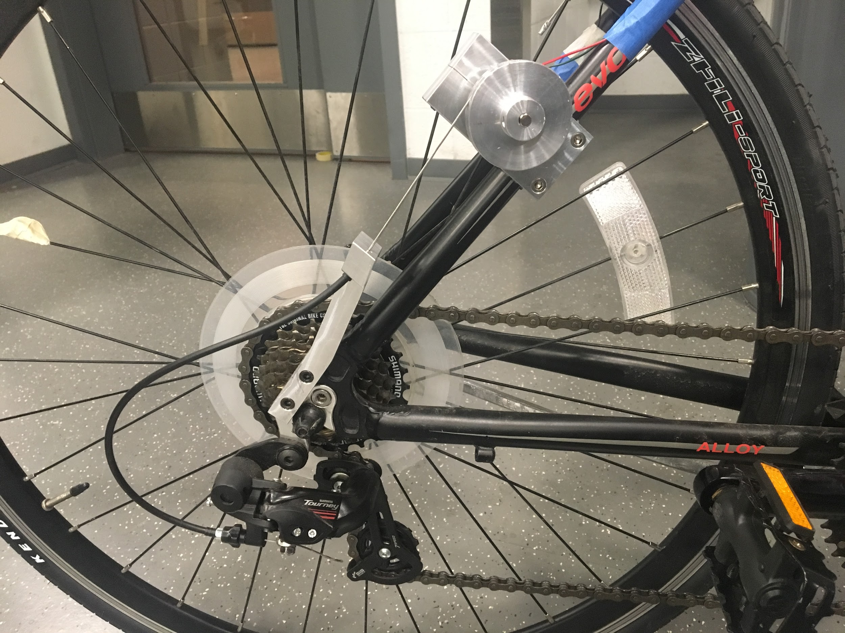

*Figure 6. Gear Motor Configuration*

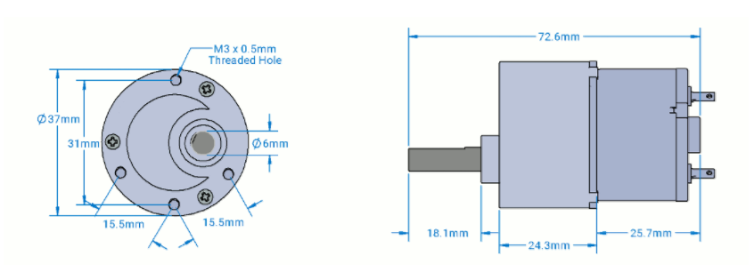

*Figure 7. Gear Motor Dimensions*

*Figure 6* shows how we mount our gear motor onto the bike and how we connect the rear derailleur to our gear motor. Our original design was to use a 6rpm gear motor, and each gear shift should cost 200 ms. Also, the length of cable pull required by each shift for our shimano 7-speed rear derailleur is 2.9 mm[2]. Thus, diameter of the metal plate that connects the shift cable to the motor is:

Since we changed our gear motor from a 6 rpm one to a 3 rpm one but the metal plate wasn’t changed, the shift time now increase to 400 ms. Even the shifting time doubled, 400ms still made a relatively quick and smooth shift.

### 2.3.2 Motor Driver

Since the microcontroller can only generate 80 mA output current[7] while the motor requires at most 500 mA, it is impossible to connect the motor with microcontroller output pin directly. Here we will use a L298N Motor driver, which can supply 12 V, 2 A for the motor[8]. The 12 V battery directly connect with its Voltage input pins and microcontroller use 2-bit digital signal to control motor rotation direction. Since the maximum current of the gear motor is 0.5 A, and the input voltage is 5 to 13 V[5], the motor driver should be able to safely control our gear motor. Also, the switching delay time is for turning on and for turning off[8], which are trivial compared the 400 ms motor operating time.

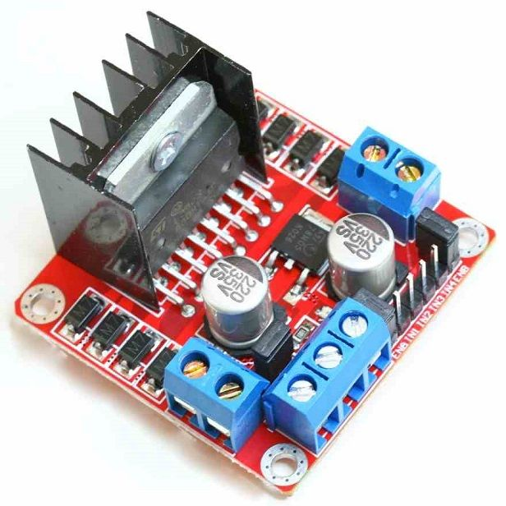

*Figure 8. L298N Motor Driver*

## 2.4 Control Unit

This unit processes data from sensing unit and user inputs, runs software to determine the optimal gear or controls the manual mode function and calibration mode function. This unit also sends upshift/downshift signals to the motor module and makes LCD screen display current gear, current speed, current cadence, and if manual mode or the calibration mode is activated.

### **2.4.1 Microcontroller**

For the microcontroller we will use ATmega328 28-pin PIPD version. We chose this microcontroller because it is the one being used on Arduino Uno[9], so that we could use existing library for the communication among this unit, the sensors and the LCD screen. Thereby, we could focus more on refining our algorithm to make sure our device can choose the optimal gear. This 8 bit microcontroller chip contains 32 KB ISP flash memory and 23 general purpose I/O lines. To power the microcontroller, we need one 10k Ohm resistor, two 10 uF capacitors, two 22 pF capacitors, and a 16 MHz clock crystal[9].

We can use the Arduino board with its microcontroller removed as an USB-to-Serial converter to load the program into our microcontroller. The circuit is like:

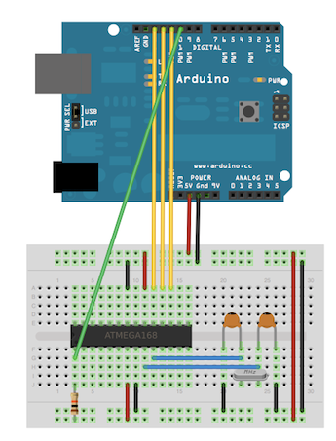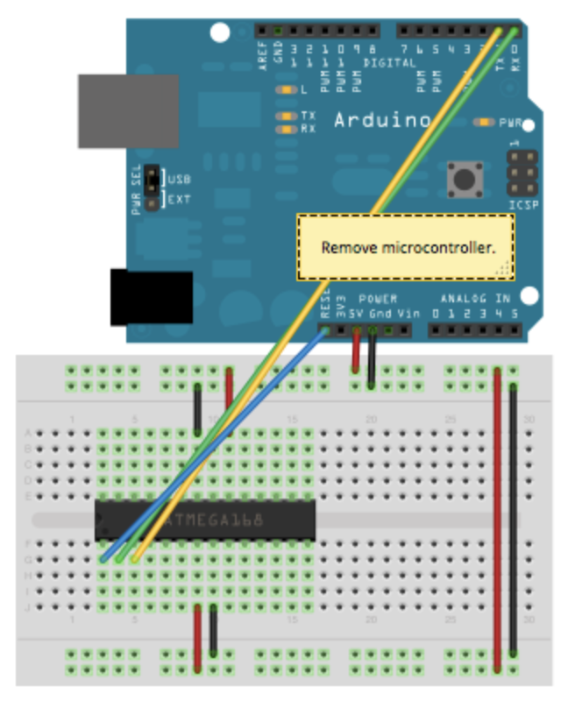

*Figure 9. Circuit for boot loading(left) and loading program(right) to the microcontroller*

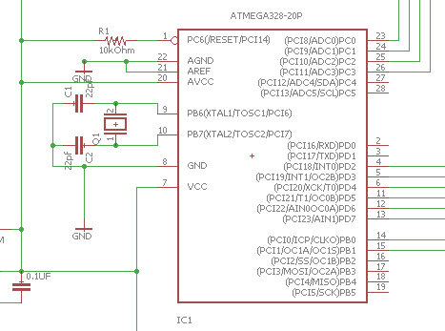

*Figure 10. Schematic for Microcontroller*

### 2.4.2 Buttons

We have three push buttons: activating/deactivating manual mode, upshifting, and downshifting. These buttons are essential for the manual mode described before.

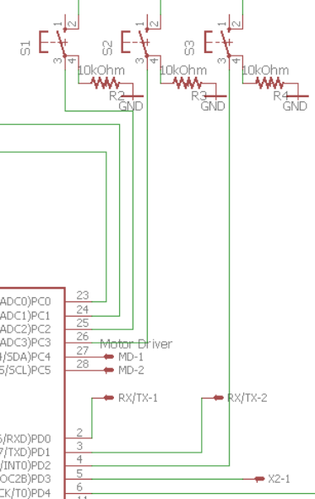

*Figure 11. Schematic for Buttons*

## 2.5 User-interface module

This module has a LCD screen displaying the current speed, cadence, gear, and mode status. It gets all the information from the microcontroller. This part of device is needed for better user experience. Providing the rider with the current speed, cadence, and gear could help the user to quantize how to paddle efficiently. Knowing whether the manual mode is on could avoid the user getting unexpected behavior from our device.

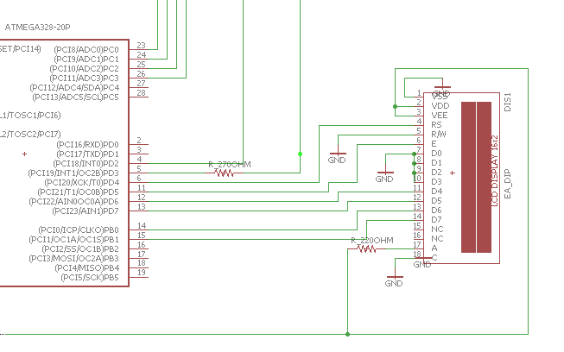

*Figure 12. Schematic for UI Module*

### 2.5.1 LCD screen

A HD44780 LCD screen is chosen by us because it could operate under 5 V voltage. Besides, it can display up to 2 16-character lines so it has enough space to display current speed, cadence, gear, and if manual mode or calibration mode is on. It also has a reasonable size(80 mm x 35 mm x 11 mm) to be mounted on the handlebar[10].

## 2.6 Control Case

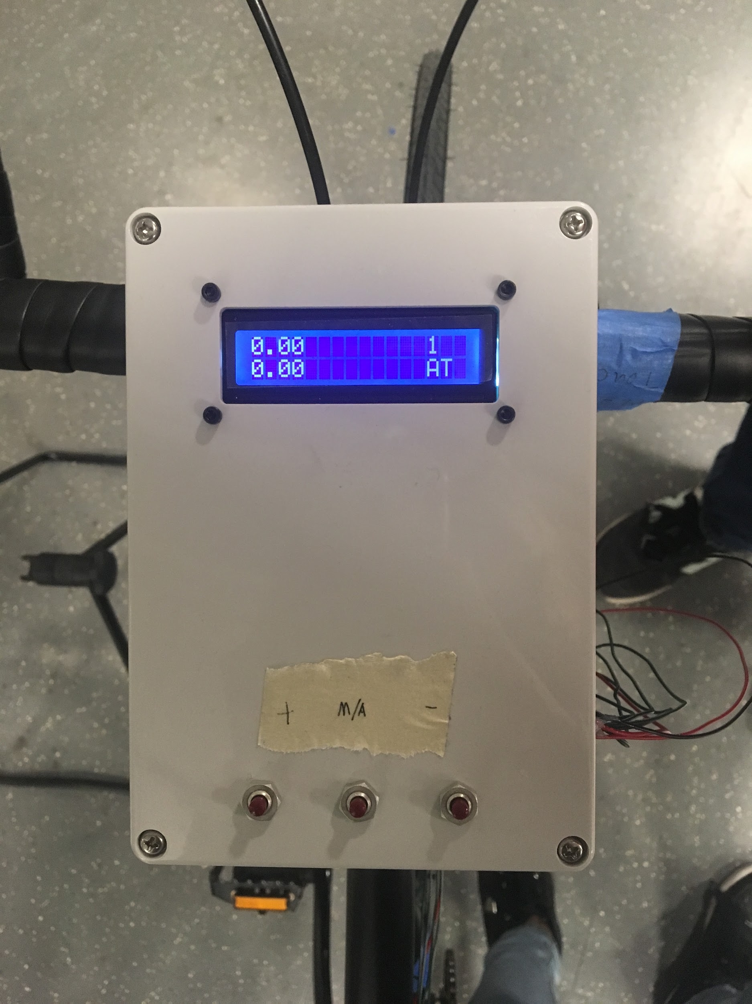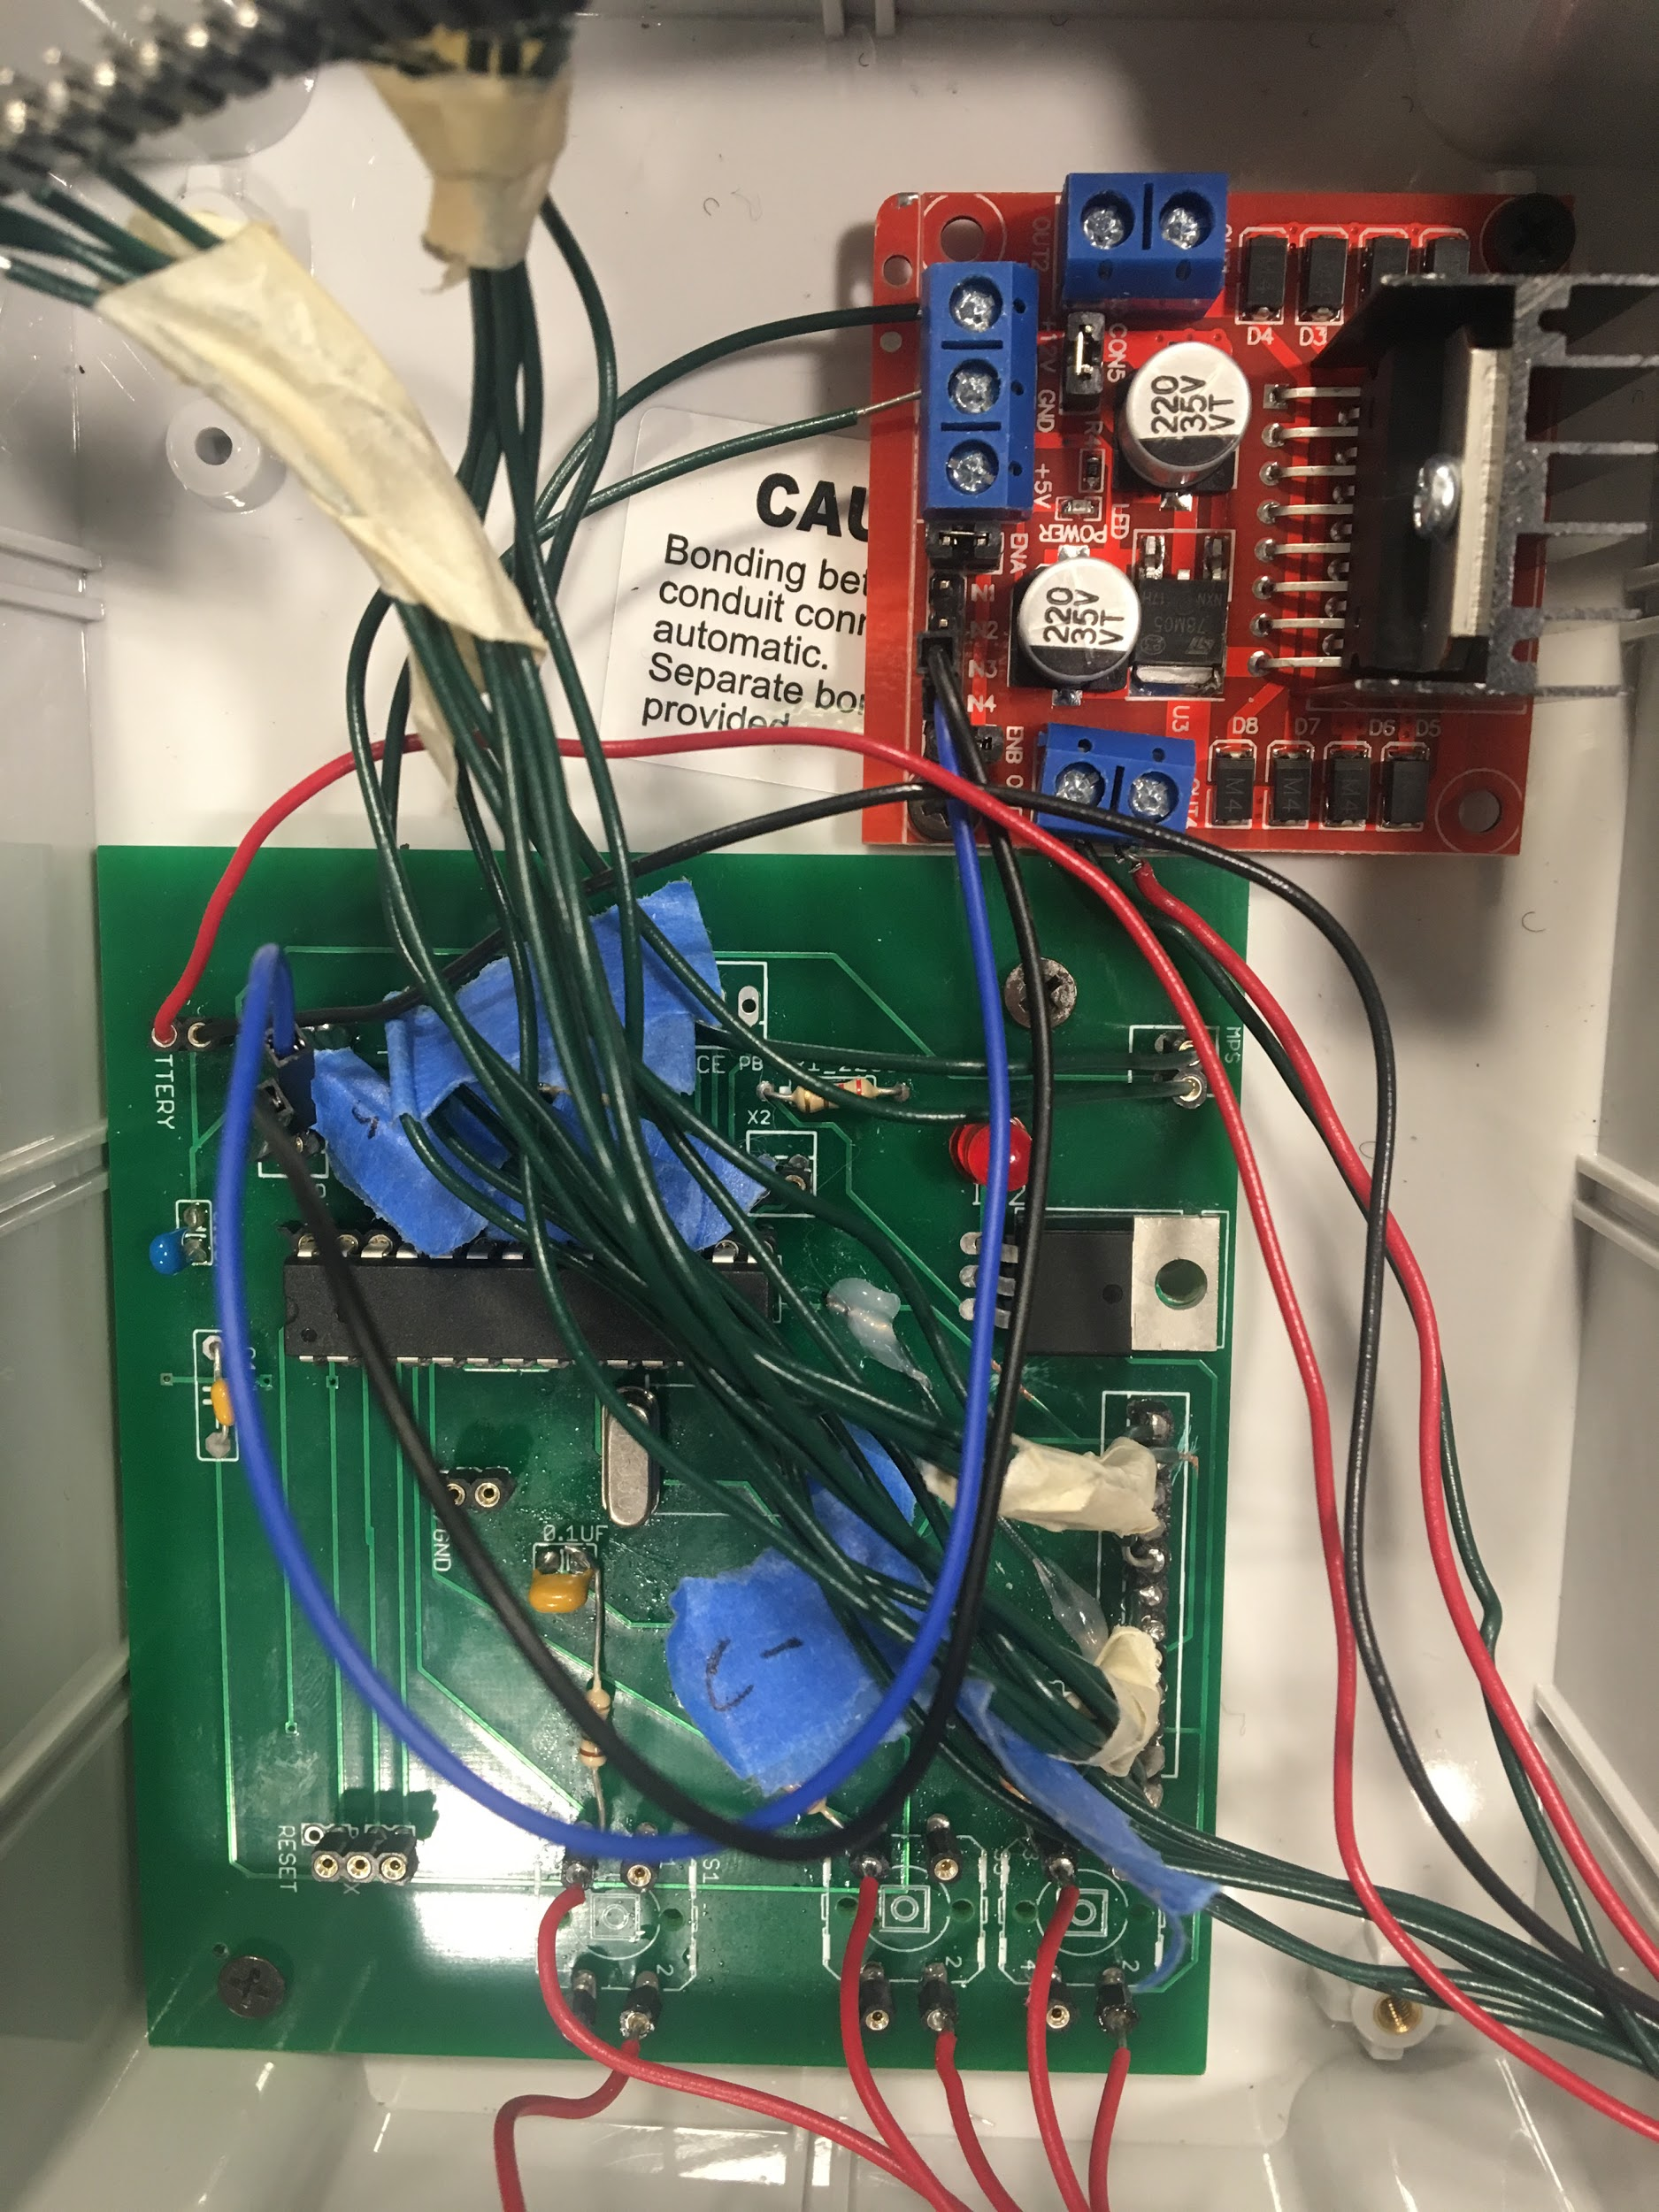

*Figure 13. Design and Internals of the Case*

As Figure13shows, we use a plastic case to contain the PCB board LCD and motor driver The machine shop helped us drill the hole to mount LCD screen and buttons.

## 2.7 Software

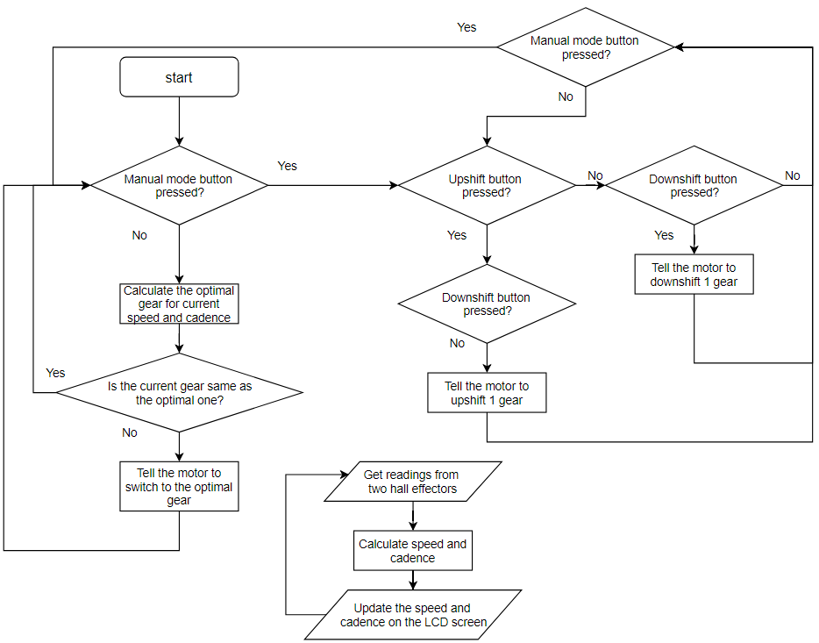

*Figure 14. Software Flowchart*

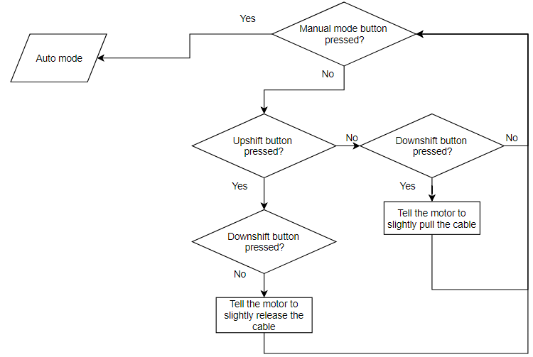

*Figure 14 (continued). Flowchart for Calibration Mode*

Figure 14 represents how our software flow. How to choose the optimal gear based on speed and current will be further discussed below. And Figure 14(continued) represents how calibration mode works. It is similar to the manual mode, but this mode would only power the motor for 100 ms each time instead of 400 ms in other two modes.

*Table 1. Bicycle’s Speed(in mph), with front ring fixed at 50 teeth, 700c x 25 mm wheels[11]*

|  |  |  |  |  |  |  |  |  |  |  |  |
| --- | --- | --- | --- | --- | --- | --- | --- | --- | --- | --- | --- |
| Cadence(rpm)  Rear Cog  (number of teeth) | 30 | 40 | 50 | 60 | 70 | 80 | 90 | 100 | 110 | 120 | 130 |
| 14 | 8.43 | 11.24 | 14.05 | 16.86 | 19.67 | 22.48 | 25.29 | 28.10 | 30.91 | 33.72 | 36.53 |
| 16 | 7.39 | 9.85 | 12.32 | 14.78 | 17.25 | 19.71 | 22.17 | 24.64 | 27.10 | 29.56 | 32.03 |
| 18 | 6.56 | 8.75 | 10.94 | 13.13 | 15.32 | 17.50 | 19.69 | 21.88 | 24.07 | 26.26 | 28.45 |
| 20 | 5.90 | 7.87 | 9.84 | 11.81 | 13.77 | 15.74 | 17.71 | 19.68 | 21.64 | 23.61 | 25.58 |
| 22 | 5.36 | 7.15 | 8.93 | 10.72 | 12.51 | 14.29 | 16.08 | 17.87 | 19.65 | 21.44 | 23.23 |
| 24 | 4.91 | 6.55 | 8.19 | 9.82 | 11.46 | 13.10 | 14.73 | 16.37 | 18.01 | 19.65 | 21.28 |
| 28 | 4.23 | 5.64 | 7.04 | 8.45 | 9.86 | 11.27 | 12.68 | 14.09 | 15.50 | 16.91 | 18.32 |

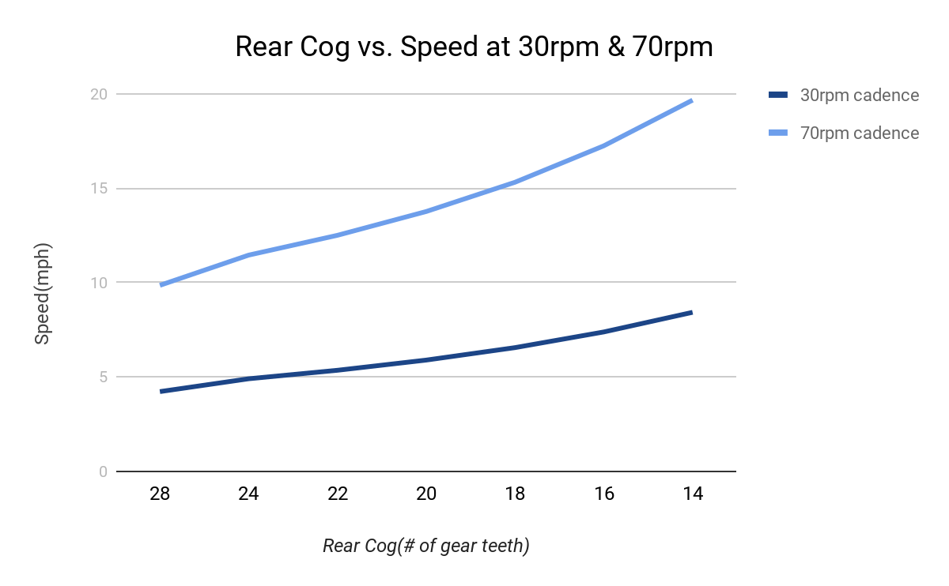

*Figure 15. Speed range for cadence between 30 and 70 rpm for different rear cogs*

In Table 1, a higher number of teeth in the rear cog means a lower gear. In short, lower gears are suitable for lower speed range. To be more specific, a rider could only deliver power efficiently and comfortably when paddling at a certain range of cadence. The optimal gear at a certain speed should put the rider to paddle within this range at that speed. Assume this range to be between 30 and 70 rpm, Figure 15 represents upper and lower speed limits of this range for each gear. Plus, a bicycle can only shift when the rider is paddling. Thus, for a gear, if the speed goes above the upper limit and the cadence is not 0, it means it’s time to upshift. While the speed goes below the lower limits and cadence is not 0 means it’s time to downshift.

# 3 Cost

*Table 2. Estimated Cost of Labor*

|  |  |  |  |
| --- | --- | --- | --- |
| **Estimated Cost of Labor** | | | |
| **Name** | **Hour Rate($/hour)** | **Hours(hours)** | **Subtotal($)** |
| **Tianqi Liu** | 40 | 100 | 4000 |
| **Ruijie Qi** | 40 | 100 | 4000 |
| **Xingkai Zhou** | 40 | 100 | 4000 |
| **Machine Shop** | 40 | 10 | 400 |
| **Total** | 40 | 310 | 12400 |

*Table 3. Cost of Parts*

|  |  |  |  |
| --- | --- | --- | --- |
| **Cost of Parts** | | | |
| **Part name** | **Quantity** | **Unit Price($)** | **Subtotal($)** |
| 12V, 2000mAh Ni-MH battery pack | 1 | 19.99 | 19.99 |
| 7805 linear voltage regulator | 1 | 0.95 | 0.95 |
| oh090u hall effector | 2 | 1.74 | 3.48 |
| ATmega328 28-pin PIPD | 1 | 4.3 | 4.3 |
| HD44780 LCD screen | 1 | 4.99 | 4.99 |
| Servocity 3rpm gear motor | 1 | 24.99 | 24.99 |
| Push buttons | 3 | 0.35 | 1.05 |
| Plastic case | 1 | 6.99 | 6.99 |
| L298N Motor Driver | 1 | 1.91 | 1.91 |
| **Total($)** |  |  | 68.65 |

**Total estimated cost = Labor cost+Parts cost = $12400 + $68.65=$12468.65**

# 4 Schedule

*Table 4. Schedule*

|  |  |  |  |
| --- | --- | --- | --- |
| **Week** | **Xingkai** | **Ruijie** | **Tianqi** |
| **2/19** | Prepare design document | Prepare design document and order parts | Prepare design document, choose the specific components |
| **2/26** | Temporarily install cadence and speed sensor on the test bicycle | Verify cadence and speed sensor are working on the test bicycle and refine the design of screen and button mount | Design the PCB board on Eagle |
| **3/5** | Design circuit schematics and verify circuit design on breadboard | Draw PCB using Eagle and verify with ECE workshop | Talk with machine shop again to design, manufacture and install motor holder and rotor |
| **3/12** | Verify the functionality of control unit and UI unit. | Verify the functionality of sensing unit and power unit. | Configure and test LCD; |
| **3/19** | Spring break | Spring break | Spring break |
| **3/26** | Test the system under manual mode on bike shelf | Develop software | Test 6rpm Motor on bike stand;  Decide to switch to 3rpm |
| **4/2** | Solder the components to PCB and test it | Connect each part to microcontroller | Install Hall Effectors;  Develop code to measure speed and cadence |
| **4/9** | Collect test data and use it to modify the circuit | Collect test data and use it to modify the control algorithm | Test the battery;  Test motor on bike stand |
| **4/16** | Redesign and remanufacture any problematic part of control unit and UI unit | Redesign and remanufacture any problematic part of sensing unit and power unit. | Conduct road test;  Refine the parameters for control algorithm |
| **4/23** | Collect data during the road test and fix any emerging issue. | Collect data during the road test and fix any emerging issue. | Prepare the control case and mount the LCD screen and buttons on it with help from ECE machine shop |
| **4/30** | Prepare for final demo | Prepare for final demo | Prepare for final demo |

# 5 Conclusion

## 5.1 Achievements, Uncertainties & Future work

We have successfully developed an affordable(<$100) automatic bike shifting system that can be easily mounted on any bike derailleur. According to the results of road test, the system could outperform traditional mechanical gear switching device because it can switch gears smoother and faster.

There are a few things that could be improved:

1. The current control algorithm contains hard-coded parameters that are purely based on one tester’s physical condition.
2. Now the system could not check the current gear. It assumes that it’s at gear 1 at the start.

To fix them, we plan to:

1. Set different control algorithms for user to choose, such as Sport, Casual, Exercise…
2. Use two gyro sensors to measure the relative angle between rear derailleur and bike frame. That angle should be a fixed value for each gear.

## 5.2 Ethnics

Our project should follow the IEEE Code of Ethics, and there are some points worth to be addressed.

According to the IEEE Code of Ethics #5 [12], our product should not injure any people nor their property. We must make sure we think thoroughly about the potential hazard that can be caused by our project. Since our project involves battery and a bicycle, we followed safety procedures when we are operating these two parts. We chose Ni-MH battery instead of Li-ion battery, because it is safer under extreme temperature and would not explode in any circumstance.

# References

[1] “THE GROWTH OF BIKE COMMUTING”, The League of American Bicyclists, 2013. http://www.bikeleague.org/sites/default/files/Bike_Commuting_Growth_2015_final.pdf.

<http://batteryuniversity.com/learn/article/nickel_based_batteries>

[2]“Science Behind the Magic | Drivetrain Compatibility”, Art’s Cyclery Blog, <http://blog.artscyclery.com/science-behind-the-magic/science-behind-the-magic-drivetrain-compatibility/>

[3]“BU-203: Nickel-Based Batteries.” *Nickel-Based Batteries Information – Battery University*, Cadex Electronics Inc, batteryuniversity.com/learn/article/nickel_based_batteries. Accessed 2 May 2018.

[4]“Voltage Regulator - 5V.”, SparkFun Electronics, [www.sparkfun.com/products/107](http://www.sparkfun.com/products/107).

[5]“3 RPM Gear Motor.” ServoCity.com, [www.servocity.com/3-rpm-gear-motor](http://www.servocity.com/6-rpm-gear-motor).

[6] “STP-MTR-23079D.” Stepper Motor: NEMA size 23 frame, dual shaft, 276 oz-in holding torque (PN# STP-MTR-23079D) | AutomationDirect, [www.automationdirect.com/adc/Shopping/Catalog/Motion_Control/Stepper_Systems/Stepper_Motors_-z-_Cables/STP-MTR-23079D?utm_source=google&utm_medium=product-search&gclid=CjwKCAiA8bnUBRA-EiwAc0hZk9misN94G8ktQH4RE8FqONAG_ESyaay8xHu0iifIg7UWQByWLIfkXBoCyA4QAvD_BwE](http://www.automationdirect.com/adc/Shopping/Catalog/Motion_Control/Stepper_Systems/Stepper_Motors_-z-_Cables/STP-MTR-23079D?utm_source=google&utm_medium=product-search&gclid=CjwKCAiA8bnUBRA-EiwAc0hZk9misN94G8ktQH4RE8FqONAG_ESyaay8xHu0iifIg7UWQByWLIfkXBoCyA4QAvD_BwE).

[7]“atmega328 datasheet.” ATMega32 AVR, 2 July 2012, atmega32-avr.com/atmega328-datasheet/.

[8]“L298 Dual Full Bridge Driver.” ST Microelectronics, 2000.

[9] “From Arduino to a Microcontroller on a Breadboard.” Arduino - ArduinoToBreadboard, Jan. 2018, [www.arduino.cc/en/Tutorial/ArduinoToBreadboard](http://www.arduino.cc/en/Tutorial/ArduinoToBreadboard).

[10]“HD44780U (LCD-II) Datasheet.” HITACHI, 1998.

[11]BikeCalc.com - Speed at all Cadences for any Gear and Wheel, www.bikecalc.com/speed_at_cadence.

[12] “IEEE IEEE Code of Ethics.”, IEEE, <http://www.ieee.org/about/corporate/governance/p7-8.html>.

*Special thanks to previous ECE445 students Peter Kowalczyk, Kevin Luong and Matt Potok. Their project Electronic Bicycle Shifting offered inspiration and priceless help to us.

# 

# 

# 

# Appendix A Requirement and Verification Table

*Table 5. Requirement and Verification*

|  |  |  |
| --- | --- | --- |
| Requirement | Verification | Results  (Y/N) |
| Battery | | |
| Can power the motor to pull the cable to each gear, which means the current through the motor > 500 mA. | 1. Connect the motor with microcontroller. Link the cable to motor output 2. Use the manual mode and upshift/downshift button to switch gears from lowest gear to highest gear. 3. Repeat it from highest to lowest gear. 4. In this process, the battery should power the motor to conduct all these actions within 0.2 second. | Y |
| Can continuously power the whole system up to 10 hours | In the 10 hour road test, the battery should be able to support the system without recharging | Y |
| Output voltage is between 11.5 V and 13.5 V | The voltage output measured by multimeter should be between 11.5 V to 13.5 V in any working conditions. | Y |
| Voltage Regulator | | |
| Sustain 550 mA - 600 mA current without overheating (<120 degree celsius ) | 1. Connect the output with a 80 Ohm resistor. 2. Connect the input to 7.4 V voltage source for 0.5 second, then disconnect it for 5 seconds. 3. Repeat for 1 min, measure the temperature of the voltage regulator surface | Y |
| Output voltage is 5 V (steady state error within 0.3 V ) when a continuous 11.5 V - 13.5 V input voltage is applied | 1. Use the voltage source to generate 11.5 V to 13.5 V input 2. The output connects a 100 Ohm resistor 3. The voltage output measured by multimeter should be between 4.7 V to 5.3 V. | Y |
| Cadence Sensor | | |
| Achieve accuracy of 3 rpm | 1. Mount the cadence sensor on bike paddle. Connect it with microcontroller and LCD screen. Put the bike on a test shelf with back wheel free to move. 2. Write a test program that print out the continuous reading of cadence sensor on the LCD. Load it to microcontroller. 3. Rotate the bike paddle for 1 minute. Count the rounds the paddle rotates. 4. Compare the counted number with the displayed number on LCD. | Y |
| Speed Sensor | | |
| Achieve accuracy of 1 m/s | 1. The control unit and LCD screen shall be installed first. The LCD should display the speed with less than 0.2 second delay 2. One tester ride the bike at a certain speed and read a steady speed value on LCD. Two signs are places with 10 meters distance. 3. When the bike pass those two signs, another tester measure the time interval. 4. Repeat the test 3 times. 5. Compare the manually measured speed with the speed displayed on LCD. In average, the difference shall be less than 1 m/s | Y |
| Motor | | |
| Have enough torque (20 kg-cm) to pull the cable of rear derailleur. | 1. Power the motor with 12 V voltage source. Connect gear motor with control unit. 2. Rotate the paddle by hand 3. Switch the gear from lowest to highest 4. Switch the gear from highest to lowest | Y |
| Motor Driver | | |
| 1. Power the motor for 0.4 seconds at 12 V. 2. The motor should switch up or down a gear based on control signal. | 1. Set bike to lowest gear. Use hand to rotate the paddle. 2. Arduino send 01 signal for 400 ms. 3. The gear motor should rotate and pull the rear derailleur to next gear. 4. Send 10 signal for 400 ms. 5. The gear motor should return to the starting point and the rear derailleur should go back to original gear. | Y |
| Microcontroller | | |
| Receive digital input without missing | 1. Connect all the digital input pin to push button. 2. Load a test program that print out the count number of digital input pulses on terminal 3. Press one push button for 100 times with 1 second interval 4. The number displayed on terminal should be exactly 100 5. Repeat for all digital input pins | Y |
| Buttons | | |
| The button is functional when connect with 5V microcontroller with error rate less than 3% | 1. Connect the button with 5V voltage source and arduino digital pin. Write a test program that print the count of button pressed on LCD screen. 2. press button for 100 times 3. The result displayed on LCD should be within 97 and 103 | Y |
| LCD | | |
| Display content correctly and refresh the content every 0.5s | 1. The screen shows cadence, speed, current gear, and current mode flawlessly. 2. The delay should be less than 0.5 seconds | Y |

# 

# 

# 

# 

# 

# 

# 

# 

# 

# 

# 

# Appendix B Verification Results

*Table 6. Verification Results for Battery*

|  |  |
| --- | --- |
| Voltage before 1 hour road test(V) | Voltage after 1 hour road test(V) |
| 13.4 | 13.28 |
| 13.19 | 13.07 |
| 13.0 | 12.95 |

*Table 7. Verification Results for Voltage regulator*

|  |  |
| --- | --- |
| Input voltage to the regulator(V) | Output voltage(V) |
| 11.5 | 4.9932 |
| 11.7 | 4.9933 |
| 11.9 | 4.9932 |
| 12.0 | 4.9940 |
| 12.2 | 4.9956 |
| 12.4 | 4.9977 |
| 12.6 | 4.9962 |
| 12.8 | 4.9975 |
| 13 | 4.9975 |

*Table 8. Verification Results for Cadence Sensor*

|  |  |
| --- | --- |
| Cadence on screen(rpm) | Counted rounds for 1 minute |
| 58~60 | 60 |
| 34~37 | 37 |
| 18~20 | 20 |
| 7~11 | 10 |

*Table 9. Verification Results for Speed Sensor*

|  |  |  |
| --- | --- | --- |
| Speed on screen(mph) | Measured time to travel 10 meters(s) | Average speed in 10 meters(mph) |
| 4~5 | 5 | 4.47 |
| 5~6 | 4 | 5.59 |
| 7~8 | 3 | 7.45 |

# Appendix C Schematic and PCB Design

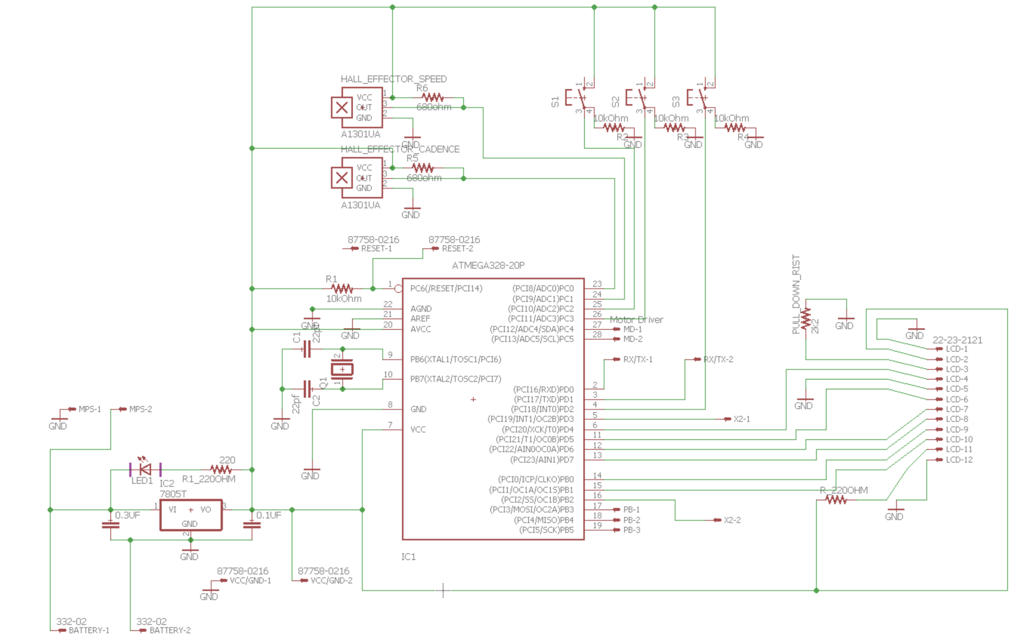

*Figure 16. Schematic of the Whole System*

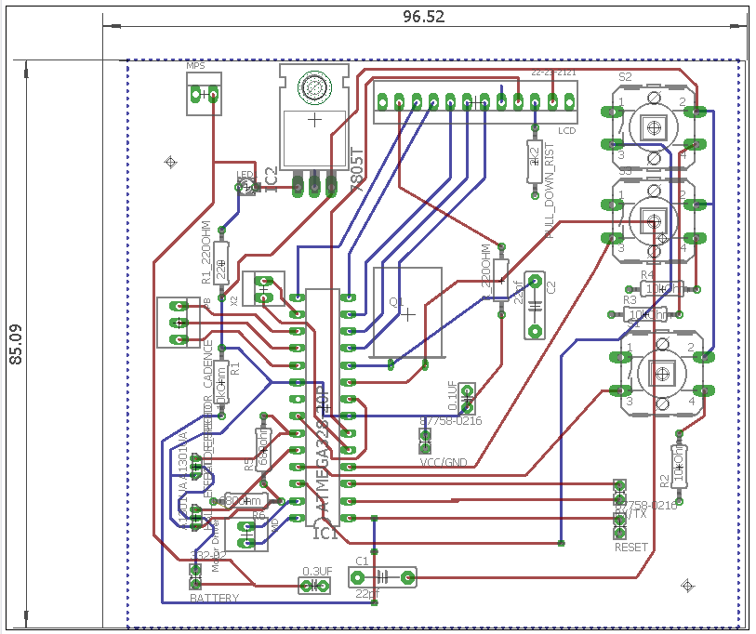

*Figure 16. PCB Design*