Documentation of the set-up "balançoire à poissons"

Table of Contents
1. Preparing the fish
2. Imaging system
3. Preparing the experiment
1- Folder organisation
2- prepare_experiment
1) Psychtoolbox
2) DMAC
3) Camera
4. Doing experiment
1- do_tilt_experiment
1) Pre section
2) Main section
2- experiment functions
1) expCaller
2) retrOMR
3) visual
4) vestibular
5) vestiVis
5. Data structure
1- data files
2- experiment files
3- figures

This document has been updated on 2018-02-07

Preparing the fish
- put the 5 – 7 dpf WT larva in a drop of warm but not hot 1.5 – 2% agarose
- drag the fish in a capillary so it is straight and centered
- remove the agarose at the third of the tail without hurting the fish
- put the capillary in the tank from the side you want to observe (rolling or tilting)

Imaging system
- tunr on the IR light
- on the PointGrey software, tune the parameters
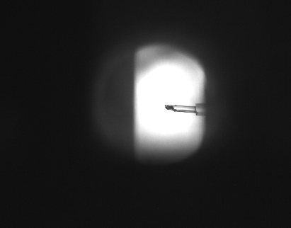this should look like this (with a fish instead of agarose)

Preparing the experiment
- start matlab
- it should open some scripts, if it does not, you can find them in
C:\Users\Jean Perrin\Desktop\Hugo\Matlab_current

Folder organisation
Matlab_current (main code folder)
classes (classes for communication with outside)
Camera.m
DMAC.m
Motor.m
Psychtoolbox.m
exp (functions for experiments)
auto.m
expCaller.m
expViewer.m
retrOMR.m
static.m
vestibularVisual.m
functions (useful functions)
Fish.m
morphomaths.m
prerun.m
rotatePattern.m
changelist.txt
do_roll_experiment.m
do_tilt_experiment.m
prepare_experiment.m
view_experiment.m

prepare_experiment
This script initialize the communication with the projector, motor, camera.

It uses the following calsses :

Psychtoolbox (old version)
This allows to create a windmill pattern (stripes in cylindrical geometry) without interacting directly with the psychtoolbox (http://psychtoolbox.org/)
here we can see :
1- the central spot, 2- the horizon, 3- the stripes
to initialize a psychtoolbox communication object, simply do :
projector = Psychtoolbox();

then if you want to change a parameter, you can do :
projector.windmill.HorizonAngle = 130

and to actualize the pattern :
projector.drawWindmill()

and to refresh the view :
projector.refresh()

The parameters you can set are the following (details are given in code comment) :
projector.windmill.WindmillWingNumber
projector.windmill.CentralSpotSize
projector.windmill.HorizonAngle
projector.windmill.WindmillBorder
projector.windmill.color
projector.windmill.power
projector.windmill.angle

Properties
handle contains variables to communicate with psychtoolbox
window window number for psychtoolbox
windowRect size of the window
windmill contains the windmill parameters
WindmillWingNumber number of stripes
CentralSpotSize size of the central spot (to avoid "blinding" the fish)
HorizonAngle angular size of the dark ceil
WindmillBorder percentage of the total size (to avoid sending too much light)
color RGB color of the 'white' stripes
power multiplies color by power
angle angle of the stripes
Methods
addAngle adds the given value to the current angle
setAngle sets the angle to the given value
refresh refreshes the pattern

Psychtoolbox (new version)
To make the use of psychtoolbox smoother, I run it in an other process which communicates trought tcp/ip connection.
To start a command line matlab, go in windows command line and enter
"C:\Program Files\MATLAB\R2018a\bin\matlab.exe" -nodesktop
Then, create a server with 'PsychLoop'. It will start listening, go in your main matlab instance and establish the communication with 'PsychCli'.
You will then have access to the following functions :
initProj
restart
translate
changePattern
speedLoop
setSpeed
stopLoop

Each of these functions send information through tcp/ip to the server, which triggers corresponding actions. When in speed loop state, the server only receives numbers (doubles). When it receives a NaN (not a number), it stops the loop and starts listening to command again.

DMAC
DMAC is a class which heritates from Motor. If you want to use the program with an other motor, you have to write a similar class.
It uses serial communication, which can be slow. When two commands can not execute one after the other, just try executing them separately (0.2 seconds of difference should be sufficient).
after initializing the object with :
motor = DMAC();
you can adjust the soft limits with :
motor.setSoftLimits(-60, 60)

More details are given inside the code.

Properties
handle inherited from Motor, for DMAC, handle is a pointer on the serial stream
degreePerStep defines the conversion factor between one step for the motor and one degree
Methods
setSoftLimits sets the minimum and the maximum allowed angles
moveAbs move to absolute position in degrees
moveRel move to relative position in degrees
setSpeed sets the speed until reaches softLimits or other instruction is given
startProgram starts the program recorded in the motor controller memory
stop stops any program or instruction and sets speed to zero
pow power on / power off the motor
home /!\ starts moving towards zero, waits 2 seconds and stops activity
setZero sets the home at the current position
readPos calls serial communication and returns value in degrees (~30ms)
program reads the instructions in a file and send them to the motor controller memory

Camera
The camera is an interface to facilitate the use the image aquisition toolbox (imaq). Because we use the trigger parameters, you have to start listening before getting a frame. Do not start listening when an other software is already listening the camera (PointGrey for instance).
start(camera.handle)
and then
stop(camera.handle)

Properties
handle video input object pointing on the camera
Methods
setROI opens a figure where the user can draw a rectangle to set the ROI
preview open a figure with a preview of what the camera can see
getFrame triggers the camera and take a frame and its timestamp camera has to be started first (see above)

Doing experiment

do_tilt_experiment
In this script, you can define a protocol and run it automatically. At the end, it will plot a figure and save the data in a specific directory.

Pre section
In the first section, the motor goes to home, soft limits are defined to +/- 60 degrees, hand all the handles are gathered in one structure.

Main section
In the second section, you can change the record path, for example like this :
recordpath= 'D:\DataHugo\2018-01\31_f01_vary_vestibular_00\';

If the folder already exists, the program stops and asks you to delete it, or to change the recordpath.

Protocol you can set a protocol with the following scheme :
protocol { type, duration (minutes), [options] }

Repetitions you can change the number of times the protocol will be repeated :
repetitions = 3;

Example this is an example of protocol :

%test fish
'changePattern', 0, { 'WindmillWingNumber', 12,
'HorizonAngle', 200, 'Power', 0.9};
'static', 0.3, {};
'retrOMR', 0.3, {'rspeed', -5, 'rcorrect', 8};
'static', 0.3, {};
'vestibularVisual', 2, {'speed', -2, 'correctionAngle', 8, 'rcorrect', 0};
It will first change the pattern with the parameters given in argument, then do 0.3 minutes of static recording, then do a OMR experiment with feedback, then do 0.3 minutes of statuc recording, then do a vestibular stimulation, without visual feedback (rcorrect is set to 0). For more details about the parameters, see each experiment function detail later. For defaults parameters (if you do not give them in argument, see expCaller, which has a set of default parameters.

experiment functions

expCaller
The expCaller function is an intermediate function which is called by the do_tilt_experiment script and calls the following experiment functions.
It sets default values if the do_tilt_experiment script does not provide it. This function manages the videowriter objects and data saving.

retrOMR
retrOMR does visual stimulation with feedback at specific parameters
- stripes rotate at rspeed (-15°/sec)
- swim bout detection
- stripes rotating at rcorrect (+60°/sec) during correctionTime (0.2 sec) which gives a corrected angle of 12°
- back to step 1
example of protocole lign :
'retrOMR', 1, {'rspeed', -10, ...
'rcorrect', 20, ...
'interboutTime', 0.3, ...
'correctionTime', 0.4};

visual
visual does visual stimulation with feedback at given parameters
- stripes rotate at rspeed (ex -2°/sec)
- swim bout detection
- stripes rotating at rcorrect during correctionTime (0.3 sec), rcorrect being computed with rangle, the total angle of correction (ex 10°)
- back to step 1
example of protocole lign :
'visual', 1, {'rangle', 10, ...
'rspeed', -2};

vestibular
vestibular stimulation with only vestibular feedback :
- platform rotating at speed
- swim bout detection
- vestibular feedback
- back to step 1
example of protocole lign :
'vestibular', 2, {'speed', -2, 'correctionAngle', 8};

vestiVis
vestibular stimulation with both visual and vestibular feedback :
- platform rotating at speed
- swim bout detection
- visual and vestibular feedback
- back to step 1
example of protocole lign :
'vestiVis', 2, {'speed', -2, 'correctionAngle', 8};

Data structure

data files
The data are stored in the directory specified in the script. For example :
recordpath= 'D:\DataHugo\2018-01\31_f01_vary_vestibular_00\';

In this directory, the data are organised like this :

D:\DataHugo\yyyy-mm\<name>
| 1-1-exp.avi
| 1-1-exp.mat
| 1-2-exp.avi
| 1-2-exp.mat
| ...
| i-j-exp.avi
| i-j-exp.mat
| analysis.fig
| protocol.mat

With i and j the number of the interation (repetition) and the order of the experiment in the protocol.
- analysis.fig is a matlab figure representing the raw data of the experiment
- protocol.mat is the cell array defined in the experiment script
- i-j-exp.avi is a grayscale movie of the fish (the framerate is not good)
- i-j-exp.mat is a matlab workspace file containing the data and parameters
example (TODO update this section) :
obj =

tframe: [1x10522 double]
moment: [1x10522 double]
motor_angle: [1x10522 double]
tstart: 6.7506e-04
params: [1x1 struct]

obj.params =

moment_threshold: 0.0400
duration: 10
speed: 200
correct: 1000

experiment files
In C:\Users\Jean Perrin\Desktop\Hugo there are three files called fish.
fish.ods contains the information about the fish
fish.odp contains figures for certain experiments
fish.odt is this manual

figures
automatic generated figures look like this :
- ellipse moment is the angle of the single ellipse fitted on the fish
- tail speed is the diff of the precedent value
- vestibular stimulus is the angle of the motor
- visual stimulus is the angle of the windmill in the lab referential
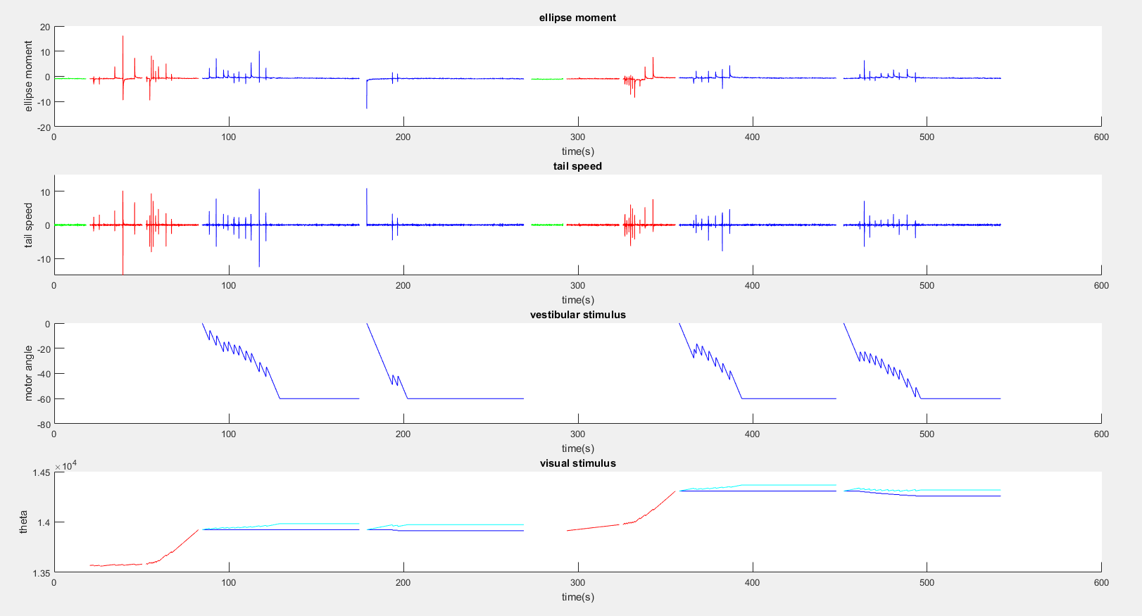
- green means static
- red means only visual stimulus
- blue means vestibular stiumulus

