

StorEase
Software Requirement Document

– HCM, Nov 2026 –

Record of changeS
Date | A*  M, D | In charge | Change Description
01/Nov | A | KhangHM | First complete version, written from the implemented system
*A - Added M - Modified D - Deleted

Table of Contents
I. Overview 6
1. Introduction 6
2. Existing Systems 6
2.1 SiteLink Web Edition (Storable) 6
2.2 Storable Edge (formerly storEDGE) 7
3. Business Process 8
4. System Functions 9
5. Entity Relationship Diagram 12
6. State transition diagram 13
II. Functional Requirements 17
1. Account & Authentication (F01) 17
a. Register 17
b. Verify Email 17
c. Login 17
d. Forgot and Reset Password 18
2. Profile & Settings (F02) 19
a. Manage Profile 19
3. Browse (public pages) 20
a. Home 20
b. Sizes & Prices 21
c. Locations 22
4. Reservation & Deposit (F03) 22
a. Choose Unit 22
b. Booking Details 23
c. Cancel Booking 24
d. Reservations Queue 24
e. Walk-in Booking 24
5. Unit Assignment (F04) 25
a. Assign Unit 25
b. Change Unit 25
6. Contract & Customer (F05) 26
a. Draft Contract 26
b. Sign Contract 26
c. Customers & Contracts 27
d. Customer Detail 28
7. Handover & Access (F06) 28
a. Handover Desk 28
b. Cancel Handover 29
c. Check-in / out 29
d. Close Visits at Closing Time 30
e. Manage Access Code 30
8. Rent Payment (F07) 30
a. Payments & Invoices 30
b. VNPay Confirmation 31
c. Record Payment 31
d. Pricing & Policies 32
9. Billing Automation & Overdue (F08) 33
a. Billing Job 33
b. Overdue Cases 33
10. Renewal (F09) 34
a. Request Renewal 34
b. Decide Renewal 34
11. Move-out & Settlement (F10) 34
a. Request Return 34
b. Returns 35
c. Lock After Deadline 37
d. Deposit Refunds 37
12. Facility & Unit Setup (F11) 37
a. Dashboard 37
b. Facilities 38
c. Add Facility 39
d. Facility Detail 39
e. Storage Units 40
f. Maintenance 41
13. User & Audit Admin (F12) 41
a. Users & Roles 41
b. Invite User 42
c. Activity Log 43
14. Reports (F13) 43
a. Reports & Exports 43
15. Language Switch (F14) 44
a. Choose Language 44
16. Support Requests 44
a. Support Requests 44
b. Support Tickets 45
17. Staff & Shifts 47
a. Staff & Shifts 47
III. Database Design 48
1. Database Schema 48
2. Table Detail 52

I. Overview

1. Introduction
StorEase is a web system for renting and running self-storage facilities in Ho Chi Minh City. It replaces phone calls, paper contracts and spreadsheets with one customer site and one staff portal. Customers find a unit, book it, pay the deposit and rent, read their access code, renew and hand the unit back. Staff assign units, run the handover desk, record visits and cash, inspect returned units and manage facilities, prices, shifts and reports.
Users: visitors, Storage Customers, Facility Staff, Facility Managers, Business Operations Managers and System Administrators. A staff member works only with the facilities assigned to them; Business Operations and System Administrators see all facilities.
Technology: a .NET 8 Web API with Clean Architecture and Entity Framework Core on SQL Server, and a React 18 single-page app. The system is written for browsers on desktop and mobile, in Vietnamese and English.
Constraints: amounts are in Vietnamese dong; dates follow Vietnam time. A unit can hold only one open contract. The handover, not the signature, starts a rental.
Assumptions and dependencies: online payment depends on VNPay; email depends on an SMTP server (without one, messages go to the server log). Each facility must have staff before it can take bookings. Visits are recorded by staff at the desk; the system does not control physical gates or locks.
The context diagram below shows the system boundary. Five kinds of people use the system; VNPay takes online payments and an SMTP server delivers email. Everything else, including physical locks, is outside the system.
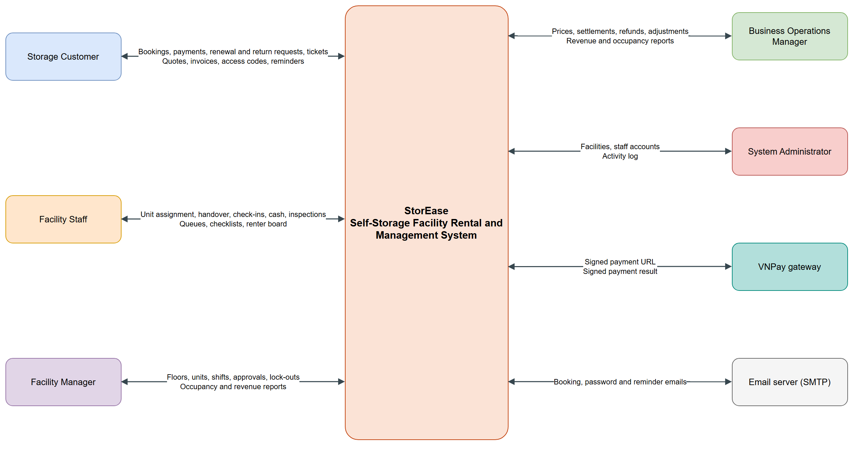
Figure 1. Context diagram

2. Existing Systems

2.1 SiteLink Web Edition (Storable)
A commercial cloud system for self-storage operators. Actors: facility staff, managers and tenants.
- Link: https://capterra.com/p/92752/SiteLink-Web-Edition/
- Features: Tenant self-service portal, online rentals, electronic payments and signatures, recurring billing, late fee calculation, reservations, multi-location support and gate access control.
- Pros: Mature and complete; covers the full tenant cycle across many sites.
- Cons: A paid product; its listings show no support for Vietnamese language or local payment methods.
- What StorEase uses: StorEase learned the tenant portal, the late-fee cycle and multi-facility scope from it.

2.2 Storable Edge (formerly storEDGE)
A commercial self-storage system aimed at small and medium facilities. Actors: facility staff, managers and tenants.
- Link: https://www.storable.com/products/edge
- Features: Tenant portal for accounts and payments, electronic signature, SMS and email reminders, revenue management, automated lien processing, document management and gate integration.
- Pros: Modern tenant experience and strong automation of overdue handling.
- Cons: Paid subscription; its lien and auction steps do not apply here.
- What StorEase uses: StorEase learned the automatic reminder and escalation steps, ending in a clear-out stage instead of a lien sale.

3. Business Process
The swimlane below shows the whole rental lifecycle. Every step has a full version, with its decisions and failure paths, in the companion file flows.drawio (flows F01 to F14).
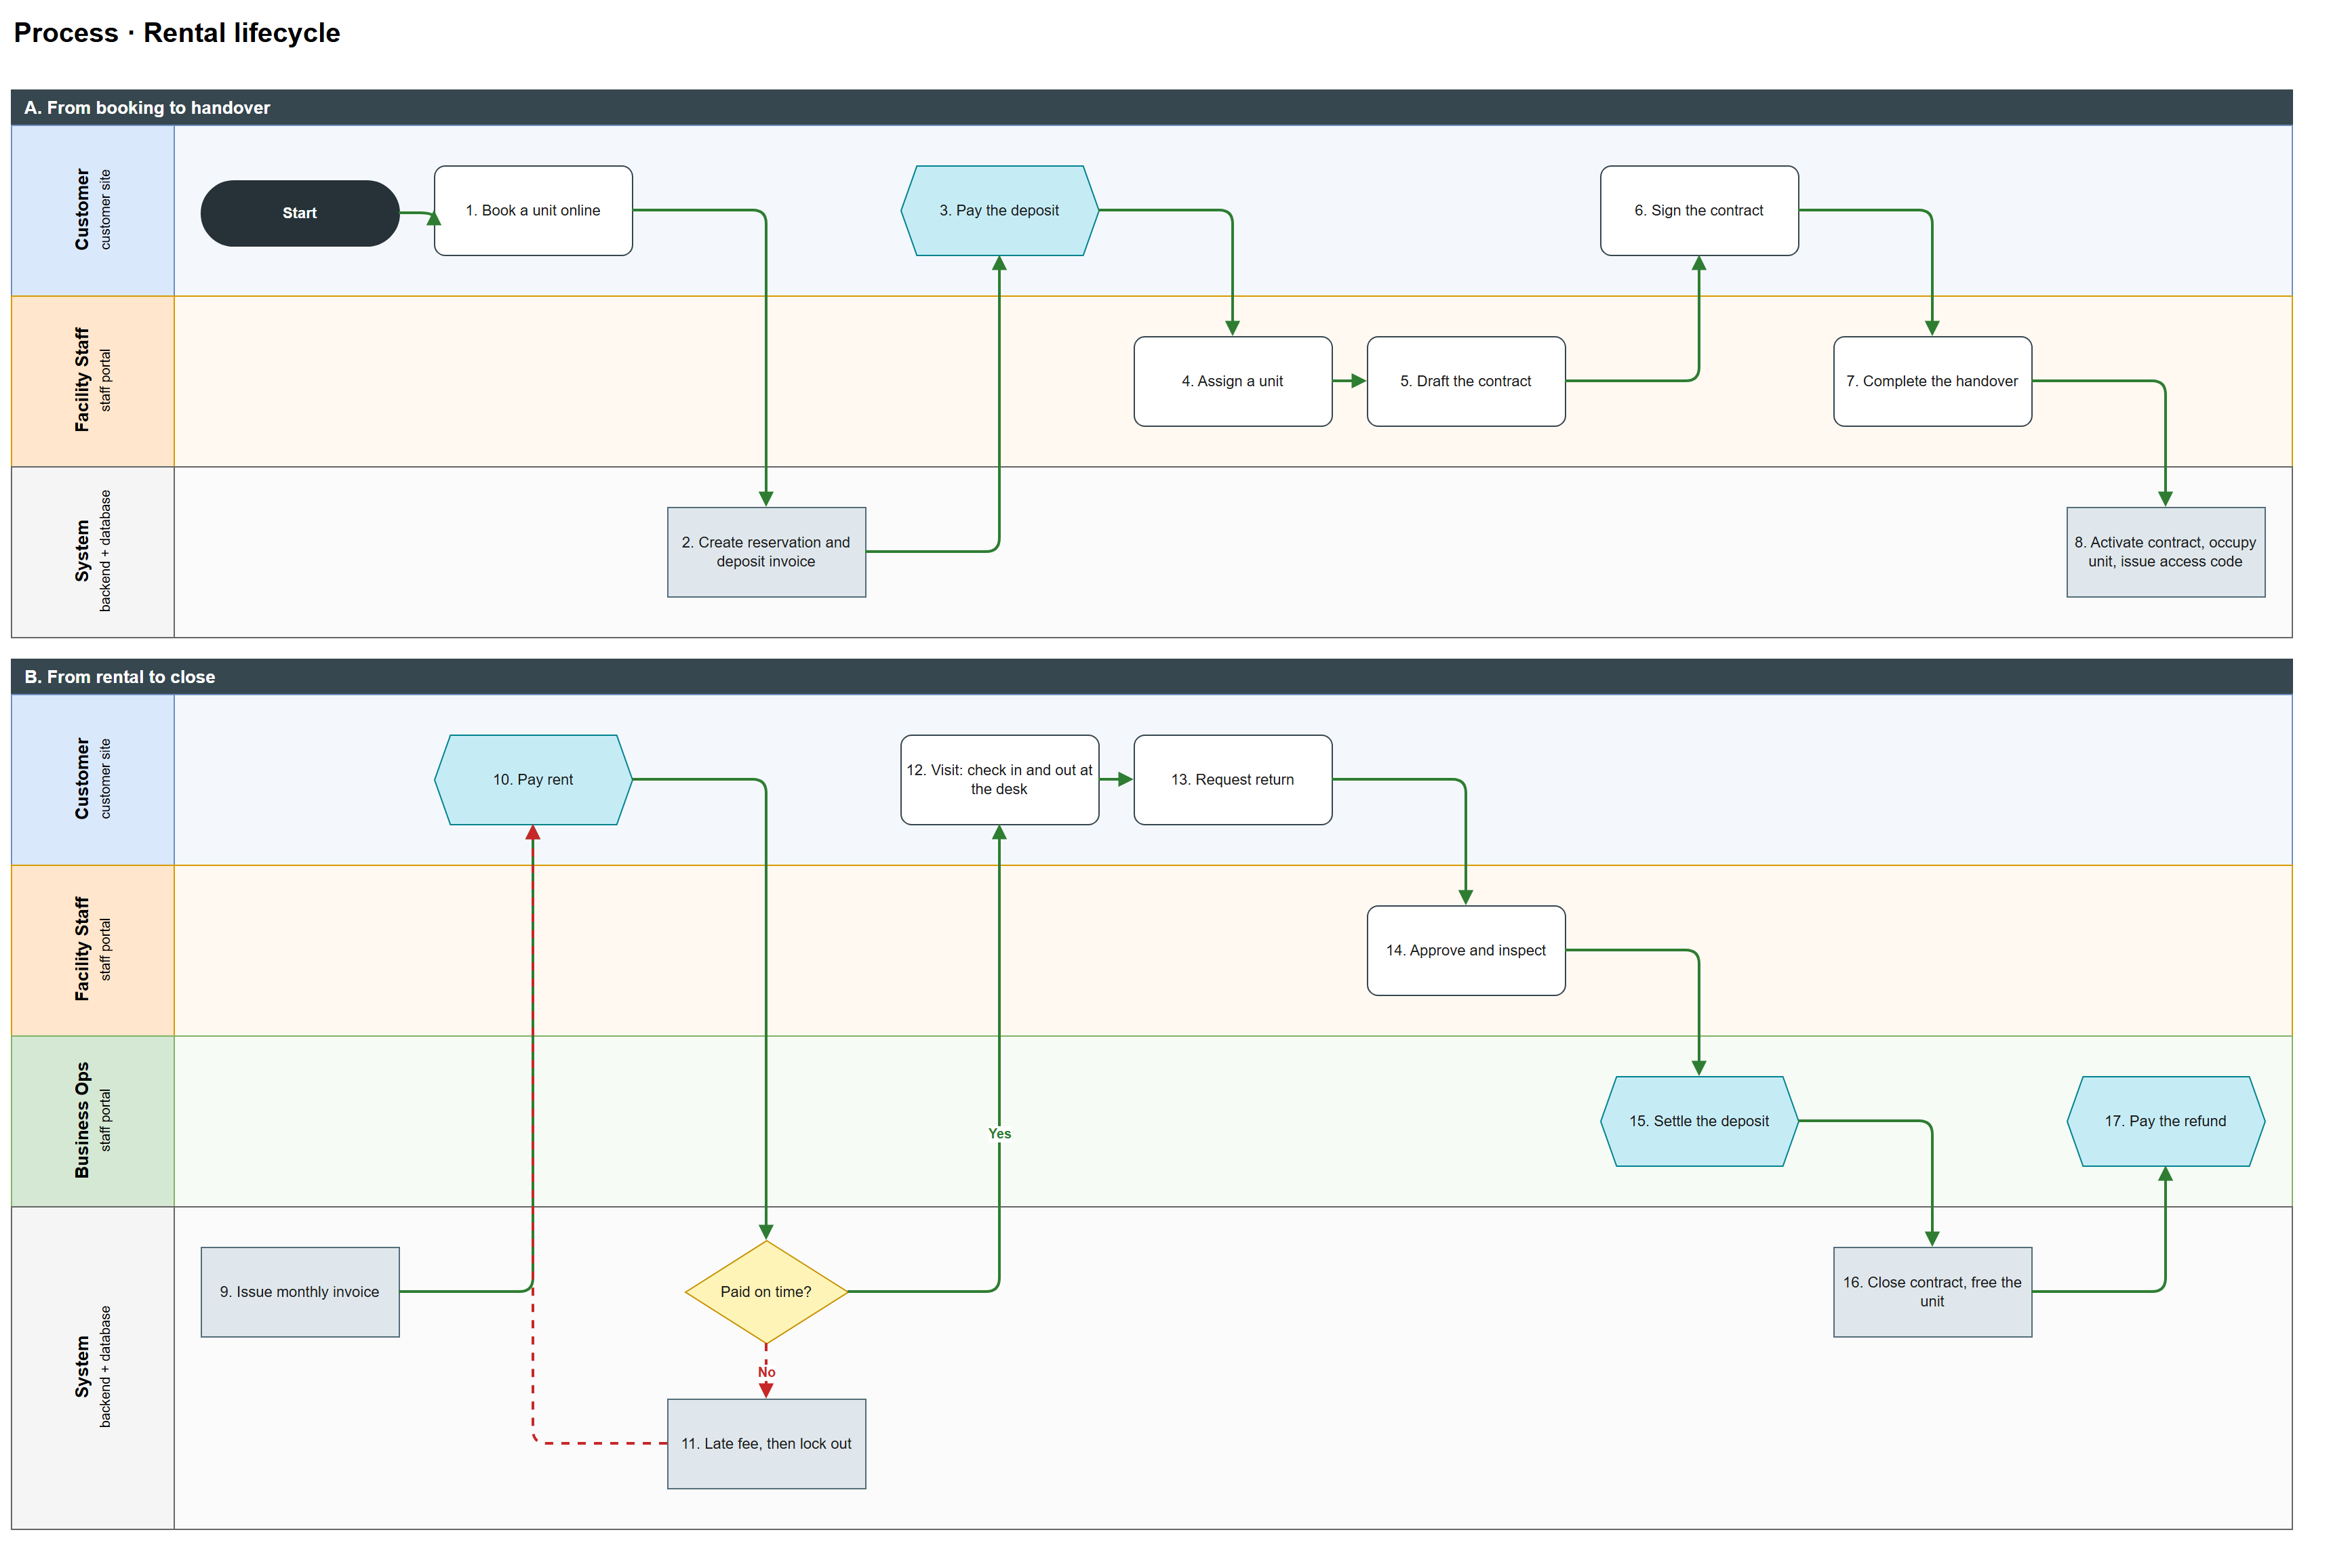
Figure 2. Rental lifecycle swimlane

# | Process Step | Description
1 | Book a unit online | The customer picks a location, size, move-in date and months. A unit type must be available at a staffed, active facility.
2 | Create reservation and deposit invoice | The system creates a Pending reservation, pins the price version and issues a deposit invoice due on the move-in date.
3 | Pay the deposit | The customer pays online. The handover is refused until the deposit is paid.
4 | Assign a unit | Staff pick an Available unit of that size. The reservation becomes Confirmed and the unit Reserved.
5 | Draft the contract | Staff draft the contract at the quoted rent and deposit and choose a payment day.
6 | Sign the contract | The customer signs online, or signs paper and staff record it. The contract stays Draft.
7 | Complete the handover | Staff check identity, deposit, unit, contract and signature, then record the lock and condition.
8 | Activate the rental | The contract becomes Active, the unit Occupied, and a 6-digit access code is issued.
9 | Issue monthly invoice | The hourly billing job issues each rent invoice 7 days before it is due.
10 | Pay rent | The customer pays online, or staff record cash at the desk.
11 | Late fee, then lock out | After the grace days a case opens. A weekly late fee is added, then access is suspended on the lock-out day until the invoice is paid.
12 | Visit | The customer says the code at the desk and staff check them in and out. Each visit ends with a new code.
13 | Request return | The customer picks a return date within 15 days. The contract becomes PendingReturn.
14 | Approve and inspect | Staff approve, set a slot and inspect the emptied unit, recording condition and charges.
15 | Settle the deposit | Business Operations settle: refund = deposit minus damage, early-return penalty and unpaid invoices, never below zero.
16 | Close contract, free the unit | The contract closes, codes stop and the unit returns to Available, or to Maintenance after major damage.
17 | Pay the refund | Business Operations pay the refund by cash or bank transfer and mark it Paid. The customer sees it under Payments.

4. System Functions

a. Screen Flow
The customer site and the staff portal are separate. Staff sign in on their own login page, and each role sees only its own menu items.
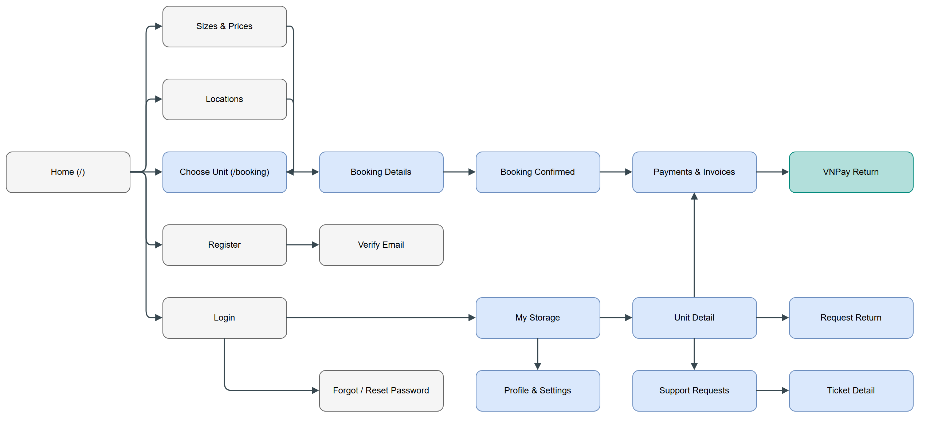
Figure 3. Customer site screen flow
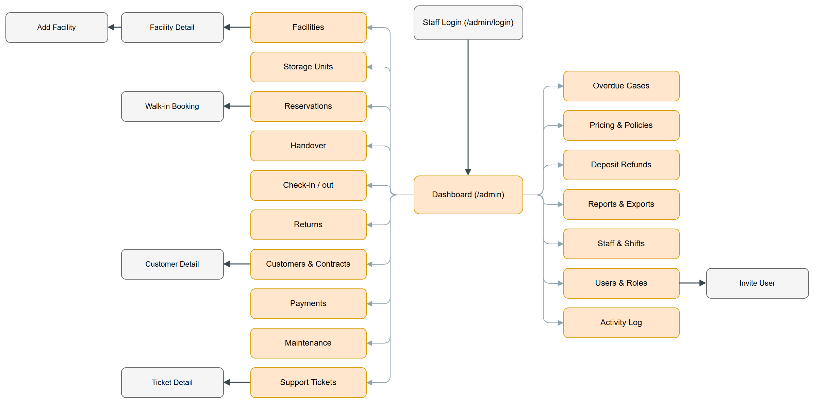
Figure 4. Staff portal screen flow

b. Screen Details
# | Feature | Screen | Description
1 | Account | Login | Sign in to the customer site.
2 | Account | Register | Create a customer account.
3 | Account | Verify Email | Confirm the address from the emailed link.
4 | Account | Forgot / Reset Password | Request a reset link and set a new password.
5 | Account | Staff Login | Sign in to the staff portal.
6 | Profile | Profile & Settings | Edit details, password and notifications.
7 | Public | Home | Introduce the service and start a search.
8 | Public | Sizes & Prices | Compare unit sizes with live prices.
9 | Public | Locations | Find facilities and free units.
10 | Reservation | Choose Unit | Pick location, size, date and period.
11 | Reservation | Booking Details | Review the quote and rules, then confirm.
12 | Reservation | Booking Confirmed | Show the code and the deposit to pay.
13 | Reservation | Reservations | Staff queue of bookings.
14 | Reservation | Walk-in Booking | Book for a customer at the desk.
15 | Rental | My Storage | Customer's units, bookings and balance.
16 | Rental | Unit Detail | Contract, access code, signing, renewal and visits.
17 | Rental | Handover | Desk steps from checklist to completed handover.
18 | Rental | Check-in / out | Renter board and visit recording.
19 | Rental | Customers & Contracts | Contract list, renewals, export and termination.
20 | Rental | Customer Detail | One customer's contracts, bookings, payments and tickets.
21 | Payment | Payments & Invoices | Customer invoices, payments and refunds.
22 | Payment | VNPay Return | Show the result of an online payment.
23 | Payment | Payments (staff) | Record cash, adjust, refund, remind.
24 | Payment | Pricing & Policies | Manage price versions and rental terms.
25 | Overdue | Overdue Cases | Follow unpaid rent, lock out, restore access.
26 | Move-out | Request Return | Customer requests to hand a unit back.
27 | Move-out | Returns | Approve, inspect and settle returns.
28 | Move-out | Deposit Refunds | Pay owed deposits back.
29 | Setup | Dashboard | Key figures and items needing attention.
30 | Setup | Facilities | List of facilities.
31 | Setup | Add Facility | Create a facility.
32 | Setup | Facility Detail | Floors, units and staff of a facility.
33 | Setup | Storage Units | All units with status and actions.
34 | Setup | Maintenance | Maintenance orders.
35 | Admin | Users & Roles | Staff accounts and permissions.
36 | Admin | Invite User | Create a staff account.
37 | Admin | Activity Log | Audit trail.
38 | Reports | Reports & Exports | Revenue and occupancy.
39 | Support | Support Requests | Customer tickets.
40 | Support | Ticket Detail (customer) | Conversation on a ticket.
41 | Support | Support Tickets | Staff ticket board.
42 | Support | Ticket Detail (staff) | Assign, reply, change status, order maintenance.
43 | Staff | Staff & Shifts | Weekly shifts.

c. User Authorization
X means the role can use the screen or action. The server enforces these rules on every request.
Screen | Customer | FS | FM | BO | SA
Home, Sizes & Prices, Locations | X | X | X | X | X
Choose Unit, Booking Details | X
My Storage, Unit Detail | X
Sign contract online | X
Request renewal, new access code | X
Payments & Invoices (own data) | X
Request Return | X
Support Requests (own data) | X
Profile & Settings | X
Dashboard |  | X | X | X | X
Facilities, Storage Units |  | X | X | X | X
Add or deactivate facility |  |  |  |  | X
Add or edit floors, units |  |  | X |  | X
Manage unit types (API only) |  |  |  | X
Reservations |  | X | X |  | X
Assign unit, cancel, no-show |  | X | X
Walk-in Booking |  | X | X
Handover |  | X | X
Check-in / out |  | X | X
Returns |  | X | X | X
Approve, inspect |  | X | X
Settle deposit |  |  |  | X
Customers & Contracts |  | X | X | X | X
Draft, sign at desk, export |  | X | X
Terminate contract |  |  | X
Decide renewal |  |  | X | X
Payments (staff) |  | X | X | X
Record cash |  | X | X
Adjust invoice, refund payment |  |  |  | X
Send reminder |  | X | X | X
Overdue Cases |  |  | X | X
Lock out, restore access |  |  | X | X
Maintenance |  | X | X | X | X
Create and update orders |  | X | X
Support Tickets |  | X | X | X | X
Assign ticket |  |  | X
Reply, change status |  | X | X
Pricing & Policies |  |  |  | X | X
Deposit Refunds |  |  | X | X | X
Mark refund paid |  |  |  | X
Reports & Exports |  |  | X | X | X
Staff & Shifts |  |  | X |  | X
Users & Roles |  |  | X |  | X
Create or edit staff account |  |  |  |  | X
Assign facilities |  |  | X |  | X
Activity Log |  |  |  |  | X

In which:
- Customer: a person who rents storage; sees only their own data.
- Facility Staff (FS): runs the desk at assigned facilities: handover, visits, cash, returns, tickets.
- Facility Manager (FM): manages assigned facilities: floors, units, shifts, staff, terminations, renewals, overdue cases.
- Business Operations Manager (BO): works across all facilities: prices, settlements, refunds, adjustments, reports.
- System Administrator (SA): manages facilities, staff accounts and the activity log.

5. Entity Relationship Diagram
The diagram shows the entities and how they relate; each arrow points from the child to the parent. Most entities also link to User; those lines are left out for clarity and are listed in part III.
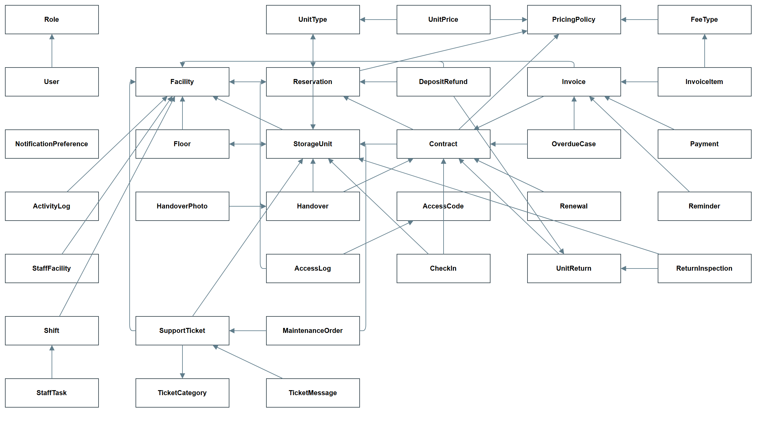
Figure 5. Entity relationship diagram
Entities Description
# | Entity | Description
1 | User | Anyone who signs in: customers and staff.
2 | Role | The five system roles.
3 | NotificationPreference | A user's email, SMS and marketing choices.
4 | ActivityLog | Audit record of each write and sign-in.
5 | StaffFacility | Links staff to the facilities they work at.
6 | Shift | A staff work shift at a facility.
7 | StaffTask | A task given to a person on a shift.
8 | Facility | A storage site with its manager and opening hours.
9 | Floor | A floor of a facility, with an open or closed status.
10 | StorageUnit | One rentable unit and its current status.
11 | UnitType | A size class of unit; this is what is priced.
12 | UnitPrice | Monthly price and period discounts of a unit type in a price version.
13 | PricingPolicy | A price version with its deposit, grace, late fee, lock-out, clear-out and cancellation terms.
14 | FeeType | A named fee defined in a price version.
15 | Reservation | A booking of a unit type for a move-in date and period.
16 | Contract | The rental agreement for one unit.
17 | Handover | The event that gives a unit to a customer and starts the rental.
18 | HandoverPhoto | A condition photo stored with a handover.
19 | AccessCode | A one-visit code, kept as a hash and as encrypted text.
20 | AccessLog | A recorded use of a code at a unit.
21 | CheckIn | One customer visit, with how it ended.
22 | Renewal | A request to extend a contract.
23 | Invoice | A bill: a deposit or one month of rent.
24 | InvoiceItem | A line on an invoice, such as rent or a late fee.
25 | Payment | Money received against an invoice.
26 | Reminder | A record of a payment reminder sent.
27 | OverdueCase | The escalation of one unpaid rent invoice.
28 | DepositRefund | A deposit owed back to a customer.
29 | UnitReturn | A request to hand a unit back, with its move-out deadline.
30 | ReturnInspection | The check of a returned unit, with charges.
31 | SupportTicket | A customer request for help.
32 | TicketCategory | The kind of ticket and its default priority.
33 | TicketMessage | One message on a ticket, public or internal.
34 | MaintenanceOrder | Work ordered on a unit.

6. State transition diagram
These diagrams show the status changes the code allows. A red arrow ends the record early; a dark box is a final or resting state. Enum values that no code reaches (Reservation Rejected, Return Cancelled) are not drawn. A Facility Manager can also terminate an Overdue, Suspended or PendingReturn contract.
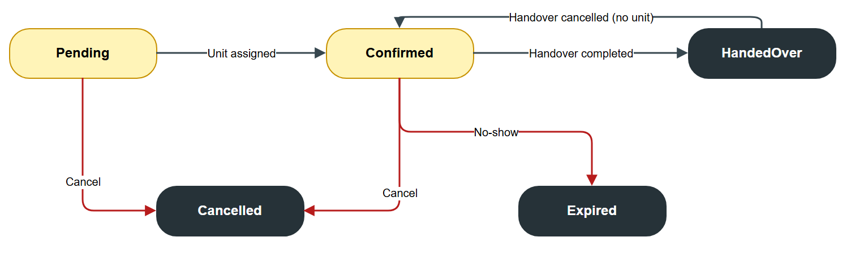
Figure 6. Reservation states
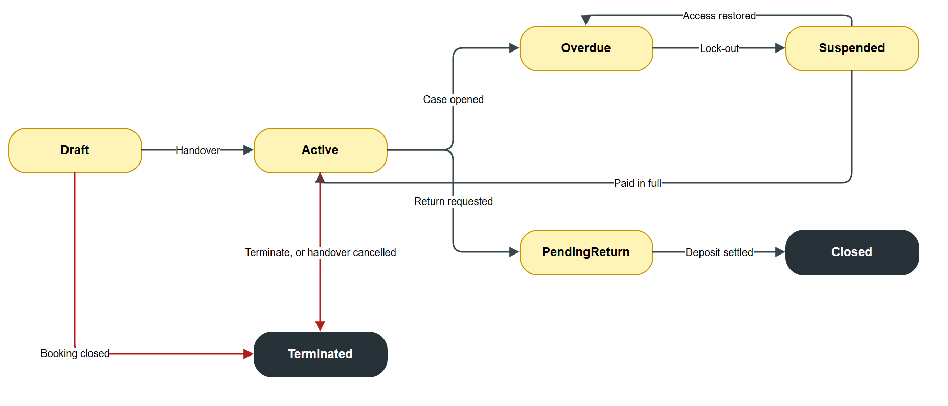
Figure 7. Contract states
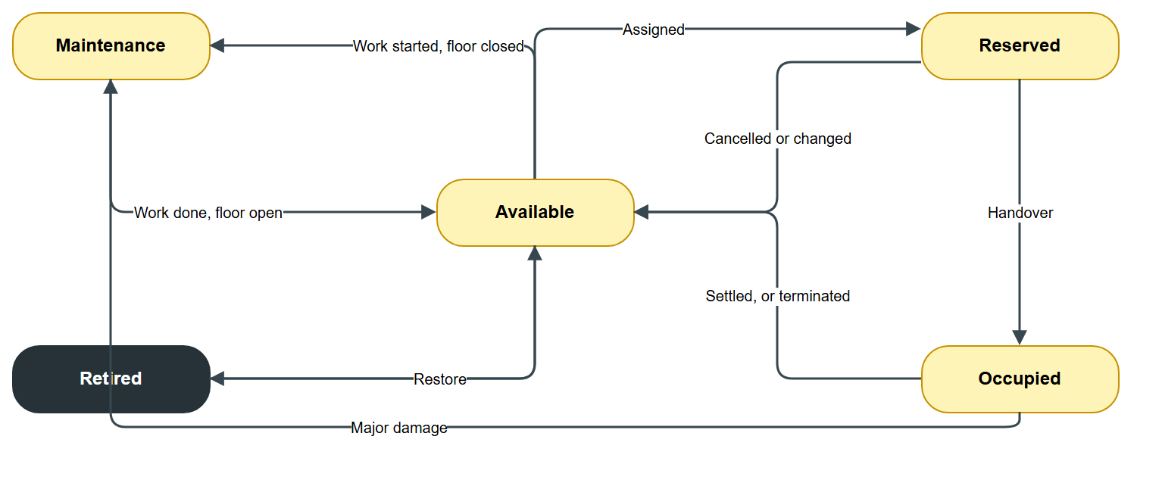
Figure 8. Storage unit states
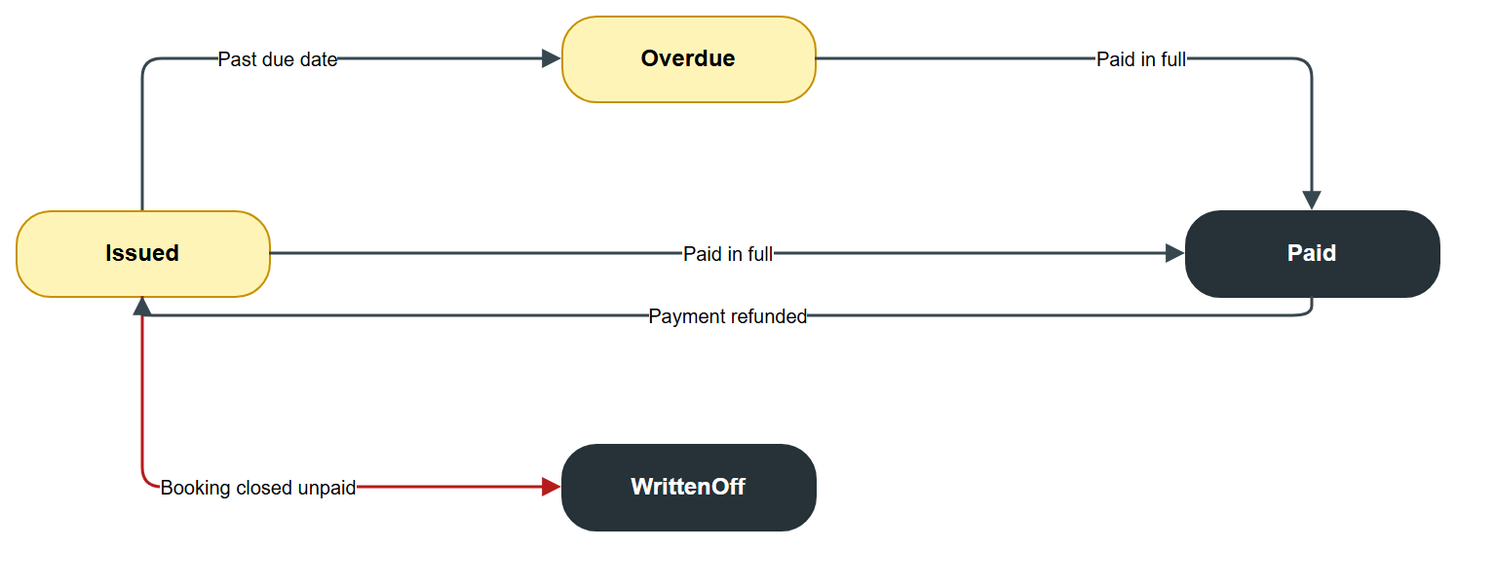
Figure 9. Invoice states
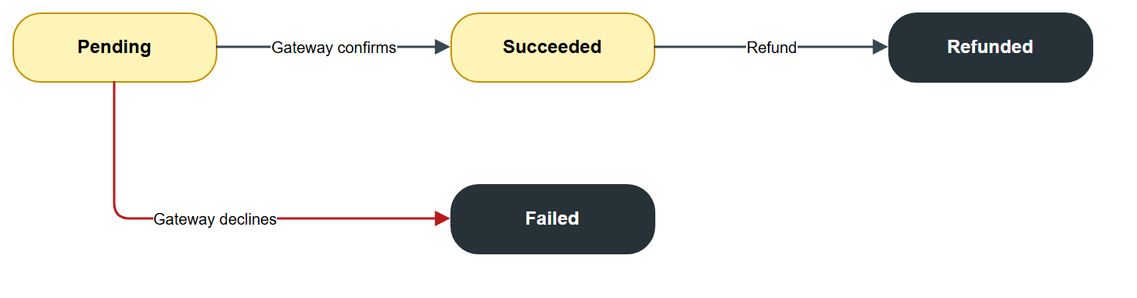
Figure 10. Payment states
Figure 11. Unit return states
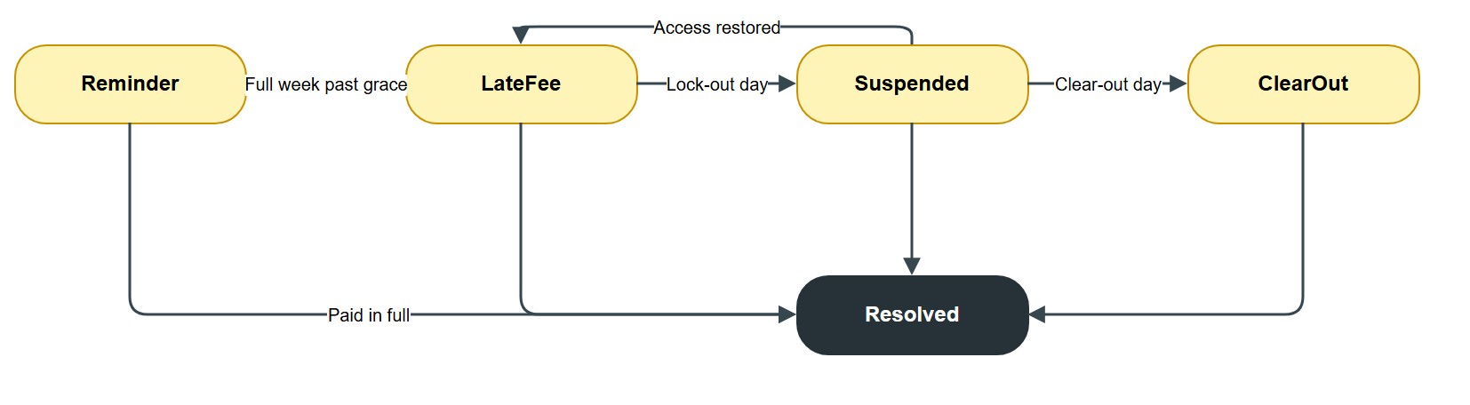
Figure 12. Overdue case stage states
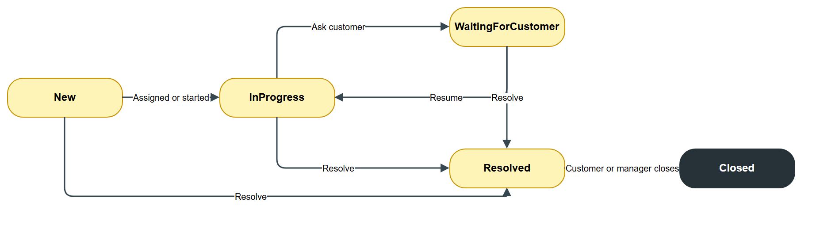
Figure 13. Support ticket states
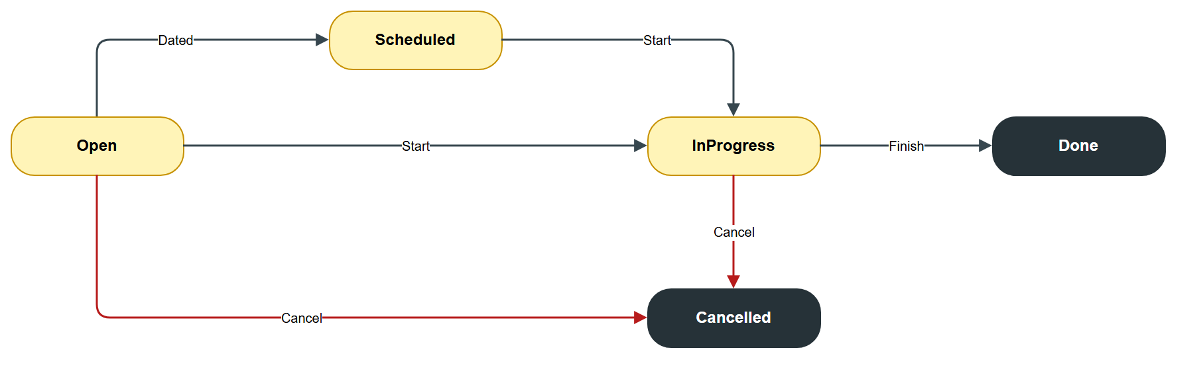
Figure 14. Maintenance order states

II. Functional Requirements

1. Account & Authentication (F01)

a. Register
- Function trigger: Visitor opens /register from Sign in or Book now.
- Function description: A visitor creates a customer account.
- Screen layout:
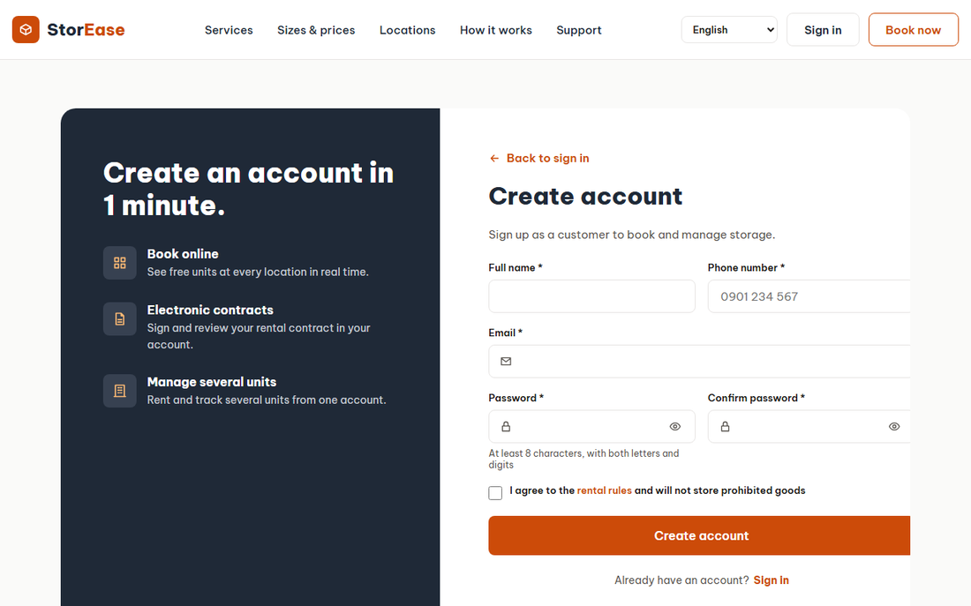
Figure 15. Register
- Function details:
  - Fields: full name, email, phone, password, confirm password, terms. All are required; the password must meet the strength rule.
  - A used email is refused with "An account with this email already exists."
  - With auto-verify on (Development) the user is Active at once. Otherwise the user is Pending and receives a link valid for 2 days.

b. Verify Email
- Function trigger: Customer opens the emailed link /verify-email.
- Function description: The customer proves they own the address.
- Function details:
  - An invalid or expired link shows an error. Opening a valid link twice is harmless.
  - A valid link changes the user from Pending to Active.
  - The resend-verification API exists, but no screen calls it yet.

c. Login
- Function trigger: Visitor opens /login, or a protected page redirects there.
- Function description: A customer signs in. Staff use the same logic at /admin/login.
- Screen layout:
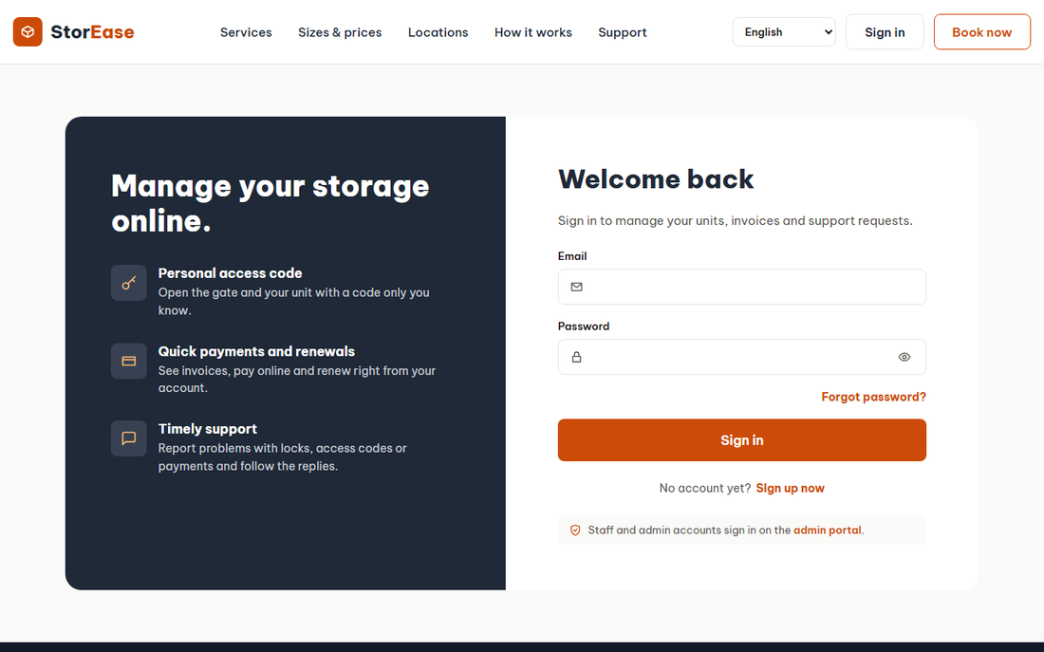
Figure 16. Login
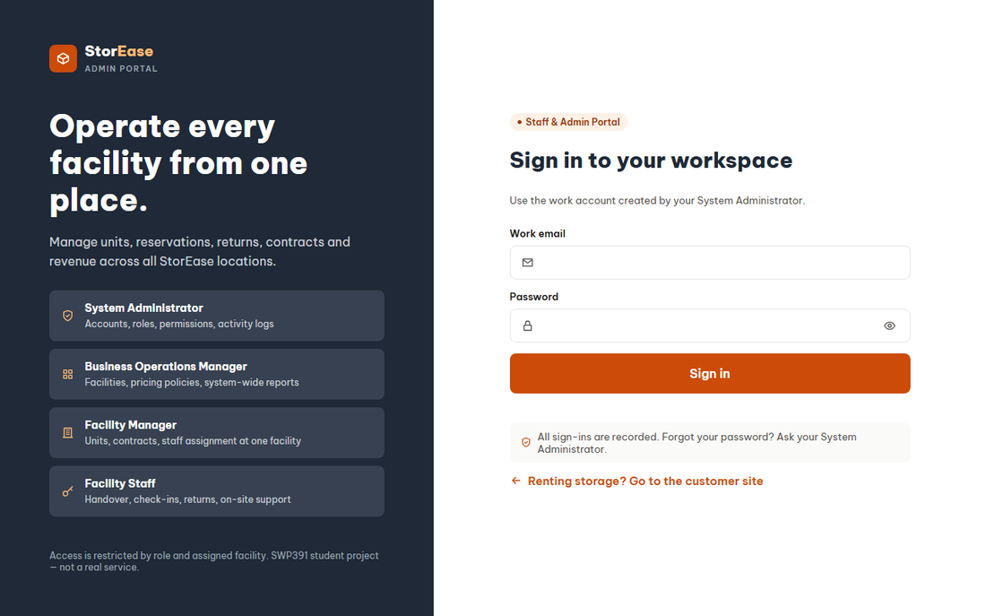
Figure 17. Login
- Function details:
  - Unknown email and wrong password show the same message, so accounts cannot be probed. Failed attempts on real accounts are logged.
  - Pending users are told to verify; Disabled users are refused.
  - Success issues a JWT and an HttpOnly session cookie and records LOGIN in the activity log.

d. Forgot and Reset Password
- Function trigger: Link on the sign-in page; emailed link /reset-password.
- Function description: A user sets a new password through their mailbox.
- Screen layout:
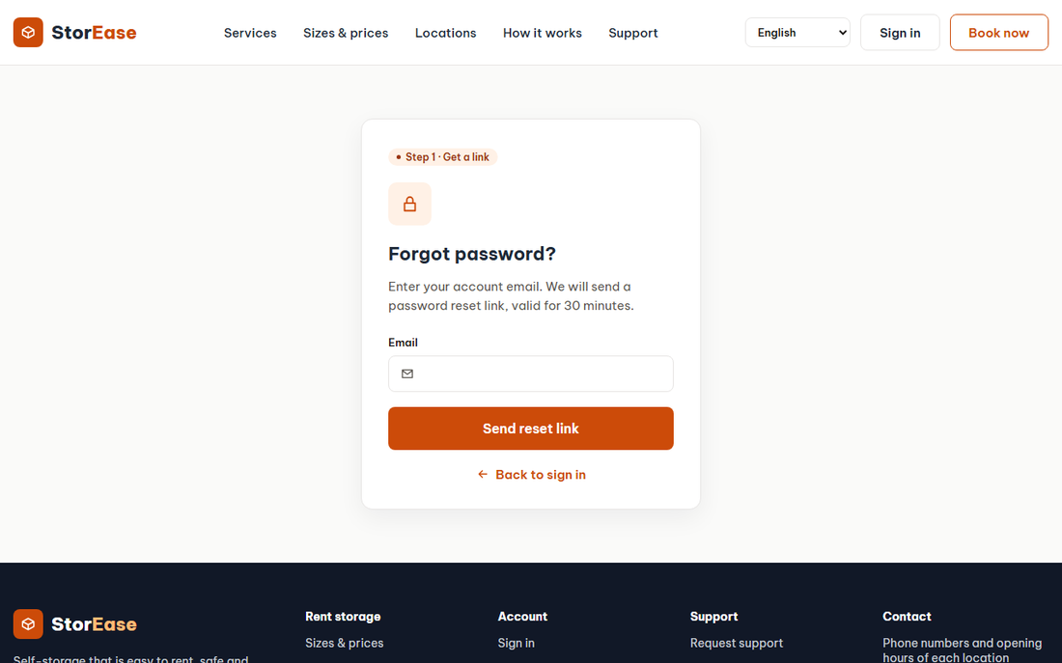
Figure 18. Forgot and Reset Password
- Function details:
  - The request always answers OK, so it cannot reveal which emails exist.
  - The reset link lasts 30 minutes and stops working once used.
  - Resetting also activates a Pending account. Walk-in customers use this to set their first password.

2. Profile & Settings (F02)

a. Manage Profile
- Function trigger: Account menu, Profile & settings (/profile).
- Function description: A signed-in user edits their own details, password and notifications.
- Screen layout:
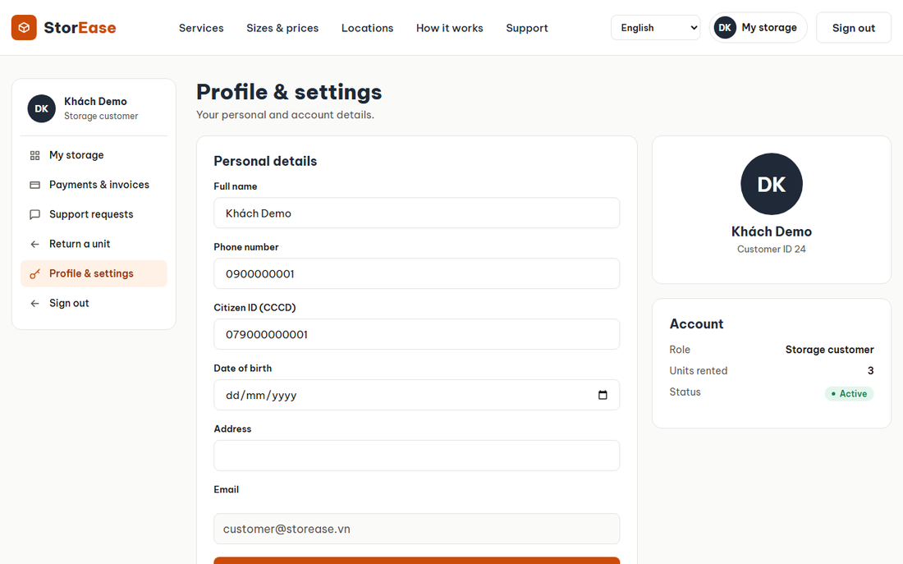
Figure 19. Manage Profile
- Function details:
  - Email is the sign-in name and cannot change. Phone must be 8 to 20 digits. Citizen ID must be 9 to 12 digits. Birth date must be in the past.
  - A new password needs the correct current password and must differ from it.
  - Notification switches: email reminders, SMS reminders, marketing. Billing skips scheduled reminders when email is off. Sending SMS is not built; the switch is only saved.

3. Browse (public pages)

a. Home
- Function trigger: Site root /.
- Function description: Introduces the service and starts a search.
- Screen layout:
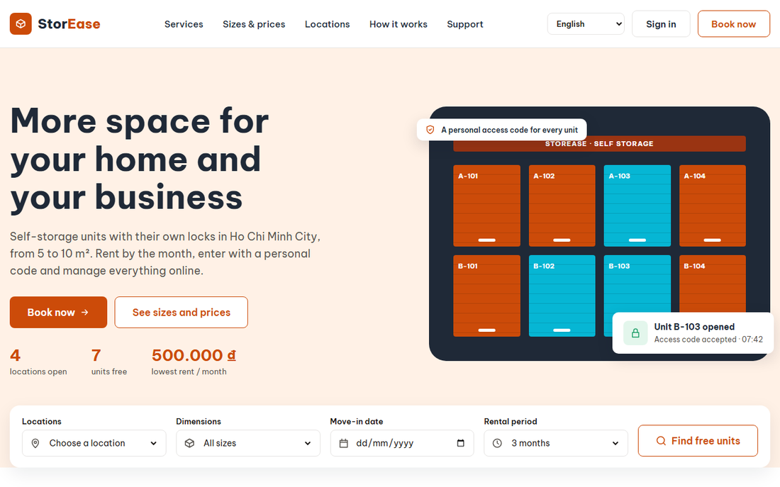
Figure 20. Home
- Function details:
  - Content is public. The search leads to the booking steps with its choices filled in.

b. Sizes & Prices
- Function trigger: Header menu.
- Function description: Compares unit types with live prices.
- Screen layout:
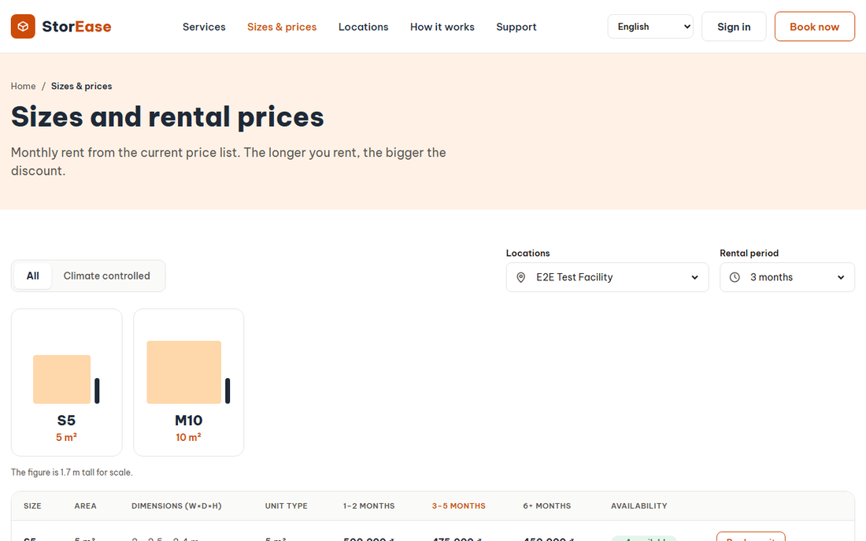
Figure 21. Sizes & Prices
- Function details:
  - Prices come from the price version in force. Discounts apply from 3, 6 and 12 months. Availability is shown per location.

c. Locations
- Function trigger: Header menu.
- Function description: Lists facilities on a list and map with free units, hours and phone.
- Screen layout:
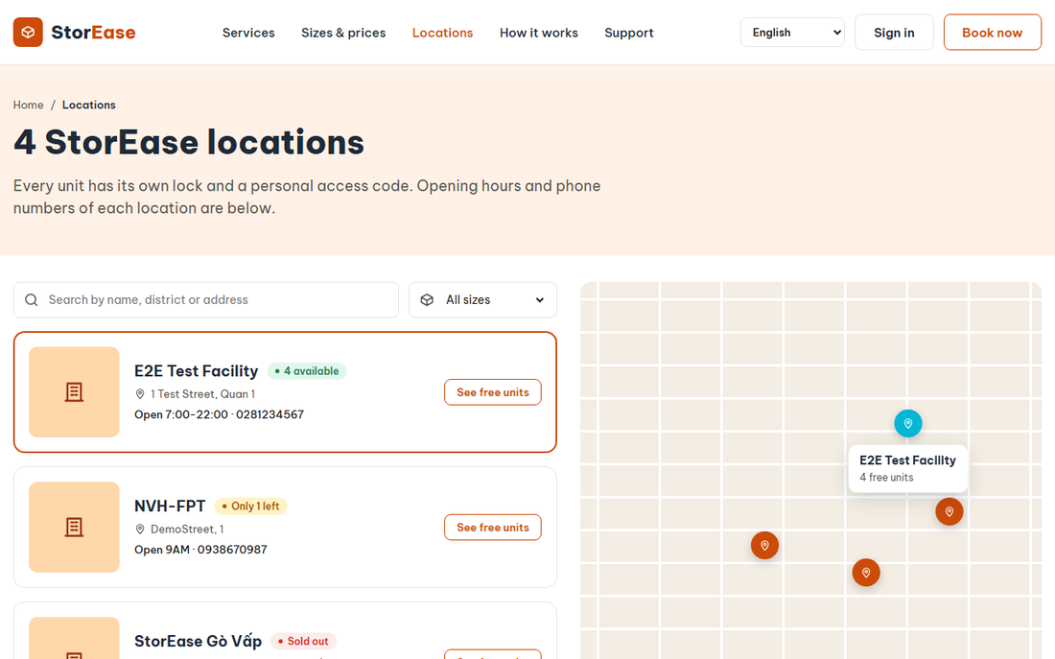
Figure 22. Locations
- Function details:
  - A facility with no free unit shows as sold out. Only Active facilities appear.

4. Reservation & Deposit (F03)

a. Choose Unit
- Function trigger: Book now, or /booking.
- Function description: A customer picks location, size, move-in date and rental period.
- Screen layout:
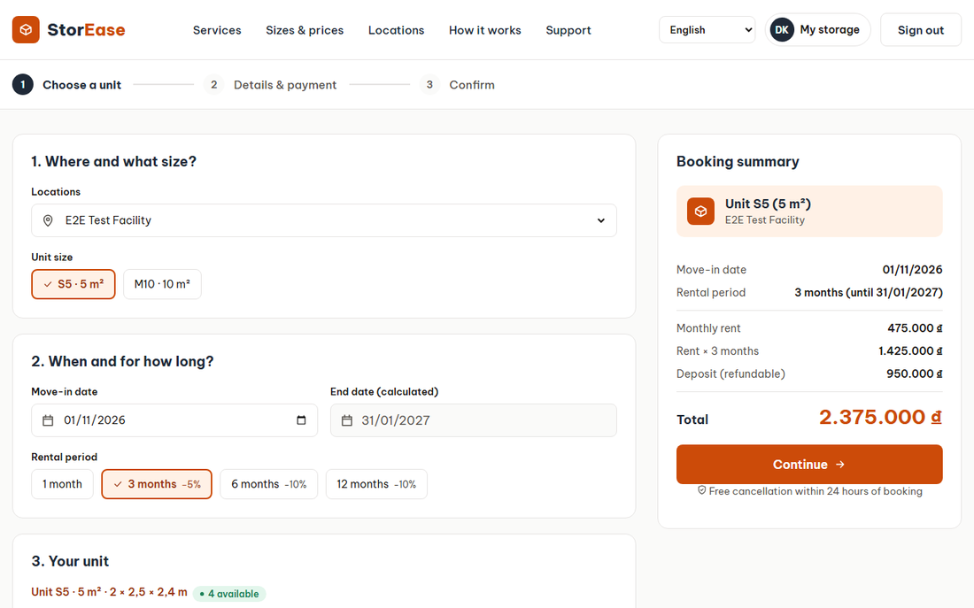
Figure 23. Choose Unit
- Function details:
  - The period can be 1 to 36 months; the screen offers 1, 3, 6 and 12. The summary shows rent, deposit and total.
  - Move-in date cannot be in the past.

b. Booking Details
- Function trigger: Continue from Choose Unit; sign-in required.
- Function description: The customer reviews the rules and confirms.
- Screen layout:
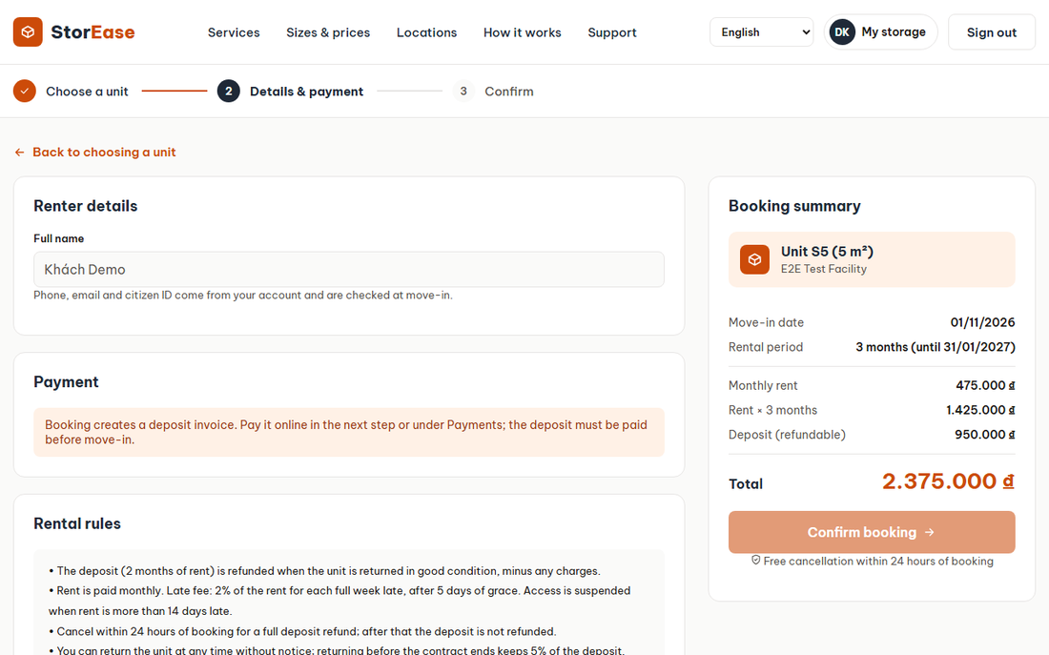
Figure 24. Booking Details
- Function details:
  - Refused when the facility is inactive or has no staff, or no unit of that type is available.
  - On success the reservation is Pending, the price version is pinned, and a deposit invoice is issued, due on the move-in date. An email confirms it.
  - Booking does not hold a specific unit; staff assign one.

c. Cancel Booking
- Function trigger: Cancel button on the customer booking or staff Reservations.
- Function description: The customer or staff close a Pending or Confirmed booking.
- Function details:
  - The reservation becomes Cancelled, a held unit returns to Available, and a Draft contract is Terminated.
  - An unpaid deposit invoice is WrittenOff. A paid deposit is refundable when staff cancel, or when the customer cancels within the free-cancellation hours; a refund becomes Pending. Otherwise it is forfeited.
  - The customer is told first whether the deposit comes back.

d. Reservations Queue
- Function trigger: Staff menu, Reservations.
- Function description: Staff see bookings, assign units, cancel, and mark no-shows.
- Screen layout:
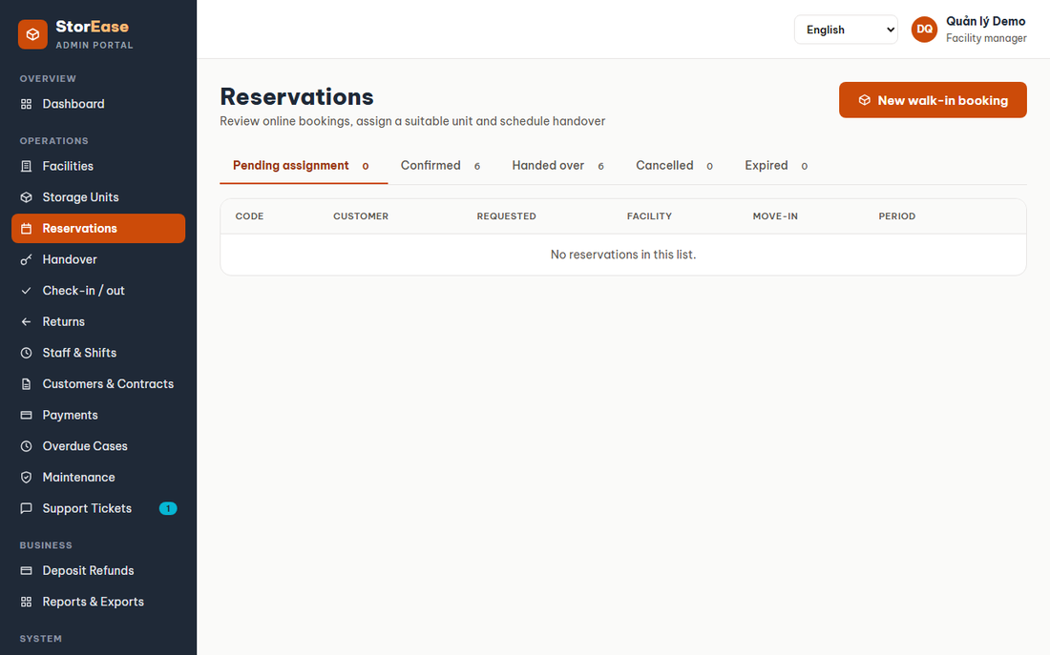
Figure 25. Reservations Queue
- Function details:
  - No-show is allowed only after the move-in date. The reservation becomes Expired and the deposit is forfeited.
  - Staff see only their facilities.

e. Walk-in Booking
- Function trigger: Reservations, New walk-in booking (/admin/walk-in).
- Function description: Staff book for a customer at the desk.
- Screen layout:
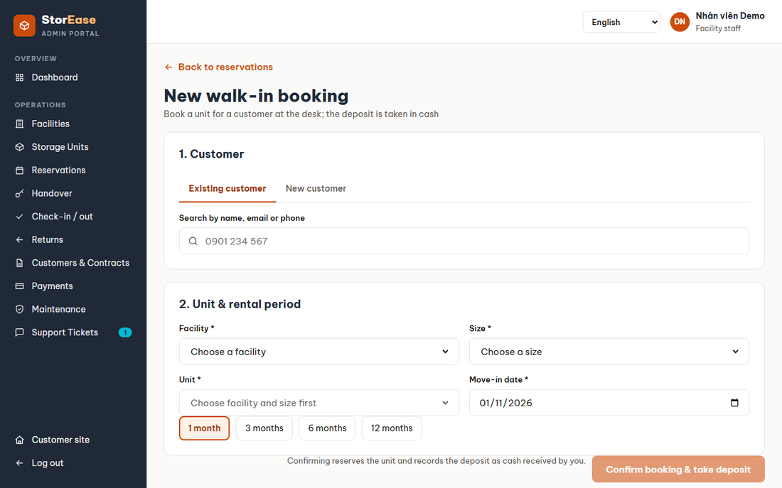
Figure 26. Walk-in Booking
- Function details:
  - Staff choose an existing customer or enter a new one. A new customer gets an Active account with a random password.
  - The chosen unit must be Available with no open contract.
  - The reservation is Confirmed at once, the unit Reserved, and the deposit is recorded as cash paid.

5. Unit Assignment (F04)

a. Assign Unit
- Function trigger: Reservations queue, Assign unit.
- Function description: Staff give a booking a real unit.
- Function details:
  - Allowed for a Pending booking, or a Confirmed one with no unit after a cancelled handover.
  - The unit must match facility and type, be Available and have no Active or Draft contract.
  - The reservation becomes Confirmed, the unit Reserved, and the customer gets an email.

b. Change Unit
- Function trigger: Handover desk, Show another unit.
- Function description: The customer saw the unit and wants another of the same size.
- Function details:
  - The new unit must be the same size at the same facility and Available.
  - The old unit returns to Available. A Draft contract moves to the new unit and its signature is cleared.

6. Contract & Customer (F05)

a. Draft Contract
- Function trigger: Handover desk, Draft the contract.
- Function description: Staff create the contract.
- Screen layout:
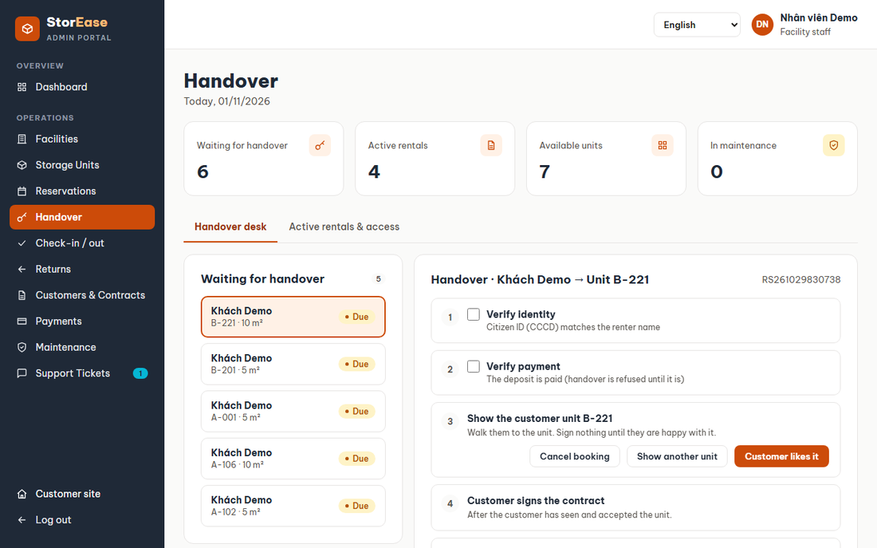
Figure 27. Draft Contract
- Function details:
  - Needs a Confirmed reservation with a unit. Payment day is 1 to 28.
  - Rent and deposit come from the pinned price version. End date = move-in date + months - 1 day.
  - Only one Active or Draft contract may exist per unit; a filtered unique index enforces it.

b. Sign Contract
- Function trigger: Unit page for the customer; Handover desk for paper.
- Function description: The customer signs online, or staff record a paper signature.
- Screen layout:
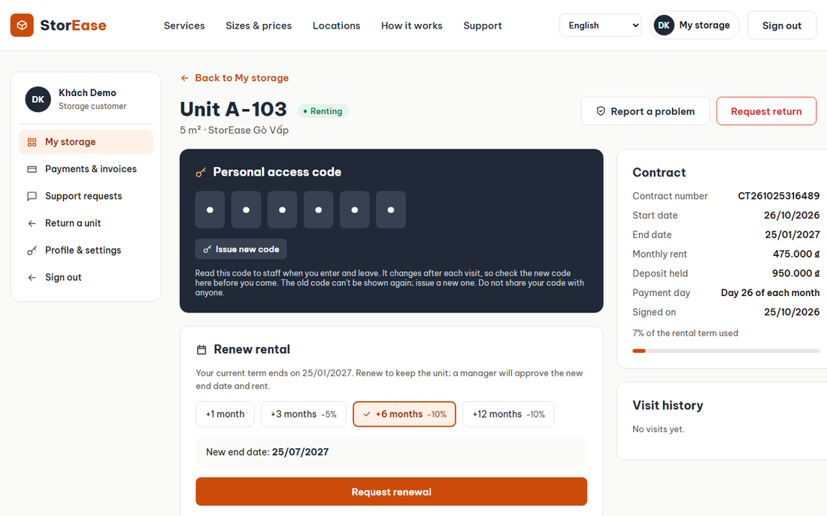
Figure 28. Sign Contract
- Function details:
  - Only a Draft contract can be signed, once. Signing records the time and does not activate the contract.

c. Customers & Contracts
- Function trigger: Staff menu.
- Function description: Staff list contracts, export them, decide renewals, and terminate.
- Screen layout:
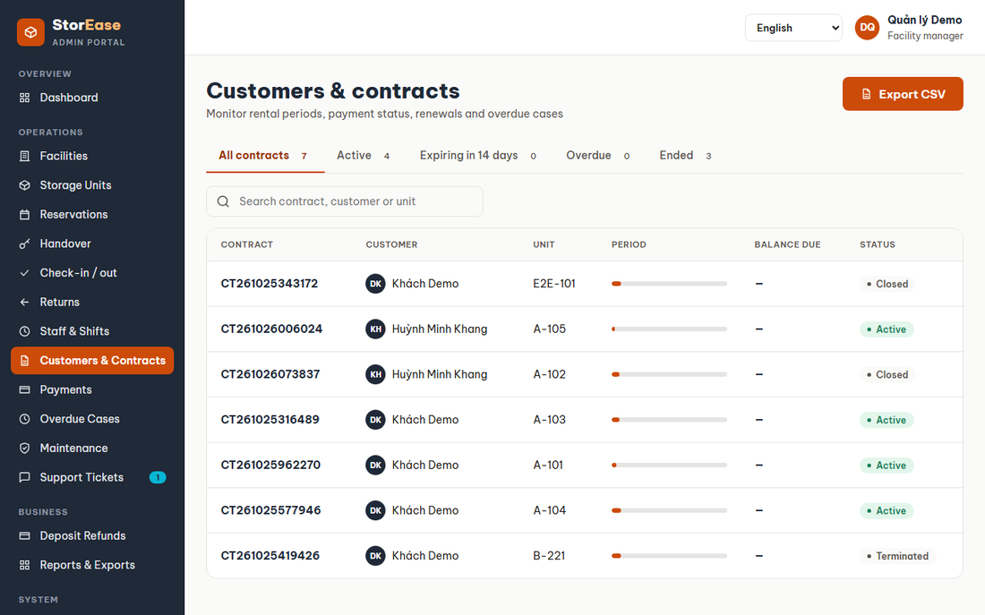
Figure 29. Customers & Contracts
- Function details:
  - The export is CSV; spreadsheet formula characters in text are neutralised.
  - Only a Facility Manager can terminate, and not a Draft, Closed or Terminated contract. Termination stops codes and frees an Occupied unit.

d. Customer Detail
- Function trigger: Link from a contract (/admin/customers/:id).
- Function description: Shows one customer's totals, contracts, reservations, payments and tickets.
- Screen layout:
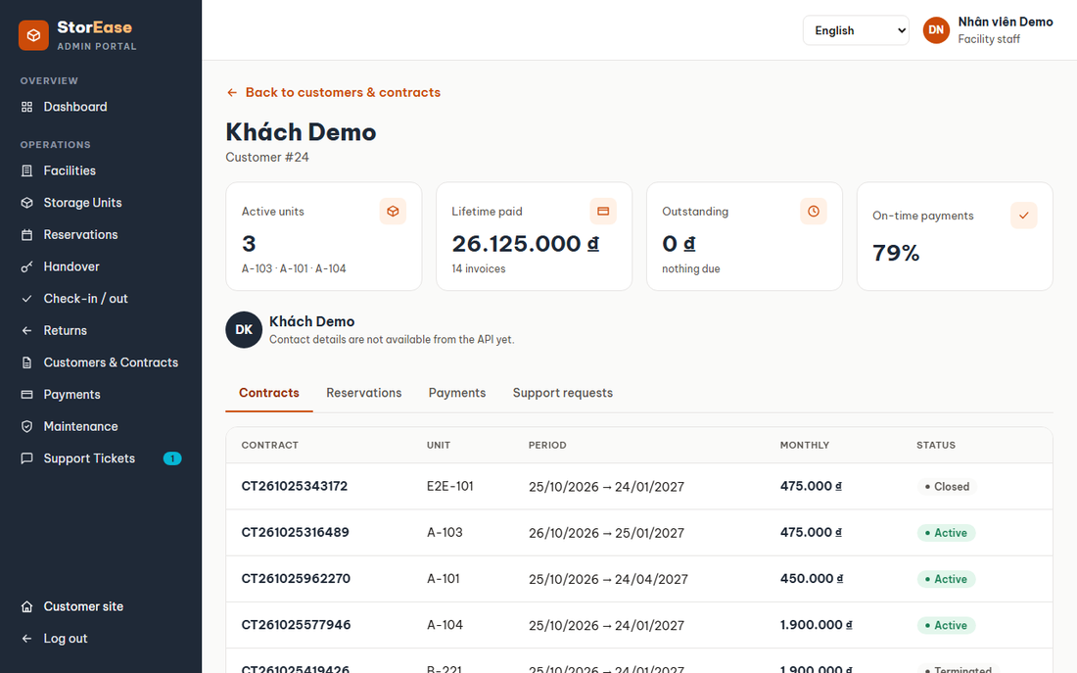
Figure 30. Customer Detail
- Function details:
  - Known gap: the page still says contact details are not available, although the API now returns them.

7. Handover & Access (F06)

a. Handover Desk
- Function trigger: Staff menu, Handover.
- Function description: Staff complete the handover that starts the rental.
- Screen layout:
Figure 31. Handover Desk
- Function details:
  - Checks: identity, deposit, unit reserved, contract, signature. The move-in date is informative; early handover is allowed.
  - Refused while the deposit is unpaid or the contract unsigned.
  - Success: Handover Completed, Reservation HandedOver, Unit Occupied, Contract Active, a 6-digit code issued, and the first visit opened.
  - Condition photos are supported by the API, but no screen uploads them yet.

b. Cancel Handover
- Function trigger: Handover, Active rentals & access.
- Function description: Staff undo a handover made by mistake.
- Function details:
  - Allowed only while the contract is Active. The contract is Terminated, codes stop, the unit is Available, and the reservation returns to Confirmed with no unit.

c. Check-in / out
- Function trigger: Staff menu (/admin/check-in).
- Function description: Staff record visits at the desk.
- Screen layout:
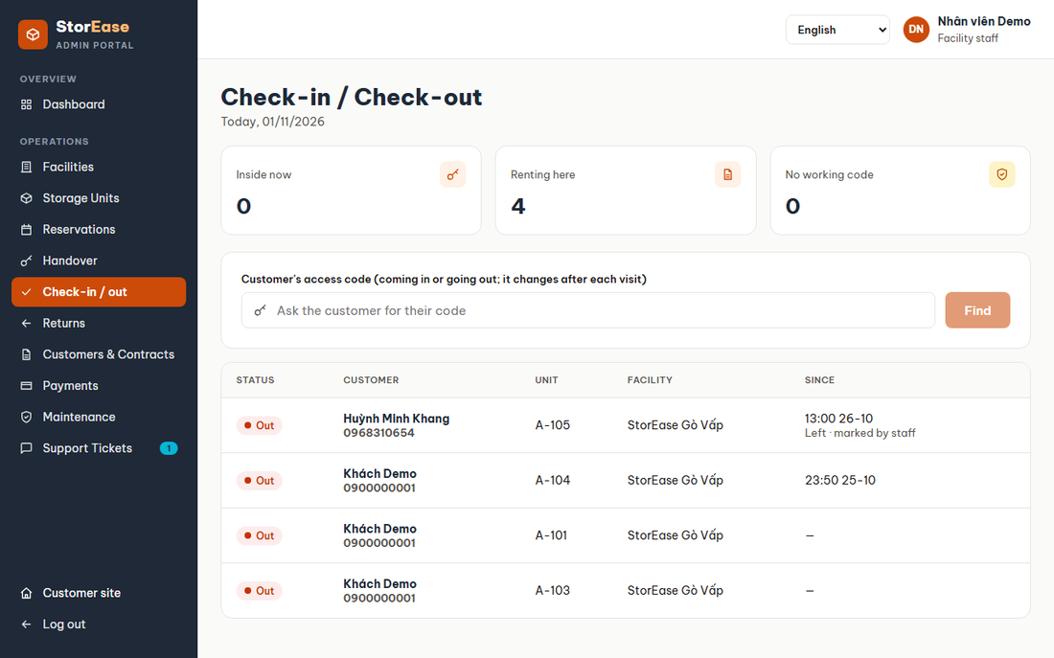
Figure 32. Check-in / out
- Function details:
  - The customer says the code and staff find them. A code that does not match, or matches two renters, gives a clear message.
  - A customer with no working code cannot enter, and one already inside must leave first.
  - Mark left records the time and reason for a forgotten check-out; the time cannot be in the future or before arrival.
  - Each finished visit issues a new code, unless the code is locked.

d. Close Visits at Closing Time
- Function trigger: Hourly job (non-screen).
- Function description: The system ends visits nobody checked out.
- Function details:
  - Each open visit ends at the facility's first closing time after arrival, read from its opening hours, or 23:59 without them.

e. Manage Access Code
- Function trigger: Unit page for the customer; Active rentals for staff.
- Function description: The customer asks for a new code; staff revoke one.
- Function details:
  - A new code replaces the old one and needs an Active contract. Codes expire the day after the contract ends.
  - Only the renter can read the digits. Codes are stored as a hash and AES-GCM encrypted text, and are unique per facility.

8. Rent Payment (F07)

a. Payments & Invoices
- Function trigger: Account menu (/payments).
- Function description: The customer sees invoices, payments and refunds, and pays online.
- Screen layout:
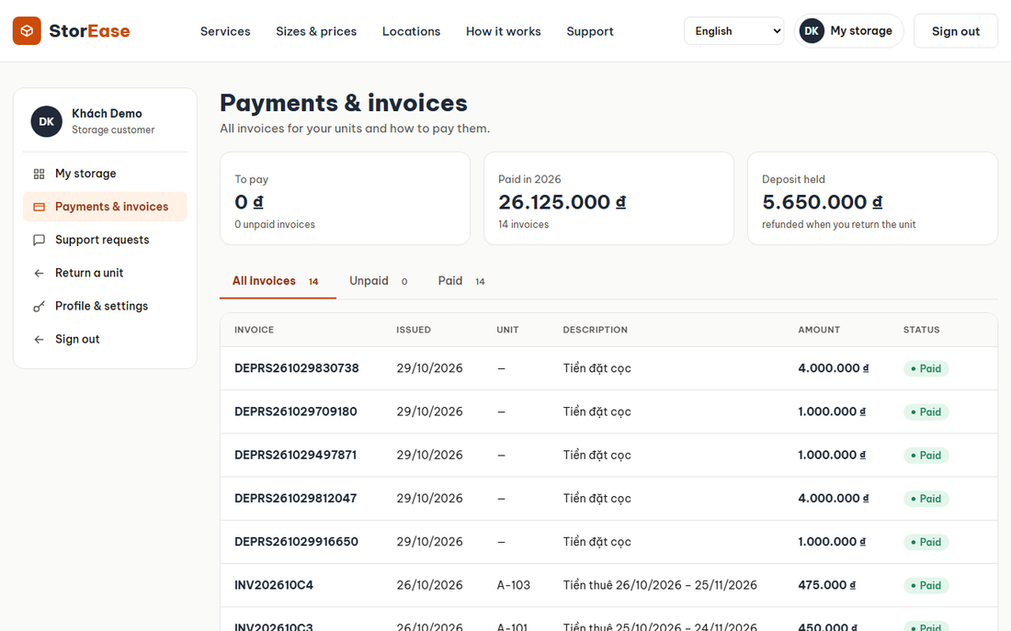
Figure 33. Payments & Invoices
- Function details:
  - The amount cannot exceed the balance. A Paid or WrittenOff invoice is closed.
  - A Pending payment is created first; nothing is credited until the gateway confirms.

b. VNPay Confirmation
- Function trigger: VNPay calls the IPN; the customer returns to /account/payments/vnpay-return.
- Function description: The system settles the payment from VNPay's signed answer.
- Function details:
  - A bad signature, unknown payment or wrong amount changes nothing. Repeated callbacks change nothing.
  - Money taken is always credited; an overpaid invoice is refunded by Business Operations.
  - Development uses a simulated success button.

c. Record Payment
- Function trigger: Staff menu, Payments.
- Function description: Staff record cash, and Business Operations adjust invoices and refund payments.
- Screen layout:
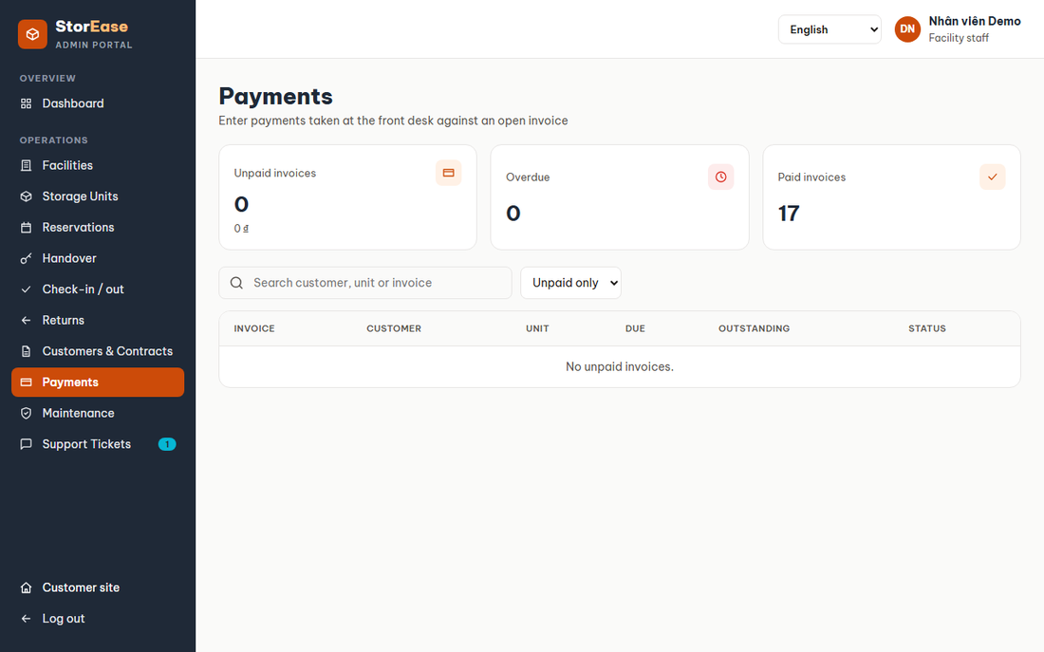
Figure 34. Record Payment
- Function details:
  - Cash succeeds at once. Paying in full closes the invoice and resolves its overdue case.
  - An adjustment cannot make the total negative or below the amount paid.
  - A refund applies to a Succeeded payment and reopens the invoice for the balance.
  - A reminder can be sent by hand; the history is listed.

d. Pricing & Policies
- Function trigger: Staff menu (/admin/pricing).
- Function description: Business Operations and Admin manage price versions.
- Screen layout:
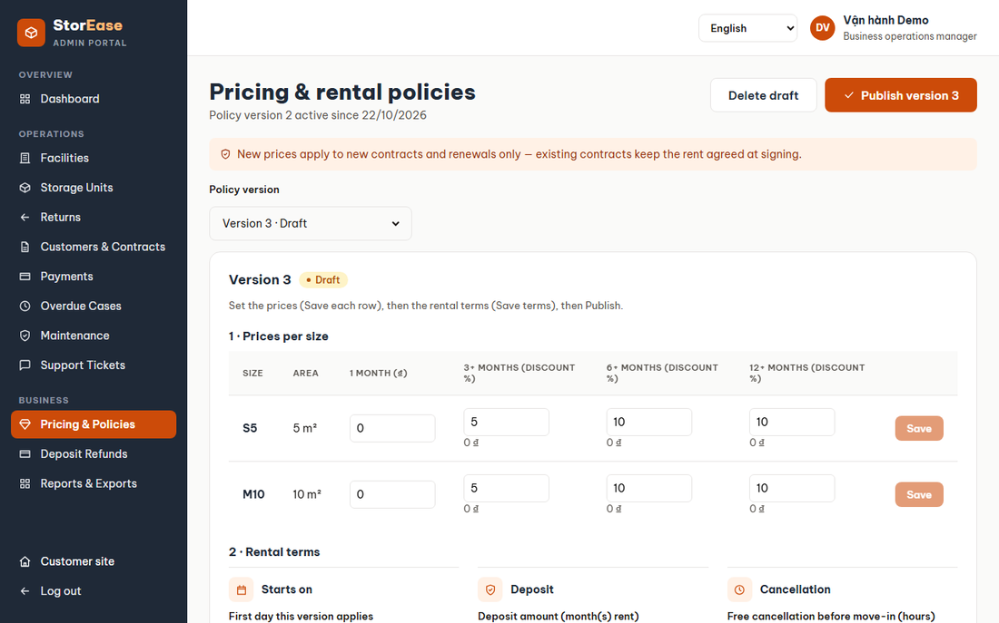
Figure 35. Pricing & Policies
- Function details:
  - Copy any version to a Draft, edit prices, dates and terms, then publish it.
  - Only a Draft can be edited or deleted. Publishing needs a reached start date and at least one price, and is refused if a later active version exists.
  - Bookings and contracts keep their pinned version. The fee-type API exists, but the screen only displays fees.

9. Billing Automation & Overdue (F08)

a. Billing Job
- Function trigger: Hourly job (non-screen); also POST /api/billing/run, which has no screen.
- Function description: The system issues invoices and escalates unpaid rent. Running it twice in a day changes nothing.
- Function details:
  - Rent invoices appear 7 days before due, on the contract's payment day.
  - An unpaid invoice past due becomes Overdue. A deposit only blocks the handover.
  - After the grace days a case opens at Reminder and the contract becomes Overdue.
  - Late fee = rent x weekly percent x full weeks past grace, on one growing line.
  - On the lock-out day codes are suspended and the contract becomes Suspended. On the clear-out day the case moves to ClearOut; the contract stays open.
  - Reminders go 3 days before due, the day after, then weekly, to customers who opted in.

b. Overdue Cases
- Function trigger: Staff menu (/admin/overdue).
- Function description: Managers and Business Operations follow cases.
- Screen layout:
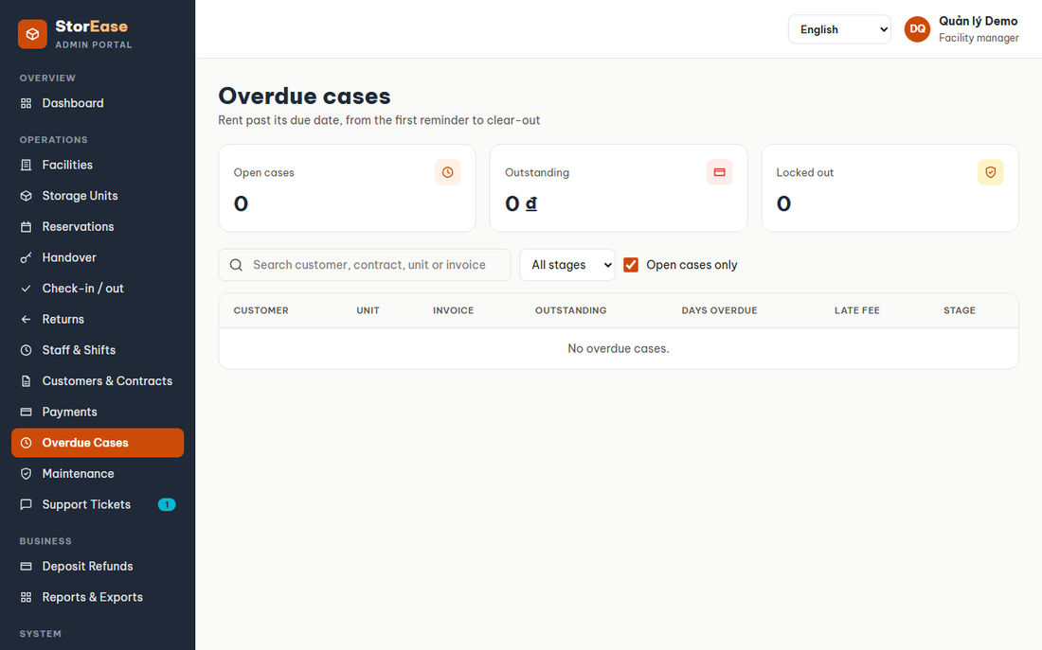
Figure 36. Overdue Cases
- Function details:
  - Lock out early from Reminder or LateFee.
  - Restore access keeps the case at LateFee, and the job will not lock it again.
  - Paying in full resolves the case; with no other open case the contract returns to Active and suspended codes work.

10. Renewal (F09)

a. Request Renewal
- Function trigger: Unit page, Renew rental.
- Function description: The customer asks to extend by 1 to 36 months.
- Function details:
  - Needs an Active contract with no renewal waiting. The new rent uses the active price and its discount.
  - The contract does not change until approved.

b. Decide Renewal
- Function trigger: Customers & Contracts, Renewals.
- Function description: A Facility Manager or Business Operations approve or reject.
- Function details:
  - Approval needs the contract still Active. It sets the new end date and rent, and moves the code expiry. Billing issues the extra months.
  - The new rent applies to every month not yet billed. Rejection leaves the contract as it is.

11. Move-out & Settlement (F10)

a. Request Return
- Function trigger: Account menu (/return).
- Function description: The customer asks to hand a unit back.
- Screen layout:
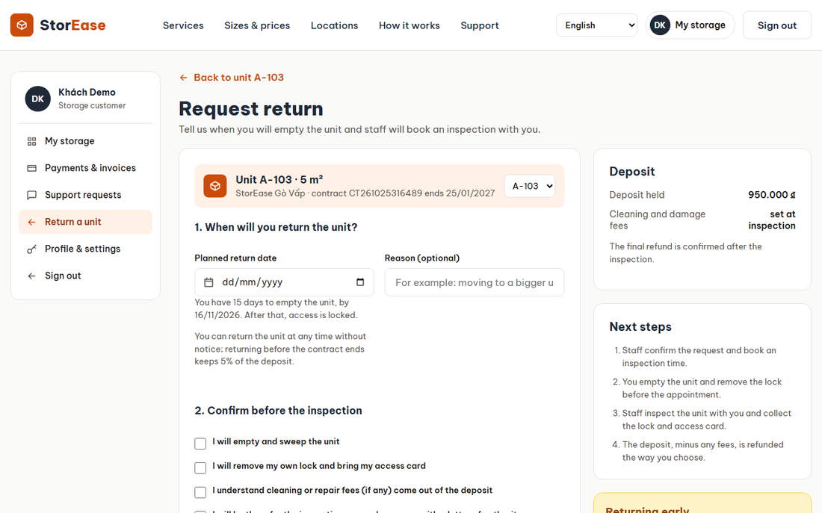
Figure 37. Request Return
- Function details:
  - Needs an Active contract with no open return. The date must be from today to 15 days ahead.
  - Includes reason, refund method and account. The contract becomes PendingReturn, and the deadline is today + 15 days.

b. Returns
- Function trigger: Staff menu (/admin/returns).
- Function description: Staff approve and inspect; Business Operations settle.
- Screen layout:
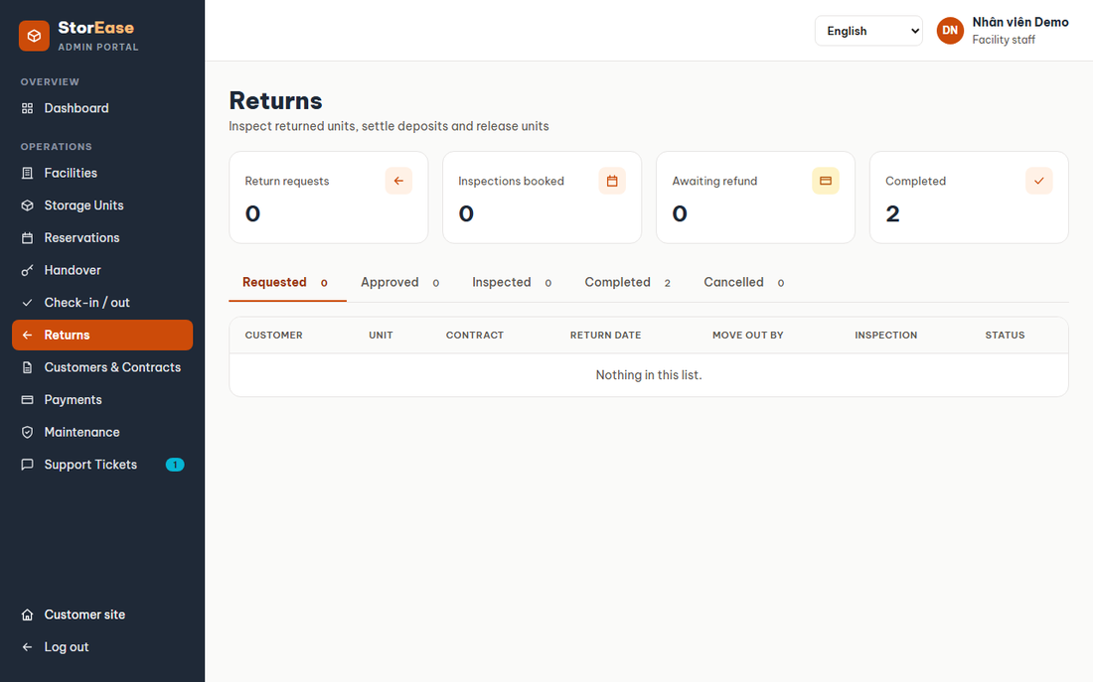
Figure 38. Returns
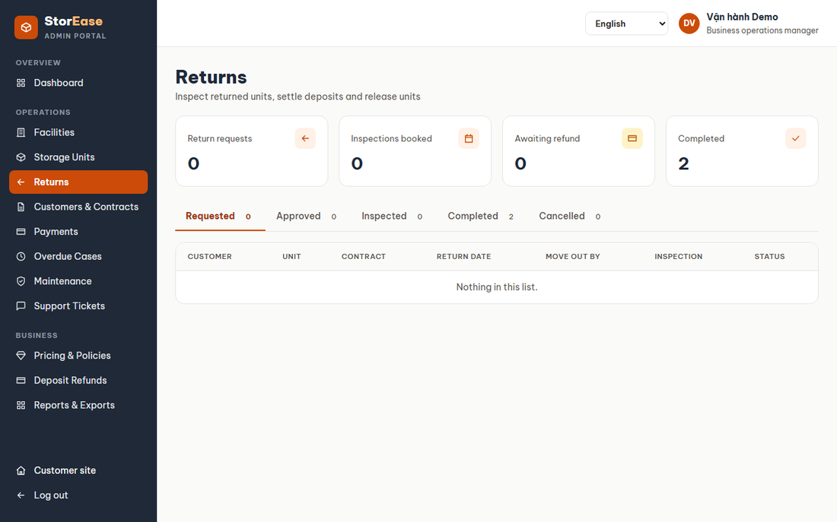
Figure 39. Returns
- Function details:
  - Approve sets an inspection slot. Inspection records condition, cleaning, repair and other charges.
  - Settlement: refund = deposit - damage - penalty - unpaid invoices, never below 0. The penalty applies to a return before the end date, at the rate of the contract's price version.
  - Settlement closes the contract and stops codes. The unit becomes Available, or Maintenance after major damage.

c. Lock After Deadline
- Function trigger: Hourly job (non-screen).
- Function description: A return not inspected after its deadline loses access.
- Function details:
  - Codes stop and staff clear the unit, then inspect and settle as usual.

d. Deposit Refunds
- Function trigger: Staff menu (/admin/deposit-refunds).
- Function description: Business Operations pay refunds owed from cancellations and returns.
- Screen layout:
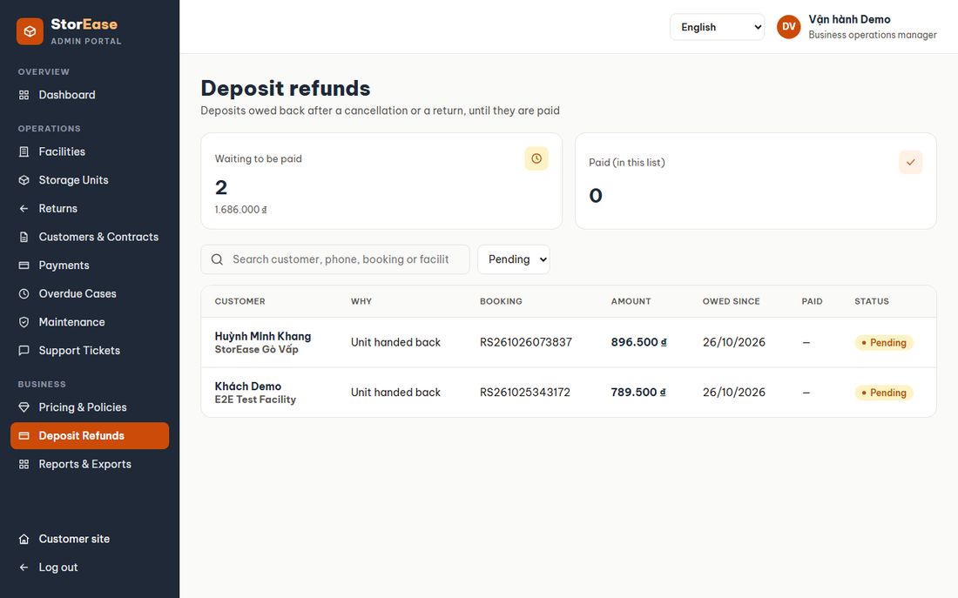
Figure 40. Deposit Refunds
- Function details:
  - Oldest first. A bank transfer needs its reference. A refund can be marked Paid only once. The customer sees it on Payments.

12. Facility & Unit Setup (F11)

a. Dashboard
- Function trigger: First page after staff sign-in (/admin).
- Function description: Shows occupancy, revenue, today's schedule and items needing attention.
- Screen layout:
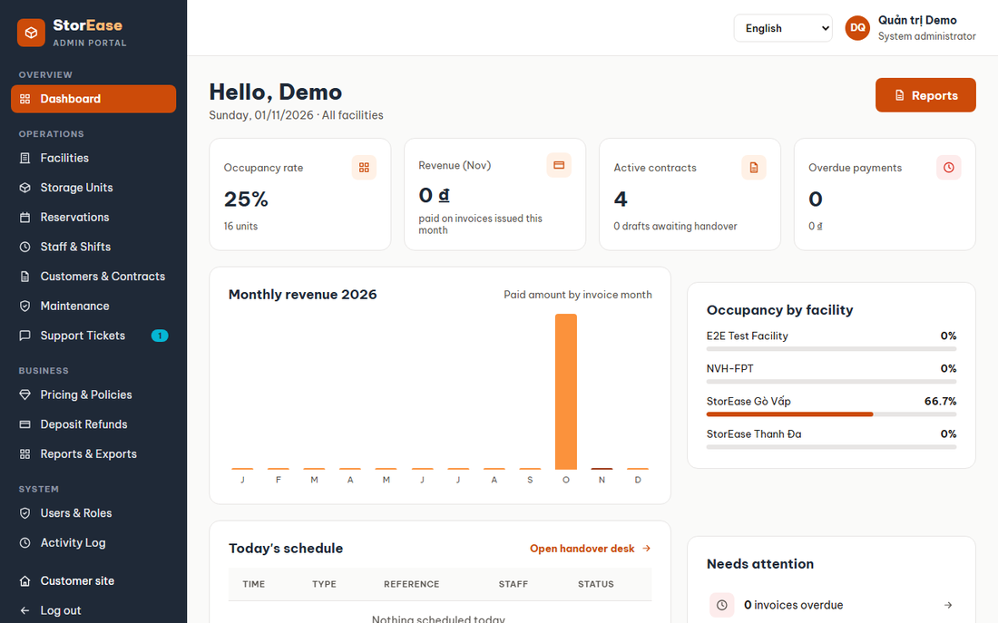
Figure 41. Dashboard
- Function details:
  - Lists refresh every 15 seconds. A warning shows when nobody works at a facility.

b. Facilities
- Function trigger: Staff menu.
- Function description: Lists facilities with units and occupancy.
- Screen layout:
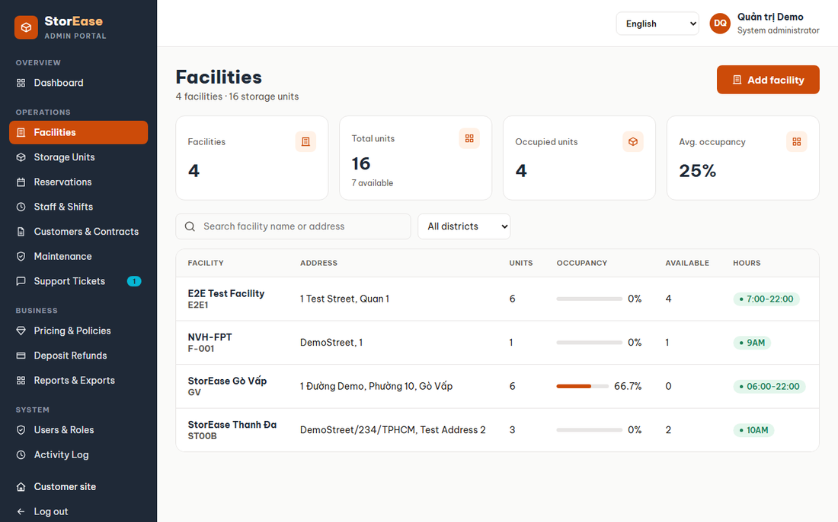
Figure 42. Facilities
- Function details:
  - Staff see their facilities. Only admins see inactive ones.

c. Add Facility
- Function trigger: Facilities, Add facility.
- Function description: An admin creates a facility.
- Screen layout:
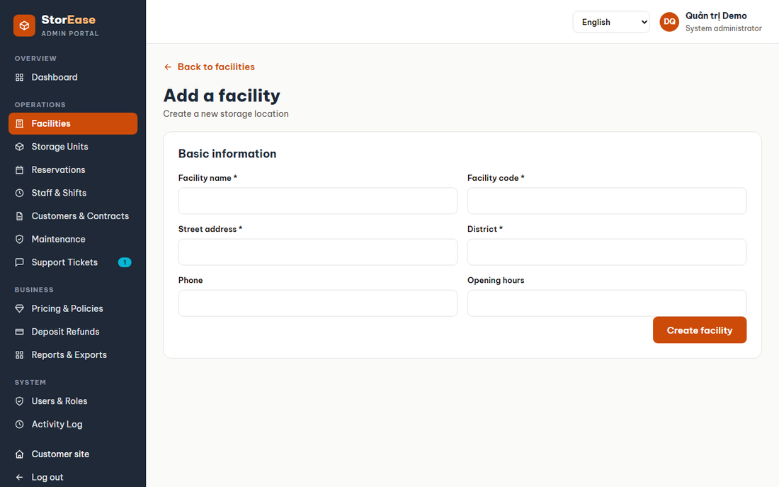
Figure 43. Add Facility
- Function details:
  - The code must be unique. The manager must be an active Facility Manager.
  - Customers can book only after staff are assigned.

d. Facility Detail
- Function trigger: A facility row.
- Function description: Manages floors, units, edit and activation.
- Screen layout:
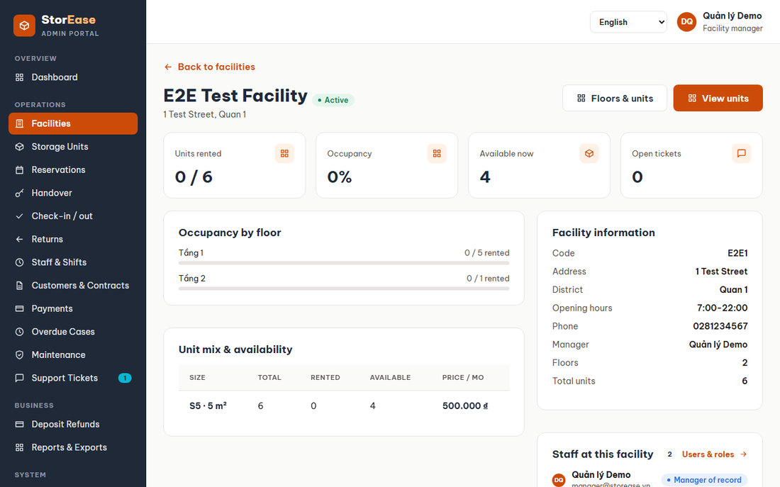
Figure 44. Facility Detail
- Function details:
  - Closing a floor takes its Available units off sale; reopening returns them. A floor holding customers cannot be removed.
  - Deactivation is refused while units are reserved or occupied, or bookings are open.

e. Storage Units
- Function trigger: Staff menu.
- Function description: Lists and filters units; edit, retire, restore.
- Screen layout:
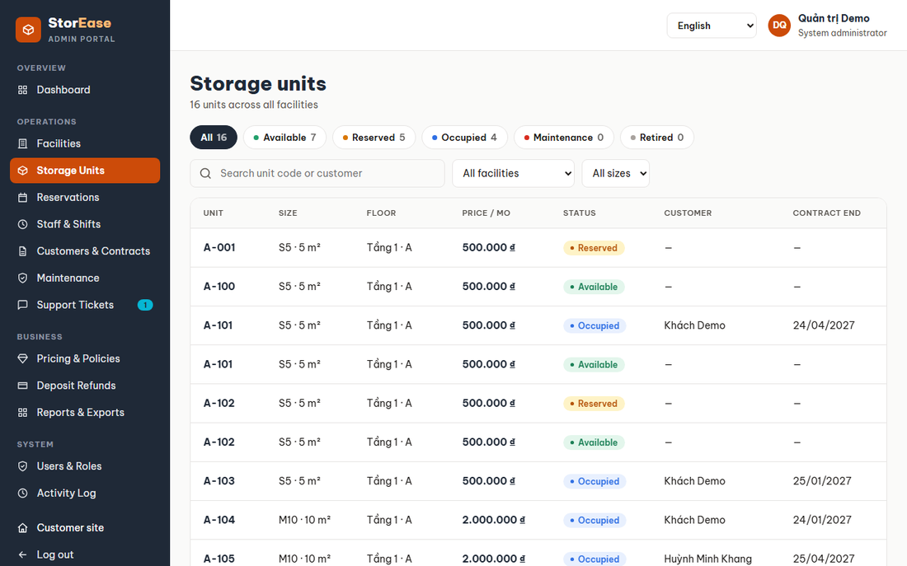
Figure 45. Storage Units
- Function details:
  - Type and floor can change only while Available. Only an Available unit can be retired.
  - The unit type API exists, but no screen uses it.

f. Maintenance
- Function trigger: Staff menu, or a ticket.
- Function description: Orders work on a unit.
- Screen layout:
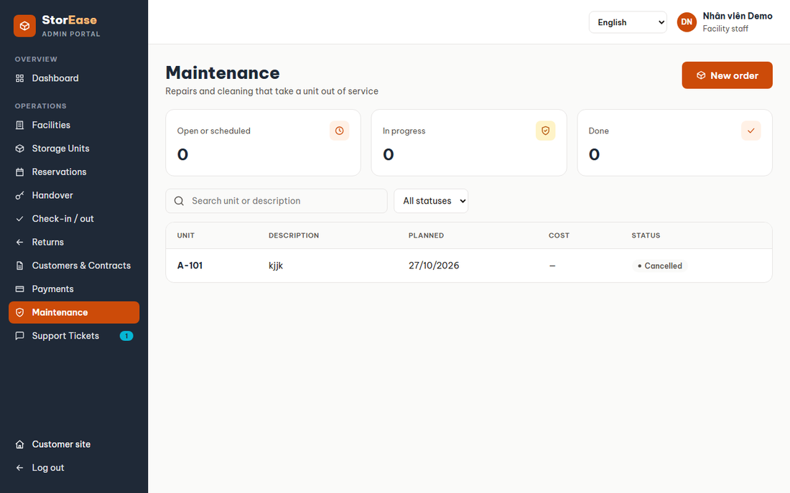
Figure 46. Maintenance
- Function details:
  - A unit a customer holds gets work only from that customer's open ticket.
  - Starting takes a free unit off the market. When work ends the unit returns to Available if no other live order exists and its floor is open.

13. User & Audit Admin (F12)

a. Users & Roles
- Function trigger: Staff menu (/admin/users).
- Function description: Shows staff accounts, facilities and the role permission matrix.
- Screen layout:
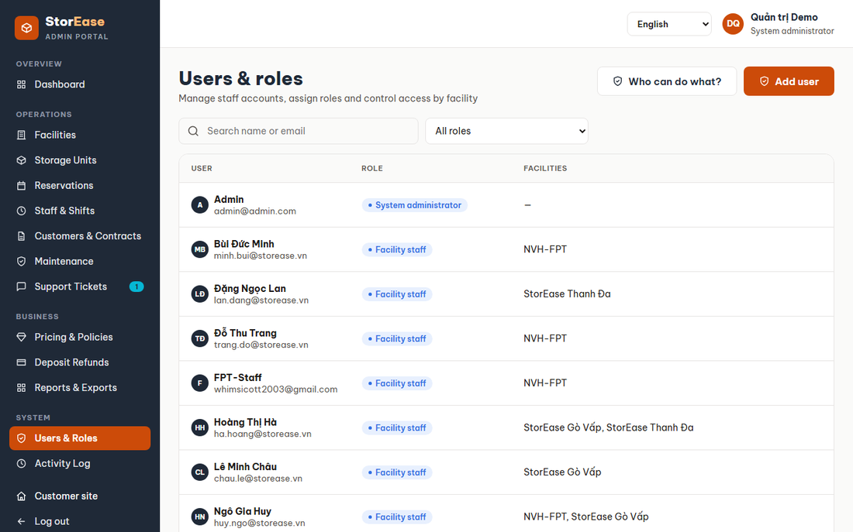
Figure 47. Users & Roles
- Function details:
  - An admin cannot disable or change their own account.
  - A manager can assign staff only at facilities they manage. A facility with open work cannot be unassigned.

b. Invite User
- Function trigger: Users & Roles, Add user.
- Function description: An admin creates a staff account.
- Screen layout:
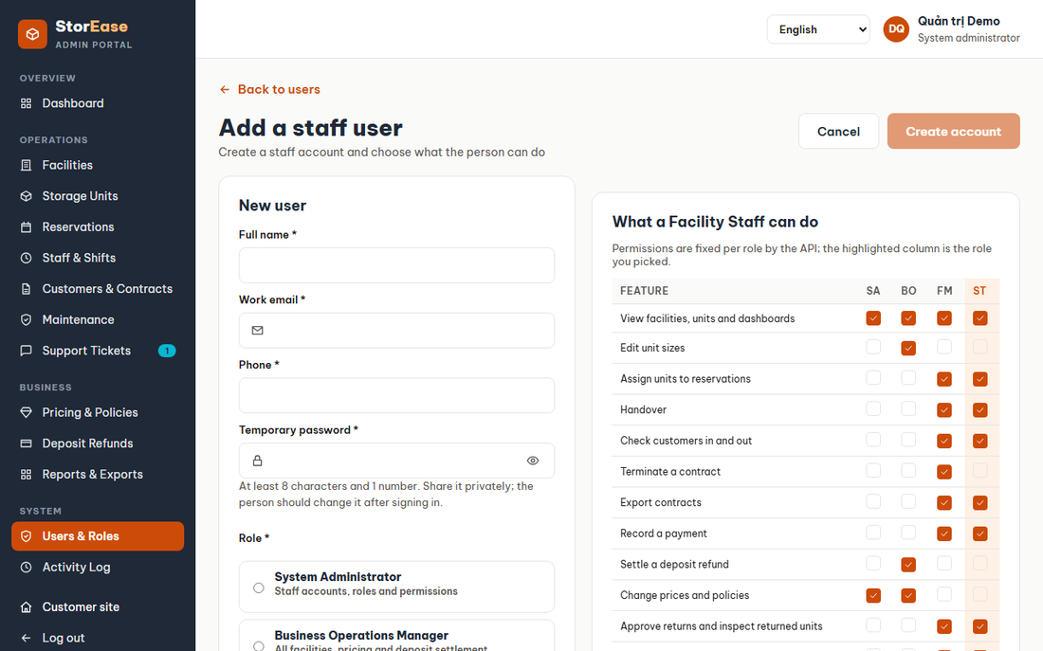
Figure 48. Invite User
- Function details:
  - The email must be unused. The account starts Active with a temporary password.

c. Activity Log
- Function trigger: Staff menu, admins only.
- Function description: Shows who did what, from where, and with what result.
- Screen layout:
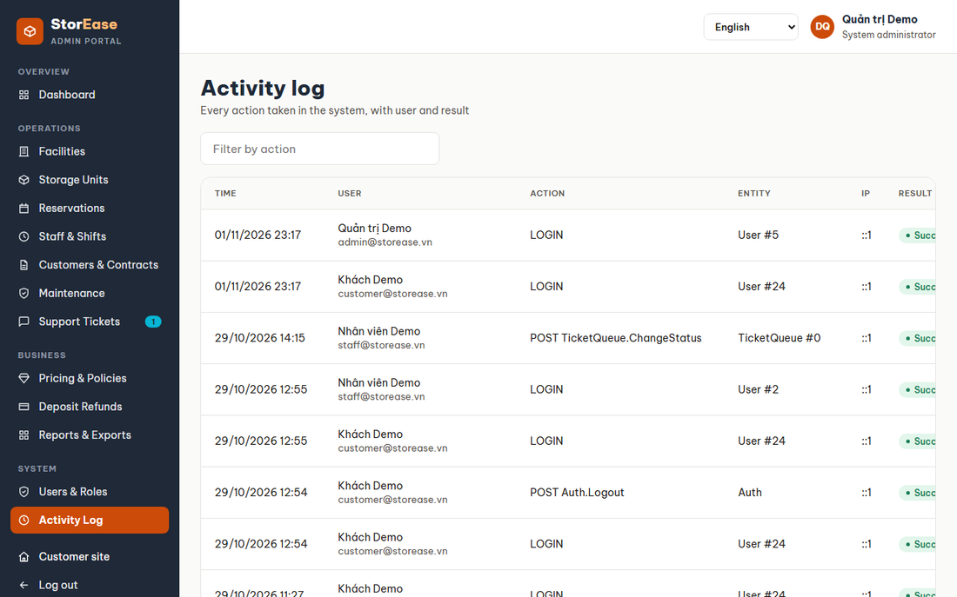
Figure 49. Activity Log
- Function details:
  - Every write by a signed-in user and each login is recorded. The screen shows the newest 100 entries.

14. Reports (F13)

a. Reports & Exports
- Function trigger: Staff menu (/admin/reports).
- Function description: Shows revenue and occupancy.
- Screen layout:
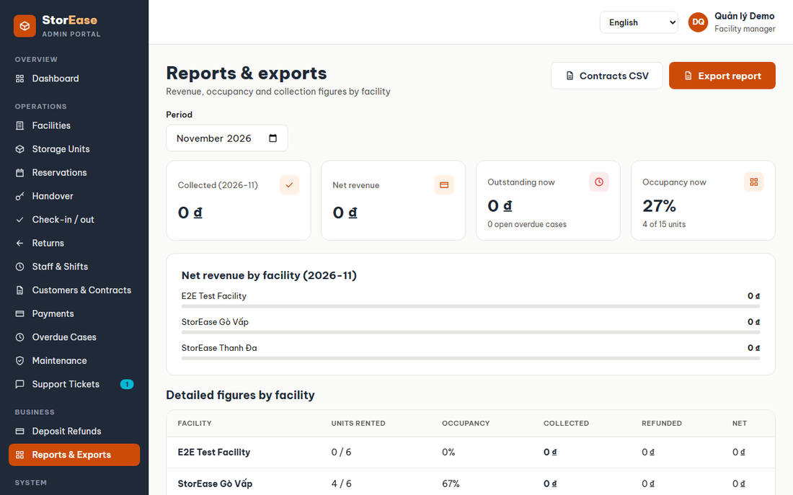
Figure 50. Reports & Exports
- Function details:
  - Data is limited to the user's facilities. The revenue range cannot exceed 3 years, and its end cannot precede its start.

15. Language Switch (F14)

a. Choose Language
- Function trigger: Header selector on both sites.
- Function description: A user switches between Vietnamese and English.
- Function details:
  - The customer site opens in Vietnamese and the staff portal in English until a choice is saved in the browser as storease.lang.
  - Each request sends Accept-Language, so API errors and validation messages follow the choice.
  - Emails, printed documents and data typed by people stay as written.

16. Support Requests

a. Support Requests
- Function trigger: Account menu (/support/requests).
- Function description: A customer opens and follows tickets.
- Screen layout:
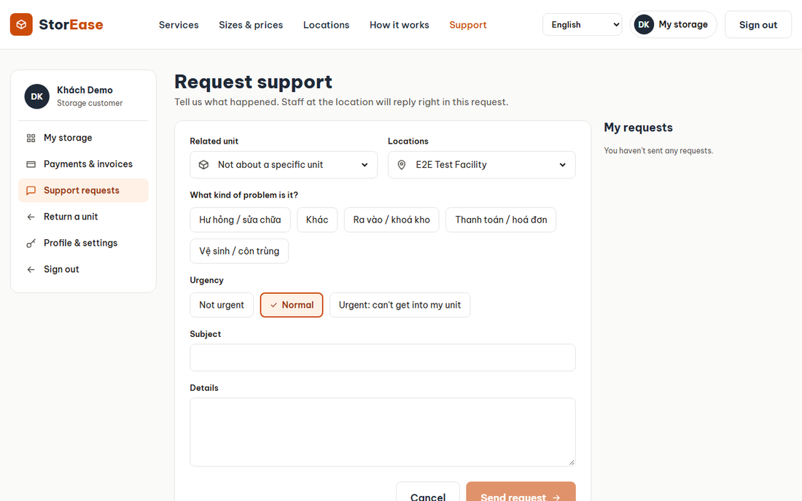
Figure 51. Support Requests
- Function details:
  - A ticket has a category, facility, optional unit, subject, details and priority. The default priority comes from the category.
  - A unit must belong to the customer's active contract.
  - A customer can close their own ticket.

b. Support Tickets
- Function trigger: Staff menu (/admin/tickets).
- Function description: Staff work through a board of tickets.
- Screen layout:
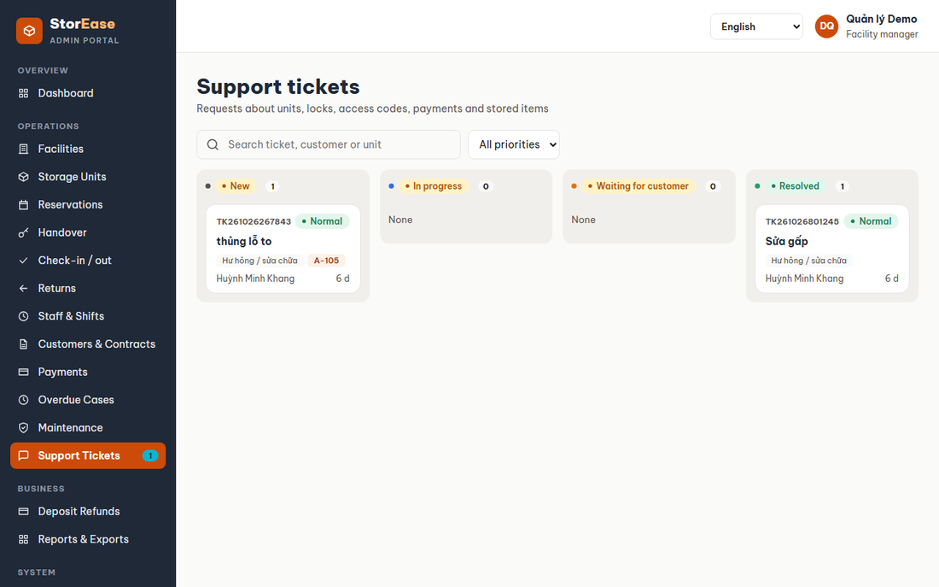
Figure 52. Support Tickets
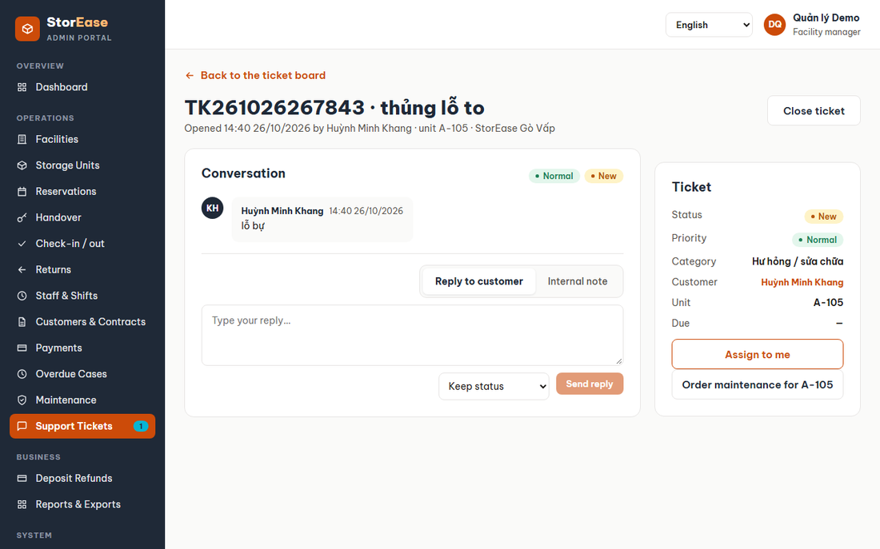
Figure 53. Support Tickets
- Function details:
  - Only a Facility Manager assigns, and only to active staff at that facility. Assigning a New ticket moves it to InProgress.
  - Internal notes are hidden from the customer.
  - Only the customer or a manager closes a ticket. A ticket about a unit can create a maintenance order.

17. Staff & Shifts

a. Staff & Shifts
- Function trigger: Staff menu (/admin/staff).
- Function description: Managers and admins plan weekly shifts.
- Screen layout:
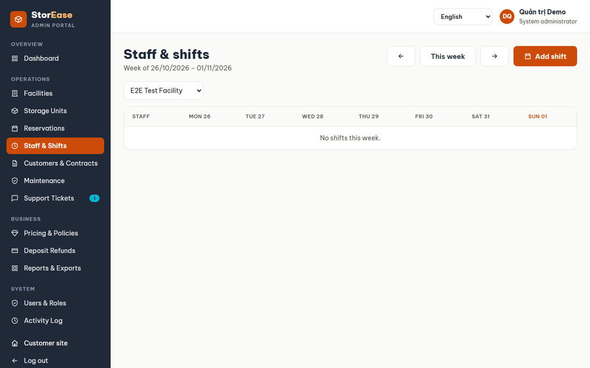
Figure 54. Staff & Shifts
- Function details:
  - The person must be Active and assigned to the facility. A shift cannot be in the past or overlap another.
  - A started shift cannot be deleted. Staff tasks have an API; a screen for creating them is not built.

III. Database Design

1. Database Schema
The database runs on SQL Server and has 34 tables. Table and column names follow the Entity Framework model in PascalCase, because the project is not on MySQL. The diagrams group tables by area. Lines join neighbouring tables only; every other link is named in the FK text.
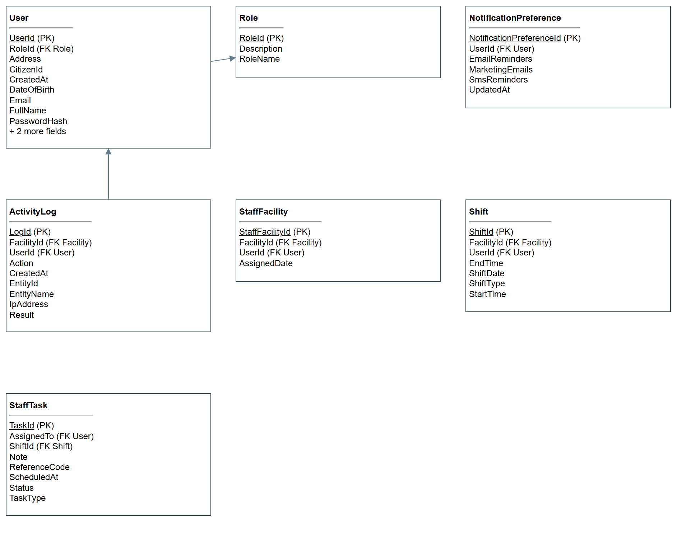
Figure 55. Accounts and staff
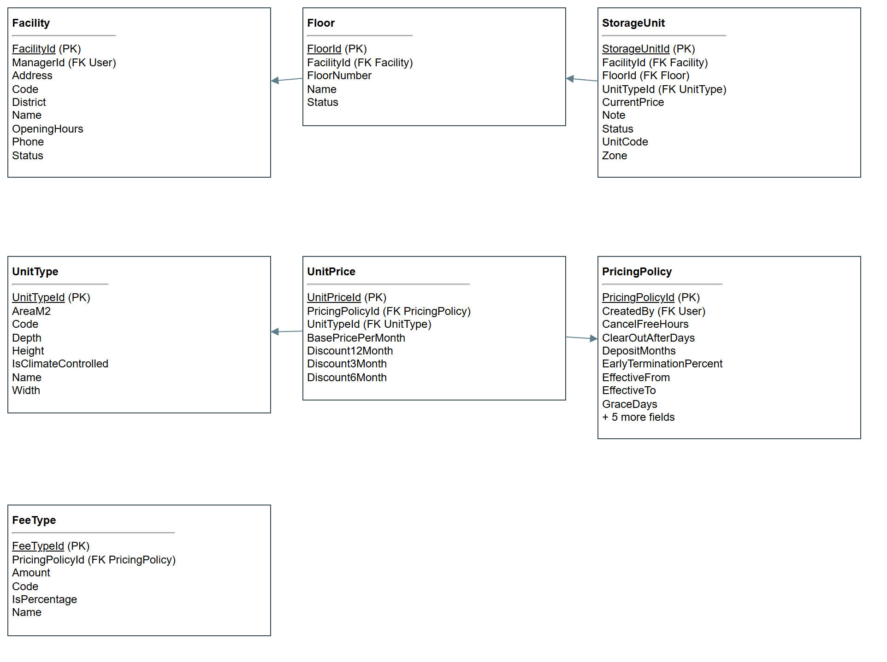
Figure 56. Facilities, units and prices
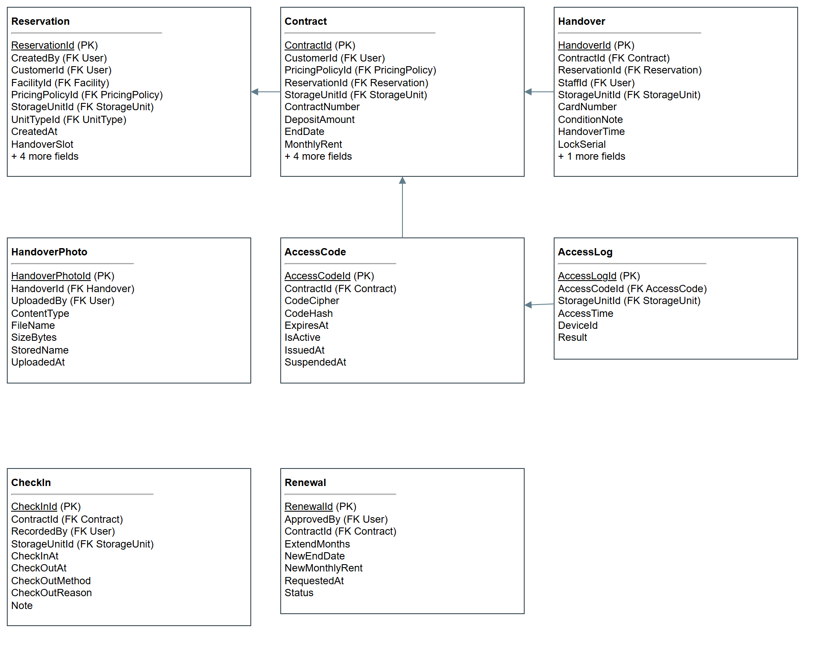
Figure 57. Reservations, contracts and access
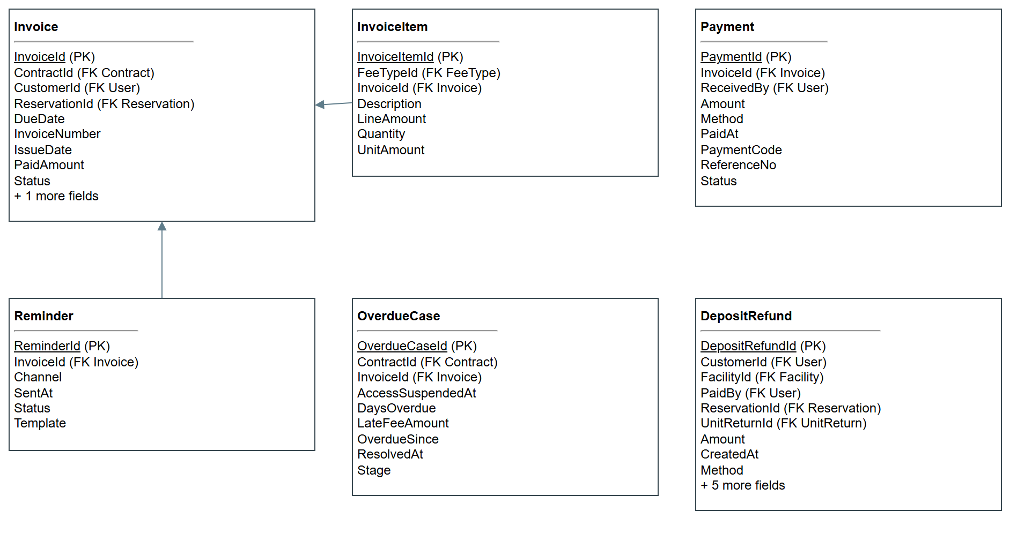
Figure 58. Billing
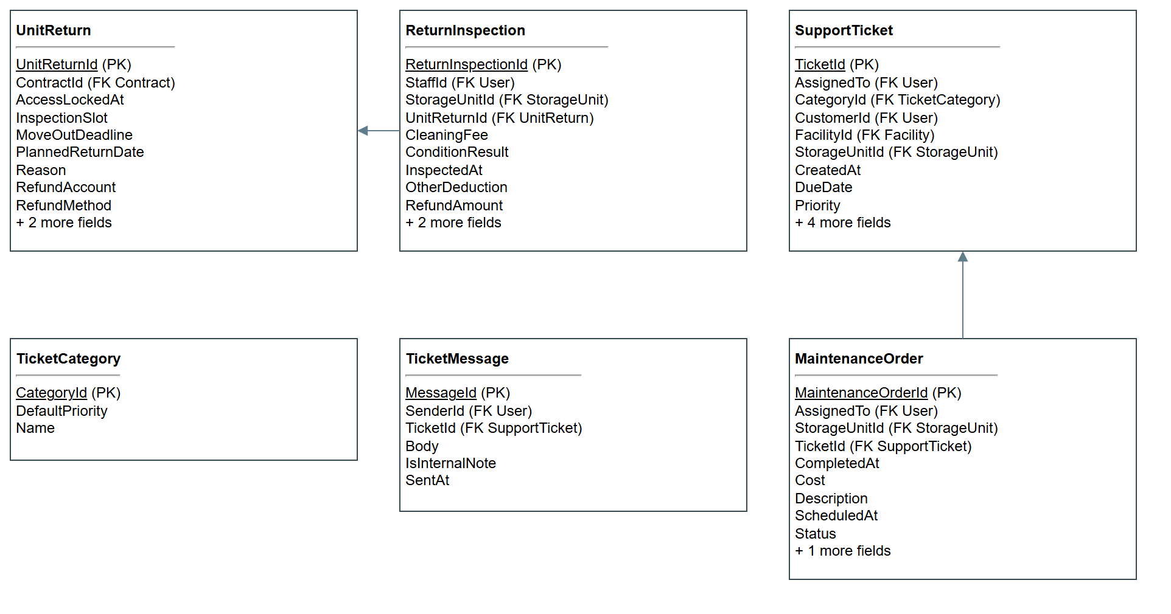
Figure 59. Returns and support
Table Description
No | Table | Description
1 | AccessCode | A one-visit code, kept as a hash and as encrypted text.
2 | AccessLog | A recorded use of a code at a unit.
3 | ActivityLog | Audit record of each write and sign-in.
4 | CheckIn | One customer visit, with how it ended.
5 | Contract | The rental agreement for one unit.
6 | DepositRefund | A deposit owed back to a customer.
7 | Facility | A storage site with its manager and opening hours.
8 | FeeType | A named fee defined in a price version.
9 | Floor | A floor of a facility, with an open or closed status.
10 | Handover | The event that gives a unit to a customer and starts the rental.
11 | HandoverPhoto | A condition photo stored with a handover.
12 | Invoice | A bill: a deposit or one month of rent.
13 | InvoiceItem | A line on an invoice, such as rent or a late fee.
14 | MaintenanceOrder | Work ordered on a unit.
15 | NotificationPreference | A user's email, SMS and marketing choices.
16 | OverdueCase | The escalation of one unpaid rent invoice.
17 | Payment | Money received against an invoice.
18 | PricingPolicy | A price version with its deposit, grace, late fee, lock-out, clear-out and cancellation terms.
19 | Reminder | A record of a payment reminder sent.
20 | Renewal | A request to extend a contract.
21 | Reservation | A booking of a unit type for a move-in date and period.
22 | ReturnInspection | The check of a returned unit, with charges.
23 | Role | The five system roles.
24 | Shift | A staff work shift at a facility.
25 | StaffFacility | Links staff to the facilities they work at.
26 | StaffTask | A task given to a person on a shift.
27 | StorageUnit | One rentable unit and its current status.
28 | SupportTicket | A customer request for help.
29 | TicketCategory | The kind of ticket and its default priority.
30 | TicketMessage | One message on a ticket, public or internal.
31 | UnitPrice | Monthly price and period discounts of a unit type in a price version.
32 | UnitReturn | A request to hand a unit back, with its move-out deadline.
33 | UnitType | A size class of unit; this is what is priced.
34 | User | Anyone who signs in: customers and staff.

2. Table Detail
Fields below come from the current Entity Framework model snapshot. Status and other enum fields hold the names shown in part I.6. Monetary fields use decimal.
AccessCode
# | Field name | Type | Size | Unique | Not Null | PK/FK | Notes
1 | AccessCodeId | int |  |  | X | PK | Identity
2 | CodeCipher | varchar | 100
3 | CodeHash | varchar | 255 |  | X
4 | ContractId | int |  |  | X | FK | References Contract
5 | ExpiresAt | datetime2 |  |  | X
6 | IsActive | bit |  |  | X
7 | IssuedAt | datetime2 |  |  | X
8 | SuspendedAt | datetime2

AccessLog
# | Field name | Type | Size | Unique | Not Null | PK/FK | Notes
1 | AccessLogId | bigint |  |  | X | PK
2 | AccessCodeId | int |  |  | X | FK | References AccessCode
3 | AccessTime | datetime2 |  |  | X
4 | DeviceId | varchar | 30
5 | Result | varchar | 20 |  | X
6 | StorageUnitId | int |  |  | X | FK | References StorageUnit

ActivityLog
# | Field name | Type | Size | Unique | Not Null | PK/FK | Notes
1 | LogId | bigint |  |  | X | PK
2 | Action | varchar | 50 |  | X
3 | CreatedAt | datetime2 |  |  | X
4 | EntityId | varchar | 30
5 | EntityName | varchar | 50
6 | FacilityId | int |  |  |  | FK | References Facility
7 | IpAddress | varchar | 45
8 | Result | varchar | 20 |  | X
9 | UserId | int |  |  | X | FK | References User

CheckIn
# | Field name | Type | Size | Unique | Not Null | PK/FK | Notes
1 | CheckInId | int |  |  | X | PK | Identity
2 | CheckInAt | datetime2 |  |  | X
3 | CheckOutAt | datetime2
4 | CheckOutMethod | varchar | 20
5 | CheckOutReason | nvarchar | 200
6 | ContractId | int |  |  | X | FK | References Contract
7 | Note | nvarchar | 200
8 | RecordedBy | int |  |  | X | FK | References User
9 | StorageUnitId | int |  |  | X | FK | References StorageUnit

Contract
# | Field name | Type | Size | Unique | Not Null | PK/FK | Notes
1 | ContractId | int |  |  | X | PK | Identity
2 | ContractNumber | varchar | 20 | X | X
3 | CustomerId | int |  |  | X | FK | References User
4 | DepositAmount | decimal | 12,2 |  | X
5 | EndDate | date |  |  | X
6 | MonthlyRent | decimal | 12,2 |  | X
7 | PaymentDay | int |  |  | X
8 | PricingPolicyId | int |  |  |  | FK | References PricingPolicy
9 | ReservationId | int |  |  | X | FK | References Reservation
10 | SignedAt | datetime2
11 | StartDate | date |  |  | X
12 | Status | varchar | 20 |  | X
13 | StorageUnitId | int |  |  | X | FK | References StorageUnit; Unique among open records

DepositRefund
# | Field name | Type | Size | Unique | Not Null | PK/FK | Notes
1 | DepositRefundId | int |  |  | X | PK | Identity
2 | Amount | decimal | 18,2 |  | X
3 | CreatedAt | datetime2 |  |  | X
4 | CustomerId | int |  |  | X | FK | References User
5 | FacilityId | int |  |  | X | FK | References Facility
6 | Method | varchar | 20
7 | PaidAt | datetime2
8 | PaidBy | int |  |  |  | FK | References User
9 | ReferenceNo | nvarchar | 50
10 | RefundAccount | nvarchar | 100
11 | ReservationId | int |  |  | X | FK | References Reservation
12 | Source | varchar | 20 |  | X
13 | Status | varchar | 20 |  | X
14 | UnitReturnId | int |  |  |  | FK | References UnitReturn; Unique among open records
Unique together: ReservationId + Source
Facility
# | Field name | Type | Size | Unique | Not Null | PK/FK | Notes
1 | FacilityId | int |  |  | X | PK | Identity
2 | Address | nvarchar | 200 |  | X
3 | Code | varchar | 10 |  | X
4 | District | nvarchar | 50 |  | X
5 | ManagerId | int |  |  |  | FK | References User
6 | Name | nvarchar | 100 |  | X
7 | OpeningHours | varchar | 50
8 | Phone | varchar | 20
9 | Status | varchar | 20 |  | X

FeeType
# | Field name | Type | Size | Unique | Not Null | PK/FK | Notes
1 | FeeTypeId | int |  |  | X | PK | Identity
2 | Amount | decimal | 12,2 |  | X
3 | Code | varchar | 20 |  | X
4 | IsPercentage | bit |  |  | X
5 | Name | nvarchar | 50 |  | X
6 | PricingPolicyId | int |  |  | X | FK | References PricingPolicy

Floor
# | Field name | Type | Size | Unique | Not Null | PK/FK | Notes
1 | FloorId | int |  |  | X | PK | Identity
2 | FacilityId | int |  |  | X | FK | References Facility
3 | FloorNumber | int |  |  | X
4 | Name | nvarchar | 50
5 | Status | varchar | 20 |  | X

Handover
# | Field name | Type | Size | Unique | Not Null | PK/FK | Notes
1 | HandoverId | int |  |  | X | PK | Identity
2 | CardNumber | varchar | 30
3 | ConditionNote | nvarchar | 300
4 | ContractId | int |  |  |  | FK | References Contract
5 | HandoverTime | datetime2 |  |  | X
6 | LockSerial | varchar | 30
7 | ReservationId | int |  |  | X | FK | References Reservation
8 | StaffId | int |  |  | X | FK | References User
9 | Status | varchar | 20 |  | X
10 | StorageUnitId | int |  |  | X | FK | References StorageUnit

HandoverPhoto
# | Field name | Type | Size | Unique | Not Null | PK/FK | Notes
1 | HandoverPhotoId | int |  |  | X | PK | Identity
2 | ContentType | varchar | 100 |  | X
3 | FileName | nvarchar | 200 |  | X
4 | HandoverId | int |  |  | X | FK | References Handover
5 | SizeBytes | int |  |  | X
6 | StoredName | varchar | 100 |  | X
7 | UploadedAt | datetime2 |  |  | X
8 | UploadedBy | int |  |  | X | FK | References User

Invoice
# | Field name | Type | Size | Unique | Not Null | PK/FK | Notes
1 | InvoiceId | int |  |  | X | PK | Identity
2 | ContractId | int |  |  |  | FK | References Contract
3 | CustomerId | int |  |  | X | FK | References User
4 | DueDate | date |  |  | X
5 | InvoiceNumber | varchar | 20 | X | X
6 | IssueDate | date |  |  | X
7 | PaidAmount | decimal | 12,2 |  | X |  | Concurrency token
8 | ReservationId | int |  |  |  | FK | References Reservation
9 | Status | varchar | 20 |  | X
10 | TotalAmount | decimal | 12,2 |  | X

InvoiceItem
# | Field name | Type | Size | Unique | Not Null | PK/FK | Notes
1 | InvoiceItemId | int |  |  | X | PK | Identity
2 | Description | nvarchar | 200 |  | X
3 | FeeTypeId | int |  |  |  | FK | References FeeType
4 | InvoiceId | int |  |  | X | FK | References Invoice
5 | LineAmount | decimal | 12,2 |  | X
6 | Quantity | int |  |  | X
7 | UnitAmount | decimal | 12,2 |  | X

MaintenanceOrder
# | Field name | Type | Size | Unique | Not Null | PK/FK | Notes
1 | MaintenanceOrderId | int |  |  | X | PK | Identity
2 | AssignedTo | int |  |  |  | FK | References User
3 | CompletedAt | datetime2
4 | Cost | decimal | 12,2
5 | Description | nvarchar | 300 |  | X
6 | ScheduledAt | datetime2
7 | Status | varchar | 20 |  | X
8 | StorageUnitId | int |  |  | X | FK | References StorageUnit
9 | TicketId | int |  |  |  | FK | References SupportTicket
10 | WorkNote | nvarchar | 500

NotificationPreference
# | Field name | Type | Size | Unique | Not Null | PK/FK | Notes
1 | NotificationPreferenceId | int |  |  | X | PK | Identity
2 | EmailReminders | bit |  |  | X
3 | MarketingEmails | bit |  |  | X
4 | SmsReminders | bit |  |  | X
5 | UpdatedAt | datetime2 |  |  | X
6 | UserId | int |  | X | X | FK | References User

OverdueCase
# | Field name | Type | Size | Unique | Not Null | PK/FK | Notes
1 | OverdueCaseId | int |  |  | X | PK | Identity
2 | AccessSuspendedAt | datetime2
3 | ContractId | int |  |  | X | FK | References Contract
4 | DaysOverdue | int |  |  | X
5 | InvoiceId | int |  |  |  | FK | References Invoice
6 | LateFeeAmount | decimal | 12,2 |  | X
7 | OverdueSince | date |  |  | X
8 | ResolvedAt | datetime2
9 | Stage | varchar | 30 |  | X

Payment
# | Field name | Type | Size | Unique | Not Null | PK/FK | Notes
1 | PaymentId | int |  |  | X | PK | Identity
2 | Amount | decimal | 12,2 |  | X
3 | InvoiceId | int |  |  | X | FK | References Invoice
4 | Method | varchar | 20 |  | X
5 | PaidAt | datetime2
6 | PaymentCode | varchar | 20 | X | X
7 | ReceivedBy | int |  |  |  | FK | References User
8 | ReferenceNo | varchar | 50
9 | Status | varchar | 20 |  | X

PricingPolicy
# | Field name | Type | Size | Unique | Not Null | PK/FK | Notes
1 | PricingPolicyId | int |  |  | X | PK | Identity
2 | CancelFreeHours | int |  |  | X
3 | ClearOutAfterDays | int |  |  | X
4 | CreatedBy | int |  |  | X | FK | References User
5 | DepositMonths | int |  |  | X
6 | EarlyTerminationPercent | decimal | 5,2 |  | X
7 | EffectiveFrom | date |  |  | X
8 | EffectiveTo | date
9 | GraceDays | int |  |  | X
10 | LateFeePercentPerWeek | decimal | 5,2 |  | X
11 | NoticeDays | int |  |  | X
12 | Status | varchar | 20 |  | X
13 | SuspendAfterDays | int |  |  | X
14 | Version | int |  |  | X

Reminder
# | Field name | Type | Size | Unique | Not Null | PK/FK | Notes
1 | ReminderId | int |  |  | X | PK | Identity
2 | Channel | varchar | 20 |  | X
3 | InvoiceId | int |  |  | X | FK | References Invoice
4 | SentAt | datetime2
5 | Status | varchar | 20 |  | X
6 | Template | varchar | 50 |  | X

Renewal
# | Field name | Type | Size | Unique | Not Null | PK/FK | Notes
1 | RenewalId | int |  |  | X | PK | Identity
2 | ApprovedBy | int |  |  |  | FK | References User
3 | ContractId | int |  |  | X | FK | References Contract
4 | ExtendMonths | int |  |  | X
5 | NewEndDate | date |  |  | X
6 | NewMonthlyRent | decimal | 12,2 |  | X
7 | RequestedAt | datetime2 |  |  | X
8 | Status | varchar | 20 |  | X

Reservation
# | Field name | Type | Size | Unique | Not Null | PK/FK | Notes
1 | ReservationId | int |  |  | X | PK | Identity
2 | CreatedAt | datetime2 |  |  | X
3 | CreatedBy | int |  |  |  | FK | References User
4 | CustomerId | int |  |  | X | FK | References User
5 | FacilityId | int |  |  | X | FK | References Facility
6 | HandoverSlot | datetime2
7 | MoveInDate | date |  |  | X
8 | PricingPolicyId | int |  |  |  | FK | References PricingPolicy
9 | RentalMonths | int |  |  | X
10 | ReservationCode | varchar | 20 | X | X
11 | Status | varchar | 20 |  | X
12 | StorageUnitId | int |  |  |  | FK | References StorageUnit
13 | UnitTypeId | int |  |  | X | FK | References UnitType

ReturnInspection
# | Field name | Type | Size | Unique | Not Null | PK/FK | Notes
1 | ReturnInspectionId | int |  |  | X | PK | Identity
2 | CleaningFee | decimal | 12,2 |  | X
3 | ConditionResult | varchar | 20 |  | X
4 | InspectedAt | datetime2 |  |  | X
5 | OtherDeduction | decimal | 12,2 |  | X
6 | RefundAmount | decimal | 12,2 |  | X
7 | RepairCharge | decimal | 12,2 |  | X
8 | StaffId | int |  |  | X | FK | References User
9 | Status | varchar | 20 |  | X
10 | StorageUnitId | int |  |  | X | FK | References StorageUnit
11 | UnitReturnId | int |  |  | X | FK | References UnitReturn

Role
# | Field name | Type | Size | Unique | Not Null | PK/FK | Notes
1 | RoleId | int |  |  | X | PK | Identity
2 | Description | varchar | 200
3 | RoleName | varchar | 50 |  | X

Shift
# | Field name | Type | Size | Unique | Not Null | PK/FK | Notes
1 | ShiftId | int |  |  | X | PK | Identity
2 | EndTime | time |  |  | X
3 | FacilityId | int |  |  | X | FK | References Facility
4 | ShiftDate | date |  |  | X
5 | ShiftType | varchar | 20 |  | X
6 | StartTime | time |  |  | X
7 | UserId | int |  |  | X | FK | References User

StaffFacility
# | Field name | Type | Size | Unique | Not Null | PK/FK | Notes
1 | StaffFacilityId | int |  |  | X | PK | Identity
2 | AssignedDate | date |  |  | X
3 | FacilityId | int |  |  | X | FK | References Facility
4 | UserId | int |  |  | X | FK | References User
Unique together: UserId + FacilityId
StaffTask
# | Field name | Type | Size | Unique | Not Null | PK/FK | Notes
1 | TaskId | int |  |  | X | PK | Identity
2 | AssignedTo | int |  |  | X | FK | References User
3 | Note | nvarchar | 200
4 | ReferenceCode | varchar | 30
5 | ScheduledAt | datetime2 |  |  | X
6 | ShiftId | int |  |  |  | FK | References Shift
7 | Status | varchar | 20 |  | X
8 | TaskType | varchar | 20 |  | X

StorageUnit
# | Field name | Type | Size | Unique | Not Null | PK/FK | Notes
1 | StorageUnitId | int |  |  | X | PK | Identity
2 | CurrentPrice | decimal | 12,2 |  | X
3 | FacilityId | int |  |  | X | FK | References Facility
4 | FloorId | int |  |  | X | FK | References Floor
5 | Note | nvarchar | 200
6 | Status | varchar | 20 |  | X
7 | UnitCode | varchar | 20 |  | X
8 | UnitTypeId | int |  |  | X | FK | References UnitType
9 | Zone | varchar | 10
Unique together: FacilityId + UnitCode
SupportTicket
# | Field name | Type | Size | Unique | Not Null | PK/FK | Notes
1 | TicketId | int |  |  | X | PK | Identity
2 | AssignedTo | int |  |  |  | FK | References User
3 | CategoryId | int |  |  | X | FK | References TicketCategory
4 | CreatedAt | datetime2 |  |  | X
5 | CustomerId | int |  |  | X | FK | References User
6 | DueDate | datetime2
7 | FacilityId | int |  |  | X | FK | References Facility
8 | Priority | varchar | 20 |  | X
9 | ResolvedAt | datetime2
10 | Status | varchar | 20 |  | X
11 | StorageUnitId | int |  |  |  | FK | References StorageUnit
12 | Subject | nvarchar | 200 |  | X
13 | TicketCode | varchar | 20 | X | X

TicketCategory
# | Field name | Type | Size | Unique | Not Null | PK/FK | Notes
1 | CategoryId | int |  |  | X | PK | Identity
2 | DefaultPriority | varchar | 20 |  | X
3 | Name | nvarchar | 50 |  | X

TicketMessage
# | Field name | Type | Size | Unique | Not Null | PK/FK | Notes
1 | MessageId | int |  |  | X | PK | Identity
2 | Body | nvarchar | 1000 |  | X
3 | IsInternalNote | bit |  |  | X
4 | SenderId | int |  |  | X | FK | References User
5 | SentAt | datetime2 |  |  | X
6 | TicketId | int |  |  | X | FK | References SupportTicket

UnitPrice
# | Field name | Type | Size | Unique | Not Null | PK/FK | Notes
1 | UnitPriceId | int |  |  | X | PK | Identity
2 | BasePricePerMonth | decimal | 12,2 |  | X
3 | Discount12Month | decimal | 5,2 |  | X
4 | Discount3Month | decimal | 5,2 |  | X
5 | Discount6Month | decimal | 5,2 |  | X
6 | PricingPolicyId | int |  |  | X | FK | References PricingPolicy
7 | UnitTypeId | int |  |  | X | FK | References UnitType

UnitReturn
# | Field name | Type | Size | Unique | Not Null | PK/FK | Notes
1 | UnitReturnId | int |  |  | X | PK | Identity
2 | AccessLockedAt | datetime2
3 | ContractId | int |  |  | X | FK | References Contract
4 | InspectionSlot | datetime2
5 | MoveOutDeadline | date |  |  | X
6 | PlannedReturnDate | date |  |  | X
7 | Reason | nvarchar | 200
8 | RefundAccount | varchar | 50
9 | RefundMethod | varchar | 20
10 | RequestedAt | datetime2 |  |  | X
11 | Status | varchar | 20 |  | X

UnitType
# | Field name | Type | Size | Unique | Not Null | PK/FK | Notes
1 | UnitTypeId | int |  |  | X | PK | Identity
2 | AreaM2 | decimal | 5,2 |  | X
3 | Code | varchar | 10 |  | X
4 | Depth | decimal | 4,2 |  | X
5 | Height | decimal | 4,2 |  | X
6 | IsClimateControlled | bit |  |  | X
7 | Name | nvarchar | 50 |  | X
8 | Width | decimal | 4,2 |  | X

User
# | Field name | Type | Size | Unique | Not Null | PK/FK | Notes
1 | UserId | int |  |  | X | PK | Identity
2 | Address | nvarchar | 200
3 | CitizenId | varchar | 20
4 | CreatedAt | datetime2 |  |  | X
5 | DateOfBirth | date
6 | Email | varchar | 100 | X | X
7 | FullName | nvarchar | 100 |  | X
8 | PasswordHash | varchar | 255 |  | X
9 | PhoneNumber | varchar | 20 |  | X
10 | RoleId | int |  |  | X | FK | References Role
11 | Status | varchar | 20 |  | X

