Design:

Class Diagram

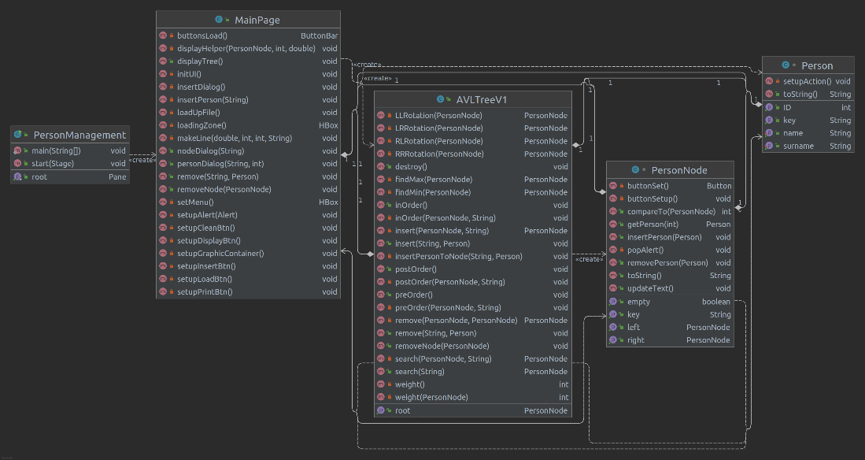

The Program stage starts up by PersonManagement class.

- MainPage: is the Main UI class.

- PersonNode: is the Button, contains 1 or multiple Person objects which are fit its Key(Last name or Surname, decided by user on interface). Each Dialog to view, modify the PersonNode will be called up by user events(clicking on the node in graphic panel).

- Person: is the MenuItem, will be located, viewed, and edited in each Dialog called up by user events(in PersonNode dialog, there is a drop list contains all Person with same pattern).

- AVLTree: Self-balance Tree structure, an attribute for MainPage. MainPage read all data, create Person objects and assemble them into PersonNode, then insert into the tree.

Features:

1. UI, load up from File, the user can define Indexing pattern by RadioButton(First name or Surname).

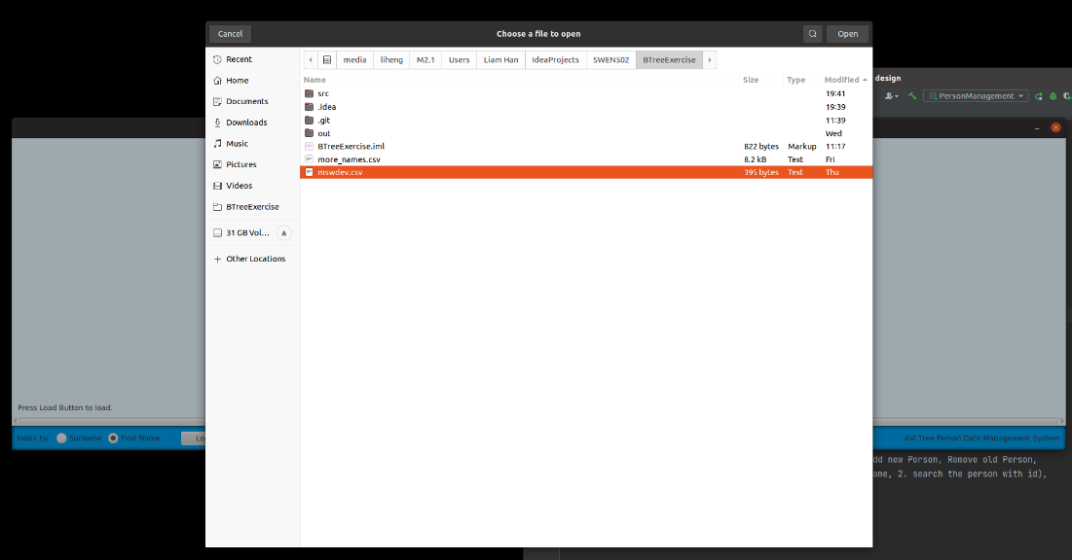

1. Auto balancing tree created and plot into the Graphic, limited at certain depth, because too many Nodes over flow the screen. The plot will automatically adjust according to the Nodes number at the bottom depth(wider when there are more nodes).

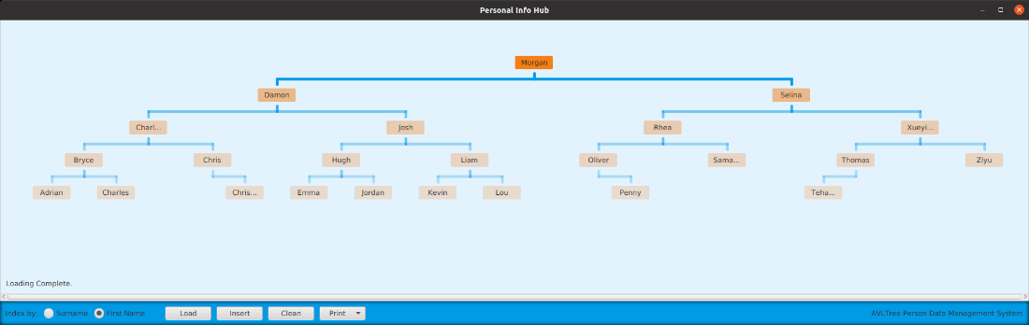

1. Insert Button brings up a insert dialog, user input name, system auto assign new uid to the new Person, and insert to the tree. If there is already a Node to hold same key pattern, inject into the Node, if not, create a new Node and inject into the Tree.

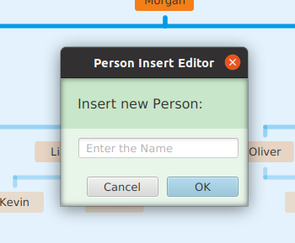

1. After some inserts of Z-name person and rebalancing, the tree becomes like this.

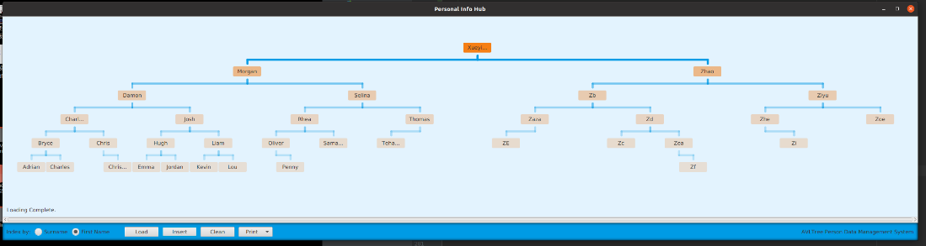

1. Click on PersonNode, it brings up the PersonNode Dialog. The user can observe, choose the Person, or delete the whole node by delete Button.

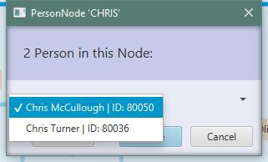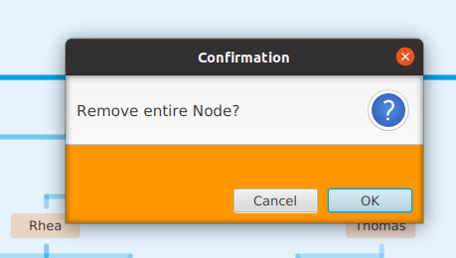

1. In PersonNode Dialog, user can choose a Person to engage by choose Button, bring the user to the Person Dialog. The user can delete this Person, Or Edit the name using TextField. The Person and the Node will be updated in the Tree as showed below. All elements inside this application have tooltips to help user.

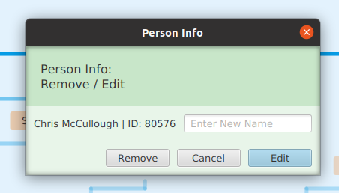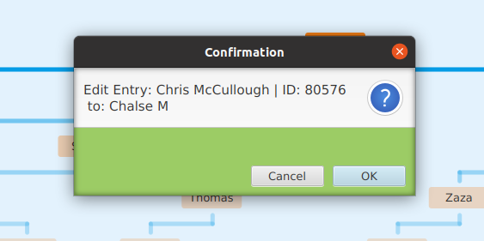

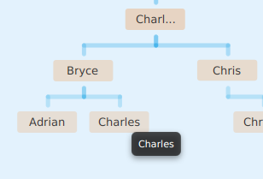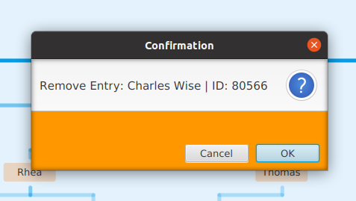

1. A print button to help maintenance, by printing information in the console area.

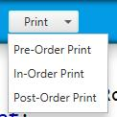

Data structure:

I used an AVLTree to help balancing while insert or remove Nodes. It monitors and balances the branch weight(height) at each Node recursively after every insert or remove happened.

Marks:

I believe this is an A+ job. If I am allowed more time at UI by introduce custom designed dialog Stage and test through all potential bugs, or the most difficult job: animate the balancing process, I can achieve the S grade. ^^