# VISVESVARAYA TECHNOLOGICAL UNIVERSITY

## BELAGAVI–590018, Karnataka

## INTERNSHIP REPORT

#### ON

“PORTFOLIO PHOTOGRAPHY”

***Submitted in partial fulfillment for the award of degree (18CSI85)***

## BACHELOR OF ENGINEERING IN

## YOUR BRANCH

***Submitted by:***

S M Muzammil

3VC20CS150

### Company logo:



Conducted at

**Varcons Technologies Pvt Ltd**



# RAO BAHADUR Y MAHABALESWARAPPA ENGINEERING COLLAGE

**Department of Computer Science**

# Cantonment, BALLARI – 583 104

# RAO BAHADUR Y MAHABALESWARAPPA ENGINEERING COLLAGE

**Department of Computer Science**

**Cantonment, BALLARI – 583 104**



**CERTIFICATE**

This is to certify that the Internship titled **“PORTFOLIO PHOTOGRAPHY”** carried out by **Mr. S M Muzammil,** a bonafide student of **Rao Bahadur Y Mahabaleswarappa Engineering Collage** , in partial fulfillment for the award of **Bachelor of Engineering**, in **COMPUTER SCIENCE** under Visvesvaraya Technological University ,Belagavi, during the year 2023-2024. It is certified that all corrections/suggestions indicated have been incorporated in the report.

The project report has been approved and satisfies the academic requirements in respect of Internship prescribed for the course Internship/Professional Practice (18CSI85)

#### Signature of Guide Signature of HOD Signature of Principal

**External Viva:**

Name of the Examiner Signature with Date

1)

2)

# DECLARATION

I, S M Muzammil, final year student of Computer Science, Rao Bahadur Y Mahabaleswarappa Enigneering Collage-584 104, declare that the Internship has been successfully completed, in **VARCONS TECHNOLOGIES PVT LTD**. This report is submitted in partial fulfillment of the requirements for award of Bachelor Degree in Branch name, during the academic year 2023-2024.

Date: 19/09/2023 :

Place : Ballari

USN:3VC20CS150

NAME: S M Muzammil

# ACKN OWLEDGEMENT

This Internship is a result of accumulated guidance, direction and support of several important persons. We take this opportunity to express our gratitude to all who have helped us to complete the Internship.

We express our sincere thanks to our Principal, for providing us adequate facilities to undertake this Internship.

We would like to thank our Head of Dept –branch code, for providing us an opportunity to carryout Internship and for his valuable guidance and support.

We would like to thank our (Lab assistant name) Software Services for guiding us during the period of internship.

We express our deep and profound gratitude to our guide, Guide name, Assistant/Associate Prof, for her keen interest and encouragement at every step in completing the Internship.

We would like to thank all the faculty members of our department for the support extended during the course of Internship.

We would like to thank the non-teaching members of our dept, for helping us during the Internship.

Last but not the least, we would like to thank our parents and friends without whose constant help, the completion of Internship would have not been possible.

NAME: S M Muzammil

USN: 3VC20CS150

# ABSTRACT

The portfolio photography consist of a different kinds of images

of portfolio photos, these photos can be seen and selected by

online audience, if they like. In today’s, generation audience want

an effective portfolio images which plays a vital role in conveying a image identity, values, and offerings. This abstract provides an overview of key elements and considerations for designing a successful portfolio photography page.

# 

# Table of Contents

|  |  |  |
| --- | --- | --- |
| **Sl no** | **Description** | **Page no** |
| 1 | Company Profile | 7-8 |
| 2 | About the Company | 9-12 |
| [3](https://1.bp.blogspot.com/-dODuK8N5h1Q/Wlnyb3V9HFI/AAAAAAAACL4/WxQtCJ1pM5wccDABg4wIrTBUB0vlikXQQCLcBGAs/s1600/poly1.jpg) | Introduction | 13-15 |
| [4](https://1.bp.blogspot.com/-dODuK8N5h1Q/Wlnyb3V9HFI/AAAAAAAACL4/WxQtCJ1pM5wccDABg4wIrTBUB0vlikXQQCLcBGAs/s1600/poly1.jpg) | System Analysis | 16-17 |
| [5](https://1.bp.blogspot.com/-dODuK8N5h1Q/Wlnyb3V9HFI/AAAAAAAACL4/WxQtCJ1pM5wccDABg4wIrTBUB0vlikXQQCLcBGAs/s1600/poly1.jpg) | Requirement Analysis | 18-19 |
| 6 | Design [Analysis](https://4.bp.blogspot.com/-IOOxgPaXMVc/Wlj3LWvcnjI/AAAAAAAACKE/UeTFYvAxDmUDel5UBjdifeWaApB3-dXVgCLcBGAs/s1600/img1.jpg) | 20-38 |
| 7 | [Implementation](https://4.bp.blogspot.com/-IOOxgPaXMVc/Wlj3LWvcnjI/AAAAAAAACKE/UeTFYvAxDmUDel5UBjdifeWaApB3-dXVgCLcBGAs/s1600/img1.jpg) | 39-42 |
| 8 | Snapshots | 43-45 |
| 9 | Conclusion | 46-47 |
| 10 | References | 48 |

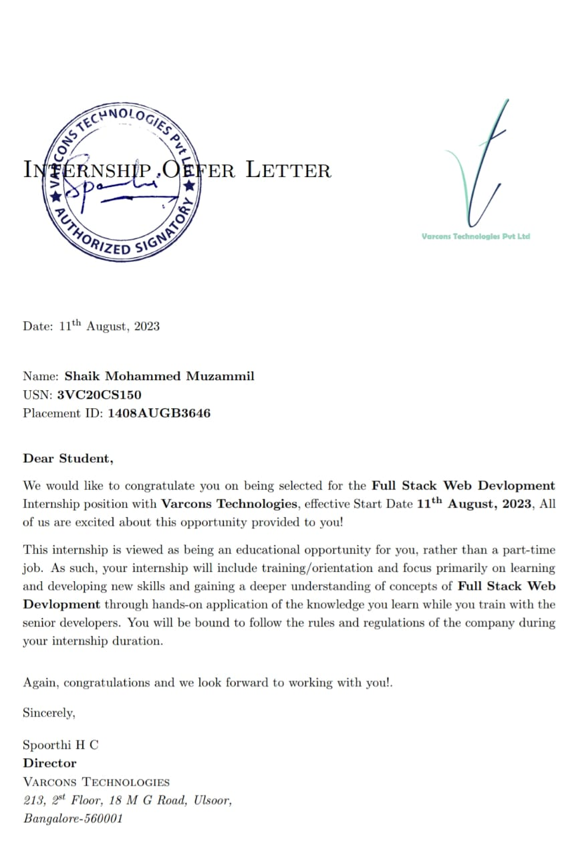

# 

# 

**[CHAPTER](https://1.bp.blogspot.com/-dODuK8N5h1Q/Wlnyb3V9HFI/AAAAAAAACL4/WxQtCJ1pM5wccDABg4wIrTBUB0vlikXQQCLcBGAs/s1600/poly1.jpg) 1** **COMPANY PROFILE**

# COMPANY PROFILE

## A Brief History of Company Name

Company Name, was incorporated with a goal ”To provide high quality and optimal Technological Solutions to business requirements of our clients”. Every business is a different and has a unique business model and so are the technological requirements. They understand this and hence the solutions provided to these requirements are different as well. They focus on clients requirements and provide them with tailor made technological solutions. They also understand that Reach of their Product to its targeted market or the automation of the existing process into e-client and simple process are the key features that our clients desire from Technological Solution they are looking for and these are the features that we focus on while designing the solutions for their clients.

Company Name is a Technology Organization providing solutions for all web design and development, MYSQL, PYTHON Programming, HTML, CSS, ASP.NET and LINQ. Meeting the ever increasing automation requirements, Sarvamoola Software Services.specializeinERP,Connectivity,SEOServices,ConferenceManagement,effectivewebpromotionandtailor-madesoftwareproducts,designingsolutionsbestsuitingclientsrequirements.

Company Name, strive to be the front runner in creativity and innovation in software development through their well-researched expertise and establish it as an out of the boxes of tware development company in Bangalore ,India. As a software development company, they translate this software development expertise into value for their customers through their professional solutions.

They understand that the best desired output can be achieved only by understanding the clients demand better. Varcons Technologies work with their clients and help them to define their exact solution requirement. Sometimes even they wonder that they have completely redefined their solution or new application requirement during the brain storming session, and here they position themselves as an IT solutions consulting group comprising of high caliber consultants.

They believe that Technology when used properly can help any business to scale and achieve new heights of success. It helps Improve its efficiency, profitability, reliability; to put it in one sentence ” Technology helps you to Delight your Customers” and that is what we want to achieve.

# [CHAPTER](https://1.bp.blogspot.com/-dODuK8N5h1Q/Wlnyb3V9HFI/AAAAAAAACL4/WxQtCJ1pM5wccDABg4wIrTBUB0vlikXQQCLcBGAs/s1600/poly1.jpg) 2

# ABOUT THE COMPANY

1. **ABOUT THE COMPANY**

Company Name is a Technology Organization providing solutions for all web design and development, MYSQL, PYTHON Programming, HTML, CSS, ASP.NET and LINQ. Meeting the ever increasing automation requirements, Varcons Technologies specialize in ERP, Connectivity, SEO Services, Conference Management, effective web promotionandtailor-made software products, designing solutions best suiting clients requirements. The organization where they have a right mix of professionals as a stakeholderstohelpusserveourclientswithbestofourcapabilityandwithatparindustrystandards.They have young, enthusiastic, passionate and creative Professionals to develop technological innovations in the field of Mobile technologies, Web applications as well as Business and Enterprise solution. Motto of our organization is to “Collaborate with our clients to provide them with best Technological solution hence creating Good Present and Better Future for our client which will bring a cascading a positive effect in their business shape as well”. Providing a Complete suite of technical solutions is not just our tag line, it is Our Vision for Our Clients and for Us, We strive hard to achieve it.

## Products of Company

**Android Apps**

It is the process by which new applications are created for devices running the Android operating system. Applications are usually developed in Java (and/or Kotlin; or other such option) programming language using the Android software development kit (SDK), but other development environments are also available, some such as Kotlin support the exact same Android APIs(and byte code),while others such as Go have restricted API access.

The Android software development kit includes a comprehensive set of development tools. These include a debugger, libraries, a handset emulator based on QEMU, documentation, sample code, and zutorials. Currently supported development platforms include computers running Linux (any modern desktop Linux distribution), Mac OS X 10.5.8 or later, and Windows 7 or later. As of March 2015, the SDK is not available on Android itself, but software development is possible by using specialized Android applications.

**Web Application**

It is a client–server computer program in which the client (including the user interface and client- side logic) runs in a web browser. Common web applications include webmail, online retail sales, online auctions, wikis, instant messaging services and many other functions. Web applications use web documents written in a standard format such as HTML and JavaScript, which are supported by a variety of web browsers. Web applications can be considered as a specific variant of client–servers of the are where the clients twareis downloaded to the client machine when visiting the relevant webpage, using standard procedures such as HTTP. The Client web software updates may happen each time the webpage is visited. During the session, the web browser interprets and displays the pages, and acts as the universal client for any web application. The use of web application frame works can often reduce the number of errors in a program, both by making the code simpler, and by allowing one team to concentrate on the framework while another focuses on a specifified usecase. In applications which are exposed to constant hacking attempts on the Internet, security-related problem scan becaused by errors in the program.

FrameworkscanalsopromotetheuseofbestpracticessuchasGETafterPOST.Therearesomewhoviewawebapplicationasatwo-tierarchitecture.Thiscanbea“smart”clientthatperformsalltheworkandqueriesa“dumb”server,ora“dumb”clientthatreliesona“smart”server.Theclientwouldhandlethepresentationtier,theserverwouldhavethedatabase(storagetier),andthebusinesslogic(applicationtier)wouldbeononeofthemoronboth.Whilethisincreasesthescalabilityoftheapplicationsandseparatesthedisplayandthedatabase,itstilldoesn‟tallowfortruespecializationoflayers,somostapplicationswilloutgrowthismodel.Anemergingstrategyforapplicationsoftwarecompaniesistoprovidewebaccesstosoftwarepreviouslydistributedaslocalapplications.Dependingonthetypeofapplication,itmayrequirethedevelopmentofanentirelydifferentbrowser-basedinterface,ormerelyadaptinganexistingapplicationtousedifferentpresentationtechnology.Theseprogramsallowtheusertopayamonthlyoryearlyfeeforuseofasoftwareapplicationwithouthavingtoinstallitonalocalharddrive.Acompanywhichfollowsthisstrategyisknownasanapplicationserviceprovider(ASP),andASPsarecurrentlyreceivingmuchattention inthesoftwareindustry.

Security breaches on these kinds of applications are a major concern because it can involveboth enterprise information and private customer data. Protecting these assets is an importantpart of any web application and there are some key operational areas that must be included inthedevelopmentprocess. Thisincludesprocessesforauthentication,authorization,assethandling, input, and logging and auditing. Building security into the applications from thebeginningcanbemoreeffective andless disruptive in thelong run.

**Web design**

It is encompasses many different skills and disciplines in the production and maintenance of websites. The different areas of web design include web graphic design; interface design;authoring,includingstandardizedcodeandproprietarysoftware;userexperiencedesign;and search engine optimization. The term web design is normally used to describe the design process relating to the front-end (client side) design of a website including writing mark up. Web design partially overlaps web engineering in the broader scope of web development. Web designers are expected to have an awareness of usability and if their role involvescreatingmarkupthentheyarealsoexpectedtobeuptodatewithwebaccessibilityguidelines. Web design partially overlaps web engineering in the broader scope of web development.

## Departments and services offered

Company Name plays an essential role as an institute, the level of education, development of student’s skills are based on their trainers. If you do not have a good mentor then you may lag in many things from others and that is why we at Compsoft Technologies gives you the facility of skilled employees so that you do not feel unsecured about the academics. Personality development and academic status are some of those things which lie on mentor’s hands. If you are trained well then you can do well in your future and knowing its importance of Compsoft Technologies always tries to give you the best.

They have a great team of skilled mentors who are always ready to direct their trainees in thebestpossiblewaytheycanandtoensuretheskillsofmentorsweheldmanyskilldevelopment programs as well so that each and every mentor can develop their own skills with the demands of the companies so that they can prepare a complete packaged trainee.

## Services provided by the Company

* Core Java and Advanced Java
* Web services and development
* Dot Net Framework
* Python
* Selenium Testing
* Conference /Event Management Service
* Academic Project Guidance
* On The Job Training
* Software Training

# [CHAPTER](https://1.bp.blogspot.com/-dODuK8N5h1Q/Wlnyb3V9HFI/AAAAAAAACL4/WxQtCJ1pM5wccDABg4wIrTBUB0vlikXQQCLcBGAs/s1600/poly1.jpg) 3 INTRODUCTION

1. **INTRODUCTION**

## Introduction to Web Apps

Web applications are similar to the traditional applications you’d install on your Information, such as Microsoft Office. They are able to perform the same kinds of tasks, they look the same and they feel the same but there is one key difference - the application itself is not installed on your phone or Information, but lives in the cloud. Web apps are not new, but It used to be that they were often unable to compete with more traditional applications for business critical functions or where rich user interaction was required. This is no longer the case. With the power of modern web technologies, we are able to design and build performing, secure, and feature rich applications that live in the cloud and bring with them a huge number of benefits.

#### They can be accessed from anywhere.

* Because web applications are built with web technologies and they run in a web browser Internet Explorer, Google Chrome, Mozilla Firefox – this allows them to be accessed from every web enabled tool. As long as you have an internet connection you can use them.
* It allows for remote working, it allows for rapid publishing of content, it allows for real time collaboration between teams. If you have web access, you have the ability to access your business tools.

#### They are cost effective.

* Web applications are cheaper to produce and maintain than traditional applications. No matter how many platforms your business uses (Mac, Linux, Windows) web application build can be used across them all.

#### They benefit from more rapid update cycles.

* A huge benefit of web applications is that when an update is released, all of your users are immediately using that version. This doesn’t happen with installed applications, especially in large organizations with IT policies that restrict administrator access.

#### They are secure.

* Web developers have had to become experts in security – the web is a platform designed to share everything with everyone! As such, the types and levels of security included in web applications are often far greater than those seen in traditional applications.

They also benefit from the ability to launch updates in real-time – the application on the servers is the application people are using. The applications on people’s laptops however is the version last installed. And when those laptops get left on a train it’s not a concern, as nothing is stored locally.

#### They enable more computing with fewer Information.

* Web applications push all of the hard work to the servers, and act as intermediaries between the user interface and the calculations happening behind the scenes. This means you can accomplish terrifyingly complex work on a tablet, or your phone.
* We’ve built web applications that allow people to understand the complex relationships between 250,000 pieces of art on their phones, and applications that run the business systems of one of the largest solar energy providers in the world. Often these products are not financially viable to build using traditional application processes.

## Problem Statement as mentioned in the proposal

Develop an application which facilitates creation of web pages having a need to install any HTML editor based software and also which can be used by any novice user (no HTML knowledge needed) that is developing web pages on the online. This module is designed to reduce the process involved in managing the activity of customers and business where the business can sell their services and the customers can buy those.

# [CHAPTER](https://1.bp.blogspot.com/-dODuK8N5h1Q/Wlnyb3V9HFI/AAAAAAAACL4/WxQtCJ1pM5wccDABg4wIrTBUB0vlikXQQCLcBGAs/s1600/poly1.jpg) 4 SYSTEM ANALYSIS

**4.SYSTEM ANALYSIS**

## Existing System

## Publishing about the company, address and contacting is complicated manually.

## Limitations of the existing system:

## It is time consuming

## It consumes lot of manpower to better results

## It is also costly

## Proposed System

## The proposed system, Landing page overcomes the drawback of the existing system. It helps to reach people in better way and faster. And an very easy way for publishing about the company

## Advantages of proposed system:

## It is very flexible and user friendly

## Easy and helpfull

## Objective of the System:

## To publish the company in an easy and better way so that it becomes easier for the company to communicate for far away customers for easy contact

# [CHAPTER](https://1.bp.blogspot.com/-dODuK8N5h1Q/Wlnyb3V9HFI/AAAAAAAACL4/WxQtCJ1pM5wccDABg4wIrTBUB0vlikXQQCLcBGAs/s1600/poly1.jpg) 5 REQUIREMENTANALYSIS

**5.REQUIREMENT ANALYSIS**

## Hardware Requirement Specification

* Processor : Pentium IV Processor
* RAM : 256 MB to 512 MB
* Hard Disk : 40GB to 80GB
* Keyboard : 108 Keys
* Mouse : Optical Mouse

## Software Requirement Specification

## Operating System : Windows 2000 and above version

## Front End Tool : JSP,HTML,CSS

## Back End :Mongo Db

## Web Server : Tomcat 6.0/XAMPP

## Developing Tool : Visual Studio Code

# [CHAPTER](https://1.bp.blogspot.com/-dODuK8N5h1Q/Wlnyb3V9HFI/AAAAAAAACL4/WxQtCJ1pM5wccDABg4wIrTBUB0vlikXQQCLcBGAs/s1600/poly1.jpg) 6 DESIGN ANALYSIS

1. **DESIGN & ANALYSIS**

## Index.html

<!DOCTYPE html>

<html lang="en">

<head>

<meta charset="utf-8">

<meta http-equiv="X-UA-Compatible" content="IE=edge">

<meta name="viewport" content="width=device-width, intial scale=1.0">

<title>Document</title>

<link rel="stylesheet" href="css/style.css">

<link rel="stylesheet" href="css/skin/color-1.css">

<link rel="stylesheet" href="https://cdnjs.cloudflare.com/ajax/libs/font-awesome/6.4.2/css/all.min.css">

<link rel="stylesheet" href="css/skin/color-1.css" class="alternate-style" title="color-1"disabled>

<link rel="stylesheet" href="css/skin/color-2.css" class="alternate-style" title="color-2"disabled>

<link rel="stylesheet" href="css/skin/color-3.css" class="alternate-style" title="color-3"disabled>

<link rel="stylesheet" href="css/skin/color-4.css" class="alternate-style" title="color-4"disabled>

<link rel="stylesheet" href="css/skin/color-5.css" class="alternate-style" title="color-5"disabled>

<link rel="stylesheet" href="CSS/style-switcher.css">

</head>

<body>

<div class="main-container">

<div class="aside">

<div class="logo">

<a href="#"><span>A</span>tlas</a>

</div>

<div class="nav-toggler">

<span></span>

</div>

<ul class="nav">

<li><a href="#home" class="active"><i class="fa fa-home"></i> Home</a></li>

<li><a href="#about"><i class="fa fa-user"></i> About</a></li>

<li><a href="#portfolio"><i class="fa fa-briefcase"></i> PortFolio</a></li>

<li><a href="#contact"><i class="fa fa-comments"></i> Contact</a></li>

</ul>

</div>

<div class="main-content">

<section class="home section" id="home">

<div class="container">

<div class="row">

<div class="home-info padd-15">

<h3 class="hello">Hello, my name is <span class="name">Shaik Muzammil</span></h3>

<h3 class="my-hobby">I' m a <span class="typing">Web Designer</span></h3>

<p>I'm a Web Designer with no experience,its just my hobby.My hobby is to create and design website,

graphic design and many more...</p>

</div>

<div class="home-img padd-15">

<img src="Images/Myself/20221011_121843_689.jpg" alt="">

</div>

</div>

</div>

</section>

<section class="about section" id="about">

<div class="container">

<div class="row">

<div class="section-title padd-15">

<h2>About Me</h2>

</div>

</div>

<div class="row">

<div class="about-content padd-15">

<div class="row">

<div class="about-text padd-15">

<h3>I'm Shaik Muzammil <span></span></h3>

<p>I love coding and creating a graphic Designer websites,well its not my profession,i just do it because i have

intrest in it.The best thing about coding is that we can create wonderful websites as we want.Coding is the best thing that i enjoy in my life.

</p>

</div>

</div>

<div class="row">

<div class="personal-info padd-15">

<div class="row">

<div class="info-item padd-15">

<p>Birthday : <span>16 feb 2000</span></p>

</div>

<div class="info-item padd-15">

<p>Age : <span>23</span></p>

</div>

<div class="info-item padd-15">

<p>Email : <span>millmuza73@gmail.com</span></p>

</div>

<div class="info-item padd-15">

<p>Degree : <span>CS</span></p>

</div>

<div class="info-item padd-15">

<p>Phone : <span>+91 9901258075</span></p>

</div>

<div class="info-item padd-15">

<p>City : <span>Banglore</span></p>

</div>

</div>

</div>

<div class="skills padd-15">

<div class="row">

<div class="skill-item padd-15">

<h5>CSS</h5>

<div class="progress">

<div class="progress-in" style="width: 90%"></div>

<div class="skill-percent">90%</div>

</div>

</div>

<div class="skill-item padd-15">

<h5>PHP</h5>

<div class="progress">

<div class="progress-in" style="width: 75%"></div>

<div class="skill-percent">75%</div>

</div>

</div>

<div class="skill-item padd-15">

<h5>HTML</h5>

<div class="progress">

<div class="progress-in" style="width: 85%"></div>

<div class="skill-percent">85%</div>

</div>

</div>

<div class="skill-item padd-15">

<h5>JAVA</h5>

<div class="progress">

<div class="progress-in" style="width: 70%"></div>

<div class="skill-percent">70%</div>

</div>

</div>

</div>

</div>

</div>

<div class="row">

<div class="education padd-15">

<h3 class="title">Education</h3>

<div class="row">

<div class="timeline-box padd-15">

<div class="timeline shadow-dark">

<div class="timeline-item">

<div class="circle dot"></div>

<h3 class="timeline-date">

<i class="fa fa-calendar"></i> 2023 - 2024

</h3>

<h4 class="timeline-title">Beginner in Computer Science:</h4>

<p class="timeline-text">I' m not so good in cs but i am practising so that i can be good at it.

Well i know cs is hard but it takes some time to learn and i love cs so i know i can be master at it.

</p>

</div>

</div>

</div>

</div>

</div>

</div>

</div>

</div>

</section>

<section class="portfolio section" id="portfolio">

<div class="container">

<div class="row">

<div class="section-title padd-15">

<h2>PortFolio PhotoGraphy</h2>

</div>

</div>

<div class="row">

<div class="portfolio-heading padd-15">

<h2>My Project:</h2>

</div>

</div>

<div class="row">

<div class="portfolio-item padd-15">

<div class="portfolio-item-inner shadow-dark">

<div class="portfolio img">

<img src="Images/Portfolio/portfolio 1.jpg" alt="">

</div>

</div>

</div>

<div class="portfolio-item padd-15">

<div class="portfolio-item-inner shadow-dark">

<div class="portfolio img">

<img src="Images/Portfolio/portfolio 2.jpg" alt="">

</div>

</div>

</div>

<div class="portfolio-item padd-15">

<div class="portfolio-item-inner shadow-dark">

<div class="portfolio img">

<img src="Images/Portfolio/portfolio 3.jpg" alt="">

</div>

</div>

</div>

<div class="portfolio-item padd-15">

<div class="portfolio-item-inner shadow-dark">

<div class="portfolio img">

<img src="Images/Portfolio/portfolio 4.jpg" alt="">

</div>

</div>

</div>

<div class="portfolio-item padd-15">

<div class="portfolio-item-inner shadow-dark">

<div class="portfolio img">

<img src="Images/Portfolio/portfolio 5.jpg" alt="">

</div>

</div>

</div>

<div class="portfolio-item padd-15">

<div class="portfolio-item-inner shadow-dark">

<div class="portfolio img">

<img src="Images/Portfolio/portfolio 6.jpg" alt="">

</div>

</div>

</div>

</div>

</div>

</section>

<section class="contact section" id="contact">

<div class="container">

<div class="row">

<div class="section-title padd-15">

<h2>Contact Me</h2>

</div>

</div>

<h3 class="contact-title padd-15">Have You Any Questions ?</h3>

<h4 class="contact-sub-title padd-15">I'M AT YOUR SERVICE</h4>

<div class="row">

<div class="contact-info-item padd-15">

<div class="icon"><i class="fa fa-phone"></i></div>

<h4>Call Me On</h4>

<p>+91 9901258075</p>

</div>

<div class="contact-info-item padd-15">

<div class="icon"><i class="fa fa-map-marker-alt"></i></div>

<h4>My Home</h4>

<p>Banglore</p>

</div>

<div class="contact-info-item padd-15">

<div class="icon"><i class="fa fa-envelope"></i></div>

<h4>Email</h4>

<p>millmuza73@gmail.com</p>

</div>

</div>

<h3 class="contact-title padd-15">SEND ME AN EMAIL</h3>

<h4 class="contact-sub-title padd-15">I'M VERY RESPOSIVE TO MESSAGES</h4>

<div class="row">

<div class="contact-form padd-15">

<div class="row">

<div class="form-item col-6 padd-15">

<div class="form-group">

<input type="text" class="form-control" placeholder="Name">

</div>

</div>

<div class="form-item col-6 padd-15">

<div class="form-group">

<input type="email" class="form-control" placeholder="Email">

</div>

</div>

<div class="form-item col-12 padd-15">

<div class="form-group">

<input type="text" class="form-control" placeholder="Subject">

</div>

</div>

</div>

<div class="row">

<div class="form-item col-12 padd-15">

<div class="form-group">

<textarea name="" class="form-control" id="" placeholder="Message"></textarea>

</div>

</div>

</div>

<div class="row">

<div class="form-item col-12 padd-15">

<button type="submit" class="btn">Send Message</button>

</div>

</div>

</div>

</div>

</div>

</section>

</div>

</div>

<div class="style-switcher">

<div class="style-switcher-toggler s-icon">

<i class="fas fa-cog fa-spin"></i>

</div>

<div class="day-night s-icon">

<i class="fas "></i>

</div>

<h4>Theme Colors</h4>

<div class="colors">

<span class="color-1" onclick="setActiveStyle('color-1')"></span>

<span class="color-2" onclick="setActiveStyle('color-2')"></span>

<span class="color-3" onclick="setActiveStyle('color-3')"></span>

<span class="color-4" onclick="setActiveStyle('color-4')"></span>

<span class="color-5" onclick="setActiveStyle('color-5')"></span>

</div>

</div>

<script src="https://cdnjs.cloudflare.com/ajax/libs/typed.js/2.0.16/typed.umd.js"

referrerpolicy="no-referrer"></script>

<script src="js/script.js"></script>

<script src="JS/style-switcher.js"></script>

</body>

</html>

## index.css

@import url('https://fonts.googleapis.com/css2?family=Clicker+Script&family=Poppins:wght@200;300;400;500;600;700&display=swap');

:root

{

--bg-black-900:#f2f2fc;

--bg-black-100:#fdf9ff;

--bg-black-50:#e8dfec;

--text-black-900:#302e4d;

--text-black-700:#504e70;

}

body.dark

{

--bg-black-900:#151515;

--bg-black-100:#222222;

--bg-black-50:#393939;

--text-black-900:#ffffff;

--text-black-700:#e9e9e9;

}

body

{

line-height: 1.5;

font-size: 16px;

font-family: 'Poppins' sans-serif;

}

*

{

margin: 0;

padding: 0;

outline: none;

text-decoration: none;

box-sizing: border-box;

}

::before,::after

{

box-sizing: border-box;

}

ul

{

list-style: none;

}

.section

{

background: var(--bg-black-900);

min-height: 100vh;

display: block;

padding: 0 30px;

opacity: 1;

}

.hidden

{

display: none !important;

}

.main-content

{

padding-left: 270px;

}

.padd-15

{

padding-left: 15px;

padding-right: 15px;

}

.container

{

max-width: 1100px;

width: 100%;

margin: auto;

}

.section .container

{

padding-top: 60px;

padding-bottom: 70px;

}

.section-title

{

flex: 0 0 100%;

max-width: 100%;

margin-bottom: 60px;

}

.section-title h2

{

font-size: 40px;

color: var(--text-black-900);

font-weight: 700;

position: relative;

}

.section-title h2::before

{

content: '';

height: 4px;

width: 50px;

background: var(--text-black-900);

position: absolute;

top: 100%;

left: 0;

}

.section-title h2::after

{

content: '';

height: 4px;

width: 25px;

background: var(--text-black-900);

position: absolute;

top: 100%;

left: 0;

margin-top: 8px;

}

.row

{

display: flex;

flex-wrap: wrap;

margin-left: -15px;

margin-right: -15px;

position: relative;

}

.btn:hover

{

transform: scale(1.05);

}

.shadow-dark

{

box-shadow: 0 0 20px rgba(48, 46, 77, 0.15);

}

.aside

{

width: 270px;

background: var(--bg-black-100);

position: fixed;

left: 0;

top: 0;

padding: 30px;

height: 100%;

display: flex;

justify-content: center;

align-items: center;

z-index: 10;

}

.aside .logo

{

position: absolute;

top: 50px;

font-size: 30px;

text-transform: capitalize;

}

.aside .logo a

{

color: var(--text-black-900);

font-weight: 700;

padding: 15px 20px;

font-size: 30px;

letter-spacing: 5px;

position: relative;

}

.aside .logo a span

{

font-family: 'Clicker Script',cursive;

font-size: 40px;

}

.aside .logo a::before

{

content: '';

position: absolute;

width: 20px;

height: 20px;

border-bottom: 5px solid var(--text-black-900);

border-left: 5px solid var(--text-black-900);

bottom: 0;

left: 0;

}

.aside .logo a::after

{

content: '';

position: absolute;

width: 20px;

height: 20px;

border-top: 5px solid var(--text-black-900);

border-right: 5px solid var(--text-black-900);

top: 0;

right: 0;

}

.aside .nav-toggler

{

height: 40px;

width: 45px;

border: 1px solid var(--bg-black-50);

cursor: pointer;

position: fixed;

left: 300px;

top: 20px;

border-radius: 5px;

background: var(--bg-black-100);

display: none;

align-items: center;

justify-content: center;

}

.aside .nav-toggler span

{

height: 2px;

width: 18px;

background: var(--text-black-900);

display: inline-block;

position: relative;

}

.aside .nav-toggler span::before

{

content: '';

height: 2px;

width: 18px;

background: var(--text-black-900);

position: absolute;

top: -6px;

left: 0;

}

.aside .nav

{

margin-top: 50px;

}

.aside .nav li

{

margin-bottom: 20px;

background: red;

display: block;

}

.aside .nav li a

{

font-size: 16px;

font-weight: 600;

display: block;

border-bottom: 1px solid var(--bg-black-50);

color: var(--text-black-900);

padding: 5px 15px;

}

.aside .nav li a.active

{

color: var(--text-black-900);

}

.home

{

min-height: 100vh;

display: flex;

color: var(--text-black-900);

}

.home .home-info

{

flex: 0 0 60%;

max-width: 60%;

}

h3.hello

{

font-size: 28px;

margin: 15px 0;

}

h3.hello span

{

font-family: 'Clicker Script' , cursive;

font-size: 30px;

font-weight: 700;

color: red;

}

h3.my-hobby

{

font-size: 30px;

margin: 15px 0;

}

.typing

{

color: red;

}

.home-info p

{

margin-bottom: 70px;

font-size: 20px;

color: var(--text-black-700);

}

.home .home-img

{

flex: 0 0 40%;

max-width: 40%;

text-align: center;

position: relative;

}

.home-img::after

{

content: '';

position: absolute;

height: 80px;

width: 80px;

border-bottom: 10px solid var(--text-black-900);

border-right: 10px solid var(--text-black-900);

right: -10px;

bottom: -60px;

}

.home-img::before

{

content: '';

position: absolute;

height: 80px;

width: 80px;

border-top: 10px solid var(--text-black-900);

border-left: 10px solid var(--text-black-900);

left: -10px;

top: -60px;

}

.home .home-img img

{

margin: auto;

border-radius: 5px;

height: 400px;

}

.about .about-content

{

flex: 0 0 100%;

max-width: 100%;

}

.about .about-content .about-text

{

flex: 0 0 100%;

max-width: 100%;

}

.about .about-content .about-text h3

{

font-size: 24px;

margin-bottom: 15px;

font-family: 700;

color: var(--text-black-900);

}

.about .about-content .about-text h3 span

{

color: red;

}

.about .about-content .about-text p

{

font-size: 16px;

line-height: 25px;

color: var(--text-black-700);

}

.about .about-content .personal-info

{

flex: 0 0 60%;

max-width: 60%;

margin-top: 40px;

}

.about .about-content .personal-info .info-item

{

flex: 0 0 50%;

max-width: 50%;

}

.about .about-content .personal-info .info-item p

{

font-weight: 600;

padding: 10px 0;

font-size: 16px;

color: var(--text-black-900);

border-bottom: 1px solid var(--bg-black-50);

}

.about .about-content .personal-info .info-item p span

{

font-weight: 400;

color: var(--text-black-700);

margin-left: 4px;

display: inline-block;

}

.about .about-content .personal-info .buttons

{

margin-top: 30px;

}

.about .about-content .personal-info .buttons .btn

{

margin-right: 15px;

margin-top: 10px;

}

.about .about-content .skills

{

flex: 0 0 40%;

max-width: 40%;

margin-top: 40px;

}

.about .about-content .skills .skill-item

{

flex: 0 0 100%;

max-width: 100%;

}

.about .about-content .skills .skill-item h5

{

line-height: 40px;

font-weight: 600;

font-size: 16px;

color: var(--text-black-900);

text-transform: capitalize;

}

.about .about-content .skills .skill-item .progress

{

background-color: var(--bg-black-50);

height: 7px;

border-radius: 4px;

width: 100%;

position: relative;

}

.about .about-content .skills .skill-item

{

margin-bottom: 25px;

}

.about .about-content .skills .skill-item .progress .progress-in

{

position: absolute;

left: 0;

top: 0;

height: 100%;

border-radius: 4px;

background-color: red;

}

.about .about-content .skills .skill-item .skill-percent

{

position: absolute;

right: 0;

color: var(--text-black-900);

top: -40px;

font-weight: 400;

line-height: 40px;

}

.about .about-content .education

{

flex: 0 0 50%;

max-width: 50%;

margin-top: 30px;

}

.about .about-content h3.title

{

font-size: 24px;

margin-bottom: 30px;

font-weight: 700;

color: var(--text-black-900);

}

.about .about-content .timeline-box

{

flex: 0 0 50%;

max-width: 50%;

}

.about .about-content .timeline

{

background-color: var(--bg-black-100);

padding: 30px 15px;

border: 1px solid var(--bg-black-50);

border-radius: 10px;

width: 100%;

position: relative;

}

.about .about-content .timeline .timeline-item

{

position: relative;

padding-left: 37px;

padding-bottom: 50px;

}

.about .about-content .timeline .timeline-item:last-child

{

padding-bottom: 0;

}

.about .about-content .timeline .timeline-item::before

{

content: '';

position: absolute;

height: 260px;

width: 1px;

left: 7px;

top: 0px;

background-color: pink;

}

.about .about-content .timeline .circle-dot

{

position: absolute;

left: 0;

top: 0;

height: 15px;

width: 15px;

border-radius: 50%;

background-color: red;

}

.about .about-content .timeline .timeline-date

{

font-weight: 400;

font-size: 20px;

margin-bottom: 12px;

color: var(--text-black-700);

}

.about .about-content .timeline .timeline-date .fa

{

margin-right: 5px;

}

.about .about-content .timeline .timeline-title

{

font-weight: 700;

font-size: 18px;

margin-bottom: 15px;

text-transform: capitalize;

color: var(--text-black-900);

}

.about .about-content .timeline .timeline-text

{

line-height: 25px;

font-size: 16px;

text-align: justify;

color: var(--text-black-700);

}

.portfolio .container

{

padding-bottom: 40px;

}

.portfolio .portfolio-heading

{

flex: 0 0 100%;

max-width: 100%;

margin-bottom: 20px;

}

.portfolio .portfolio-heading h2

{

color: var(--text-black-900);

font-weight: 500;

}

.portfolio .portfolio-item

{

flex: 0 0 40.40%;

max-width: 40%;

margin-top: 40px;

}

.portfolio .portfolio-item-inner

{

border: 6px solid var(--bg-black-100);

border-radius: 20px;

overflow: hidden;

cursor: pointer;

}

.portfolio .portfolio-item-inner .portfolio-img img

{

width: 100%;

display: block;

}

.contact-title

{

color: red;

text-align: center;

font-size: 25px;

margin-bottom: 20px;

}

.contact-sub-title

{

color: var(--text-black-900);

text-align: center;

font-size: 15px;

margin-bottom: 60px;

}

.contact .contact-info-item

{

flex: 0 0 25%;

max-width: 25%;

text-align: center;

margin-bottom: 60px;

}

.contact .contact-info-item .icon

{

display: inline-block;

}

.contact .contact-info-item .icon .fa

{

font-size: 25px;

color: red;

}

.contact .contact-info-item h4

{

font-size: 18px;

font-weight: 700;

color: var(--text-black-900);

text-transform:capitalize;

margin: 15px 0 5px;

}

.contact .contact-info-item p

{

font-size: 16px;

line-height: 25px;

color: var(--text-black-700);

font-weight: 400;

}

.contact .contact-form

{

flex: 0 0 100%;

max-width: 100%;

}

.contact .contact-form .col-6

{

flex: 0 0 50%;

max-width: 50%;

}

.contact .contact-form .col-12

{

flex: 0 0 100%;

max-width: 100%;

}

.contact .contact-form .form-item

{

margin-bottom: 30px;

}

.contact .contact-form .form-item .form-control

{

width: 100%;

height: 50px;

border-radius: 25px;

background: var(--bg-black-100);

border: 1px solid var(--bg-black-50);

padding: 10px 25px;

font-size: 16px;

color: var(--text-black-700);

transition: all 0.3s ease;

}

.contact .contact-form .form-item .form-control:focus

{

box-shadow: 0 0 20px rgba(48, 46, 77, 0.15);

}

.contact .contact-form .form-item textarea.form-control

{

height: 140px;

}

.contact .contact-form .btn

{

height: 50px;

padding: 0 50px;

}

@media (max-width:1199px)

{

.aside

{

left: -270px;

}

.main-content

{

padding-left: 0;

}

.about .about-content .personal-info .info-item p span

{

display: block;

margin-left: 0;

}

}

@media (max-width:991px)

{

.contact .contact-info-item,

.portfolio .portfolio-item

{

flex: 0 0 50%;

max-width: 50%;

}

.home .home-info

{

flex: 0 0 100%;

max-width: 100%;

}

.home .home-img

{

display: none;

}

}

@media (max-width:767px)

{

.about .about-content .education

.about .about-content .skills,

.about .about-content .personal-info

{

flex: 0 0 100%;

max-width: 100%;

}

}

## Index.js

var typed = new Typed(".typing",{

strings:["Web Developer","Graphic Designer","Web Designer"],

typeSpeed:100,

BackSpeed:60,

loop:true

**})**

# [CHAPTE](https://1.bp.blogspot.com/-dODuK8N5h1Q/Wlnyb3V9HFI/AAAAAAAACL4/WxQtCJ1pM5wccDABg4wIrTBUB0vlikXQQCLcBGAs/s1600/poly1.jpg)R 7

# IMPLEMENTATION

1. **IMPLEMENTATION**

Implementation is the stage where the theoretical design is turned into a working system. Themost crucial stage in achieving a new successful system and in giving confidence on the newsystemfor theusersthat itwillworkefficiently andeffectively.

The system can be implemented only after thorough testing is done and if it is found to workaccording to the specification. It involves careful planning, investigation of the currentsystem and it constraints on implementation, design of methods to achieve the change overandanevaluationofchangeovermethods apartfromplanning.

Two major tasks of preparing the implementation are education and training of the users andtesting of the system. The more complex the system being implemented, the more involvedwillbethesystem analysisanddesigneffortrequiredjustfor implementation.

The implementation phase comprises of several activities. The required hardware andsoftware acquisition is carried out. The system may require some software to be developed.For this, programs are written and tested. The user then changes over to his new fully testedsystemandtheold system isdiscontinued.

## TESTING

The testing phase is an important part of software development. It is the Information zedsystem will help in automate process of finding errors and missing operations and also acomplete verification to determine whether the objectives are met and the user requirementsaresatisfied.Software testing is carriedout inthree steps:

1. The first includes unit testing, where in each module is tested to provide itscorrectness,validity and also determine any missing operations and to verify whether theobjectiveshave been met. Errors arenoteddownandcorrected immediately.
2. Unit testing is the important and major part of the project. So errors are rectified easily inparticular module and program clarity isincreased. In this project entire system is dividedinto several modules and is developed individually. So unit testing is conducted toindividualmodules.
3. The second step includes Integration testing. It need not be the case, the software whosemodules when run individually and showing perfect results, will also show perfectresultswhenrunasawhole.

# [CHAPTE](https://1.bp.blogspot.com/-dODuK8N5h1Q/Wlnyb3V9HFI/AAAAAAAACL4/WxQtCJ1pM5wccDABg4wIrTBUB0vlikXQQCLcBGAs/s1600/poly1.jpg)R 8 SNAPSHOTS

* 1. **SNAPSHOTS**

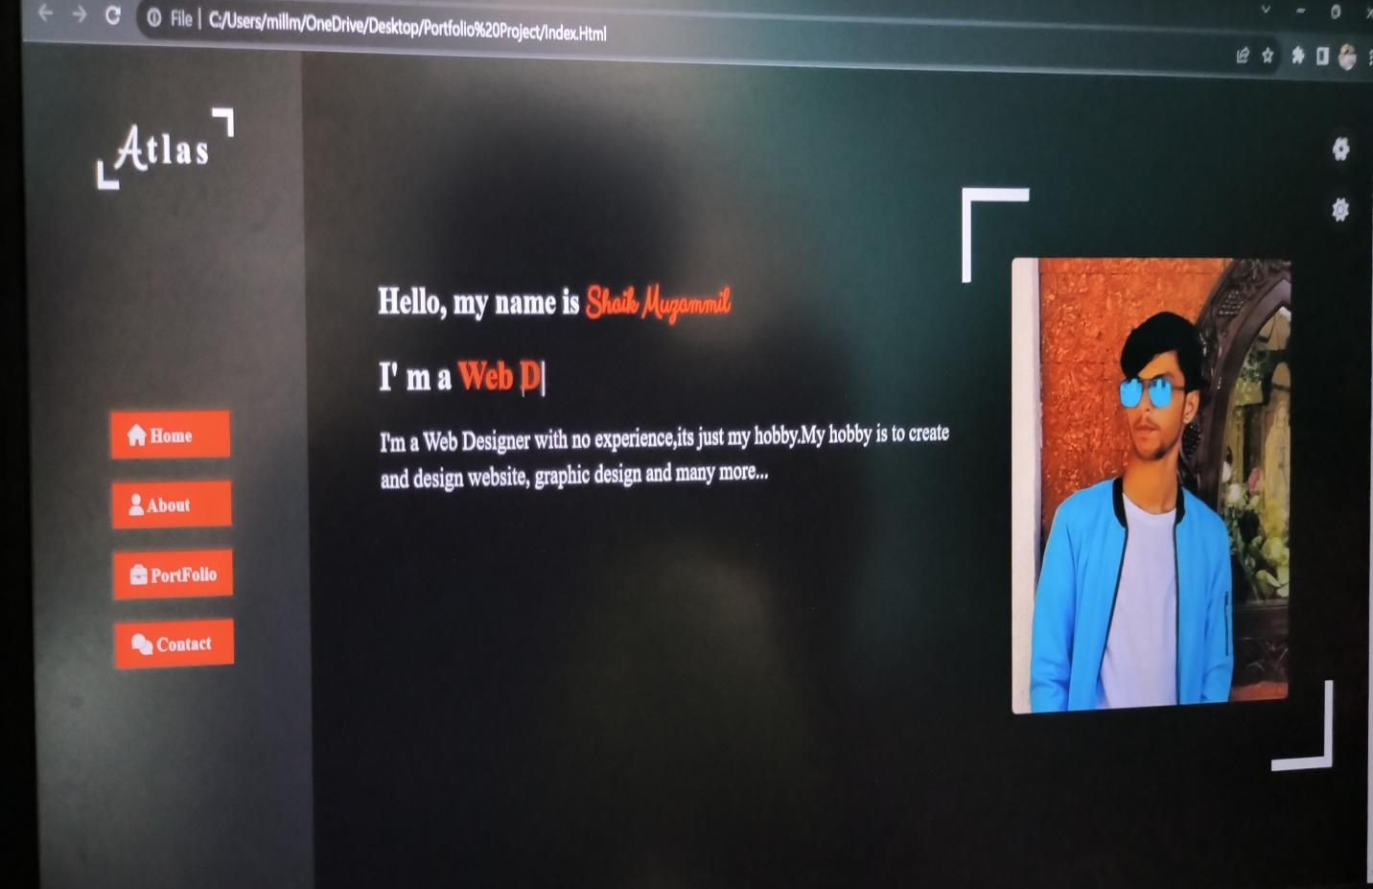

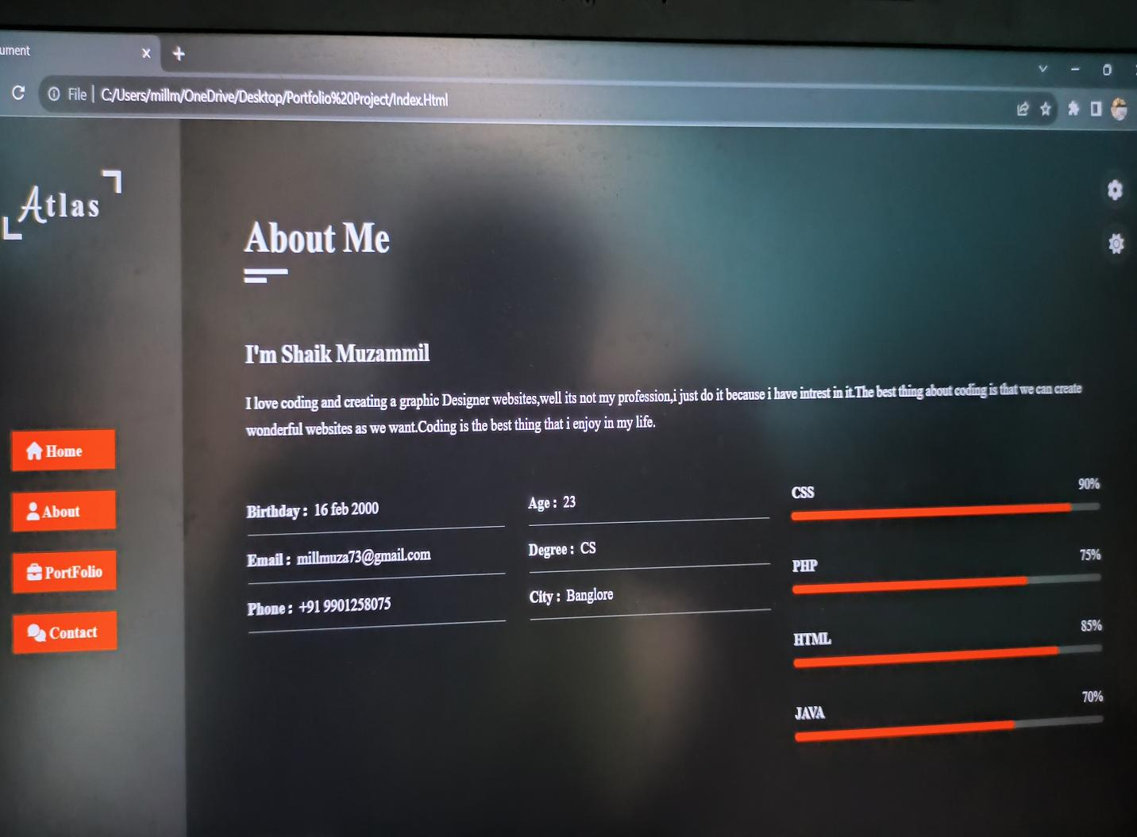

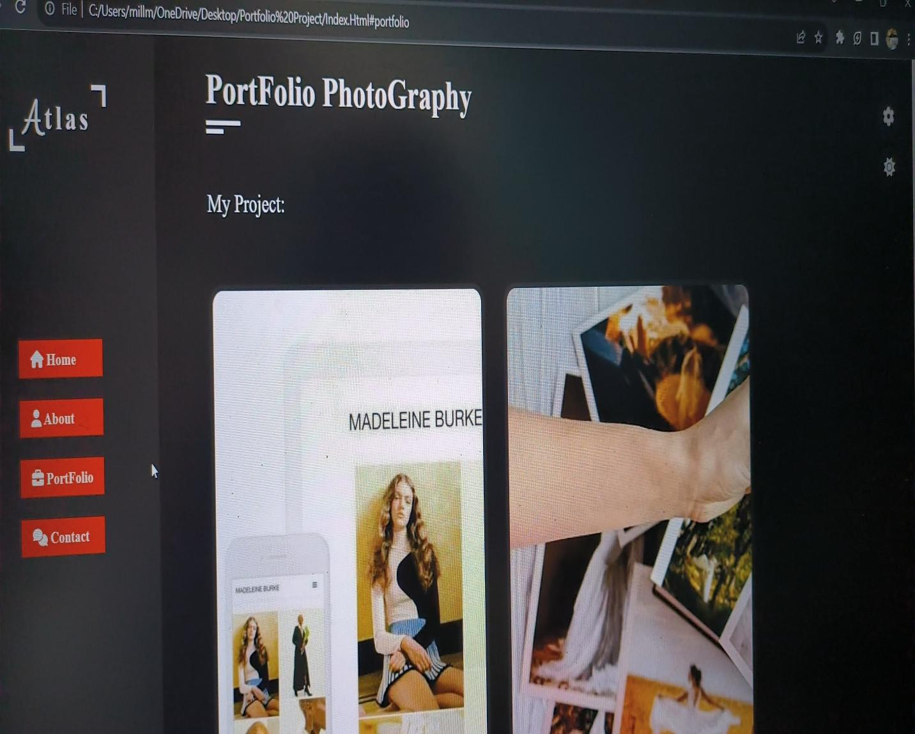

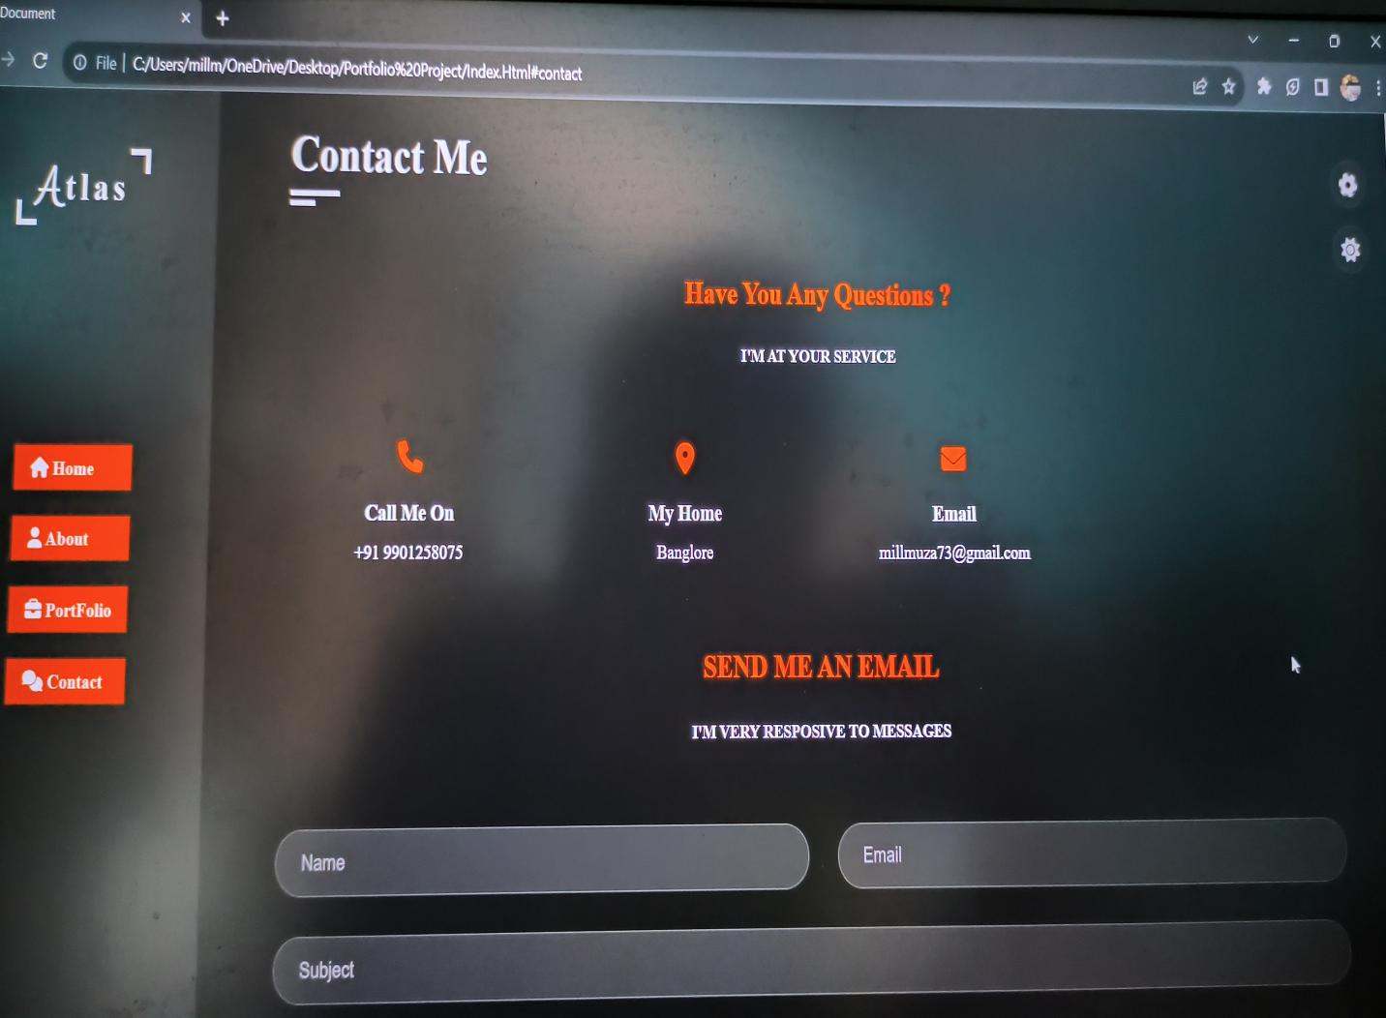

# [CHAPTE](https://1.bp.blogspot.com/-dODuK8N5h1Q/Wlnyb3V9HFI/AAAAAAAACL4/WxQtCJ1pM5wccDABg4wIrTBUB0vlikXQQCLcBGAs/s1600/poly1.jpg)R 9 CONCLUSION

* 1. **CONCLUSION**

The package was designed in such a way that future modifications can be done easily. Thefollowing conclusionscan bededucedfromthedevelopmentoftheproject:

* Automationoftheentire systemimprovestheefficiency
* It provides a friendly graphical user interface which proves to be better when comparedtotheexistingsystem.
* Itgivesappropriateaccessto theauthorizedusersdependingon theirpermissions.
* Iteffectivelyovercomesthedelayin communications.
* Updatingofinformationbecomes so easier
* Systemsecurity,datasecurityandreliability arethestrikingfeatures.
* TheSystemhasadequatescope formodificationinfuture ifitis necessary.

# REFERENCE

1.[How to create a Portfolio page using HTML CSS and JavaScript ? - GeeksforGeeks](https://www.geeksforgeeks.org/how-to-create-a-landing-page-using-html-css-and-javascript/)

2. [W3Schools Online Web Tutorials](https://www.w3schools.com/)