HotelEnergySense
Energy Efficiency Optimization using Hotel Booking Demand Prediction
Product Prototype and Technical Report

Product Name | HotelEnergySense
Application Domain | Hospitality Energy Management and Demand Forecasting
Subject | Machine Learning
Course Code | CS-447
Department | Computer Science (Evening)
Semester / Section | 6th (C)
Submitted To | Ms. Aneeza Fatima
Submitted By / Group Members
No. | Group Member Name | Registration No.
1 | Muhammad Abu Bakar | 23014119-030
2 | Fahad Farooq | 23014119-037
3 | Syed Ghayoor Abbas | 23014119-058
4 | Talha Liaqat | 23014119-125
Department of Computer Science (Evening)

Table of Contents
Section | Page
Executive Summary | 3
Introduction | 3
1. Product Design | 3
1.1 Data Source and Theme Selection | 3
1.2 End User Requirements | 4
1.3 Software Architecture and Use Cases | 4
2. Product Development | 4
2.1 Tools, Platforms and Methodology | 4
2.2 Machine Learning Models and Workflow | 5
2.3 Dashboard Visual Analytics | 5
2.4 Testing and User Evaluation | 12
3. Project Management | 12
3.1 Three-Month Project Timeline | 12
3.2 Risk, Quality and Governance | 13
3.3 Customer Relationship and Marketing Strategy | 13
Conclusion | 13
References | 14

Executive Summary
HotelEnergySense is a Streamlit decision-support prototype that combines hotel demand forecasting with building energy-load estimation. The system uses booking records to estimate the probability of realised occupancy and uses an energy-efficiency dataset to predict heating and cooling loads. These outputs are connected through an adjustment formula, allowing hotel managers to translate expected demand into a practical energy-readiness recommendation.

Introduction
Hotels must maintain guest comfort while also controlling operating costs and reducing unnecessary energy use. Heating, cooling and ventilation are among the most important energy-consuming services because their workload changes with guest demand, seasonality, building structure and service expectations. During periods of high occupancy, energy systems must be ready to support comfort. During low-demand periods, avoidable heating and cooling can be reduced. For this reason, predictive analytics is well suited to hotel energy planning.
This report presents HotelEnergySense, a data science prototype that connects booking-demand prediction with building energy-load estimation. It is designed for practical users such as hotel managers, facility teams and sustainability officers. Through the Streamlit interface, a user can enter booking and building information, view the predicted occupancy probability, estimate heating and cooling demand, and receive a plain-language energy recommendation without interacting directly with code.
The prototype uses two publicly available datasets. The hotel booking dataset contains records for city and resort hotels and supports demand modelling through variables such as hotel type, arrival month, lead time, guest count, stay duration, average daily rate, booking changes, parking spaces and special requests. The UCI Energy Efficiency dataset supports heating-load and cooling-load prediction using building geometry and glazing features. Because the two datasets describe different real-world contexts, they are not physically merged; instead, the project links them through the predicted occupancy probability.
The integration rule is: Adjusted Energy Consumption = Predicted Energy Load x Occupancy Probability. This rule simulates how expected guest demand can influence energy preparation. The prototype is not intended to replace a complete building-management system; rather, it demonstrates how machine learning outputs can be converted into a simple decision-support workflow for sustainable hotel operations.

1. Product Design

1.1 Data Source and Theme Selection
Hospitality energy optimisation was selected because hotels need to balance guest comfort, cost control and sustainability goals. The booking dataset is used to model demand, while the energy-efficiency dataset is used to model building energy behaviour. In the booking data, a non-cancelled reservation is treated as realised occupancy, while a cancelled reservation is treated as unrealised demand. This assumption is suitable for the prototype because the dataset does not include live room-occupancy sensor readings. In the energy dataset, heating load and cooling load are used as the prediction targets.
Before model development, missing values were inspected with df.isnull().sum(). In the original hotel booking dataset, the columns with missing values were children, country, agent and company. Children had 4 missing values and was filled with 0, while country had 488 missing values and was labelled as Unknown. Agent and company had 16,340 and 112,593 missing values respectively, so they were excluded from the final feature set because they were not essential to the occupancy model. After cleaning and feature selection, the hotel modelling table contained 118,565 rows and 10 selected columns with no remaining null values. The energy-efficiency table contained 768 rows and 10 selected columns, also with no missing values.

1.2 End User Requirements
The intended users are hotel managers, operations staff, facility managers and sustainability officers. These users need clear operational guidance rather than technical model details. Therefore, the product must be simple to navigate, quick to interpret and practical for daily decision-making. Users should be able to review demand patterns, enter prediction inputs and understand the energy recommendation without needing specialist machine learning knowledge.
The functional requirements include loading datasets, preprocessing records, generating exploratory visualisations, training models, saving and loading trained models, predicting occupancy, estimating heating and cooling loads, calculating adjusted energy demand, displaying evaluation metrics and presenting the project timeline. The non-functional requirements include usability, reasonable response speed, maintainable code structure, transparent outputs, modular file organisation and basic data-governance awareness.

1.3 Software Architecture and Use Cases
The system is organised in a modular structure. The data-preparation component cleans the raw datasets and creates derived variables, including total guests, total stay nights and arrival month number. The machine-learning workflow trains the hotel occupancy classifier and the heating and cooling regression models, then stores the trained files in the models directory. The Streamlit app is divided into pages for the homepage, analytics dashboard, prediction workflow and model evaluation, which improves testing and maintainability.
A normal usage scenario starts with a manager reviewing dashboard trends such as monthly occupancy demand, guest distribution and energy relationships. The manager then enters booking and building values on the prediction page. The system estimates occupancy probability, predicts base heating and cooling loads, adjusts those loads by the occupancy probability and displays the final recommendation. High expected occupancy leads to a readiness recommendation, while low expected occupancy supports energy-saving action.

2. Product Development

2.1 Tools, Platforms and Methodology
Python was chosen because it supports both data-science experimentation and rapid application development. Pandas and NumPy handle data processing, scikit-learn supports model development, joblib saves trained models, Plotly provides interactive charts and Streamlit delivers the web interface. Since the datasets are moderate in size, development can be completed on a normal laptop or desktop computer. Streamlit is especially suitable because the project requires a usable prototype rather than a large enterprise deployment.
The development approach follows rapid prototyping. The first version focused on a working pipeline for loading data, cleaning features, training models and saving results. Later versions added dashboard charts, evaluation outputs, business recommendations, visual styling and project-management content. This iterative method is appropriate for a data-science product because feature choices, preprocessing decisions and model settings often need repeated testing.

2.2 Machine Learning Models and Workflow
The hotel component predicts whether a booking is likely to become realised occupancy. The selected inputs are hotel type, arrival month number, lead time, total guests, total stay nights, average daily rate, booking changes, required parking spaces and total special requests. Hotel type is treated as the categorical feature and is transformed through one-hot encoding. A Random Forest Classifier is used because the target is binary. The model returns both a class label and an occupancy probability, and the probability is used as the linking variable for the energy adjustment.
The energy component estimates heating and cooling requirements through two separate regression models. The inputs are relative compactness, surface area, wall area, roof area, overall height, orientation, glazing area and glazing area distribution. Separate models are trained because heating and cooling represent different load behaviours. Random Forest Regressors are used because they can model non-linear relationships between building characteristics and energy outcomes. Performance is evaluated using Mean Absolute Error and R-squared values.
The workflow moves from data loading to missing-value inspection, cleaning, feature transformation, exploratory analysis, model training, model saving, app-based model loading, user input collection, prediction generation and adjusted energy calculation. The final integrated value is calculated by multiplying each base energy prediction by the occupancy probability and then adding the adjusted heating and cooling loads.
Exploratory analysis supports the modelling process by showing monthly demand variation, guest-count patterns, stay-length distribution and relationships between building features and energy loads. These outputs are presented in the dashboard so the product works as both an analysis tool and a prediction tool. This context helps users interpret the model output more carefully.

2.3 Dashboard Visual Analytics
The following dashboard screenshots demonstrate the prototype interface, exploratory analysis outputs and energy-efficiency visualisations.

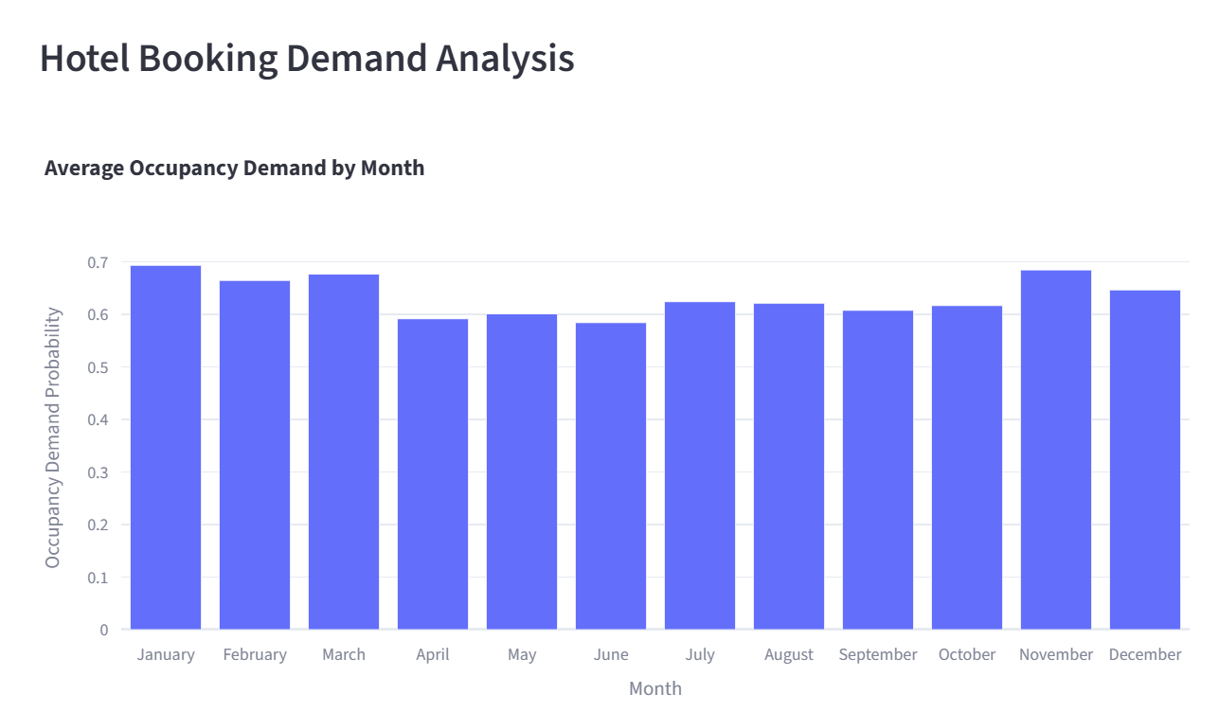
Figure 1. Hotel booking demand analysis: average occupancy demand by month.
Interpretation: The monthly demand chart indicates stronger occupancy probability in January, March and November, while April to June shows weaker demand. This pattern supports season-aware energy scheduling.

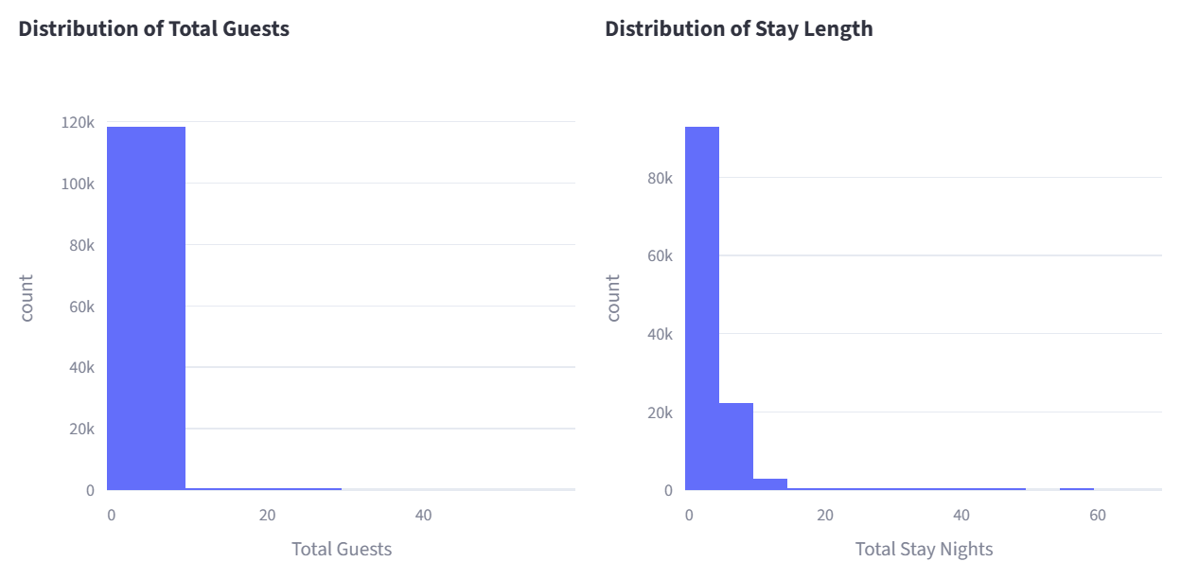

Figure 2. Distribution of total guests and total stay nights.
Interpretation: The distributions suggest that most bookings involve relatively small guest counts and shorter stays. This supports the use of derived features such as total guests and total stay nights in the demand model.

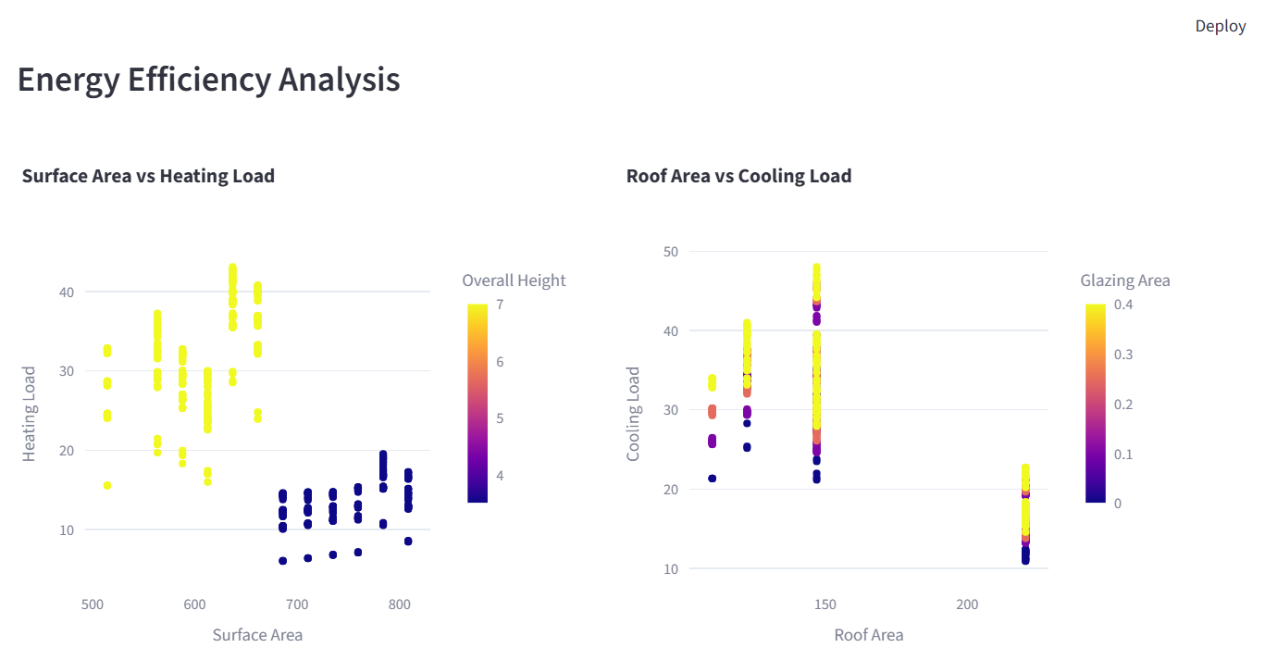

Figure 3. Energy efficiency scatter plots for heating and cooling load behaviour.
Interpretation: The energy plots show the relationship between building geometry, glazing-related inputs and predicted heating or cooling behaviour.

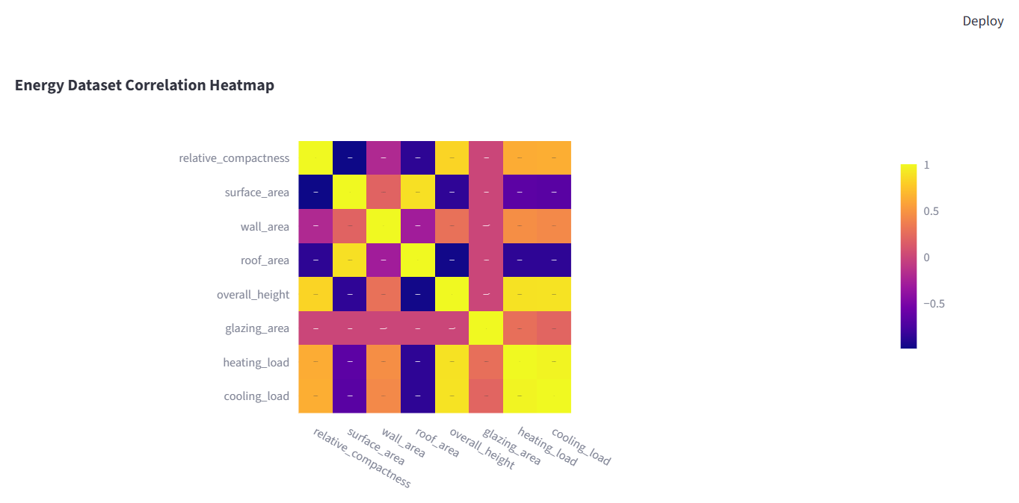

Figure 4. Correlation heatmap for the energy efficiency dataset.
Interpretation: The heatmap highlights the strongest relationships between building-geometry variables and the heating and cooling load targets.

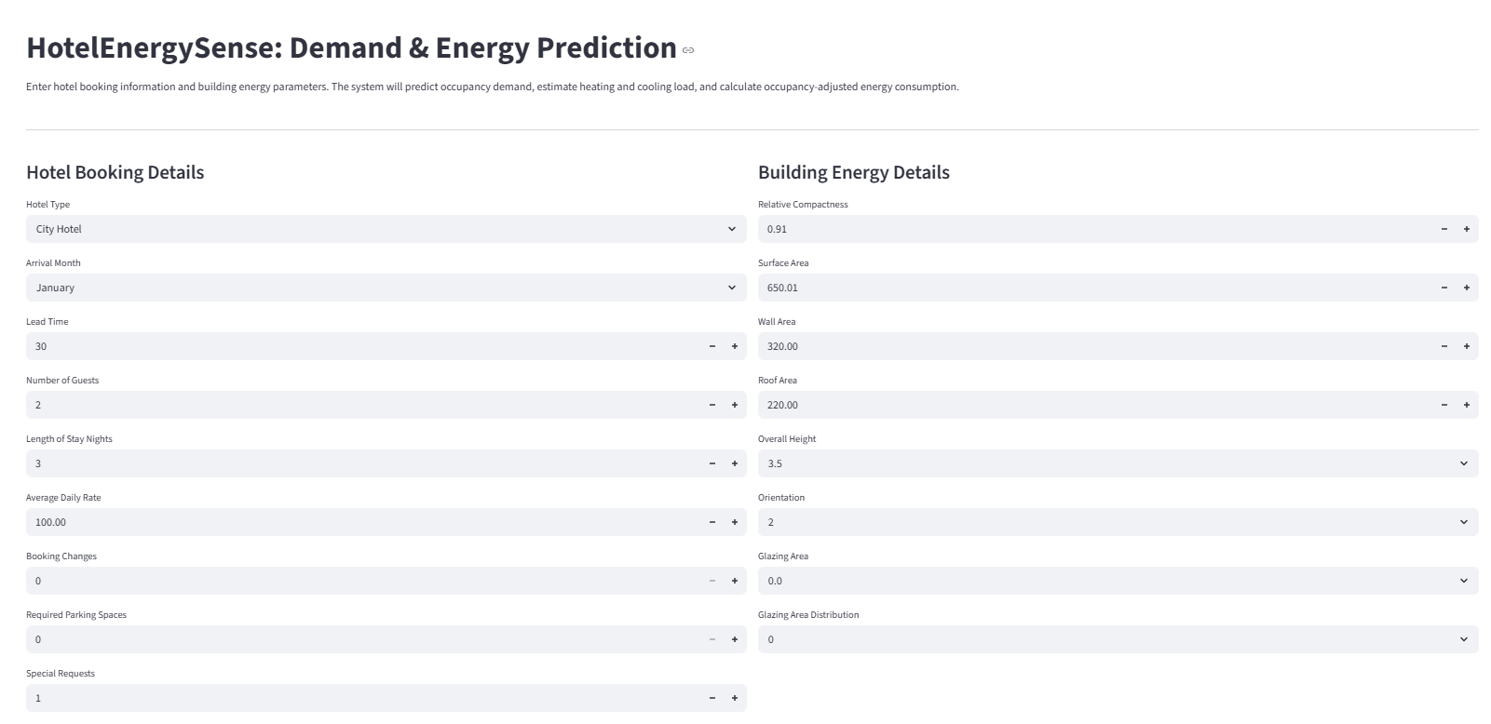
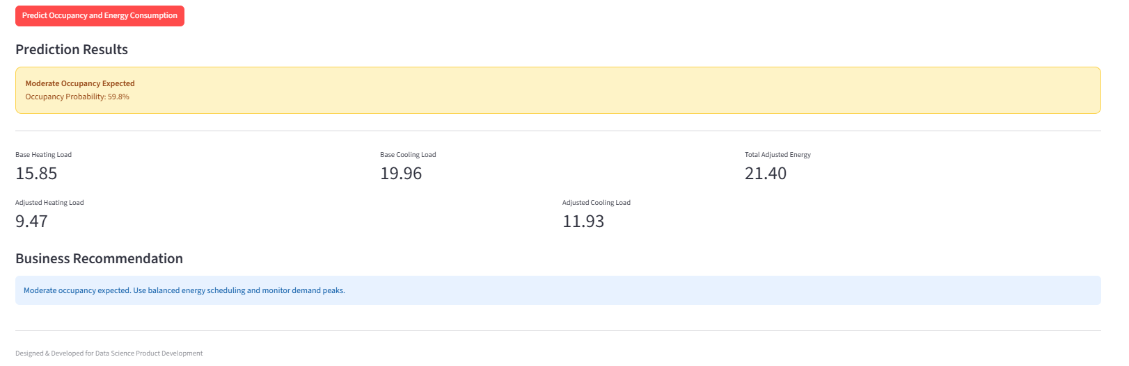
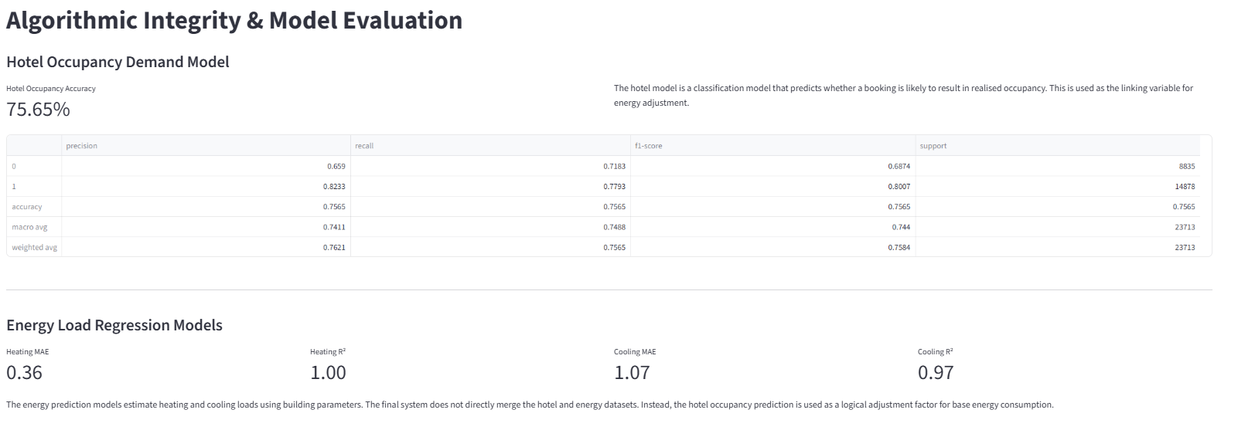

2.4 Testing and User Evaluation
Testing confirms that datasets load correctly, selected modelling columns contain no missing values, model files are created successfully and the Streamlit pages run without import errors. Prediction testing uses several scenarios, including low guest numbers, high guest numbers, longer stays and different building configurations. The evaluation page is also checked to confirm that accuracy, MAE and R-squared values are displayed correctly.
A short usability test can be used for user evaluation. A hotel-management user can be asked to review dashboard trends, generate an energy prediction and explain the final recommendation. Feedback should focus on clarity, navigation, confidence in the output and usefulness for routine hotel operations. This feedback can guide future interface improvements.
The final submission includes the Python source code, Streamlit interface, exploratory visualisations, trained model files, evaluation outputs and this technical report. Although a prototype is not always required in such assignments, it strengthens the project by showing that the predictive method can be converted into a simple working product.

3. Project Management

3.1 Three-Month Project Timeline
The project plan covers a three-month period. The first month focuses on dataset selection, cleaning and exploratory analysis. The second month focuses on model development and integration. The third month is reserved for Streamlit refinement, testing, evaluation and report writing. This schedule is realistic because it separates research, implementation and documentation into manageable stages.
Table 1. Three-month Gantt plan
Task | Month 1 | Month 2 | Month 3 | Main Output
Dataset research and selection | Yes |  |  | Dataset justification
Data cleaning and preprocessing | Yes |  |  | Prepared datasets
Exploratory data analysis | Yes | Yes |  | Dashboard charts
Hotel demand model |  | Yes |  | Occupancy classifier
Energy load models |  | Yes |  | Heating and cooling regressors
Model integration |  | Yes | Yes | Adjusted energy logic
Streamlit prototype |  | Yes | Yes | Working app
Testing and report writing |  |  | Yes | Final submission

3.2 Risk, Quality and Governance
Risk management is necessary because demand and energy predictions can influence operational decisions. Although the dataset used in this project is anonymised, a real deployment would require stronger governance controls. Personal data should be minimised, identifiers should be removed where possible, access should be limited and files should be stored securely. Energy and occupancy information can also be commercially sensitive because it may reveal business activity, so system access should be restricted to authorised staff.
Quality control is supported by modular code, clear file naming, reusable functions, repeatable setup steps and regular testing. The folder structure separates datasets, model files and application pages. Training logic is separated from the Streamlit interface so the app can load saved models during prediction. This reduces runtime errors and improves maintainability. Evaluation metrics are displayed so users understand that predictions are estimates rather than guaranteed outcomes.
Table 2. Key risks and controls
Risk | Impact | Likelihood | Control
Poor model accuracy | Incorrect energy decisions | Medium | Show metrics and treat results as decision support
Data privacy concerns | Loss of trust or non-compliance | Medium | Use anonymised data and access control
Dataset mismatch | Integration is simulation-based | Medium | Use occupancy probability as the logical link
Usability problems | Low adoption by hotel staff | Medium | Use simple forms and plain-language outputs
Time limitation | Incomplete prototype | Medium | Prioritise the core prediction workflow

3.3 Customer Relationship and Marketing Strategy
Customer relationship management for this prototype focuses on involving target users during review. Hotel managers can be asked whether the selected inputs reflect real operational decisions and whether the recommendation text is easy to understand. Their feedback can guide future enhancements such as weather integration, room-level occupancy inputs, smart-meter connections and downloadable reports.
The product can be positioned as a lightweight cost-control and sustainability tool for small and medium-sized hotels. Its main value is the connection between expected booking demand and energy planning, helping managers reduce waste without ignoring guest comfort. A future commercial version could include monthly forecasts, property-management-system integration and sustainability-audit reporting.

Conclusion
HotelEnergySense shows how machine learning can be applied to hospitality energy planning in a practical way. The booking model estimates the probability of realised occupancy, while the energy models estimate heating and cooling loads from building-design inputs. By linking these outputs through occupancy probability, the prototype converts separate model predictions into an adjusted energy estimate that is easier for hotel managers to interpret.
Overall, the project meets the core requirements by using two open-source datasets, applying cleaning and preprocessing, producing exploratory visualisations, training machine-learning models, integrating the results and presenting the workflow through a Streamlit application. The main limitation is that the booking and energy datasets come from different sources, so the integration is a simulation rather than a measurement from one real hotel site. Future development should include live occupancy signals, weather variables, smart-meter readings, HVAC specifications and hotel-specific energy records. Despite this limitation, the prototype provides a clear foundation for sustainable hotel energy decision support and demonstrates how data science can be transformed into a usable product interface.

References
Antonio, N., Almeida, A. and Nunes, L. (2019) 'Hotel booking demand datasets', Data in Brief, 22, pp. 41-49. Available at: https://doi.org/10.1016/j.dib.2018.11.126
UCI Machine Learning Repository (2012) Energy Efficiency Data Set. Available at: https://archive.ics.uci.edu/ml/datasets/Energy%2Befficiency
Tsanas, A. and Xifara, A. (2012) 'Accurate quantitative estimation of energy performance of residential buildings using statistical machine learning tools', Energy and Buildings, 49, pp. 560-567.

