Rip Configuration

Step 1

Router configuration both

Pc configuration

Rip protocol

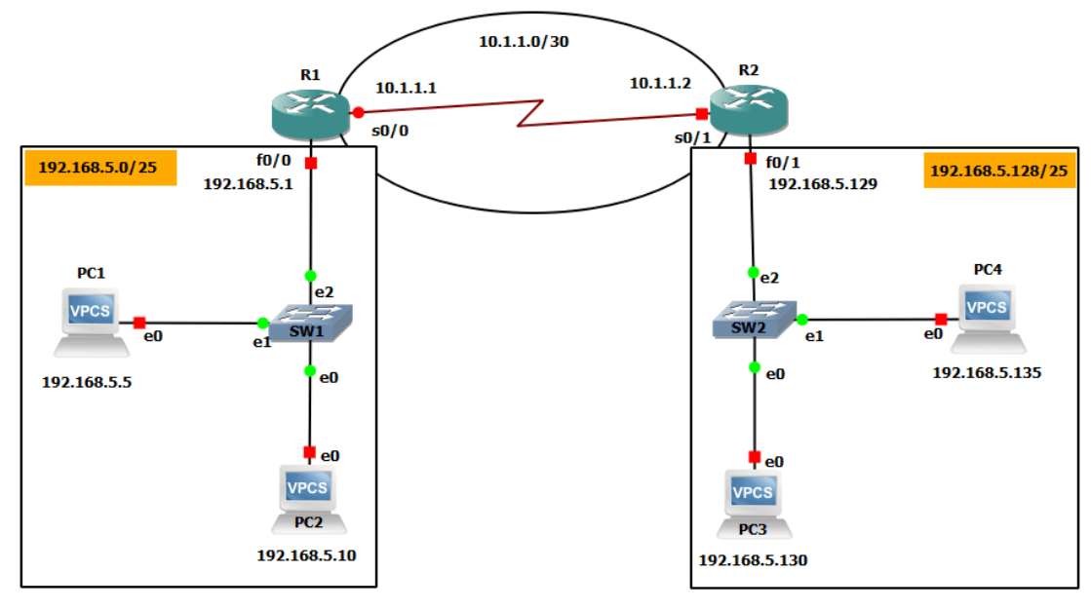

PC1> ip 192.168.5.5 255.255.255.128 192.168.5.1

PC2> ip 192.168.5.10 255.255.255.128 192.168.5.1

PC3> ip 192.168.5.130 255.255.255.128 192.168.5.129

PC4> ip 192.168.5.135 255.255.255.128 192.168.5.129

R1#conf t

R1(config)#interface fastethernet 0/0

R1(config-if)#ip address 192.168.5.1 255.255.255.128

R1(config-if)#no shutdown

R1(config-if)#exit

R1(config)#

R1(config)#interface serial 0/0

R1(config-if)#ip address 10.1.1.1 255.255.255.252

R1(config-if)#no shutdown

R1(config-if)#end

R1#

R1#show ip interface brief

R2#conf t

Enter configuration commands, one per line. End with CNTL/Z.

R2(config)#interface fastethernet 0/1

R2(config-if)#ip address 192.168.5.129 255.255.255.128

R2(config-if)#no shutdown

R2(config-if)#exit

R2(config)#

R2(config)#

R2(config)#interface serial 0/1

R2(config-if)#ip address 10.1.1.2 255.255.255.252

R2(config-if)#no shutdown

R2(config-if)#end

R2#

R1#conf t

R1(config)#router rip

R1(config-router)#version 2

R1(config-router)#network 10.1.1.0

R1(config-router)#network 192.168.5.0

R1(config-router)#end

R1#

R2#conf t

Enter configuration commands, one per line. End with CNTL/Z.

R2(config)#router rip

R2(config-router)#version 2

R2(config-router)#network 10.1.1.0

R2(config-router)#network 192.168.5.128

R2(config-router)#end

R2#

**show ip route**