Name: Xiaoyu Liu (Mia)

The result is still different from the correct result, and I am still actively solving the problem.

The following pages are the theory of my code:

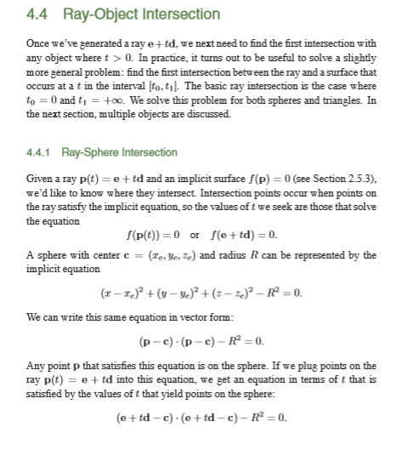

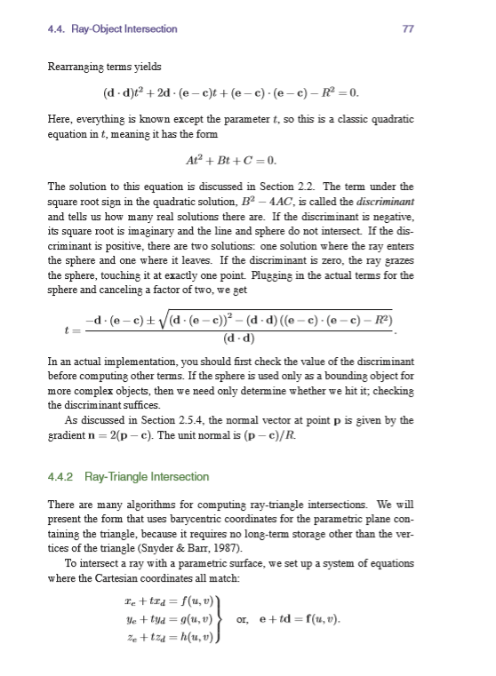

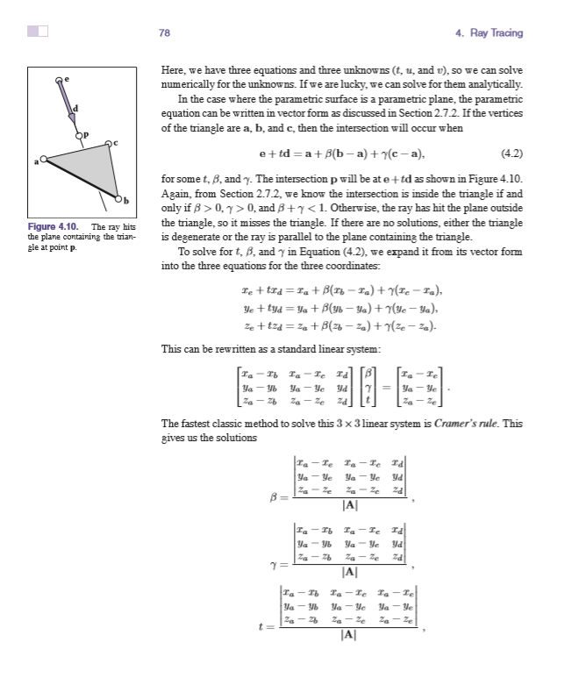

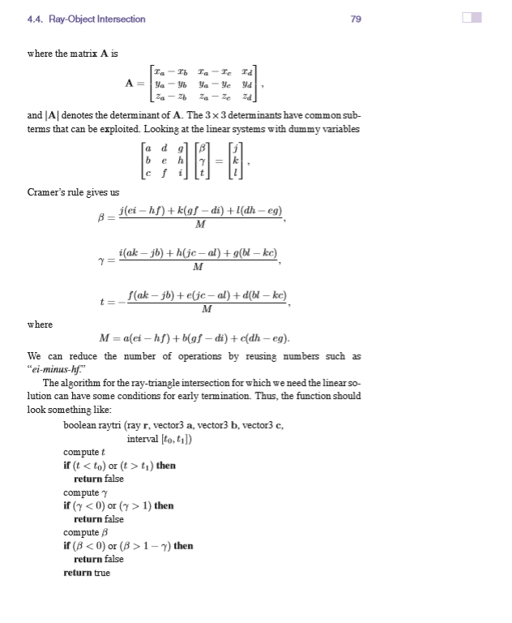

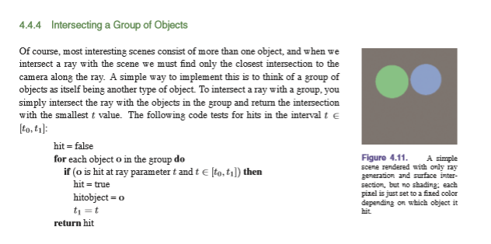

I also referred to a code which I found on the website:

<https://github.com/JinHuiXu1991/CMSC435/tree/ab90b3507e682cf93c340f28989bbb647a9836b0/proj2>

Here is the output of balls.nnf

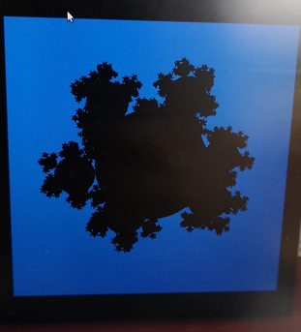

The output of teapot.nnf is all blue.