Huarui Lu, Zhiwei Li, NUID:001050438

Ranking System

Spring 2020 INFO6205 Project

**Team Member**

The prediction of English Premier League in 2019-2020 season.

# Introduction

## What is Ranking System?

A ranking is a relationship between a set of items such that, for any two items, the first is either 'ranked higher than', 'ranked lower than' or 'ranked equal to' the second.[1] A ranking system is a system that analyzes the input provided by users to provide the ranking for each element.

Our task is to develop a ranking system which is able to evaluate the following expression where are elements from a set of competing elements :   
where is the probability that would beat if they met in a head to head matchup at neutral territory.

In this project, we created a ranking system for English Premier League (EPL). The input to our system is a set of prior encounters with a result. These results are scores of each game. The output is the probability of win-draw-lose in coming games in season 2019-2020 according to the schedule.

To present our prediction result, probability density function (PDF) is used to show the probability .

## Probability Density Function

In probability theory, a probability density function (PDF), or density of a continuous random variable, is a function whose value at any given sample (or point) in the sample space (the set of possible values taken by the random variable) can be interpreted as providing a relative likelihood that the value of the random variable would equal that sample.[2]

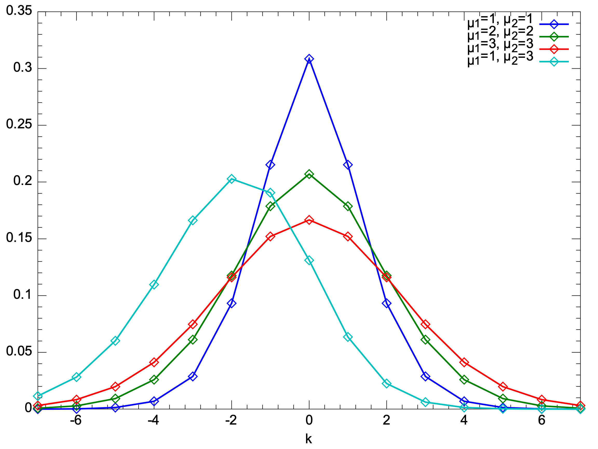

Fig.1. Probability density function of Skellam Distribution.

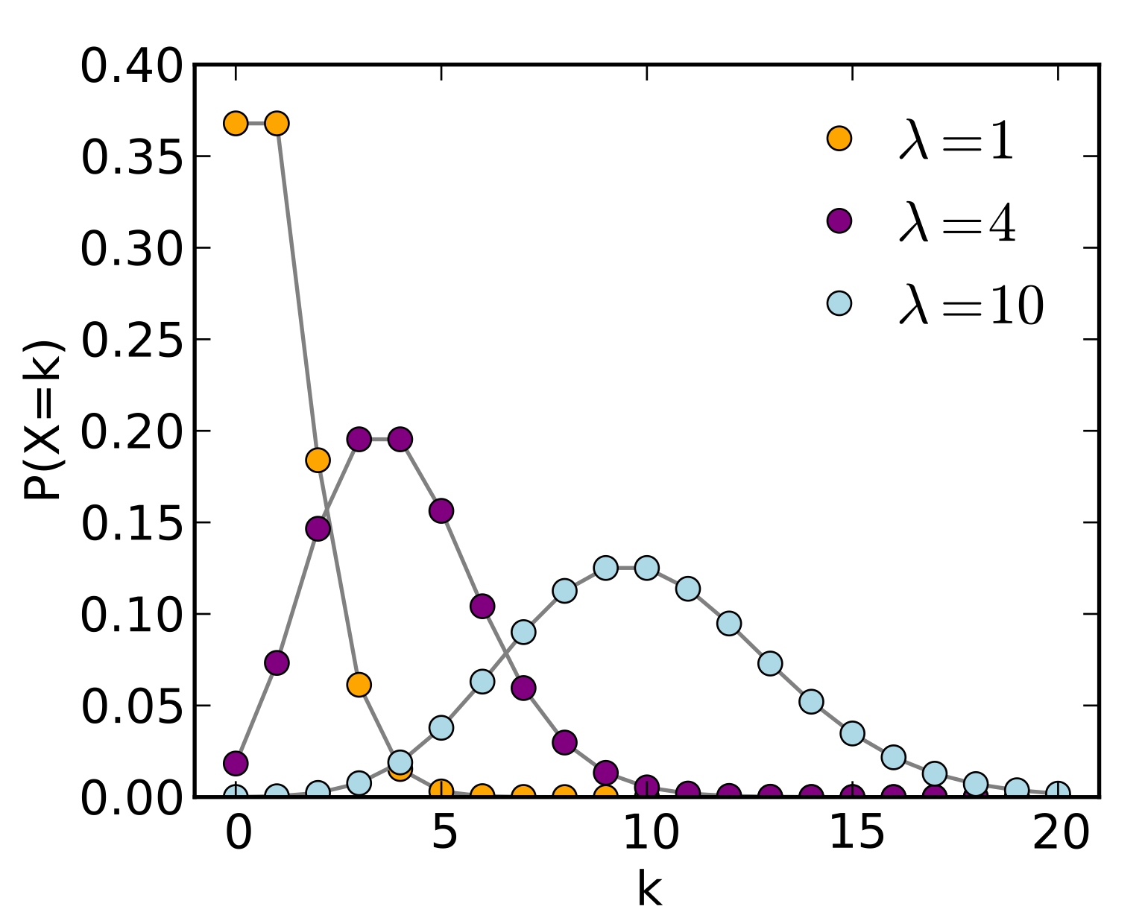

Fig.2. Probability density function of Poisson Distribution.

[数学原理]

# Aim of the Project

Designed the EPL Ranking System.

* Calculate the win, draw and loss probability that team A will beat team B if they meet with each other in a head to head matchup.
* Draw the probability density function for goal difference in each game.
* Predict those coming games. “Complete the season” and give a final table with 38 matches “played” by each team.

# Dataset used in this project

In this project, dataset is EPL 2019-2020 season result (those games finished). Data is saved in a CSV file.

Fig.3. An overview of data in 2019-2020 season

# Project Description

# Implementation

[类截图]

# Output

1. Win/Draw/Loss Probability

Fig.4 A screenshot of output in command line

1. Probability Density Function

Fig.5 Two examples of product density function graph.

1. Final Table

# Conclusion and Future Implementations

1. [最后的比赛结果，谁是冠军，谁降级了]
2. In the future, we would analysis the effect of home team advantage. And quantify it into a parameter in our prediction, which make our prediction and ranking system more precise. And we could also make a GUI for our ranking system and do some visualization work, which can improve our project into an interactive system.

# References

[1] <http://www.merriam-webster.com/dictionary/ranking>

[2] Grinstead, Charles M.; Snell, J. Laurie (2009). "Conditional Probability - Discrete Conditional" (PDF). Grinstead & Snell's Introduction to Probability. Orange Grove Texts. ISBN 161610046X. Retrieved 2019-07-25.

[3] <https://en.wikipedia.org/wiki/Skellam_distribution>

[4] <https://en.wikipedia.org/wiki/Bessel_function#Modified_Bessel_functions_:_I.CE.B1.2C_K.CE.B1>

[5] <https://en.wikipedia.org/wiki/Poisson_distribution>