It is well known that the power spectrum of the sEMG shifts to a lower frequency during a sustained muscle contraction. The spectral parameters, such as the mean frequency (MNF) and the median frequency (MF), are the manifestation of localized muscle fatigue.

The Progression of Muscle Fatigue During Exercise Estimation With the Aid of High-Frequency Component Parameters Derived From Ensemble Empirical Mode Decomposition

A useful nonstationary and nonlinear signal processing technique, known as empirical mode decomposition (EMD), has been proposed. With an iterative decomposition of signals, EMD separates the full signal into ordered elements with frequencies ranging from high to low in each intrinsic mode function (IMF) level. Results showed that HHT-derived (Hilbert-Huang Transform) spectral and linear regression parameters were consistent and more reliable than those obtained with the short-time Fourier transform and the wavelet transform.

The procedure of the Ensemble EMD is to add statistically zero-mean noise into the signal with sufficient trials, and the ensemble IMF is estimated by the summation of the IMF from each trial of the same level. The goal of this study is not to quantify the myoelectric manifestation of muscle fatigue. Our goal is to find a more sensitive and stable method to sense the progression of muscle fatigue in the local muscle during exercise.

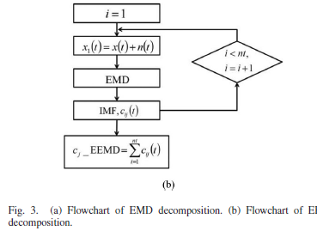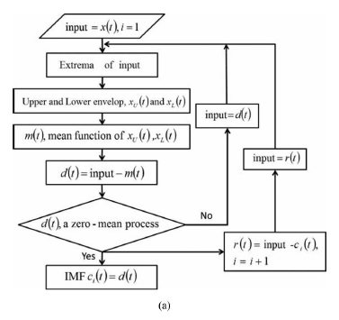

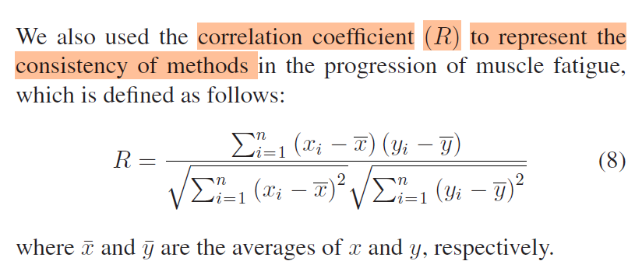

Proposed Fatigue Index for the Objective Detection of Muscle Fatigue Using Surface Electromyography and a Double-Step Binary Classifier

They suggested that the frequency spectrum of the EMG can be classified into three regions, namely,

* low-frequency components (LFC) (20–45 Hz),
* intermediate-frequency components (IFC) (46–80 Hz),
* high-frequency components (HFC) (81–350 Hz).

It is suggested that the power of the LFC increases, while that of the HFC decreases.

Fatigue occurs when the power of the LFC is equal to the power of the HFC (<https://ieeexplore.ieee.org/document/7591924/>).

The segmented EMG signal was filtered by two band-pass filters separately to produce two sub-signals, namely,

* a high-frequency sub-signal (HFSS) and
* a low-frequency sub-signal (LFSS).

Then, the instantaneous mean amplitude (IMA) was calculated for the two sub-signals to ultimately obtain the fatigue index, which represents

the difference between the IMA values of the LFSS and HFSS, respectively.

* The high-frequency components had been identified to be in the range of 80–350 Hz.
* The LFC lay in the range of 25–79 Hz.

An kai erxetai se antithesi me theoria einai afto pou ulopoieitai sto paper. Apofevgetai h xrhsh tou intermediate component.

Then, the fast Fourier transform (FFT) was applied to these sub-signals to produce the LFSSf and HFSSf.

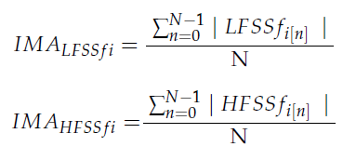

Apo katw einai ta duo IMA gia to LFC kai to HFC. Apo oti fainetai se afton otan to low perasei to high exoume fatigue. Afto genika to akolouthisa sthn diplwmatiki alla se emena ta IMA den suberiferontai etsi. Pistevw pws paizei polu rolo to oti einai allos mus giati aftos exei kanei sto xeri thn askhsh.

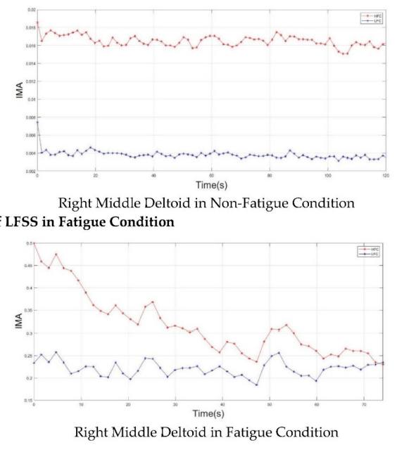

For an accurate evaluation and in considering each sEMG signal as having segments of length N, the fatigue indices of the first and last three sEMG segments of all the subjects in fatigue condition were calculated. A fatigue index with a negative value was an indication of non-fatigue, while a zero or positive value was an indication of fatigue.

HIGH ACCURACY RECOGNITION OF MUSCLE FATIGUE BASED ON SEMG MULTIFRACTAL AND LSTM

more research into changes in the local features of various levels of sEMG signals is necessary using the multifractal technology. A spectrum that depicts a subset and the appropriate fractal dimension is typically used to define multifractals. The major algorithms are:

* multifractal detrended fluctuation analysis (MFDFA)
* multifractal detrended moving average (MFDMA).

According to the calculations that MFDMA can perform, the four multiple fractal characteristics of SOM, DOM, DFS and PSE widths of the multifractal spectra were wider during fatigue than when they were during non-fatigue.

SOM: Strength of Multifractality

DOM: Degree of Multifractality

DFS: Difference of Multifractal Spectrum

PSE: Peak Singularity Exponent

The multifractal spectra are symmetrical along the approximate axis in the non-fatigued condition, but with muscular fatigue, this symmetry tendency is greatly diminished.

The SOM, DOM and PSE features have clear feature distinctions between the non-fatigue and fatigue states, and the feature overlap rate of the two states is low,

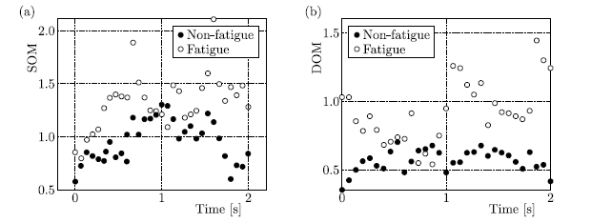

whereas the DFS features have a greater overlap, and the distinction is less clear.

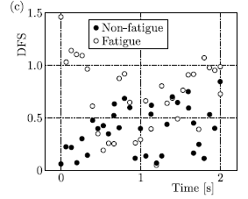

The difference between the aforementioned mean values of the properties of the myoelectric signals of 10 subjects under the fatigue and non-fatigue scenarios was observed using the t-test method in order to further determine whether the SOM, DOM, DFS and PSE extracted by the MFDMA algorithm have statistically significant differences under such scenarios.

According to the findings, the three characteristics (SOM, DOM and PSE) that were derived from the multiple fractal spectrum using the MFDMA method were statistically significant (P-value 0.01) in determining whether or not the muscles were exhausted.

Comparatively, the difference in DFS variability is relatively small. The findings could offer a fresh feature reference for deep learning and machine learning models that recognize muscle fatigue.

METRICS EXPLAINED

SOM – Strength of Multifractality

* SOM measures the range of singularity strengths (αmax−αmin​) in the multifractal spectrum.
* Larger amplitude fluctuations create a wider multifractal spectrum, increasing αmax−αmin​.
* In sEMG, as fatigue progresses, motor units fire irregularly, leading to more significant amplitude changes and a higher SOM value.

DOM - Degree of Multifractality

* DOM measures the range of Hurst exponents (Hmax−Hmin​), which describe long-term correlations in the signal.
* As muscle fatigue sets in, irregular motor unit recruitment causes the amplitude fluctuations to lose consistency, widening the range of Hurst exponents.
* H>0.5 suggests persistent trends (high amplitudes last longer), while H<0.5 suggests anti-persistent trends (amplitudes switch more often).

DFS - Difference of Multifractal Spectrum

* DFS measures the height difference in the multifractal spectrum (f(αmax)−f(αmin)).
* Larger asymmetries in amplitude changes (e.g., sharp spikes or drops) lead to more significant differences in f(α), increasing DFS.
* Fatigue often introduces these asymmetries due to chaotic motor unit behavior.

PSE - Peak Singularity Exponent

* PSE focuses on a specific point in the multifractal spectrum (α(q=−5)), representing the dominant local scaling behavior.
* The peak singularity captures the strength of the largest amplitude variations in the signal.
* Fatigue leads to more extreme amplitude changes, increasing PSE.

*** The Hurst exponent quantifies the tendency of a time series to either:

* Persist in its current trend (positive correlation in the signal),
* Revert to the mean (negative correlation), or
* Behave like a random process.

The value of H ranges between 0 and 1:

* H=0.5: The signal behaves like a random walk (no memory), (uncorrelated behavior).
* H>0.5: The signal shows persistent behavior, meaning high values are likely to be followed by high values, and low values by low values, (long-term positive correlations).
* H<0.5: The signal exhibits anti-persistent behavior, where high values are likely to be followed by low values, and vice versa, (long-term negative correlations).

***************To moving average mikrainei to len tou simatos*****************

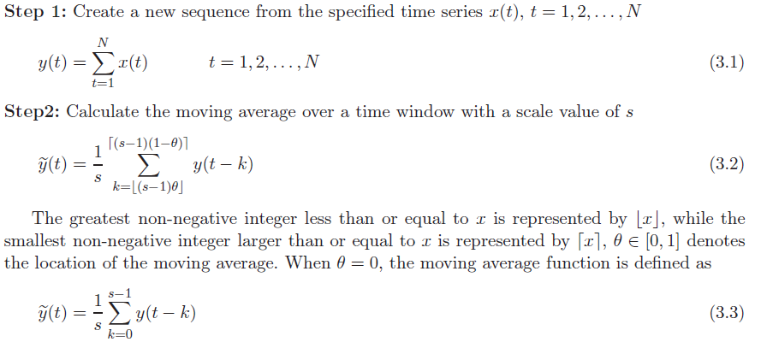

How to decide on θ?

The value of θ typically lies in the range [0,1].

* θ=0 would position the window at the start of the current sample, giving a right-aligned (causal) moving average.
* θ=1 would center the window, making it a symmetric (centered) moving average.
* Intermediate values of θ result in a window that is slightly shifted to the left or right.

Application to Muscle Fatigue:

To track muscle fatigue in real time and want the moving average to be updated immediately as new data comes in, a smaller θ closer to 0 might be appropriate. This would ensure that the output reflects the current and past muscle activity, without waiting for future data.

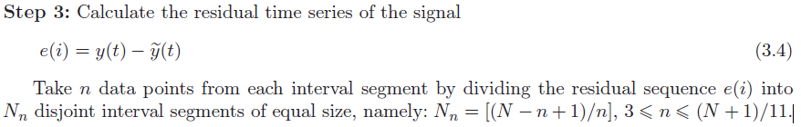

* The n data points in this context represent the window size,
* The formula Nn=[(N−n+1)/n] ensures that the segments do not overlap

!!! This is MFDFA, not MFDMA !!! (Still you can have insights on the way this analysis works)

<https://pypi.org/project/MFDFA/>

<https://ar5iv.org/html/2104.10470v1>

Results for when running the mfdma_analysis_rms_hurst_exponents.py

Choosing

* the file active_next2_ID2.json
* window sizes from 600 to 800 with step 100 (so 600,700,800)
* overlap automatically at 50% of the ws
* q_values from -3 to 3 with a step of 1 (-3, -2, -1, 0, 1, 2, 3)

MF-DMA Results (RMS Fluctuations for Different Window Sizes):

Each key represents a window size, and the values are the RMS fluctuations (Fq_values) for the corresponding q-values:

{

600: [172.15, 176.27, 180.46, 184.68, 188.88, 193.04, 197.15],

700: [173.79, 177.60, 181.49, 185.38, 189.25, 193.05, 196.76],

800: [176.09, 179.64, 183.21, 186.77, 190.27, 193.69, 196.99]

}

Comment: The RMS fluctuations grow consistently with increasing q-values, indicating stronger variability as q becomes more positive. This behavior aligns with the theoretical multifractal scaling properties.

Generalized Hurst Exponents h(q):

Each key represents a q-value, and the values are the calculated Hurst exponents:

{

-3: 0.0783,

-2: 0.0655,

-1: 0.0523,

0: 0.0388,

1: 0.0252,

2: 0.0113,

3: -0.0031

}

h(q) decreases as q increases, a typical feature in multifractal time series.

For q>0, smaller h(q) values indicate the series is less persistent in larger fluctuations.

For q<0, higher h(q) suggests stronger contributions from smaller fluctuations (anti-persistent behavior).

Being able to calculate the Fq values and the H(q) values, for different window sizes and q values 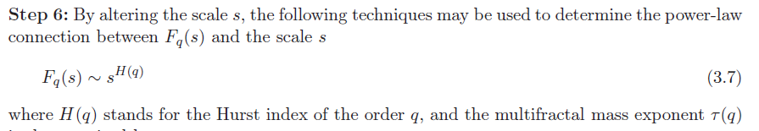

the next steps to be calculating are the following,

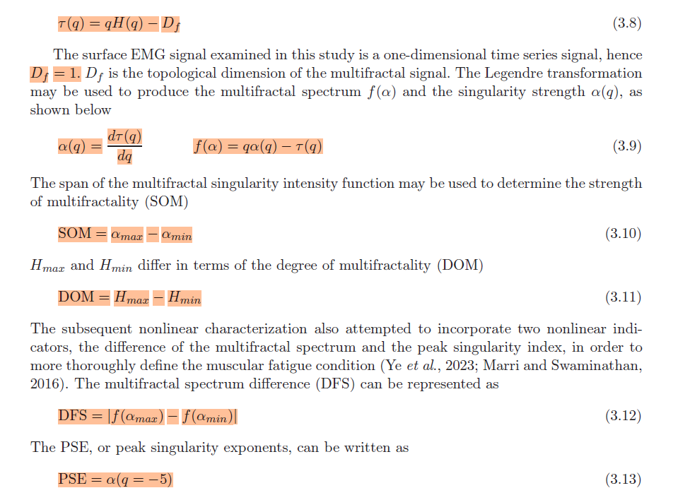

Done.

The results obtained for the same file (active_next2_ID2.json) as above were the following:

1. MF-DMA Results:

For each window size (600, 700, and 800), the following Fq​ values were obtained for the corresponding q-values (-3, -2, -1, 0, 1, 2, 3):

* For window size 600:
  + Fq= [172.149,176.267,180.459,184.675,188.877,193.040,197.148]
* For window size 700:
  + Fq= [173.788,177.603,181.486,185.382,189.246,193.045,196.757]
* For window size 800:
  + Fq= [176.094,179.640,183.213,186.770,190.272,193.686,196.989]

These values represent the scaling behavior of the signal with respect to different scales of the window size. Higher window sizes generally lead to larger fluctuation values as expected.

2. Hurst Exponents (h(q)):

The generalized Hurst exponents were computed for the q-values (-3, -2, -1, 0, 1, 2, 3):

Hurst Exponents:

* h(−3)=0.078
* h(−2)=0.065
* h(−1)=0.052
* h(0)=0.039
* h(1)=0.025
* h(2)=0.011
* h(3)=−0.003

The decreasing Hurst exponents indicate a more pronounced randomness in the signal as q increases, with the signal's temporal dependence becoming less pronounced at higher scales.

3. Multifractal Mass Exponent τ(q):

The multifractal mass exponent τ(q) was calculated as:

τ(q):

* τ(−3)=−1.235
* τ(−2)=−1.131
* τ(−1)=−1.052
* τ(0)=−1.000
* τ(1)=−0.975
* τ(2)=−0.977
* τ(3)=−1.009

The τ(q) values decrease as q increases, which is consistent with the typical behavior of multifractal time series, indicating a weaker scaling behavior with larger q-values.

4. Singularity Strength a(q):

The singularity strength a(q) is the derivative of τ(q) and represents the degree of singularity for each q-value

Singularity Strength a(q):

* a(−3)=0.104
* a(−2)=0.091
* a(−1)=0.065
* a(0)=0.039
* a(1)=0.011
* a(2)=−0.017
* a(3)=−0.032

These values indicate a gradual decrease in singularity strength as q increases, which suggests a less pronounced multifractal structure as we move to higher scales.

5. Multifractal Spectrum f(a):

The multifractal spectrum f(a) was computed as:

f(a):

* f(a(−3))=0.923
* f(a(−2))=0.948
* f(a(−1))=0.987
* f(a(0))=1.000
* f(a(1))=0.986
* f(a(2))=0.943
* f(a(3))=0.914

The spectrum is centered around 1.0 for a(0), with values slightly decreasing as the singularity strength moves away from the origin.

6. Strength of Multifractality (SOM):

The strength of multifractality is the difference between the maximum and minimum values of a(q):

* SOM = amax−amin=0.136

This indicates a moderate degree of multifractality, as the range of a(q) is not too large but still noticeable.

7. Degree of Multifractality (DOM):

The degree of multifractality (DOM) is the range of the Hurst exponents h(q):

* DOM = hmax−hmin=0.081

This relatively small value suggests that the signal has a mild degree of multifractality, with Hurst exponents showing a slight variation over the range of q-values.

8. Difference of Multifractal Spectrum (DFS):

The DFS is the absolute difference between the maximum and minimum values of f(a):

* DFS = ∣f(amax)−f(amin)∣=0.086

This indicates a moderate spread in the multifractal spectrum, showing variability in the scaling exponents across the signal.

9. Peak Singularity Exponent (PSE):

The peak singularity exponent is the value of a(q) at q=−5. However, as q=−5 was not included in the selected range of q-values (which went from -3 to 3), the PSE could not be computed for this signal:

PSE = None (because q=−5 was not part of the range)

General Comments until now:

* The Hurst exponents (h(q)) reflect the **degree of persistence** in the signal. A decreasing trend in h(q) (as observed in your results) could indicate increasing randomness in the muscle activity as fatigue sets in. This is consistent with fatigue theory, where fatigued muscles exhibit less coordinated firing patterns as motor unit recruitment becomes more irregular.
* The values you observed (ranging from ~0.078 to -0.003) suggest that the muscle activity in this case is transitioning from being persistent to more random as fatigue develops, which is typical.
* The singularity strength values for each q-value indicate how sharply the signal exhibits singularities (rapid changes). The decreasing trend in a(q) (from 0.104 at q=−3 to -0.032 at q=3) suggests that the signal becomes less **singular** (i.e., it exhibits less variation or "spike-like" behavior) as the muscle approaches fatigue. This behavior is also consistent with muscle fatigue, where the signal smooths out as muscle activity becomes more synchronized.
* The multifractal spectrum f(a) reflects the distribution of singularities within the signal. The values obtained, mostly between 0.914 and 1.0, indicate a relatively narrow spectrum, which typically suggests a **moderate degree of multifractality**. In the case of fatigue, we often see a **shift toward more uniform behavior**, which matches the trend of the spectrum approaching unity.
* SOM (0.136) and DOM (0.081) suggest that while the signal is multifractal, the multifractality is **moderate** rather than extreme. This is in line with the expectations for muscle activity, where there is some degree of nonlinearity and complexity, but not to the extent of chaotic or highly irregular signals.
* The DFS value of 0.086 is indicative of some variability in the multifractal spectrum, reflecting changes in the signal as fatigue sets in. This difference suggests that there is noticeable change in the multifractal behavior of the signal during the course of muscle fatigue, which could be useful for detecting the onset of fatigue in real-time.

NEXT STEPS – To be studied and then implemented…

