Install docx

**C:\Users\cxzhang>C:\Users\cxzhang\AppData\Local\Programs\Python\Python37\Scripts\pip.exe install python-docx -i http://mirrors.aliyun.com/pypi/simple/ --trusted-host mirrors.aliyun.com**

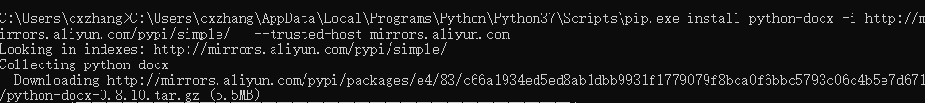

c