Set proxy

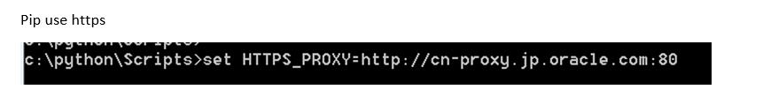

Install selenium
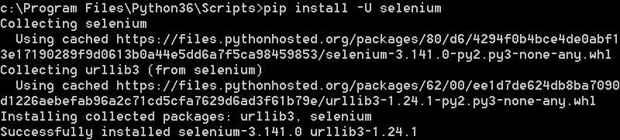

Install chrome driver
https://sites.google.com/a/chromium.org/chromedriver/downloads

copy chromedriver.exe to python/Script folder.

