
POST-ACUTE WOUND & SKIN INTEGRITY COUNCIL (PAWSIC)
Q A P I T O O L K I T
Wound Rounds Playbook
Creating the Ground Rules

© 2026 Jeanine Maguire, PhD, MPT. All rights reserved.
Licensed Use: Permission is granted to the Post-Acute Wound & Skin Integrity Council (PAWSIC) to use, reproduce, adapt, and distribute this Playbook for its educational and quality-improvement purposes. All other use requires the written permission of the author.

How to use this Playbook: This is a working document meant for team discussion and debate. Work through each section together, then capture your team’s decisions in the Focus Group Discussion boxes that follow each topic.
As you work, reflect on Federal guidelines and your current policy, procedures, education, and everyday practice: Are they aligned today? What can be improved? Will the new plan align? What changes to policy or practice may be needed?
Conclude each cycle with the Action Plan & Measurable Goals box. There is no one-size-fits-all — each section is a guideline to optimize outcomes for your patients and your center.

Contents
0. How This Playbook Works — The QAPI Framework 3
I. Purpose, Scope & Intent 4
II. The Interdisciplinary Team & Governance 5
III. Wound Rounds: Creating the Ground Rules 6
A. Logistics & Scheduling 7
B. Patient Selection Criteria 7
C. Bedside Protocol 8
IV. The Standardized Wound-Rounds Patient Checklist 13
V. Measurement & Monitoring 15
VI. Action Plan & Measurable Goals 18
VII. Review, Analysis & Sustaining Improvement 20
30-Day Review Log 20
Team Review & Commitment 20
Appendix A. CMS F-Tag Crosswalk 22
Appendix B. Reproducible Wound Rounds Forms 23

0. How This Playbook Works — The QAPI Framework
APPLICABLE CMS F-TAGS
F865 — QAPI Program (§483.75(a))
F867 — QAA Activities: feedback, data systems & PIPs (§483.75(g))
F868 — QAA Committee (§483.75(g)(2))

Quality Assurance & Performance Improvement (QAPI) is the data-driven, continuous approach CMS expects every post-acute center to use to improve care. This Playbook is built as a complete QAPI program for skin and wound management: each section advances one of the five QAPI elements, and the whole program is driven by the Plan-Do-Study-Act (PDSA) improvement cycle.
Use the map below to see where you are at any point. The blue pill on each section banner names the QAPI element that section builds.
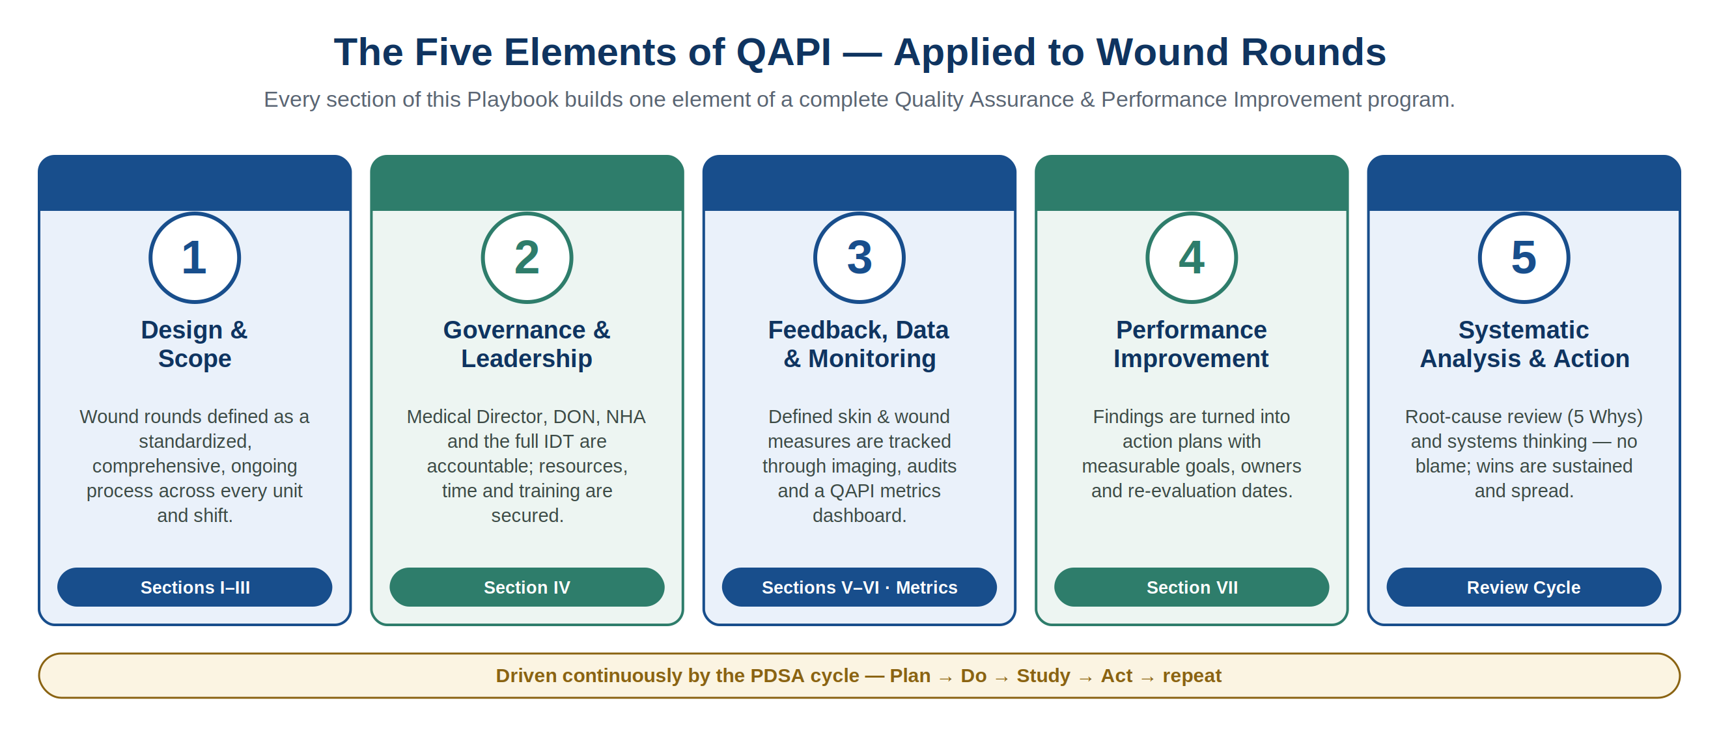
The Improvement Engine: PDSA
Every decision your team records in this Playbook becomes a small test of change. Plan the round, Do it, Study the data it produces, and Act on what you learn — then repeat. The 30-day review cycle in Section VII is one full turn of this wheel.
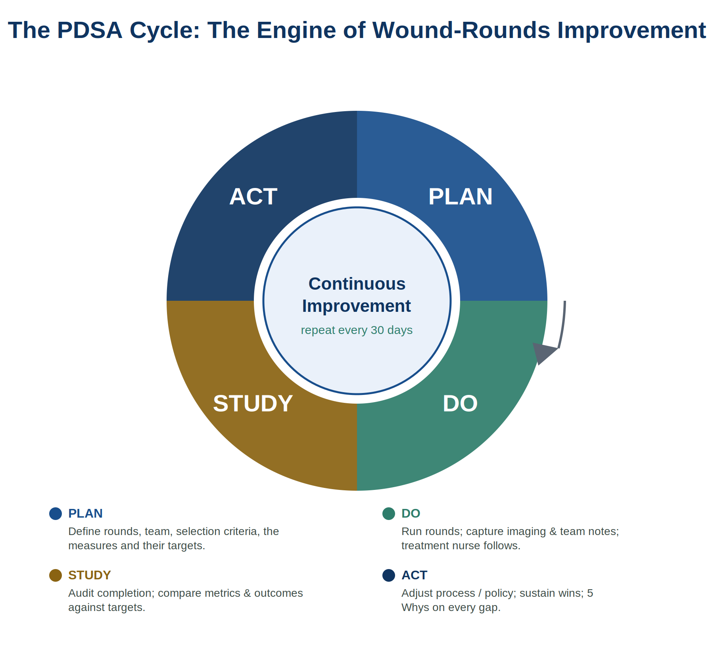

I. Purpose, Scope & Intent
QAPI ELEMENT Element 1 — Design & Scope
APPLICABLE CMS F-TAGS
F684 — Quality of Care (§483.25)
F686 — Treatment/Services to Prevent/Heal Pressure Ulcers (§483.25(b))
F838 — Facility Assessment: resources & competencies (§483.70(e))
F865 — QAPI Program: program design & scope (§483.75(a))

Purpose
To define a standardized procedure for interdisciplinary wound rounds — ensuring a consistent, efficient, and patient-centered approach to skin health and wound management across the post-acute care setting.
Scope
This Playbook is a tool to create your center (or corporate) guideline or policy for all interdisciplinary team members involved in the prevention, assessment, and treatment of skin and wound issues — including full-thickness and partial-thickness wounds — across all units.
Intent
This is a working playbook intended for team discussion and debate, so that wound rounds meet the needs of your patients/residents, their wound types, and their overall care — alongside your center’s capabilities and resources.
There is no one-size-fits-all. Each section is a structured team discussion designed to produce a guideline that optimizes outcomes for your patients and your center.

II. The Interdisciplinary Team & Governance
QAPI ELEMENT Element 2 — Governance & Leadership
APPLICABLE CMS F-TAGS
F841 — Medical Director (§483.70(g))
F725 / F726 — Sufficient & Competent Nursing Staff (§483.35)
F882 — Infection Preventionist (§483.80(b))
F868 — QAA Committee (§483.75(g)(2))
F838 — Facility Assessment (§483.70(e))

Successful rounds depend on leadership accountability and a named team. The Medical Director, Director of Nursing (DON), and Nursing Home Administrator (NHA) are responsible for securing the time, staffing, and resources that make rounds possible and for sustaining a culture of safety and improvement.
Core Focus-Group Composition
The essential focus group for creating and participating in wound rounds includes, but is not limited to:
- Medical Director
- Director of Nursing (DON)
- Nursing Home Administrator (NHA)
- Wound Certified Provider (Mobile Wound Group, Wound Consultant- see PAWSIC MWG Checklist)
- Infection Control / Preventionist (IC)
- Center Skin Team Leader / Care Coordinator / Lead Certified Wound Specialist
- RN (Unit Manager, MDS Coordinator, IC, or other)
- LPN (Treatment Nurse)
- Therapy (PT / OT / ST)
- Registered Dietitian (RD)
- Social Worker (SW)
- Certified Nursing Assistant (CNA)
- Resident Council representative or patient / family member
✍ FOCUS GROUP DISCUSSION
Prompt: Who will make up your center’s core wound-rounds team? Confirm members, alternates, and the team leader.

III. Wound Rounds: Creating the Ground Rules
QAPI ELEMENT Element 1 — Design & Scope (operational design)
APPLICABLE CMS F-TAGS
Clinical quality of care
F684 — Quality of Care / other wound types (§483.25)
F686 — Prevent/Heal Pressure Ulcers (§483.25(b))
F697 — Pain Management at dressing changes (§483.25(k))
F692 — Nutrition/Hydration Status (§483.25(g))
F689 — Accident Hazards: off-loading & positioning devices (§483.25(d))
Infection prevention
F880 — Infection Control & Enhanced Barrier Precautions (§483.80(a))
F881 — Antibiotic Stewardship (§483.80(a)(3))
Resident rights & consent
F550 — Dignity & bodily privacy during exposure (§483.10(a)–(b))
F552 — Inform / Make Treatment Decisions — consent, incl. imaging (§483.10(c))
F553 — Participate in Care Planning (§483.10(c))
F580 — Notification of Changes to physician & representative (§483.10(g)(14))
F583 — Personal Privacy & Confidentiality — wound photos/imaging (§483.10(e),(h))

The team establishes — and routinely re-evaluates — a comprehensive “playbook” for wound rounds to ensure efficiency, clarity, and patient-centered care. The process below repeats every week and feeds the data and improvement cycle.
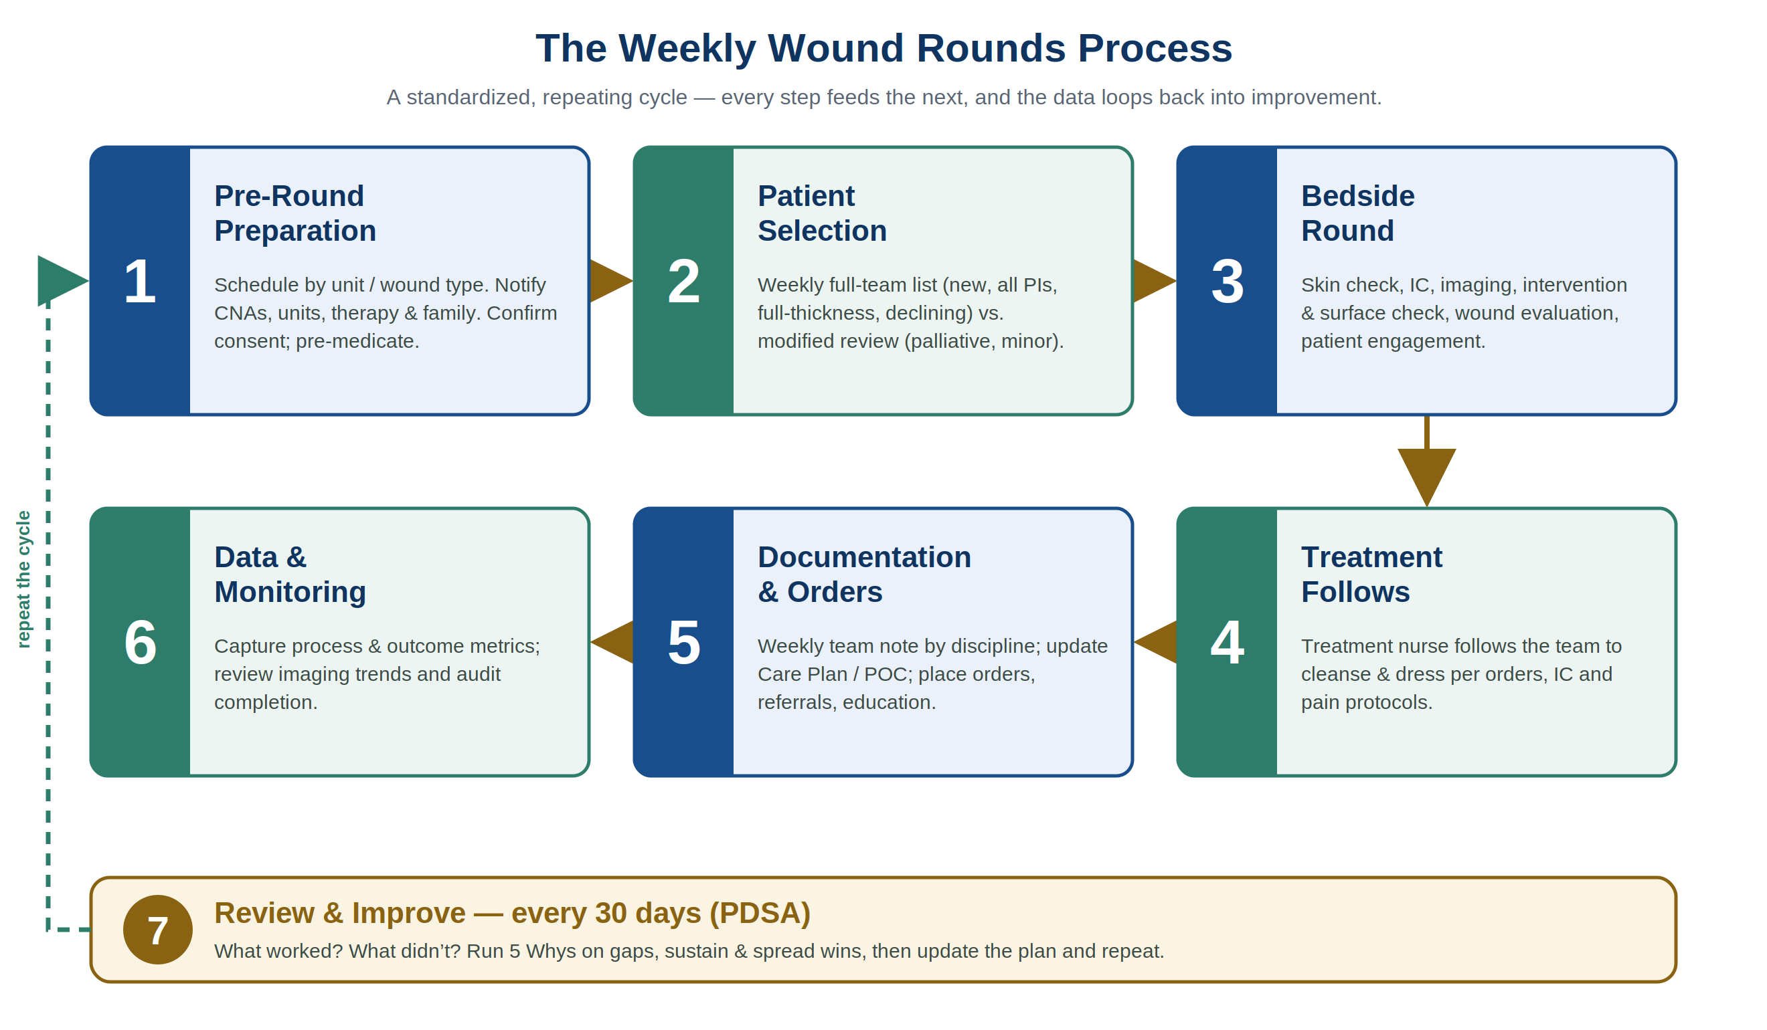

A. Logistics & Scheduling
- Time and day: Determine the most appropriate, patient-centered day and time, considering unit type (STR vs. LTC), wound types, and therapy needs. If a patient is on STR, will rounds interfere with — or become part of — a therapy session? How many patients with wounds are on each unit? What wound types? Would it make sense to group certain patients or wound types on certain days?
- Coordination: Coordinate rounds with each patient’s existing schedule — CNA ADLs, activities, therapy, dialysis, and medication administration.
✍ FOCUS GROUP DISCUSSION
Prompt: How will your center schedule and coordinate rounds around patient care, therapy, and staffing?

B. Patient Selection Criteria
Patients are categorized for weekly full-team review versus modified / less-frequent review.
Weekly Full-Team Visits
All new wounds; all Pressure Injuries (PI); all full-thickness wounds with a goal of healing (including VLU, DFU, AU, AT, SSI); and all declining wounds.
Questions for the team to resolve:
- Will all rounds be in-person by the team? Any hybrid telehealth? Store-and-forward?
- When, how, who, and why? In each case, how will interventions (viable bed surfaces, heel off-loading, etc.) be approached?
- What happens if a team member is unavailable — what is the back-up plan or person?
- What day of week? What time? By floor? Unit? Wound type?
- How will communications occur in advance, every week — to patients; to CNAs, Unit Managers, Rehab, Activities, and others?
- How will pre-medication be managed, if applicable?
Less Often / Modified Team
Patients with palliative goals / comfort care, and minor skin tears. Discuss how these patients are selected, communicated, and reviewed.
✍ FOCUS GROUP DISCUSSION
Prompt: Define your weekly-visit criteria and your modified-review criteria, including the communication plan.

C. Bedside Protocol
Visualization & Skin Check
- All wounds must be visualized, unless the wound is covered by a non-removable dressing or device (ex: a skin graft that is covered by a dressing that can not be removed for a period of time, or a non-removable cast such as a total contact cast- check on when/who will remove it & ensure the wound is a known factor in the time till removal).
- A full-body skin check should be performed when possible and appropriate, with patient consent. For lower-extremity wounds, both lower extremities are always observed during rounds and routine wound care.
✍ FOCUS GROUP DISCUSSION
Prompt: What is your center’s standard for visualization and full-body skin checks during rounds?

Infection Control
- How will enhanced barrier precautions be followed?
- What if there is a new or different visiting wound consultant or mobile wound group?
- How will imaging and other devices be sanitized?
- How will the team ensure proper hygiene at the bedside — hand hygiene, positioning, dressing removal, wound hygiene, imaging, wound/skin assessment, and waste disposal?
- How will treatments be performed with appropriate infection-control practices?
✍ FOCUS GROUP DISCUSSION
Prompt: Define your infection-control guideline for rounds, devices, consultants, and treatment.

Wound Imaging
- Ensure policy permits wound imaging. If not, skip this section.
- Wound images should be encrypted, protected, EMR-embedded wound imaging improves consistency, communication, and accuracy. Ensure patient / responsible-party consent (this may be part of the admission process).
- Wound imaging is recommended for all wounds — on new admission, weekly, with decline, and at discharge — to improve continuity of care.
- Imaging is a diagnostic aid/tool and can improve consistency and accuracy with wound measurements and tissue types. It also enhances hybrid options like telehealth to access expertise (wound specialists, dermatology, and other).
- Imaging use does not replace the team’s bedside engagement to assess other factors (skin checks, surface checks, mobility, moisture, and so on). Ensure a bedside assessment of the patient and interventions is performed with and/or alongside imaging
- All users of imaging must be trained on privacy, technique, and infection control.
- If an image is used for a tele/virtual discussion, set the acceptable window between capture and review — typically within 8 hours, and no longer than 24 — ensuring no significant change occurred in that window.
✍ FOCUS GROUP DISCUSSION
Prompt: Define your imaging standard: when images are taken, who is trained, and the tele/virtual review window.

Intervention Check
- On entering, note bed-surface viability, seating-surface condition, and patient position — including positioning devices such as wedges or heel off-loading. Discuss nutrition, hydration, time in/out of bed, and any mobility schedule. Note continence management, if applicable, and general skin condition. Confirm that Care-Plan interventions are actually in practice.
Wound Evaluation
- Removing the dressing is an essential part of rounds (to evaluate the patient’s response, exudate on the dressing, and so on). However, the application of treatment should not be completed during rounds — a treatment nurse should follow the wound team to provide cleansing and treatment per infection-control and pain-management protocols and patient-specific orders.
  - Dressings are evaluated to determine whether they are effectively managing exudate, adhering to skin, not causing skin stripping, and so on.
  - The in-person review lets the team evaluate the wound in the context of positioning and mobility strategies at the bedside.
For example: Is the patient using a DFU boot for off-loading during transfers/ambulation, even at the bedside? Is the heel off-loading boot effectively off-loading in bed and/or chair? Are the wedge and/or glide devices maintaining position and supporting shear/friction-free mobility? Is the bed still viable, allowing space for safe turning and positioning? Is the cushion viable and used correctly? Is continence care per the care plan (pH-balanced cleanser, barriers, appropriate moisture-wicking products — with no misuse such as a double brief or a cloth chux that may increase pressure and infection risk)? Ensure the availability of breathable/disposable pads for high end surfaces, like low air loss.
- Administrator and DON discussion of staffing support for wound-round success is essential.
- Failure to coordinate treatment with rounds can cause infection, treatment delays, slower healing, patient discomfort, and treatment errors — and can slow the entire team, preventing completion of rounds.
✍ FOCUS GROUP DISCUSSION

Bedside Rounds Discussion
Clearly define which information is discussed at the bedside with the patient and what is reserved for the post-meeting review. Define roles and expectations:
- Role example: the Infection Control specialist has full authority to ensure the team follows all IC policies. Determine who leads skin checks, patient engagement, wound assessment, surface assessment / off-loading, and follow-up documentation.
- Patient role: the patient is THE center of the wound team and should be engaged to the appropriate level based on agreement, comfort, and cognition. Use situational awareness to gauge patient ability and readiness.
Engagement Rules
- Skin and wounds can be upsetting and emotional, and the patient experience varies. Not all patients will want a conversation with a team while exposed for wound care.
- Always respect patient dignity. Have a patient-trusted partner (physician, CNA, or other) explain the purpose of rounds, ask permission for the team to enter and discuss, confirm understanding, and invite questions — now or privately afterward.
- Respect privacy: keep body parts covered as much as possible, ensure comfort, and anticipate that rest breaks, continence care, and repositioning may be needed.
- Pain management: if pain is not mitigated, re-evaluate the cause and offer options — pre-moistening the dressing, pre-medication, repositioning, additional rest breaks, guided meditation, non-pharmacological approaches, etc. This may require a break in rounds or a skip-and-return when the patient is more ready.
✍ FOCUS GROUP DISCUSSION
Prompt: Define bedside roles, patient-engagement rules, and your pain-management approach during rounds.

Patient & Family Readiness
- Patients must be aware, ready, correctly positioned, and pre-medicated if applicable. With patient permission, it may be appropriate to invite a family member — especially to support discharge planning and to demonstrate proper wound cleansing and treatment. Ensure family are emotionally prepared to visualize the wound; not all will want to participate at this level, despite the patient’s consent.
- Photos: if a family member is taking photos, refer to facility policy and discuss with leadership. Protect the patient’s privacy and discourage posting on social media. Discuss options with risk management — it may be appropriate to share the center’s approved wound images and hold a family meeting. Preventing photos may not be possible; transparency with care, imaging, and the care plan is more likely to mitigate independent photos, misuse, or litigation risk.
✍ FOCUS GROUP DISCUSSION
Prompt: What is your center’s guideline for patient/family readiness, family attendance, and photography?

IV. The Standardized Wound-Rounds Patient Checklist
QAPI ELEMENT Element 5 — Systematic Analysis at the point of care
APPLICABLE CMS F-TAGS
F641 — Accuracy of Assessment / MDS wound coding (§483.20(g))
F656 / F657 — Comprehensive Care Plan & Revision (§483.21(b))
F658 — Services Meet Professional Standards: orders vs. TAR (§483.21(b)(3))
F684 / F686 — Quality of Care & Pressure Ulcers (§483.25)
F842 — Medical Records / documentation (§483.70(i))

Implement the same structured approach for every patient during interdisciplinary wound rounds. This checklist standardizes the conversation and surfaces gaps consistently. If a mobile wound group attends rounds but is running late or absent, the wound assessment should never be delayed. Ensure that this possible issues have a plan in advance.

Wound Rounds Checklist
Assessment Area | Checklist Questions to Cover
Wound Diagnosis & Goals | Is the wound type accurate (e.g., PI, VLU, DFU, etc.)?
 | Is the wound goal clear to the team, the patient, and reflected in the Care Plan (CP)? Healing? Maintenance? Palliative? Are referrals needed to for wound diagnosis and/or outcome goal (vascular, derm, infectious disease, podiatry, tests to rule-out osteo, other)?
Treatment & Interventions | What are the treatment (tx) orders? What is actually being used? Is there a discrepancy, and why?
 | Review the Treatment Administration Record: have any treatments been missed or refused? Why?
 | Are the Care-Plan interventions actually in place and working? E.g., bed surface, seat surface, heel off-loading, DFU boots/shoes/inserts, VLU compression, nutrition, foam prevention dressings, contracture management, continence/skin-fold care, skin care, medical-device safety / off-loading of tubes or ear protectors, skin sleeves, and more.
Progress & Barriers | Is the wound status meeting the goal? Are there any signs of infection?
 | What are the barriers to healing? What are the risks of decline or infection?
 | Review the image, measurements, and tissue types for accuracy and wound progression.
Co-morbidities & Risks | Does the Care Plan reflect the risks to skin impairment, the wound type, and to healing?
 | Are co-morbid conditions (PAD, DM & A1c), medications, mobility, nutrition, moisture, friction/shear, infection, cognition/sensation, and previous wounds all addressed?
Patient & Family Engagement | Is the patient having pain or anxiety related to the wound(s)?
 | Does the patient understand the ‘why’ of the wound type, the risks that can impair healing, the Plan of Care and risks related to any interventions/treatments? Do they agree? What are potential barriers to adherence to the plan of care? If the wound is related to end-of-life, is the patient/responsible party fully informed and do they understand? When the patient/responsible party are not aligned with any aspect- how should the team respond and what are the appropriate steps to work toward alignment?
Interventions | Are the interventions identified on the CP in place and in action, viable and appropriate per center protocol, and agreeable to the patient? Is the CNA aware?
Action Plan & Follow-up | What are the changes to the Plan of Care (POC)?
 | Who is responsible for changes (equipment, MD orders, CP changes, family notification, referrals, etc.)?
 | Are there other issues that need to be discussed or reported?
 | If a Wound Consultant attends, how will the team support the patient/provider with procedures, infection control, and consent — and where is the consultant’s documentation?
Documentation | Where is the comprehensive weekly assessment documented? Ensure the team is noted by discipline, with wound types, risks, imaging (if applicable), measurements/tissue types, progression, POC changes, patient education and response (pain), agreement with the plan, and any referrals, labs, tests, procedures, or new orders.  If a Mobile Wound Group/wound consultant is involved, ensure 100% alignment of documentation.

✍ FOCUS GROUP DISCUSSION
Prompt: Discuss findings and gaps from the checklist. What needs to change in your current practice?

V. Measurement & Monitoring
QAPI ELEMENT Element 3 — Feedback, Data Systems & Monitoring
APPLICABLE CMS F-TAGS
F867 — QAA Activities: feedback, data systems & monitoring (§483.75(g))
F865 — QAPI Program (§483.75(a))
F868 — QAA Committee (§483.75(g)(2))
F686 — Pressure-injury incidence tracking (§483.25(b))
F881 — Antibiotic Stewardship: infection metrics (§483.80(a)(3))

A process you cannot measure cannot be improved. Define a small, balanced set of measures up front, decide how each is collected and how often it is reviewed, and assign an owner. Track process, outcome, and balancing measures together so a gain in one area is never won at the cost of another.
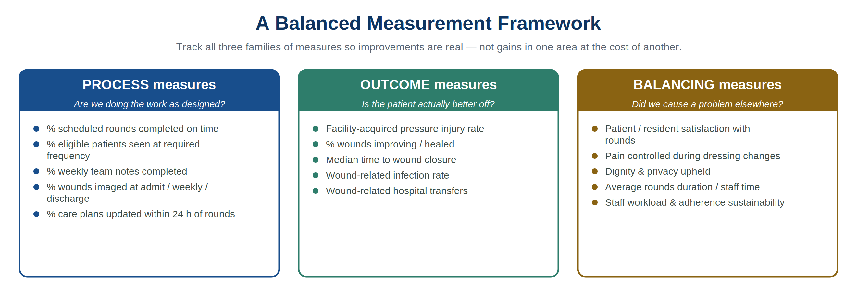
Measure (Numerator ÷ Denominator) | Target | Data Source | Frequency | Owner
PROCESS MEASURES — Are we doing the work as designed?
Rounds completed on time  Rounds completed on schedule ÷ rounds scheduled | ≥ 95% | Rounds log / EMR | Weekly | Skin Health Team Lead
Eligible-patient coverage  Eligible patients seen at required frequency ÷ eligible patients | 100% | Rounds roster vs. wound census | Weekly | Skin Health Team Lead
Weekly IDT note completion  Patients with a complete team wound note ÷ patients rounded | 100% | EMR | Weekly | Unit Manager
Imaging compliance  Wounds imaged at admit/weekly/decline/discharge ÷ wounds requiring image | ≥ 95% | Imaging system / EMR | Weekly | Skin Health Team Lead
Care-plan currency  Care plans updated ≤ 24 h post-rounds ÷ patients with POC changes | ≥ 90% | EMR audit | Weekly | Unit Manager
Order–TAR concordance  Treatments on TAR matching active orders ÷ wound-treatment orders | ≥ 95% | TAR audit | Weekly | Treatment Nurse
OUTCOME MEASURES — Is the patient actually better off?
Facility-acquired PI incidence  New facility-acquired pressure injuries (Stage 2+) ÷ 1,000 resident-days | ↓ trend (e.g., 6% → 3%) | Incident reports / MDS | Monthly | DON / Infection Preventionist
Wound improvement rate  Tracked wounds improving or healed ÷ wounds with a healing goal | ≥ 75% | Wound tracking / imaging | Monthly | Skin Health Team Lead
Median time to closure  Median days from onset/admit to wound closure (healable wounds) | ↓ trend | Wound registry | Monthly | Skin Health Team Lead
Wound infection rate  Tracked wounds with new clinical infection ÷ tracked wounds | ≤ benchmark | Infection-control log | Monthly | Infection Preventionist
Wound-related transfers  ED/hospital transfers attributable to wound or skin ÷ census | ↓ trend | Transfer log | Monthly | DON
CMS short-stay pressure ulcer/injury QM  Part A residents with a new or worsened Stage 2–4 PU/PI at discharge ÷ eligible short-stay residents | ↓ trend / ≤ national avg | MDS 3.0 / iQIES / Care Compare | Quarterly | MDS Coordinator / DON
CMS long-stay pressure ulcer QM  Long-stay residents with one or more Stage 2–4 pressure ulcers ÷ eligible long-stay residents (risk-adjusted) | ↓ trend / ≤ national avg | MDS 3.0 / iQIES / Care Compare | Quarterly | MDS Coordinator / DON
BALANCING MEASURES — Did we create a problem elsewhere?
Patient/resident satisfaction  Respondents satisfied with rounds ÷ respondents surveyed | ≥ 90% | Resident Council / survey | Monthly | Social Worker
Pain controlled at dressing change  Dressing changes with pain ≤ acceptable level ÷ changes assessed | ≥ 90% | Pain reassessment / EMR | Weekly | Treatment Nurse
Rounds duration  Average minutes per wound; total rounds time within agreed window | ≈ 5 min/wound | Rounds log | Weekly | Skin Health Team Lead

Suggested metric — CMS pressure ulcer/injury quality measures
CMS publishes two MDS 3.0–based pressure ulcer/injury quality measures on Nursing Home Care Compare and uses them in the Five-Star Quality Rating System, and your wound-rounds program directly influences both. The short-stay measure reports the percentage of Medicare Part A (post-acute, generally up to a 100-day stay) residents who develop one or more new or worsened Stage 2–4 pressure ulcers/injuries between admission and discharge. The long-stay measure (updated October 2023) reports the risk-adjusted percentage of residents in the center more than 100 days who have one or more Stage 2–4 pressure ulcers on their target assessment. Because both are calculated directly from MDS coding, accurate wound-type identification and timely care-plan documentation during rounds are exactly what move these publicly reported scores. Tracking them alongside your internal facility-acquired PI incidence rate lets the team connect everyday rounds performance to the survey, referral, and reputational outcomes these measures drive.

Data-review cadence
Weekly huddle: review process measures; fix scheduling, documentation, and imaging gaps immediately.
Monthly QAA/QAPI committee: review outcome trends, run charts, and any adverse events; launch a PIP where a measure misses target.
Quarterly: review the full measure set, retire stable measures, and re-prioritize the next focus.

✍ FOCUS GROUP DISCUSSION
Prompt: Which three to five measures will your center start with? Confirm each measure’s target, data source, frequency, and owner.

VI. Action Plan & Measurable Goals
QAPI ELEMENT Element 4 — Performance Improvement Projects (PIPs)
APPLICABLE CMS F-TAGS
F867 — Performance Improvement Projects (PIPs) (§483.75(g))
F865 — QAPI Program: written plan (§483.75(a))
F868 — QAA Committee oversight (§483.75(g)(2))

Bring the team’s discussion together into a single, measurable plan. Capture the problem statement, the decisions for each element of rounds, the support needed, and a clear goal with a re-evaluation date.
★ ACTION PLAN & MEASURABLE GOALS
Plan Element | Your Center’s Decision (examples shown in italics — replace with your own)
Problem Statement (Why)  Why are we defining wound rounds? | e.g. We need to improve team alignment to improve our healing rates.
What  Define wound rounds for your center. | e.g. We will run multidisciplinary wound rounds to align a patient-centered approach to wound prevention and healing.
Who  Disciplines that must attend, and which patients are included. | e.g. Skin Health Team Lead, Mobile Wound NP, Unit Manager, treatment nurse, PT, CNA, and dietitian. Patients include all pressure injuries (any stage) and all full-thickness ulcers. Minimal healing skin tears may need only the nurse — unless non-healing or worsening. Palliative patients are carefully selected so rounds align with their goals; a reduced schedule or smaller bedside team may be appropriate.
Roles  Define the role of each discipline. | e.g. The SHTL builds the schedule in advance, ensures patients are ready/medicated, and manages IC for the team. The treatment nurse follows to apply the new dressing. The CNA supports positioning and flags intervention concerns. PT evaluates bed, chair, and other interventions and identifies new needs. The Unit Manager reviews treatments and the Care Plan, ensures accurate wound dx for the EMR/MDS, documents changes, and ensures orders. The dietitian reviews nutrition needs.
When  Day and time — by unit, floor, or wound type. | e.g. Every Tuesday: STR unit at 3:00 pm, after therapy concludes. Every Thursday: LTC units, directly after breakfast.
How  Round length; what is discussed and documented; follow-up; infection control. | e.g. The SHTL guides the round and keeps time (~5 min per wound). The Unit Manager documents follow-up needs and the team note. Each discipline records its own EMR note as applicable.
Education Needs | e.g. The Unit Manager follows up on education needs — or the SHTL when wound-related.
Communication Needs | e.g. Follow-ups, new orders, and any changes are reported to the next shift.
Process / Policy Needs | e.g. We do not yet have a wound-rounds policy. After 30 days we will re-evaluate, revise, and establish a written guideline to ensure ongoing consistency.
Barriers / Risks | e.g. If short-staffed or during an outbreak, a modified round (Unit Manager + treatment nurse) runs, with all images reviewed by a CWS and a virtual team meeting to review the CP, images, and plan. If the Mobile Wound Group is late, high-risk patients move to the end of rounds; a weekly advance communication structure is established. During survey, additional staff or a modified round may be instituted.
Timeline for Implementation | e.g. Begin in two weeks, allowing time to educate all units, team members, Resident Council, and families, and for therapy/activities to adjust schedules.
Measurable Goal & Re-Evaluation Date  State the metric, the target, and the date the team will re-evaluate. | e.g. Wound rounds are completed by the team every Tuesday and Thursday, within the timeslot, with 100% of weekly team notes and follow-up notes complete and 0 scheduling issues × 30 days.  e.g. Resident Council reports a high level of satisfaction with rounds.  e.g. The facility-acquired pressure-injury incidence rate decreases from 6% to 3% within 30 days.
Plan date: __________ Next review date: __________

VII. Review, Analysis & Sustaining Improvement
QAPI ELEMENT Element 5 — Systematic Analysis & Systemic Action
APPLICABLE CMS F-TAGS
F867 — Systematic analysis, adverse-event review & PIPs (§483.75(g))
F868 — QAA Committee review (§483.75(g)(2))
F865 — QAPI Program sustainability (§483.75(a))
F580 — Notification of change in condition (§483.10(g)(14))

Review the action plan, the goals, the progress, and the outcomes every 30 days. Depending on results, you may continue monthly monitoring or move to quarterly or annual review. Print additional copies of this Playbook to support ongoing reviews and process improvement.
- Review each action step from the previous cycle and any audits completed in that window; each discipline reports against current outcomes and goals.
- Decide what to continue, stop, or revise. This review is for process improvement — determine what worked, what didn’t, and what should change.
- Use systems thinking. For anything that didn’t work, do not blame an individual — seek the deeper driving factors (ask “why” five times).
- Celebrate the wins — even the small ones.

30-Day Review Log
Action Step | Goal | Progress Update | Issues | Next Steps / Goals
Review date: __________ Next scheduled review: __________

Team Review & Commitment
Each member confirms their department’s contribution to the plan. Record any individual statements, commitments, or alternatives.
Name | Signature | Department | Comments / Commitments / Alternatives
Schedule next review date: __________

Appendix A. CMS F-Tag Crosswalk
This crosswalk maps each ground rule in the Playbook to the federal requirements (Appendix PP, State Operations Manual) it supports. It is a planning aid, not a determination of compliance — actual survey citations rest with the surveyor and your QA / compliance leadership for the specific situation.
F-Tag | 42 CFR | Title | Where it applies in this Playbook
Clinical Quality of Care
F684 | §483.25 | Quality of Care | Non-pressure wound types (skin tears, surgical, vascular, arterial); palliative wound care
F686 | §483.25(b) | Prevent/Heal Pressure Ulcers | Pressure-injury prevention, off-loading, surfaces, healing goals & incidence (Sec. I, III, IV, V)
F697 | §483.25(k) | Pain Management | Pain assessment & mitigation at dressing changes and rounds (Sec. III)
F692 | §483.25(g) | Nutrition / Hydration Status | Nutrition’s role in healing; dietitian review (Sec. III, IV)
F689 | §483.25(d) | Free of Accident Hazards / Devices | Safe, correct use of off-loading boots, wedges & positioning devices (Sec. III)
Person-Centered Care & Resident Rights
F550 | §483.10(a)–(b) | Resident Rights / Dignity | Dignity & bodily privacy during exposure (Sec. III)
F552 | §483.10(c) | Inform / Make Treatment Decisions | Informed consent for treatment & imaging; right to refuse (Sec. III)
F553 | §483.10(c)(2)–(3) | Participate in Care Planning | Resident & representative engagement in the plan (Sec. II, III, IV)
F580 | §483.10(g)(14) | Notification of Changes | Reporting change of condition to physician & representative (Sec. III, IV, VII)
F583 | §483.10(e),(h) | Personal Privacy & Confidentiality | Wound photography/imaging privacy; family photos & social media (Sec. III)
Care Planning, Assessment & Documentation
F641 | §483.20(g) | Accuracy of Assessment | Correct wound-type coding flowing to the MDS (Sec. IV)
F656 | §483.21(b)(1) | Comprehensive Care Plan | Interventions in place and working (Sec. III, IV)
F657 | §483.21(b)(2) | Care Plan Timing & Revision | Updating the POC after rounds (Sec. III, IV)
F658 | §483.21(b)(3) | Services Meet Professional Standards | Orders-vs-TAR concordance; evidence-based care (Sec. IV, V)
F842 | §483.70(i) | Medical Records | Weekly interdisciplinary documentation (Sec. IV)
Infection Prevention & Control
F880 | §483.80(a) | Infection Prevention & Control / EBP | Enhanced Barrier Precautions, device sanitation, hygiene technique (Sec. III)
F881 | §483.80(a)(3) | Antibiotic Stewardship | Wound-infection assessment & antibiotic use (Sec. III, V)
F882 | §483.80(b) | Infection Preventionist | IP role and authority on the rounds team (Sec. II, III)
Governance, QAPI & Staffing
F841 | §483.70(g) | Medical Director | Medical-director oversight & policy implementation (Sec. II)
F838 | §483.70(e) | Facility Assessment | Resources & competencies needed for the program (Sec. I, II)
F725 | §483.35(a) | Sufficient Nursing Staff | Staffing to support rounds (Sec. II)
F726 | §483.35(a)(3),(c) | Competent Nursing Staff | Demonstrated skin/wound competency (Sec. II)
F865 | §483.75(a) | QAPI Program | The program this Playbook operationalizes (Sec. 0, I, V, VI, VII)
F867 | §483.75(g) | QAA Activities (data & PIPs) | Metrics, monitoring & improvement projects (Sec. 0, V, VI, VII)
F868 | §483.75(g)(2) | QAA Committee | Committee review of data & action plans (Sec. 0, II, V, VI, VII)

Appendix B. Reproducible Wound Rounds Forms
The blank forms below are designed to be photocopied or duplicated for each wound-rounds cycle. They mirror the worked examples earlier in this Playbook: Form B-1 is the patient-level rounds checklist with a follow-up tracker; Form B-2 lets the team evaluate the whole wound-rounds program; and Form B-3 turns the team’s discussion into a SMART action plan with measurable goals. Adapt fields to fit your center’s EMR, policy, and workflow.

Form B-1. Wound Rounds Checklist & Follow-Up
Complete one form per wound, per weekly round. Capture findings in the team discussion and record every follow-up need with an owner and due date in the tracker at the bottom.
Patient / Resident | Unit / Room | Rounds Date | Wound # / Type | Wound Goal

Assessment Area | Prompts to Cover | Findings / Notes | Follow-Up Needed (Action / Who / Due)
Wound Diagnosis & Goals | Is the wound type accurate (PI, VLU, DFU, etc.)? Is the goal (healing / maintenance / palliative) clear to team, patient, and Care Plan? Are referrals needed (vascular, derm, ID, podiatry, osteo rule-out)?
Treatment & Interventions | What are the treatment orders vs. what is actually used — any discrepancy and why? Review the TAR: any missed or refused treatments? Are Care-Plan interventions in place and working (surfaces, off-loading, compression, nutrition, dressings)?
Progress & Barriers | Is the wound meeting its goal? Any signs of infection? What are the barriers to healing or risks of decline? Are image, measurements, and tissue types accurate and trending?
Co-morbidities & Risks | Does the Care Plan reflect the risks to skin, the wound type, and to healing (PAD, DM/A1c, meds, mobility, nutrition, moisture, friction/shear, cognition, prior wounds)?
Patient & Family Engagement | Pain or anxiety related to the wound? Does the patient understand the ‘why,’ the risks, and the plan — and agree? Barriers to adherence? End-of-life alignment where applicable?
Interventions in Place | Are CP interventions in action, viable, appropriate per protocol, and agreeable to the patient? Is the CNA aware?
Action Plan & Follow-Up | What changes to the Plan of Care? Who is responsible (equipment, MD orders, CP changes, family notification, referrals)? Other issues to report? Consultant documentation located?
Documentation | Is the comprehensive weekly assessment documented by discipline (wound types, risks, imaging, measurements/tissue, progression, POC changes, education/response, agreement, referrals/labs/orders)? Is consultant documentation 100% aligned?

Follow-Up Action Tracker
Follow-Up Action | Responsible | Due Date | Status / Completed

Rounds team members present: ________________________________________________________________________
Next review / re-check date: __________

Form B-2. Wound Rounds Program Self-Evaluation
Use this form to evaluate the wound-rounds program as a whole — ideally at each 30-day review and at least quarterly. Rate each element, document the evidence or gap, and flag priorities to carry into the action plan (Form B-3).
Self-rating scale
1 — Not started: no defined process; ad hoc or absent.
2 — Developing: process drafted or partially in place; inconsistent.
3 — Established: process defined, in routine practice, and documented.
4 — Optimized: consistently performed, measured, and improving over time.

Program Element | What ‘Good’ Looks Like | Rating (1–4) | Evidence / Gaps / Notes
Purpose, Scope & Intent (Sec. I) | A written purpose and scope for rounds that fits the center’s population, wound types, and resources.
Team & Governance (Sec. II) | Named core team with alternates and a leader; Medical Director, DON, and NHA secure time, staffing, and resources.
Logistics & Scheduling (Sec. III-A) | Patient-centered day/time set by unit and wound type; rounds coordinated with ADLs, therapy, dialysis, and meds.
Patient Selection Criteria (Sec. III-B) | Clear weekly-visit vs. modified-review criteria with a back-up plan and an advance communication structure.
Visualization & Skin Check (Sec. III-C) | Standard for wound visualization and full-body skin checks; both lower extremities observed for LE wounds.
Infection Control (Sec. III-C) | Enhanced Barrier Precautions, device sanitation, hand/wound hygiene, and consultant IC expectations defined.
Wound Imaging (Sec. III-C) | Policy permits encrypted, consented, EMR-embedded imaging; trained users; defined tele/virtual review window.
Intervention & Wound Evaluation (Sec. III-C) | Surfaces, off-loading, positioning, nutrition, and continence checked; treatment follows rounds, not during.
Bedside Roles & Engagement (Sec. III-C) | Defined roles and patient-engagement and pain-management rules that protect dignity and comfort.
Patient & Family Readiness (Sec. III-C) | Patients prepared/positioned/pre-medicated; family attendance and photography guidance per policy.
Standardized Checklist Use (Sec. IV) | The same structured checklist is used for every patient; assessment never delayed if a consultant is late/absent.
Measurement & Monitoring (Sec. V) | A balanced set of process, outcome, and balancing measures with targets, sources, frequency, and owners.
CMS Quality Measure Tracking (Sec. V) | Short-stay and long-stay CMS pressure ulcer measures tracked from MDS and reviewed against Care Compare.
Action Plan & Goals / PIPs (Sec. VI) | Team decisions captured as a SMART action plan with measurable goals and a re-evaluation date.
Review & Sustaining (Sec. VII) | 30-day review log completed; systems thinking applied; wins celebrated; cadence adjusted by results.
Documentation & F-Tag Alignment (App. A) | Weekly IDT documentation supports the relevant F-Tags; consultant notes are aligned and retrievable.

Program Evaluation Summary
Top strengths (what is working):

Top priorities to improve:

Overall program readiness (circle): Not started / Developing / Established / Optimized

Evaluator(s) & date:

Form B-3. SMART Action Plan & Measurable Goals
Bring the team’s discussion together into a single, measurable plan. Complete the action plan, then write each goal through the SMART builder so it is Specific, Measurable, Achievable, Relevant, and Time-bound.
Plan Element | Your Center’s Decision
Problem Statement (Why)
Why are we defining wound rounds?
What
Define wound rounds for your center.
Who
Disciplines that must attend, and which patients are included.
Roles
Define the role of each discipline.
When
Day and time — by unit, floor, or wound type.
How
Round length; what is discussed and documented; follow-up; infection control.
Education Needs
Communication Needs
Process / Policy Needs
Barriers / Risks
Timeline for Implementation
Measurable Goal & Re-Evaluation Date
State the metric, the target, and the date the team will re-evaluate.

Plan date: __________ Next review date: __________

SMART Goal Builder
Element | Prompt | Your Goal Statement
Specific | What exactly will change, for whom, and where? (e.g., wounds, units, disciplines)
Measurable | What metric and target will show success? (numerator ÷ denominator, %, count, trend)
Achievable | Is it realistic with current staffing, resources, and resident mix? What support is needed?
Relevant | How does it tie to healing, prevention, resident goals, and CMS measures / F-Tags?
Time-bound | By when? Set the start, the checkpoint, and the re-evaluation date.

Write your final SMART goal as one sentence:

