# Churn prediction of mobile and online casual games using log data

1. Introduction

* Categorizing games:
* By platform: console, handheld, PC, online, smartphone, tablet, TV, etc.
* Complexity and intensity: hardcore vs casual games
* Churn definition: using observation period (OP) and churn prediction period (CP)
* Target group: new players of non-subscription-based casual games
* Experiment:
* 3 datasets: 2 from mobile casual games + 1 online casual game
* Analysis model – observing a new player’s play log data from the first OP days of play
* Predict if the player will player will play again in the following CP days (A player might not play for the CP days but then return at the time further in the future -> still considered a churner)

1. Related works (see paper)

* Existing works’ limitations:
* Most studies focus on blindly defining features for predicting user churn & do not provide in-depth analysis
* Prediction performance significantly varies depending on how features are defined
* Difficult to make churn rate improvement without fully understanding the chosen features and their implications in the domain
* Provide thee details of defining and analyzing features in this study
* Algorithms & features for a prediction model can have a substantial effect on building a predicting model >< limitations to using algorithms in the past studies
* Design prediction models using 3 representative algorithms together with 2 of the latest deep learning models & compare performances
* Existing studies set the observation period (OP) and churn prediction period (CP) arbitrarily without conducting additional studies for setting those periods
* Analyze their effects

1. Churn definition

* Focus on new players of casual games (no subscription)
* Predict if a new player will stop playing after a certain number of days since the first day of play
* For a player $u:$
$s_{i}:score of the player^{'}s i^{th}play$

$t_{i}^{abs}:timestamp of the player^{'}s i^{th}play$

* New players only -> convenient to define $t_{i}^{rel}$, relative time with respect to the player’s first play time
* Represent as $t_{i}$ for the rest of the paper
$$t_{i}= \left\{\begin{aligned}0, i=1 \\ t_{i}^{abs}-t_{1}^{abs}, i≠1\end{aligned}\right.$$

* Define churner in terms of observation period and churn prediction period
* OP: period for observing a user’s plays -> play log data used to create features and predict churn for the following CP days
* CP: period for determining whether a user actually churned or not
* Churner: a user playing the game for the first time when $t_{1}=0$ and possibly more in the first OP days, and not playing the game at all in the following CP days
* Definition applies for each individual player
* Player’s own clock since the first play time is used for defining OP and CP

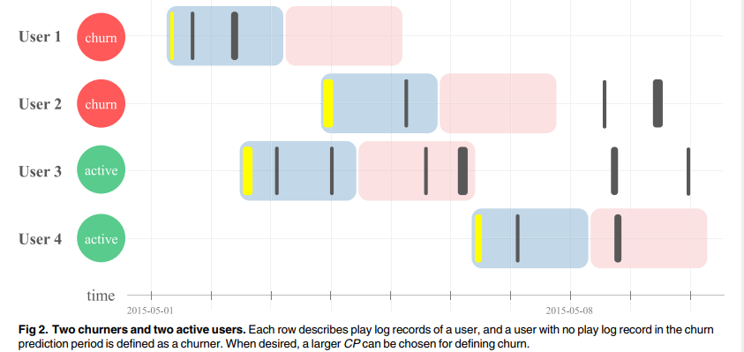

* Fix OP to 5 days and CP to 10 days

1. Data

* 3 casual games chosen for prediction

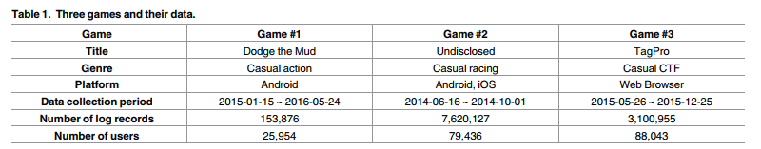

1. Feature engineering

* Intuitively meaningful features are extracted first, and their importance is evaluated by analyzing single feature ranking and by identifying the best feature combinations

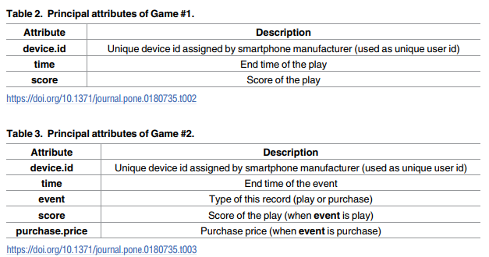

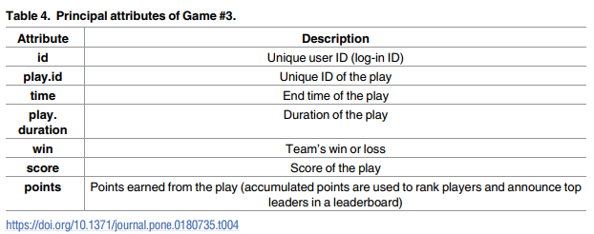

1. Feature extraction

* Extract 10 common features for the 3 games and 2 game-specific features for Game #2 and #3
* 3 games have same attributes:
* Unique ID
* Score
* Time
* Generate 10 common features focusing on user’s player pattern and game scores

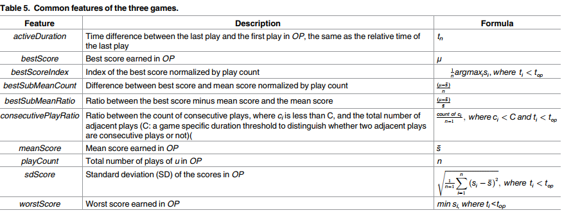

* Game-specific features extracted from the data field that are related to genre or characteristics of the game
* Game 2:
$p_{j}:price paid for the j^{th}vehicle, where j=1,2,…, L$

$t_{j}^{pur}:relative time of the j^{th}purchase$

* Game 3:

$w_{i}= \left\{\begin{aligned}1, if points of i^{th}game>0 \\ 0, if points of i^{th}game=0 \end{aligned}\right.$

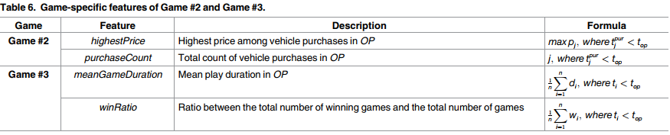

1. Single feature ranking

* Perform single feature ranking analysis
* Evaluate rankings in 5 different ways:
* Absolute value of Pearson correlation coef between a feature and churn
* Three classification performance values (AUC) of the 3 traditional machine learning algorithms using only a single feature as input
* Feature importance calculated by gradient boosting library
* Overall ranking determined by comparing average ranking of 5 results

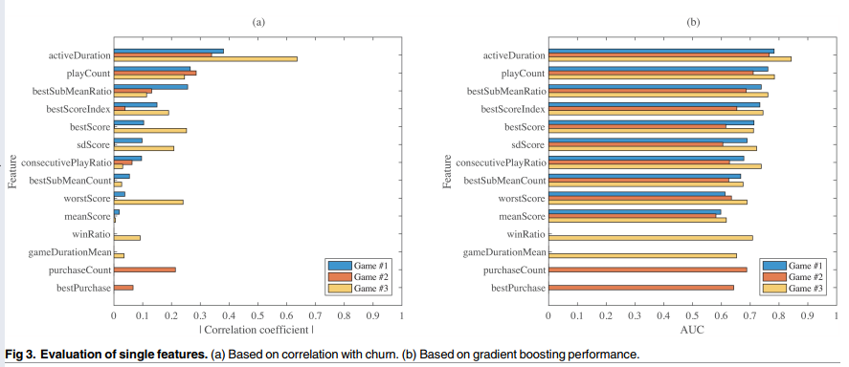

* Overall single feature rankings, by average ranking of 5 results:

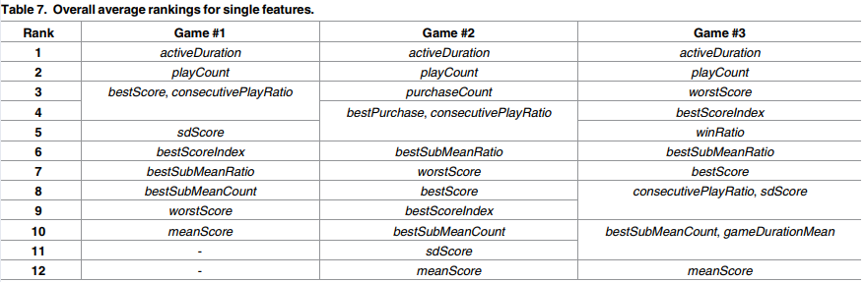

1. Feature combinations

* Checking performance of all possible feature combinations and identifying the best (only 10-12 features for each game)
* Only gradient boosting algorithm is used for evaluations
* Overall, activeDuration and playCount are included in all 3 games’ combinations

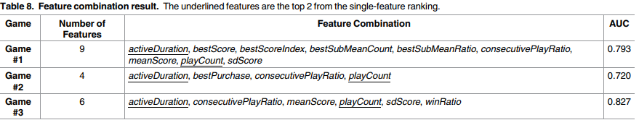

* Performance improves when the number of features increases from 1 to 2-3. Beyond that point, having more features have very marginal effect
* Casual games are very simple and analysis beyond single-feature ranking might not be very helpful

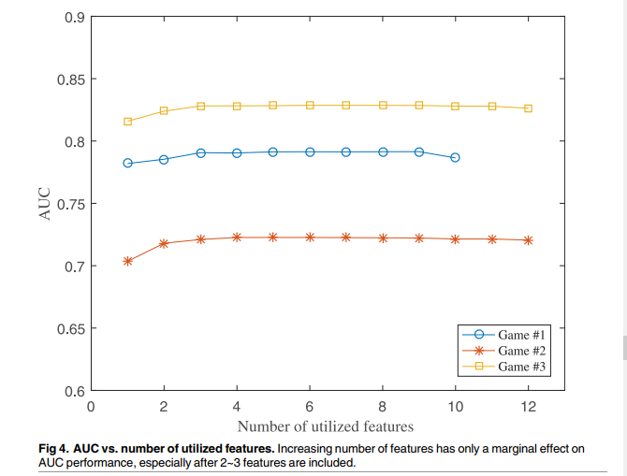

* For technical completeness, combination lists shown in Table 8 are used for the performance evaluations

1. Performance results

* Effects of algorithm choice and OP/CP choice on AUC performance

1. Performance for different algorithms

* 3 traditional algorithms: logistic regression, gradient boosting, random forests
* Deep learning algorithms: CNN, LSTM
* CNN: 2 convolutional layers with successive pooling layers, followed by 2 fully connected layers
  + Tuned hyperparams: number of filters, filter sizes, pooling sizes using grid search
* LSTM: Tuned number of neurons and input dimensions using grid search
* Implemented using TensorFlow 1.0 library
* Features:
* 3 traditional algorithms: Features engineered
* Deep learning algorithms: Raw data minimally processed such that the data’s time patterns potentially can be utilized
* Play log data is transformed into a one-dimensional vector as input
* Value for each 10-minute time frame is calculated
* Performance results of 5 algorithms
* Data of the 3 casual games might not have a strong structure or pattern to take advantage of
* Simply running a reasonably well chosen ML algorithm might suffice for churn prediction

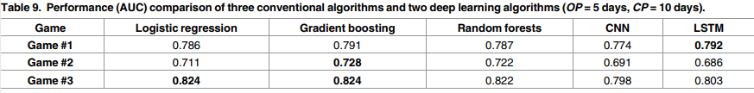

1. Performance for different choices of OP and CP

* Evaluated AUC for OP between 1 and 30 days and CP between 1 and 30 days
* Game #2: OP evaluated up to 15 days

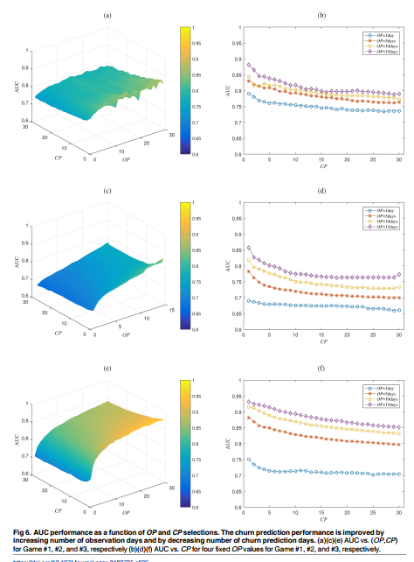

* Increasing OP – strongly positive impact on prediction performance
* Longer observation period – more data for playing pattern and playing frequency
* However, large OP -> longer waiting time before churn can be predicted & might be almost no chance to contact ‘likely-to-churn’ players and take preventive actions
* Decreasing CP – positive effect on prediction performance
* Shorter churn prediction period – focus on short-term behaviors without worrying about long-term churning or returning
* CP = 5 days or larger might be sufficient to model most players’ long-term behaviors as well as short-term behaviors

1. Discussion

* Behaviors of game players cannot be the same as behaviors of telecom or newspaper subscribers
* Behaviors of casual game players can be even more different because of the light and temporal nature of playing causal games (players can easily quit without worrying about a contract or a subscription fee)
* Single feature analysis and feature combinations:
* Comparison of prediction performance of algorithms
* Choosing OP and CP