# Semi-supervised and inductive embedding model for churn prediction of large-scale mobile games

1. Introduction

* Previous studies on mobile game churn prediction using traditional ML models (e.g., logistic regression, random forests, Cox regression)
* Limitations:
* Developed for predicting churn of one or a few mobile games -> none is capable of handling the churn prediction of large-scale mobile apps and users
* User-app interaction data often comes with rich contextual info (e.g., wifi connection status, screen brightness, audio volume) >< not considered in previous studies
* Rely on handcrafted features -> usually cannot scale well in practice
* Contributions:
* First solution for **churn prediction of large-scale mobile games** using hundreds of millions of user-app interaction records
* Novel **semi-supervised and inductive model based on embedding** – capture the dynamics between users and mobile games based on introduced temporal loss in the formulated objective function. Model is able to **embed new users or games not used in training**
* Attributed **random walk technique** -> **sample contexts of edges** in an attributed bipartite graph that takes into account both topological adjacency and attribute similarities
* Comprehensive **experimental evaluation with large-scale real-world data** collected from Samsung Game Launcher

1. **Problem formulation**

* Churn: player stopping using a game within a given period (i.e., no app usage in the period). Duration T of the period may vary (e.g., T= 14 or T=30)
* In this paper, we consider the **generic game churn prediction problem without assuming any particular value of T**
* Note: uninstall is different from churn (there may be a large time gap between cessation of playing and uninstall, if any)
* Relationship between players and games – represented by an attributed bipartite graph

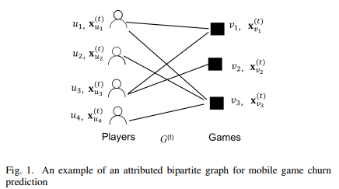

* **Notations**

|  |  |
| --- | --- |
| **Notations** | **Descriptions or Definitions** |
| $$G^{\left(t\right)}$$ | Attributed graph at time $t$ |
| $$G^{\left(t+1\right)}$$ | Attributed graph at time $t+1$ |
| $$H^{\left(t\right)}$$ | Historical attributed graphs $\{G_{i}\}{i=t \atop i=0}$ |
| $$U^{\left(t\right)}$$ | Set of all player nodes in $G^{\left(t\right)}$ |
| $$V^{\left(t\right)}$$ | Set of all game nodes in $G^{\left(t\right)}$ |
| $$E^{\left(t\right)}$$ | Set of all edges in $G^{\left(t\right)}$ |
| $$e_{uv}^{(t)}$$ | Indicator of the existence of edge ($u, v$) in $G^{\left(t\right)}$ |
| $$x_{u}^{\left(t\right)}$$ | Feature vector of user $u∈U^{\left(t\right)}$ |
| $$x_{v}^{\left(t\right)}$$ | Feature vector of game $v {∈V}^{\left(t\right)}$ |
| $$z_{uv}^{\left(t\right)}$$ | Aggregated feature vector of edge $\left(u, v\right)∈E^{\left(t\right)}$ |
| $$n_{u}, n_{v}$$ | Number of attributes in $x_{u}^{\left(t\right)} and x_{v}^{\left(t\right)}$ |
| $$d$$ | Number of attributes in $z_{uv}^{\left(t\right)}$ |
| $$m$$ | Embedding dimension |
| $$g$$ | The edge embedding function $g:R^{d}→R^{m}$ |
| $$f$$ | The churn prediction function $f:R^{m}→[0,1]$ |
| $$l_{n}$$ | Number of prediction hidden layers |
| $$l_{p}$$ | Number of embedding hidden layers |

* Let $G^{\left(t\right)}$ be the attributed bipartite graph at time $t$
* Vertex set $U^{\left(t\right)}$ denote the set of users
* Vertex set $V^{\left(t\right)}$ denote the set of games
* Player represented by a node $u∈ U^{\left(t\right)}$
* Game represented by a node $v∈ V^{\left(t\right)}$
* Each user $u$ is associated with a feature vector $x_{u}^{\left(t\right)}∈R^{n_{u}}$, where $n_{u}$ is the size of $x_{u}^{\left(t\right)}$
* Each game $v$ is associated with a feature vector $x_{v}^{\left(t\right)} ∈R^{n_{v}}$, where $n_{v}$ is the size of $x_{v}^{\left(t\right)}$
* There is an edge between nodes $u and v in G^{\left(t\right)}$ if player $u$ has played $v$ in the time window $[t+1, t+T]$
* Set of edges denoted by $E^{\left(t\right)}$
* Definition 1: Mobile game churn prediction
* Consider **collection of attributed bipartite graphs observed from time $t_{0} to time t (t>t_{0})$** , which is denoted by $H^{\left(t\right)}=\{G^{\left(i\right)}\}{i=t \atop i=t_{0}}$
* Let $e_{uv}^{\left(i\right)}$ be the **indicator of the existence of edge $\left(u,v\right)$** in $G^{\left(i\right)}$
* **For any edge $\left(u,v\right) in G^{(t)}$** , predict the prob. $\operatorname{Pr}\left(e_{uv}^{\left(t+1\right)}=0 | e_{uv}^{\left(t\right)}=1, H^{\left(t\right)}\right)$, that is the **probability that $\left(u,v\right) disappears in G^{\left(t+1\right)}$**

1. **Methods**
2. **Overview of solution**

* Recent progress in DL and graph embedding, a natural promising direction is to adopt graph embedding frameworks for churn prediction
* **Key technical challenges:**
* All existing methods are transductive -> cannot produce embeddings for new player-game pairs
* Existing methods are either purely supervised or unsupervised -> do not take full advantage of relevance between embedding and a task
* Existing methods are node-centric -> not directly applicable to edge related tasks
* Existing methods only handle a static graph and do not incorporate graph dynamics in embedding >< new players, new games, new player-game relationships every day
* **Propose: a novel inductive semi-supervised embedding model** in dynamic graphs that jointly learns the **prediction function f** and the **embedding function g**

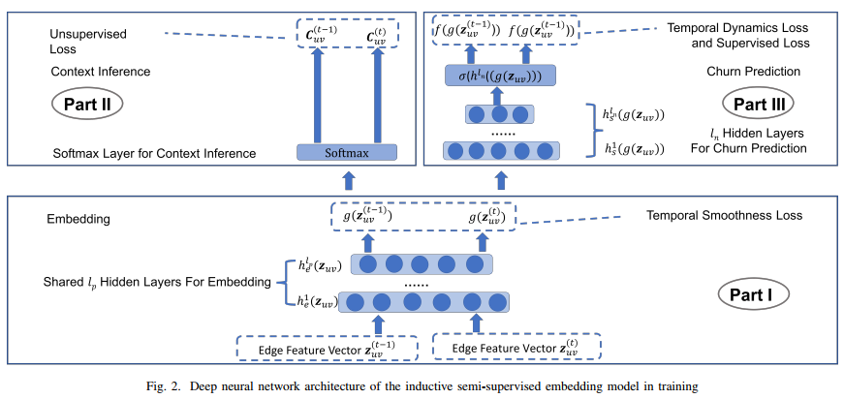

* **DNN consists of 3 parts:**
* **Part I: produce embedding feature vectors $g(z_{uv}^{\left(t\right)})$** from raw edge feature vectors $z_{uv}^{\left(t\right)}∈R^{d}$, where $d$ is the size of raw edge feature vectors
  + To learn the prob. of churn, we need to construct a feature vector for each $\left(u, v\right) with e_{uv}^{\left(t\right)}=1$
  + It is impractical to calculate features for all possible edges which may appear in the prediction period because the number of possible edges is large, which is $O\left(\left|U^{\left(t\right)}\right| ⋅\left|V^{\left(t\right)}\right|\right)$
  + Instead, we **construct the feature vector $z_{uv}^{\left(t\right)} of (u,v)$** **from attribute-wise cosine similarity aggregation of similarity aggregation** of $x_{u}^{\left(t\right)} and x_{v}^{\left(t\right)}$
* **Part II: infer contexts from embedding feature vectors**
  + Context of an edge – the edges that are **similar to and co-occur with the edge under some graph sampling strategy** (e.g., random walk)
  + Part I and II – unsupervised component of the model. Jointly trained by minimizing the **error due to incorrect context inference and inconsistency with temporal smoothness** (III-C for explanation)
  + Part I and II – trained in an inductive and edge-centric way – learn an **embedding function that generalizes to any unseen edges** as long as their feature vector is available
    - Novel attributed random walk to sample similar edges as contexts (III-D)
* **Part III: supervised churn prediction task from embedding feature vectors**
  + Trained by minimizing the error of incorrect churn predictions
* Supervised and unsupervised component are simultaneously trained in **a single objective function**
* Part III and Part II share the **common hidden layers** in part I -> latently coupled with each other -> helps embedding align with the supervised prediction task
* Part I and III both consider **graph dynamics** in training
* Part I: handle graph dynamics by requiring the **embeddings of the same edge at 2 consecutive timestamps to stay close**
* Part III: handles graph dynamics by requiring the **churn prob of the same edge at 2 consecutive timestamps to follow a decaying pattern**
* **Objective function composed of 4 parts:**

$L :=L_{S}+αL_{U}+βL_{T}+γL_{R}$ (1)

Where:

$L_{S}:supervised loss due to incorrect predictions$

$L_{U}:unsupervised loss from failures of context inference$

$L_{T}:temporal loss consisting of 2 parts:temporal smoothness and temporal dynamics$

$L_{R}:regularization term$

$α,β, γ:trade-off weights$

1. Static Loss Functions

$Supervised Loss Function L_{S}-designed for part III$

* **k-th hidden layer for churn prediction** (prediction hidden layer)
$$h_{s}^{k}\left(g\left(z_{uv}^{\left(t\right)}\right)\right)=ϕ(W_{s}^{k}h_{s}^{k-1}\left(g\left(z_{uv}^{\left(t\right)}\right)\right)+b^{k})$$

* Model churn prediction $f$ by $l_{n}$ **hidden layers**
* **Prediction output layer** represented by **(2)**:

$f\left(g\left(z_{uv}^{\left(t\right)}\right)\right) :=Pr\left(e_{uv}^{\left(t+1\right)}=0 | e_{uv}^{\left(t\right)}=1, H^{\left(t\right)}\right) :=σ\left(h_{s}^{l_{n}}\left(g\left(z_{uv}^{\left(t\right)}\right)\right)\right) :=\frac{exp⁡(h_{s}^{l_{n}}{\left(g\left(z_{uv}^{\left(t\right)}\right)\right)}^{T}w_{s})}{1+exp⁡(h_{s}^{l_{n}}{\left(g\left(z_{uv}^{\left(t\right)}\right)\right)}^{T}w_{s})}$

Where:

$σ\left(⋅\right):sigmoid function$

$w_{s}:sigmoid weights vector that combines the output from the last hidden layer$

$to predict churn$

* **Supervised loss** (3):
$$L_{S}=\frac{1}{L}\sum_{i=0}^{t-1}{\sum_{\left(u,v\right)∈E^{\left(i\right)}}{δ_{uv}^{\left(t+1\right)}{\left(1-e_{uv}^{\left(i+1\right)}-\frac{\exp\left(h_{s}^{l_{n}}{\left(g\left(z_{uv}^{\left(i\right)}\right)\right)}^{T}w_{s}\right)}{1+\exp\left(h_{s}^{l_{n}}{\left(g\left(z_{uv}^{\left(i\right)}\right)\right)}^{T}w_{s}\right)}\right)}^{2}}}$$

$Unsupervised Loss Function L_{U}-designed for part II$

* Part II: **embed handcrafted features $z_{uv}^{\left(t\right)}∈R^{d}$** **into a latent space $g\left(z_{uv}^{\left(t\right)}\right)∈R^{m}$**  where m is the size of latent space
* **K-th hidden layer for embedding** (embedding hidden layer)
$$h_{e}^{k}\left(z_{uv}^{\left(t\right)}\right)=ϕ\left(W_{e}^{k}h_{e}^{k-1}\left(z_{uv}^{\left(t\right)}\right)+b_{e}^{k}\right)$$

* $we use l_{p}$**layers in part I to represent embedding function g**
* **Embedding output layer**: $g\left(z_{uv}^{\left(t\right)}\right)≔h_{e}^{l_{p}}(z_{uv}^{\left(t\right)})$ (4)
* **Unsupervised loss function**:

$$L_{U}= -\sum_{i=t_{0}}^{t}{\sum_{\left(u,v\right)∈E^{\left(i\right)}}{\sum_{\left(u^{'},v^{'}\right)∈C_{uv}^{\left(i\right)}}{δ_{uv}^{\left(i\right)}\log\left(\operatorname{Pr}\left(\left(u^{'}, v^{'}\right) | g\left(z_{uv}^{\left(i\right)}\right)\right)\right)} }}$$

Where:

* + . Contextual edges are obtained by attributed random walk on the bipartite graph (discussed later)
* Likelihood of having a contextual edge $\left(u^{'},v^{'}\right) of (u,v)$ conditional on the embedding of $\left(u,v\right):$

$\operatorname{Pr}\left(\left(u^{'},v^{'}\right) | g\left(z_{uv}^{\left(i\right)}\right)\right)=\frac{exp⁡(g{\left(z_{uv}^{\left(i\right)}\right)}^{T}w_{u^{'}v^{'}})}{\sum_{(u*, v*)}{exp⁡(g{\left(z_{uv}^{\left(i\right)}\right)}^{T}w_{u*v*})}}$**(6)**

$Regularization Loss L_{R}-introduced mainly to avoid over-fitting$

* Weights for regularization consists of $\left\{{\left\{W_{e}^{i}, b_{e}^{i}\right\}}_{i=1}^{l_{p}}, {\left\{W_{s}^{i}, b_{s}^{i}\right\}}_{i=1}^{l_{n}}, w_{s}\right\}$
* Regularization part can be expressed as:

$L_{R}≔ λ_{0}\sum_{i=1}^{l_{p}}{{\left\|W_{e}^{i}\right\|}_{2}^{2}}+λ_{1}\sum_{i=1}^{l_{p}}{{\left\|b_{e}^{i}\right\|}_{2}^{2}}+λ_{2}\sum_{i=1}^{l_{n}}{{\left\|W_{s}^{i}\right\|}_{2}^{2}}+λ_{3}\sum_{i=1}^{l_{n}}{{\left\|b_{s}^{k}\right\|}_{2}^{2}}+λ_{4}{\left\|w_{s}\right\|}_{2}^{2}$ (7)

Where ${\{λ_{i}\}}_{i=0}^{4}$ are trade-off weights on different regularization terms

1. **Temporal Loss Function**

* Loss related to graph dynamics
* **Observation 1**: For a given user-game play relationship, **the longer the relationship exists, the more likely the user is to churn the game**
* 71% of all mobile app users churn within 90 days (higher for mobile games)
* Average retention rate of mobile games as a function of time: 95% of user-game play relationships end after 40 days

$f\left(g\left(z_{uv}^{\left(i\right)}\right)\right)≲f\left(g\left(z_{uv}^{\left(i+1\right)}\right)\right) ∀0≤i≤t-1, \left(u, v\right)∈D^{\left(i\right)}$ (8)

Where $D^{\left(i\right)}=\{\left(u,v\right):\left(u,v\right)∈E^{\left(i\right)}∩E^{\left(i+1\right)}\}$

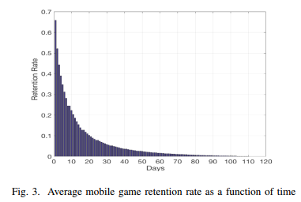

* **Observation 2:** For a given **user-play relationship** denoted by an edge in the attributed bipartite graph, its **context usually evolves slowly at 2 consecutive timestamps**
* Topology and attribute values of the attributed bipartite graph mostly evolve smoothly at 2 consecutive timestamps -> similar contexts for a given edge at consecutive timestamps
  + - Embeddings at these 2 timestamps should also be close – temporal smoothness

$g\left(z_{uv}^{\left(i+1\right)}\right)≊g\left(z_{uv}^{\left(i\right)}\right) ∀0≤i≤t-1, \left(u,v\right)∈D^{\left(i\right)}$ (9)

* **Observation 3**: by definition, churn in nature introduces **right censoring** to the training dataset
* Observation period – some time duration in history from time $t_{0} to t$
* Data for train and test all come from the observation period
* Label of a player-game pair at a specific timestamp is determined by their interaction in the next T time duration -> labels of some player-game pairs in the last T duration could be unknown
* Introduce a binary indicator $δ_{uv}^{\left(i\right)}$ to indicate whether an edge (u,v) is censored at timestamp i (0: censored, 1: otherwise)
* Inequality in (8) is updated by:

$$f\left(g\left(z_{uv}^{\left(i\right)}\right)\right)≲f\left(g\left(z_{uv}^{\left(i+1\right)}\right)\right) ∀0≤i≤t_{uv}-1, \left(u, v\right)∈D^{\left(i\right)}$$

$f\left(g\left(z_{uv}^{\left(t_{uv}\right)}\right)\right)≲f\left(g\left(z_{uv}^{\left(i\right)}\right)\right) ∀t_{uv}≤i≤t, \left(u, v\right)∈E^{\left(t_{uv}\right)}$ (10)

Where $t_{uv}$ denotes the timestamp when the edge (u,v) was observed

$$t_{uv}=max⁡\{i:δ_{uv}^{\left(i\right)}=1\}$$

* After timestamp $t_{uv}$, the label of (u, v) becomes unknown
  + - More reasonable to require that (10) holds pairwise between time point $t_{uv} and all time points after t_{uv}$
* **Temporal loss (11)**:
$$\left(11\right): L_{T}= \sum_{i=t_{0}}^{t-1}{\sum_{\left(u,v\right)∈D^{\left(i\right)}}{\{{\left\|g(z_{uv}^{\left(i+1\right)})-g(z_{uv}^{\left(i\right)})\right\|}_{2} +{\left[1(δ_{uv}^{\left(i+1\right)}=1)f(g(z_{uv}^{\left(i\right)}))+1(δ_{uv}^{\left(i+1\right)}=0)f(g(z_{uv}^{\left(t_{uv}\right)}))-f(g(z_{uv}^{\left(i+1\right)}))\right]}_{+}\}}}$$

$1\left(A\right):indicator function for event A$

${\left[x\right]}_{+}=max⁡\{x, 0\}$

* First term = temporal smoothness
* Second term = temporal dynamics
* Taking (2) and (4) into (11):

$$\left(12\right): L_{T}= \sum_{i=t_{0}}^{t-1}{\sum_{\left(u,v\right)∈D^{\left(i\right)}}{\{{\left\|h_{e}^{l_{p}}(z_{uv}^{\left(i+1\right)})-h_{e}^{l_{p}}(z_{uv}^{\left(i\right)})\right\|}_{2} +{\left[1\left(δ_{uv}^{\left(i+1\right)}=1\right)\frac{\exp\left(h_{s}^{l_{n}}{\left(g\left(z_{uv}^{\left(i\right)}\right)\right)}^{T}w_{s}\right)}{1+\exp\left(h_{s}^{l_{n}}{\left(g\left(z_{uv}^{\left(i\right)}\right)\right)}^{T}w_{s}\right)}+1(δ_{uv}^{\left(i+1\right)}=0)\frac{exp⁡(h_{s}^{l_{n}}{\left(g\left(z_{uv}^{\left(t_{uv}\right)}\right)\right)}^{T}w_{s})}{1+exp⁡(h_{s}^{l_{n}}{\left(g\left(z_{uv}^{\left(t_{uv}\right)}\right)\right)}^{T}w_{s})}-\frac{exp⁡(h_{s}^{l_{n}}{\left(g\left(z_{uv}^{\left(i+1\right)}\right)\right)}^{T}w_{s})}{1+exp⁡(h_{s}^{l_{n}}{\left(g\left(z_{uv}^{\left(i+1\right)}\right)\right)}^{T}w_{s})}\right]}_{+}\}}}$$

1. Context generation by attributed random walk

* Goal: embed an edge (not a node)
* A simple topology-based random walk may return 2 adjacent edges having the same player or the same game while totally ignoring thee similarity of the other end
  + - Undesirable
* Attributed random walk measures similarity by attributes and allows to transit to similar nodes even if they are not connected
* Novel attributed random walk technique that takes into account both topological adjacency and attribute similarities to make the transition decision of the walk
* Example of attributed random walk in an attributed bipartite graph

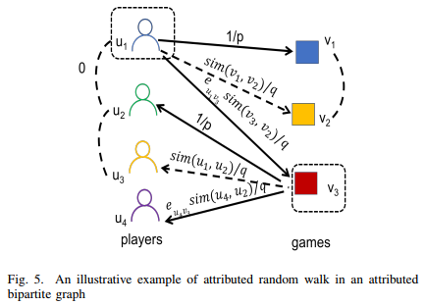

* Solid line – there exists an edge in the attributed bipartite graph
* Denote type of node o by type(o) – Node type can be of value either player or game
* Dashed directed lines – do not exist in the original attribute graph but may be considered as transitions by attributed random walk due to attribute similarities
* Dashed undirected lines – added augmented edges between nodes and their similar same type nodes
* Time-consuming to calculate pairwise similarities between a node and all other nodes with the same type
* Add augmented edges for a proportion of the same type nodes
* Augmented edges of node $o_{1} are:\left\{\left(o_{1},o\right):sim\left(o_{1},o\right)>1- ϵ, type\left(o_{1}\right)=type\left(o\right)\right\}, where 0<ϵ<1$ is a filtering param and:
$$sim\left(o_{1},o\right)≔\frac{x_{o_{1}}⋅x_{o}}{\left\|x_{o_{1}}\right\| \left\|x_{o}\right\|}$$

* Consider a random walker that just traversed edge $(v_{1},u_{1})$ and now resides at node
  + - Decide which node to transit to
* Attribute similarities matter -> cannot just evaluate those nodes that are neighbors of $u_{1}$
* Need to evaluate all nodes of the same type within the 2-hop neighborhood of $v_{1}$
* One-hop same type adjacent nodes of $v_{1}$: $N_{1}\left(v_{1}\right)=\{v: d\left(v_{1},v\right)=1, type\left(v\right)=type\left(v_{1}\right)\}$
* Two-hop same-typed neighbor nodes of $v_{1}$: $N_{2}\left(v_{1}\right)=\{v:d\left(v_{1},v\right)=2, type\left(v\right)=type(v_{1})\}$
* Transition prob in attributed random walk can be calculated as follows:

$$\left(14\right): p\left(o | u_{1}\right)= \left\{\begin{aligned}0, if type\left(o\right)≠type\left(v_{1}\right) \\ \frac{1}{p}, if o=v_{1} \\ \frac{sim\left(v_{1},o\right)}{q}, if o∈N_{1}\left(v_{1}\right) \\ \frac{sim\left(v_{1},o\right)e_{u_{1}o}}{q}, if o∈N_{2}\left(v_{1}\right)\end{aligned}\right.$$

Where p and q are normalization constants used to control the walk strategy

$e_{u_{1}o}=1 if there is an edge between u_{1} and o$

* The attributed walk in an attributed bipartite graph walks through different types of nodes repeatedly
* Enlarges the prob that any 2 consecutive edges in a path are similar and thus the prob that the whole set of edges on the attributed random walk path are similar
* When choosing next node to visit:
* Nonzero prob to choose those that are not connected to the present node but share similar attributes to the previous node
* For those connected to the present node, the prob to choose from them is weighted by the similarity between the descendant and the ancestor nodes
  + - An edge can be the context of another even when they are not adjacent but similar in both ends

1. Experimental evaluation

* Compare the semi-supervised (SS) model with:
* LR – logistic regression based solution
* RS – supervised variant of the SS mode (loss function only contains the supervised component and the regularization term)
* DT – decision tree
* RF – random forests
* SVM – support vector machine
* In the experiments, consider the churn duration T = 14
* Proposed solution is not restricted to any particular choice of T

1. Dataset and feature/label construction

* Features and labels – taken from disjoint periods to avoid data leakage

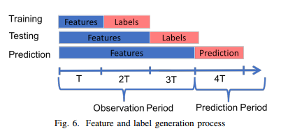

* Labels: whether a player churns a game on that day
* Features: constructed from historical data before the day to be predicted
* Training and testing set are split by label days in chronological order
* Taking labeled data in the first 2/3 of the observation period as training set and the remaining 1/3 as testing set -> ensure there is a time difference between testing and training set

1. Experimental settings

* Hyperparams tuned: grid search and combination yielding the best performance is chosen
* Learning rate
* Batch size
* Regularization terms
* Number of players
* Number of neurons per player
* Regularization params ${\{λ_{i}\}}_{i=0}^{4}$– all set to 1
* $α,β , γ$ in (1) set to be 0.02, 0.01, 1e-5
* $ϵ, p, and q$– set to be 1, 1, and 0.05
* Parameters used for training the deep neural network:

|  |  |  |
| --- | --- | --- |
| Param | USA dataset | Korea dataset |
| Player feature dimension | 10042 | 10042 |
| Game feature dimension | 10042 | 10042 |
| Player-game feature dimension | 30 | 30 |
| Learning rate | Initial value = 0.017  Decay by $η=\frac{η_{0}}{1+\frac{k}{2}}$ where k is the number of epochs | Initial value = 0.019  Decay by $η=\frac{η_{0}}{1+\frac{k}{2}}$ where k is the number of epochs |
| Number of neurons | Input layers 30  Embedding layers 50  Output layers 380k | Input layers 30  Embedding layers 50  Output layers 632k |
| Number of epochs | 6-8 | 8-12 |
| Batch size | 1024 | 4096 |
| Context number per user-game pair | 4 | 4 |
| Optimizer | Adam | Adam |
| Activation function | ReLU | ReLU |

1. Experimental results

* Evaluation metrics:
* ROC-AUC
* Precision - not used because data is imbalanced with around 85% negative instances in the US and 86% in Korea dataset
* Recall
* Results

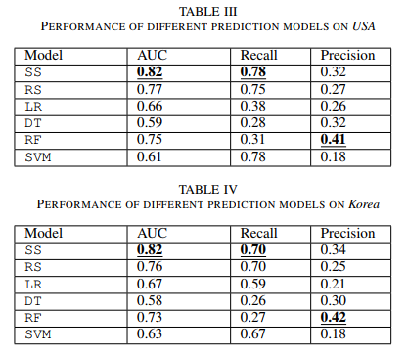

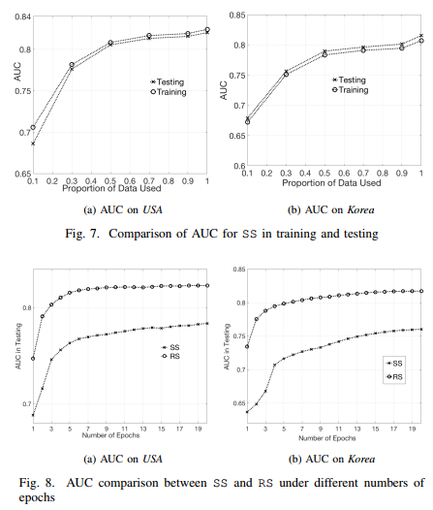

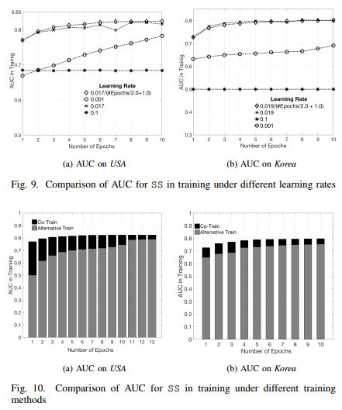

* Training methods for the supervised component and unsupervised component: co-train and alternative train
* Co-train: simultaneously train the supervised loss function and unsupervised loss function
* Alternative train: alternately train the unsupervised component with the unsupervised loss function and the supervised component with the supervised loss function
* In general, co-train outperforms alternative train in terms of AUC under a different number of epochs (Fig 10) -> choose co-train as the final training methods

1. Related works (see paper)
2. Conclusion (see paper)