# Time series forecasting

1. Time series – definition

* Data points indexed in time order
* Collection of observations obtained through repeated measurements over time
* Time series have values and a time index variable

1. Time series examples
2. Forecasting

* Predicting future values of the time series through values and events in the past and present
* Examples
* Sales
* Product demand
* Income through donations
* Energy demand and production
* Stock price

1. Forecasting challenges

* Supervised learning
* Know the value of predictor var
* Assume that future data looks like past data
* Forecasting
* Often don’t know the value of the predictors
* Sometimes don’t even have predictors
* Time series are dynamic: distributions change respect to training data

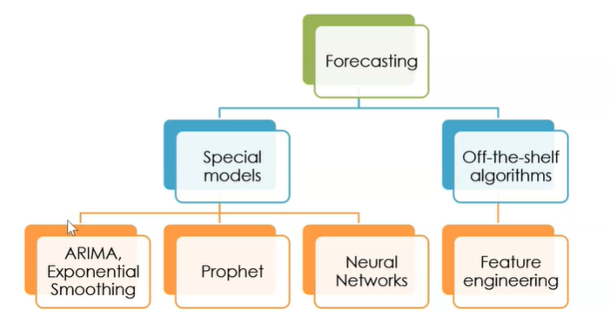

# Forecasting models

1. Time series forecasting

* We don’t have predictors
* We need to use past data

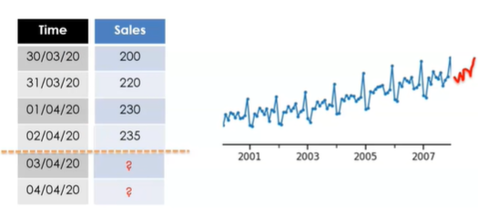

* Simple models:
* Predict last value
* Predict the mean of the last x values (moving average)
* Special models
* Exponential smoothing: weighted average of last values
* ARIMA – autoregression: forecast with a linear combination of past values of the variable
* Prophet
* Neuronal networks – RNN
* These models can take raw time series as input
* Neural networks can also take additional features
* Off-the-shelf ML models
* Linear regression
* Random forests
* GBM (xgb, lightGBMs)
* SVM, KNN, etc.
* We need predictors!
* Need a suitable target

1. Extract features

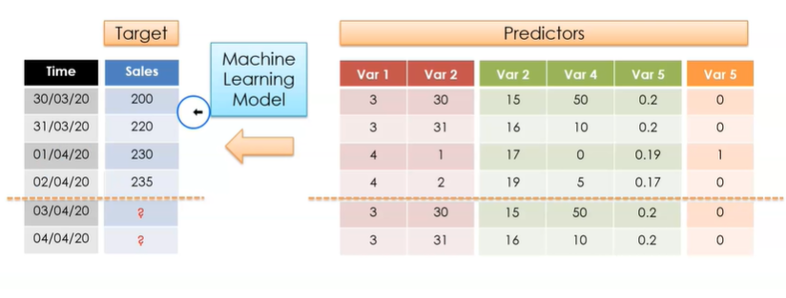

# Datasets, features, and targets

1. Single time series

* Single column time series (plus time index)
* Real life dataset – more challenging

1. Multiple time series

* Often we want to forecast more than 1 time series, simultaneously
* We have more data accompanying the target series -> predictor variables
* Additional info about the time and situation in which the events developed

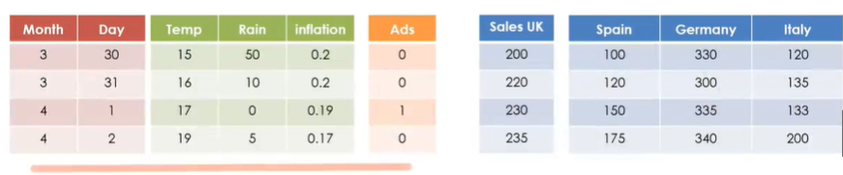

1. Predicting future values

* Predict future events based on past data
* For some features, we know the values in the future
* For some other, we do not know the values in the future -> need proxies
* Through additional features, we can simulate plausible scenarios
* What would happen if we launch an ads campaign?
* We can **predict the target based solely on predictor variables**
* Energy production = f(temperature, sun, wind, #solar panels, #wind turbines)
* We can **predict target based on past records of the target** itself
* Sales, temperature, stock prices
* We can **use both features and targets** to predict future events
* Mixed models, panel data, dynamic regression

1. Summary

* Datasets can be complex: predictors + target variables
* Predictors can be known or unknown at the time of prediction
* We can use predictors, target data or both for prediction and forecasting

# Forecasting Framework

1. Define

* What do I want to forecast?
* When do I want the forecast?
* What data do I have available?

1. What to forecast?

* E.g.:
* Sales per country/product vs. total sales?
* Energy demand per household vs. per city?
* Daily temperature or hourly temperature?
* We may need to group / aggregate our time series

1. The forecasting horizon

* How far in advance we want our predictions / forecast to be?
* Forecast point
* Forecast weekly sales for next week
* Daily energy demand for tomorrow
* Hourly stock price next hour
* Forecasting window (several forecasts)
* Forecast weekly sales for next 3 weeks
* Forecast daily energy demand over the next 7 days
* Hourly stock price in the next 6 hours

1. The available data

* What data do we have up to (but not including) the time of forecast?
* E.g.,
* Sales revenue up to last week
* Energy demand up to yesterday
* Stock prices up to now

1. Forecasting framework

* In the simplest case,
* We have data up to a certain point in time
* We want to forecast 1 single point ahead
* E.g. forecast sales next week with weekly sales data up to last week

* We have data up to a certain point in time
* We want to forecast various points ahead (forecasting window)
* E.g. forecast weekly sales in the next 3 weeks, with weekly sales data up to last week

* There may be a gap between available data and forecasting window / point

* We want to predict a value at time t
* We can use previous data: t-1, t-2, etc.

1. Feature derivation window

* We extract features from the feature derivation window

* Forecasting models should be trained on available data
* The feature derivation window changes for each time point

* Features that we know -> data (independent of the derivation window)
* Future unknown features -> can only extract from the feature derivation window

1. Summary

* Define what we want to forecast
* Define forecasting horizon
* Define available data
* Future unknown features can be created only from data available up to the forecasting point

# Feature engineering overview

1. Dataset and features

* We want to predict an event at time t
* We can use data at time t if available and previous data (t-1, t-2, etc.)
* As past events can inform future behavior, we can create new features from past info taking the temporal aspect of the data into account

1. Lagged features

* We can infer the value at time t utilizing the previous value of the feature
* A lagged feature is any feature that is from a fixed period in the past relative to the target
* The lag can vary, we can create multiple features with multiple lags

1. Sliding window features

* We can infer the value at t utilizing previous values within a certain period -> windows
* We can use statistical parameters within those windows, i.e. min, max, mean, std, etc.
* The window can vary, we can create multiple features from multiple window sizes
* Note: Common in financial data

1. Temporal features

* We can create new features from the timestamp -> day, month, hr, time, is weekend, business hrs, public holidays, etc.
* We can capture elapsed time, e.g., time since last transaction

1. Target features – lags and windows

* We can create new features from the target
* Lag and window features, multiple statistical params at previous time points

1. Target features – seasonality and trend
2. Feature combination

* We can combine features into new features
* Total sale / total population
* Energy demand / area
* Temperature and rain -> humidity
* Transform features mathematically -> log
* We can combine and transform the ts features itself or the derived values

1. Feature engineering – aim

* Some forecasting models are able to take the raw data as input
* For example, models supported by FB’s Prophet
* ARIMA, Holt Winters, ETS
* Potentially some RNNs
* For forecasting or classification with off-the-shelf algorithms like linear models, decision tree-based algorithms, SVMs, etc. -> we need to pre-process the datasets
* For some deep learning models as well

1. Summary

* We can create predictive features from past behavior
* There are multiple approaches to create features (lags, windows, trends, seasonality, etc.)