# Types of trend

1. Motivation

* Time series can be modeled by different types of trend
* Different types of trend require different features

1. Linear trend
2. Changepoints

* Abrupt change in the property of a time series (e.g., trend, seasonality, autoregressive properties)

* Piecewise linear trend

1. Non-linear trends

* Can try transforming time series to make more linear

1. Different types of trend need different features

# Linear trend: using time as a feature

1. Linear trend

* Let’s consider a linear model: $y=β_{0}+β_{1}x_{1}+β_{2}x_{2}+…$
* Model linear trend using time passed since a reference time, $t_{0}$, as feature $\left(t-t_{0}\right)$
$$y_{t}= β_{0}+β_{1}(t-t_{0})$$

* We typically set $t_{0}$ to the start time of the time series:

$$y_{t}=β_{0}+β_{1}t$$

1. Creating the feature for training and prediction

1. Forecasting with just the time feature

* Out of sample prediction

1. Tree based models with time feature

1. Implementation

* Pandas & numpy

* Sktime

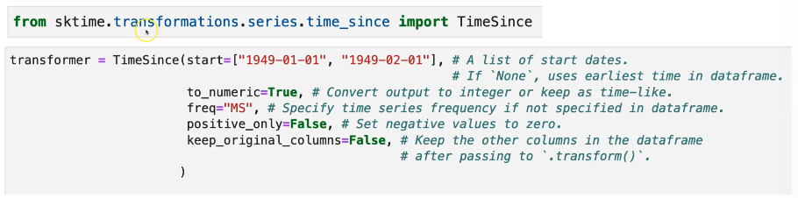

1. Summary

* For standard tree-based models, will not be able to use this feature to extrapolate

# Non-linear trends: using time as a feature

1. Non-linear trends with linear models

* Consider the model:
* When extrapolated, the resulting forecasts are often unrealistic
* Risk of overfitting to the training data and extrapolating poorly
* Piecewise linear trend is recommended instead for non-linear trends
* Alternative: try regularizing to limit overfitting

1. Example

* Linear regression with t

* Linear regression with

* Linear regression with

* Linear regression with and less data

* Linear regression with and less data

* Ridge regression with and less data

1. Implementation

* Pandas
* Sklearn

1. Summary

* Possible but not recommended to use non-linear time features to model non-linear trends
* Risk of overfitting and poor extrapolation
* Regularization can help reduce overfitting

# Recursive forecasting with lags, windows, and trends

1. Recursive forecasting: features built with target

* Lag features
* Rolling window features

* Impute or drop the missing values at the start of the time series

* Predicts one time step into the future -> recursive forecasting

1. Example: linear regression

* If > 1 then will increase exponentially

1. Recursive forecasting: lags, window, and time

