1. What is convolution?

* A feature transformation on the image
* What makes one convolution (blur) different from another (edge detection)?
* The filter
* Mechanics of convolution
* Input length = N, kernel length = K -> Output length = N - K + 1
* Images are not usually square, kernels are
* Pseudocode:

* Convolution equation (what we’re really doing is cross-correlation)
$${\left(A*w\right)}_{ij}= \sum_{i^{'}=0}^{K-1}{\sum_{j^{'}=0}^{K-1}{A\left(i+i^{'}, j+j^{'}\right)w\left(i^{'}, j^{'}\right)}}$$

* Valid mode: Output is always smaller than input
* Padding (same mode): what if we want output to be the same size as input?
* Imaginary 0 around the input
* Full mode (more padding)
* We could extend the filter and still get non-zero outputs
* Input length = N
* Kernel length = K
* Output length = N + K – 1

1. More on CNN

* Vectorization:
* Dot product – cosine similarity [-1, 1] -> measure of correlation
$$\cos\left(a, b\right)=\frac{\sum_{i=1}^{N}{a_{i}b_{i}}}{\sqrt{\sum_{i=1}^{N}{a_{i}^{2}}} \sqrt{\sum_{i=1}^{N}{b_{i}^{2}}}}=\frac{a ⋅b}{\left|a\right||b|}$$

* Pearson correlation – almost the same, just with mean subtraction

$$ϱ_{ab}=\frac{\sum_{i=1}^{N}{(a_{i}-\overline{a})(b_{i}-\overline{b})}}{\sqrt{\sum_{i=1}^{N}{{\left(a_{i}-\overline{a}\right)}^{2}}} \sqrt{\sum_{i=1}^{N}{{\left(b_{i}-\overline{b}\right)}^{2}}}}$$

1. Alternative perspectives on CNN

* How to view convolution as matrix multiplication
* 1D convolution
* Same as 2D convolution, just without 2nd index
$$b_{i}= \sum_{i^{'}=0}^{K-1}{a_{i+i^{'}}w_{i^{'}}}$$

* Matrix multiplication
* Same operation using matrix multiplication – repeat operation along each row and shift it
* By repeating the same filter again and again -> convolution without actually doing convolution
* Problem: takes up too much space
* Convolution:
* Instead of a full matrix multiplication -> replace with convolution
* Only use the same 2 weights over and over?
* Less params, use up less RAM, more efficient computation
* Why do this?
* Convolution = pattern finder
* We want the same filter to look at all locations in the image
* Translational invariance
* Translational invariance
* E.g.: Dog vs. cat recognizer

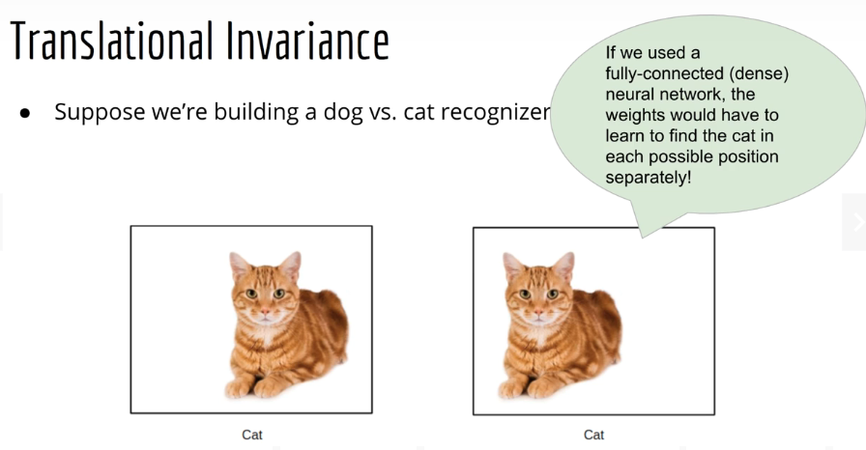

1. Convolution on color images

* Images – 3d objects: HxWxC

* 3D dot product = color pattern finder
$${\left(A*w\right)}_{ij}= \sum_{c=1}^{3}{\sum_{i^{'}=0}^{K-1}{\sum_{j^{'}=0}^{K-1}{A\left(i+i^{'}, j+j^{'},c\right)w\left(i^{'}, j^{'},c\right)}}}$$

* Input image: HxWx3
* Kernel: KxKx3
* Output image (2D): (H-K+1)x(W-K+1)
* Neural networks have repeating structures
* E.g., for Dense layer, input is 1D vector, output is also 1D vector
* Can be fed into another Dense layer
* But if output is 2D, how can we do another convolution later?
* Multiple features – We should have more than 1 filter per image, because each filter is looking for sth different
* A.shape = HxWx3
* If we use same mode, then B1.shape = HxW, B2.shape = HxW
* If we stack B1 and B2, we get B.shape=HxWx2
* We can add any number of features
* Depth of output can be much more than 3 (same as number of filters used)
* Convolution in a DNN
$B=A*w$

$shape\left(A\right)=H×W×C_{1}$

$shape\left(w\right)=C_{1}×K×K×C_{2}$

$shape\left(B\right)=H×W×C_{2}$

$$B\left(i,j,c\right)= \sum_{c^{'}=1}^{3}{\sum_{i^{'}=0}^{K-1}{\sum_{j^{'}=0}^{K-1}{A(i+i^{'}, j+j^{'}, c')w(c^{'}, i^{'},j^{'},c)}}}$$

* Summary so far
* Convolution for 2D images with 2D filters
* Extended into color images by saying the filter should just have the same depth=3 -> dot along all 3 axes
* Breaks uniformity, because output is 2D
* Would not be able to stack multiple convolutions sequentially
* Extended further by noting that each layer should find multiple features (using multiple filters)
* Multiple 2D outputs which can be stacked upon each other to get a 3D image once again (depth = n_filters)
* Color:
* Input to the neural network is a true color image
* But after subsequent convolutions, we just have arbitrary depth
* Our terminology must be more general -> feature maps
* Size of the final dimension: number of maps/features
* Convolution layer
* What does a convolution look like as a neural network layer?
* Convolution is like a shared-weight version of matrix multiplication (e.g., in a Dense layer)
* In a Dense layer, we also have a bias term and activation function
* So does a convolution layer
* Shape of bias term
* In a dense layer, if $W^{T}x$ is a vector of size M, b is also a vector of size M
* In a Conv layer, b does not have the same shape as $W*x$ (3-D image)
* Technically, this is not allowed by rules of matrix arithmetic
* But the rules of broadcasting (in numpy) allow it
* If $W*x$ has the shape HxWxC2, then b is a vector of size C2 (one scalar per feature map)
* How much do we save?
* Savings from doing convolution instead of matrix multiplication
* See video for explanation
* How are convolution filters found?
* See video for explanation

1. CNN architecture