1. Reinforcement learning

* Supervised learning – static function
* RNN – still a static function (input varies over ‘time’)
* RL – more like a loop
* A goal to achieve
* Time
* Plan for the future
* In supervised learning, training set must include labels (assigned by humans)
* E.g. Supervised driving – given an image, can you give it a target?

1. RL approach

* **RL uses goals rather than targets**
* E.g. solve a maze
* Goal: find the exit
* Do not need to label the correct direction for each maze position
* Magically, RL will figure out what to do during the preceding steps leading up to the goal (i.e. **planning for the future**)

1. RL terminology

* Main objects – **agent and environment**
* E.g. Tic tac toe
* Environment: the computer program that implements the tic-tac-toe game
* This itself may contain some form of AI that acts as the other player
* A bunch of if-statements?
* Imagine thee game has an API
* The agent interfaces with the game (via the API) – picking the best move
* **Episode**:
* With tic-tac-toe, I will eventually win/lose, and then I can restart
* ML algorithms learn using data
* Playing tic-tac-toe multiple times allows us to collect more data to learn from
* Colloquially, you might call these games / rounds / matches, but in RL we call them episodes
* **An environment is episodic if it ends and you can start a new episode**
* No relationship between one episode and the next
* There are non-episodic environments too, e.g. stock market
* It can go on forever, there is no end
* E.g.: online ads – agent should choose the right ad to maximize revenue -> no end to an online ad service
* Infinite horizon
* **States, actions, rewards**
* Describe how the agent and environment interact
* E.g. tic-tac-toe
  + State – for each location, what’s there? X/O/empty
  + Action – where to place the next X/O
  + Reward – a number, received at each step of the game (e.g., +1 for win, -1 for lose, 0 for draw)
* E.g. Maze
  + State: position in maze
  + Action: direction you can go (up/down/left/right)
  + Reward: ?
  + +1 for solving the maze, 0 otherwise
* Is this good?
  + Suppose the agent plays 10000 eps and never finds the exit (assume ep ends at 100 steps)
  + The agent learns that no matter what it does, it still gets the same reward (0)
* No incentive to do better
* Better reward: assign -1 upon arrival in every state
* Reward is now maximized by completing the maze as fast as possible
* Remove any bias you have about the connotations of the word ‘reward’
  + Reward does not necessarily means ‘good thing’ in RL
  + A real number: +ve, -ve, or 0
  + The agent will try to maximize its rewards (-100 > -1million)
* E.g. Breakout: states, actions, rewards
* Several options for state
* One (actually real) option is to read the game’s RAM
* Can be thought of as a proxy to the previously defined ‘perfect’ state
* In contemporary applications, we simply use screenshots of the game
* RL agent must interpret images of the game, just as we humans do!
* CNN would be useful here >< Complication: with just a single screenshot, we have no concept of movement
* Important: the state need not be only what I observe at a single moment
* The state can be derived from current and past observations
* In the famous DQN paper, they used 4 consecutive frames to represent the state
* Action: just the different buttons / inputs on the joystick control pad
* Reward: +1 every time you remove a block
* **Spaces**:
* High-level concepts -> math that helps solve RL problems
* Describe state spaces and action spaces – set
* **State space** – set of all possible states
* **Action space** – set of all possible actions
* Canonical RL example – Gridworld
  + State space = {(0,0), (0,1), (0,2), (0,3), (1,0), (1,1), (1,2), (1,3), (2,0), (2,1), (2,2), (2,3)}
  + Action space = {up, down, left, right}

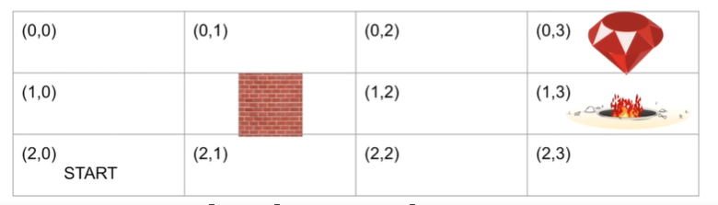

* Large state spaces
* State space is complicated
* E.g. tic-tac-toe: Action space is simple: just the different places you can put your X/O
* E.g. breakout:
  + Technically, it’s the screen resolution * 2^24
  + Usually images, like time series, are considered continuous-valued
  + They appear discrete because computers have finite precision, values must be quantized
  + In some environments, actions can also be continuous / infinite
* **Summary**:
* Agent and environment
  + Environment: the world or the game you are teaching your agent to win
  + Agent: your computer program, the one that will learn
* Episode: one round / match of a game
* States, actions, rewards
* Reward: a number that the agent tries to maximize (+ve, -ve, 0)
* Action: what the agent does in the environment
* State: what we observe in the environment, but can be derived from one or more observations
* Last state of an episode – terminal state
* State space and action space – set of all states / actions

1. States, actions, rewards, policies

* How do we encode states and actions in code?
* Rewards are just numbers, no need to encode them
* **States**:
* Can be discrete or continuous
  + Discrete e.g.: Tic-tac-toe – state is a specific configuration of the board
  + Continuous e.g.: robot with sensors – camera, microphone, gyroscope, GPS, proximity sensor, etc.
* Digression to supervised learning
  + If targets are discrete, encode them as 0, 1, …, K-1
  + If targets are continuous, store them in a vector (images are stored in tensors)
* In RL: generally, state will be stored as tensor with 1 or more dimensions
* **Policies**
* How do you represent a policy in math?
* Policy: **what the agent uses to determine what action to perform** (given a state)
* Policy yields an action given only the current state
* Does not use any combination of past states or any rewards
* The state theoretically could be made up of past observations or rewards >< unconventional
* **Policy as a function or mapping**
* Input is the state s (dictionary key)
* Output is an action a (dictionary value)
* Mathematical representation?
* An example policy

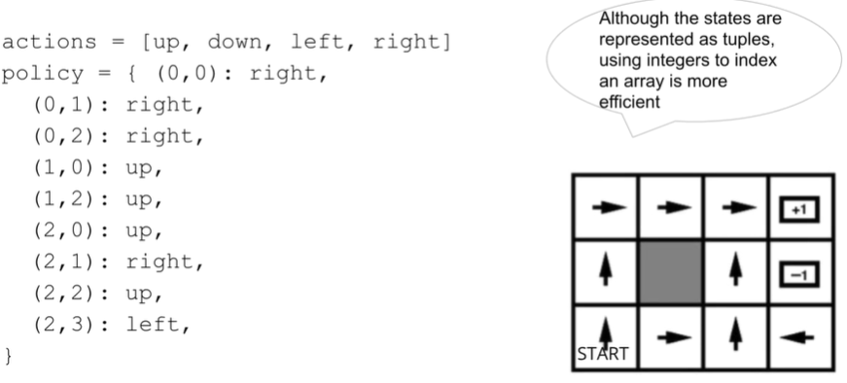

* This approach is somewhat limited
* What if we have an infinite state space?
* We cannot have an infinite number of dictionary keys
* Doesn’t allow us to explore the environment
* Think of training an agent like teaching a baby
* Must try new things to build intuition
* Makes sense to policies to be stochastic / random
* A more general way to represent policies is with probability
* **Policy as probability**
* Allows agent to have a degree of randomness (or not)
* One method is called **epsilon-greedy** (common value of 0.1)

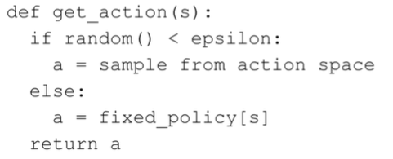

* Continuous state spaces – s is a D-dimensional vector
* Policy parameters – W (shape of W is D x |A|)
* How do we get prob from a vector? Softmax function
* For a given state s, we can calculate the prob we should perform each action,
* To choose an action: sample from or take the argmax
* Is only the state needed?
* How can an agent make an intelligent decision based only on the current state?
* If you think in terms of SL, you may insist that this requires a target (how else would an agent know what to do for this state?)
* **In RL, an agent can learn to plan for the future by gaining experience**
* Instead of an explicit target, it will try to **maximize future rewards**

1. Markov decision process (MDP)

* Problems, frameworks, solutions
* Goal: come up with a framework
* Using that, we can more accurately define the problem, and find a solution
* The **Markov assumption**
* In RL, the main assumption we make is the Markov assumption
* Normally, this is discussed in the context of sequence modeling
* E.g.: predict whether tomorrow weather will be rainy, sunny, or cloudy
* The Markov assumption: tomorrow’s weather depends only on today’s weather, but not on any earlier day
* E.g.: predict the next word in a sentence
  + Preceding word is ‘lazy’
* What is the next word?
* In general, we say that **the state at time t depends only on the state at time t-1**
* By itself, the Markov assumption is weak
* **Recall: we can make the state whatever we want**
* Can consist of 3 or 4 words / observations
* MDP: describes a RL system
* Previously, we defined the Markov assumption in terms of state only
* **In an MDP, we describe the environment with the state-transition probability**
* **State-transition**
* is the most general
* But sometimes (e.g., maze example), the reward is deterministic
* No need to model it with prob.
* State transition prob:
* Reward function:
* What is the usefulness of the state-transition probability?
  + In complex games, the state space is infeasible to enumerate – how can we calculate this prob?
* In algorithms such as Q-learning, it’s not used at all
* So what’s the point? Think of MDPs as a stepping stone
* Allows us to build our way up to practical RL solutions
* **State-transition probability**?
* State may not capture the complete info about the game
* In tic-tac-toe, there is another player – you can’t deterministically predict their move
* Physical systems involve chaos theory – even if you know the physical laws of motion, you still cannot deterministically predict the future
* The further you try to predict, the more inaccurate your predictions
* We refer to state-transition prob as **environment dynamics**
* The language of probability
* By representing both agent and environment as mathematical objects (probs) we can describe a system using equations, which then allows us to solve those equations (need a problem to find a solution)

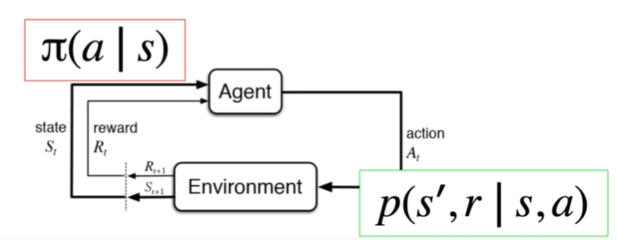

1. The return

* **Maximizing rewards**
* Rewards may be structured differently in different environments
* Tic-tac-toe: +1 for winning, -1 for losing
* Maze: -1 for every step
* What exactly does it mean to maximize reward?
* Does it mean ‘maximize the reward I get on the next step’?
* Does it mean ‘maximize total reward over entire episode’?
* Future rewards
* A more accurate statement would be: the agent wants to **maximize the sum of future rewards**
* We can’t maximize the rewards we already got
* We don’t want to only maximize the reward on the next step
* The agent would not be incentivized to do anything useful – each step yields the same reward (e.g. a maze gives you -1 on every step)
* By trying to maximize the sum of future rewards, the agent plans for the future
* E.g. preparing for a math exam
* You don’t receive any reward until you finish the exam – your reward signal is your exam grade
* Imagine the actions required to maximize the reward – study/ homework/ forego socializing -> Those do not sound very rewarding at all
* Immediate gratification does not work
* Must use long-term planning to maximize future rewards
* **The return**
* **Sum of future rewards**
* Some people also call it the **utility**
* Infinite horizon MDP – a game that never end
* Will your return be inf?
* Not if we use **discounting**
* Is used for episodic tasks too
* We call the **discount factor** – usually a number close to 1 (0.9, 0.99, etc.)
* Works like money – I want to receive $100 now, not in 10 years
* Recursiveness
* The return can be **defined in terms of a later return**
* Return at time t = Reward at time t+1 + gamma * return at time t+1

1. Value functions and the Bellman equation

* Expressing the problem as an equation
* Let’s start with expected values (the mean)
* E.g. model the heights of 1000 students as a Gaussian distribution
* Average height to be 70 inch, standard deviation to be 4 inch
* The expected value is NOT the value you expect to get
* The expected value has a precise definition for both discrete and continuous random variables
* Discrete: -> weighted sum of all the possible values of a random variable where the weights are the probability of that value
* Continuous:
* Coin example:
* Suppose p(heads) = 0.6 -> biased coin
* Heads = 1, tails = 0
* E(X) = 0.6 * 1 + 0.4 * 0 = 0.6
* Why expected values?
* The reward (and hence return, since it’s the sum of rewards) is a random variable
* If I play the same game for 100 eps with the same policy and same environment, I will get different rewards each time
* Both environment dynamics and policy are probabilistic
* Makes sense not to think of a single return, but the expected value of the return
* Maximize the expected sum of future rewards
* Value function
* Expected return – the value function
* Conditioned on the state s at time t
* Value of state s
* Recursiveness:
  + Return can be defined recursively
* Value function can also be defined recursively
* Why do this?
* In order to find a solution, we must have a problem to solve
* Express the expected value in terms of prob. distributions
* **Bellman Equation**
* Implications
* We only used the rules of math (prob.) to arrive here
* Its physical meaning is deeper: and come from different physical processes
* One represents the agent, the other is the environment
* Problem and solution
* We now have a problem -> solution
* There are multiple possible policies - some good, some bad
* How can we tell which are good and which are bad?
* Check value functions
* Finding the value function for a given policy is called the prediction problem
* How is this simple
* Just multiplication and addition
* is just a function we wrote in code – we know what it is
* Assume we know too
* System of linear equations
* If we have 3 states, the Bellman equation would boil down to the expression below (b’s and c’s are just constants)

1. What does it mean to learn?

* In RL, there are 2 main types of tasks:
* Prediction problem: Given , find the corresponding value function V(s)
* Control problem: Find the optimal policy , which yields maximum V(s)
* Action-value
* V(s) = state-value function
* Q(s, a) = action-value function (usually we just call it a ‘Q-table’)
* Bellman equation for Q
  + Note: no sum over action, because it is given
* Space complexity
* How much space it takes to store V(s) and Q(s)
* Assume a finite set of discrete states and actions
* We have |S| states and |A| actions
* V(s) can be stored in an array of size |S| -> linear complexity
* Q(s, a) can be stored in a 2D array of size |S|x|A|-> quadratic complexity
* The optimal policy
* The optimal policy is the best policy – maximizes the value (for all states)
* We can say is better than if V(s) for is greater than V(s) for for all states s in the state space
* The best policy and the best value function
* The best value function
* The best policy
* Relationship between Q and V
* The optimal action-value
* From Q* we can easily obtain V*
* What about the action-value?
* If we find the optimal action-value, it is very easy to choose the best action given any state
* The optimal policy is not unique – multiple policies can lead to best value
* Suffice to find one
* Finding the optimal policy
* Can we use the definition directly? Yes
* Control problem
* Suppose we’re playing Gridworld or tic-tac-toe
* State space and action space are finite
* Naïve search will suffice

* Impractical

1. Solving the Bellman equation with RL – Prediction problem

* Recap of simple / naïve solutions to RL
* Prediction – find V(s)
* Control – find
* Prediction: if we know all the probs -> simple linear algebra problem
* Control: exhaustively loop through all possible policies, return the one that yields the best V(s)
* Are these approaches realistic?
* Prediction problem: we need to know
* Not realistic
* The state space is also extremely large – cannot enumerate all states and their transition probs
* Control: can we enumerate all possible policies?
  + Consider we have |S| possible states and |A| possible actions
  + Total # of policies is -> exponential growth
* Would not work at all if |S| or |A| is infinite
* The solution
* Recall: the expected value is the mean
* To calculate the expected value, we must know the distribution
* Key point: we can estimate the mean with the sample mean
* As N -> inf, estimate becomes more accurate
* Application to RL
* Value function -> simply the expected return
* Sample many returns to estimate the value of each state
* G(t) means generic random variable – return at time t
* g(i, s) means a sample – the ith time reaching state s
* where do the samples come from?
* How do we sample a return?
* Every time we play an ep, even if we use the same policy in the same environment, we get a different result
* Both the policy and environment dynamics are probabilistic
* Simply playing the game works
* Pseudocode – Monte Carlo approach
* Prediction: given a policy, find the value function
* High-level idea: playing an ep yields a series of states and corresponding rewards

* Calculating returns
* Go backward and use the recursive definition
* since there are no future states
* Value of a terminal state is 0

* Pseudocode for prediction
* Just do the same thing 100s or 1000s of times to collect samples

* For each state, take the average return of the samples

1. Solving the Bellman equation with RL – Control problem

* General pattern: for prediction, we want V(s)
* For control, we want Q(s, a)
* Select the best action to perform
* Policy iteration and policy improvement
* Given a policy, we can use Monte Carlo to evaluate the value function V(s) or Q(s,a)
* Given the action-value, we can choose what we currently believe to be the best action, using the argmax
* These 2 facts are interdependent
* Repeat in a loop: find Q(s,a) given , find as the argmax over Q(s,a)