Judge Symmetric Matrix



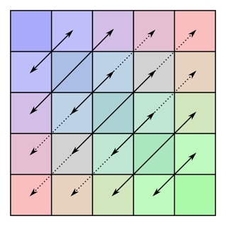

Maximum matrix size S=10

