The implementation methods of facial recognition for home security systems

Mia Brown

Harrisburg University of Science and Technology

CISC/ISIT 298

Spring 2023

# **Abstract**

This paper goes through and gives an in-depth overview of Facial Recognition and its various stages, datasets, and techniques to enact the process. This deep dive will uncover the best possible method of implementing Facial Recognition. The methods chosen for the project implementation are Haar cascades for face detection and Linear Discriminant Analysis for feature extraction. These methods will then be used in future implementation of facial recognition into a security system.

Table of Contents

**Abstract** 2

**List of Figures** 6

**List of Tables** 6

**Introduction** 7

**Project Overview** 7

**Definition of Terms** 7

**Significance of the Project** 8

**Theoretical Framework or Construct** 9

**Ethical & Legal Considerations** 9

**Project Topic Statement and Justification** 10

**Project Statement** 10

**Goal(s) and Objective(s) of The Project** 10

**Deliverables** 10

**Results and Findings** 11

**Problem Justification** 16

**Limitations of Your Project** 16

**Literature Review** 17

**Literature Review on Face Recognition methods** 17

**Literature Review for Feature Extraction comparison of LDA and PCA** 21

**Research Design and Methodology** 22

**Conclusion, Summary and Recommended Future Work** 23

**References** 25

# **List of Figures**

Figure 1.1 Haar features (Top to bottom)

Figure 1.2 use of Haar features

Figure 1.3 Flow diagram for Haar Cascade

Figure 1.4 data table LDA example

Figure 1.5 Calculate the mean and variance for female class.

Figure 1.6 Calculate the mean and variance for male class.

Figure 1.7 Bayes’ Theorem for calculating probability.

Figure 1.8 Kernal canonical analysis flow diagram

Figure 1.9 Good class separation within LDA

Figure 2.1 DFD of LDA process

Figure Time 2.2 taken comparison between LDA (left) and PCA (right).

Figure 2.3 Comparison recognition rate between LDA (left) and PCA (right).

# **List of Tables**

Table 1.1. Definition of terms

Table 1.2 LDA results

Table 1.4 Accuracy %

Table 1.6. Time taken Comparison LDA v PCA

# **Introduction**

Facial recognition is a computer application that it used for identifying or verifying a person from an image of a video frame automatically. Facial Recognition is a fast growing and increasingly popular tool that has many different uses ranging from things like security to social media applications. This paper will focus on the different techniques and algorithms that can be used to carry out facial recognition.

## **Project Overview**

Facial Recognition is the technological process of detecting the presence of a human face and classifying the identity of that person. Real-time or automatic Facial Recognition is important and used for many things like Criminal Investigations, Healthcare, Human Machine learning, Security systems, and many other avenues. Facial Recognition has four major steps i.e., Face Detection, Feature Extraction, Face Representation, and Face Classification. All these stages make up the process of Facial Recognition. Face detection is when the camera is detecting and locating a face in an image or in a live video feed. Feature extraction is the part when the face is converted to data and the dimensions of it are reduced to create a small data set. The facial classification is the facial verification process. This is the ending process where the identity of the face that has been detected and extracted is finally identified.

## **Definition of Terms**

|  |  |
| --- | --- |
| Term | Definition |
| Machine learning | Computer systems that are developed for the use of learning to adapt without human intervention or explicit direction, by using algorithms and statistical models. |
| Neural Networks | Artificial Neural Networks are computer systems that mimic the human brain, learning from data and finding patterns. |
| Biometrics | Unique physical characteristics that can be used for automated recognition. |
| Supervised Learning | Uses **labeled datasets** to train algorithms that classify and or predict an outcome. |
| Unsupervised Learning | Uses machine learning algorithms to analyze and cluster **unlabeled datasets** and discovering hidden patterns. |
| Natural Language Processing (NLP) | Natural Language Processing (NLP) is a subfield of artificial intelligence that focuses on enabling machines to understand, interpret, and generate human language. |

## 

## **Significance of the Project**

## Undertaking this project has helped be better grasp different aspects of security that I have been curious about considering that I want to have a future career in cyber security**.** Currently I have no related courses and I have not taken any related courses to this topic that I have chosen for my project. As I was researching topics to do for my project, I wanted to choose something that was interesting to me and where I want to take my career. I chose that way because I knew that I would spend many hours researching and learning about whatever topic that I chose, and I wanted it to be related to my interests within computer science.

## 

## **Theoretical Framework or Construct**

## The information that I will need to learn for this project is everything about facial recognition. I will need to do in-depth research to gain knowledge on all the stages that make up facial recognition. This knowledge will assist with knowing which algorithms will be used for the actual implementation step of the project.

## **Ethical & Legal Considerations**

When it comes to facial recognition, having legal and ethical issues can be a problem and currently is a problem in society. Since Facial recognition can be used in public areas, facial recognition technology could potentially violate privacy rights by collecting and processing biometric data without consent or knowledge. This can be done through apps and in public areas. This can raise the question of where companies store this data and what for. When facial recognition is used by law enforcement agencies for surveillance purposes it can raise questions about civil liberties being violated and abuse of power. For my project, the only chance that I can run into any legal and ethical issues is with the project two stages of the project. To combat that, the project implementation will only use images of people that have consented to the research study that uses their face for facial recognition tests. This data will be images and live video of the consenting individuals.

# **Project Topic Statement and Justification**

## **Project Statement**

The implementation methods of facial recognition for home security systems

## **Goal(s) and Objective(s) of The Project**

The goal of this project is to find the best implementation methods for facial recognition. The focus is to find not only the best methods but also the easier methods for beginners with Machine Learning and Artificial Intelligence. The backbone of this paper goes deeper into the methods and the mathematics behind the algorithms. By doing this, the paper can help further grasp what is within each of the stages to better understand their functions. The goal of this project is to gain the necessary knowledge on how to implement facial recognition into a home security system where is captures the image, uses the stages of face detection, feature extraction, Face Representation, and Face Classification. After that process, it will then send a notification to the user on the face classification of the person on their property to their device.

## 

## **Deliverables**

This paper will go in-depth about the research and the findings that I have made while researching the topic that I chose. It will walkthrough a few different methods that a researched and why I chose a certain method, or even why I chose a certain method over another method. This paper will also explain the direction of where all the research on the different stages and ways of implementations will end up and what the end goal of this project will hopefully be.

# **Results and Findings**

Face detection is an AI (Artificial Intelligence) based computer technology that is used to extract and identify the presence of human faces in a digital image or video. A method that can be used for face detection is Haar Cascade.Haar Cascade uses a process known as a slicing window, that continuously slides a fixed window shape across a given image at multiple scales. In each movement phase, the Slicing Window computes and classifies if,yes, the region contains a face, or no, this region does not. There are many stages that make up the process of Haar cascade. The first stage is calculating Haar features. This stage involves summing the pixels in each region and calculating the differences between the sums. It uses a series of Haar features shown in Figure 1. 1.. These features are used for the movement phase and the slicing windows. The Haar features are used to find parts of an image that resemble features of a human face like the nose, mouth, eyebrows, and eyes. The use of the Haar feature depends on the shape of the feature due to the white section of the Haar feature being the excluded data that doesn’t need to be used for finding the

(3)

1. Line features (2)

**Figure 1.1 Haar Features**

feature. The black section of the Haar feature detects the part of the feature that is needed to detect the feature, this is shown in Figure 1. 2.. The next stage is creating integral images. The stage involves computing the sum of pixel intensities in a rectangular region of the input. This stage speeds up the calculation of Haar features by creating sub-rectangles and creates array references for each of the sub- triangles, instead of calculating every pixel. The Haar features are irrelevant when it comes to finding the best features to use out of the image. The way that it chooses its best features is through Adaboost training. Adaboost training chooses the best features and then trains the classifier to use them. It uses a combination of “weak classifiers” to create a “strong classifier”. Weak learners are created by moving a window over the implant image in computing her features for each subsection of the image. The cascade is designed to quickly reject negative samples, which can improve the overall speed of the algorithm. The final stage if object detection. This is where the

**Figure 1.2 Use of Haar-like features**

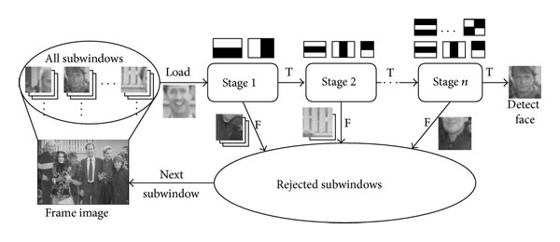strong classifier that was created by the combination of weak classifiers is applied to the input image. The classifier computes the Haar-like features for each sub-window of the image. It goes through a process of if the window does not.

**Figure 1.3 Flow diagram for Haar Cascade**

contain any needed features, it is classified as negative, and the sub-windows with the features that are necessary for classifying the detection of a particular object are stored as positive. Feature Extraction is a process of dimensionality reduction by which a set of data is then transformed into smaller, more manageable groups by selecting and combining variables into features. The last stage Feature Extraction is used in machine learning and image processing. In the case of Facial detection, the purpose of feature extraction is to collect the particular features in a face which is then converted into data variables. It is also used in Natural Language Processing (NLP), to help identify keywords by the frequency of occurrence in a file or a sentence using pattern learning. *Principle Components Analysis* (PCA) is a linear appearance based Facial Recognition method. The process of PCA is finding out the most important features or principle components that have the most impact on the target variable. PCA is interested in finding the direction of the components. PCA is an unsupervised learning algorithm, meaning regards variation in the data but disregards the data labels. There are six general steps to performing the PCA approach with feature extracting. The first would consist of taking the entire dataset of *d*-dimensional samples and ignoring the class labels. By ignoring the class labels this makes the PCA approach an unsupervised learning algorithm which can lead to misclassifications of data in some cases.The next step in the algorithm is to calculate the d-dimensional mean vector. This is done by finding the means of each dimension in the whole dataset. The following step would be to calculate the covariance matrix of the entire dataset. Using the formula: **covariance (X, Y) = .** This can then be placed into a matrix. The next stages are to compute the eigenvalues and the eigenvector. The eigenvalues tell you the amount of variation in the entire dataset. After those are calculated, the values are then sorted in decreasing order and then the samples are transformed onto the new subspace with the use of a d×k eigenvector matrix. The next method that I researched for feature extraction is Linear Discriminant Analysis. Unlike PCA, LDA is a supervised classification technique. It can be used for not only dimensionality reduction, but since it is supervised and uses data labels, LDA can also be used for classification and data visualization. There are also stages that are part of completing LDA. The first step is that the datasets are divided into individual classes with labels. Take an example where there are two classes for gender of male and female and have a record of their weight. This table shows the data for this example.

The next stages for the mathematics within LDA are to calculate the mean of variance for each class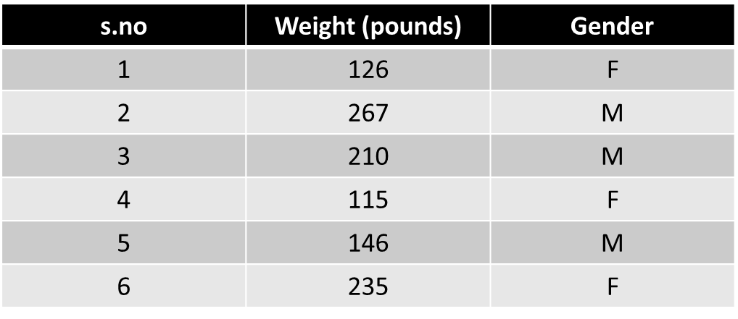, and to calculate the variance of the variable for each class. The equation used to

Figure 1.4 data table LDA example

calculate the variance is: Variance, = . For this data the mean and variance for each class would be as follows:

For Female Class:

Mean age,

Variance, =

**Figure 1.5 Calculate the mean and variance for female class.**

For Male Class:

Mean age,

Variance, =

**Figure 1.6 Calculate the mean and variance for male class.**

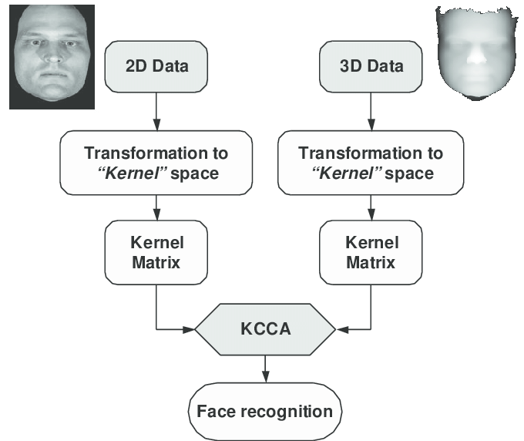The next step would be to calculate the probability for each class. This is done by using the Bayes’ Theorem. The theorem is shown in Figure 1.7. This calculation is necessary and will be used for the final data model calculation. The Bayes’ Theorem helps the algorithm to make informed decisions that are based on uncertain or incomplete information. All the information will be then used in the last and final stage. The values of mean, variance and prior probability will be used by assuming normal distribution of the variable in each class. This will then be used to develop the final model. The next stage that goes into facial recognition is the extracted data comparison. This process is where the software takes the data that was extracted and compares that data to the data of the known faces thar are stored in the database. This data comparison is of things like the Facial landmarks and the key elements that distinguish one face from another. The data that is compared is known as a faceprint which is a unique characteristic that a person has which is a form of biometrics. The data comparison is referred to as **1: N matching** or **1: to many matchings**, where **N** is the number of face signatures in the database. The final stage of facial recognition is Face classification. After the unique data is compared to the individual face signature faces within the database, if a match is found, then the identity of the person is found. This form of classification can only happen if the match is within the database. There is a form of facial recognition that can use a broad database of every image uploaded to the internet, but for this project that will be conducted, the database consists of a controlled set of images. With face classification, the image within the database, and the image that has been extracted has to be in the same format. For example, if the image that is in the database is 3 dimensional, then the image that is being compared to it that has been taken from the image of the camera or the live feed, must also be in three-dimensional format. If they are both in the same format, then the facial match can be completed and there won't be any changes necessary. If the format of the image extracted is in 3D format and the image that is stored in the database is in 2D format, data mathematical algorithm will have to be executed for there to be a correct match. One algorithm that can be used for this that is derived from principal component analysis, is called kernel canonical correlation analysis.

**Figure 2.5 Kernal Canonical Analysis**

**Figure 1.7 Bayes’ Theorem for calculating probability.**

## **Problem Justification**

The reason for choosing this topic for the project is due to the curiosity that I have for the topic of facial recognition. This project is important because there are so many ways to perform facial recognitions, and I wanted to highlight a way that is not only easy for implementation but also great in accuracy and run-time speed. I wanted to learn what goes into the implementation behind Facial recognition for a beginner with the topics. Relating this to my professional goals, I want to work in cybersecurity. Facial recognition technology plays a large role in security with law enforcement, and I wanted to further my knowledge on the topic.

## **Limitations of Your Project**

The limitation of this project is that it mostly focuses on the background of the algorithms within facial recognition. This thesis will not go in depth on the coding side of the implementation that is used for Facial recognition. A limitation that I had run into as well is that since I had chosen a topic that I had no prior knowledge of, I had to start all my learning from scratch. I had to uncover all the inner workings of Facial recognition because I walked into this project without the slightest idea of how facial recognition worked, and what is needed to make it work.

# **Literature Review**

There are many research papers and articles about the best way to implement facial recognition for the best accuracy, recognition rate, and run-time of the entire process. The purpose of this section is to highlight the key findings that had provided the foundation of my project’s research. Many of the research papers that will be reviewed in the next section focus on highlighting the different methods that can be used for the various stages that make up facial recognition. By focusing on the individual stages, this can compare the efficiency, accuracy and robustness of the algorithms and techniques, and find the best option for use.

**Literature Review for Feature Extraction Method LDA**

The first piece of literature that was used for the research done within this paper focuses on a method that can be used for the feature extraction stages for facial recognition. Feature extraction is the process of dimensionality reduction to a large dataset. This can be done with many different methods, and some are more efficient than others depending on the size of the dataset that is being reduced. The paper is about the method Linear Discriminant Analysis or LDA. In this paper the Author evaluates the performance of LDA on various datasets and compares its performance with other methods that are also used for feature extraction.

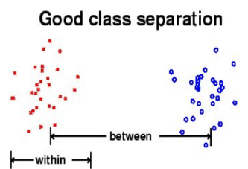The main aim of LDA when it comes to data reduction is to reduce by maximizing the component axes for class separation. This helps to find the goal of good class separation which is shown in **Figure 1.3.** There are stages within LDA that need to be completed for the feature extraction to be completed successfully. A flow diagram showing this process that is partaken by LDA is shown the **Figure 1.4** below. This study had used 40 subjects and used LDA as the feature extraction algorithm to test facial recognition performance. The images that were used are called “The ORL Database of faces. These images were taken for a project that was the product of in collaboration with the Speech, Vision and Robotics Group of the Cambridge University Engineering Department between April 1992 and April 1994.The first stage consists of creating a training set. This training set aids in the production of having accurate results with feature extraction. Referring to the paper, this training set should have many images of each individual subject with varying views, lighting, background, facial expressions, and with and without glasses. For increased difficulty, some of the subjects may also have similar facial hair or certain features, to test the accuracy of the algorithm. In this study done, they captured ten photos, **Figure 2.2,** of each subject with variation to each image taken. The next step that will be taken within LDA is to constudct the vector expansion.This is done for every image as well as for every subimage. By doing this, it makes it possible to apply mathematical operations to identify similarites and dissimilarities between the faces. The starting point of this is a two-dimensional array m x n which is then transformed into a vector expansion : **Φ in R(m x n)**, space. This vector serves as the initial representation of the face The third step would be to define each individual set of subjects as separate classes. TRhis is where the class seperation comes into play with LDA. Once every subject within the training set is labeled by class,then *within-class* and *between-class scatter* matrices can be made.A *within-class*scatter matrix represents the scatter of the data or the variance of the data within each individual class. The *between-class scatter* is the variation between the different classes.The results of the study using LDA for feature extraction. The data comparision was done on the trainin images and **Table 1.2** shows the image number, and T if the face was recognized and F if it was not recognized. As shown in **Table 1.2.** the algorthim had recognized 37 out of 40 images. It shows a false result that occurred three times. The images that were mistakingly matched with people that are not the same people is show in **Table 1.3**. As you can see, the images are similar in different ways. Taking the third image in the table, both men in the images have a huge beard, same hair and hairlime, as well as they both wear glasses. Due ot the simularity of them both it makes sense as to why the algorithm mistakingly found them to be a match. The same reasoning can be used for the other images that were also mistakingly matched to others. Knowing this information, this can tell the reader what LDA’s recognition accuracy is with this particular set of images used. The accuracy of LDA with this particular study Is 92.5%.

**Figure 1.9 Good class separation.**

Figure 1.3

Table 1.2

Figure 2.2 subject image dataset

**Table 1.4 Accuracy %**

Table. 1.3

# **Literature Review for Feature Extraction comparison of LDA and PCA**

The next paper that has aided in the research done within this project is, "A comparative study of feature extraction using PCA and LDA for face recognition," by E. Hidayat, N. A. Fajrian, A. K. Muda, C. Y. Huoy and S. Ahmad. This study compares the performance of Principal Component Analysis (PCA) and Linear Discriminant Analysis (LDA) for feature extraction in facial recognition. The authors exam the necessary steps within each of the algorithms which I have already iterated above. The next stage of this study was to evaluate the performance of each and compare that performance to a set of datasets. These images are shown in **Table 1.7**. They used six different sets of datasets which are COPPEDYALE [24], FACE94, FACE95, and FACE96 [25], JAFFE [26], and AT&T “The Database of Faces”. There is a difference between PCA and LDA where PCA is an unsupervised linear algorithm and LDA is a supervised linear algorithm. Another difference is the eigenvalues are calculated differently for LDA v PCA. For PCA, the total scatter matrix calculation must be taken in order to calculate the eigenvalues and for LDA the eigenvalues are calculated from the between-class scatter matrix and the within-class scatter matrix calculations.

These results show that LDA outperforms PCA when it comes to recognition accuracy. LDA particularly outperforms PCA when then number of train samples is smaller. LDA was able to reach 100% recognition.

**Table 2.3. Feature extraction Accuracy**

accuracy on the 6th dataset whereas in comparison,

PCA was only able to reach a 92.60% recognition accuracy on the same dataset. When it comes to the time taken for the recognition rate this is shown in **Table 1.6.** When in comparison PCA outperforms LDA in the time taken for the recognition with PCA’s slowest time being 2.6(ms/img), while on the same

dataset, LDA’s time is 6.5(ms/img). The reason for the major difference in the time taken for recognition is. that LDA is a continuation of PCA.

**Table 2.4. Time taken Comparison LDA v PCA**

given that they are both forms of Linear Algorithms. Since it is a continuation, it takes longer to process. When is comes to choosing which is better to implement, it comes down to the size of the dataset, whether data labels are needed, and if the user wants quality over quantity or vice versa.

# **Research Design and Methodology**

For the implementation of facial recognition, the algorithm that I chose to complete the first stage of facial recognition, which is face detection, is Haar cascade. The reason I chose to use this form of implementation is because it has high accuracy. Haar cascade can detect faces and complex backgrounds with high accuracy. Although there are algorithms that can be more accurate, hard cascade is different because it can be used on a wider range of devices. This can make it easier for implementation which is the next reason why I chose Haar cascade. The implementation is also easier than others since you don't need extensive knowledge to be able to use it and understand its process. The method approach that I chose to use for my implementation is the Holistic method approach. This approach involves using the calculation of eigenvalues or Fishervalues, for the facial recognition process. The algorithms that are covered in this paper that fall under the holistic approach are Linear discriminant analysis and principal component analysis. The next algorithm that I chose for implementation for feature extraction would be linear discriminant analysis. This is used for the stage of feature extraction and data reduction. The main reason for this choice of implementation is the fact that LDA is a supervised algorithm. This is important because being supervised gives a leg up compared to an algorithm like PCA, which is unsupervised, because supervised uses data labels. Data labels are helpful when it's a large set of data so that you won't be losing any important data by just finding the variance of the entire set but splitting each individual extract feature into classes and then finding the variance within each class and between each class. Oftentimes with unsupervised algorithms for feature extraction, there is a better chance of losing vital data that is needed because of the lack of data labels.

The idea of this project is to gather test subjects and create my very own image data set with multiple images of each person. These images will vary from lighting, distortion, expression and facial angle. This data will then be stored and used for real-time live facial recognition. I will implement the algorithms that I have studied into a camera. This camera will also have an implementation of motion detection. This will then detect movement and capture a still image of the video feed, then use Haar cascade methods to classify if the image has a face within it. Once it classifies if it does include a face or not, it will then go through the LDA algorithm, and compare the face to the stored data faces that are from the created image dataset. I will also implement an algorithm that can return the runtime as well as the accuracy of the recognition rate. With the feedback on the algorithms that I have chosen, I will be able to see how successful the implementation methods that I have chosen for my project really are. If they are not up to par, I can always try other algorithms and methods that carry out the same stages. This is something that I have considered since there are many ways to carry out facial recognition. But the goal of the project is to successfully have a very accurate facial recognition system implemented into a security system. Not only will it return the algorithm performance, but the goal is to have the system notify the owner of the security camera, the identity of the person is in the camera view. As I was writing this paper I have realized that I may want to take my entire project a step further and have the camera be Bluetooth connected to a device where the information notification will be sent.

# **Conclusion, Summary and Recommended Future Work**

In conclusion, Facial recognition is a growing technological process that is used for many different things all around the world. Facial recognition has four stages that must be taken to make the process complete. These stages are Face detection, Feature extraction, Extracted data comparison, and face classification. The goal of this project is to implement the methods that I have found to create a facial recognition system into a security camera. This will then send a notification to the security system owner of the identity whilst also notifying them of their presence at the door. One of the findings from the research that has been conducted is, Haar cascade is a great method that can be used for face detection. It not only is very accurate, but it is very fast when computing Haar-like features and is relatively easy to implement. There are many other ways that Face detection can be implemented, but Haar cascade is the chosen method. For the method of Feature extraction, two methods, Principal Component Analysis (PCA) and Linear Discriminant Analysis (LDA), have been explained in detailed process as well shown in a real-life implementation. This implementation is then compared and shown the comparison of recognition accuracy, time taken for recognition, as well as the major differences and what method outperforms the other. In the end, the chosen method for future work with my project will be Linear Discriminant Analysis. When compared to PCA, LDA is slower in runtime since it is a continuation of PCA. The use of LDA results in higher accuracy with the recognition. In the real-life example, LDA was able to reach an accuracy percentage of 100% while in comparison, PCA’s recognition percentage on the same dataset was only 92.60%. With the use of these algorithms, I will implement these for my project two. That is all my research for my chosen topic of facial recognition for how Facial recognition can be implemented for security purposes.

# **References**

Cummings, J. N., Butler, B., & Kraut, R. (2002). The quality of online social relationships. *Communications of the ACM, 45(7),* 103-108.

Hu, Y., Wood, J. F., Smith, V., & Westbrook, N. (2004). Friendships through IM: Examining the relationship between instant messaging and intimacy. *Journal of Computer-Mediated Communication, 10,* 38-48*.*

Tidwell, L. C., & Walther, J. B. (2002). Computer-mediated communication effects on disclosure, impressions, and interpersonal evaluations: Getting to know one another a bit at a time. *Human Communication Research, 28,* 317-348*.*

Underwood, H., & Findlay, B. (2004). Internet relationships and their impact on primary relationships. *Behavior Change, 21(2),* 127-140*.*

Machine Learning Tutorial Python - 19: Principal Component Analysis (PCA) with Python

Code. (n.d.).

Supervised vs. Unsupervised Learning. (n.d.). www.youtube.com.

Hurra, T. (2020, April 16). Linear Discriminant Analysis — Basics with hands-on practice. The

Startup

Maindola, G. (2021, June 27). Face Detection with HAAR Cascade in OpenCV Python. MLK –

Machine Learning Knowledge

Mittal, A. (2020, December 21). Haar Cascades, Explained. Medium.

Katara, V. (2020, December 30). Dimensionality Reduction — PCA vs LDA vs t-SNE. Analytics Vidhya

Hidayat, E., Fajrian, N. A., A. Muda, Choo, Y., & Ahmad, S. (2017). A comparative study of

feature extraction using PCA and LDA for face recognition. 2011 7th International Conference on Information Assurance and Security (IAS0)

Raschka, S. (2014, August 3). Linear discriminant analysis. Sebastian Raschka, PhD. Retrieved April 16, 2023, from <https://sebastianraschka.com/Articles/2014_python_lda.html>

[(PDF) Face recognition by linear discriminant analysis (researchgate.net)](https://www.researchgate.net/publication/285683251_Face_recognition_by_linear_discriminant_analysis)

[A comparative study of feature extraction using PCA and LDA for face recognition | IEEE Conference Publication | IEEE Xplore](https://ieeexplore.ieee.org/document/6122779)