Grammars used in problem 1.

# <program> --> VOID MAIN "(" ")" <block>

# <block> --> "{" {<statement>} "}"

# <assign> --> id = < term>

# <term> --> <factor> { (*|/|%) <factor> }

# <factor> --> identifier | int | float

# <returnstmt> --> return <factor>

# <statement> --> <ifstmt> <assign> |<return>; |<forstmt>| <foreachstmt>| <dowhilestmt>| <whilestmt> | <switchstmt>

# <forstmt> --> for "(" <ID>”;” <boolstmt> “;” <assign> ")" <block>

# <ifstmt> --> if (<boolstmt>) "{" <block> "}" else "{" <block> "}"

# <foreachstmt> --> for_each "(" <id>;<id>")" <block>

# <dowhilestmt> --> do <block> while "(" <boolstmt> ")"

# <whilestmt> --> while "(" <boolstmt> ")" <block>

# <switchstmt> --> switch "(" <id>")" "{" {<case_stmt>} "}"

# <casestmt> --> case <factor> “:” <block>

# <boolstmt> --> <factor> (>|<) <factor>

**Testing Example 1:**

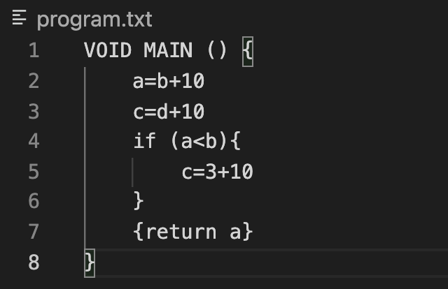

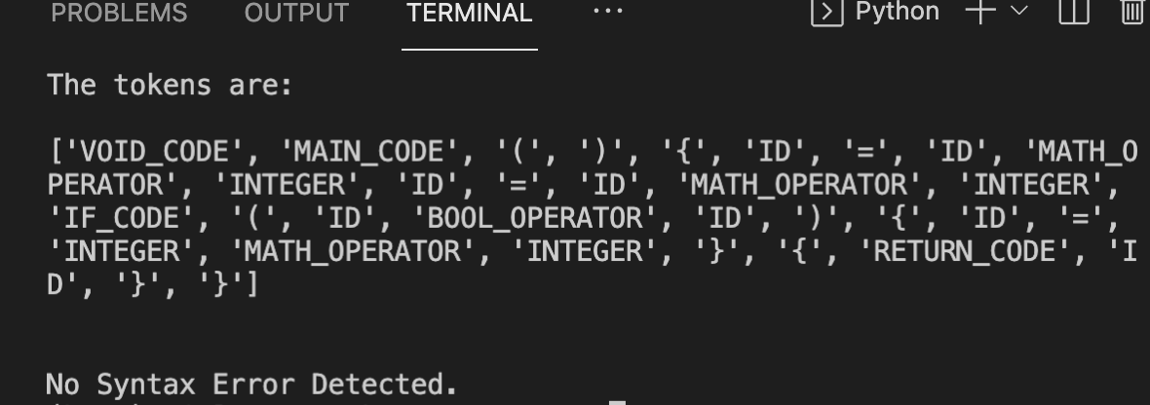

**Testing Example 2:**

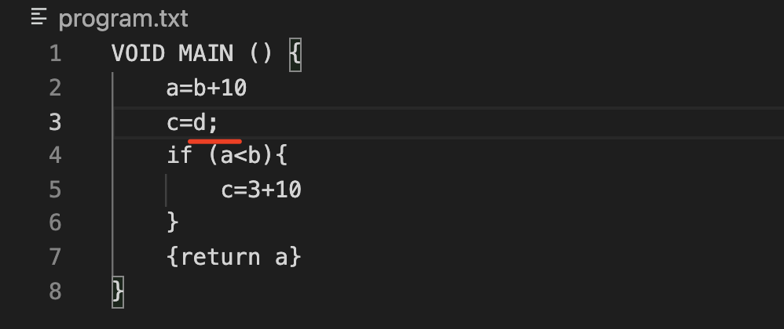

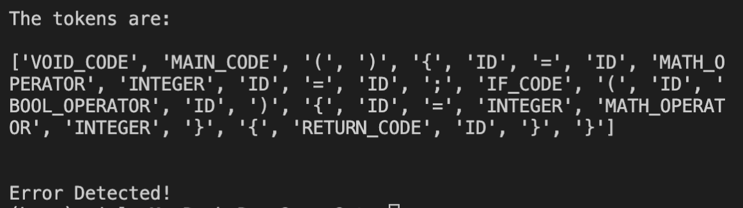

**Testing Example 3:**

