ANA 515 Week 5 Activity

Saumya Rajamohan

2024-06-21

#Graph 1: Variation in Societal pressure by Sexual Orientation

This graph looks into the pressure experienced by men from society and whether their sexual orientation affects their perception or awareness of this pressure. This is a co-variation graph created using the geom_count() function that is in-built in R.This function counts the number of observations for each category and displays it as a circle. the size of the circle indicates the number of observations for each combination of the categorical variables. The graph suggests that a high proportion of men (>1000) irrespective of their sexual orientation, felt that society puts an unhealthy pressure on men. 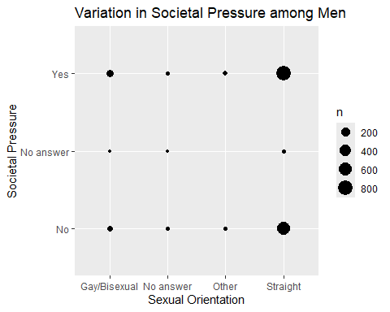 #Graph 2: Variation in External perception of masculinity by Age group

This graph looks into the significance men attach to others’ perception of their masculinity and whether this need to appease society differs among age groups. This is a co-variation graph created using the geom_tile() function within the dplyr package.This function counts the number of observations for each category and creates a heat map to display the same. The color indicates the number of observations for each combination of the categorical variables. The graph suggests that men in the 35-64 years age group mostly attach some significance to how masculine society perceives them to be as opposed to men in the 18-34 years age group, who do not give it any importance.

