# **Pañn**

# **ODD description**

The description is based on the updated version (Grimm et al. 2010) of the ODD protocol that was originally proposed by Grimm and his colleagues in 2006.

## Overview

## **Purpose**

The Pañn Agent Based Model (ABM) represents bloody cockle (*Senilia senilis*) fishing in Senegal. It was co-designed and used with Falia and Niodior communities as a tool to collectively think the future of this fishing activity in the villages in a context of social and environnemental changes.

The model represents an imaginary case of a village surrounded by 6 mudflats.

Simulations starts at the opening of the fishing period, on the first of november.

## **Entities, state variables, and scales**

The Pañn model is based on two main entities: the fishers and the shellfishes. Two classes of agent have been created to represent these two entities in the ABM. A Fisher is characterized by it’s profil, it’s daily needs and the mudflat it fishes on. A Shellfish is characterized by an age (in days, which is the unit of time used for all temporal parameters), a size (in milimeters) and a stage (not adult or adult). The behaviour (reproduction or not) and the mortality rate of a Shellfish depends on its stage. The lifehistory parameters are listed in table 1.

|  |  |  |  |  |
| --- | --- | --- | --- | --- |
| **Parameter** | **Stage** | **Value** | **Unit** | **Source** |
| Sexual maturity | Adult | 1888 | days | COÏC, 2025 |
|  |  |  |  |  |
|  |  |  |  |  |

The elementary spatial entity in the model is a Cell representing 1 ha. There are four land covers: village, sand, mud and water, set at initialisation. They remain unchanged during a simulation except for mud that can become sand. The grid is composed of 70 by 70 cells for a territory of 4900 ha.

Figure 1 shows the class diagram of the model.

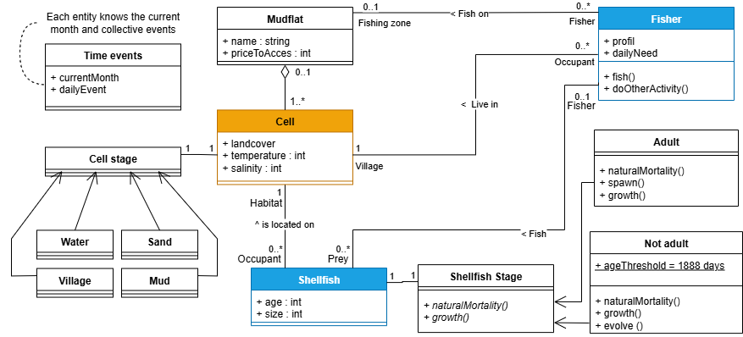

Figure 1. Pañn class diagram

## **Process overview and scheduling**

The time-step of the model is the day. Two season formats are included in the model: the fishing season (biological rest from July to October) and the climatic season (wet season from June to October).

Each step, fishers (in a random order) choose their activity for the day, then they choose the fishing zone, they fish the shellfish of the concerned mudflat, they sell the shellfishes flesh and pay for their daily needs. Then the shellfishes spawn. Adults spawn all year long but two times more from week 18 to 27 (may and june) and 49 to 5 (december and january) (Sané et al., 2023). Then, shellfishes age and grow by 0.05 to 0.008 mm each day depending on the time of year. We simplify this to: a shellfish grows 1mm per month.

The simulation experiments were run for 10 years.

## **Design concepts**

## **Basic principles**

The model is meant to be run interactively : the fisheable mudflats and the period of fishing are to be choosen by the participants. The decisions made the first year are recorded so that they can be repeated 10 times if there is no change by the participants during the simulation.

## **Sensing**

Fishers can detect mudflats where fishing is prohibited.

Shellfishes can sense the temperature and salinity of their cell.

## **Stochasticity**

The random nature of the model lies in two processes that have a specific probability : the natural mortality functions of shellfish and the recurrence of ceremonies in the village.

## **Observation**

The laptop screen is displayed on the wall with a beamer. The elements visible on the simulations were explained in French and translated into the local language (Serer) by a villager.

## **Details**

## **Initialization**

Figure 2 shows the initial situation. The village is represented at the center of the grid. The mudflats location is the same for every simulation. Number of shellfish at the begining

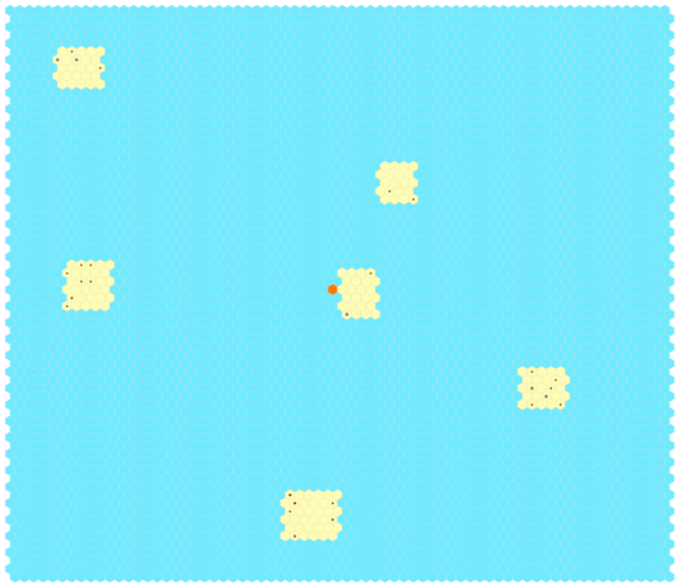

Figure 2. Initiallisation of the model

## **Input data**

The input data are the number of fishers, autorized tools, accessible mudflats, fishing ban period and minimum catch size.

## **Submodels**

## **Growth**

The model time step is one day, which means that all the temporal attributes or parameters are expressed in days. Thus, the age of each shellfish agent is increased by 1 at each time step.

At each step, the shellfishes also grow from 0.05 to 0.008 mm depending on the time of the year.

Each cohort move to the biger size cohort each 16 steps (0,48cm). When they are in the bigest cohort, they accumulate.

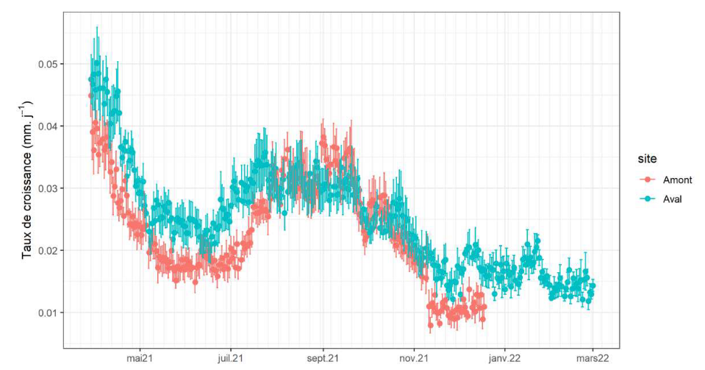

Figure 3. Taux de croissance en fonction de la période de l’année (Sané, 2024)

Growth follows the Von Bertalanffy model :



with Lt the length at age t, Linf the asymptotic length (mm), K the Von Bertalanffy growth constant (year-1) and t0 the theoretical age for which the individual length is zero (here equal to 0).

## **Movement**

The fishers move from a mudflat to another depending on where they want to fish. If they choose to do another activity, they are in the village.

## **Reproduction**

the size of first sexual maturity (50% of the size class is mature) is between 18 and 20 mm (Tito De Morais, 2011). We will simplify with 19mm.

Spawning periods correspond to may and december. They are negatively related to salinity.

## **Mortality**

Salinity sensitivity (12 to 62)

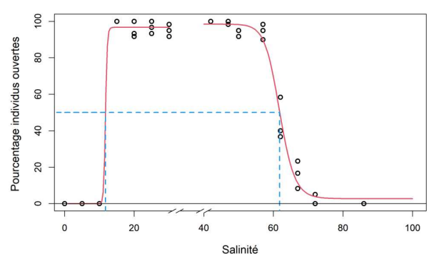

Temperature sensitivity (< 39°C for more than 24 hours)

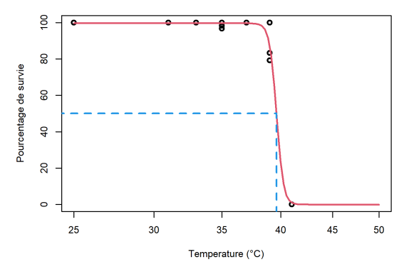

## **Fishing**

The regulations initialy impose a minimum fishing size of 16 mm.

There is no fishing on friday and a part of the fishers dont fish when ceremonies occures.

The number of fishers fishing and the fishing zones are choosen by the participants.

**Scenario**

« Compte tenu des changements futurs, qui prévoient une augmentation de la fréquence des événements extrèmes de pluies et une augmentation de la température dans la région du Sine-Saloum, comprise entre 1,4 et 2 ∞C d'ici ‡ 2050 (Camara et al., 2022), cela risque de modifier considérablement le fonctionnement du delta du Sine-Saloum avec des diminutions de salinité plus importantes et des températures plus élevées. »

« Dans une perspective ‡ moyen terme, nos rÈsultats laissent Ègalement envisager que le retour de pluies plus intenses ces derniËres annÈes (Descroix et al. 2016 ; Faye et al. 2020), pourrait avoir pour consÈquence une rÈduction de la vitesse de croissance des arches dans le delta du Sine-Saloum du fait d’une augmentation du ruissellement d'eau douce et d’une réduction plus marquÈe de la salinitÈ dans certaines parties du delta, en particulier dans les sites en amont, moins influencés par l’océan. L’arche pourrait ainsi mettre plus de temps avant d’atteindre sa taille exploitable, rÈduisant les capacitÈs de capture pour la pÍche artisanale. » (Sané, 2024, p74)

Social scenario :

* Make some cooperative agents and some defective agents (goal to maximize own profit). Change the percentage of each