Rouxel Jérémy TD3
TD : Maven

Dépôt git : https://github.com/Miafiaj/ProjetMaven.git

1-Mon premier projet Maven :

Exercice 1-9 :
Création et mise en place du projet, présent dans le git.

Exercice 10 :

public void testApp()
{
assertEquals(5,App.max(4,5));
assertEquals(5,App.max(5,4));
}

Exercice 11 :

-------------------------------------------------------
T E S T S
-------------------------------------------------------
Running jrouxel.AppTest
Tests run: 1, Failures: 0, Errors: 0, Skipped: 0, Time elapsed: 0.009 sec

Results :

Tests run: 1, Failures: 0, Errors: 0, Skipped: 0

[INFO] ------------------------------------------------------------------------
[INFO] BUILD SUCCESS
[INFO] ------------------------------------------------------------------------
[INFO] Total time: 1.421s
[INFO] Finished at: Tue Apr 11 18:10:45 CEST 2017
[INFO] Final Memory: 10M/200M
[INFO] ------------------------------------------------------------------------

Exercice 12 :
<project xmlns="http://maven.apache.org/POM/4.0.0" xmlns:xsi="http://www.w3.org/2001/XMLSchema-instance"
xsi:schemaLocation="http://maven.apache.org/POM/4.0.0 http://maven.apache.org/maven-v4_0_0.xsd">
<modelVersion>4.0.0</modelVersion>
<groupId>jrouxel</groupId>
<artifactId>jrouxel</artifactId>
<packaging>jar</packaging>
<version>1</version>
<name>jrouxel</name>
<url>http://maven.apache.org</url>
<dependencies>
<dependency>
<groupId>junit</groupId>
<artifactId>junit</artifactId>
<version>3.8.1</version>
<scope>test</scope>
</dependency>
</dependencies>

<build>
<plugins>
<plugin>
<groupId>org.apache.maven.plugins</groupId>
<artifactId>maven-compiler-plugin</artifactId>
<version>2.3.2</version>
<configuration>
<source>1.6</source>
<target>1.6</target>
</configuration>
</plugin>
</plugins>
</build>
</project>

Exercice 13 :

On créé la release (ici jrouxel) , on obtient un build succes :

[INFO] ------------------------------------------------------------------------
[INFO] Building jrouxel 1
[INFO] ------------------------------------------------------------------------
[INFO]
[INFO] --- maven-resources-plugin:2.3:resources (default-resources) @ jrouxel ---
[WARNING] Using platform encoding (UTF-8 actually) to copy filtered resources, i.e. build is platform dependent!
[INFO] skip non existing resourceDirectory /promo2019/jrouxel/Outil_developpement/TD_Maven/ProjetsMaven/jrouxel/ProjetMaven/src/main/resources
[INFO]
[INFO] --- maven-compiler-plugin:2.3.2:compile (default-compile) @ jrouxel ---
[INFO] Nothing to compile - all classes are up to date
[INFO]
[INFO] --- maven-resources-plugin:2.3:testResources (default-testResources) @ jrouxel ---
[WARNING] Using platform encoding (UTF-8 actually) to copy filtered resources, i.e. build is platform dependent!
[INFO] skip non existing resourceDirectory /promo2019/jrouxel/Outil_developpement/TD_Maven/ProjetsMaven/jrouxel/ProjetMaven/src/test/resources
[INFO]
[INFO] --- maven-compiler-plugin:2.3.2:testCompile (default-testCompile) @ jrouxel ---
[INFO] Nothing to compile - all classes are up to date
[INFO]
[INFO] --- maven-surefire-plugin:2.10:test (default-test) @ jrouxel ---
[INFO] Surefire report directory: /promo2019/jrouxel/Outil_developpement/TD_Maven/ProjetsMaven/jrouxel/ProjetMaven/target/surefire-reports

-------------------------------------------------------
T E S T S
-------------------------------------------------------
Running jrouxel.AppTest
Tests run: 1, Failures: 0, Errors: 0, Skipped: 0, Time elapsed: 0.013 sec

Results :

Tests run: 1, Failures: 0, Errors: 0, Skipped: 0

[INFO]
[INFO] --- maven-jar-plugin:2.4:jar (default-jar) @ jrouxel ---
[INFO] Building jar: /promo2019/jrouxel/Outil_developpement/TD_Maven/ProjetsMaven/jrouxel/ProjetMaven/target/marelease.jar
[INFO]
[INFO] --- maven-dependency-plugin:2.5.1:copy-dependencies (copy-dependencies) @ jrouxel ---
[INFO] Copying commons-logging-1.2.jar to /promo2019/jrouxel/Outil_developpement/TD_Maven/ProjetsMaven/jrouxel/ProjetMaven/target/dependency-jars/commons-logging-1.2.jar
[INFO] Copying opencsv-3.9.jar to /promo2019/jrouxel/Outil_developpement/TD_Maven/ProjetsMaven/jrouxel/ProjetMaven/target/dependency-jars/opencsv-3.9.jar
[INFO] Copying commons-lang3-3.5.jar to /promo2019/jrouxel/Outil_developpement/TD_Maven/ProjetsMaven/jrouxel/ProjetMaven/target/dependency-jars/commons-lang3-3.5.jar
[INFO] Copying commons-collections-3.2.2.jar to /promo2019/jrouxel/Outil_developpement/TD_Maven/ProjetsMaven/jrouxel/ProjetMaven/target/dependency-jars/commons-collections-3.2.2.jar
[INFO] Copying commons-beanutils-1.9.3.jar to /promo2019/jrouxel/Outil_developpement/TD_Maven/ProjetsMaven/jrouxel/ProjetMaven/target/dependency-jars/commons-beanutils-1.9.3.jar
[INFO]
[INFO] --- maven-install-plugin:2.4:install (default-install) @ jrouxel ---
[INFO] Installing /promo2019/jrouxel/Outil_developpement/TD_Maven/ProjetsMaven/jrouxel/ProjetMaven/target/marelease.jar to /promo2019/jrouxel/.m2/repository/jrouxel/jrouxel/1/jrouxel-1.jar
[INFO] Installing /promo2019/jrouxel/Outil_developpement/TD_Maven/ProjetsMaven/jrouxel/ProjetMaven/pom.xml to /promo2019/jrouxel/.m2/repository/jrouxel/jrouxel/1/jrouxel-1.pom
[INFO] ------------------------------------------------------------------------
[INFO] BUILD SUCCESS
[INFO] ------------------------------------------------------------------------
[INFO] Total time: 9.358s
[INFO] Finished at: Wed Apr 12 15:26:12 CEST 2017
[INFO] Final Memory: 11M/241M
[INFO] ------------------------------------------------------------------------

Exercice 14 :

On a bien l'éxecution du main

jrouxel@SA202-24A:~/Outil_developpement/TD_Maven/ProjetsMaven/jrouxel/ProjetMaven$ java -jar target/jrouxel.jar
Max :5

Exercice 16 :

On obtient une erreur lors de la release du projet, dû au mauvais résultats des test. (Le programme attendait 5 et a reçu 4) .

-------------------------------------------------------
T E S T S
-------------------------------------------------------
Running jrouxel.AppTest
Tests run: 1, Failures: 1, Errors: 0, Skipped: 0, Time elapsed: 0.011 sec <<< FAILURE!

Results :

Failed tests: testApp(jrouxel.AppTest): expected:<5> but was:<4>

Tests run: 1, Failures: 1, Errors: 0, Skipped: 0

[INFO] ------------------------------------------------------------------------
[INFO] BUILD FAILURE
[INFO] ------------------------------------------------------------------------
[INFO] Total time: 0.633s
[INFO] Finished at: Tue Apr 11 18:21:43 CEST 2017
[INFO] Final Memory: 8M/240M
[INFO] ------------------------------------------------------------------------
[ERROR] Failed to execute goal org.apache.maven.plugins:maven-surefire-plugin:2.10:test (default-test) on project jrouxel: There are test failures.
[ERROR]
[ERROR] Please refer to /promo2019/jrouxel/Outil_developpement/TD_Maven/ProjetsMaven/jrouxel/ProjetMaven/target/surefire-reports for the individual test results.
[ERROR] -> [Help 1]
[ERROR]
[ERROR] To see the full stack trace of the errors, re-run Maven with the -e switch.
[ERROR] Re-run Maven using the -X switch to enable full debug logging.
[ERROR]
[ERROR] For more information about the errors and possible solutions, please read the following articles:
[ERROR] [Help 1] http://cwiki.apache.org/confluence/display/MAVEN/MojoFailureException

2-Open CSV :

Exercice 20-21 :
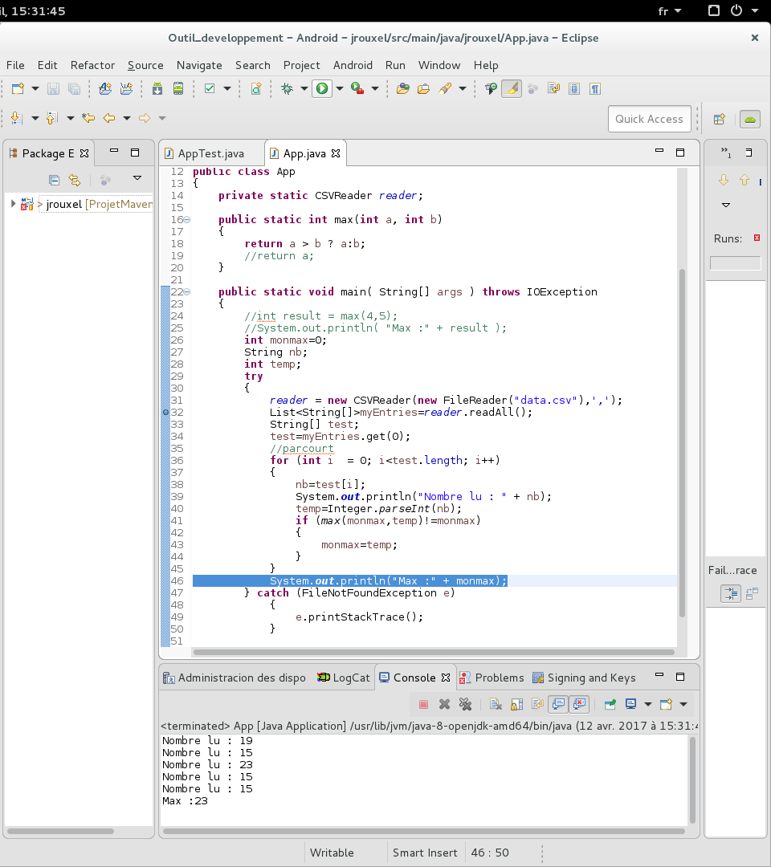

Le code affiche les nombres lus dans le fichier csv et récupère bien le nombre max.

Exercice 22 :
Avec le code du stagiaire on obtient max=0, le max n'est pas changé vu que la fonction max renvoit seulement la valeur de max qui est au départ 0.

Exercice 23 :

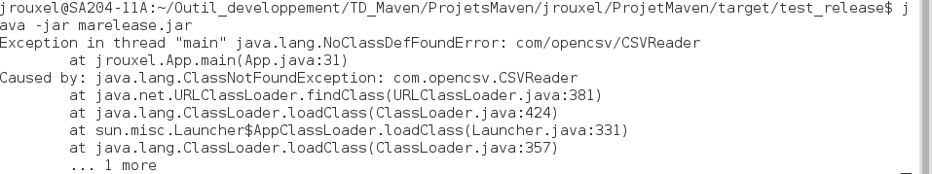
Quand on exécute le jar on obtient une erreur, il ne trouve pas le fichier csv qu'il doit lire.
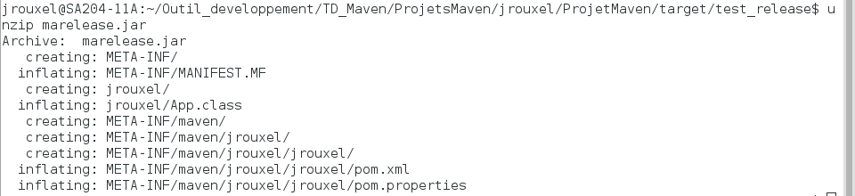

En dézippant la release on voit ce qu'il y a dans la release, on y trouve les fichiers de classe de java ainsi que les fichiers de configuration du projet maven. Il manque donc bien le fichier csv à lire.

Exercice 25 :
Après avoir édité le fichier pom.xml avec le plugin du TD, la release nouvellement faite contient les bibliothèques CSV nécessaire pour lire les fichiers.

