Homework3——有限状态机
- 分析
- 状态说明
S0：初始态；
S1：已投币5元
S2：已投币10元
S3：已投币15元
S4：已投币20元
S5：已投币25元
S6：已投币30元

- 状态图
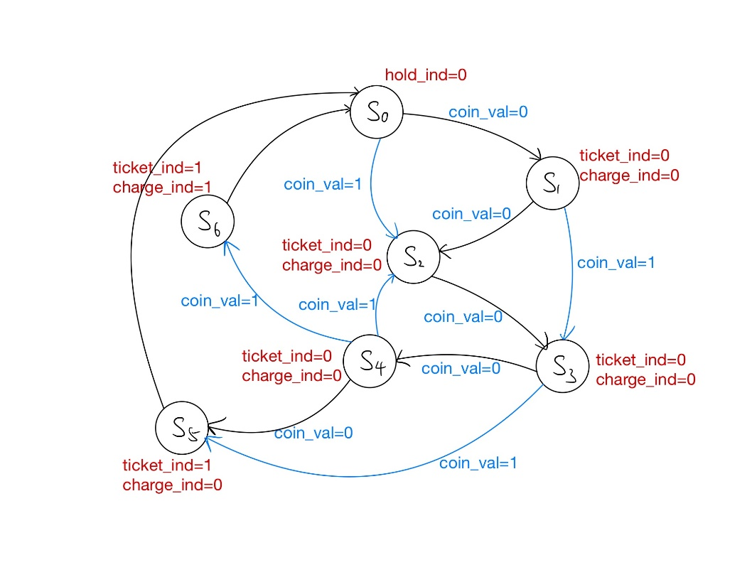
- 说明
- 在S0状态下，检测到op_start=1，开始检测是否投币，投币成功开始售票；
- 在S1/S2/S3/S4下，如果监测到cancel_flag=1，取消操作，退回S0；
- 在S5下，售出票不用找零；S6售出票需要找零；
- S5/S6执行完，返回S0；
- 只有S0下hold_ind=0，可以开始售票。

- VHDL语言
library IEEE;
use IEEE.STD_LOGIC_1164.ALL;

entity ticket is
Port (
clk:in std_logic;
op_start:in std_logic;--1表示开始操作
coin_val:in std_logic;--0表示5元，1表示10元
cancel_flag:in std_logic;--1表示取消
hold_ind:out std_logic;--0表示不占用，1表示占用
ticket_ind:out std_logic;--0表示不出票，1表示出票
charge_ind:out std_logic;--0表示不找钱，1表示找钱
charge_val:out std_logic--0表示0元，1表示5元
);
end ticket;

architecture Behavioral of ticket is
type states is (s0,s1,s2,s3,s4,s5,s6);
signal next_state:states;
begin
process(clk,op_start)
begin
if(op_start='1') then
next_state<=s0;elsif(clk'event and clk='1') then
case next_state is
when s0=>
if cancel_flag='1' then
next_state<=s0;
elsif coin_val='0' then next_state<=s1;else next_state<=s2;
end if;
when s1=>
if cancel_flag='1' then
next_state<=s0;
elsif coin_val='0' then next_state<=s2;else next_state<=s3;
end if;
when s2=>
if cancel_flag='1' then
next_state<=s0;
elsif coin_val='0' then next_state<=s3;else next_state<=s4;
end if;
when s3=>
if cancel_flag='1' then
next_state<=s0;
elsif coin_val='0' then next_state<=s4;else next_state<=s5;
end if;
when s4=>
if cancel_flag='1' then
next_state<=s0;
elsif coin_val='0' then next_state<=s5;else next_state<=s6;
end if;
when s5=>
charge_val<='0';
when s6=>
charge_val<='1';
end case;
end if;
case next_state is
when s0=> ticket_ind<='0';charge_ind<='0';hold_ind<='0';
when s1=> ticket_ind<='0';charge_ind<='0';hold_ind<='1';
when s2=> ticket_ind<='0';charge_ind<='0';hold_ind<='1';
when s3=> ticket_ind<='0';charge_ind<='0';hold_ind<='1';
when s4=> ticket_ind<='0';charge_ind<='0';hold_ind<='1';
when s5=> ticket_ind<='1';charge_ind<='0';hold_ind<='1';
when s6=> ticket_ind<='1';charge_ind<='1';hold_ind<='1';
end case;
end process;
end Behavioral;

- 激励文件
library IEEE;
use IEEE.STD_LOGIC_1164.ALL;

entity tickettb is
end tickettb;

architecture Behavioral of tickettb is
component ticket port(
clk:in std_logic;
op_start:in std_logic;--1表示开始操作
coin_val:in std_logic;--0表示5元，1表示10元
cancel_flag:in std_logic;--1表示取消
hold_ind:out std_logic;--0表示不占用，1表示占用
ticket_ind:out std_logic;--0表示不出票，1表示出票
charge_ind:out std_logic;--0表示不找钱，1表示找钱
charge_val:out std_logic--0表示0元，1表示5元
);
end component;

signal clk:std_logic:='0';
signal op_start:std_logic:='0';
signal coin_val:std_logic:='0';
signal cancel_flag:std_logic:='0';
signal hold_ind:std_logic:='0';
signal ticket_ind:std_logic:='0';
signal charge_ind:std_logic:='0';
signal charge_val:std_logic:='0';

begin
dut:ticket port map(
clk=>clk,op_start=>op_start,coin_val=>coin_val,cancel_flag=>cancel_flag,
hold_ind=>hold_ind,ticket_ind=>ticket_ind,charge_ind=>charge_ind,charge_val=>charge_val
);
process
begin
clk<='1';wait for 10 ns;
op_start<='1';--hold_ind<='0';ticket_ind<='0';charge_ind<='0';charge_val<='0';
clk<='0';wait for 10 ns;
op_start<='0';
coin_val<='0';--+5r
clk<='1';wait for 10 ns;
clk<='0';wait for 10 ns;
--coin_val<='0';--+5r
cancel_flag<='1';
clk<='1';wait for 10 ns;
clk<='0';wait for 10 ns;
end process;
end Behavioral;

- 仿真波形
情景1：投5元、5元、10元、5元，不用找零
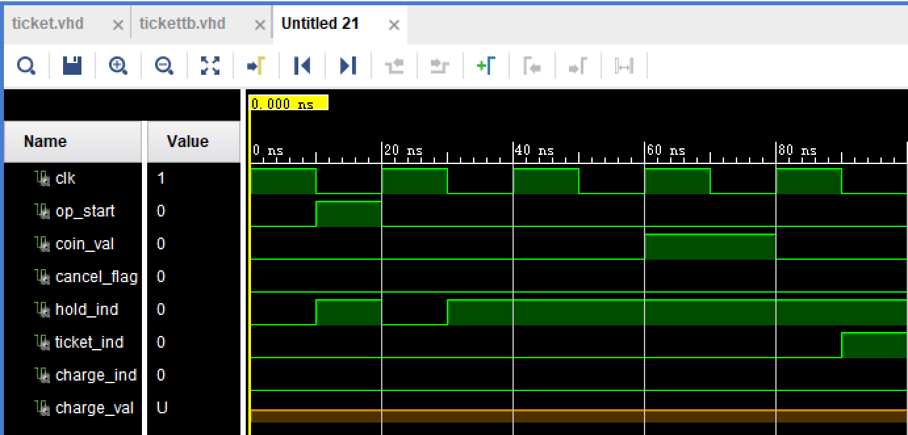

情景2：投5元、5元、10元、10元，用找零5r
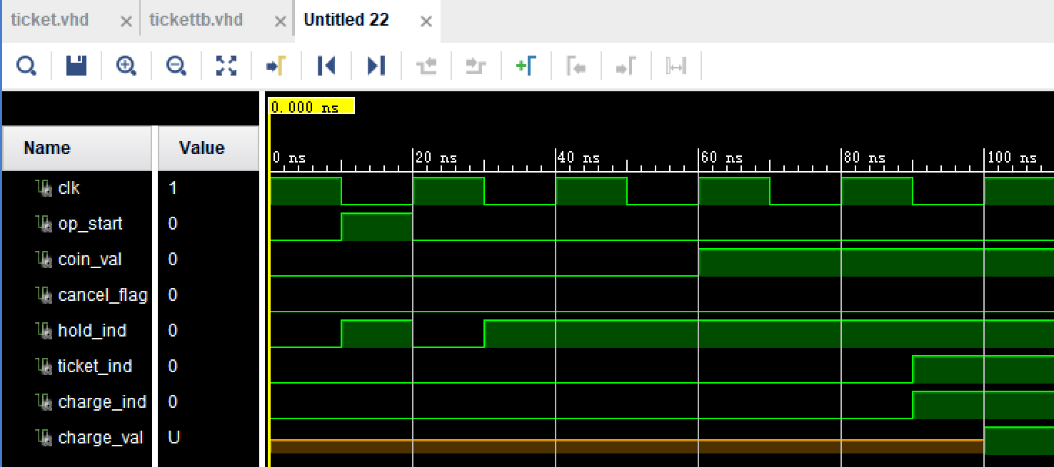

情景3：投5元后，退出投币
