# CHAPTER 1

# INTRODUCTION

## Introduction:

We can see that the population is increasing rapidly around us, which results in major management crises in every field. But thanks to the rapidly evolving technology which is replacing manual work and helps in solving a lot of problems.

Nowadays every physical management system is enhancing into online management system, which is necessary to fulfill today’s requirements.

In the field of medicine and healthcare, getting an appointment from doctor is often very difficult. Sometimes, it requires to visit physically to doctor’s clinic before the date of the appointment. Other times it may be done on the phone but the given number can only be contacted in a specific time interval. Doctors are life savers, they shouldn’t be too far away from people who needs healthcare.

To overcome these difficulties we have developed an online appointment system through which the clients can book their appointment immediately with the doctor from his PC or smartphones whenever they need healthcare.

## Project in Brief:

This website is developed for managing various activities in hospitals. For the past few years the number of hospital is increasing rapidly. Thereby the number of appointments is also increasing for treatment. This particular project deals with the problems on managing a hospital and avoids the problems which occur when carried manually. Identification of the drawbacks of the existing system leads to the designing of computerized system that will be compatible to the existing system which is more user friendly and more GUI oriented. We can improve the efficiency of the system, thus overcome the drawbacks of the existing system. This system is designed in favor of the Appointment management which will help the patients to reserve their appointment easily and also allows them to cancel their appointment. In this website all the hospitals, fields and doctors are listed in a precise manner. The clients can find a specific doctor for particular field in any hospital without visiting physically. Doctors will have their own personal profiles in which he can see all of his appointments. The doctor appointment system will also contain special features like how many patients are registered. Patients will also have their profiles through which they will be able to book an appointment with any doctor, they can check online whether the doctor is active or not and which number is in progress. It will help them to reach hospital in time. After their checkup the patient can also post their feedback about that doctor.

## Project Significance:

This Doctor Appointment System is developed in favor of the appointment management team which helps them attract the patients to their hospital because everyone prefers simple and easy way to reach a doctor . It helps them from the manual work from which it is very difficult to take an appointment from doctor and the information about hospitals , related fields and doctors. This solution is developed on the plight of the appointments management team, through this they cannot require so efficient or qualified person to handle and manage the work of clerk in a hospital, all you need to do is to login as administrator and you can see the information of all the patients who have obtained and registered their appointment with doctor, click verify to see how much patients are registered today. Identification of the problems of the existing appointment management leads to the development of computerized solution that will be compatible to the existing doctor appointment management with the solution which is more users friendly and more GUI oriented. We can improve the efficiency of the appointment management, thus overcome the drawbacks of the existing management.

## Project Objectives:

The main objectives of this project work are as follows:

* Patient will no longer book their appointment manually.
* The doctor or the admin can see and access the patient, appointment detail.
* This also will reduce the manual work of people in hospital.
* It helps the doctor or admin to know the number of appointments that are registered, how much appointments are done and also the remaining appointments.
* Patients will be attended sequentially E.g the ones who registered first will be checked by the doctor first.

The system helps the admin/doctor to know:

* All information about appointment.
* Payment detail.
* Edit the details of the appointment.

## 1.5 Tool used in Project:

* HTML
* CSS
* JAVASCRIPT
* BOOTSTRAP
* PHP
* JQUERY
* SQL
* MySQLyog
* SUBLIME Text Editor
* XAMPP Control Panel

## 1.5.1 HTML:

HTML is the standard markup language for creating Web pages.

* HTML stands for Hyper Text Markup Language
* HTML describes the structure of Web pages using markup
* HTML elements are the building blocks of HTML pages
* HTML elements are represented by tags
* HTML tags label pieces of content such as "heading", "paragraph", "table", and so on
* Browsers do not display the HTML tags, but use them to render the content of the page

## 1.5.2 CSS:

* **CSS** stands for **C**ascading **S**tyle **S**heets
* CSS describes **how HTML elements are to be displayed on screen, paper, or in other media**
* CSS **saves a lot of work**. It can control the layout of multiple web pages all at once
* External stylesheets are stored in **CSS files**

## 1.5.3 JAVASCRIPT:

JavaScript is the programming language of HTML and the Web.

JavaScript is easy to learn.

## 1.5.4 BOOTSTRAP:

Bootstrap is the most popular HTML, CSS, and JavaScript framework for developing responsive, mobile-first websites.

## 1.5.5 PHP:

PHP is a server scripting language, and a powerful tool for making dynamic and interactive Web pages.

PHP is a widely-used, free, and efficient alternative to competitors such as Microsoft's ASP.

## 1.5.6 JQUERY:

jQuery is a JavaScript Library.

jQuery greatly simplifies JavaScript programming.

jQuery is easy to learn.

## 1.5.7 SQL:

SQL stands for structure query language. SQL is a standard language for storing, manipulating and retrieving data in databases.

## 1.5.8 SQLyog:

SQLyog provides us with a powerful means to manage our MySQL databases.

* Create/Drop/Alter Tables, Stored Procedures, Functions, Views, Triggers and Events.
* Very fast retrieval of data.
* SQLyog Import External Data wizard - use the GUI or specify a query.
* Schema and Data synchronization tools.
* Powerful compressed Scheduled Backup with email notification.
* Update result returned from query - also supports queries with JOINs. No dialogues - just edit!
* Manage foreign key relationships.

## 1.5.9 XAMPP:

XAMPP is the most popular PHP development environment

XAMPP is a completely free, easy to install Apache distribution containing MariaDB, PHP, and Perl. The XAMPP open source package has been set up to be incredibly easy to install and to use.

## 1.5.10 SUBLIME:

Sublime text is a sophisticated text editor for code, markup and prose. You'll love the slick user interface, extraordinary features and amazing performance.

Sublime Text is a shareware cross-platform source code editor with a Python application programming interface. It natively supports many programming languages and markup languages, and functions can be added by users with plugins, typically community-built and maintained under free-software licenses

CHAPTER:2

SYSTEM ANALYSIS

## 2.1 Introduction:

System analysis is a method of problem-solving that deals with the breaking down of a system into components parts in order to study how well the individual parts work and interact to accomplish their purpose. It involves the process of enumerating the existing problems, analyzing the proposed system for costs and benefits, analyzing the system and user requirements, and considering possible alternative system.

System analysis is important in the design of subsequent systems. System design consists` of design activities that produce system specifications which satisfy the functional requirements that have been developed in the system analysis process. System design is basically the structural implementation of system analysis.

In this chapter we will discuss about the doctor appointment system. This software is general software and it uses for most of hospitals.

## 2.2 Key Issues

The following issues will be solved in this Doctor Appointment system.

* **Lack of immediate retrievals: -**

The information is very difficult to retrieve and to find particular information like- E.g. - To find out a specific hospital and doctor for a specific field and, the user has to go through various hospitals to find a good doctor with enough experience for specific field. This results in wastage of time.

* **Lack of immediate information storage: -**

The information generated by various appointments takes time and efforts to be stored at right place for particular interval of time.

* **Lack of prompt updating: -**

Various changes to information like patient details are difficult to make as paper work is involved.

* **Preparation of accurate and prompt reports: -**

This becomes a difficult task as information is difficult to collect from various register.

* Economic Development
* Focus on the main goals.

## 2.3 Benefits of Doctor Appointment System

Doctor appointment System is an integral part of modern health care processes. This website use for both large and small practices as they offer significant benefits for care providers, doctors, and patients.

The benefits for doctors include:

* Growth of patient’s base.
* Adjustment of time.
* Can manage number of patients.

The benefits for patients are obvious too:

* Visit a doctor at a time convenient for a patient.
* Access to the best doctors in any specialty.
* Cost and time saving for doctor and patient.

**2.4 EXISTING SYSTEM:**

Hospitals currently use a manual system for the management and maintenance of critical information. The current system requires numerous paper forms, with data stores spread throughout the Doctor Appointment System infrastructure. Often information is incomplete or does not follow management standards. Forms are often lost in hospitals requiring a comprehensive auditing process to ensure that no vital information is lost. Multiple copies of the same information exist in the hospitals and may lead to inconsistencies in data in various data stores.

## 2.5 PROPOSED SYSTEM:

The Doctor Appointment System is designed for any hospital to replace their existing manual paper based system. The new system is to control the information of patients, Doctor and attendant. These services are to be provided in an efficient, cost effective manner, with the goal of reducing the time and resources currently required for such tasks.

## 2.6 FEASIBILITY STUDY

During system analysis the feasibility study of the proposed system is to be carried out. For feasibility analysis, some understanding of the major requirements for the system is essential.

Two key considerations involved in the feasibility analysis are:

### 2.6.1 Economic Feasibility:

This study is carried out to check the economic impact on the system. The client will visit hospital only once at his time of appointment. He won’t need to spend so much on visiting again and again for appointment and other information, which is a great improvement in system and also results in growth of patient’s base. Hence it will provide economic feasibility for doctor and patient.

### 2.6.2 Technical Feasibility:

This proposed system will provide more proficient than the existing one. It will replace the present paper work by online management system, which results in minimizing the errors carried out manually and will improve the accuracy of the management.

According to the study carried out by our project team, this online system is both economically and technically feasible.

## 2.7 SYSTEM REQUIREMENTS

**SOFTWARE REQUIREMENT:**

The Introduction of the software requirements specification states the goals and objectives of the software, describing it in the context of the computer-based system. Actually, the Introduction may be nothing more than the software scope of the planning document.

The main goal of our project is that we lead our society to advance level by replacing the manual system with advance online system.

The main objectives of this project work are as follows:

Patient will no longer book their appointment manually. The doctor or the admin can see and access the patient, appointment detail. This also will reduce the manual work of people in hospital. It helps the doctor or admin to know the number of appointments that are registered, how much appointments are done and also the remaining appointments. Patients will be attended sequentially E . g the ones who registered first will be checked by the doctor first.

**HARDWARE REQUIREMENTS Processor: Intel Pentium**

It is fully responsive website which displays on every screen whether it is mobile, tab or laptop screen.

It will require minimum RAM: 1GB

Hard Disk: 16GB

## 2.8 Review of Document

Due to large number of diseases hospitals are opened everywhere and thousands of patients registered their self for treatment. All of the work were paper-work, there records were very unsecure, and can be very difficult to retrieve the specific data.

Therefore, we analyzed to develop the doctor appointment system to keep the data unique, in sequence, and all the records that are concern to the patient.

**Chapter 2**

**Website Development Methodology**

#### **2.1 Introduction**:

Website project methodology refers to a method or technique which is used to plan and control the development process. This chapter will give an overview of the development process and give information on how the website was developed.

2.2 Website Development Methodology:

Website can be developed through different development methodologies. Website development methodologies represent the process of how to develop a website. Each development methodology is a set of tasks and procedures that when performed results in a website product. These methodologies and techniques consist of various activities that monitors the development of the website from the initial stage till the deployment of the project.

In these different website development methodologies, we had a variety of choices. We selected the Waterfall Process Model because it is the most common model and follows a straight-forward procedure to complete the first task or phase then move to the next phase. The Waterfall Model starts with specification of the website, designing of the database and modules, implementation of the programs, and maintenance. In Waterfall Model every phase is dependent on the previous phase because every phase is dependent on the provided information which is passed from the previous phase. Waterfall Model is the easiest approach to understand, monitor and to lead effectively. For our project, Waterfall Model is the best because it allows us to solve all sort of issue that arise at each phase.

These following are the benefits of using the Waterfall Model over other Models:

* It provides clear instructions of how to develop the website

* It can be implemented without having a huge team

* Development of modules is efficient.
* The waterfall model costs less to alter requirements in each phase.

* We have the ease to test the website and debug in every iteration process.

* There is a very low risk of failure the website because we debug the problems earlier.

* There is less chance of crashing the whole website as all the bugs are removed before moving to another step.

2.3 Project Overview:

This project is an online Doctor Appointment System where clients can book an appointment with doctor from wherever he wants. And he can see number of doctors for a particular field. This project is uniquely designed so that everyone can use it easily.

In this website doctors will have their own admin area in which he can edit any detail and also he can manage appointments according to his daily schedule, and patients will also have their own admin area in which they can book or cancel their appointments with doctor and also can edit their profile.

2.4 Process Model:

Analyzing the nature and difficulties for project requirements we make reference to use the water fall model as a process model for our project.

It is the simplest process model which states that the development phases are organized in a linear order. This model suggest us systematic sequential approach to software development that begins at the system level and progresses through analysis, design, coding, testing and maintenance.

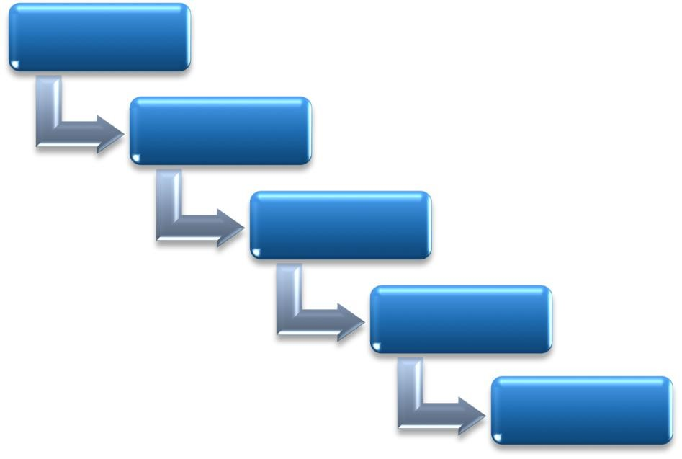

**REQUIREMENTS**

**DESIGN**

**IMPLEMENTATION**

**VERIFICATION**

**MAINTENANCE**