Git & GitHub Collaborative Assignment
Pair-Based Practical Assignment with Screenshot Evidence

Student Information
Student 1 Name / Roll No. / GitHub Username:
ALI HAIDER----MSDSF26M012
Student 2 Name / Roll No. / GitHub Username:
M Imran Mian / MSDSF25A007 / https://github.com/memrranmian
________________________________________________________________________________
GitHub Repository URL:
https://github.com/MianAliHaider/Student-Task-Manager.git

1. Assignment Scenario
You and your partner are working as a small software development team. Your team has been asked to develop a simple web application called Student Task Manager. The application will allow users to add tasks, display tasks, mark tasks as completed, delete tasks, and search tasks. The main purpose of this assignment is to demonstrate Git and GitHub as a real collaborative software-development workflow.
You will work through the following workflow:
Create Project
↓
Initialize Git
↓
Create Commits
↓
Create GitHub Repository
↓
Create Branches
↓
Develop Features
↓
Push Branches
↓
Create Issues
↓
Create Pull Requests
↓
Code Review
↓
Merge
↓
Create and Resolve Merge Conflict
↓
Use Git Recovery Commands
↓
Create Tag and Release

2. Learning Objectives
- Configure Git and understand Git identity.
- Create and initialize a local Git repository.
- Understand the working directory, staging area, local repository, and remote repository.
- Create meaningful commits and inspect history.
- Create, switch, push, and merge branches.
- Clone and synchronize a GitHub repository.
- Use GitHub Issues and Pull Requests.
- Perform code review and collaborative merging.
- Create and resolve a merge conflict.
- Use git stash, restore, reset, and revert.
- Create tags and a GitHub release.
- Document evidence using screenshots and explanations.

3. Submission Requirements
Your assignment has two evidence sources. First, your public GitHub repository will be inspected for commits, branches, issues, Pull Requests, reviews, merges, tags, release, and contributions. Second, you must submit one Word document containing the required screenshots and short explanations.
Important: Screenshots are mandatory wherever this document says “Take Screenshot”.
Do not submit screenshots without captions or explanations. Each screenshot should be readable and show the relevant command/output.

4. Team Roles
Student 1 initially handles project initialization, README, index.html, and the first feature. Student 2 initially handles styling and a second feature. Both students must perform Git operations, create commits, participate in branches, review each other’s work, and contribute to the final repository.

Git Basics and Local Repository

Task 1 — Install and Configure Git
Verify Git installation and configure your Git identity.
git --version
git config --global user.name "Your Name"
git config --global user.email "your@email.com"
git config --list
📸 Screenshot 1 — Git Configuration
Show Git version, username, and email.
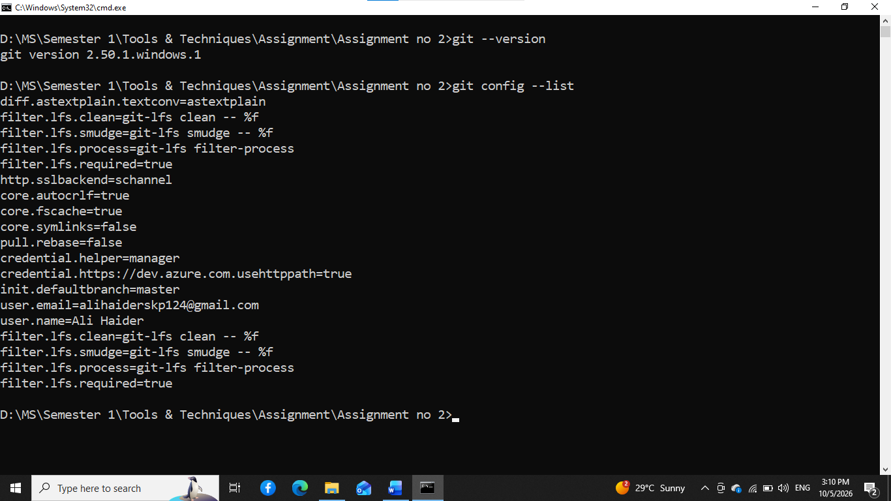
Figure 1: Git Configuration.

Task 2 — Create the Project
Create a folder named student-task-manager. Inside it create the initial project files.
mkdir student-task-manager
cd student-task-manager
# Create: index.html, style.css, script.js, README.md
📸 Screenshot 2 — Initial Project
Show the project files in your editor/file explorer and, if possible, the basic application interface.
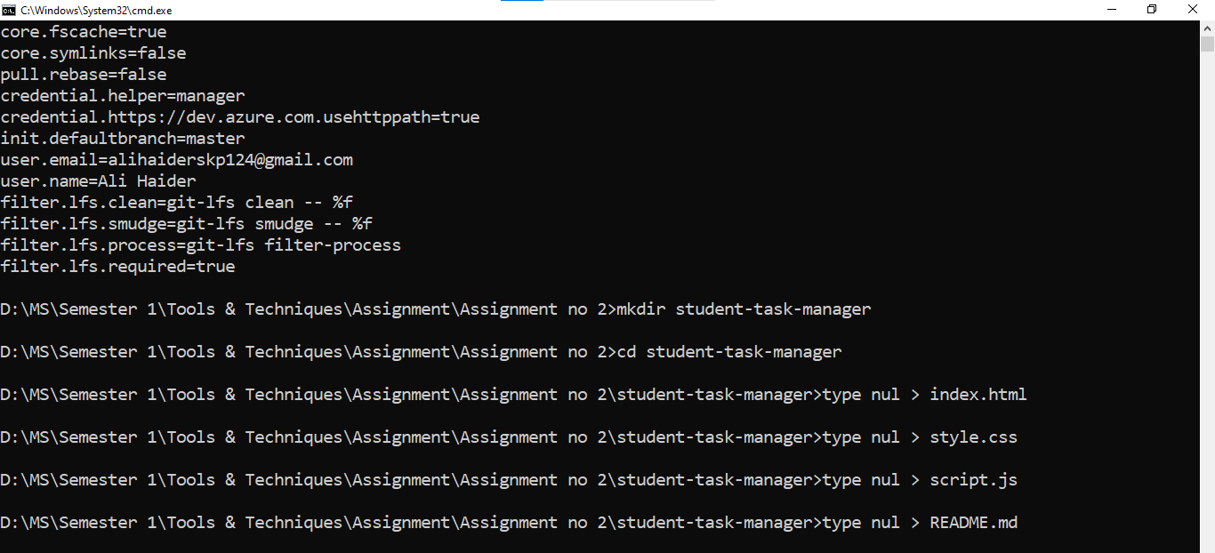Figure 2: Initial Project.

Task 3 — Initialize Git
Initialize the local Git repository and check its status.
git init
git status
📸 Screenshot 3 — Git Initialization
Show git init and git status in the terminal.
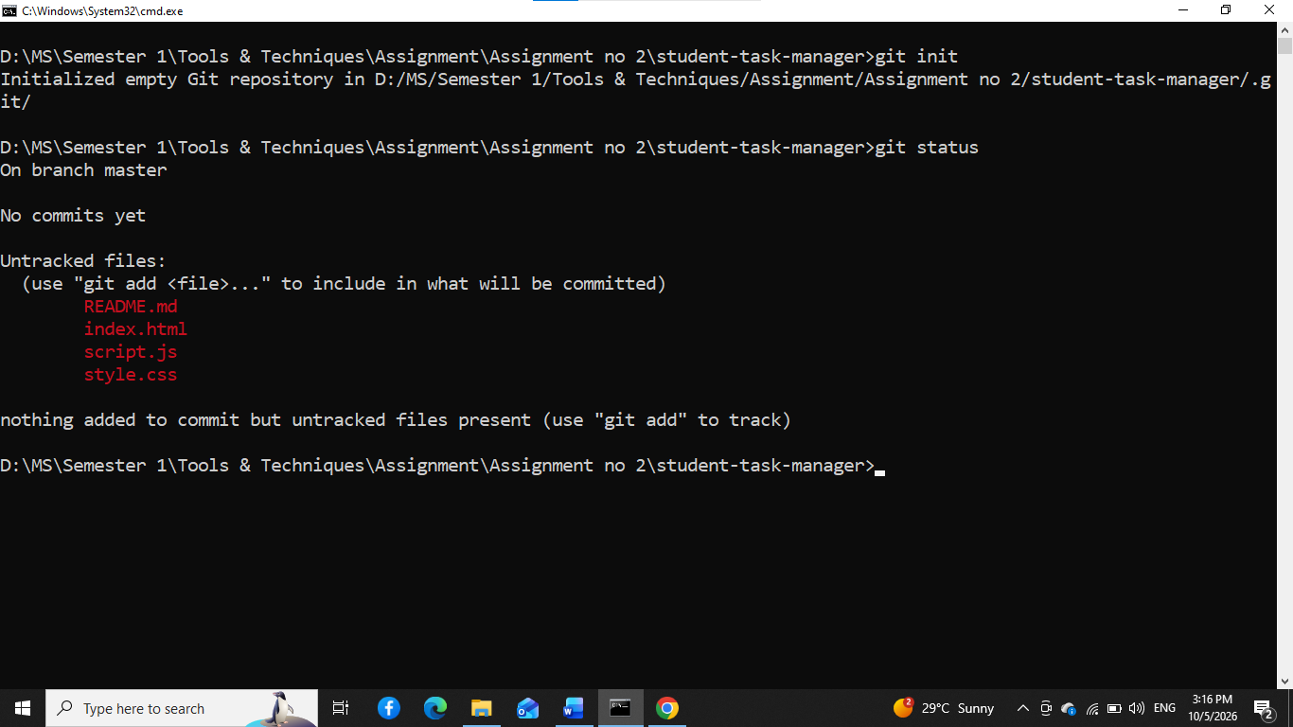
Figure 3: Git Initialization.

Task 4 — Stage Files
Stage the project files and verify the staging area.
git add .
git status
📸 Screenshot 4 — Staging Area
Show files under Changes to be committed.
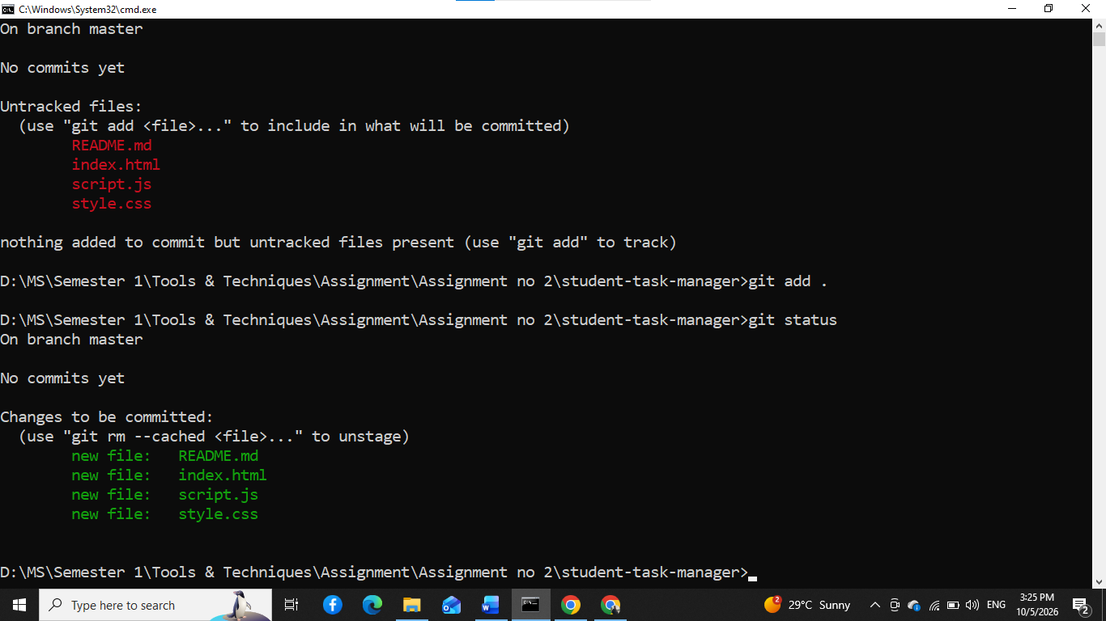
Figure 4: Staging Area.

Task 5 — Create the First Commit
Create the first meaningful commit and confirm the working tree is clean.
git commit -m "Initial project setup"
git status
📸 Screenshot 5 — First Commit
Show the commit and a clean working tree.
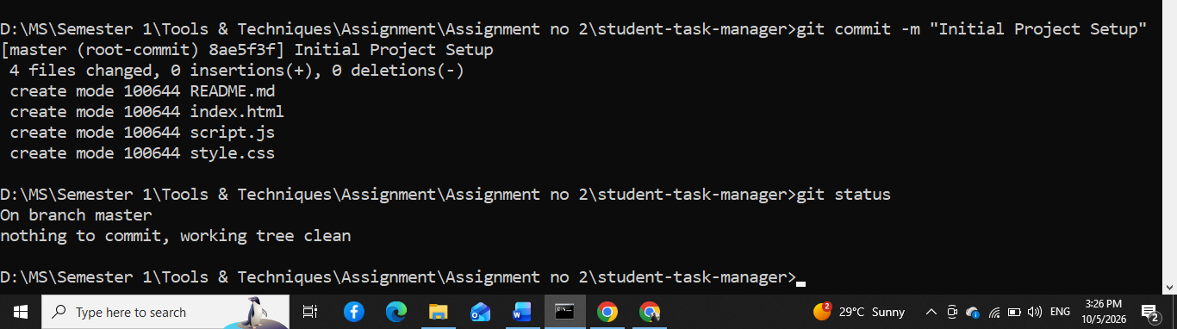
Figure 5: First Commit.

Task 6 — Inspect Git History
Inspect the commit history using compact and graph views.
git log
git log --oneline
git log --oneline --graph
📸 Screenshot 6 — Git History
Show the initial commit in the history.
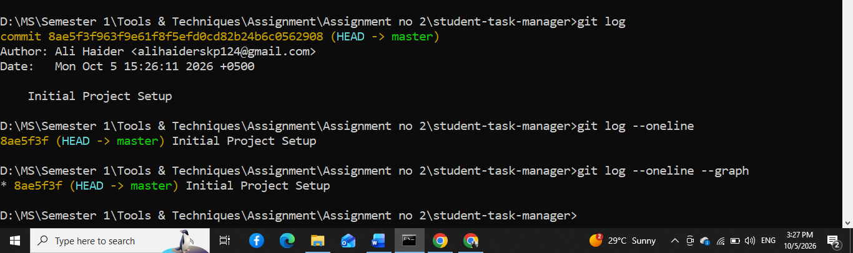
Figure 6: Git History.
Questions / Explanation:
- What information does a Git commit contain?

A Git commit contains a unique commit ID (hash), author and committer information, date and time, a commit message, parent commit reference(s), and a snapshot of the project's files at that point. This information allows Git to track the history of changes and identify who made each change and when.

GitHub and Branching

Task 7 — Create the GitHub Repository
Create a public GitHub repository named student-task-manager. Do not create a second README on GitHub if you already have one locally. Add the GitHub repository as the remote.
git remote add origin https://github.com/MianAliHaider/Student-Task-Manager.git
git remote -v
📸 Screenshot 7 — GitHub Repository
Show repository name, owner, and files on GitHub.
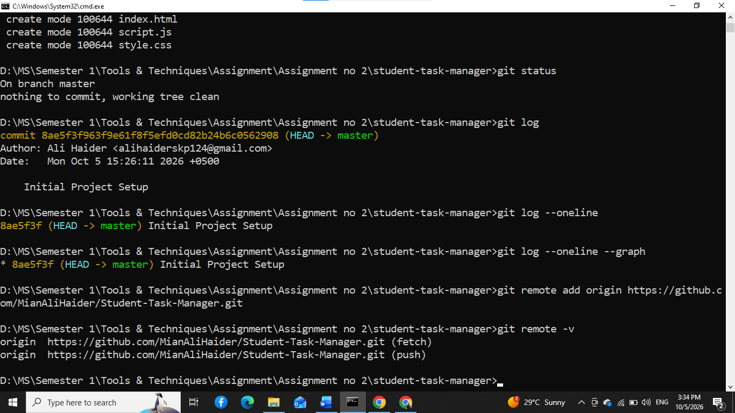
Figure 7: GitHub Repository.

Task 8 — Push the Main Branch
Rename the local branch to main and push it to GitHub.
git branch -M main
git push -u origin main
📸 Screenshot 8 — First GitHub Push
Show the GitHub repository containing the project files.
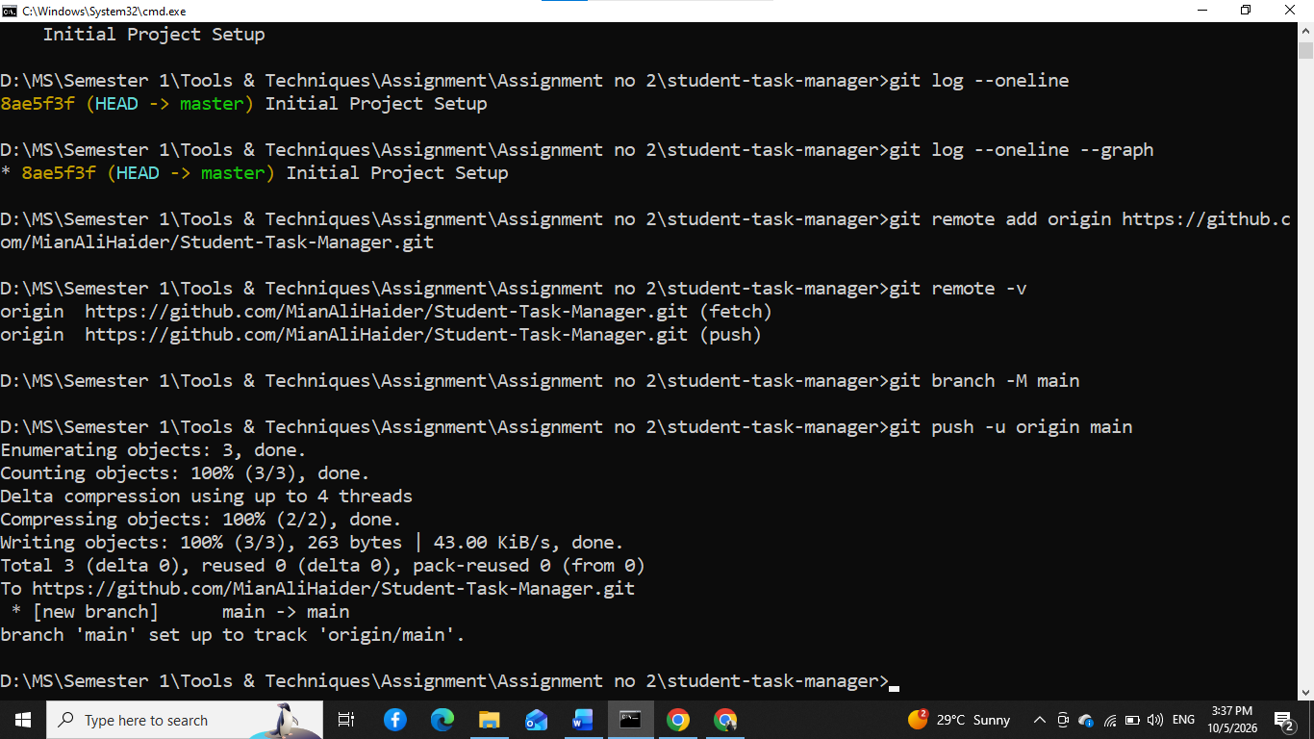
Figure 8: First GitHub Push.

Task 9 — Create a Feature Branch
Student 1 creates a branch for the task form feature.
git switch -c feature/task-form
git branch
📸 Screenshot 9 — Feature Branch
Show the new branch and current branch.
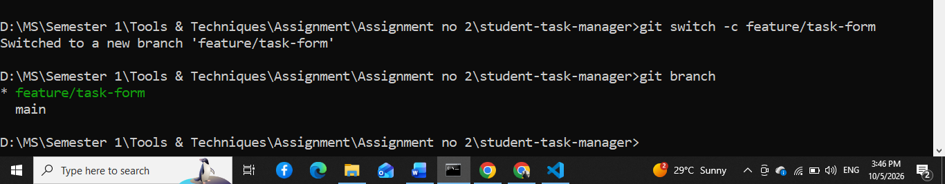
Figure 9: Feature Branch.

Task 10 — Develop the Task Form
Student 1 modifies index.html to add a task title field, description, and Add button. Inspect the changes.
git status
git diff
📸 Screenshot 10 — Git Diff
Show the changes made before committing.
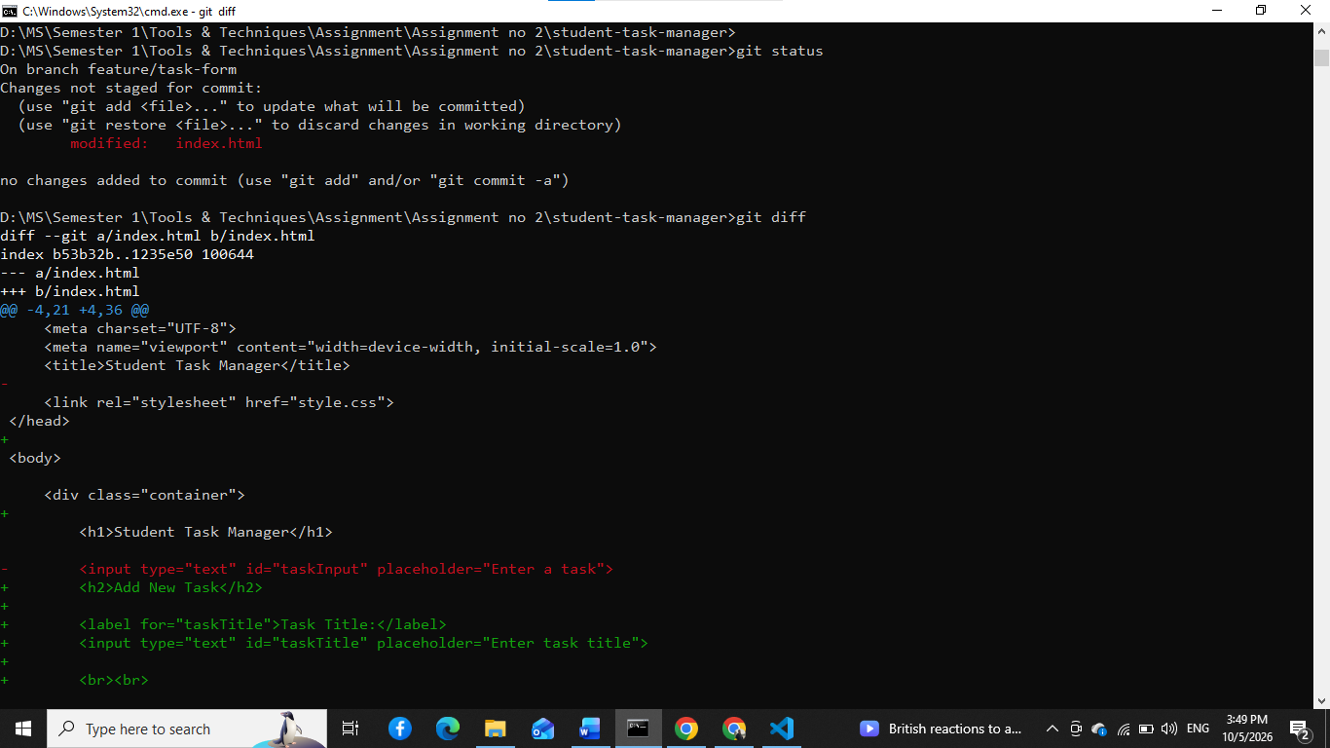
Figure 10: Git Diff.
Questions / Explanation:
- What does git diff show?

git diff shows the differences between the current working files and the last committed version. It displays which lines were added, removed, or modified before the changes are committed.
📸 Screenshot 11 — Updated Application
Show the task input form in the application.
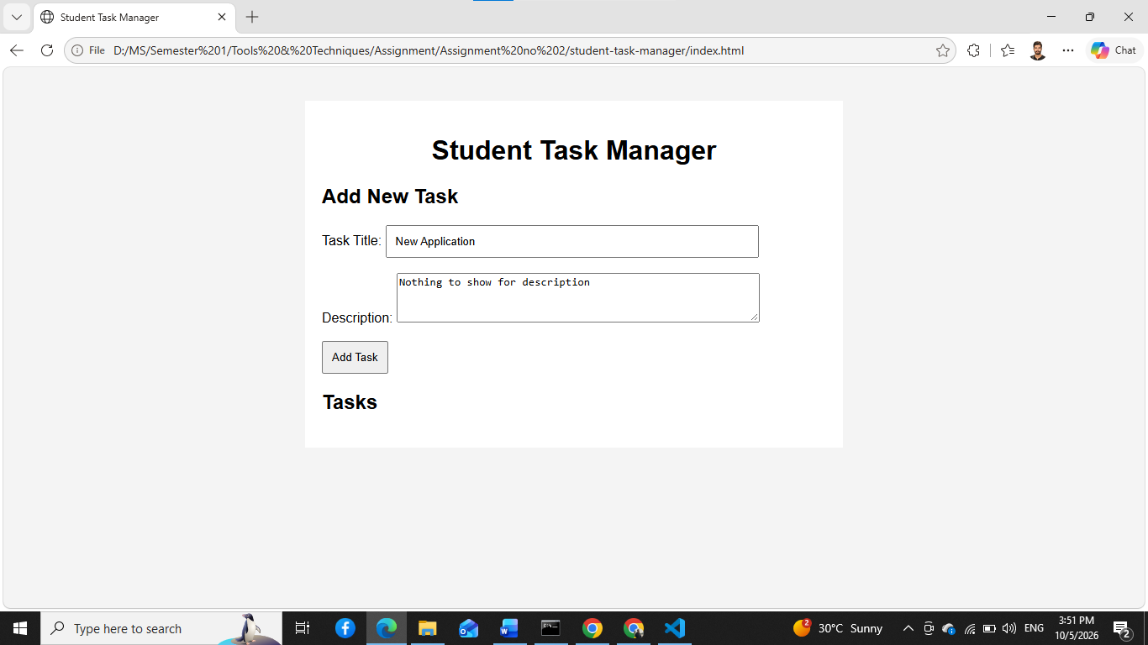
Figure 11: Updated Application.

Task 11 — Commit the Feature
Stage and commit the task form feature.
git add .
git commit -m "Add task input form"
git log --oneline
📸 Screenshot 12 — Feature Commit
Show the new feature commit.
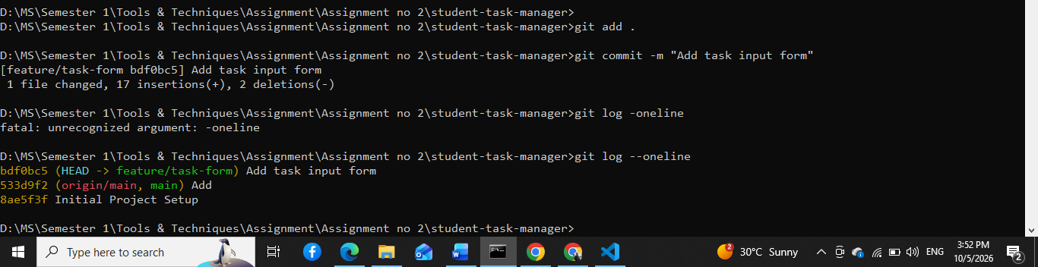
Figure 12: Feature Commit.

Task 12 — Push the Feature Branch
Push the feature branch to GitHub.
git push -u origin feature/task-form
📸 Screenshot 13 — Remote Feature Branch
Show the feature branch on GitHub.
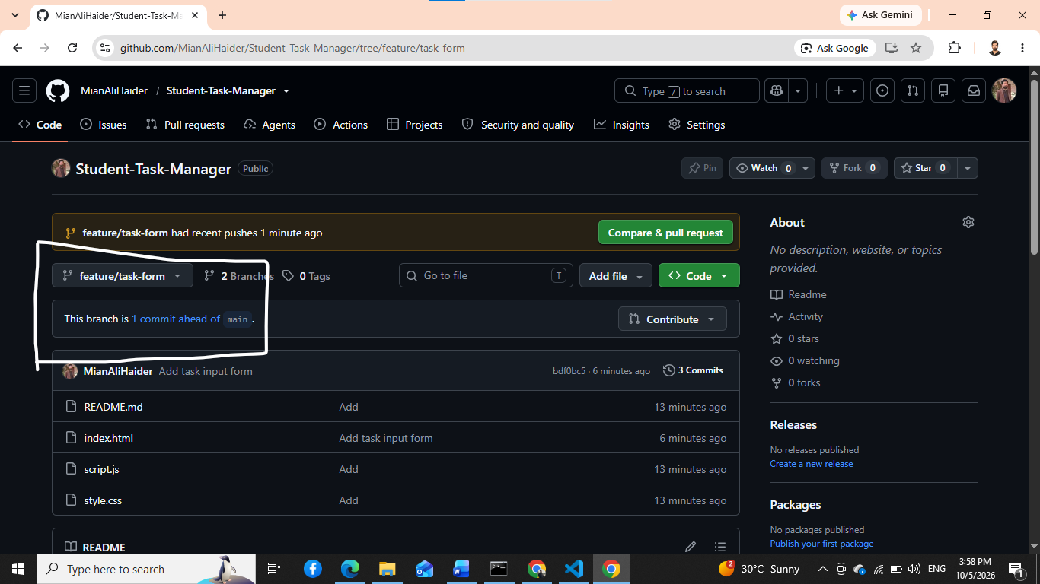
Figure 13: Remote Feature Branch.

Task 13 — Student 2 Creates a Branch
Student 2 clones the repository and creates a styling branch.
git clone <repository-url>
cd student-task-manager
git switch -c feature/task-style
git branch
📸 Screenshot 14 — Student 2 Branch
Show the feature/task-style branch.
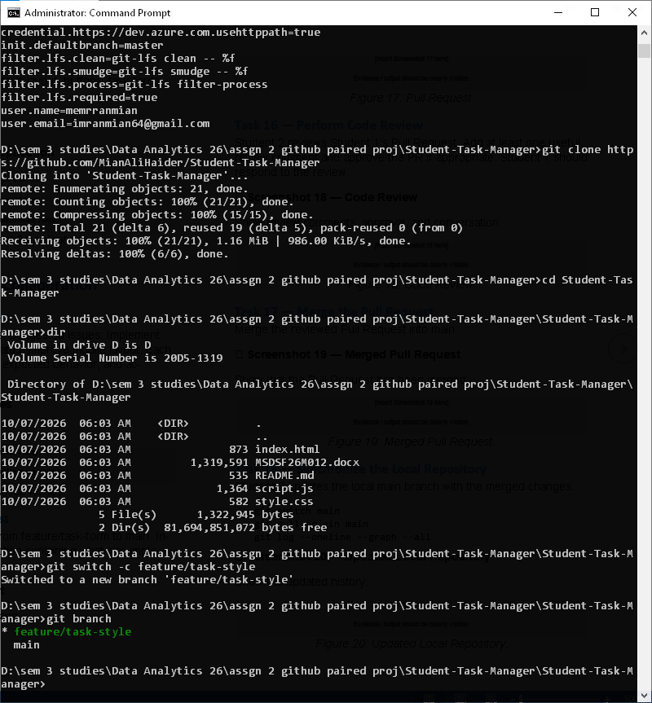Figure 14: Student 2 Branch.

Student 2 — Develop Styling
Student 2 modifies style.css to improve layout, buttons, task cards, and responsive design.
git status
git diff
📸 Screenshot 15 — Student 2 Application
Show the styling changes in the application.

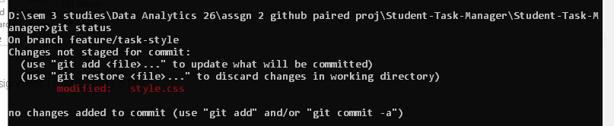
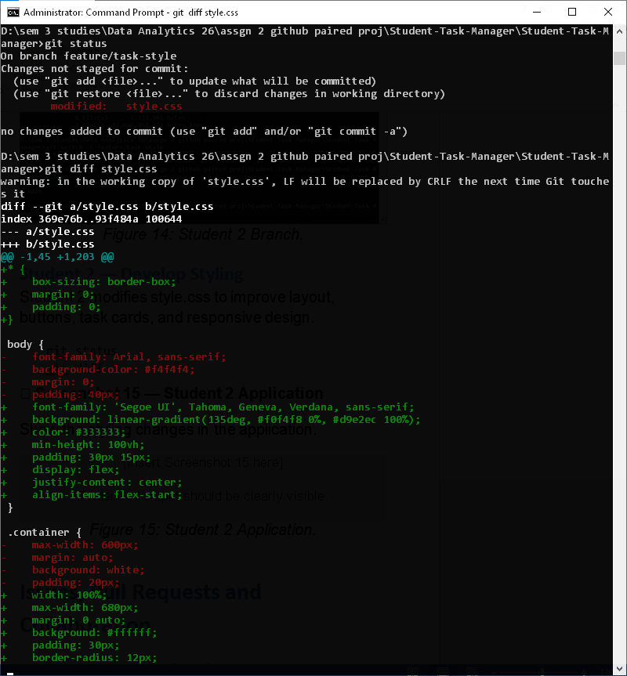

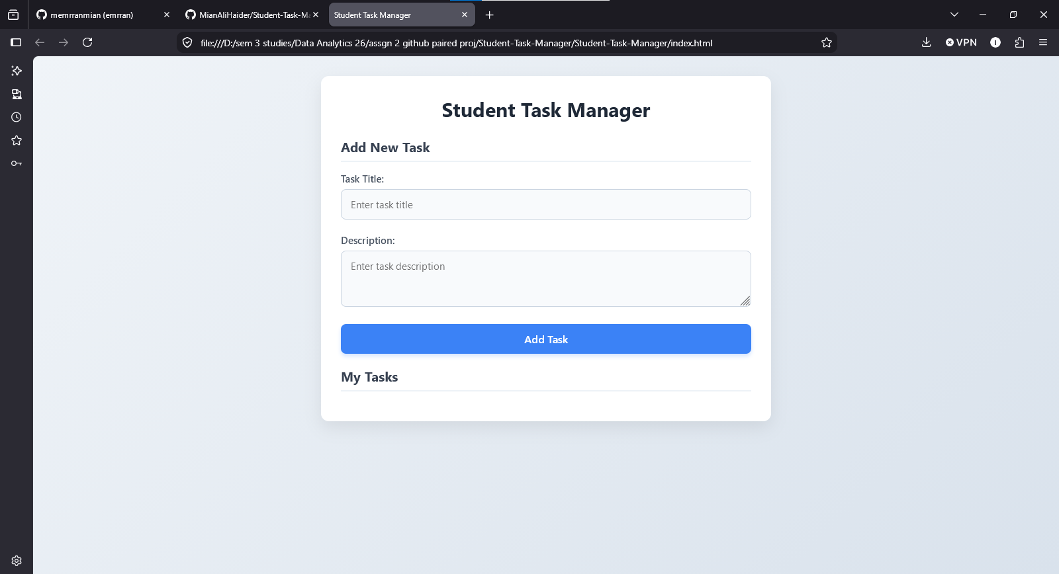
Figure 15: Student 2 Application.

Issues, Pull Requests and Collaboration

Task 14 — Create GitHub Issues
Create at least three GitHub Issues. Suggested issues: Implement task search; Add completed task status; Improve mobile layout. Each issue should contain a description, expected behavior, and acceptance criteria.
📸 Screenshot 16 — GitHub Issues
Show at least three issues.

- Installed Gh CLI terminal to add issues from the local PC via cmd line . And auth the user to connect to github repo.
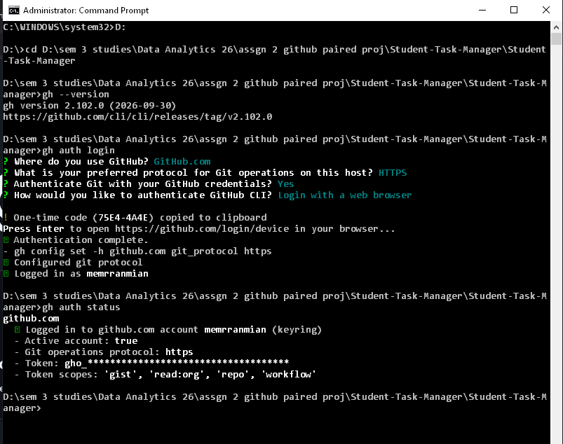

- Add Issues via command Line
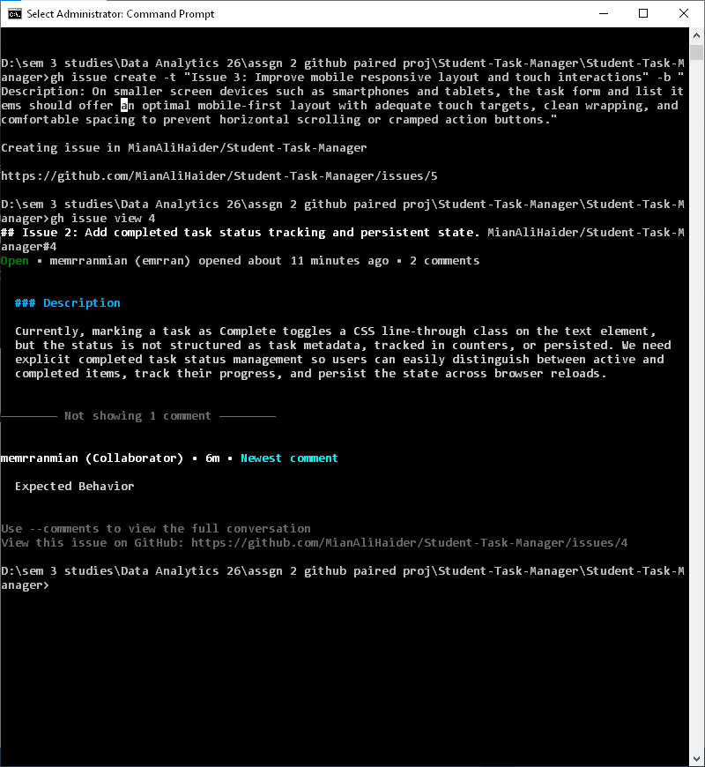

- Issue added to GitHub Issue tabs with the appended Issue numbers
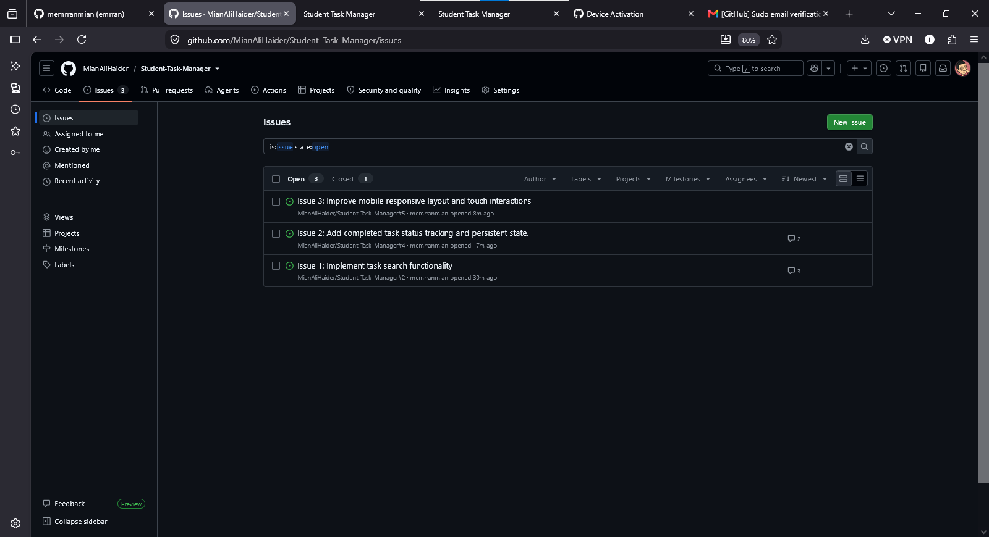
- Issue 1
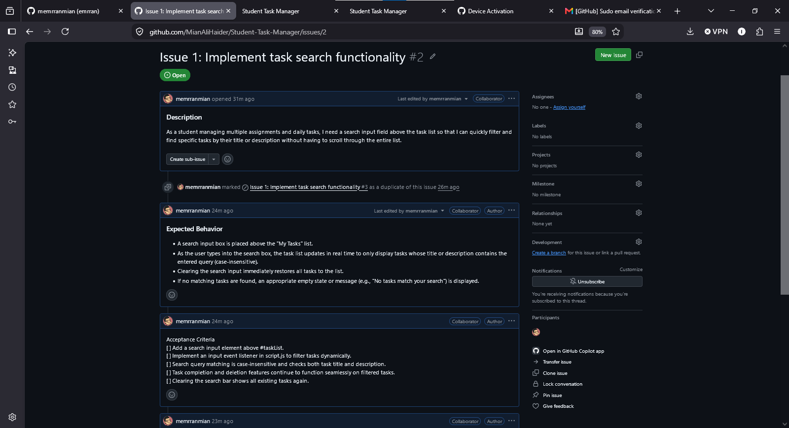

- Issue 2
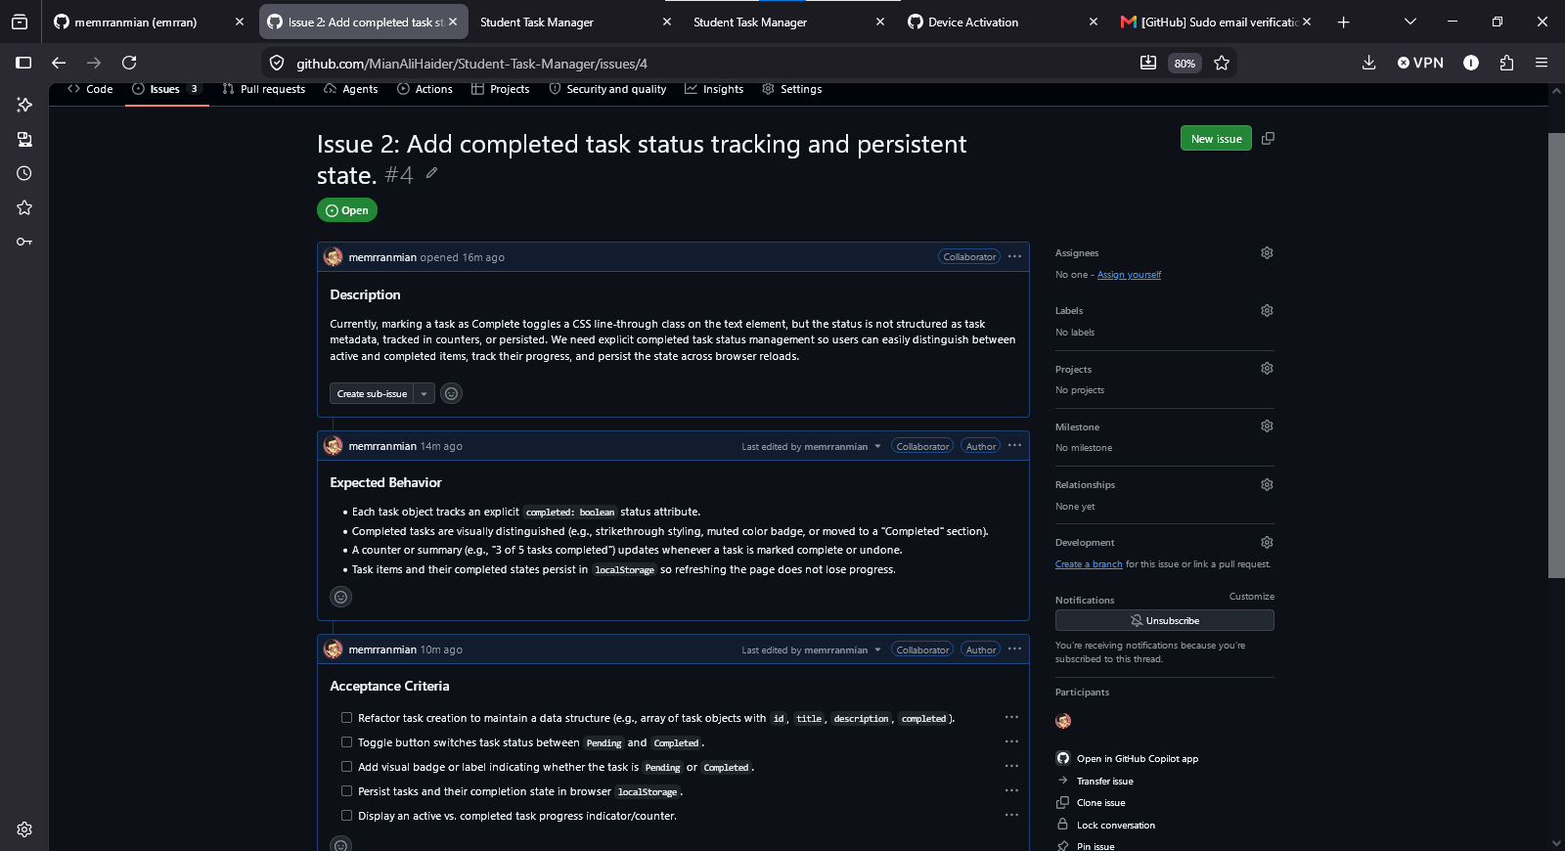
- Issue 3
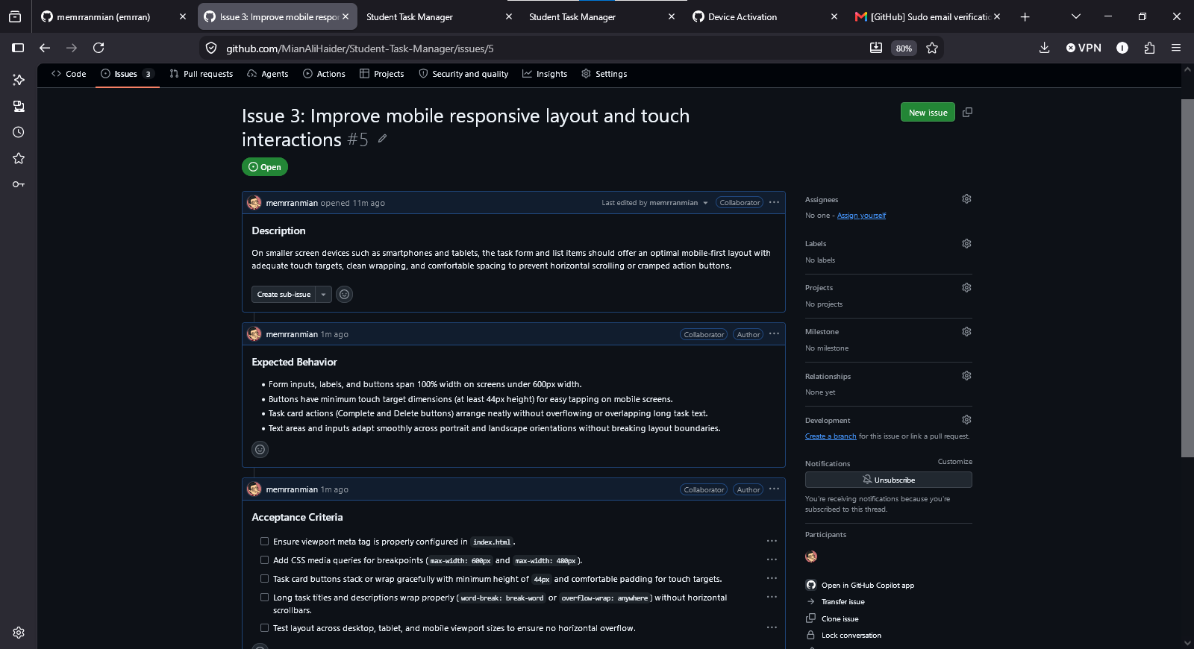

Figure 16: GitHub Issues.

Task 15 — Create a Pull Request
Student 1 creates a Pull Request from feature/task-form to main. Include a meaningful title and description explaining what was implemented and how it was tested.
📸 Screenshot 17 — Pull Request
Show the complete Pull Request page.
- Added the file to staging and then commit the changes
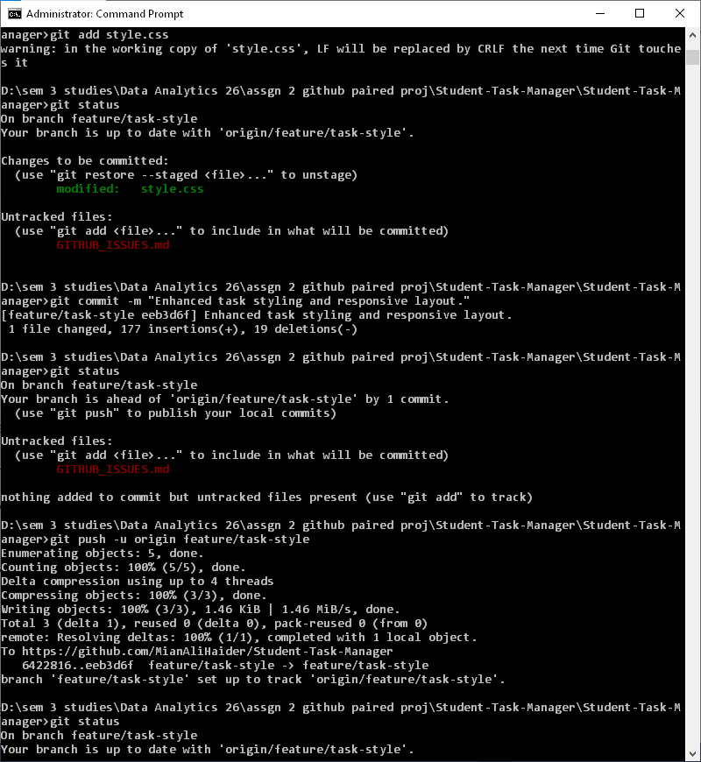

- Generating Pull request and confirming the status
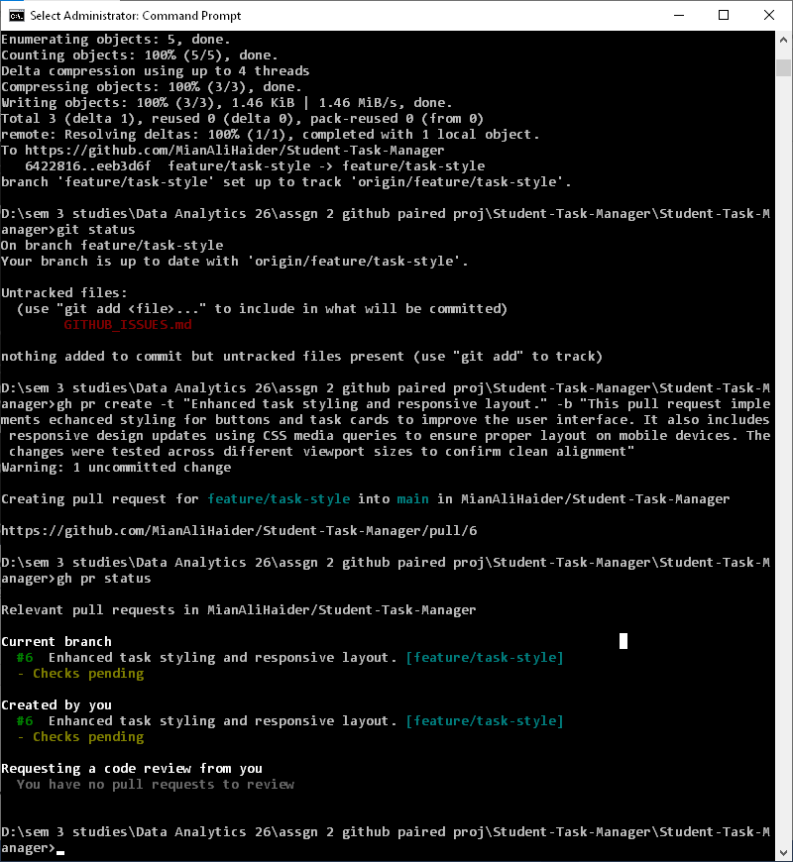Figure 17: Pull Request.

Task 16 — Perform Code Review
Student 2 reviews Student 1’s Pull Request. Add at least one useful review comment and approve the PR if appropriate. Student 1 should respond to the review.
📸 Screenshot 18 — Code Review
Show review comments, approval, and conversation.
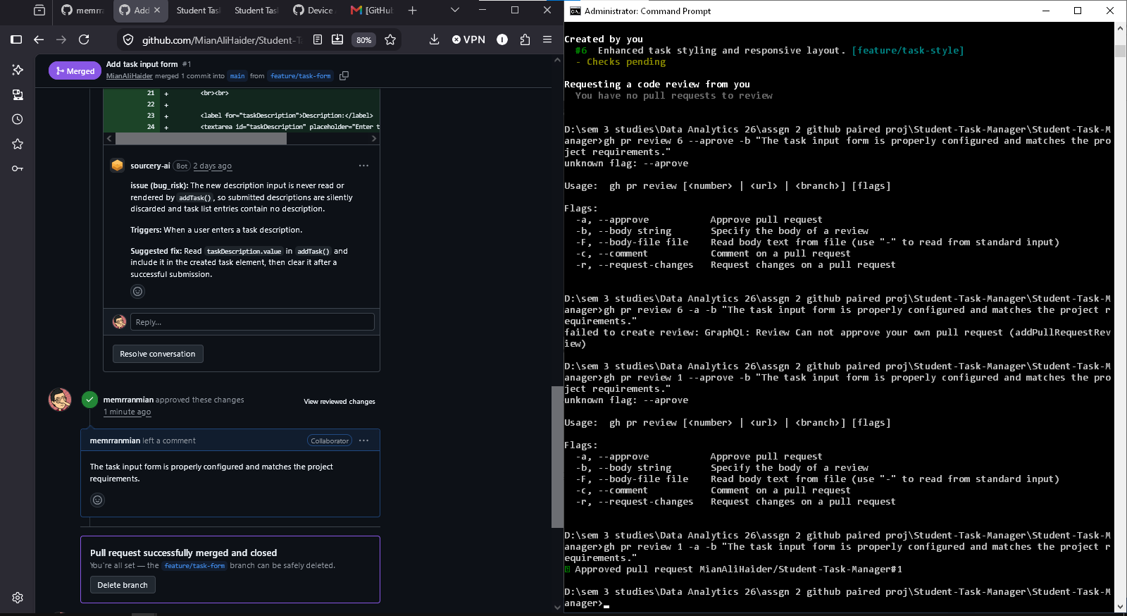Figure 18: Code Review.

Task 17 — Merge the Pull Request
Merge the reviewed Pull Request into main.
📸 Screenshot 19 — Merged Pull Request
Show that the Pull Request has been merged.
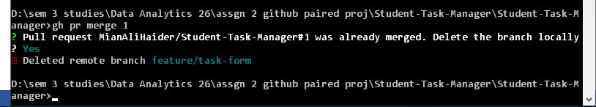Figure 19: Merged Pull Request.

Task 18 — Synchronize the Local Repository
Student 2 updates the local main branch with the merged changes.
git switch main
git pull origin main
git log --oneline --graph --all
📸 Screenshot 20 — Updated Local Repository
Show the updated history.
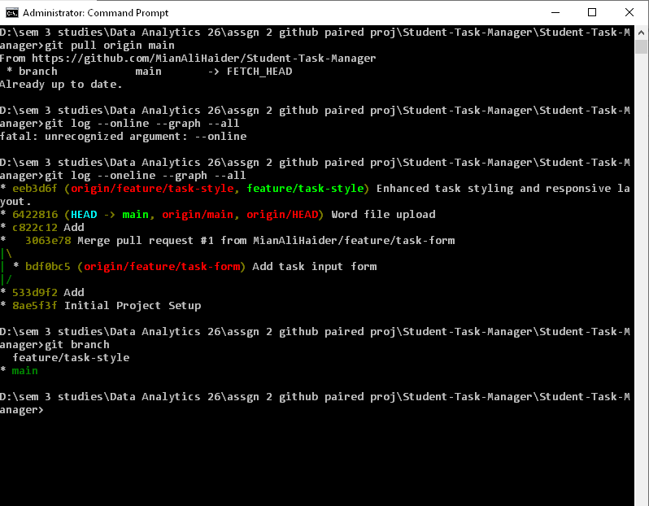Figure 20: Updated Local Repository.

Task 19 — Second Pull Request
Student 2 pushes feature/task-style, creates a Pull Request, and Student 1 reviews and merges it.
git push -u origin feature/task-style
📸 Screenshot 21 — Second Pull Request
Show the second Pull Request.
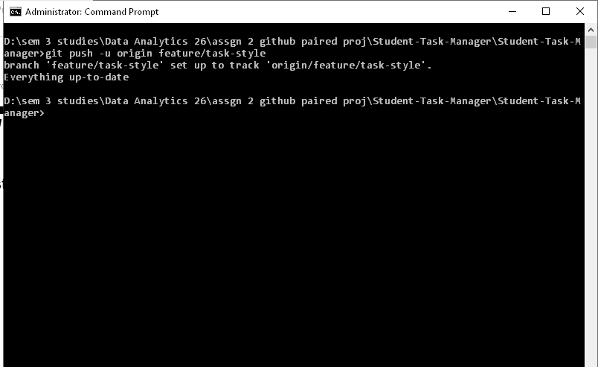
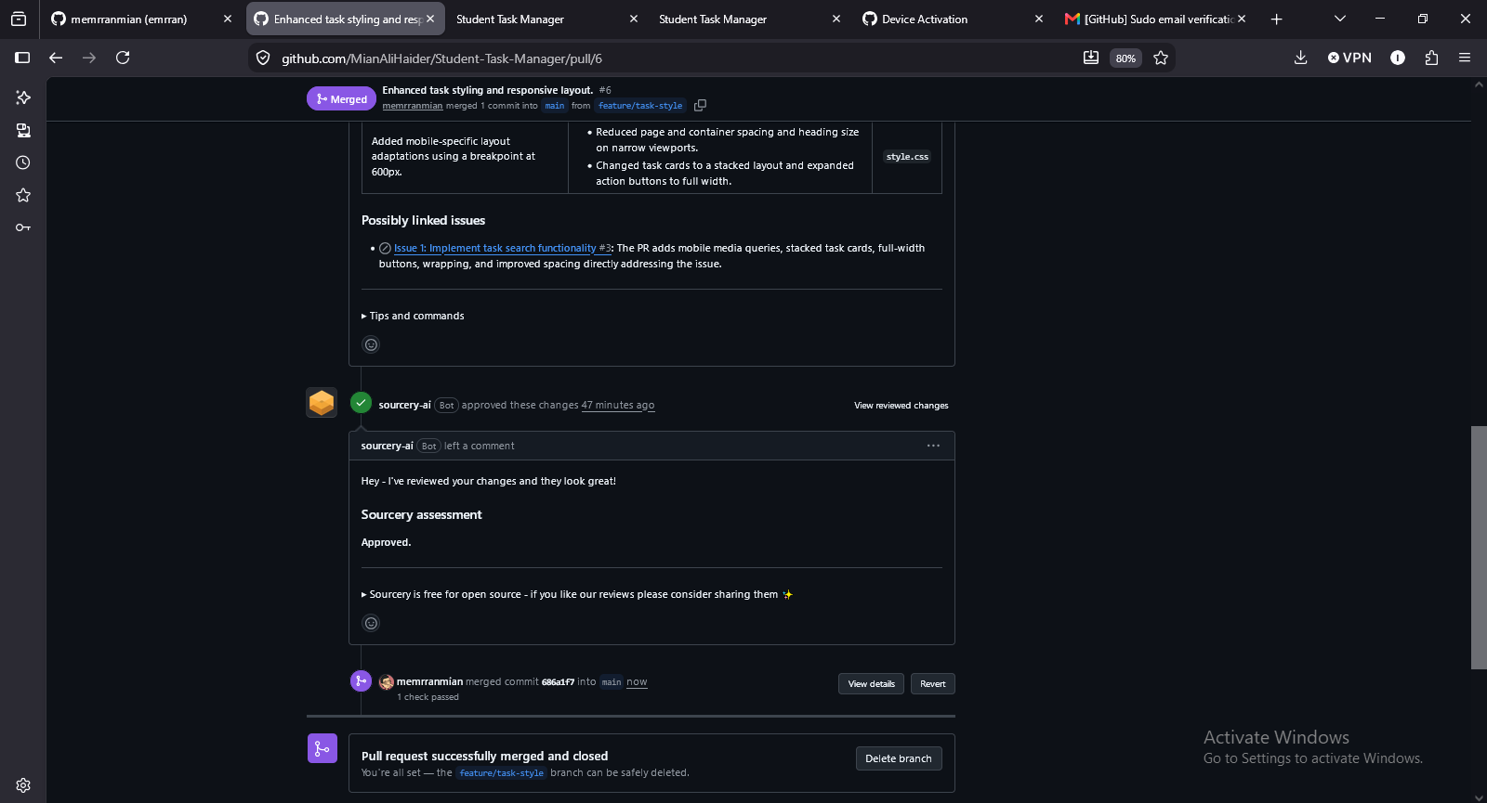Figure 21: Second Pull Request.
📸 Screenshot 22 — Second Code Review
Show Student 1’s review/comment and approval.
[Insert Screenshot 22 here]
Evidence / output should be clearly visible.
Figure 22: Second Code Review.
📸 Screenshot 23 — Second Merge
Show that the second Pull Request was merged.
[Insert Screenshot 23 here]
Evidence / output should be clearly visible.
Figure 23: Second Merge.

Merge Conflicts and Git Recovery

Task 20 — Create a Merge Conflict
Both students must intentionally edit the same part of README.md differently on separate branches. For example, one student writes “Student Task Management System” while the other writes “Student Task Management Application”. Commit both changes and attempt to merge.
git status
git merge <branch-name>

Student 2 created a new branch for this task feature/conflict-student2 with modification in README.md (Opening line changed to # Student Task Management Application) and pushed the branch to github.

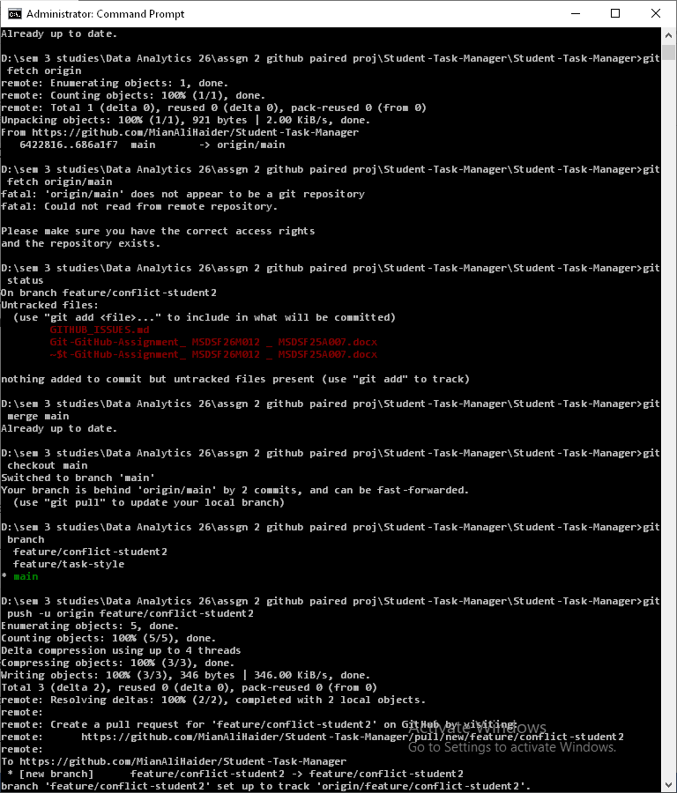

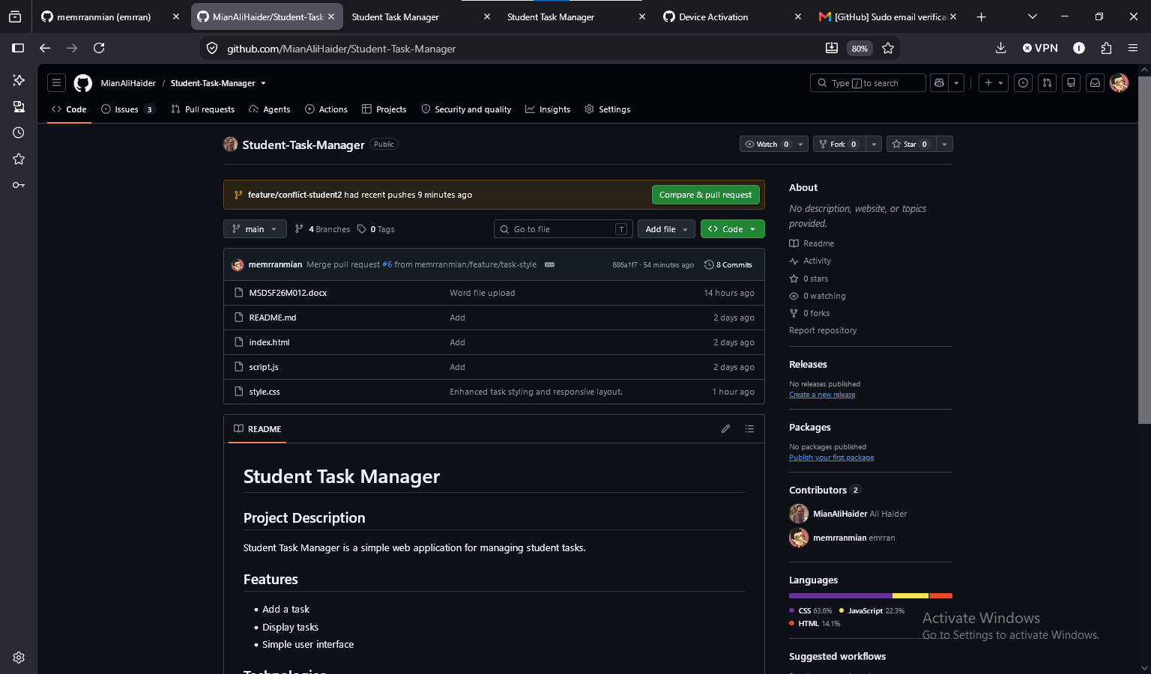
📸 Screenshot 24 — Merge Conflict
Show the terminal reporting a conflict.
[Insert Screenshot 24 here]
Evidence / output should be clearly visible.
Figure 24: Merge Conflict.
📸 Screenshot 25 — Conflict Markers
Open the conflicted file and show the <<<<<<<, =======, and >>>>>>> markers.
[Insert Screenshot 25 here]
Evidence / output should be clearly visible.
Figure 25: Conflict Markers.

Task 21 — Resolve the Merge Conflict
Discuss the final wording with your partner, remove conflict markers, save the file, stage it, and complete the merge.
git add README.md
git commit
git status
📸 Screenshot 26 — Conflict Resolution
Show the clean status after the conflict is resolved.
[Insert Screenshot 26 here]
Evidence / output should be clearly visible.
Figure 26: Conflict Resolution.

Task 22 — Demonstrate Git Stash
Modify a file without committing it. Temporarily save the work, verify the clean status, inspect the stash, and restore the work.
git stash
git status
git stash list
git stash pop
📸 Screenshot 27 — Git Stash
Show stash, stash list, and stash pop evidence.
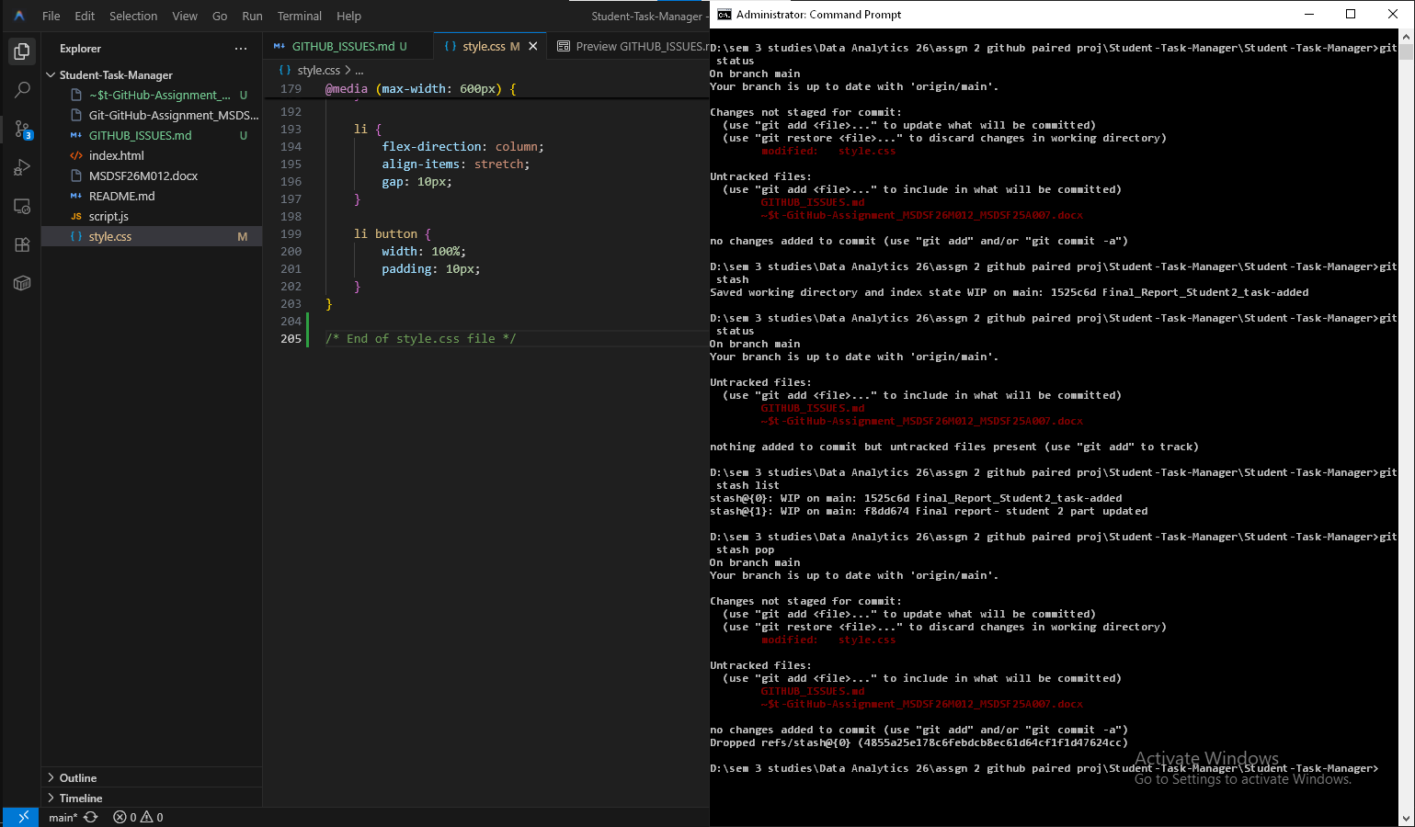Figure 27: Git Stash.
Questions / Explanation:
- Why would a developer use git stash?
git stash temporarily stores uncommitted changes when switching branches or contexts without losing work. Use cases:
- Switching branches mid-feature to fix an urgent bug
- Pulling remote changes without committing incomplete work
- Cleaning working directory without discarding progress
- Pausing work to review another developer's code
Industry practice: Developers stash when interrupted by higher-priority tasks; it's essential in interrupt-driven environments.

Task 23 — Demonstrate Git Restore
Modify style.css, inspect the changes, then discard the uncommitted modification.
git diff
git restore style.css
git status
📸 Screenshot 28 — Git Restore
Show the change before restore and clean status afterward.
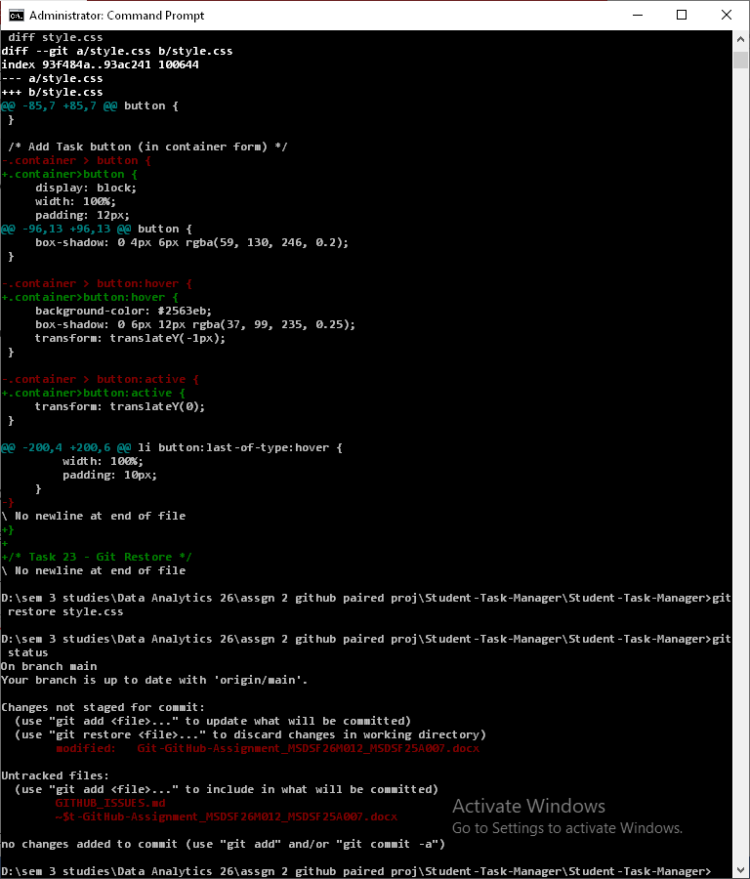Figure 28: Git Restore.
Questions / Explanation:
- What happened to the uncommitted modification?
When using git restore <file>:
- The uncommitted changes are permanently discarded
- Working directory reverts to the last committed state
- Changes are not recoverable (unless previously stashed)
- This is irreversible, so it should only be used when intentionally abandoning changes

Task 24 — Demonstrate Git Reset
Create a temporary commit and then use a soft reset to remove the commit while keeping the changes staged.
git add .
git commit -m "Temporary test commit"
git log --oneline
git reset --soft HEAD~1
git status
📸 Screenshot 29 — Git Reset
Show the temporary commit and the result of the soft reset.
[Insert Screenshot 29 here]
Evidence / output should be clearly visible.
Figure 29: Git Reset.
Questions / Explanation:
- What happened to the commit?
With git reset --soft HEAD~1:
- The commit is removed and HEAD pointer moves back one commit
- The --soft flag is critical: changes remain staged in the index
- Changes are not lost—they stay in the staging area ready for re-commit
- Differs from --hard, which would discard them entirely

- What happened to the file changes?
After git reset --soft HEAD~1:
- File changes remain intact in the staging area
- Files are marked as "Changes to be committed"
- Developer can re-examine, modify, or split changes before a new commit
- Running git commit again will create a fresh commit with the same content.

- What does --soft mean?
--soft is a reset mode that preserves both the working directory and staging area:
- --soft: Moves HEAD only; changes stay staged
- --mixed (default): Moves HEAD; unstages changes but keeps them in working directory
- --hard: Moves HEAD and permanently discards all changes
Use case: --soft is ideal for amending commits or reorganizing staged work without losing content.

Task 25 — Demonstrate Git Revert
Create a small temporary change, commit it, find the commit hash, and revert it. The original commit should remain in history and a new revert commit should be created.
git log --oneline
git revert <commit-hash>
git log --oneline
📸 Screenshot 30 — Git Revert
Show the original commit and the new revert commit.
[Insert Screenshot 30 here]
Evidence / output should be clearly visible.
Figure 30: Git Revert.
Questions / Explanation:
- Explain the difference between git reset and git revert.

Difference between git reset and git revert
Aspect | git reset | git revert
History | Rewrites commit history (destructive) | Preserves all commits (safe)
Operation | Moves HEAD pointer backward | Creates a new inverse commit
Collaboration | ⚠️ Risky in shared repos (rewrites history) | ✅ Safe for shared repos
Use Case | Local cleanup, undoing unpushed commits | Undoing published/shared commits
Example | git reset --hard HEAD~1 | git revert <commit-hash>
- Industry Rule: Use reset locally before pushing; use revert after pushing to remote to avoid breaking collaborators' history.

Issue-Based Development, Tag, Release and Final Evidence

Task 26 — Implement a GitHub Issue
Choose one of your GitHub Issues, create a feature branch, implement it, commit it, and push the branch.
git switch -c feature/task-search
git add .
git commit -m "Add task search functionality"
git push -u origin feature/task-search

Task 27 — Link the Pull Request to the Issue
Create a Pull Request for the issue-based feature. In the Pull Request description use “Closes #<issue-number>”. Merge the Pull Request and verify that GitHub closes the issue.
📸 Screenshot 31 — Issue and Pull Request
Show the issue, linked Pull Request, merge, and closed issue evidence.
[Insert Screenshot 31 here]
Evidence / output should be clearly visible.
Figure 31: Issue and Pull Request.

Task 28 — Create a Git Tag
After reaching a stable version, create and push version tag v1.0.0.
git tag v1.0.0
git tag
git push --tags
📸 Screenshot 32 — Git Tag
Show the v1.0.0 tag on GitHub or in the terminal.
[Insert Screenshot 32 here]
Evidence / output should be clearly visible.
Figure 32: Git Tag.

Task 29 — Create a GitHub Release
Create a GitHub Release for v1.0.0 and include concise release notes describing the completed features.
📸 Screenshot 33 — GitHub Release
Show the v1.0.0 release page.
[Insert Screenshot 33 here]
Evidence / output should be clearly visible.
Figure 33: GitHub Release.

Task 30 — Final Git History
Inspect the complete repository history, all branches, and the configured remote.
git log --oneline --graph --all
git branch -a
git remote -v
📸 Screenshot 34 — Final Git History
Show meaningful commit history and branches.
[Insert Screenshot 34 here]
Evidence / output should be clearly visible.
Figure 34: Final Git History.
📸 Screenshot 35 — Final GitHub Repository
Show repository name, description, files, and visible project information.
[Insert Screenshot 35 here]
Evidence / output should be clearly visible.
Figure 35: Final GitHub Repository.
📸 Screenshot 36 — Team Contributions
Show evidence that both students contributed to the repository.
[Insert Screenshot 36 here]
Evidence / output should be clearly visible.
Figure 36: Team Contributions.
📸 Screenshot 37 — Final Application
Show the completed Student Task Manager running.
[Insert Screenshot 37 here]
Evidence / output should be clearly visible.
Figure 37: Final Application.

5. Screenshot Evidence Rules
- Take screenshots immediately after completing the relevant task.
- Every required screenshot must be readable and show the relevant command, output, or GitHub page.
- Each screenshot must have a figure number/caption in the Word document.
- Add a short explanation under or beside each important screenshot.
- Do not crop away the command/output that proves what was done.
- Do not submit a Word document containing screenshots only; explanations are required.
- Use GitHub as the source of truth. The instructor may verify screenshots against the actual repository.

7. Git Command Demonstration Table
Command | Purpose | Evidence
git init | Initialize a local Git repository. | Screenshot 3
git status | Show working-tree and staging status. | Screenshots 3–5
git add | Stage changes for the next commit. | Screenshot 4
git commit | Create a permanent snapshot in local history. | Screenshot 5
git log | Inspect commit history. | Screenshot 6
git branch | List local branches. | Screenshots 9, 14
git switch | Switch branches. | Screenshots 9, 20
git diff | Show unstaged changes. | Screenshot 10
git diff --staged | Show staged changes. | Demonstrate and document
git clone | Create a local copy of a remote repository. | Screenshot 14
git remote -v | Show configured remote URLs. | Screenshot 34
git push | Upload commits to a remote repository. | Screenshots 8, 13
git fetch | Download remote references without integrating them. | Demonstrate and document
git pull | Fetch and integrate remote changes. | Screenshot 20
git merge | Integrate one branch into another. | Screenshots 23–26
git stash | Temporarily store uncommitted work. | Screenshot 27
git restore | Restore file content / discard working-tree changes. | Screenshot 28
git reset | Move HEAD/branch reference and optionally reset index/worktree. | Screenshot 29
git revert | Create a new commit that reverses an earlier commit. | Screenshot 30
git show | Inspect a commit and its changes. | Demonstrate and document
git blame | Show line-by-line authorship information. | Demonstrate and document
git tag | Create a named version marker. | Screenshot 32

9. Required README.md
The final README should contain at least:
- Project Description
- Team Members
- Features
- Technologies
- Git Workflow
- Branches
- Git Commands Demonstrated
- GitHub Features Demonstrated
- How to Run
- Screenshots
- Version History
- Contributors

10. Commit Message Guidelines
Use meaningful commit messages such as:
Initial project setup
Add task input form
Add task manager styling
Implement task creation
Implement task deletion
Add task completion
Add task search
Update project documentation
Fix responsive layout
Prepare version 1.0 release
Avoid meaningless messages such as: changes, update, final, abc, test, work, new.

11. Final Report Questions
Q1. What is the difference between the Working Directory, Staging Area, Local Repository, and Remote Repository?
Answer: _• Working Directory: The local folder on your filesystem where you actively view, add, and edit files. Changes here are untracked or unstaged until explicitly added.
• Staging Area (Index): An intermediate preview layer where files are marked with git add to indicate they are prepared to be included in the next commit.
• Local Repository: The .git directory on your local machine storing committed project history, snapshots, and local branches permanently.
• Remote Repository: A centralized version of the repository hosted on a network or server platform (e.g., GitHub, GitLab) used for team collaboration, code reviews, and remote backups.
Q2. What is the difference between git fetch and git pull?
Answer: • git fetch: Downloads the latest commits, branches, and tags from the remote repository to your local machine, updating remote tracking branches (such as origin/main) without modifying your current working files or active branch.
• git pull: Performs a git fetch immediately followed by a git merge (or rebase), integrating incoming remote changes directly into your active working branch.
Q3. What is the difference between git merge and git rebase? You only need to explain rebase; you do not have to perform it.
Answer: • git merge: Combines independent branch histories by creating a dedicated merge commit, preserving the exact chronological sequence and branch topology.
• git rebase: Moves or applies the commits of your current feature branch on top of another branch (e.g., main), rewriting commit hashes to create a clean, linear project history without merge commits.

Q4. What is the difference between git reset and git revert?
Answer: • git reset: Moves the current branch pointer backward to an earlier commit, altering commit history. Depending on the flag used (--soft, --mixed, --hard), changes can remain staged, unstaged, or be permanently discarded.
• git revert: Creates a new commit that applies inverse changes to undo an earlier commit, preserving existing commit history safely for collaborative repositories.

Q5. Why should developers normally create feature branches instead of making every change directly on main?
Answer: • Isolates in-progress features, experiments, or bug fixes without destabilizing production code on main.
• Enables team collaboration via Pull Requests, peer code reviews, and automated CI/CD checks before code merges.
• Permits multiple developers to work concurrently on distinct features without colliding in active working branches.

Q6. What causes a Git merge conflict?
Answer: A merge conflict occurs when two branches modify the exact same lines of code within a file differently, or when one branch deletes a file that another branch edits, preventing Git from resolving the differences automatically.
Q7. How did you resolve your merge conflict?
Answer: • Opened the conflicting file(s) containing conflict markers (<<<<<<<, =======, >>>>>>>).
• Discussed changes with the collaborator, edited the conflicting sections to combine the correct logic, and removed all conflict marker tags.
• Staged the resolved files using git add <file> and completed the merge via git commit before pushing to GitHub.
Q8. Why is a Pull Request useful?
Answer: • Provides a formal code review mechanism to verify code quality, structure, and functionality prior to merging into production branches.
• Facilitates team discussion, inline commenting, and automated integration checks.
• Documents architectural decisions and historical context tied to specific feature branches.
Q9. Why should commit messages be meaningful?
Answer: • Communicates the specific intent and business logic behind changes to collaborators and future maintainers.
• Accelerates debugging and code auditing when inspecting history using commands like git log, git blame, and git bisect.
• Enables automated changelog generation and structured release tracking.
Q10. What problems did you encounter during this assignment and how did you solve them?
Answer: • Merge Conflicts: Encountered overlapping modifications between feature branches and main. Resolved by inspecting file markers, selecting appropriate code edits, staging resolved files, and finalizing merge commits.
• Tracking Remote Branches: Ran into detached HEAD states or missing upstream tracking when pushing new branches (feature/task-style). Resolved by executing git push -u origin <branch-name> and verifying log trees with git log --oneline --graph --all.
• Collaborator Approvals: Handled pull request review requirements and branch protection rules by coordinating approvals and comments on GitHub before completing the merge.

12. Final Submission Checklist

☐ Git installed and configured
☐ Local repository initialized
☐ Multiple meaningful commits created
☐ Branches created and used
☐ GitHub repository created and connected
☐ Feature branches pushed
☐ At least 3 GitHub Issues created
☐ At least 3 Pull Requests completed
☐ Code reviews completed
☐ At least one merge conflict created and resolved
☐ git stash demonstrated
☐ git restore demonstrated
☐ git reset demonstrated
☐ git revert demonstrated
☐ Git tag v1.0.0 created
☐ GitHub Release created
☐ Both students contributed
☐ All required screenshots inserted
☐ Screenshots have captions and explanations
☐ Final application screenshot included
☐ Final GitHub screenshot included
☐ Final Git history screenshot included
☐ Final questions answered

15. Submission to Google Classroom
Each pair submits ONE Word document.
Recommended filename:
Git-GitHub-Assignment_<RollNo1>_<RollNo2>.docx
The submission must also include the public GitHub repository URL in the Word document. Keep the repository public until grading is completed.

17. Quick Student Hint Sheet
I want to... | Try
Start Git | git init
Check changes | git status
Stage a file | git add file
Stage everything | git add .
Commit | git commit -m "message"
See history | git log
Compact history | git log --oneline
See changes | git diff
See staged changes | git diff --staged
Create branch | git switch -c branch-name
Change branch | git switch branch-name
List branches | git branch
Merge | git merge branch-name
Clone | git clone URL
Add GitHub remote | git remote add origin URL
See remote | git remote -v
Download remote references | git fetch
Download and integrate | git pull
Upload changes | git push
Temporarily save work | git stash
Restore stash | git stash pop
Discard working change | git restore file
Undo a commit safely | git revert HASH
Inspect commit | git show HASH
Tag version | git tag v1.0.0
Push tags | git push --tags
See line authorship | git blame file

