Software Requirements Specification

for

<Electricity Consumption Planner>

**Version <1.0>**

**Prepared by**

**Group Name: FCB LM10**

| **Zain Allaudin** | **23L-3036** | **l233036@lhr.nu.edu.pk** |
| --- | --- | --- |
| **Muhammad Umer** | **23L-3085** | **l233085@lhr.nu.edu.pk** |
| **Talha Farooq** | **23L-3043** | **l233043@lhr.nu.edu.pk** |
| **Hassnain Saleem** | **23L-3073** | **l233073@lhr.nu.edu.pk** |
| **Ahmed Javed** | **23L-3092** | **l233092@lhr.nu.edu.pk** |

| **Instructor:** | ***Sir Zeeshan Rana*** |
| --- | --- |
| **Course:** | ***Software Requirements Engineering*** |
| **Project Domain:** | ***Electricity*** |
| **Teaching Assistant:**  **Organization:** | ***Sir Hamza Naveed***  ***FAST NUCES LAHORE*** |
| **Date:** | ***22nd October, 2024*** |

**Table of Contents**

**1 Introduction 1**

**1.1 Purpose 1**

**1.2 Document Conventions 1**

**1.3 Intended Audience and Reading Suggestions 2**

**1.4 Product Scope 3**

**1.5 References 3**

**2 Overall Description 4**

**2.1 Product Perspective 4**

**2.1.1.Origin and Context: 4**

**2.1.2.Relation to Larger System and Independency: 4**

**2.1.3.System Architecture Overview: 5**

**2.1.3.1:Major Components: 5**

**2.1.3.2.External Interfaces: 5**

**2.1.3.2.System Interconnections by Diagram: 5**

**2.2 Product Functions: 6**

**2.3 User Classes and Characteristics 8**

**2.4 Operating Environment 10**

**2.5 Design and Implementation Constraints 11**

**2.6 User Documentation 12**

**2.7 Assumptions and Dependencies 12**

**3. External Interface Requirements 13**

**3.1 User Interfaces 13**

**3.2 Hardware Interfaces 15**

**3.3 Software Interfaces 16**

**3.4 Communications Interfaces 17**

**4 System Features 17**

**5 Other Nonfunctional Requirements 37**

**5.1 Performance Requirements 37**

**5.2 Safety Requirements 38**

**5.3 Security Requirements 39**

**5.4 Software Quality Attributes 40**

**5.5 Business Rules 41**

**6. Other Requirements 41**

**Appendix A: Glossary 42**

**Appendix B: Analysis Models 42**

**Appendix C: To Be Determined List 43**

**Revision History**

| **Name** | **Date** | **Reason For Changes** | **Version** |
| --- | --- | --- | --- |
| Requirements  Document | 22-10-24 | New Document | 1.0 |
|  |  |  |  |

# 1 **Introduction**

## 1.1 **Purpose**

The purpose of this document is to define and detail the software requirements for the **Electricity Consumption Planner System (ECPS),** version 1.0. This Software Requirements Specification document focuses on the requirements of the **ECPS software**, which is designed to help residential and small to medium-sized enterprise (SME) users to effectively manage and optimize their electricity usage. The goal of the **ECPS** is to minimize electricity costs by generating optimal schedules for appliance operation based on peak and off-peak tariff rates, appliance usage patterns, and user preferences.

The **ECPS** is a desktop-based application developed to run on Windows operating systems and includes key functionalities for creating and managing appliance schedules, monitoring electricity consumption, and providing feedback on appliance usage patterns. This Software Requirements Specification document covers the entire scope of the **ECPS software**, like appliance scheduling and consumption monitoring, and provides a comprehensive set of requirements to guide the system’s design, code and development.

This Software Requirements Specification document specifically describes **ECPS** as a complete system rather than a subsystem.This Software Requirements Specification document does not cover multi-user or cloud-based capabilities,instead it describes a single-user, laptop-friendly desktop application specifically for residential and SME users seeking a cost-effective solution for managing electricity consumption.

## 1.2 **Document Conventions**

The following standards and conventions have been followed in writing this SRS:

**1.2.1.Font Style and Highlighting**: Key terms and sections are emphasized using **boldface** to improve readability, while any code snippets or command inputs are in monospaced font for clarity.

**1.2.2.Acronyms and Abbreviations**: Common abbreviations used throughout this SRS include:

* **ECPS**: Electricity Consumption Planner System
* **SMEs**: Small and Medium Enterprises
* **UI**: User Interface
* **SRS**: Software Requirements Specification

These acronyms are used consistently to streamline reading and maintain document clarity.

**1.2.3. Priority Inheritance**: Higher-level requirements set priorities that apply to all associated sub-requirements unless explicitly stated otherwise.

**1.2.4.Requirement Statement Prioritization:** Each requirement statement is assigned an individual priority designation to focus development on critical functionalities.

## 1.3 **Intended Audience and Reading Suggestions**

**1.3.1.Intended Audience:**

The intended audience for this document includes:

* **Developers**: To understand detailed functional requirements and design considerations.
* **Project Managers**: For project planning, tracking progress, and ensuring that requirements align with project goals.
* **Users**: Residential users, SME users, and commercial entities to understand system capabilities and functionalities.
* **Testers**: To design tests and ensure that all functional requirements are adequately met.
* **Documentation Writers**: To create end-user documentation based on system capabilities and use cases.

**1.3.2.Reading Suggestions:**

* **1.3.2.1 Overview Sections**
  + Begin with the "**1. Abstrac**t" to grasp the high-level objectives and vision of the Electricity Consumption Planner System (ECPS).
  + Proceed to "**1.1 Purpose**" to understand the primary goals and purpose of the ECPS, especially concerning efficient energy planning for consumers.
* **1.3.2.2 Project Scope Summary**
  + Review the "Summary of Project Scope" (Section 2) to get insights into the scope, goals, and key features of ECPS, providing context on the overall impact of the system.
* **1.3.2.3 Functional Requirements**
  + **Developers:** Focus on "**3. Functional Requirements**" for a detailed breakdown of the system's capabilities, expected behaviors, and user interactions.
  + **Project Managers:** Pay attention to the scope of the project, business goals, and objectives outlined in "**3. Functional Requirements**" to understand the project's alignment with user needs.
* **1.3.2.4 Non-Functional Requirements**
  + **QA/Testers:** Review "**4. Non-Functional Requirements**" to understand criteria for performance, security, and reliability, crucial for ensuring system quality.
  + **Developers:** Examine the technical aspects relevant to the system's infrastructure, scalability, and maintainability.
* **1.3.2.5 User Classes and Characteristics**
  + **Requirement Analysts**: Review "**2.3. User Classes and Characteristics**" to understand the intended user types, including Residential People, SMEs, Commercial Buildings, and utility providers, to support tailored requirement gathering and design considerations.
* **1.3.2.6 Document Conventions**
  + **Documentation Writers**: Refer to "**1.2. Document Conventions**" to understand formatting standards and conventions used throughout the SRS, such as priority inheritance and term abbreviations like ECPS and SMEs.

By following this suggested sequence, each reader type can concentrate on the sections most relevant to their role, ensuring a well-rounded understanding of the **ECPS** and its requirements.

## 1.4 **Product Scope**

The **Electricity Consumption Planner System** is designed to help users optimize their electricity consumption by providing data-driven, cost-effective appliance schedules. This system allows residential users, small to medium enterprises (SMEs), and commercial users to input their appliances, track historical schedules, receive optimized schedules, and provide feedback on system effectiveness.

**1.4.1 Objectives and Goals**:

* Assist users in reducing electricity costs by planning appliance usage based on tariff data and consumption patterns.
* Support corporate strategies for sustainable energy use and cost savings through efficient electricity management.
* Enhance user experience by offering feedback mechanisms and an intuitive interface tailored to diverse user classes, such as residential users and SMEs.

## 1.5 **References**

* Wang, J., & Li, H. (2021). The impact of electricity price on Power-Generation Structure: Evidence from China. *Frontiers in Environmental Science*, *9*.

<https://doi.org/10.3389/fenvs.2021.733809>

* Bertsimas, D., & Tsitsiklis, J. (1997). *Introduction to linear optimization*. <https://www.semanticscholar.org/paper/Introduction-to-linear-optimization-Bertsimas-Tsitsiklis/c8557a70ecdeec83f70954c5f169393c7f04fc9e>
* Santos, G. P. D. (n.d.). *Design patterns by tutorials learning design patterns in Swift 42 2ndnbspED 978 1942878667 Compress*. Scribd. <https://www.scribd.com/document/674521882/Design-Patterns-by-Tutorials-Learning-Design-Patterns-in-Swift-42-2ndnbsped-978-1942878667-Compress>
* TA, Z., & V, R. (2014). Using evolutionary heuristics for solving the outdoor advertising optimization problem. *Journal of Computer Sciences and Applications*, *2*(2), 23–30. <https://doi.org/10.12691/jcsa-2-2-2>
* CLRS Solutions. (n.d.).

<https://sites.math.rutgers.edu/~ajl213/CLRS/CLRS.html>

* Lautner, D., Hua, X., DeBates, S., Song, M., & Ren, S. (2018). Power efficient scheduling algorithms for real-time tasks on multi-mode microcontrollers. *Procedia Computer Science*, *130*, 557–566.

<https://doi.org/10.1016/j.procs.2018.04.099>

* 830-1984 - IEEE Guide for Software Requirements Specifications. (n.d.). IEEE Standard | IEEE Xplore.

<https://ieeexplore.ieee.org/document/278253>

# 2 **Overall Description**

## 2.1 **Product Perspectiv**e

## 2.1.1.Origin and Context:

The **ECPS** aims to streamline the process of managing electricity usage by providing users with a user-friendly interface to input appliance data and generate optimized schedules based on real-time electricity tariffs. By focusing on local storage and processing, the application is optimized for individual users operating on Windows-based laptops, ensuring ease of access and usability without the need for internet connectivity or multi-user capabilities.This approach allows **ECPS** to efficiently support single users by leveraging locally stored data to create and maintain scheduling information, catering to the needs of users who seek to minimize their electricity costs.

## 2.1.2.Relation to Larger System and Independency:

The **Electricity Consumption Planner System (ECPS)** is a new, self-contained desktop application aimed at optimizing electricity consumption for residential and small to medium-sized enterprise (SME) users. The ECPS is designed as an **independent** software solution, focusing on single-user functionality and is not designed to be part of any larger integrated system or product suite. This initial version, ECPS 1.0, establishes a standalone application with a specific focus on addressing the specific needs of users seeking to minimize their electricity costs through efficient appliance scheduling.

## 2.1.3.System Architecture Overview:

## 2.1.3.1:Major Components:

The ECPS consists of the following main components:

1. **User Interface (UI):** Facilitates user interactions, allowing input of appliance details and schedule preferences.
2. **Data Input Module:** Handles user data entry regarding appliances and usage patterns.
3. **Scheduling Engine:** Processes input data to create optimized appliance schedules based on user needs and electricity tariff rates.
4. **History Tracker:** Maintains records of previous schedules for user reference and analysis.
5. **Feedback Processor:** Collects and processes user feedback on generated schedules to enhance future performance.
6. **Output Module**: Displays the generated appliance schedules to the user, providing a clear view of optimized operation times based on the scheduling engine's processing.

## 2.1.3.2.External Interfaces:

The application interacts with the following external interfaces:

* **Utility Tariff Data:** The9 system retrieves electricity tariff information from a designated file or external source, ensuring that the scheduling engine is informed of peak and off-peak rates.
* **Feedback Mechanism:** Allows users to provide feedback on schedules directly through the UI, which can be saved in a file and analyzed for further improvements.
* **History Track Mechanism:** Provides users with access to previous scheduling records stored locally, allowing them to compare historical schedules with current results for better decision-making.

## 2.1.3.2.System Interconnections by Diagram:

The system interconnections for **ECPS** are as follows:

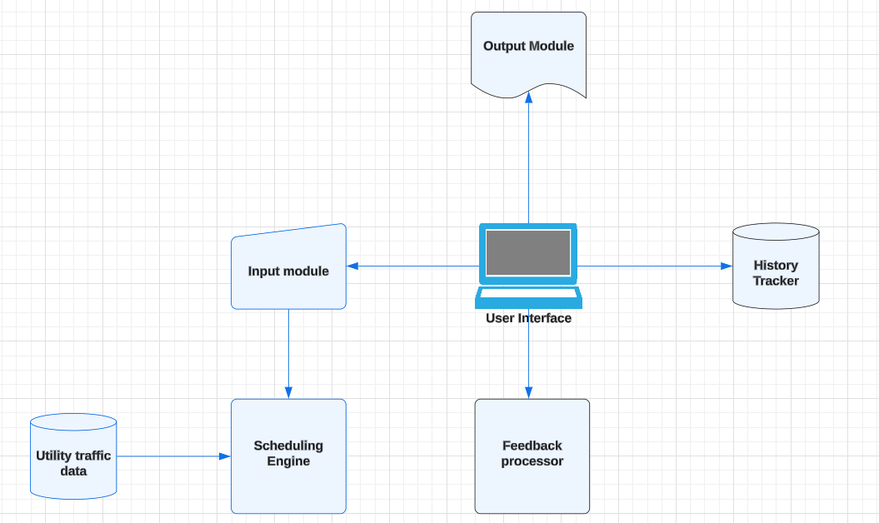

## 2.2 **Product Functions**:

The key functions of **ECPS** are organized to provide a high-level summary of the major

capabilities that the product must perform or enable users to perform. Detailed explanations and

specifications are provided in Section 3. The functions can be summarized as follows:

**2.2.1.Appliances Data Entry:**Users can input details about their household appliances, including power consumption, preferred usage times, and other relevant settings.

**2.2.2.Schedule Generation:** Based on the provided appliance data and electricity tariff information, the system generates optimized daily, weekly, or monthly schedules to help users reduce electricity costs.

**2.2.3.Historical Schedule Tracking:**Users can view past schedules to compare and analyze how their usage patterns have impacted electricity consumption over time.

**2.2.4.Feedback Submission:** Users can provide feedback on the generated schedules, allowing them to communicate preferences and improvements for future scheduling.

**2.2.5.Tariff Data Integration:** Users can input or update electricity tariff rates, ensuring that the generated schedules consider peak and off-peak rates for cost optimization.

**Use Case Diagram:**

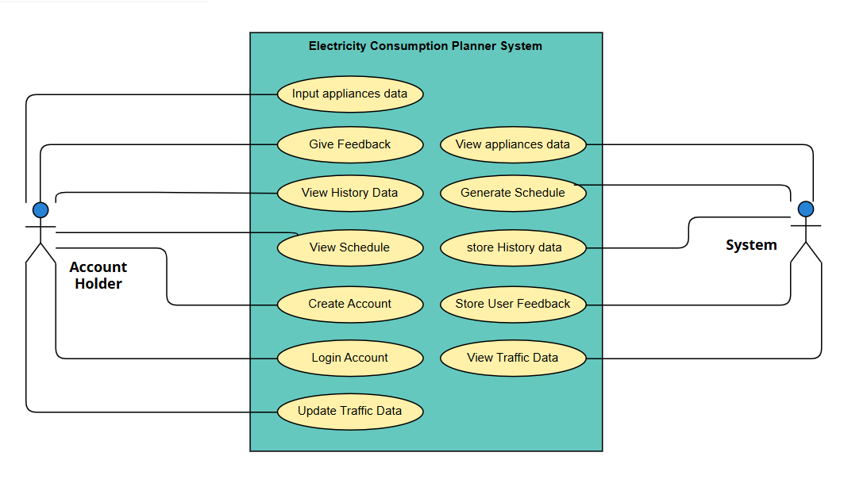

**Context Level Data Flow Diagram:**

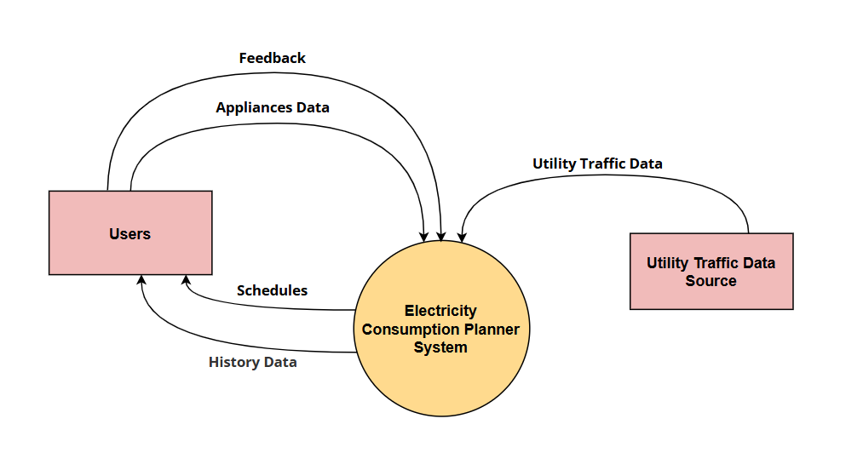

## 2.3 **User** **Classes and Characteristics**

Following are the major user classes that actively take part in using this system **ECPS** after and before its deployment.These user classes are differentiated based on their frequency of usage, technical expertise, interactions, privilege levels and specific needs in the software development process.

**2.3.1.Residential Users:**

**2.3.1.1.Frequency of Use: Moderate to frequent**, especially during seasonal changes or as utility rates fluctuate.

**2.3.1.2.Pertinent Characteristics:Basic to moderate** technical skills, generally prioritizing ease of use and simplified schedules that fit their lifestyle.

**2.3.1.3.Technical Expertise:Basic to moderate**, typical users may not have extensive technical knowledge and will need a user-friendly interface.

**2.3.1.4.Interactions:**Primarily focused on appliance data entry, viewing schedules, and tracking savings. They may periodically adjust settings based on new tariffs or seasonal changes.

**2.3.1.5.Privilege Levels:Basic** user privileges; can access only their own data and schedules, with no administrative controls.

**2.3.1.6.Importance: High** , Residential users represent a significant portion of the user base, and their needs directly impact the core functionalities of the system, such as appliance data entry, daily scheduling, and cost-saving analysis.

**2.3.2.Small and Medium Enterprises**

**2.3.2.1.Frequency of Use: Regular**, possibly with daily or weekly schedule checks and adjustments.

**2.3.2.2.Pertinent Characteristics:**May have slightly **higher** technical expertise than residential users, focusing on both cost savings and operational efficiency.

**2.3.2.3.Technical Expertise: Moderate**, SME users may have some familiarity with business tools and are likely comfortable with basic data input and interpretation of results.

**2.3.2.4.Interactions:Regularly** engage with scheduling features and reporting tools to optimize appliance usage. May also provide feedback on scheduling effectiveness.

**2.3.2.5.Privilege Levels:Basic to intermediate**, have access to business-specific settings and data, with options to customize schedules but without system-wide administrative privileges.

**2.3.2.6.Importance: Medium to High** , SMEs are likely to use more of the system's advanced features and potentially provide more frequent feedback, helping to refine the scheduling and optimization algorithm.

**2.3.3.Commercial Buildings**

**2.3.3.1.Frequency of Use: High**, often with continuous monitoring and adjustments to schedules.

**2.3.3.2.Pertinent Characteristics:**Typically have dedicated personnel with technical expertise in managing large-scale systems; require detailed and customizable scheduling options.

**2.3.3.3.Technical Expertise:Intermediate to advanced**, personnel managing energy usage in commercial buildings often have technical expertise or are trained in managing building systems.

**2.3.3.4.Interactions:Frequent** interaction with the scheduling tool, possibly integrating other building management data and customizing schedules extensively to reduce costs.

**2.3.3.5.Privilege Levels:Intermediate**, have permissions to manage more advanced scheduling settings for large systems but are limited to their own facility’s data without full administrative privileges.

**2.3.3.6.Importance: Medium*,*** important for promoting the system's scalability, this group may use fewer features than smaller users and require specialized features, which might be less emphasized during initial development.

**2.3.4.Software Engineer**

**2.3.4.1.Frequency of Use: Frequent** during the development cycle, with occasional use for maintenance and updates.

**2.3.4.2.Pertinent Characteristics:High** technical expertise, especially in software development, C++, and algorithms.

**2.3.4.3.Technical Expertise:Very high**, specialized in software development, system architecture, and algorithms.

**2.3.4.4.Interactions:**Ongoing throughout the development process; involved in implementing and refining system functionalities, debugging, and testing.

**2.3.4.5.Privilege Levels:High**, has administrative access to system functions, codebase, and configuration settings, though no direct access to user-specific data..

**2.3.4.6.Importance: High** , as the core technical team, they’re crucial to translating requirements into a functional, user-friendly product.

***2.3.5.*Requirement Engineer**

**2.3.5.1.Frequency of Use: Frequent** during the requirements gathering, analysis, and validation phases.

**2.3.5.2.Pertinent Characteristics:Moderate** technical expertise with a strong focus on understanding user needs and aligning them with system capabilities.

**2.3.5.3.Technical Expertise:Moderate to high**,expertise in requirement analysis, documentation, and possibly some technical aspects of software development.

**2.3.5.4.Interactions:High** interaction level during the requirements gathering and validation stages, ensuring user needs are accurately captured and communicated to the development team.

**2.3.5.5.Privilege Levels:High**, administrative access to project documentation and system requirements, but limited or no access to implementation details or user-specific data.

**2.3.5.6.Importance: High** , Their role is foundational, ensuring the product meets stakeholder expectations and aligns with real-world needs.

## 2.4 **Operating Environmen**t

This section describes the environment where the Electricity Consumption Planner System **(ECPS)** will operate, covering hardware, operating systems, and compatible software.

#### 2.4.1. Hardware Platform

* **Device**: The ECPS is designed to operate on personal computers and laptops.
* **Specifications**: The minimum hardware requirements include:
  + **Processor**: Intel Core i3 or equivalent (or higher)
  + **Memory**: 4 GB RAM or more
  + **Storage**: 1 GB of available disk space for system files and data storage
  + **Display**: Minimum 1024x768 resolution to ensure compatibility with the graphical user interface layout.

#### 2.4.2. Operating System

* **Supported Operating System**: The system will run on Microsoft Windows.

**Supported Versions**: Windows 10 and Windows 11, both 32-bit and 64-bit versions.

**Updates**: The system will be compatible with the latest Windows updates, ensuring continued functionality with new system updates and patches.

**2.4.3**. **Required Software Components**

* **Development Language**: The system will be built using **C++** with **WinForms** for the user interface.
* **Runtime Requirements**:
  + **Microsoft .NET Framework**: Version 4.8 or later (for WinForms support).
  + **C++ Redistributable Packages**: Required for running C++ applications on Windows platforms.

#### 2.4.4.External Data Sources

* **Utility Tariff Data**: The system will retrieve utility tariff information from an external data provider. This data will be stored locally in text or JSON files to support scheduling optimization based on real-time electricity tariffs.

**2.4.5.Coexistence with Other Applications**

* **Background Compatibility**: ECPS will operate independently and does not require interaction with other applications. However, it should coexist peacefully with:
  + **Antivirus Software**: Common antivirus applications should not interfere with ECPS’s functions.
  + **User Productivity Software**: Applications like Microsoft Office and PDF readers should be able to run alongside ECPS without conflicts or significant memory/resource contention.

**2.4.6. Network Requirements**

* **Offline Operation**: The system is designed to function entirely offline. Utility tariff data and other updates can be manually entered by the user without requiring a network connection.

This setup ensures that the ECPS system can operate smoothly in a common desktop environment without requiring high-end specifications, making it accessible and user-friendly for a broad range of users.

## 2.5 **Design and Implementation Constraints**

**2.5.1 Language Requirements**: The system will be delivered in English, including all user interface elements, documentation, and system messages, ensuring consistency and accessibility for English-speaking users.

**2.5.2.Hardware Limitations**: Designed for standard desktop and laptop configurations, the software will operate effectively without requiring high-performance hardware. Memory and processing requirements will be optimized to function well on devices with moderate RAM and CPU capabilities.

**2.5.3.Operating System Compatibility**: The application will run exclusively on the Windows operating system, with no requirement for cross-platform functionality.

**2.5.4.File Handling and Data Storage**: All data—such as user entries, appliance information, past schedules, and feedback—will be managed through local file handling. No external database is required, supporting a fully offline operation.

**2.5.5.Development Language and Tools**: The system will be developed in C++ and will utilize WinForms for the user interface. These choices align with the requirement for a simple, desktop-only solution.

**2.5.6.Security and Access Control**: Since the system is intended for single-user offline operation, minimal security measures are necessary. Basic input validation will be implemented to maintain data integrity, though complex encryption or user authentication is not required.

**2.5.7.Design Conventions and Standards**: Adherence to standard design conventions in C++ and WinForms will ensure maintainability. Comprehensive documentation will be provided, enabling future developers or maintainers to easily understand and modify the code.

**2.5.8.User Interface Design**: The interface will focus on clarity and ease of use, avoiding complex graphics to ensure compatibility with basic hardware. The design will emphasize usability for non-technical users.

## 2.6 **User Documentation**

The following documentation components will be delivered to help users understand and operate the Electricity Consumption Planner System (ECPS):

***2.6. Software Requirements Specification (SRS)****This document serves as the primary guide for understanding the features, functionality, and usage of the Electricity Consumption Planner System (ECPS). It provides comprehensive information on the system's requirements, intended behaviors, and expected performance.*

**2.6.1. User Manuals**The SRS details system functions, requirements, and intended operations for various user roles, including residential, commercial, and administrative users. This section helps users understand how to interact with the system based on their specific needs.

**2.6.2. Reference Guide**A quick reference section is included, summarizing functional and non-functional requirements. This allows users to grasp system capabilities and limitations without delving into technical detail.

**2.6.3. System Overview and GUI Navigation**This section includes a simple navigation guide based on the GUI descriptions, explaining the main screens, input fields, and essential interactions related to appliance scheduling, feedback submission, and tariff data integration.

**2.6.4. Architecture and Interfaces**An introductory overview is provided for users needing system setup or administrative information, utilizing the architecture and interface requirements sections.

**2.6.5. Delivery Formats**The SRS is available in PDF format, serving as both technical and user documentation. It includes a navigable table of contents for easy reference. There are no separate tutorials or extensive guides.

**2.6.6. Error Handling Guidelines**Instructions for managing potential errors are included in the SRS. Users receive guidance on correcting invalid inputs and responding effectively to system messages.

**2.6.7. Format and Access**Users can refer to the SRS as their primary document for all system requirements, setup instructions, and operational guidance. The PDF format ensures accessibility and ease of use.

## 2.7 **Assumptions and Dependencies**

### 2.7.1. Assumptions

**2.7.1.1. Offline Operation**: The system is designed to operate entirely offline, with no requirement for an internet connection. All data storage and retrieval will be managed locally. If future requirements include online connectivity, such as cloud-based storage or remote data access, significant changes in architecture will be required.

**2.7.1.2. Single-User, Desktop Application**: The application is intended for single-user operation on a Windows desktop or laptop. Multi-user functionality or cross-platform support is not anticipated. If these requirements change, updates will be necessary for user authentication, session management, and compatibility.

**2.7.1.3. Non-Technical End Users**: The intended user base is assumed to have limited technical expertise, which has shaped the system’s simple and intuitive interface. If the user demographic changes to a more technical group, the design may need to be adjusted to provide additional advanced functionality or customization options.

### 2.7.2. Dependencies

**2.7.2.1. WinForms Library**: The development of the user interface relies on the availability and

compatibility of the WinForms library in C++. If any changes occur in WinForms support or

functionality, it may impact the UI and require alternative solutions.

**2.7.2.2.** **File-Based Data Management**: All data, including user inputs, appliance information,

history of schedules, and feedback, will be managed through file handling, without relying on

external databases. If database functionality becomes a requirement, the project will require a

substantial redesign to support data querying, management, and synchronization.

**2.7.2.3. Windows Operating System Compatibility**: The system depends on compatibility with the Windows operating system, as cross-platform functionality is not planned. A shift in OS requirements would necessitate a reassessment of system architecture to accommodate compatibility needs.

# 3. **External Interface Requirements**

## 3.1 **User Interfaces**

**3.1.1 Main Application Interface**

* **3.1.1.1** The main application interface will feature a user-friendly design with a clear layout for ease of navigation.
* **3.1.1.2** Key elements will include input fields for entering electricity consumption data, buttons for generating reports, and a display area for results.
* **3.1.1.3** The GUI will follow standard desktop application design principles to enhance user experience.

**3.1.2 Data Entry Form**

* **3.1.2.1** Users will input their electricity usage data through a straightforward form with labeled fields.
* **3.1.2.2** Validation will ensure all required fields are filled correctly, providing error messages where necessary.
* **3.1.2.3** A “Save” button will allow users to save their data for later use.

**3.1.3 Report Generation Screen**

* **3.1.3.1** Users can generate reports based on their entered data with a single button click.
* **3.1.3.2** The report will display consumption statistics.
* **3.1.3.3** Options to print or export the report will be available.

The system features a user-friendly interface with well-defined layouts that facilitate intuitive navigation. The following sections describe the logical characteristics of some the interfaces :

**3.1.4 Login Screen**

* **Description**: The login screen allows users to securely access the system by entering their email and password. It includes input fields with clear labels and a visually distinct “Login” button to initiate the authentication process.
* **GUI Standards**: The login screen adheres to standard authentication interface practices, ensuring a clear, modern design that aligns with the system’s aesthetic.
* **Screen Layout**: The layout features input fields for email and password, a gradient “Login” button, and background visuals emphasizing renewable energy. The design aims to convey a sustainable energy theme.
* **Standard Elements**: The login interface includes standard error messages for incorrect login details, improving user experience and clarity.

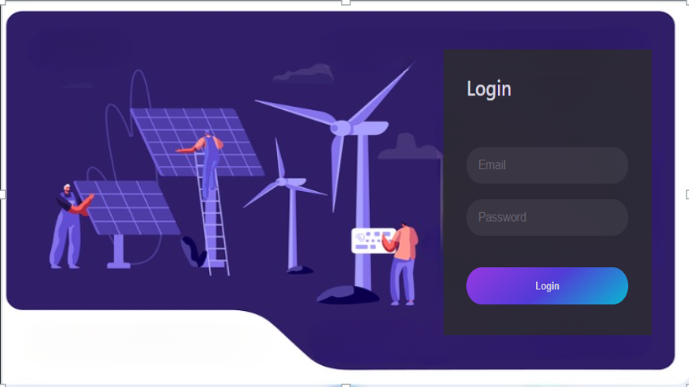

**3.1.5. Main Menu Interface**

* **Description**: Once logged in, users are presented with the main menu, offering navigation to key functions: Input Appliances Data, Give Feedback, View Schedule, and Update Appliances Data. An "Exit" button allows users to leave the system safely.
* **GUI Standards**: The menu follows a modular structure with clearly labeled buttons for each option, ensuring easy access to all primary features.
* **Screen Layout**: Each button is spaced for readability and ease of selection, with a backdrop reflecting the system's focus on energy management.
* **Standard Elements**: The interface features consistent button placement and labels across all screens, with each option leading to a distinct function.

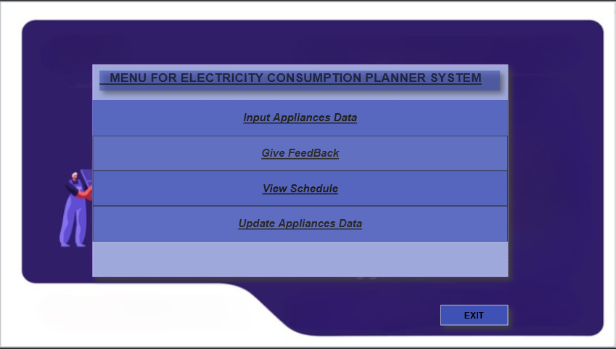

**3.1.6 Sign-Up Interface**

* **Description**: The sign-up interface allows new users to create an account in the system by entering essential information such as their name, email, password, and possibly a confirmation password for security. The form is designed to be straightforward, enabling quick registration.
* **GUI Standards**: The interface maintains consistency with the system’s overall design aesthetic, featuring clear field labels, distinct input areas, and a prominent “Sign Up” button. This screen follows standard user registration practices.
* **Screen Layout**: The layout includes input fields arranged vertically for easy form completion. Each field has a label to clarify its purpose, and the “Sign Up” button is centrally positioned at the bottom of the form.
* **Standard Elements**:
  + **Required Fields**: Fields such as email and password are required, and users will be prompted to complete these before submission.
  + **Validation and Error Messages**: If there are errors (e.g., missing required fields or weak password), clear error messages will display near the relevant fields, guiding users to correct input.
  + **Confirmation and Feedback**: After successful registration, users receive confirmation and are redirected to the login screen.

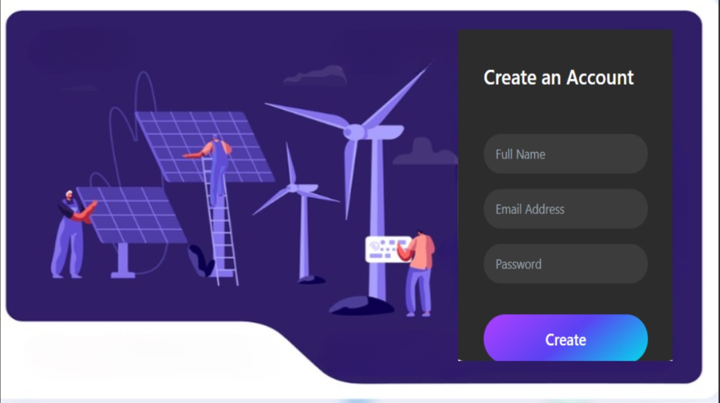

## 3.2 **Hardware Interfaces**

**3.2.1 Supported Device Types**

* **Computers**: Desktops and laptops running Windows and other Operating Systems.

**3.2.2 Logical Characteristics**

* **Input Devices**:
  + **Keyboard**: Standard keyboard input for user commands and data entry.
  + **Mouse**: Point-and-click interface for navigation and selection.
* **Output Devices**:
  + **Monitor**: Support for standard display resolutions (e.g., 1920x1080, 2560x1440) and refresh rates.

**3.2.3 Data and Control Interactions**

**Data Input**:

* Users will enter their electricity consumption data manually via the keyboard or mouse interactions.

**Data Output**:

* The application will generate visual reports and graphs displayed on the monitor.

**3.2.4 Communication Protocols**

**None**:

* The application does not require any communication protocols as it operates in a standalone mode without networking capabilities.

**3.2.5 Physical Characteristics**

* **Ports**:
  + **USB Ports**: For connecting external devices like printers or external storage if needed.
  + **HDMI/VGA**: Video output ports for external monitors.
* **Form Factor**:
  + Standard dimensions and mounting options for devices, ensuring compatibility with typical hardware enclosures.

## 3.3 Software Interfaces

The Electricity Consumption Planner System (ECPS) is designed to operate independently while integrating with specific software components and data sources to enhance its functionality. Below is an overview of its connections, data flow, and communication interfaces:

#### 3.3.1 File Handling System

* **3.3.1.1** The application will utilize file handling to store user data and electricity consumption records in text files (e.g., CSV or TXT).
* **3.3.1.2** Data items exchanged include user profiles, consumption logs, and generated reports, which will be read from and written to the specified files.
* **3.3.1.3** The application will implement file operations (open, read, write, and close) to ensure data integrity and accessibility.

#### 3.3.2 Reporting Module

* **3.3.2.1** Integration with a reporting functionality that generates consumption schedules based on the data stored in files.
* **3.3.2.2** The module will read relevant data from the files to create schedules, which can be displayed within the application.

#### 3.3.3 WinForms Interface

* **3.3.3.1** The application is developed using WinForms for the user interface, providing a graphical environment for user interaction.
* **3.3.3.2** WinForms will handle user inputs and display outputs in real-time, enhancing user experience through interactive elements like buttons, text boxes, and data grids.

## 3.4 Communications Interfaces

#### 3.4.1 User Interaction

* **3.4.1.1** Real-time interaction will occur between the user and the application, with no external communication required.
* **3.4.1.2** Input from users will be processed immediately, with feedback displayed on the screen.
* **3.4.1.3** User inputs and application responses will be logged locally within the file system.

#### 3.4.2 Data Backup (Optional)

* **3.4.2.1** File transfer will occur through standard file operations, ensuring data integrity during the process.
* **3.4.2.2** No network communication will be involved; all interactions will remain local to the user's computer.

# 4 System Features

**4.1 User Account Management**

**4.1.1** **Description and Priority**

**4.1.1.1.** **Description:** Enables users to create an account with a unique username, email, and password for managing preferences and schedules.

**4.1.1.2. Priority:** Medium

* **Benefit**: 6
* **Penalty**: 3
* **Cost**: 5
* **Risk**: 4

**4.1.2 Stimulus/Response Sequences**

**4.1.2.1.**

* **Stimulus:** User selects the "Create Account" option.
* **Response:** The system validates the input and confirms successful account creation with a notification message.

**4.1.3 Functional Requirements**

**4.1.3.1:** The system shall allow users to create an account by entering a username, email, and password.

**4.1.3.2:** The system shall display a confirmation message once the account is successfully created.

**4.1.3.3:** The system shall provide a secure login feature, requiring users to enter their username and password to access their accounts.

**4.1.3.4:** The system shall authenticate users based on their stored credentials and display an error message for failed login attempts.

| **ID & Name** | **US-01 Account Management** |
| --- | --- |
| **Created By** | Muhammad Umer **DateCreated:**22/10/24 |
| **Primary Actors** | Residential People, Small and Medium Enterprises **Secondary Actor:** N/A |
| **Description** | * Enables users to create an account with a unique username, email, and password for managing preferences and schedules. This feature allows users to securely log in to their accounts to access and manage their electricity consumption schedules and preferences. |
| **Trigger** | * User selects the "Create Account" option on the login page. |
| **Pre-Conditions** | * **Pre-1** Users must have access to the ECPS application. * **Pre-2** Users must have selected the Create Account option. * **Pre-3** Users must provide a unique username, valid email address, and secure password. |
| **Post-Conditions** | * **Post-1** User account is successfully created and stored in the system. * **Post-2** User is notified of successful account creation. |
| **Normal Flow** | 1. User selects the "Create Account" option. 2. System prompts the user to enter a username, email, and password. 3. User inputs the required information. 4. System validates the input for uniqueness (username) and correctness (email format). 5. If validation is successful, the system creates the account and stores the user information. 6. System displays a confirmation message indicating successful account creation. |
| **Alternative Flow** | * **Flow a.** If the username is already taken, the system will notify the user and prompt them to choose a different username. * **Flow b.** If the email format is invalid, the system will indicate the error and ask for a correct email format. * **Flow c.** If any of the information detail is missing , the system shall generate an error message and prompt the user to enter complete Information. |
| **Exceptions** | * If the system encounters an error during account creation, an error message will be displayed, and the user will be prompted to try again. |
| **Priority** | * Medium |
| **Frequency of Use** | * High, as new users may frequently create accounts to access the system. |
| **Business Rules** | * Each username must be unique within the system. * Passwords must meet security criteria (e.g., minimum length, inclusion of special characters). |
| **Other Information** | * User data will be stored securely in a file, ensuring privacy and data protection. |
| **Assumptions** | * Users have access to create accounts and manage their schedules. * Users are familiar with basic account creation procedures. |

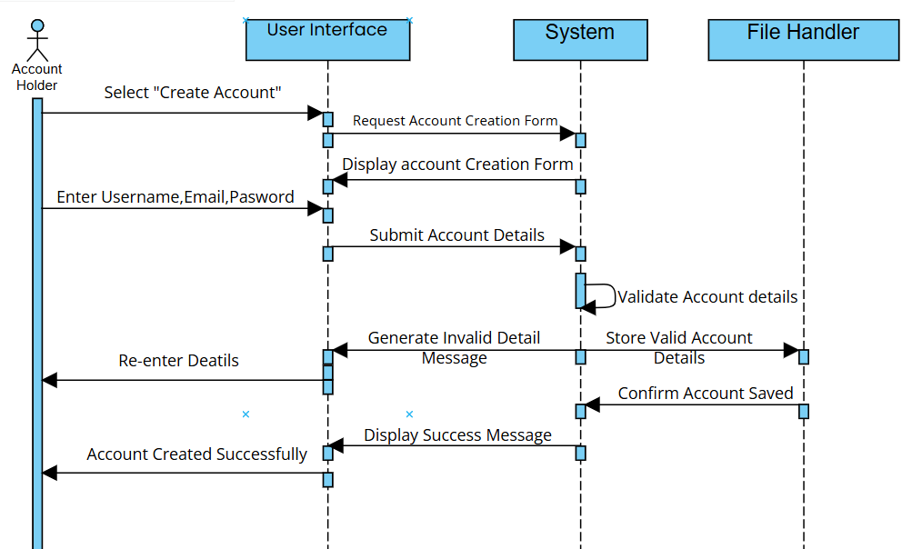

**4.2** **Appliance Data Entry**

#### 4.2.1 Description and Priority

**4.2.1.1. Description**: Allows users to enter information about household appliances, such as power consumption, preferred usage times,allows to select the type and size of appliances, adjusting power forecasts based on these parameters and other relevant details, monitors the power consumption of registered appliances and updates usage data in real-time.

**4.2.1.2. Priority**: High

* **Benefit**: 9
* **Penalty**: 2
* **Cost**: 4
* **Risk**: 3

#### 4.2.2 Stimulus/Response Sequences

**4.2.2.1.**

* **Stimulus**: The user selects "Add Appliance data" from the interface.
* **Response**: The system displays input fields for appliance details (name, power consumption, usage preference).

**4.2.2.2.**

* **Stimulus**: User selects appliance type and size from the input menu.
* **Response**: The system updates power consumption forecasts accordingly.
* **Stimulus**: The user clicks "Save."
* **Response**: Appliance details are saved, and confirmation is displayed.

**4.2.2.3.**

* **Stimulus**: The user registers an appliance.
* **Response**: The system provides power consumption updates every five seconds.
* **Stimulus**: The user clicks "Save."
* **Response**: Appliance details are saved, and confirmation is displayed.

#### 

#### 4.2.3 Functional Requirements

**4.2.3.1.**The system shall allow users to enter an appliance name, power factor, and preferred usage period for at least 10 appliances.

**4.2.3.2.**The system shall allow users to select appliance type (e.g., refrigerator, washing machine).

**4.2.3.3.**The system shall allow users to select appliance size (small, medium, large) and update power forecasts based on this selection.

**4.2.3.4.**The system shall monitor power consumption and provide updates every five seconds.

**4.2.3.5.** The system shall alert users when an appliance exceeds a set power consumption threshold, allowing them to take necessary actions to reduce usage.

**4.2.3.6.**The system shall log instances where power usage exceeds the user-defined threshold for future analysis and reporting.

**4.2.3.7.**The system shall display error messages for incorrect appliance data inputs.

**4.2.3.8.**The system shall provide guidance on correcting input errors.

| **ID & Name** | **US-02 Input Appliances Data** |
| --- | --- |
| **Created By** | Muhammad Umer **Date Created:**22/10/24 |
| **Primary Actors** | Residential People, Small and Medium Enterprises **Secondary Actor:** N/A |
| **Description** | * Allows users to enter information about household appliances, such as power consumption and preferred usage times. Users can select the type and size of appliances, adjust power forecasts, and monitor power consumption in real-time. |
| **Trigger** | * User selects "Add Appliance Data" from the interface. |
| **Pre-Conditions** | * **Pre-1** Users must be logged in to their account. * **Pre-2** Users must have access to appliance data input fields. * **Pre-3** Users must have selected the Input Appliances DAta option from the menu. |
| **Post-Conditions** | * **Post-1** Appliance details are successfully recorded in the system. |
| **Normal Flow** | 1. User selects "Add Appliance Data." 2. System displays input fields for appliance details (name, power consumption, usage preference). 3. User enters the appliance information and selects the appliance type and size. 4. System updates power consumption forecasts accordingly. 5. User clicks "Save." 6. System saves appliance details and displays a confirmation message. 7. System provides power consumption updates every five seconds. |
| **Alternative Flow** | * **Flow-1** If the user inputs invalid data (e.g., incorrect power consumption), the system displays an error message and prompts for correction. |
| **Exceptions** | * If the system encounters an error while saving data, an error message is displayed. |
| **Priority** | * High |
| **Frequency of Use** | * High, as users frequently add or update appliance information. |
| **Business Rules** | * The system must allow users to enter data for at least 10 appliances. * The system must alert users when an appliance exceeds a set power consumption threshold. |
| **Other Information** | * The system logs instances where power usage exceeds the user-defined threshold for analysis. |
| **Assumptions** | * Users are knowledgeable about their appliances and can provide accurate data. |

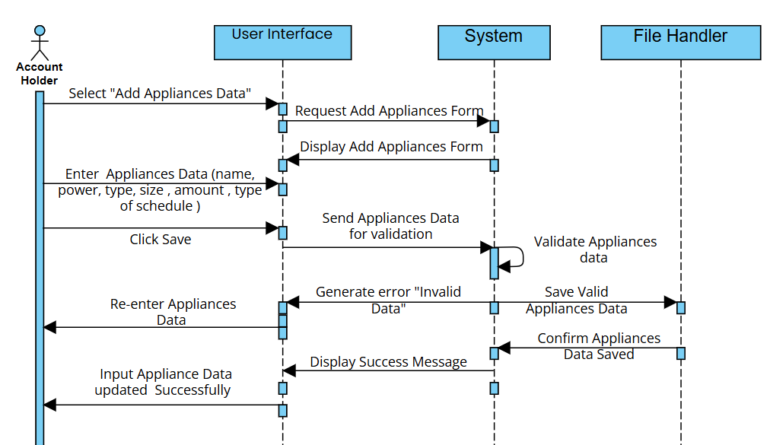

**4.3 Schedule Generation**

#### 4.3.1 Description and Priority

**4.3.1.1. Description:** ,System shall provide a 24-hour optimized appliance schedule based on electricity traffics, highlighting peak and off-peak times in schedule , minimizes electricity costs through optimal scheduling , optimizes appliance schedules to run during cost-effective time slots based on peak/off-peak tariffs , provides users with a reminder to review appliance schedules when they are updated.

**4.3.1.2. Priority**: High

* **Benefit**: 9
* **Penalty**: 2
* **Cost**: 3
* **Risk**: 2

#### 4.3.2 Stimulus/Response Sequences

**4.3.2.1.**

* **Stimulus**: User inputs appliance information and tariff details.
* **Response**: The system stores the input and access traffic data.
* **Stimulus**: User requests the 24-hour schedule.
* **Response**: The system displays the schedule upon user request based on traffic data and input appliances.

**4.3.2.2.**

* **Stimulus**: User enables cost-effective scheduling.
* **Response**: The system schedules appliances in cost-effective time slots and notifies users.

**4.3.2.3.**

* **Stimulus**: User requests peak and off-peak information in the schedule generation.
* **Response**: The system displays peak/off-peak hours and tariffs within the schedule.

**4.3.2.4.**

* **Stimulus**: System reads tariff data and initiates optimization.
* **Response**: The system optimizes appliance schedules to minimize costs, achieving a target reduction in electricity costs.

**4.3.2.5.**

* **Stimulus**: A schedule update occurs.
* **Response**: The system displays a reminder message for users to review the schedule.

#### 4.3.3 Functional Requirements

**4.3.3.1.**The system shall generate an appliance usage timetable within 10 seconds after data input.

**4.3.3.3.**The system shall identify and use cost-effective time slots for appliance operation based on tariff data.

**4.3.3.4.**The system shall display a 24-hour appliance schedule with peak and off-peak distinctions within 10 seconds.

**4.3.3.5.**The system shall calculate optimal appliance schedules to minimize electricity costs by up to 10% based on tariff data.

**4.15.3.1.**The system shall display a reminder for users to check appliance schedules daily upon updates.

| **ID & Name** | **US-03 Generation of schedule** |
| --- | --- |
| **Created By** | Zain Allaudin **Date Created:**22/10/24 |
| **Primary Actors** | Residential People, Small and Medium Enterprises **Secondary Actor:** N/A |
| **Description** | * The system provides a 24-hour optimized appliance schedule based on electricity traffic, highlighting peak and off-peak times, and minimizing electricity costs. |
| **Trigger** | * User inputs appliance information and requests the 24-hour schedule. |
| **Pre-Conditions** | * **Pre-1** User must have entered appliance data and tariff details. * **Pre-2** Users must have selected the Generate Schedule option from the menu. |
| **Post-Conditions** | * **Post-1** A 24-hour appliance schedule is generated and displayed to the user. * **Post-2** A remainder message is shown to the User about the Schedule. |
| **Normal Flow** | 1. User inputs appliance information and tariff details. 2. System stores the input and accesses traffic data. 3. User requests the 24-hour schedule. 4. System generates and displays the schedule based on traffic data and input appliances. 5. System notifies the user of cost-effective scheduling and displays peak/off-peak information. 6. System reminds the user about the Schedule. |
| **Alternative Flow** | * If the user requests the schedule without entering data, the system prompts for necessary input. |
| **Exceptions** | * If the optimization process fails, the system displays an error message. |
| **Priority** | * High |
| **Frequency of Use** | * High, especially during billing cycles. |
| **Business Rules** | * The system shall calculate optimal appliance schedules to minimize electricity costs by up to 10% based on tariff data. |
| **Other Information** | * The system displays reminders for users to check appliance schedules daily upon updates. |
| **Assumptions** | * Users understand how to input and interpret appliance and tariff data. |

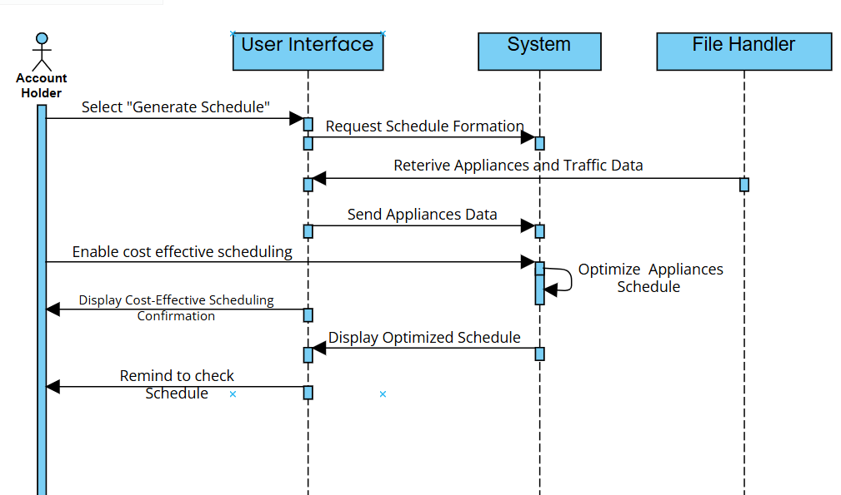

**4.4 Historical Schedule and Cost Data**

#### 4.4.1 Description and Priority

**4.4.1.1. Description:** Allows users to view appliance schedule history and electricity costs for the past six months which the system is storing in a file.

**4.4.1.2. Priority**: Medium

* **Benefit**: 5
* **Penalty**: 4
* **Cost**: 5
* **Risk**: 3

#### 4.4.2 Stimulus/Response Sequences

**4.4.2.1.**

* **Stimulus**: User requests historical data.
* **Response**: The system retrieves and displays historical data from a file using file handling.

**4.4.2.1.**

* **Stimulus**: System encounters a file write error for History storing.
* **Response**:The system displays an error message explaining the issue and suggests checking file permissions.

#### 4.4.3 Functional Requirements

**4.4.3.1.**The system shall maintain historical schedule and cost data for six months.

**4.4.3.1.**The system shall retrieve historical data within five seconds of a user request.

**4.4.3.1.**The system shall display an error message for file read or write issues.

**4.4.3.2.**The system shall suggest checking file permissions if file handling errors occur.

| **ID & Name** | **US-04 Scheduling of History** |
| --- | --- |
| **Created By** | Zain Allaudin **Date Created:**22/10/24 |
| **Primary Actors** | Residential People, Small and Medium Enterprises **Secondary Actor:** N/A |
| **Description** | * Allows users to view appliance schedule history and electricity costs for the past six months, with data stored in a file. |
| **Trigger** | * User requests historical data. |
| **Pre-Conditions** | * **Pre-1** Users must be logged in to their account. * **Pre-2** Users must select the “History Track” option form menu. |
| **Post-Conditions** | * **Post-1** Historical schedule and cost data is retrieved and displayed. |
| **Normal Flow** | 1. User requests historical data by clicking on the menu. 2. System retrieves and displays historical data from a file using file handling. 3. User views the historical schedule and associated costs. |
| **Alternative Flow** | * If the user requests data outside the six-month range, the system indicates that data is not available. |
| **Exceptions** | * If a file read/write error occurs, the system displays an error message and suggests checking file permissions. |
| **Priority** | * Medium |
| **Frequency of Use** | * Medium, as users may check historical data periodically. |
| **Business Rules** | * The system shall maintain historical schedule and cost data for six months. |
| **Other Information** | * The system logs historical data for future analysis. |
| **Assumptions** | * Users have a basic understanding of how to access and interpret historical data. * Users have a basic knowledge of how to compare the current result with previous history results. |

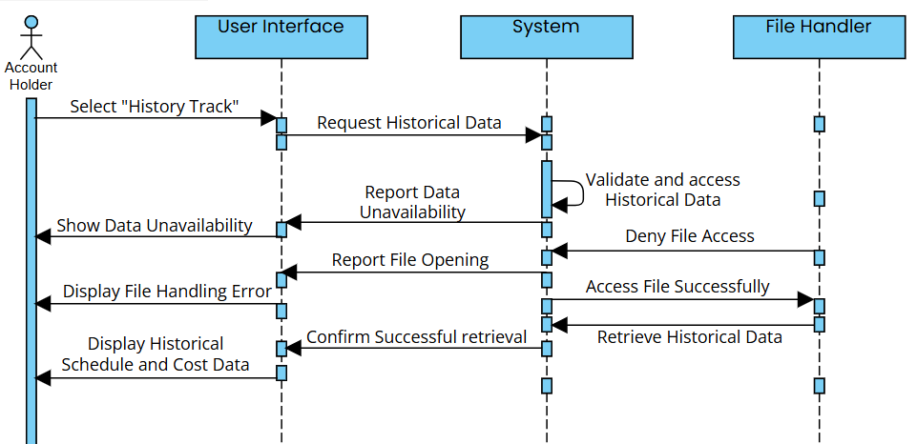

**4.5 Feedback Collection**

#### 4.5.1 Description and Priority

**4.5.1.1. Description:** Provides users with a feedback form to rate and comment on the generated schedules.

**4.5.1.2. Priority**: Medium

* **Benefit**: 5
* **Penalty**: 3
* **Cost**: 3
* **Risk**: 2

#### 4.5.2 Stimulus/Response Sequences

**4.5.2.1.**

* **Stimulus**: User accesses the feedback form.
* **Response**: The system displays options for rating and comment submission.

**4.5.2.2.**

* **Stimulus**: System encounters a file write error for Feedback writing.
* **Response**:The system displays an error message explaining the issue and suggests checking file permissions.

#### 4.15.3 Functional Requirements

**4.5.3.1.**The system shall allow users to rate generated schedules (e.g., 1-5 stars).

**4.5.3.2.**The system shall allow users to provide comments or suggestions.

**4.5.3.3.**The system shall display an error message for file read or write issues.

**4.5.3.4.**The system shall suggest checking file permissions if file handling errors occur.

| **ID & Name** | **US-05 Collection of Feedback** |
| --- | --- |
| **Created By** | Talha Farooq  **Date Created:**22/10/24 |
| **Primary Actors** | Residential Users , Small and Medium Enterprises **Secondary Actor:** N/A |
| **Description** | * Provides users with a feedback form to rate and comment on the generated appliance schedules, enabling continuous improvement based on user input. |
| **Trigger** | * User accesses the feedback form after reviewing the generated schedules. |
| **Pre-Conditions** | * **Pre-1** Users must be logged in to their account. * **Pre-2** Users must have generated schedules to provide feedback on. * **Pre-3** User must have selected the Feedback option form the Menu. |
| **Post-Conditions** | * **Post-1** User feedback is successfully recorded in the system. * **Post-2** The confirmation message is shown by the system to the user through the user interface about the successful storing of FeedBack. |
| **Normal Flow** | 1. User accesses the feedback form. 2. System displays options for rating the schedule (e.g., 1-5 stars) and a comment section for additional input. 3. User rates the schedule and provides comments or suggestions. 4. User clicks the "Submit" button. 5. System saves the feedback and displays a confirmation message. |
| **Alternative Flow** | * If the user tries to submit feedback without selecting a rating, the system prompts the user to provide a rating. |
| **Exceptions** | * If the system encounters a file write error while saving feedback, it displays an error message explaining the issue and suggests checking file permissions. |
| **Priority** | * Medium |
| **Frequency of Use** | * Medium, as users may provide feedback periodically after reviewing schedules. |
| **Business Rules** | * The system shall allow users to rate generated schedules using a star rating system (1-5 stars). * The system shall ensure that all feedback submissions are logged for future analysis. |
| **Other Information** | * Feedback data can be analyzed to improve scheduling algorithms and user experience. |
| **Assumptions** | * Users are willing to provide feedback based on their experiences with the generated schedules. |

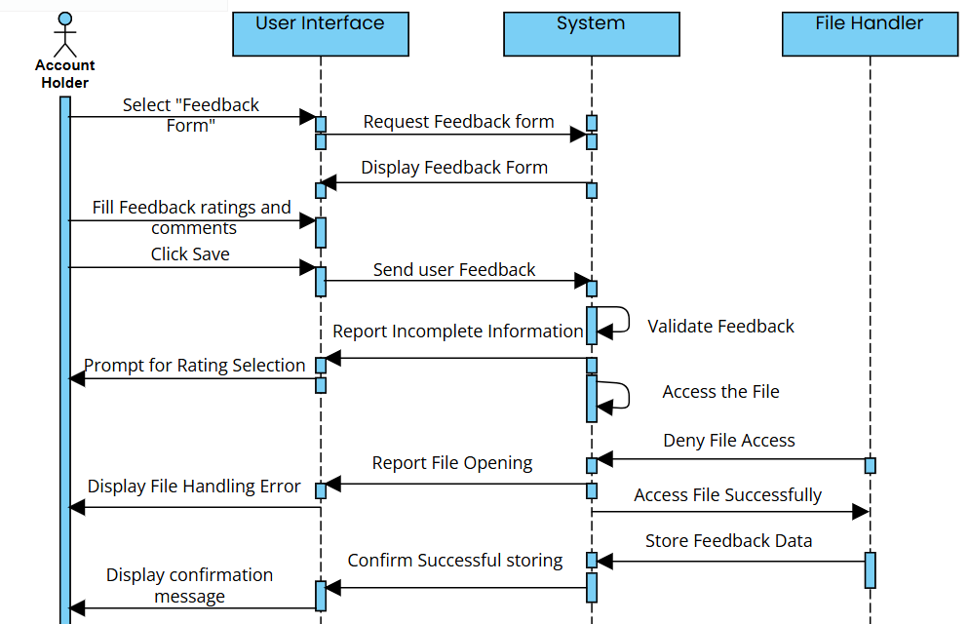

### 4.6 Tariff Data Integration

**4.6.1 Description and Priority**

**4.6.1.1. Description**: Allows users to update the traffic data , peak/off-peak tariffs, enabling accurate cost-effective scheduling based on current tariff rates, and also recovers from unexpected errors gracefully without system crashes.

**4.6.1.2.Priority**: High

* + **Benefit**: 9
  + **Penalty**: 2
  + **Cost**: 3
  + **Risk**: 2

**4.6.2 Stimulus/Response Sequences**

**4.6.2.1.**

* **Stimulus**: User inputs updated current traffic data , peak and off-peak tariff data
* **Response**: The system updates the tariff data and displays it within two seconds of data entry or request.

**4.6.2.2.**

* **Stimulus**: System encounters an unexpected error (e.g., missing file).
* **Response**: The system logs the error, displays a user-friendly message, and advises restarting if necessary.

**4.6.3 Functional Requirements**

**4.6.3.1**: The system shall allow users to input or update current traffic data , peak/off-peak tariff data, with changes reflected in the schedule generation process.

**4.6.3.2**: The system shall display updated peak/off-peak tariff data message two seconds.

**4.6.3.3**: The system shall notify the user upon successful update of tariff information.

**4.6.3.4.**The system shall implement exception handling to avoid crashes.

**4.6.3.5.**The system shall log error details and display an appropriate message for missing files or invalid formats.

| **ID & Name** | **US-06 Updating Traffic Data** |
| --- | --- |
| **Created By** | Talha Farooq **Date Created:**22/10/24 |
| **Primary Actors** | Small and Medium Enterprises **Secondary Actor:** N/A |
| **Description** | Allows users to update traffic data and peak/off-peak tariffs, enabling accurate cost-effective scheduling. |
| **Trigger** | User inputs updated current traffic data and peak/off-peak tariff data. |
| **Pre-Conditions** | * **Pre-1:**Users must be logged in and authorized to update tariff data. * **Pre-2:** Users have selected Update traffic Data form the menu. |
| **Post-Conditions** | * **Post-1:**The tariff data is successfully updated in the system. * **Post-2:** The confirmation message is shown by the system to the user after successful Updation of Traffic Data. |
| **Normal Flow** | 1. User inputs updated traffic data and peak/off-peak tariff data. 2. System updates the tariff data and reflects changes in the schedule generation process. 3. System displays updated tariff data within two seconds of data entry. |
| **Alternative Flow** | * If the user inputs invalid tariff data, the system displays an error message. |
| **Exceptions** | * If the system encounters an unexpected error, it logs the error and advises the user to restart if necessary. |
| **Priority** | * High |
| **Frequency of Use** | * Medium, as users update tariff information based on changing conditions. |
| **Business Rules** | * The system must implement exception handling to avoid crashes and ensure user data integrity. |
| **Other Information** | * The system logs error details for troubleshooting. |
| **Assumptions** | * Users are familiar with current tariff data and understand how to update it. |

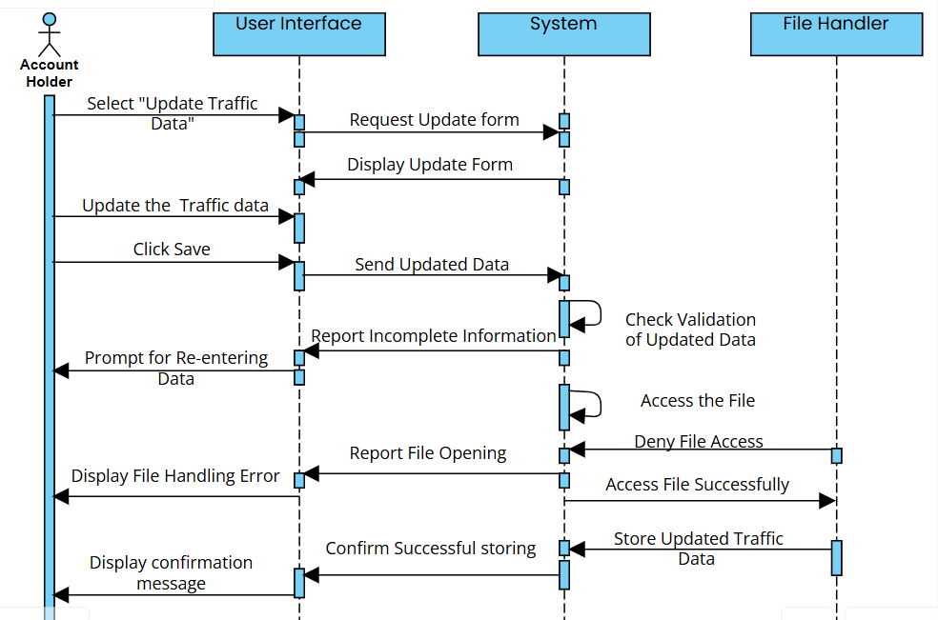

# 5 **Other Nonfunctional Requirements**

## 5.1 **Performance Requirements**

**5.1.1** The system shall provide appliance usage timetables, peak and off-peak times, and electricity prices pertinent to the situation within **2 seconds** following a user request to facilitate service speed.

**5.1.1.1** For nominal conditions having fewer than **5,000 users**, the system shall access appliance usage information **in less than 1 second**.

**5.1.1.2** Under heavy load (above 10,000 users), the system shall provide appliance usage information without taking more than **2 seconds**.

**5.1.2** The system shall perform optimization computations to give input on the optimal time slots in view of average household appliance input; the proposed duration shall not be more than **10 seconds**.

**5.1.2.1** In normal operating conditions, the optimization calculation time shall not exceed **5 seconds** for an average household configuration.

**5.1.2.2** In the case of high traffic, optimization computation should not exceed **10 seconds.**

**5.1.3** The system shall retrieve historical usage data for the last six months of a user's appliance data within **5 seconds** of a user's request.

**5.1.3.1** When the usage is normal and less than **5,000 users**, the time taken to retrieve historical usage shall not exceed **3 seconds**.

**5.1.3.2** The system shall recover historical usage data within **5 seconds** under high-traffic conditions.

**5.1.4** Where real-time power consumption is to be measured, the system shall refresh displayed data regarding power consumption every **5 seconds** subsequent to inputting the appliance.

**5.1.4.1** The system shall refresh power consumption data within **3 seconds** for normal conditions.

**5.1.4.2** For high-traffic conditions, the power consumption data shall refresh within **5 seconds** after an appliance enters.

These requirements hence ensure that data-intensive tasks are responded to within a least possible time and performed promptly.

## 5.2 **Safety Requirements**

**5.2.1** The system shall use data encryption methods in order to safeguard all information related to electricity usage, as well as information associated with appliances from unauthorized access.

**5.2.2** The system must have detailed error handling avoiding all forms of system crashes and unauthorized attempts at access of a system or corrupt data arising from the use and process of optimization.

**5.2.2.1** In case there is an illegal input of data, there must be an explanation from the system to the user about what is wrong and then this will lead to some corrective action.

**5.2.3** The system shall make a daily automatic copy of all appliance scheduling and usage data to prevent potential loss of data in case of an unforeseen system failure.

**5.2.3.1** Backups shall be kept in a secure, encrypted space for at least 30 days.

**5.2.3.2** Recovery shall be provided by the system, and users should be able to recover the data from the most current backup within 5 minutes.

**5.2.4** The system shall comply with the relevant safety requirements and codes applicable to the environment in which it is to be installed including, but not limited to, residential and commercial markets (for example, safety electrical code IEC 60364).

**5.2.4.1** As part of the compliance process, annually review the system for any regulatory requirements.

**5.2.5** The system shall automatically log out users after 30 minutes of inactivity to reduce load on the server and provide security to users.

**5.2.5.1** All data entered by the user shall be deleted during logout to prevent unauthorized use from the unused session.

These safety requirements ensure the user data, the integrity of a system, and compliance to regulatory standards for secure and reliable user experience.

## 5.3 **Security Requirements**

**5.3.1** The system shall ensure data security and privacy for all user information, protecting data against unauthorized access and ensuring compliance with relevant privacy standards.

**5.3.2** The system shall require user identity authentication for access to personal and usage data.

**5.3.2.1** Users shall authenticate using a username and password combination, with password requirements enforced (e.g., minimum length, special characters) to enhance security.

**5.3.3** The system must comprise of access control that enforces minimum roles-based user permissions in user access.

**5.3.3.1** Users can be authenticated to see the self-assigned usage and appliances but not any administrative while administrators will have access to all system configurations and capabilities relating to the management of accounts.

These security requirements protect user data, maintain system integrity, and ensure compliance with relevant privacy and security standards.

## 5.4 Software Quality Attributes

**5.4.1 Adaptability:**

The system shall adapt easily to updates in electricity tariff structures and more types of appliances without requiring important modifications on the core codebase.

**5.4.2 Availability:**

The system shall be available 99.9% of the time so that there is continuous access to the appliance scheduling and monitoring services without scheduled down-time of up to two hours in a month.

**5.4.3 Correctness:**

The system shall perform the appliance usage schedules and optimal electricity cost computation such that the error in computation of the latter does not exceed 0.5% tolerance.

**5.4.4 Flexibility:**

The system shall allow an easy addition of new features, such as extra optimization algorithms or reporting formats without significant rework.

**5.4.5 Maintainability:**

The system shall be maintainable with an average time of less than 2 hours per maintenance task, ensuring that regular updates and bug fixes can be deployed efficiently.

**5.4.6 Portability:**

The system shall be portable across devices, with minimal adjustments required to transfer and run the application on desktop or laptop systems.

**5.4.7 Reliability:**

The system shall deliver a 95% success rate for all scheduled tasks and optimizations, ensuring that users receive accurate, timely scheduling data.

**5.4.8 Reusability:**

Components for data processing and optimization shall be designed as reusable modules to facilitate potential integration with other energy management systems.

**5.4.9 Robustness:**

The system should gracefully handle input errors as well as unexpected conditions for stable operations even with bad or irregular data or hardware conditions.

**5.4.10 Testability:**

All components of the system should be testable independent of each other, 90% of the basic functionalities covered by automated test cases to ensure efficient quality assurance.

**5.4.11 Usability:**

The system shall focus usability and have user-friendly interfaces, clear labels, and tooltips for main functionalities. The usability score in user satisfaction surveys shall be above 80%.

## 5.5 **Business Rules**

**5.5.1** Only **authenticated users** shall get the data of appliance usage, features for optimizing the schedule and the historical electricity consumption reports.

**5.5.2** **Administration users** shall only have access to the administration features for managing users, system configuration features that may include changing tariff data and data backup.

**5.5.3 Standard users** shall only get to see and make changes to their own appliance schedules with no other user’s data.

**5.5.4** **Scheduling recommendations** will be made on peak and off-peak tariff information acquired from the utility service provider, thus ensuring the usage follows the guidelines based on tariff to ensure cost-effectiveness.

**5.5.5** **Data retention** policies must apply to all users with a minimum of six months storage of appliance usage for comparison and reporting purposes.

**5.5.6** Scheduling recommendations will have **user feedback** collected for the future use of improvement of the development and support team without interfering with real-time scheduling operations.

**5.5.7** **Regular data security audits and patterns** shall be made by approved personnel to meet the requirement of privacy policy and achieve better performance from the system.

The business rules determine how a system operates and at what access level, so privacy, efficiency, and following usage guidelines are enforced.

# 6. **Other Requirements**

Based on the thorough analysis of stakeholder needs and project objectives, all necessary requirements for the system have been identified and documented above. At this time, no further requirements are deemed necessary to achieve the project’s functional and non-functional goals, thus a separate other requirements section is not applicable.

# Appendix A: Glossary

All terminologies used within this document were simple and self-explanatory, thus a separate glossary section is not applicable.

# Appendix B: Analysis Models

**Entity Relationship Diagram**

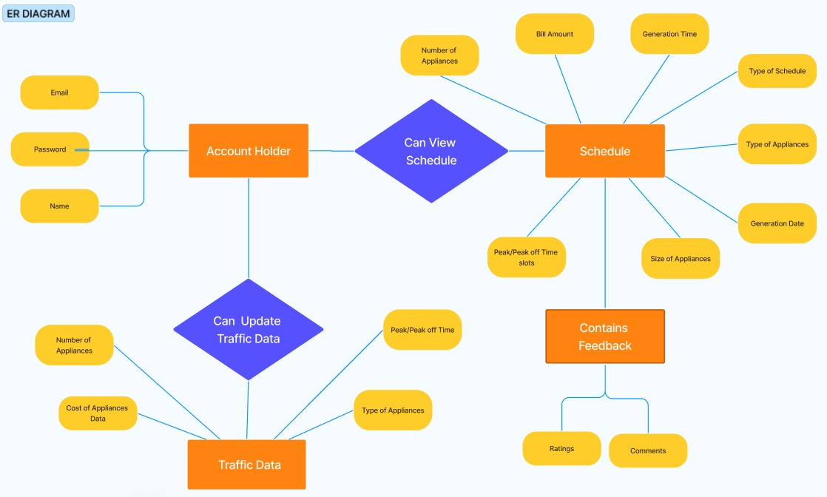

**Data Flow Diagram**

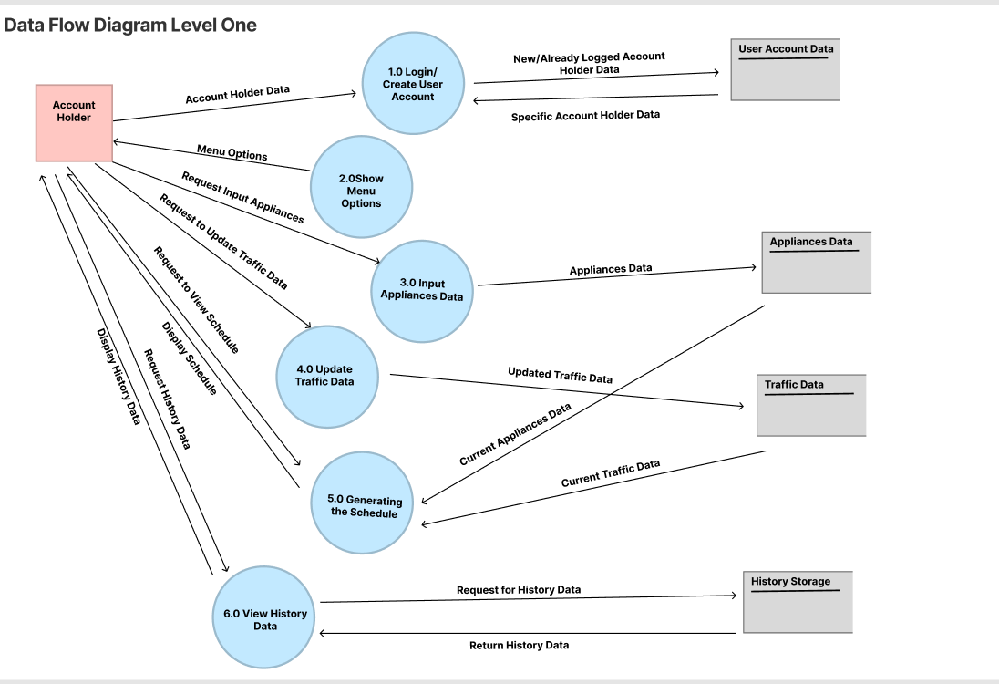

# Appendix C: To Be Determined List

There are currently no items that have been identified as to-be-determined. This section is not applicable and may be updated in future revisions of the document as needed.