Weekly Report （5.04-5.11）

MiaoDX(缪东旭)

2016218041

miaodx@tju.edu.cn

My project: A survey of ways to synthesize data (images) with Simulation Software.

1. Task Description
   1. Choose some simulation software for surveying
   2. Try some of the simulation software
2. Task Progress
   1. Choose some simulation software

By far, I still have not be given a field to research by my director, and since the project requirement said that:” The project must include a significant programming component of computer graphics techniques”, and my major (or my director’s research topic) is heavily on Computer Vision, this project

As I said last week, I think there are three main fields in simulation:

1) Physics Simulations, like Bullet, Havok, MuJoCo, ODE and PhysX, etc

2) Game Engines, like Unity3D, Unreal, cocos2d-x, godot and so on

3) Closed Games with API for developer, like GTA V

The potential difficulty is that the lacking of game development experience, especially in the second and third one. But the promising outcome is really appealing and maybe not so much experience in game development is needed at all.

What’s more, all of these three have successful prior work, the openai gym uses [MuJoCo i](https://github.com/openai/gym#mujoco)n their project, and there is [unrealcv](https://github.com/unrealcv/unrealcv) which aim to help computer vision researchers build virtual worlds using Unreal Engine 4, then there is one article [Using Virtual Worlds, Specifically GTA5, to Learn Distance to Stop Signs.](http://orfe.princeton.edu/~alaink/SmartDrivingCars/DeepLearning/GTAV_TRB_Final.pdf) So I am going to survey these three in the first round.

* 1. Try some of the simulation software.

The results are shown in part 3 – Have a glance at unrealcv.

1. Have a glance at unrealcv

I have made a post (blog) about it and can be found at [have_a_glance_at_unrealcv](https://miaodx.github.io/2017/05/11/blogs/synthesis/have_a_glance_at_unrealcv/)

The official documents are well organized and just follow them is enough and to conclude, I did these things:

* install unrealcv to computer
* use the command interactively in [RealisticRendering](http://unrealcv.org/reference/model_zoo.html#realistic_rendering) map
* use python code to fetch data

There are some images got from the last process, which are original, normal, object_mask, and depth image respectively, note that the depth image is in png format and can be lossy, the depth.exr will be much more precious but cannot be visualized without certain software.

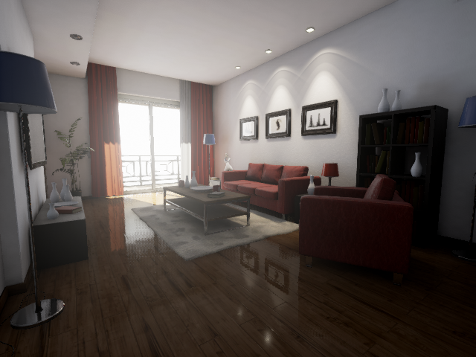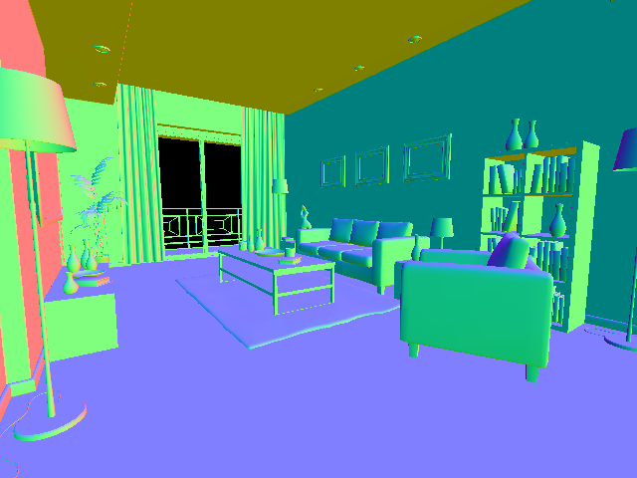

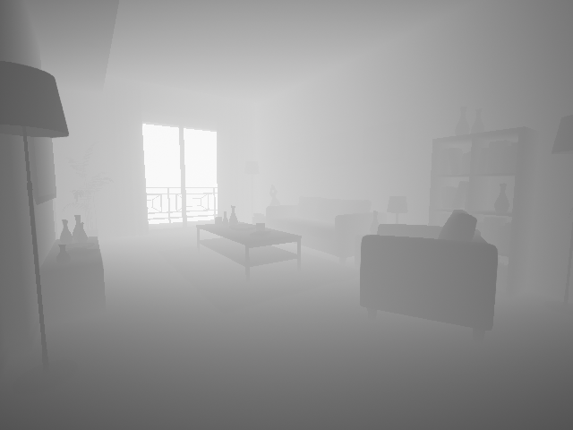

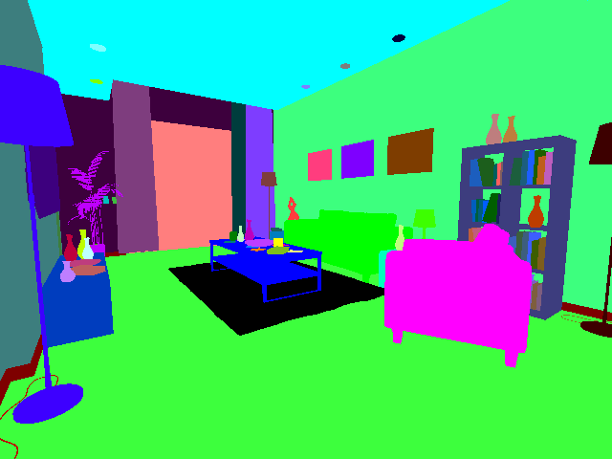

1. Working Plan for Next Week

And since time is enough for the other two, I will try the left two, i.e. MuJoCo and GTA V next week.

REFERENCES

Since most of my references are links on the internet, I just list the links instead of use the more official cite format.

1. Unreal Website, <http://unrealcv.org/>
2. Unreal github, <https://github.com/unrealcv/unrealcv>
3. Unreal Document, <http://docs.unrealcv.org/en/master/>