# 校招提前批面试 – 实习总结文档或其他项目成果

在地平线实习正好一月，此时进行提前批面试准备也是一个阶段总结。在这一个月内参与了对内项目开发，也进行了一小段时间的预研任务，目前是负责对外项目的一部分。算是各个工作方式均有所涉猎，虽并未有很可观的产出，但对整个工作氛围、工作内容有了初步的认识。客观地讲，相对于正式员工们有明确的任务时间节点，实习期间压力还是比较小的，由于通勤时间的存在，比起在实验室的工作强度也是相差不少。所以效率便显得十分重要，另外，身边诸位小伙伴对自己还是有很大的冲击的。不少同学是在此实习进行过渡，秋季开学便进行深造或赴外游学，另有默默无闻但是简历骇人的同学，几乎所有人都异常谦虚，当然稍有过度的互相吹捧还是不那么好的 -.-

下面介绍一下本月的工作，因为是与编程、项目或科研相关，便以英文书写，略去转译的麻烦。

## Refine Label Tool (1-3 weeks)

<http://gitlab.hobot.cc/dongxu.miao/refine_label_GT>

<http://gitlab.hobot.cc/dongxu.miao/labelme_RefineLabel>

In the first three weeks, we built one tool named **Refine Label Tool**. With the great success of Machine/Deep learning methods on perception tasks, the pursuit of data amount and quality is endless. However, with the manually labeled result as GT (ground truth), even with double/triple check, it will still has room for improvement.

This tool is used for refining existing GT labels with the help of trained models’ predict result.

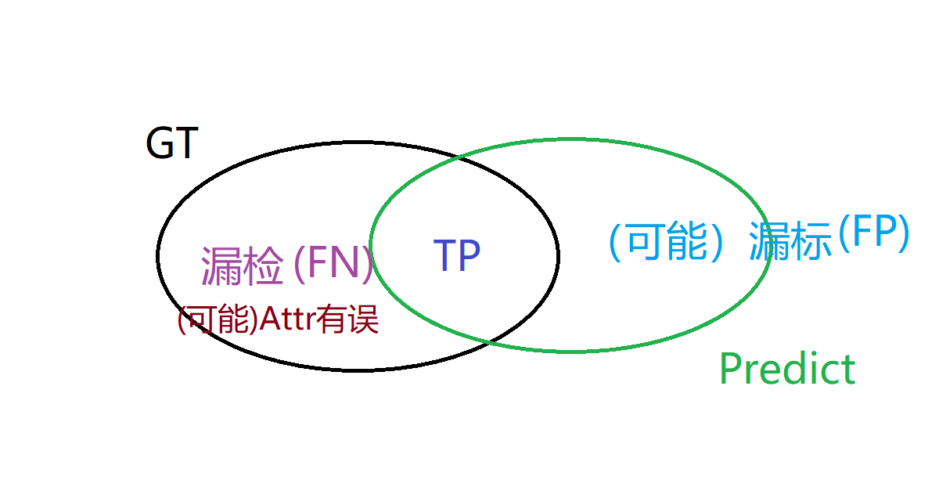

The relationship of GT and predict

* Input: Predict results, (merged) GT file, the path of image folders
* Pipeline:
  + Split GT file to standalone json file for each image (custom file)
  + Extend custom file with predict results, add bboxes from predict, specify the type of each bbox
  + Manually refining with the changed labelme software
  + Filter the bboxes (save GT and new added one) and formating
  + Save back
* Output: changed GT files

## Research work

### 3D point cloud semantic segmentation

* PointSIFT: A SIFT-like Network Module for 3D Point Cloud Semantic Segmentation
* Superpoint Graphs, Large-scale Point Cloud Semantic Segmentation with Superpoint Graphs

### Vanishing point based(/and) lane detection

* VPGNet: Vanishing Point Guided Network for Lane and Road Marking Detection and Recognition
* DeepVP: Deep Learning for Vanishing Point Detection on 1 Million Street View Images