The SPE Annual Technical Conference and Exhibition (ATCE) 2025
SPE-228061-MS

Exploring Modern Feature Extraction Techniques for Improved Offshore Fault Detection in Oil and Gas Operations
R. A. Wibawa¹, M. Wang¹, B. Jha¹

¹ Mork Family Department of Chemical Engineering and Materials Science, University of Southern California, Los Angeles, California, USA

Abstract
Fault detection in offshore oil and gas operations is vital due to the high risks and costs associated with unforeseen failures. This study benchmarks a variety of feature extraction techniques for this critical task, with a particular focus on RandOm Convolutional KErnel Transform (ROCKET), aiming to improve the detection and prevention of failures. ROCKET is evaluated alongside wavelet-based features, statistical features, and those derived from self-supervised learning (SSL) approaches, all using a consistent linear evaluation protocol. This standard method is commonly employed to assess the quality of features in representation learning. Experiments were conducted using a Stratified Group K-Fold (SGKF) cross-validation framework on a multiclass classification problem. Results show that ROCKET consistently outperformed all baseline models across multiple metrics, including macro F1 score, accuracy, balanced accuracy, and Matthews Correlation Coefficient (MCC). Notably, ROCKET achieved a balanced accuracy significantly higher than that of a recent transformer-based model while maintaining a comparable F1 score. These findings underscore the effectiveness of ROCKET’s training-free feature extraction and its ability to generate highly discriminative representations suitable for downstream classification. Moreover, the use of a simple linear classifier highlights the strength of the extracted features, suggesting further gains may be possible with non-linear classifiers. This study reaffirms the value of lightweight and scalable methods for fault detection in offshore oil and gas operation.
Introduction
In the oil and gas industry, ensuring reliable production from wells is a critical objective, as interruptions or inefficiencies can lead directly to substantial financial losses, operational risks, and environmental impacts. In this study, we define a fault as any deviation from the expected operational behavior of a well that leads to a reduction in performance, production capacity, or safety margin. Specifically, faults refer to abnormal events that manifest as anomalous trends in measured process variables, if not addressed, can escalate to partial or total production loss. This definition aligns with prior studies where faults are viewed as unpermitted deviations in process behavior (Russell et al., 2000) and as anomalous conditions deviating from normal operating states (Aldrich and Auret, 2013).
The significance of early and accurate detection of such faults cannot be overstated. Faults in oil wells, particularly offshore naturally flowing wells, often lead to production losses, elevated operational expenses, and, in extreme cases, catastrophic failures. For instance, hydrate blockages, scaling, or severe slugging can halt production for days or weeks, costing millions of dollars in deferred oil output. Similarly, spurious closures of safety valves or rapid productivity losses may require costly interventions or repairs with offshore rig. Even moderate events such as unstable flow or increased water cut can accumulate substantial operational inefficiencies and necessitate reactive maintenance activities, thereby undermining field economics.
This study is inspired by the publicly available 3W dataset (Vargas et al., 2019), which captures multivariate time series data from offshore naturally flowing wells under both normal and faulted conditions. The dataset provides a valuable representation of real-world operational scenarios where faults arise from a variety of sources, including abrupt increases in Basic Sediment and Water (BSW), spurious safety valve closures (DHSV), severe slugging, flow instabilities, rapid productivity loss, quick restrictions in production chokes (PCK), scaling, and hydrate formation. These faults, though infrequent, are highly critical. They typically originate under normal operating conditions and progress through a transient phase in which early symptoms of failure begin to appear, eventually leading to a faulty steady-state condition as shown by Fig 1. From an operational standpoint, detecting these early warning signs start from the transient phase is particularly valuable, as it creates an opportunity to implement proactive corrective actions. Timely intervention at this stage can help mitigate risks, prevent major system failures and bigger oil loss, and avoid potentially worst consequences.
Notably, the 3W dataset captures the real-world conditions of offshore operations, including noisy signals, sensor malfunctions, and the changing nature of faults over time and across different wells. It serves as a realistic benchmark for developing and validating machine learning models for fault classification. This study benchmarks various feature extraction techniques, most notably ROCKET, against wavelet-based features, statistical approach, and derived features of self-supervised learning (SSL) approaches for fault detection in offshore wells. A linear evaluation protocol is employed to assess the quality of the extracted features. This protocol, widely adopted in SSL research, involves training a simple linear classifier on top of fixed features to objectively evaluate the representational power of each method after pretext training.
Previous studies have framed the problem as a binary classification task, aiming to distinguish between normal and undesired events. One study experimented with the Synthetic Minority Over-sampling Technique (SMOTE) and reported that Random Forest (RF) yielded the best results (Aslam et al., 2022). Another binary classification effort applied an unsupervised Fuzzy C-Means algorithm to identify abnormal patterns (De Salvo Castro et al., 2021). A separate approach sought to improve one-class classification performance by leveraging features extracted from an LSTM-based memory autoencoder, followed by classification using a one-class SVM (Machado et al., 2022). Additionally, statistical features were used to predict normal and abnormal conditions, with experiments across various classifiers again highlighting RF as the top performer (Carvalho et al., 2021).
For studies that approached the task as a multiclass classification problem, one employed wavelet-based feature extraction combined with RF, achieving an overall accuracy of 94% (Marins et al., 2021). Another used automatic feature extraction via the TSFRESH library, followed by feature selection, and found that a decision tree achieved F1 score of 85% (Turan et al., 2021). An interesting approach involved feature extraction using a convolutional autoencoder, with RF again emerging as the best model, achieving an F1 score of 89.8% (Gatta et al., 2022). While these studies used earlier versions of the 3W dataset, a more recent effort applied a transformer-based model on the updated dataset version and used both general and specialized data strategies, showing promising results in a multiclass classification setting (Oliveira et al., 2025).
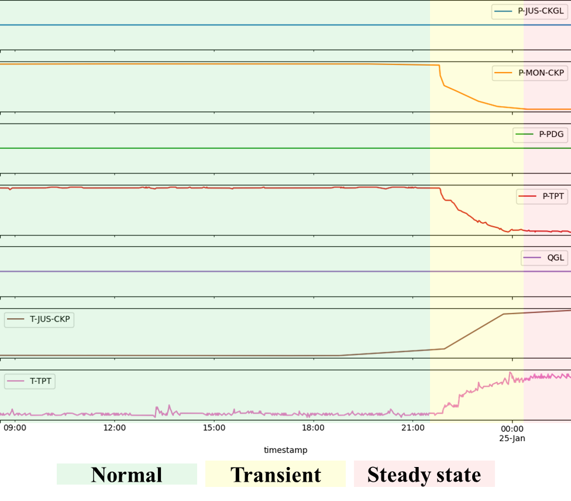
Fig. 1—Development of Failure Condition Based on Sharp Increase in Basic Sediment and Water (BSW)
Random Convolutional Kernel Transform (ROCKET)
Overview
ROCKET was introduced as a fast and scalable method for extracting features from time series data through the application of large numbers of random convolutional kernels (Dempster et al. 2020). It is designed specifically to achieve state-of-the-art performance on time series classification tasks, with minimal computational overhead compared to deep learning models.
Unlike traditional convolutional neural networks (CNNs), where kernel parameters are learned via backpropagation, ROCKET uses randomly generated kernels to transform the input time series into a feature space. This randomization, together with simple nonlinear feature mappings, enables the creation of rich and informative representations of temporal dynamics without the need for complex model tuning or optimization procedures.
Mathematical Formulation
Given a univariate time series $X$, ROCKET applies a set of $K$ random convolutional kernels ${\left\{\left.w_{k}\right\}\right.}_{k=1}^{K}$ to generate features. Each kernel is defined by random parameters:
- Kernel length $l$: The length is randomly chosen from the set {7, 9, 11} with equal likelihood, resulting in kernels that are typically much shorter than the input time series.
- Weights $w_{k}$ : The values are sampled from normal distribution $\left(0,1\right)$ and are mean centered after initialization.
- Bias $b_{k}$ : The values are drawn from uniform distribution $\left(-1,1\right)$. Since only positive values in the feature maps are kept, the bias helps two similar kernels highlight different parts of the input by shifting the feature map values up or down by a fixed amount.
- Dilation $d_{k}$ : Dilation is selected on an exponential scale using $d= \left\lfloor \left.2^{x}\right\rfloor \right.$ and $x$ is sampled from uniform distribution $\left\{\left.0,A\right\}\right.$, where $A=log\frac{l_{input}-1}{l_{kernel}-1}$. This ensures that the dilated kernel can span up to the full length of the input time series. Dilation enables similar kernels with different dilation rates to detect similar patterns occurring at different frequencies and scales.
- Padding $p_{k}$ : It is randomly decided whether to apply padding or not when each kernel is created. Without padding, the kernel cannot be centred at the very beginning or end of the time series, so it focuses more on the central part. With padding, the kernel can also detect patterns at the edges of the time series.
The transformation results from applying the above elements, which are calculated as follows:
$$X_{i}*w=\sum_{j=0}^{l_{kernel}-1}{X_{i+(j×d)}×w_{j}}$$
Instead of learning features through backpropagation, ROCKET extracts two specific statistics from each transformed time series $s_{k}$:
- Maximum Value: Like global max pooling
- Proportion of Positive Values (PPV): PPV measures how often a specific pattern appears in the input.
These two values are concatenated to produce the final feature vector. Fig 2. Illustrates the procedures used in ROCKET method followed by linear classifier.
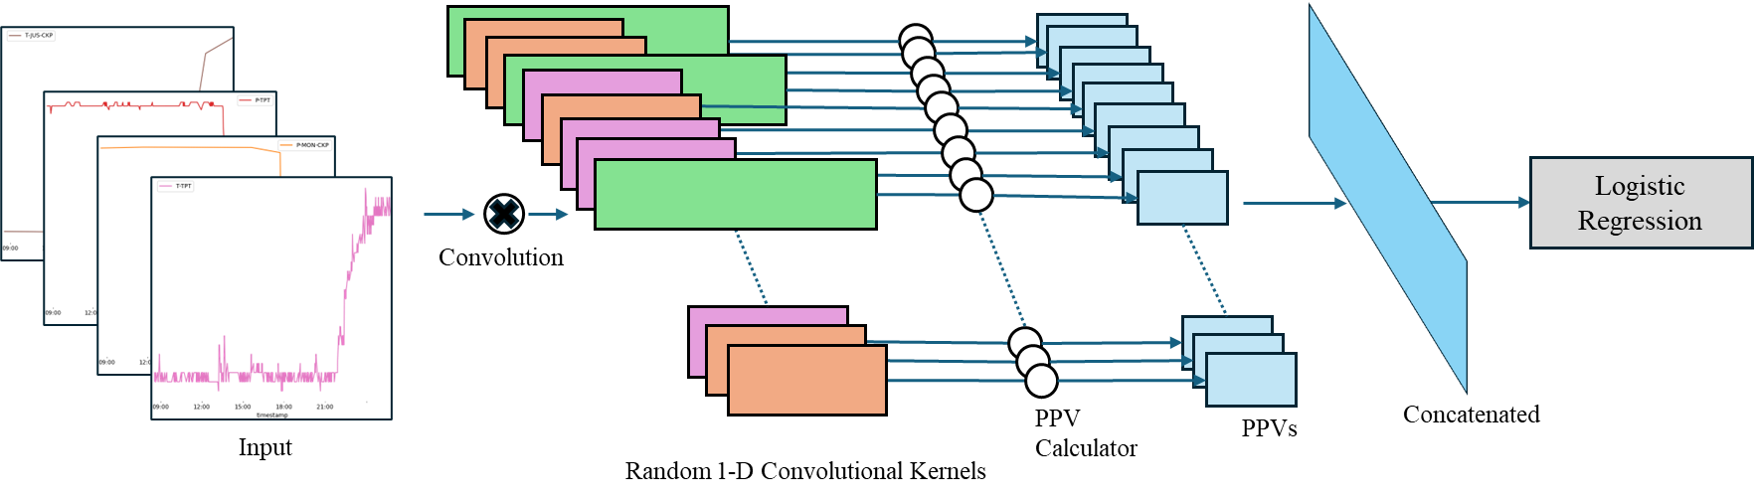
Fig. 2—ROCKET Architecture as Feature Extractor and Logistic Regression as Classifier Model
Intuition and Advantages
The random convolutions act as a diverse set of nonlinear transformations capturing local patterns, trends, and transitions within the time series at different temporal resolutions. The use of maximum and PPV provides a simple but powerful statistical summary of these transformed signals. Together, they form a highly discriminative representation suitable for classification task. The advantages of ROCKET include:
- Speed and Scalability: Linear time complexity relative to the number of kernels and time series length; suitable for large industrial datasets.
- No Model Training: No backpropagation or gradient computation required.
- Strong Performance: Achieves competitive or superior accuracy compared to traditional deep learning approaches on standard time series benchmarks.
- Robustness: Performs well even on noisy, unbalanced, or limited-label datasets, making it ideal for industrial monitoring tasks.
Application in Fault Detection
In this work, ROCKET is employed to extract features from multivariate time series data collected from offshore wells. The extracted features are used to detect various types of faults related to flow instability, hydrate formation, and equipment malfunctions. By transforming raw sensor signals into a discriminative feature space, ROCKET enables efficient and accurate fault classification even with simple linear classifiers, contributing to reduced downtime and improved operational safety. In the absence of labeled data, the extracted features are valuable for similarity-based tasks, such as querying whether the current operating condition resembles a known target condition.
Methodology
Data
The data used in this study is the public 3W Dataset version 2.0.0, released on July 25, 2024. This version includes updates such as: the addition of a new failure class (hydrate in service line), expanded instances for several existing classes, expert-based label corrections, and the removal of certain instances, particularly for Class 1 (Sudden Increase in BSW). Additionally, the variable T-JUS-CKGL (downstream temperature of the gas lift choke) was removed, and 20 new variables were added. The fault classification used in this study is summarized in the Table 1 below:

Table 1—Mapping of Class Labels
Regarding the parameters selected for analysis, 7 variables out of the 27 available were used, based on the availability and completeness of the data. The input parameters used in this study is shown in Table 2:

Table 2—Class Label Definitions
As regards to data preprocessing, the dataset was resampled to 60-second intervals to reduce memory consumption while preserving the original signals characteristic. Missing values were imputed using iterative imputation with linear regression. The data was normalized and reformatted by applying a sliding window of 60 time steps with a stride of 1, using the average value within each window to resample the data.
Feature Extraction Methods
Free-training methods
- Simple Statistics
For feature extraction, simple statistical and signal-based features were used. These include entropy to capture the randomness of the data, zero and mean crossing counts to reflect the signal fluctuation behavior, and a set of descriptive statistics such as percentiles (5th, 25th, 50th, 75th, 95th), mean, standard deviation, and variance. These features are widely used in time-series analysis to capture both the distributional and dynamic characteristics of the signals.
- Wavelet Transform
Wavelet-based feature extraction was conducted using the Haar wavelet. Each signal component was decomposed into multiple frequency bands through wavelet decomposition. For each set of wavelet coefficients, statistical and signal-based features, consistent with those used in the simple statistical method, were extracted. The resulting features from all components and frequency bands were concatenated to form the final feature vector for each sample.
- ROCKET
The method, previously explained in detail, was used to transform the multivariate time-series data into a discriminative feature space through random convolutional kernels and simple non-linear transformations. The extracted features were then used for classification following the same linear evaluation protocol as the other methods.
Training-based method
Feature extractors based on various backbone architectures were trained using SSL through a Missing Value Prediction (MVP) task. This approach was employed to extract meaningful representations from synthetic gas lift operation data in an offshore field (Wibawa et al., 2024).
Training and Evaluation
To ensure a fair comparison of feature extraction methods, a linear evaluation protocol was adopted using logistic regression as the classifier. Performance was assessed through 5-folds of SGKF, which maintains group consistency to avoid data leakage and provides reliable generalization estimates. For clarity and focus, only the most relevant metrics are reported below, as they collectively evaluate overall accuracy, sensitivity to class imbalance, and robustness:
- Accuracy: Overall correctness of predictions.
- Balanced Accuracy: Accounts for class imbalance via per-class recall.
- Macro F1 Score: Class-agnostic average of precision and recall.
- Matthews Correlation Coefficient (MCC): A robust correlation metric suitable for imbalanced multi-class problems.

The overall process is clearly illustrated in the workflow diagram below, which outlines each step taken in the data preparation, feature extraction, and evaluation stages. Fig. 3 provides a comprehensive and intuitive understanding of the methodology applied throughout this study:
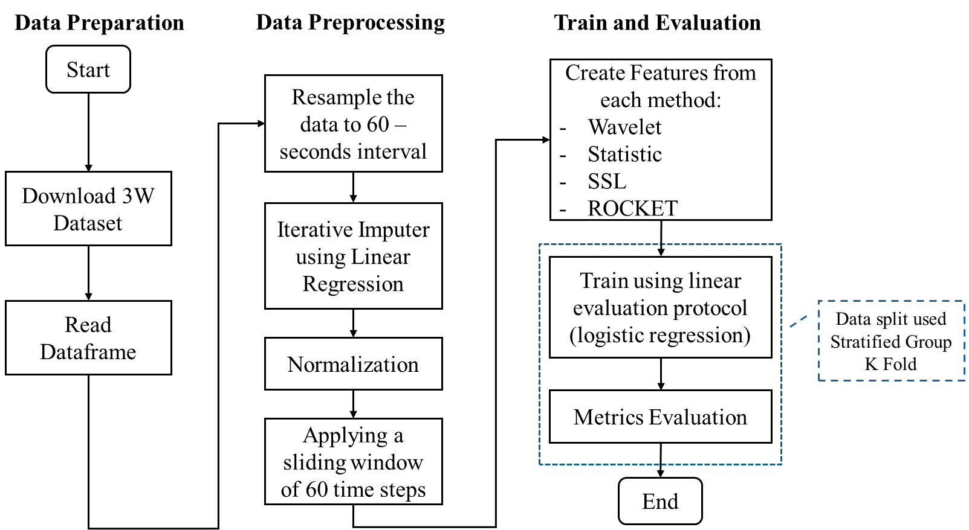
Fig. 3—Workflow for Assessing the Effectiveness of Feature Extractors
Result
The evaluation results in this study, as shown by Table 3, were obtained using logistic regression, with performance metrics averaged across all splits generated through Stratified Group K-Fold (SGKF) cross-validation. Overall, the ROCKET method consistently outperformed all baseline models across every metric considered, followed closely by the wavelet-based approach. Notably, ROCKET achieved the highest scores throughout the evaluation, despite being a training-free method. This is particularly significant when compared to more complex deep learning models trained using MVP task, which required substantial training and computational resources. Among the training-based models, TSSequencerPlus delivered the strongest results, though it still lagged behind the performance of simpler, training-free methods like ROCKET and wavelets.
Table 3—Experimental Results of Feature Extractor Evaluation
Furthermore, when benchmarked against a recent study that employed a transformer-based model trained using a general-purpose data approach and MinMax scaling, ROCKET showed a clear advantage in terms of balanced accuracy. The transformer model achieved an F1 score of 95.8% and a balanced accuracy of 76% (Oliveira et al., 2025). In comparison, ROCKET not only achieved a comparable F1 score but also outperformed the transformer model in balanced accuracy, highlighting its robustness across imbalanced classes. Notably, these results were obtained using only a linear classifier, emphasizing the high quality and structure of the features generated by ROCKET. This suggests that the representations learned by ROCKET are inherently meaningful for downstream classification tasks. These findings reinforce the value of efficient, training-free approaches like ROCKET in fault detection applications, offering competitive performance with significantly lower computational overhead compared to deep learning models.
Conclusion
This study shows that ROCKET, a training-free feature extraction method based on random convolutional kernels, is highly effective for fault detection in offshore oil and gas operations. It consistently outperformed wavelet-based, statistical, and self-supervised approaches across several key metrics evaluated using a simple linear classifier.
ROCKET even rivalled a recent transformer-based model, highlighting its ability to deliver strong performance with minimal computational cost. These results underscore ROCKET’s practicality for industrial deployment, offering a scalable and efficient solution for early fault detection in complex systems.
References
Russell, E. L., Chiang, L. H., & Braatz, R. D. 2000. Fault detection in industrial processes using canonical variate analysis and dynamic principal component analysis. Chemometrics and intelligent laboratory systems, 51(1), 81-93.
Aldrich, C., & Auret, L. 2013. Unsupervised process monitoring and fault diagnosis with machine learning methods (Vol. 16, No. 3, pp. 593-606). London: Springer.
Vargas, R. E. V., et al 2019. A realistic and public dataset with rare undesirable real events in oil wells. Journal of Petroleum Science and Engineering 181: 106223. https://doi.org/10.1016/j.petrol.2019.106223
Aslam, N., Khan, I. U., Alansari, A. et al. 2022. Anomaly Detection Using Explainable Random Forest for the Prediction of Undesirable Events in Oil Wells. Applied Computational Intelligence and Soft Computing 2022: 1–14. https://doi.org/10.1155/2022/1558381
De Salvo Castro, A. O., De Jesus Rocha Santos, M., Leta, F. R. et al. 2021. Unsupervised Methods to Classify Real Data from Offshore Wells. AJOR 11 (05): 227–241. https://doi.org/10.4236/ajor.2021.115014
Machado, A. P. F., Vargas, R. E. V., Ciarelli, P. M. et al. 2022. Improving Performance of One-Class Classifiers Applied to Anomaly Detection in Oil Wells. J Pet Sci Eng 218: 110983. https://doi.org/10.1016/j.petrol.2022.110983
Carvalho, B. G., Vaz Vargas, R. E., Salgado, R. M. et al. 2021. Flow Instability Detection in Offshore Oil Wells with Multivariate Time Series Machine Learning Classifiers. Paper presented at the 2021 IEEE 30th International Symposium on Industrial Electronics (ISIE), Kyoto, Japan, 20–23 June. https://doi.org/10.1109/ISIE45552.2021.9576310
Marins, M. A., Barros, B. D., Santos, I. H. et al. 2021. Fault Detection and Classification in Oil Wells and Production/Service Lines Using Random Forest. J Pet Sci Eng 197: 107879. https://doi.org/10.1016/j.petrol.2020.107879
Turan, E. M. and Jaschke, J. 2021. Classification of Undesirable Events in Oil Well Operation. Paper presented at the 2021 23rd International Conference on Process Control (PC), Strbske Pleso, Slovakia, 1–4 June. https://doi.org/10.1109/PC52310.2021.9447527
Gatta, F., Giampaolo, F., Chiaro, D. et al. 2022. Predictive Maintenance for Offshore Oil Wells by Means of Deep Learning Features Extraction. Expert Syst 41 (2). https://doi.org/10.1111/exsy.13128
Oliveira I. M. N., Junior, E. T. L. et al 2025. Deep Transformer Networks Applied to Anomaly Detection in Oil and Gas Wells. Paper presented at the Offshore Technology Conference, Houston, Texas, USA. 5 - 8 May 2025. https://doi.org/10.4043/35939-MS
Dempster, A., Petitjean, F. & Webb, G.I. 2020. ROCKET: exceptionally fast and accurate time series classification using random convolutional kernels. Data Min Knowl Disc 34, 1454–1495. https://doi.org/10.1007/s10618-020-00701-z
Wibawa, R. A., Rahman, F., & Arsyad, K. M. 2024. Utilization of Artificial Intelligence as Pattern Recognition and Optimization in Gas Lift Operation. AIP Conference Proceedings, 3076, 020001. https://doi.org/10.1063/5.0209077

