**MODULE 2**

RECTIFIERS AND POWER SUPPLIES:BLOCK DIAGRAM DESCRIPTION OF A DC POWER SUPPLY,WORKING OF A FULL WAVE BRIDGE RECTIFIER,CAPACITOR FILTER(NO ANALYSIS),WORKING OF SIMPLE ZENER VOLTAGE REGULATOR.

**BLOCK DIAGRAM OF DC POWER SUPPLY:-**

All electronic equipments include a circuit that converts ac supply into dc supply which is called dc power supply.The output of the dc power supply is used to provide a constant dc voltage.The block diagram of dc power supply is given below,

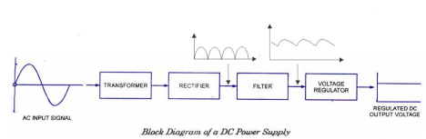The power supply consists of four elements a transformer, a rectifier, a filter and a regulator.

*Transformer*:-is used to step-up or step down the supply voltage.It can provide isolation from the supply line.It may also include internal shielding to prevent unwanted electrical noise signal on the power line from getting into the power supply.

*Rectifier:-* is a device which converts the sinusoidal ac voltage into either positive or negative pulsating dc.PN junction diode is used for the conversion of ac into dc. Rectifiers may be half wave or full wave type.The output voltage from the rectifier circuit has a pulsating character i.eit contains unwanted a.c component along with d.c component.

*Filter:-*is a device which passes d.c component to the load and blocks a.c component of the rectifier output.Filter is typically constructed from circuit elements such as resistor, capacitor and inductors.

*Voltage Regulator*:-Its main function is to maintain a constant d.c output voltage.It also rejects any a.c ripple voltage that is not removed by the filter. The voltage regulator is constructed using a zener diode or discrete transistors or Integrated Circuits(IC).The regulator may also include protective devices such as short circuit protection,current limiting, thermal shutdown or overvoltage protection.

**RECTIFIERS:-**

There are two types of rectifiers,

*Half wave rectifiers*:-converts alternating voltage into unidirectional pulsating voltage using one half cycles of the applied voltage.

*Full wave rectifiers*:- converts alternating voltage into unidirectional pulsating voltage using both half cycles of the applied voltage.There are two types of full wave rectifier circuits, center tap rectifier and bridge rectifier.

**BRIDGE RECTIFIER**

The working & operation of a full wave bridge rectifier is given below In the circuit diagram, 4 diodes are arranged in the form of a bridge or closed configuration. The transformer secondary is connected to two diametrically opposite points of the bridge at points A & C. The loadresistance RL is connected to bridge through points B and D.

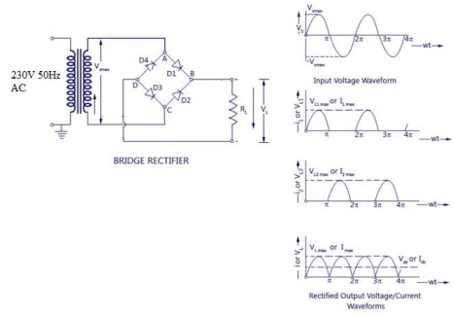Full Wave Bridge Rectifier – Circuit Diagram with Input and Output Wave Forms

**During the first half cycle(Positive Half Cycle)**

During the positive half cycle of the input voltage, the upper end of the transformer secondary winding is positive with respect to the lower end. Thus diodes D1 and D3 are forward biased and current flows through arm AB, enters the load resistance RL, and returns back flowing through

arm DC. During this input cycle, the diodes D2 and D4 are reverse biased and current is not allowed to flow in arms AD and BC. The flow of current is indicated by solid arrows in the figure below – the green arrows indicate the beginning of current flow from the source (transformer secondary) to the load resistance. The red arrows indicate the return path of current from load resistance to the source, thus completing the circuit.

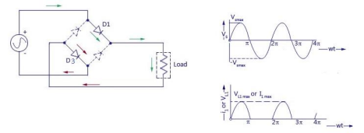Flow of current in Bridge Rectifier

**During the second half cycle(Negative half cycle)**

During the negative half cycle of the input voltage, the lower end of the transformer secondary winding is positive with respect to the upper end. Thus diodes D2 and D4 become forward biased and current flows through arm CB, enters the load resistance RL, and returns back to the source flowing through arm DA. The flow of current has been shown in the figure using red and green arrows. Thus the direction of flow of current through the load resistance RL remains the same during both half cycles of the input supply voltage.

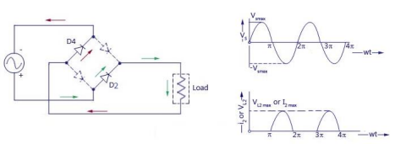Path of current in Negative Half Cycle

**Advantage**

Does not require center tap transformer.

Diodes of low PIV ratings can be used.

**Disadv.**

Needs four diodes.

**Full Wave Bridge Rectifier with Capacitor Filter**

The output voltage of the full wave rectifier is not constant, it is always pulsating. In order to achieve a smooth and constant voltage, a filter with a capacitor or an inductor is used. The circuit diagram below shows a bridge rectifier with capacitor filter.

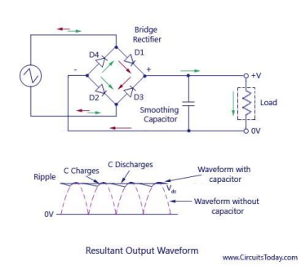 Full Wave Rectifier – with Capacitor Filter

**Working:-**

During the first cycle of input, the diode current reaches the filter and charges the capacitor. However, the charging of the capacitor happens only when the applied AC voltage is greater than

the capacitor voltage.

Initially, the capacitor is uncharged. That means no voltage exists between the plates of the capacitor. So when the voltage is turned on, the charging of the capacitor happens immediately.

During this conduction period, the capacitor charges to the maximum value of the input supply voltage. When the AC voltage starts decreasing and becomes less than the capacitor voltage, then the capacitor starts to discharge.

The discharging of the capacitor is very slow as compared to the charging of the capacitor. So the capacitor does not get enough time to discharge completely. When the supply voltage becomes greater than the capacitor voltage, the capacitor again starts charging So before the complete discharge of the capacitor happens, the charging again takes place. So only half or more than half of the capacitor charge get discharged.

The pulsating Direct Current (DC) produced by the full wave rectifier contains both AC and DC components.

The capacitor allows the AC components and blocks the DC components of the current. When the DC current that contains both DC components and AC components reaches the filter, the DC components experience a high resistance from the capacitor whereas the AC components experience a low resistance from the capacitor.

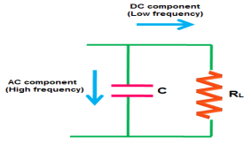

Electric current always prefers to flow through a low resistance path. So the AC components will flow through the capacitor whereas the DC components are blocked by the capacitor. Therefore, they find an alternate path and reach the output load resistor RL. The flow of AC components through the capacitor is nothing but the charging of a capacitor.

Thus, the filter converts the pulsating DC into pure DC.

**ZENER DIODES:-**

**Zener diodes** are special type of diodes which works in breakdown region, given that the current does not exceed a defined limit(IZK and IZM ). The flow of current in zener diodes is controlled by the minority charge carriers under the reverse bias condition, so they are referred to as break down diodes. The breakdown in zener diode is influenced by two effects, Zener and Avalanche breakdown.

These diodes are a unique kind of diodes with heavy doping concentration at the time of fabrication. Because of high temperature and current capability , Si is usually preferred for the manufacture of zener diodes.The breakdown voltage VZ and resistance Rz of zener diode is controlled by varying the doping.Increasing the impurity will decrease both breakdown voltage and resistance.Zener diodes are available with a reverse breakdown voltage (Vz) of 2.4 V to 200 V. The symbol of zener diode is shown below,

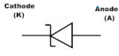

**Zener Diode V-I Characteristics Curve**

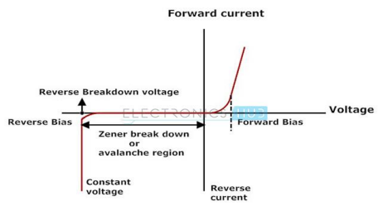

In the forward bias condition, the zener diode behaves like an ideal diode. In reverse bias condition, a constant leakage current flow through the diode till breakdown voltage Vz.Beyond this voltage the reverse current increases rapidly.The current corresponding to breakdown voltage is called breakdown current.This is the minimum current(IzK) required to sustain breakdown.When zener diode operate in this region the voltage Vz across it remains constant even though the current flowing through it is varied.

**Applications**

Voltage regulator

Fixed reference voltage source.

Over voltage protection circuit**.**

**Zener Diode as Voltage Regulator**

**Working Principle:-**

A voltage stabilizer is designed to ensure a constant output voltage Vo irrespective of change in the source voltage Vs and load current IL.The V-I characteristics of zener diode make it suitable for application such as a voltage regulator.The key in using the zener diode as voltage regulator is that ,when zener diode operate in breakdown region the breakdown voltage Vz across it

remains constant even though the current flowing through it is varied.The zener diode will continue in regulating the voltage when the zener diode current is between Iz K and Iz M.This constant voltage drop across the Zener diode produced by reverse breakdown is represented by a DC voltage .

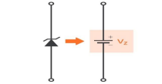

**Using Zener Diode as a Voltage Regulator**

The Zener diode voltage regulator is very economical as it is very inexpensive, simple and easy to build. Two parameters used to measure the performance of voltage regulator are line regulation and load regulation.

*Line regulation* is the ratio of change in output voltage to the change in source voltage. *Line regulation=ΔVo/ΔVs*

*Load regulation* is the ratio of change in output voltage to the change in load current. *Load regulation=ΔVo/ΔIL*

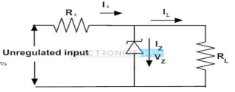

Fig. shows the basic circuit arrangement for a zener voltage regulator. The zener diode is selected according to the required output voltage.

Here zener diode with a breakdown voltage Vz is connected in reverse bias across the diode.The resistor Rs is necessary to limit the reverse current through the diode to a safer value.The voltage source Vs and Rs are so selected that the diode operates in the breakdown region. The output voltage across RL is Vz ,the zener breakdown voltage.

When Vs increases the current through the diode and RL increases.At the same time the zener diode resistance decreases and the current through the diode increases more than proportionately and the output voltage is regulated.As a result a greater voltage drop occur across Rs.

When the load resistance RL decreases for constant input voltage Vs, load current IL increases.this additional current is not supplied from the source but the demand for additional current is met by decrease in zener current Iz.This keeps the voltage drop across RS constant and so the output voltage.The diode current attain its maximum when load current IL is zero.Thus the value of Rs can be determined using the equation Rs=(Vs-Vout)/Izmax.

Drawbacks of a Zener Diode Voltage Regulator

Though Zener diodes are used as voltage regulators, they have a low efficiency for heavy load currents. It is because if the load current is large, there will be considerable power loss in the series limiting resistance (**Rs**). When the power dissipated on **Rs** exceeds its power rating, this will eventually damage the resistor. This is a common problem of a Zener diode voltage regulator.