PROJECT PROPOSAL
ClinicFlow AI
WhatsApp-Based Patient Appointment, Queue and Clinic Operations Automation
Prepared for | Sohail Anwar
Prepared by | Muhammad Ibrahim
Date | 27 August 2026

Proposal in one sentence: Build a clinic operations system that receives patient requests on WhatsApp, understands the request, books the correct doctor, manages live queues and waitlists, handles delays and cancellations, and sends unclear or safety-sensitive cases to clinic staff.

1. Problem
Many clinics manage appointments through phone calls, WhatsApp chats, notebooks and spreadsheets. Reception staff repeatedly ask the same questions, check doctor timings manually, resolve schedule conflicts and answer patients asking when their turn will come. When a doctor is late or cancels, the clinic must contact every affected patient by hand.
A simple booking chatbot does not solve this. The clinic needs one system for appointment intake, doctor availability, the live OPD queue, walk-ins, cancellations, waitlists, reminders and staff escalation.

2. Proposed Solution
ClinicFlow AI will act as the operational layer between patients, reception staff and doctors. Patients will use the clinic's existing WhatsApp number. The system will collect the required details in short messages, convert them into structured data, check the requested doctor's schedule and complete or route the request.
- Patients can book a specific doctor, reschedule, cancel, join a waitlist and check their own queue position.
- Reception staff can see all appointments, walk-ins, waiting patients, exceptions and manual-review cases.
- Doctors can receive a daily schedule and operational notifications through a dashboard or clinic-approved email channel.
- The system supports English, Urdu and Roman Urdu messages, while keeping medical decisions with trained staff.

3. Example: From WhatsApp Message to Appointment
Patient message: Assalamualaikum, mujhe kal Dr Usman ko dikhana hai. Skin ka masla hai. Koi evening appointment available hai?

- Identify the request. The AI extracts the intent as appointment booking, the requested doctor as Dr Usman, the preferred date as tomorrow and the preferred period as evening.
- Collect missing details. The automation asks for the patient's name, phone number and a short reason for the visit. Existing patients can be matched through their verified phone number.
- Validate the request. The system checks that Dr Usman exists, works at the selected branch and is accepting appointments on that date.
- Check availability. The scheduling engine reads the doctor's real schedule and returns only valid slots. It does not allow the AI to invent a time.
- Reserve and confirm. If 5:30 PM is available, the system temporarily reserves it and asks the patient to confirm. On confirmation, the appointment is stored in the database.
- Notify the clinic. The appointment appears on the receptionist dashboard. The doctor can receive the updated schedule or a short clinic-approved notification.
- Manage arrival and queue. Before the visit, the patient confirms attendance. After check-in, the live queue assigns a position and recalculates the estimated consultation time.
Patient-facing queue update: You are checked in. There are 3 patients before you. Your estimated consultation time is 6:25 PM. This estimate may change if an emergency or longer consultation occurs.

For privacy, a patient sees only their own position and estimated time. The full queue and waitlist are visible only to authorized clinic staff.

4. Waitlist and Capacity Recovery
If the requested doctor is fully booked, the patient can choose another valid slot, another doctor of the same specialty, or join the waitlist. If a confirmed patient cancels, ClinicFlow checks the waitlist and offers the released slot to an eligible patient. The first valid acceptance receives the appointment; the database prevents two patients from taking the same slot.

5. System Architecture
AI is used only to understand natural-language messages and produce structured fields. Scheduling, permissions, availability and booking rules remain deterministic and database-controlled.
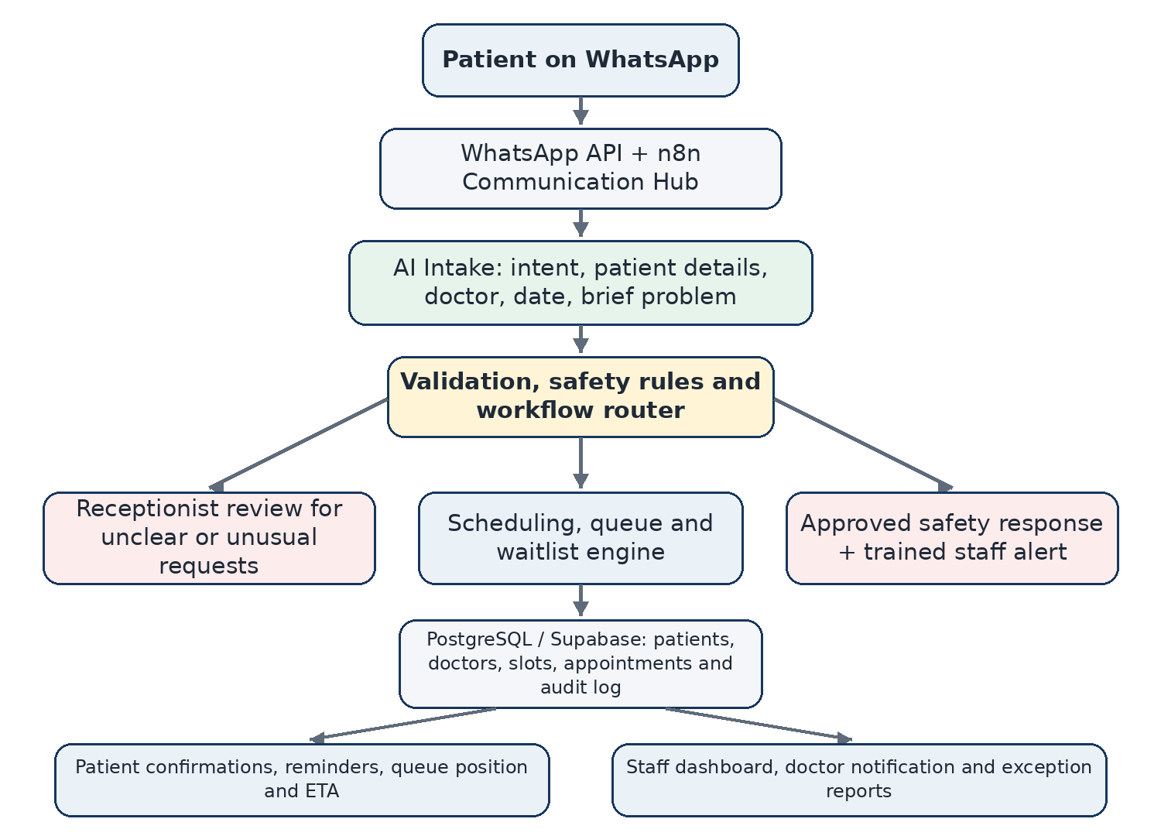
Figure 1. Proposed ClinicFlow AI architecture
Layer | Responsibility
Communication | Receive and send WhatsApp messages; use email/SMS only as approved fallback channels.
AI intake | Detect intent and extract patient name, phone, doctor, date, language and brief reason for visit.
Validation and safety | Validate structured output, detect missing data and stop normal booking for approved safety triggers.
Scheduling engine | Read doctor availability, reserve slots, prevent double booking, support walk-ins, delays and cancellations.
Queue and waitlist | Track check-ins, estimate waiting time, fill cancelled slots and notify affected patients.
Database | Store patients, doctors, schedules, appointments, queue events, messages, escalations and audit records.
Staff interface | Show the daily schedule, live queue, waiting list, unresolved requests and manual controls.

6. Main Data Stored
- Patients and verified contact details
- Doctors, specialties, branches, working hours and absences
- Appointment slots, bookings, status changes and no-shows
- Live queue entries, walk-ins, waitlists and estimated times
- Patient messages, staff escalations, notifications and audit logs

7. Human-in-the-Loop and Safety Boundary
ClinicFlow is an operational system, not a diagnostic system. It will not diagnose disease, prescribe medicine, interpret laboratory results or decide treatment. A trained person remains responsible for medical decisions and unusual administrative cases.
Situation | System response
AI confidence is low | Ask a short clarification question; if still unclear, create a receptionist review task.
Doctor name cannot be matched | Show verified clinic doctors or route to reception. Never invent a doctor.
Schedule conflict or manual override | Pause the action and request receptionist confirmation.
Potential emergency wording | Stop normal booking, send a clinic-approved safety message and alert trained staff.
Doctor cancels a full clinic | Freeze affected slots, prepare alternatives and let staff supervise mass rescheduling.
Patient disputes a no-show or booking | Preserve the audit trail and send the case to staff.

8. Real Failure Scenarios
Failure | Required handling
Two patients select the same slot | Use a database transaction and unique constraint so only one booking succeeds.
Doctor is one hour late | Recalculate queue estimates, notify affected patients and allow them to keep or reschedule.
Patient cancels | Release the slot and offer it through the waitlist workflow.
Patient does not confirm attendance | Send one follow-up, apply the clinic's grace period and mark no-show only by policy.
WhatsApp or LLM API fails | Retry safely, log the failure and create a staff task instead of losing the request.
Workflow runs twice | Use an idempotency key so one message cannot create duplicate appointments.
Invalid AI output | Reject it through schema validation, retry once and then route to a human.
Database is unavailable | Queue the request, show a temporary message and resume without duplicate booking.

9. Privacy and Access
- Collect only information required for appointment operations.
- Use role-based access for receptionist, doctor and administrator views.
- Do not expose other patients' names or reasons for visiting in queue updates.
- Keep an audit record of bookings, changes, staff overrides and automated decisions.

10. Proposed MVP
The first working version will demonstrate one complete clinic flow rather than many disconnected features.
- Patient intake. WhatsApp conversation in English or Roman Urdu collects and validates booking details.
- Doctor-specific booking. The patient selects a doctor, receives available slots and confirms one slot.
- Database and staff view. Appointments, schedules and status changes are stored and shown to clinic staff.
- Reminder and attendance. The system sends confirmation and reminder messages and records confirm, cancel or late responses.
- Live queue. Staff check in appointments and walk-ins; patients receive their own position and estimated time.
- Waitlist recovery. A cancelled slot is offered to a waiting patient without double booking.
- Exception handling. The demo includes doctor delay, doctor cancellation, low-confidence AI and safety escalation.

11. Suggested Technology
Component | Proposed choice
Workflow orchestration | n8n Cloud
Patient channel | WhatsApp Business Cloud API or an approved test provider
Database | PostgreSQL through Supabase
AI | LLM API for multilingual intent detection and structured extraction
Staff interface | Simple web dashboard or Supabase-backed operational view
Notifications | WhatsApp first; clinic-approved email/SMS fallback where needed

12. Expected Value and Project Difference
The project is more than an appointment chatbot. Its main value is the integration of natural-language WhatsApp intake with a reliable scheduling engine, live OPD queue, waitlist, local-language support, human supervision, failure recovery and a complete audit trail.
For the academic project, success will be measured through booking completion rate, zero double bookings, response time, recovered cancelled slots, queue-estimate accuracy, manual-escalation rate and successful execution of the planned failure scenarios.
Approval requested: Permission to proceed with ClinicFlow AI as the proposed project, beginning with requirements, database design and the complete MVP workflow defined above.

