ANIMALIAN MANOR
Project Bible & Development Guide
A creature-collecting card battle game
with a wholesome Victorian naturalist aesthetic
─────────────────────────────────────────
Version 1.0 — Concept & Planning Phase
Built with vibecoding by two young developers

Table of Contents
1. Game Concept & Story
2. The Manor — Room Guide
3. Creature Types & Naming
4. Card Design & Stats
5. Battle System
6. Economy (Coins & Gems)
7. Art Direction & Visual Style
8. Technical Architecture
9. V1 Scope & Build Order
10. Prompt Templates for Vibecoding
11. Research Notes (What We Learned from Other Apps)
12. Open Questions & Future Ideas

1. Game Concept & Story

The Pitch
You inherited the manor of your Uncle, ‘Uncle Argon’, a world-famous zoologist who discovered how to create and train mysterious creatures. Explore the rooms of his estate — brew new creatures in his Lab, display them in the Menagerie Garden, battle challengers in the Arena, play games in the Vault to earn coins, and trade with visiting villagers in the Parlor. His study is full of journals with secrets still waiting to be discovered.

Core Themes
- Wholesome exploration — not scary, not dark, not violent
- Victorian naturalist / zoologist aesthetic (think Newt Scamander, Gravity Falls journals)
- Discovery and creativity — the player MAKES their own creatures
- The uncle is a lovable eccentric, not a mad scientist
- Old-timey inventor style: gears, brass, leather journals, handwritten notes, wooden furniture, glass jars, candlelight

Player Experience Loop
- Create creatures in the Lab (draw/upload art, set stats, name them)
- Admire them in the Menagerie Garden
- Earn coins/gems in the Vault minigames
- Battle challengers in the Arena
- Buy/trade in the Parlor
- Discover uncle's secrets in the Study

Game Name
Name: Animalian Manor
Status: Confirmed original — no existing game, app, or trademark uses this name.
Domain: animalianmanor.com (Own the domain, want to work on site)

2. The Manor — Room Guide
The manor is the main navigation hub. The player sees a top-down illustrated floor plan and taps rooms to enter them. Each room is a different screen/feature of the app. See illustration created for this.

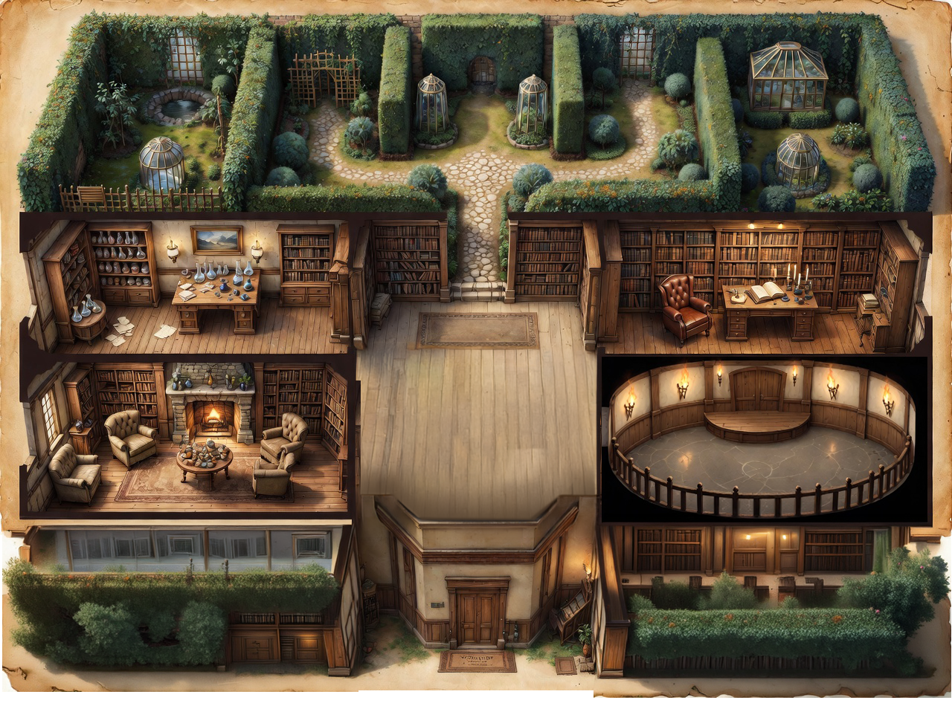

The Menagerie Garden
Location: Across the entire top of the manor
What it is: A menagerie is a private collection of exotic animals — like a personal mini-zoo. This one is an enclosed secret garden with tall hedgerows, hidden stone pathways winding between overgrown bushes, ivy-covered trellises, round ponds partially obscured by foliage, and glass terrariums tucked among thick hedges. It feels mysterious and overgrown, like it hasn't been touched in years.
What you do: Browse your creature collection. Tap a creature to see its full card. Sort by type or power level.
Think of it like: A huge overgrown greenhouse garden with glass terrariums and hidden paths, where your creatures live among the plants and ponds.

The Lab
Location: Left side, below the garden
What it is: Uncle's creature workshop. A wooden workbench with bubbling beakers, specimen jars on shelves, and scattered papers.
What you do: Create new creatures. Draw or upload monster art, pick its type, name it, set its stats (HP, Attack, Defense, Speed), and give it special moves. This is where the AI "Pokefy" feature lives — draw a sketch and the AI transforms it into polished creature art.
Think of it like: A mad scientist's workshop but wholesome — more like a nature lab with magnifying glasses and field sketches.

The Study
Location: Right side, below the garden
What it is: A room packed floor-to-ceiling with bookshelves, a big leather chair, a desk covered in open journals with handwritten notes and sketches. Ink bottles, a candle, a magnifying glass.
What you do: Read uncle's research journals to learn backstory, discover creature lore, and unlock tips. This is also where the tutorial lives — uncle "teaches" you through his old notes.
SECRET: One of the bookcases hides a secret passage to the Hidden Vault! The player discovers this through gameplay, it is NOT shown on the map.
Think of it like: Belle's library in Beauty and the Beast, but messier and full of creature sketches.

The Hidden Vault
Location: Behind a hidden bookcase in the Study (not visible on the map)
What it is: A locked room with a heavy brass door, treasure chests, puzzle boxes, and coin stacks.
What you do: Play minigames to earn coins and gems. The card-matching game lives here — flip cards to find pairs and earn currency.
Think of it like: A pirate treasure room but fancier, with puzzle boxes and a card-flipping game set up on a wooden table.

The Parlor
Location: Bottom left, with the manor's front door
What it is: A cozy sitting room with a stone fireplace, velvet chairs, and a round trading table. This is where the front entrance is — visitors come in through here.
What you do: NPC villagers knock on the door and come to buy, sell, and trade. Spend coins on booster packs (random creature cards), special items, or rare ingredients. Different visitors offer different deals.
Think of it like: A market stall inside a nice living room. Traveling merchants lay out their goods on the fancy table.

The Arena
Location: Bottom right
What it is: A big round room with a wooden fighting stage, torches on the walls, and a brass scoreboard.
What you do: Pick one of your creatures and fight against the computer. Turn-based combat: your creature and the enemy take turns attacking. Damage depends on stats and type advantages. Win to earn coins. Each player can go through 5 of their cards in the course of the game. Last player standing wins.
Think of it like: An underground arena with a wooden stage and torch lighting. The stats on the card go down as they take damage, card also shows cracks and rips in distress as it loses or heals as it gets better (with potions or gems to restore during battle)

3. Creature Types & Naming
The game uses a re-themed type system that fits the Victorian naturalist world. Types sound like entries in uncle's field journal.

Type | Color | Ink Color (hex) | Strong Against | Weak Against
Ember | Red / Orange | #8B2500 | Thorn | Tide
Tide | Blue | #1B4F72 | Ember | Storm
Thorn | Green | #1E5631 | Tide | Ember
Storm | Yellow / Gold | #7D5A00 | Tide | Thorn
Phantom | Purple | #4A1942 | All (1.25x) | All (0.75x)
Iron | Gray / Black | #1A1A1A | None (neutral) | None (neutral)

Type Advantage Circle
Ember beats Thorn, Thorn beats Tide, Tide beats Ember, Storm beats Tide. Phantom has a slight advantage against all types but also takes slightly more damage from all types. Iron is neutral — no advantages or disadvantages.

Naming Convention
Creature names should sound like entries in a Victorian naturalist's field journal. Combine a type-themed prefix with a descriptive suffix.

Type | Prefixes | Example Names
Ember | Flam, Emb, Pyr, Char, Scor, Cind | Flameclaw, Emberfang, Pyrotail
Tide | Aqua, Tid, Rip, Wav, Mar, Mist | Marshglider, Tidescale, Aquafin
Thorn | Fern, Thorn, Leaf, Bud, Root, Vine | Thornmaw, Vinelash, Rootfury
Storm | Volt, Zap, Spark, Bolt, Surge | Voltspark, Boltdash, Surgehorn
Phantom | Shad, Nox, Wraith, Dusk, Void | Noxwisp, Duskfang, Voidpulse
Iron | Ferr, Tin, Bolt, Clad, Forge | Ironclad, Forgehide, Ferroscale

4. Card Design & Stats

Card Layout (Top to Bottom)
- Header bar (dark wood color) — Creature name (serif font, left) + HP (right)
- Art window (parchment background) — The creature illustration, largest zone on the card (~40%)
- Type badge — Small pill-shaped badge with type icon and name (e.g. Tide, Ember)
- Two attack slots — Each shows: attack name (serif font) + damage number
- Stats bar (bottom) — ATK, DEF, SPD in small text

Card Visual Style
- Parchment/cream background (#FFF8E7)
- Dark wood header bar (#5C3A1E)
- Border color matches the creature's type ink color
- Serif font (Georgia) for creature names and attack names
- Sans font for stats, labels, UI elements
- Field journal aesthetic — looks like a page from uncle's notebook

Basic ideas for cards
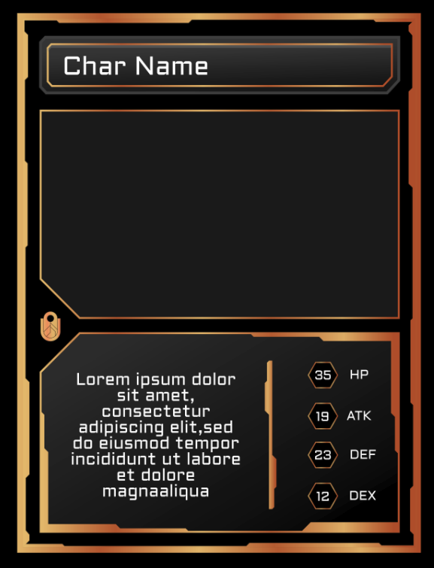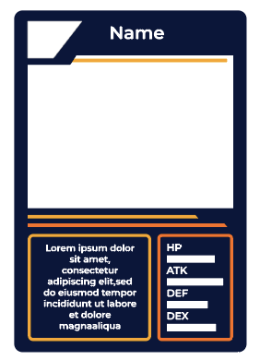

Stat Ranges
Stat | What It Does | Range
HP (Health) | How much damage it can take before fainting | 50 – 200
Attack | How hard it hits | 10 – 100
Defense | How much damage it blocks | 10 – 100
Speed | Who goes first in battle | 10 – 100

5. Battle System

Battle Rules
Turn order: The creature with higher Speed goes first. If tied, random.
Damage formula: Damage = Attacker's Attack – Defender's Defense (minimum 5 damage so nobody does 0).
Type advantage: If the attacker's type is strong against the defender's type, damage is multiplied by 1.5x. If weak, multiplied by 0.75x.
Win condition: Battle ends when one creature reaches 0 HP.
Rewards: Winner earns coins. Amount based on difficulty of opponent.

Battle Flow
- Player selects a creature from their collection (up to 5 max)
- Computer opponent is revealed with their creature
- Compare Speed to determine who attacks first
- Player picks which attack to use (each creature has 2)
- Damage is calculated and HP bars update
- Turns alternate until one creature faints
- Winner screen shows rewards earned

6. Economy (Coins & Gems)

Currency Types
Coins: The common currency. Earned from battles and minigames. Used to buy booster packs and basic items in the Parlor.
Gems: The rare/premium currency. Earned from the matching minigame in the Vault and special achievements. Used for rare items, special booster packs, or cosmetic upgrades.

- Main money denomination is Rubies
- Emeralds are bonuses that can be applied to change your stats

How You Earn
- Win a battle in the Arena → earn coins
- Complete a card match in the Vault minigame → earn gems
- Discover secrets in the Study → earn bonus gems
- Trade with NPC villagers in the Parlor (sell creature cards you don't want)

How You Spend
- Booster packs (random creature cards) — costs coins
- Special ingredients for the Lab — costs coins
- Rare booster packs — costs gems
- Cosmetic items (card borders, arena themes) — costs gems

7. Art Direction & Visual Style

The Vibe
Victorian naturalist / zoologist uncle's estate. Wholesome, warm, handcrafted. NOT scary, NOT futuristic, NOT neon. Think: Newt Scamander's suitcase meets Gravity Falls journals meets the movie Up's explorer equipment.

Color Palette
Name | Hex | Use | Where
Dark Oak | #2C1810 | Darkest tone | Text, heavy borders
Walnut | #5C3A1E | Primary wood | Card headers, walls, UI bars
Brass | #8B6914 | Metallic accent | Buttons, frames, hinges
Aged Gold | #C49A3C | Warm highlight | Badges, accents, coins
Leather | #D4A574 | Medium warm | Backgrounds, straps
Parchment | #E8C9A0 | Paper tone | Card backgrounds, notes
Cream | #FFF8E7 | Lightest tone | Card bodies, highlights
Linen | #F5F0E1 | Soft background | Page backgrounds

Typography
Display / headings: Georgia or similar serif — for room names, creature names, card titles
Uncle's notes / lore: Georgia italic — for journal entries, flavor text
UI / stats / buttons: Sans-serif — for HP numbers, stat labels, navigation

Visual Vocabulary for AI Prompts
USE these words: warm, aged, handwritten, botanical, field notes, brass hardware, ink sketches, candlelit, specimen jars, leather-bound, wax seal, explorer's journal, parchment, wooden shelves, naturalist, Victorian, overgrown garden
AVOID these words: neon, futuristic, chrome, digital, pixel, glitch, cyber, hologram, laser, metallic, sci-fi, high-tech, minimalist, flat UI, corporate

8. Technical Architecture

Platform
Type: Web app (React?) deployed to Netlify
Why not native Android: Web app runs on any device via browser, no Play Store needed, easy to deploy via Netlify drag-and-drop, can be installed as PWA for native app feel – Still open to doing android app
Domain: animalianmanor.com (is registered)
Hosting: Netlify (free tier)

Creature Art Pipeline
Method: Draw → Pokefy with AI
Flow: Kid draws creature on in-app canvas → sketch sent to Replicate API (SDXL img2img) → AI transforms sketch into polished creature art → art appears on card
Cost: ~$0.02-0.04 per image via Replicate. Budget cap of ~15 generations per kid built into app.
Key setting: Denoise/prompt_strength at 0.55-0.65 to preserve kid's sketch composition while polishing art style
Style prompt template: "cute [type] monster creature, [type-specific details], pokemon style, clean digital art, white background, chibi proportions, game character design"
Fallback: Kids can upload hand-drawn images directly if AI is unavailable

Data Storage
For v1, all data stored in browser localStorage (creature collection, currency, progress). No backend server needed.

9. V1 Scope & Build Order

What's IN for V1
- Manor map home screen (top-down illustration with tappable rooms)
- The Lab (creature creator with drawing canvas + stat setting)
- The Menagerie Garden (browse your collection)
- The Arena (battle vs computer, turn-based)
- Basic coin display (earned from battles)

What's OUT until V2+
- The Parlor (NPC trading) — V2
- The Hidden Vault (minigames) — V2
- The Study (uncle's notes / lore) — V2
- Gems currency — V2
- Booster packs — V2
- AI Pokefy integration — V1.5 (can be added once core works)

Build Order (do NOT skip ahead)
- Manor map screen — the home base. Illustrated background + tappable room hotspots.
- Single creature card component — hardcode one creature. Get the visual design right.
- Card type themes — border/style changes based on creature type.
- The Lab — creator form (name, type, stats, image upload) + live card preview.
- Save to collection + Menagerie Garden browse screen.
- Battle screen — two cards facing off with HP bars.
- Damage formula + type advantages + winner screen.
- Coin rewards from battles.
- Polish, test, deploy to Netlify.

10. Prompt Templates for Vibecoding
These are starting prompts the kids can customize and paste into Claude or another AI assistant.

Manor Map Screen
"Build a React component for the home screen of a game called Animalian Manor. It shows a top-down illustrated manor floor plan as a background image. Overlay invisible tappable hotspot zones for 6 rooms: Menagerie Garden (top), Lab (mid-left), Study (mid-right), Vault (hidden, behind Study), Parlor (bottom-left), Arena (bottom-right). When you tap a room, it navigates to that room's screen. Use warm parchment colors (#FFF8E7 background, #5C3A1E for wood accents, #C49A3C for brass highlights). Victorian naturalist style. The Vault hotspot should not be visible until the player discovers it."

Creature Card Component
"Build a creature card component (250px wide, 350px tall, rounded corners). Parchment background (#FFF8E7). Dark wood header bar (#5C3A1E) with creature name in Georgia serif (left) and HP number (right) in gold. Large art window with cream background below. Type badge as a small pill with type icon. Two attack slots showing attack name (Georgia serif) and damage number, with a left border accent in the type's ink color. Bottom stats bar showing ATK, DEF, SPD. Card border color matches creature type: Ember=#8B2500, Tide=#1B4F72, Thorn=#1E5631, Storm=#7D5A00, Phantom=#4A1942, Iron=#1A1A1A."

Image Generation (for Grok Imagine)
"Top-down bird's eye view floor plan of a Victorian manor house in the style of a hand-drawn naturalist field journal. Warm parchment background with dark wood walls. Layout: across the entire top is a walled secret garden enclosed by tall dense hedgerows, with hidden stone pathways winding between overgrown bushes, ivy-covered trellises, round ponds partially obscured by foliage, and glass terrariums tucked among thick hedges. The garden feels mysterious and overgrown like it has been untouched for years. Below the garden on the left is a workshop room with a wooden workbench, glass beakers, specimen jars on shelves, and scattered papers. On the right is a library room with floor-to-ceiling bookshelves on every wall, a leather reading chair, a desk with open books, ink bottles, and a candle. Bottom left is a cozy sitting room with a stone fireplace, two armchairs, and a small round table with goods displayed on it. There is a front entrance door with a welcome mat on the bottom wall of this sitting room leading outside. Bottom right is a large circular arena room with a raised wooden platform in the center, torches mounted on the walls, and stone flooring. A hallway with a worn rug connects all the rooms. Color palette of aged cream, warm brown, dark oak, deep green, and antique brass gold. Illustrated like a vintage board game map. Flat top-down view, no 3D perspective, no text, no labels, no words, no letters."

11. Research Notes

What We Learned from Other Apps

Good Examples
Card Maker for PKM (GW Studio): Surprisingly user-friendly. Tap-to-edit interface. Supports EX, GX, V, Vmax templates. Good live preview.
Mini Monsters Card Collector: Nice blend of card collecting + minigames to earn packs. Master duel tournaments.
Card Monsters: Fast 3-minute matches with 16-card deck (8 monsters, 8 items). Good simple battle system to learn from.
Nexomon Extinction: Best Pokemon-like alternative. Has enough unique flavor to stand apart legally.
Neo Monsters: 4v4 battle system with cooldown mechanic — heavy hitters are slow, fast monsters act more often.

What NOT to Do
- Forced ads with no removal option (Monsters Card Collector Game got destroyed in reviews for this)
- Buggy UX — can't delete elements, crashes, images don't resize (Card Maker for PKM complaints)
- Using real Pokemon IP (names, sprites, official art) — legal risk, apps get removed
- Overcomplicated battle systems — kids lose interest fast
- Too many types for v1 — start with 4-6, not 18
- No save/export — every good app lets you save your creations

12. Open Questions & Future Ideas

Still To Decide
- Uncle's name — gives the whole manor personality ("Uncle Aldric's Manor"?)
- How does the Hidden Vault get discovered? What triggers the bookcase reveal?
- What NPC villagers visit the Parlor? Do they have names and personalities?
- What specific minigames are in the Vault besides card matching?
- Do creatures evolve or level up? Or are stats fixed at creation?
- Is there a storyline/quest system or is it purely open sandbox?
- Shared collection between kids (co-op) or separate collections (competitive)?

V2+ Feature Ideas
- AI Pokefy integration (draw → AI-polished creature art via Replicate)
- Creature evolution (combine two creatures to make a stronger one)
- PvP battles (two players on different devices)
- Seasonal events and limited-time NPC visitors
- Manor customization (decorate rooms, unlock new wings)
- Achievement system tied to uncle's journal entries
- Sound effects and background music per room
- Export/share cards as images for social media
─────────────────────────────────────────

End of Project Bible v1.0
Good luck building, team!

