Data Import Task

Please import the data from the Assets worksheet in AssetImport_2023_03_30.xlsx into the Assets database

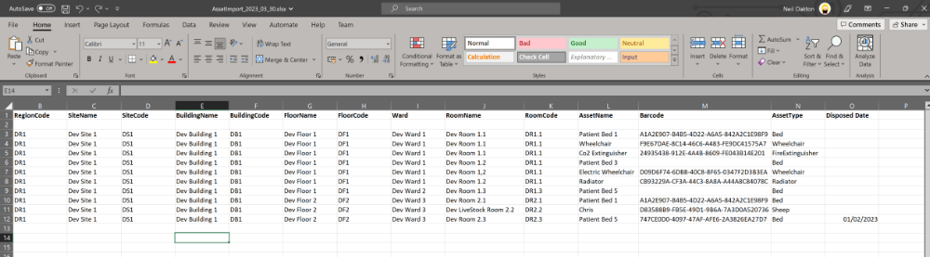

The import routine can use any method that you are comfortable using e.g. webpage, desktop application, ace driver.

The import routine should be demonstrable i.e. start with an empty database, run the import routine, see the data in the database.

You may make reasonable assumptions during the execution of this task but please make a note of these assumptions and be able to discuss your solution to this task.

If you have any blocking questions please contact the test supervisor.

Test Environment
We have created a virtual machine on which you can create your import routine.
Please use remote desktop connection to connect to our test VM
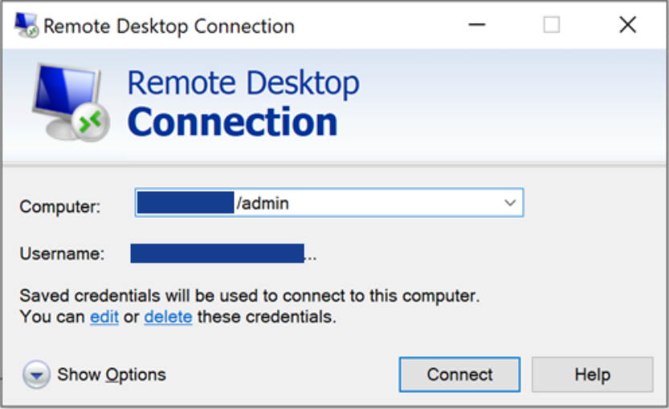
The current credentials will be sent in a separate communication.
The VM has IIS, MSSQL and the Microsoft Access Database Engine (64bit ACE driver) installed.

Internet Information Services (IIS)
IIS is hosting a sample MVC C# website which can be accessed, from the VM, at http://localhost. If you want to create a webpage to import the data, the source code for this website can be cloned from https://github.com/MicadSystems/DeveloperSandbox.git. You will have to manually copy your local website to C:\inetpub\developer_sandbox on the VM.
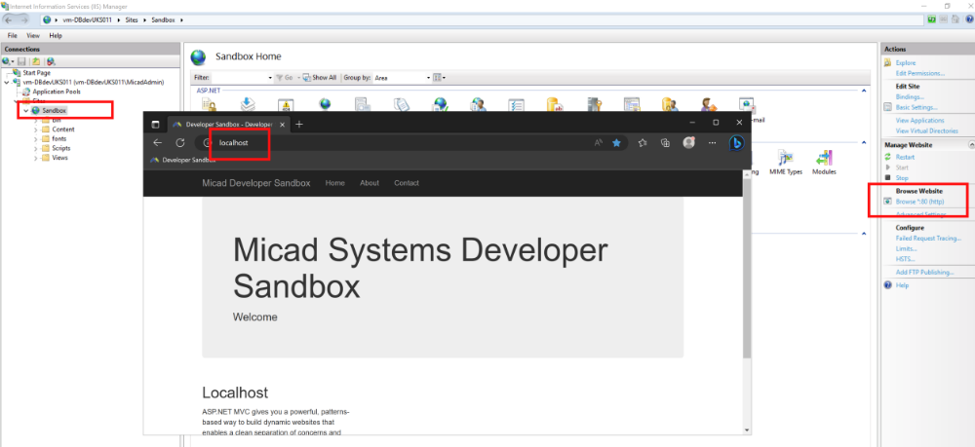

MSSQL Instance
