**Group 5 Sub-Report: PCA Observations and Outcomes**

Definition of Principal Component Analysis according to Wikipedia:

“Principal component analysis is a popular technique for analyzing large datasets containing a high number of dimensions/features per observation, increasing the interpretability of data while preserving the maximum amount of information, and enabling the visualization of multidimensional data.”

Here, we take a visualization-based data mining approach to PCA, plotting numerical attribute columns in a series of cross-plots to observe correlations and interesting data clusters throughout the training data frames collected from the ‘collisions’, ‘parties’, and ‘victims’ tables of the switrs.sqlite database file.

We begin with a cross-comparison of the numeric attributes under two alternate data preparation schemes: “as-is”, and “min-max normalized”. “As-is” attribute comparisons reveal general data trends, as well as correlation patterns between attributes with the units presented as they exist in the source data. “Min-max normalization” standardizes numeric attribute columns with respect to the minimum and maximum values in each attribute column.

We begin by viewing cross-plots of non-standardized data to observe general correlations and patterns, then view an identical set of cross-plots produced with min-max normalized data to reveal meaningful clusters highlighted by the normal vector space.

Note: Please disregard the yellow points, they represent a code artifact and are not semantically meaningful under this analysis.

BEGIN: AS-IS NUMERIC PCA CROSS-PLOTS

**Plot:**

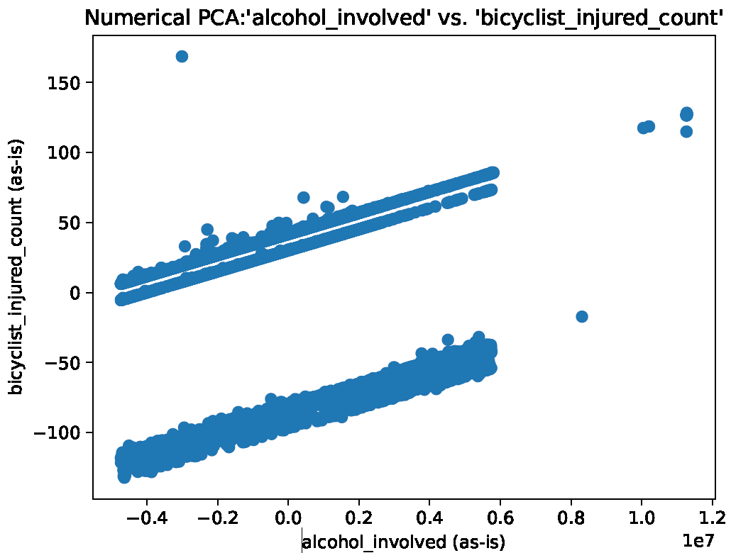

**Observations:** a linear trend is observed between alcohol-involvement and the rate of bicyclist collisions.

**Action:** This pattern can easily be fitted with a linear regression model to predict outcomes based on numerical trends.

**Plot:**

**Observations:** good separation based on whether the accident involved a bicycle related injury.

**Action:** this is likely a good categorization to split data points on in active classifier and/or decision models.

**Plot:**

**Observations:** Again, a good clustering pattern is observed here based on the bicyclist_injured_count numerical attribute.

**Action:** We can leverage this separation in almost all of the classification models we plan on using in this assignment.

**Plot:**

**Observations:** A four-way split.

**Action:** this appears to be a near optimal class separation based on the ‘bicyclist_injured_count’ and ‘killed_victims’ binary attributes. Leverage this separation in the classification models.

**Plot:**

**Observations:** killed_victims is a reasonable class identifier in its own right.

**Action:**

**Plot:**

**Observations:**

**Action:**

**Plot:**

**Observations:**

**Action:**

**Plot:**

**Observations:**

**Action:**

**Plot:**

**Observations:**

**Action:**

**Plot:**

**Observations:**

**Action:**

**Plot:**

**Observations:**

**Action:**

**Plot:**

**Observations:** ‘cellphone_use’ does not appear correlated with ‘pedestrian_collisions’

**Action:**

**Plot:**

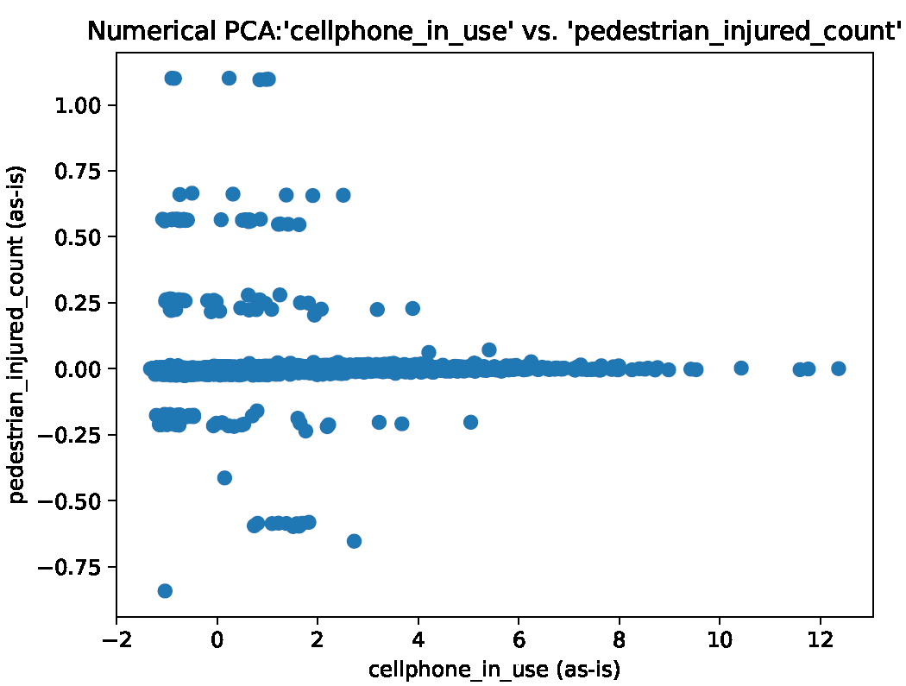

**Observations:**

**Action:**

**Plot:**

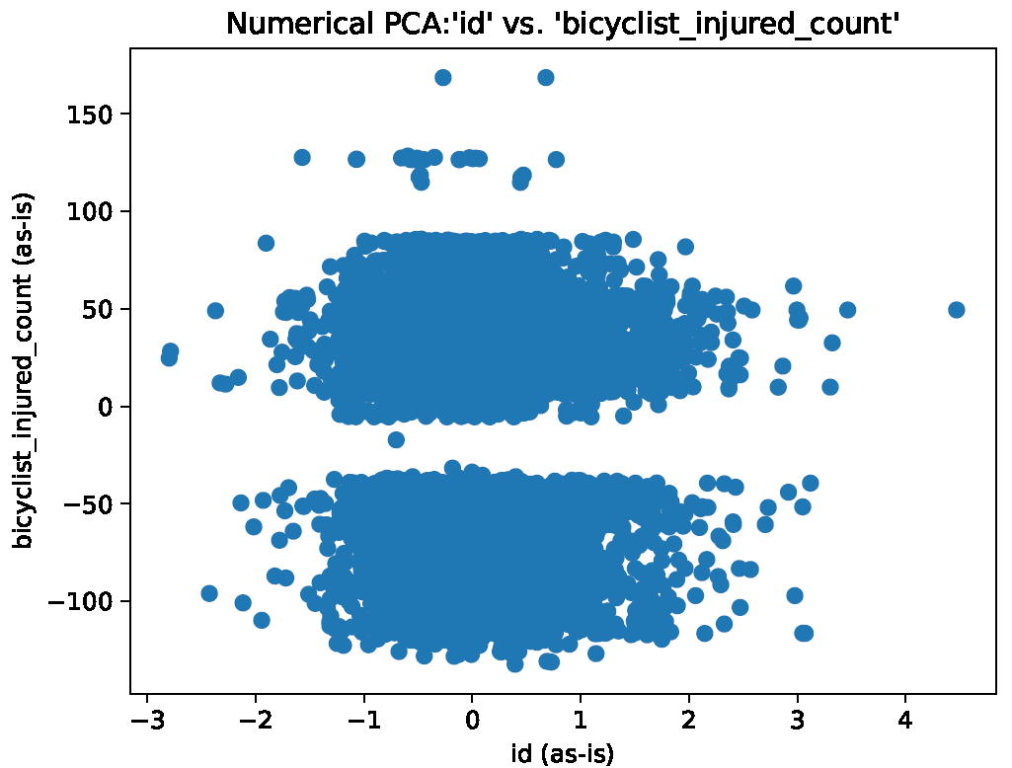

**Observations:** the ratio of injured to uninjured bicyclists looks to be about 50%

**Action:**

**Plot:**

**Observations:** combining this cross-section with the latitude dimension should produce a meaningful data cube structure. Use ‘pedestrian_killed_count’ as the dependent variable.

**Action:**

**Plot:**

**Observations:** combining this cross-section with the latitude dimension should produce a meaningful data cube structure. Use ‘severe_injury_count’ as the dependent variable.

**Action:**

**Plot:**

**Observations:** Desirable clustering.

**Action:**

**Plot:**

**Observations:** another latitude+longitude spatial data cube snapshot (motorcyclists killed by region).

**Action:** make a data cube

**Plot:**

**Observations:** most motorcycle accidents involve younger drivers.

**Action:**

**Plot:**

**Observations:** most bicycle collisions occur away from public property, such as in a residential area.

**Action:** This graphic is important because it shows that the chances of colliding with a bicycle are higher in domestic settings than in urban settings. AI systems can easily detect and avoid bicyclists, using contextual clues about the environment to ascertain the relative likelihood of encountering a bicyclist.

**Plot:**

**Observations:**

**Action:** the distribution shown here indicates that cell phone involvement in domestic areas is likely under-reported. ‘not_private_property’ responses near 0.0 represent a “no response”, indicating that the cellphone usage in !not_private_property = private_property occurs much less frequently than in urban settings. Cell phone usage is still dangerous in domestic settings, the lack of phone control in these environments could explain some of the other distributions we have seen.

**Plot:**

**Observations:** unexpected distribution

**Action:** younger drivers tend to be involved in residential accidents, as ‘party_age’ increases so does the likelihood of a collision in an urban area.

**Plot:**

**Observations:** Bimodal pattern observed.

**Action:** good candidate for regression fitting.

**Plot:**

**Observations:** dead motorcyclists tell no lies.

**Action:** examine cluster to determine underlying causes of deadly motorcycle accidents. The sparse cluster to the right may link to autopsy reports.

**Plot:**

**Observations:** Older victims tend to get more mashed up in automobile accidents.

**Action:** AI system features that provide enhanced vehicle road support for senior citizens would probably do very well under certain demographics, as elderly people are known to have more disposable income to spend on enhanced (software based) safety systems.

**Plot:**

**Observations:** vehicles with additional passengers do not appear to add to the safety risk.

**Action:** vehicles with many passengers are more likely to be a contributing factor to many collisions due to the increased number of distractions experienced by the driver. The visible injury count of these passengers does not appear to increase in correlation to the number of passengers in the vehicle. Therefore, distraction prevention systems tailored to a younger crowd would probably be the best choice for this demographic. Younger people are more likely to purchase “high value” vehicles, meaning vehicles that are reliable, easy to afford, and as feature rich as possible within certain budgetary restrictions.

**Plot:**

**Observations:** Guess who uses their cell phones while driving the most!

**Action:** younger parties are more likely to be involved in a phone-related collision than their parents or grandparents.

**Plot:**

**Observations:** younger drivers tend to have more difficulty at intersections.

**Action:** If the AI system is aware of the driver’s approximate age, enhanced safety features can be turned on whenever (perhaps the family car) is approaching an intersection. An AI system can also act as a driving coach!

**Plot:**

**Observations:** collisions involving young drivers are more likely to be fatal.

**Action:** Parents are often sentimental to the fact that teenage driving can be dangerous. AI based safety features may test well with audiences of concerned parents.

**Plot:**

**Observations:** collision with a motorcycles (as well as non-motorcycles) decreases with party_age.

**Action:** Note that this is a cross-section of a binomial attribute ‘motorcycle_collision’, which fits under a yes or no category, and ‘party_age’ on the x-axis, demonstrating the decrease in collisions of both types as party_age increases (as evidenced by the clustering and relative support shown in the figure).

**Plot:**

**Observations:** distribution showing the relative likelihood of dying in a motorcycle accident.

**Action:** This is an interesting statistic.

**Plot:**

**Observations:** this cluster appears to represent a cluster of reckless teenage drivers.

**Action:** AI systems may be able to monitor environmental conditions and determine the probability of being involved in an accident under the circumstances. Hardline intervention measures are usually avoided at all costs for the sake of customer convenience. In a life-or-death situation or when it comes to avoiding (e.g., a bicycle collision at an intersection) however, the best policy may be for the AI system to act fast and ask forgiveness later. Reckless teenage drivers are a major safety concern on US roadways.

**Plot:**

**Observations:** the odds of a pedestrian being struck by a young driver also decreases with party_age.

**Action:**

**Plot:**

**Observations:** more pedestrians are likely to be involved in a pedestrian collision involving a minor party.

**Action:** The evidence for this claim is observed by the relative support shown above.

**Plot:**

**Observations:** there appear to be more injuries associated with collisions involving minor parties.

**Action:** notice the density of the plot on either side of the 0.0 y-axis. There are clearly more injuries observed when the party_age is low.

**Plot:**

**Observations:** people who have been drinking tend to drive alone, or with a single partner.

**Action:**

**Plot:**

**Observations:** people are more likely to use a cell phone when they are alone than with passengers.

**Action:** A safety reminder can be set by the driver of the vehicle to remind them not to use the phone while driving, as cellphone use has negative implications on traffic safety. It’s best not to be *too* annoying with these features, however.

**Plot:**

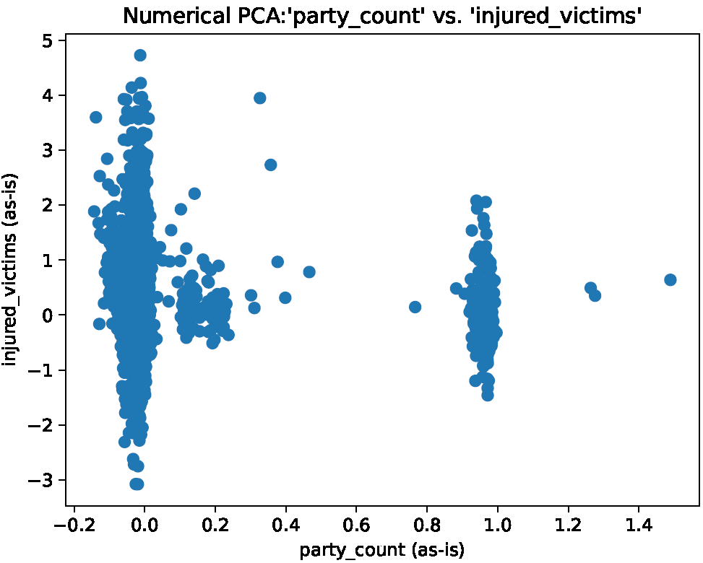

**Observations:** it is safer to drive with a co-pilot

**Action:** this is not surprising but could indicate a need for AI-features or modes suited to individual drivers. In many ways, the ideal AI system would act as this second passenger, without distracting or annoying the driver. Highlighted forward-facing dash cameras are one of the most promising technological developments that could be tailored to suit this purpose.

**Plot:**

**Observations:** individual drivers have more difficulty at intersections (although they’ll never admit it).

**Action:** A “silent ride-along parter” could be just the right safety feature for more *private* consumers.

**Plot:**

**Observations:** Again, single drivers are more likely to be involved in an accident, whether it involves fatalities or not.

**Action:** The real trick to developing an AI ride-along system is ***stealth***. Since solitary drivers are not likely to tolerate annoying system faults or interruptions for very long, before taking a solitary ride back to the dealership. Stealth is the reason why image-recognition dashboard camera systems has been so popular in recent publications. (See prior works for more details.)

**Plot:**

**Observations:** solo-drivers are more likely to hit bicylists.

**Action:**

**Plot:**

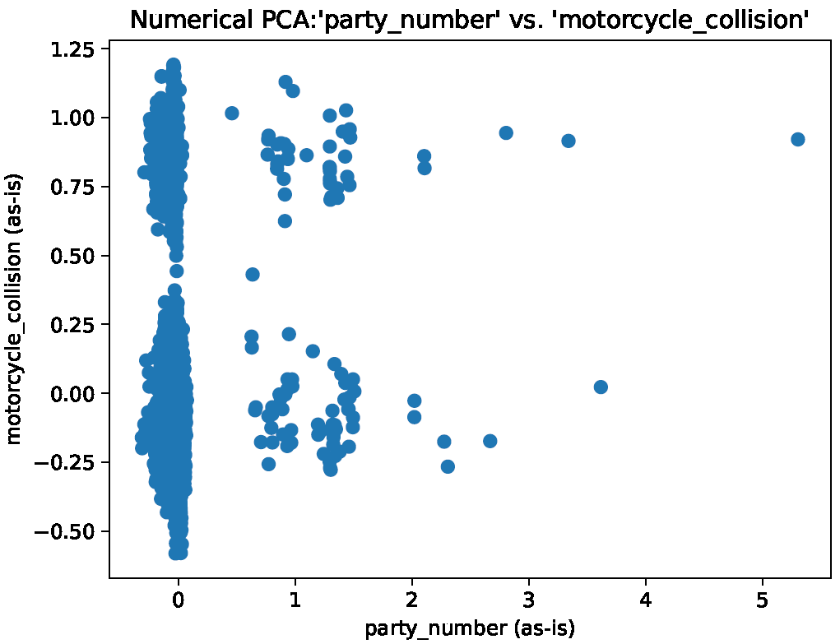

**Observations:** solo-drivers would appear to be more likely to hit motorcycles based on this observation.

**Action:** this observation (solo-drivers are more dangerous) is likely to have been affected by the relative abundancy of solo-drivers compared with other drivers. This does not however, detract from the numerous safety benefits of driving with a passenger. This effect of relative support on rule generation can be assessed using a chi-square table to compare expected vs. observed members in each category created by the intersection of ‘party_number’ and ‘motorcycle_collision’ (for example). A similar analysis can be performed anytime the distribution of relative support is not even, and when the validity of the rule may be affected.

**Plot:**

**Observations:** a negative correlation between ‘party_number’ and ‘pedestrian_collision’. This time the support for single-party drivers does not appear to be clouding the model.

**Action:** determine if this trend is meaningful by observing the integrity of the underlying data. It seems the plot is most clearly saying “the likelihood of a pedestrian collision decreases with party_number”. Investigate to examine the source of this trend.

**Plot:**

**Observations:** Most of the school bus related collisions appear to occur when there are 1-3 people in the car. These poor folks were probably on their way to drop the kids off at school.

**Action:** Life is challenging and messy sometimes. Luckily, a school bus should be an easy object for an AI-guided automobile to detect and avoid.

**Plot:**

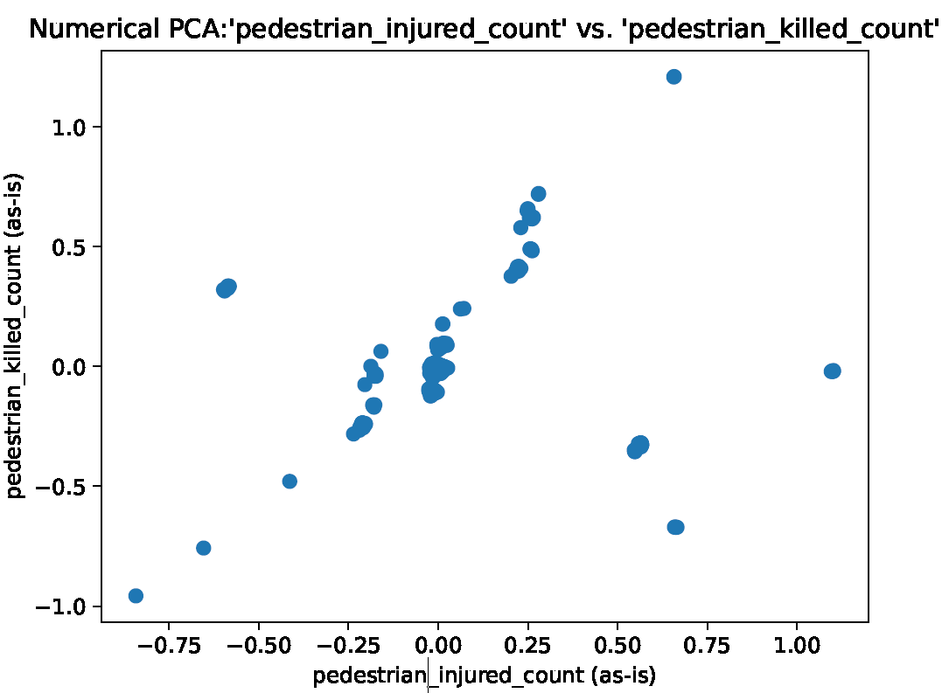

**Observations:** pedestrian injuries are correlated with pedestrian deaths.

**Action:** the only surprising thing about this observation (really) is just how well these variables are correlated.

**Plot:**

**Observations:** It appears that the likelihood of a tow-away decreases as the severe injury count increases, with a slight inflection near the 0.0 x-axis mark. There appear to be a handful of outliers near the top of the plot, these individuals most likely totaled their vehicles. Maybe it is California policy to leave the road on the side of the vehicle if the passenger prefers?

**Action:** I’m not quite sure what to make of this plot. My first suspicion is that the likelihood of a tow_away would increase with the severe_injury_count. We see from the plot however that this is not the case.

**Plot:**

**Observations:**

**Action:**

**Plot:**

**Observations:**

**Action:**

**Plot:**

**Observations:**

**Action:**

**Plot:**

**Observations:**

**Action:**

**Plot:**

**Observations:**

**Action:**

MIN-MAX NORMALIZED PCA ON COLLISIONS DATA

**Plot:**

**Observations:**

**Action:**

**Plot:**

**Observations:**

**Action:**

**Plot:**

**Observations:**

**Action:**

**Plot:**

**Observations:**

**Action:**

**Plot:**

**Observations:**

**Action:**

**Plot:**

**Observations:**

**Action:**