Supplemental Figure S2 — Age Effects in Swing Districts
All analyses restricted to Democratic and Republican candidates in swing districts (Cook PVI ±7, n = 69; n = 34 with valid age). Party affiliation excluded from all models. Age data collected via GPT-4o web search; ~48% of records lacked age.
Figure S2a — Win rates by decade, party breakdown, and power curves
Left: win rates by age decade (chi-square p = 0.015, df = 5, χ² = 14.13). Centre: win rates by party — the 40s advantage holds for Democrats (87.5%) and Republicans (100%). Right: power curves for key demographic signals; n = 34 yields ~51% power for age linear (r = 0.283, p = 0.021).
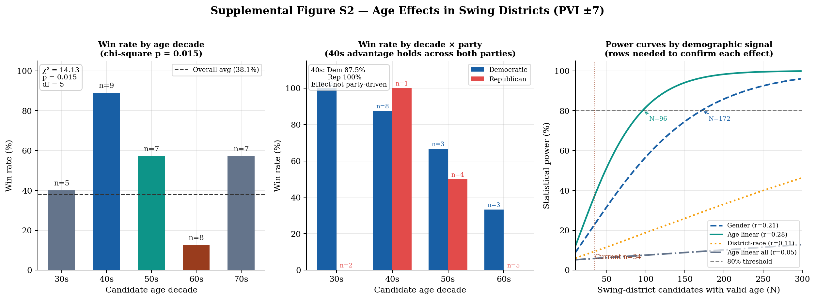

Figure S2b — 5-year bin analysis and rows needed for significance
Left: win rates by 5-year age bin (chi-square p = 0.18, underpowered; only 1 of 7 bins meets n ≥10). Right: power as a function of sample size for 5-year bin chi-square; ~175 swing-district candidates with valid age needed for 80% power.
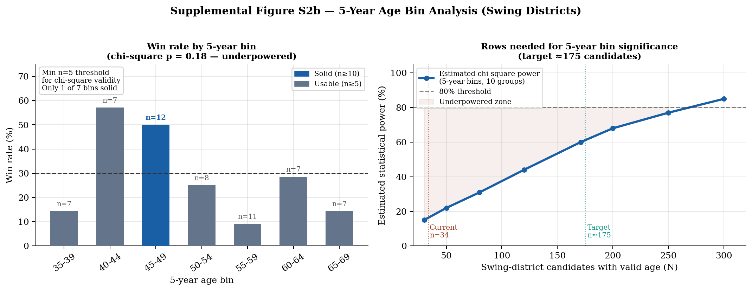

Table S2a — Win rates by age decade (underlying data for Figure S2a left panel)
Pairwise p-values from chi-square comparing each decade against all others combined. ** p < 0.01, * p < 0.05. Party breakdown shown for decades where both parties are represented in the swing sample.
Decade | n | Won | Lost | Win rate | Dem win% (n) | Rep win% (n) | Pairwise p | Sig
30s | 5 | 2 | 3 | 40.0% | 100.0% (n=2) | 0.0% (n=2) | p = 0.812
40s | 9 | 8 | 1 | 88.9% | 87.5% (n=8) | 100.0% (n=1) | p = 0.003 | **
50s | 7 | 4 | 3 | 57.1% | 66.7% (n=3) | 50.0% (n=4) | p = 0.007 | **
60s | 8 | 1 | 7 | 12.5% | 33.3% (n=3) | 0.0% (n=5) | p = 0.045 | *
70s | 7 | 4 | 3 | 57.1% | 0.0% (n=1) | 75.0% (n=4) | p = 0.381
All | 34 | 19 | 15 | 55.9% | 56.5% (n=17) | 52.9% (n=17) | —

Note: Valid age = 22–85; 48% of swing-district records excluded due to missing age. All chi-square tests two-sided, α = 0.05. Pairwise tests not corrected for multiple comparisons; treat as exploratory. Replication code: https://github.com/MicahHertzler/Machine-Learning-Analysis-of-FEC-Campaign-data

