**Home Activity**

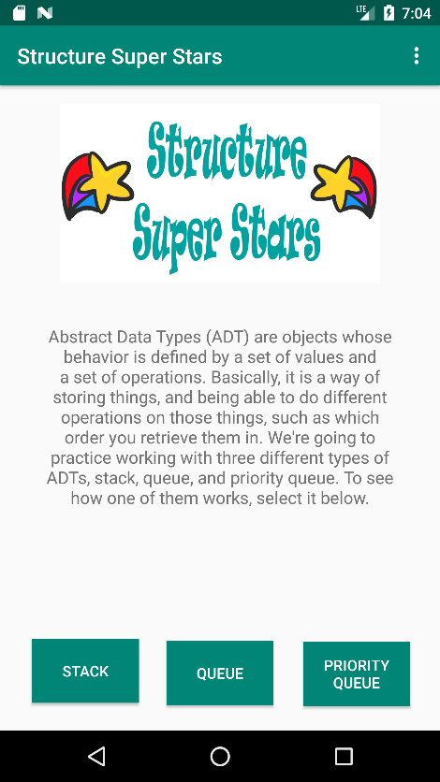*

*Contains a short description of ADTs and contains three buttons linking to the three game activities

*

**Priority Queue Game (Micah Jones’ Activity)**

The priority queue game is meant to demonstrate how a priority queue removes it’s elements. The game is played by adding three different kinds of patients (sick, sicker, and sickest) to a hospital line. Once the user has added five different patients in any order, they can then try to remove the patients from the “line” or priority queue by dragging and dropping the correct patient to the nurse. If they pick the wrong patient, they are told why the patient they picked is not correct, and can try again. If they want, they can simulate a true line once the game has begun by adding new patients to the line. The game rewards the user with a congratulations once they have completely emptied their priority queue, and then they can start the game again by adding a new 5 patients to the line.

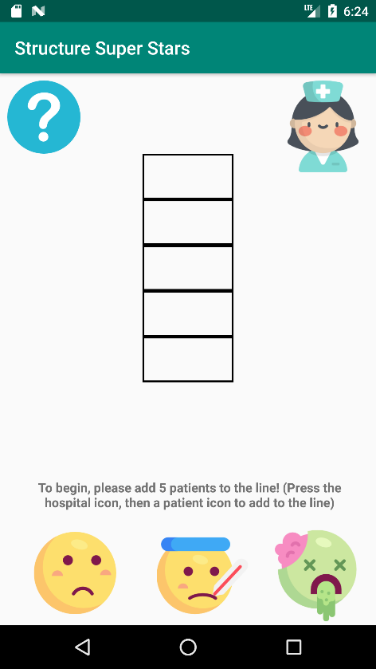*

Screen On Load –

*Tells user to add 5 patients into the “hospital line” to start the game

*Contains “help” button, which can be clicked to give info on the priority queue, and explain the game

*

*

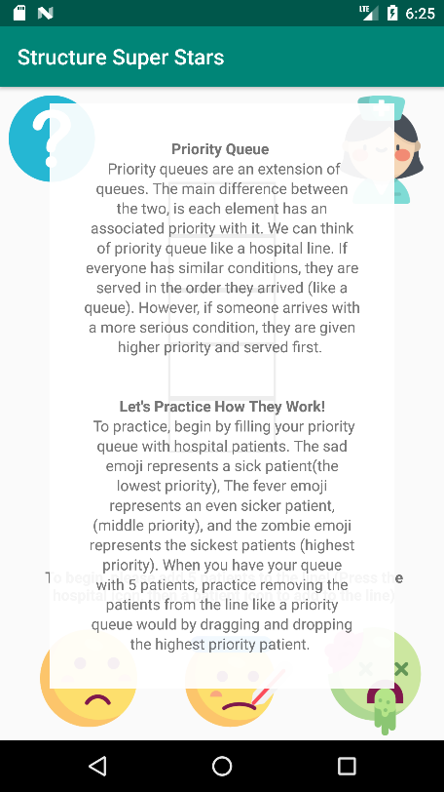*

Help pop up window-

*When the help button is clicked, a help window pops up telling the user how a priority queue works, and how they can play the game

*

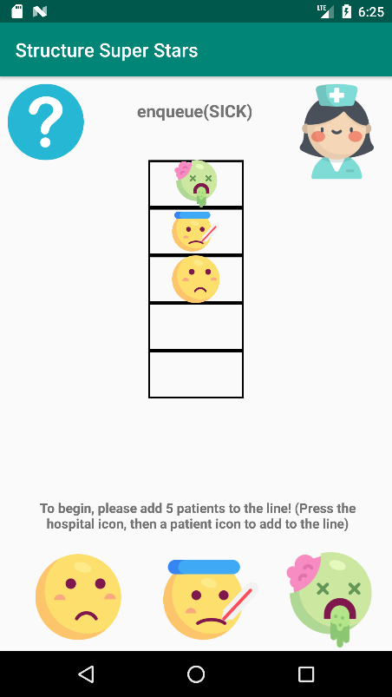*

Adding “patients”

*The user can add patients to the priority queue in any order.

*The sad emoji represents the “sick” patients (lowest priority), the fever emoji represents the “sicker” patients (middle priority), and the zombie emoji represents the “sickest” patients (highest priority)

*When the user adds a patient to the line, the priority queue equivalent command shows at the top of the screen

*

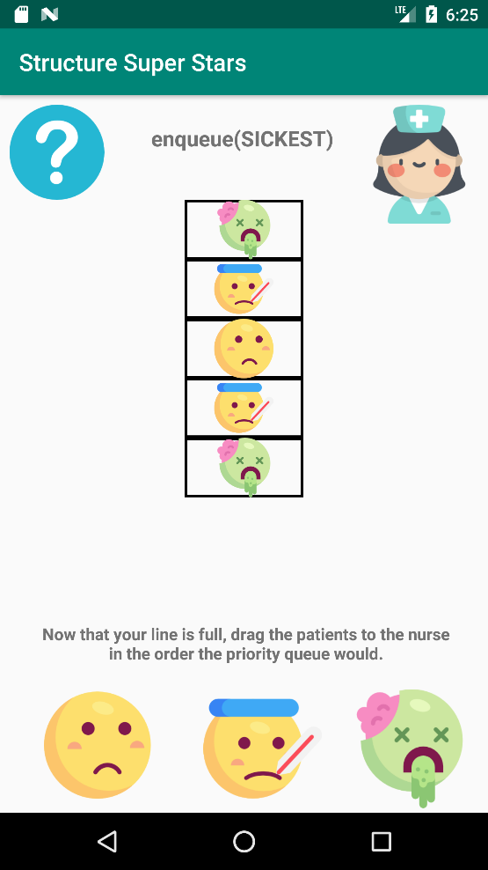*

Line is full, game begins!

*Once 5 patients have been added, the prompt above the patients tells the user they can begin trying to drag the patients in the correct order. When the user drags and drops a patient to the nurse in the correct order, the line updates by dequeueing the dragged patient

*

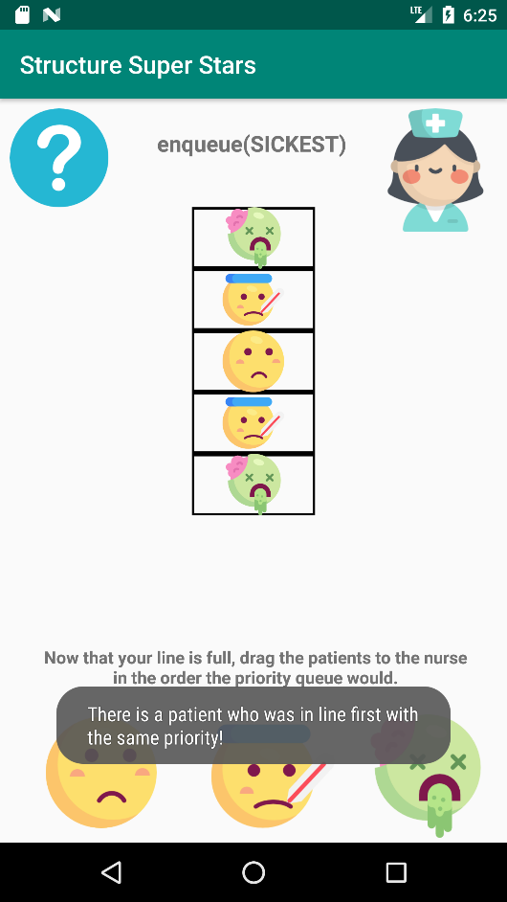*

Incorrect dequeue()

*If the user drags a patient, and there is a patient with the same priority who was in line first, the answer is incorrect, and a toast message tells the user why their answer was incorrect

*

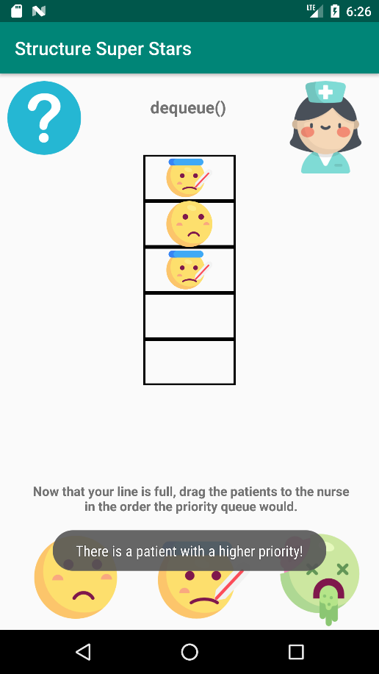*

Incorrect dequeue()

*If the user drags a patient, and there is another patient in line with a higher priority, a toast error message displays to the user telling them why their answer was incorrect

*

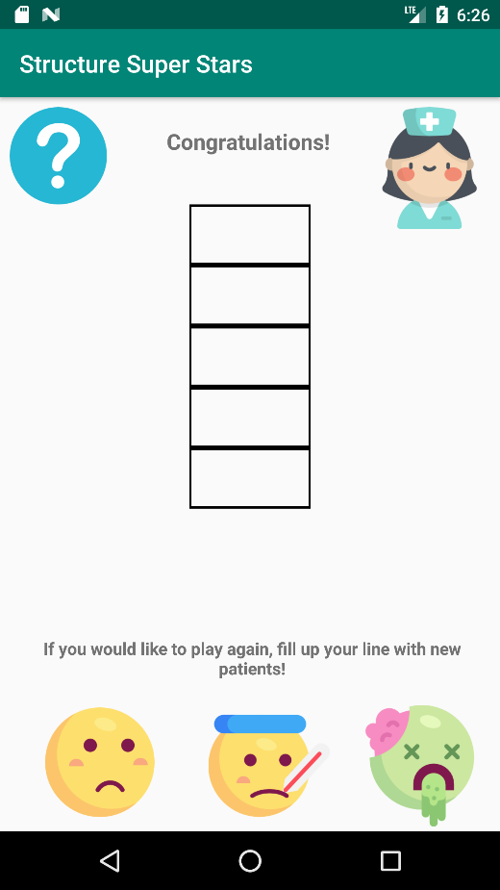*

“line” has been emptied

*The game has been completed, and the message at the top of the page gives the user congratulations for winning. They are prompted to start the game again.

*