CSC 440 Fall 2021 Individual Project

Micah Meadows

Use Case Diagram

Functional Requirements

1. The system shall allow the user to login to the system
   1. The system shall display a login form to the user A picture containing text, grass, close

      Description automatically generated
   2. The user shall ender their username and password and submit the login form
      1. If the username and password are invalid an error will be presented telling the user their password or username was wrong and allow for them to change and resubmit
   3. The system should verify and log the user in
2. The system shall allow for new grades to be added for each course into the database from one or multiple formatted files
   1. The user shall select ‘Upload Records’ from the navigation menu on the GUI
   2. The system shall display the upload records page
   3. Graphical user interface, text, application

      Description automatically generated
      1. A user shall be able to drag and drop a file onto the page or upload them manually
         1. If a file is of the incorrect file type or has an incorrect name that is unrecognizable it should be rejected
      2. The user shall press ‘Upload Files’ in order to submit them to the automated system
      3. The system shall process the files and give a log for any files that were duplicates
3. The system shall allow for the searching of students by id, name, and gpa
   1. The user shall select ‘Student Search’ from the navigation menu on the GUI
   2. The user shall be displayed with a list of all students
   3. Graphical user interface, application

      Description automatically generated
   4. The user shall input information into the filter fields to narrow down the student selection
      1. The system will output a list of students that apply to the inputted information
   5. The user shall be able to select a student to display their course records
   6. 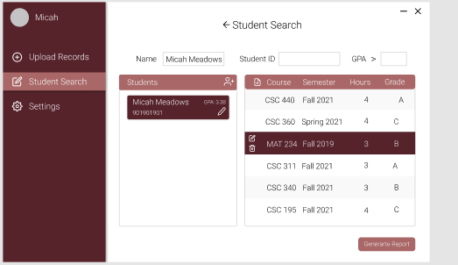
      1. If a user has no course records the list will be empty and they will have the option to add new course records by following R4
4. The system shall allow for manual input of course records
   1. The user shall select a student by following R3
   2. The user will select the option to add a course record manually to a student
   3. The system shall display a form popup allowing for the input of information pertaining to the added course record
   4. Graphical user interface, application, website

      Description automatically generated
   5. The system shall attempt to import the new course record into the database
      * + 1. If the database already holds the record return an error telling the user, the data already exists
5. The system shall allow for the editing of course records
   1. The user shall select a student by following R3
   2. The user will have the option to edit a course record manually by selecting the course record after selecting a student
   3. The system shall display a form popup allowing for the edit of information pertaining to the selected course record
   4. Graphical user interface, website

      Description automatically generated
      * + 1. If the database already holds the record return an error telling the user, the data already exists
6. The system shall allow for the deletion of course records
   1. The user shall select a student and then course by following R3
   2. The user shall be present with the option to delete a course
   3. The user shall click the option to delete a course
   4. The system shall prompt the user for confirmation of deletion
   5. Graphical user interface, text, application

      Description automatically generated
      1. If the user cancels it should close the form
   6. The system shall delete the course from the database
7. The system shall allow for the creation of a Transcript or Report Card
   1. The user shall select a student by following R3
   2. The user shall have the option to generate a report
   3. A form will pop up with settings related to the report and display information pertaining to the report
   4. Graphical user interface, application, PowerPoint

      Description automatically generated
   5. The user will select download report
   6. The report will be generated and downloaded to the users computer
8. The user shall have the choice to view application settings
   1. The user shall select ‘Settings’ From the navigation menu
   2. The user will be presented with a page of settings
   3. Graphical user interface

      Description automatically generated
      1. The user shall select change picture
         1. The user shall select a new picture
         2. The new picture will be uploaded to the database
         3. The image by the user profile will update
      2. The user shall select change password
         1. the user shall select a new password
         2. the new password will be uploaded to the database
      3. The user shall select log out
         1. The user will be logged out of the system
         2. The system shall display the login form R1

Levels of Data Flow Diagrams

Level 0 Context

Level 1 From P0

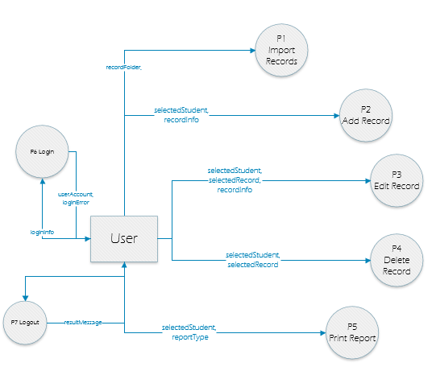

Level 2 From P1

Level 2 From P2

Level 2 From P3

Level 2 From P4

Level 2 From P5

Level 2 From P6

Level 3 From P5.2

